# Research Project Documentation

# Test Run

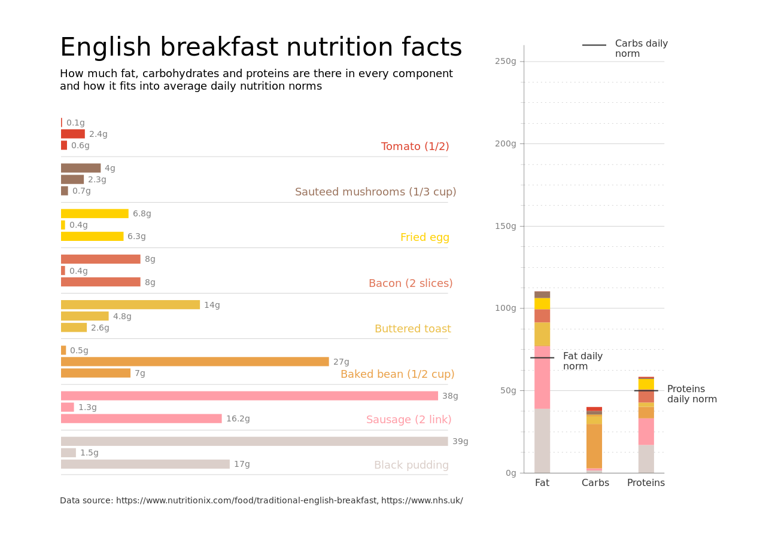

Figure: Charts/Comparison/png/bar.png

## Prompt Used

Task: Extract detailed information from a given graph image and generate JSON files (`data.json`, `layout.json`, and `config.json`) compatible with Plotly. Use the specified delimiters to wrap each JSON section.  
  
### Instructions:  
  
#### Graph Analysis:  
  
1. **Identify and categorize** the plot types present in the graph. Include both simple and complex plots:  
 - Simple plots: `scatter`, `bar`, `pie`, `line`, `area`  
 - Complex plots: `stacked bar`, `scatter3d`, `surface`.  
 Confirm the presence of each plot type. Ensure that area plots are identified with `"type": "area"`.  
  
2. **Extract data points** for each plot type:  
 - For `scatter`, `line`, and `area` plots: Extract `x` and `y` values.  
 - For `bar` and `stacked bar` plots: Extract `x` (categories) and `y` values.  
 - For `pie` charts: Extract `labels` and `values`.  
 - For `scatter3d` and `surface` plots: Extract `x`, `y`, and `z` values.  
  
3. **Note any multiple plots** on the same figure and their configurations:  
 - For stacked plots, identify the stacking order and group.  
 - For area charts, ensure `fill` is specified correctly.  
  
#### Generate `data.json`:  
  
For each plot, include details such as:  
- **type**: The type of plot (e.g., `"scatter"`, `"bar"`, `"pie"`, `"area"`, `"scatter3d"`, `"surface"`).  
 - For area charts, use `"type": "scatter"` and specify `"fill"`.  
- **x**, **y**, and **z** (if applicable): Arrays of data points for the `x`, `y`, and `z` axes.  
- **labels** and **values** for pie charts.  
- **mode**: For line and scatter plots (e.g., `"markers"`, `"lines"`, `"markers+lines"`).  
- **name**: Legend entry for the plot.  
- **marker**: Properties such as color, size, and symbol for markers.  
- **line**: Properties such as color, width, and dash style for lines.  
- **text**: Hover text for each data point.  
- **hoverinfo**: Information displayed on hover (e.g., `"x+y+text"`).  
- **fill**: For area charts, specify the fill (e.g., `"tozeroy"`, `"tonexty"`).  
- **fillcolor**: The color used to fill the area under the line.  
- **stackgroup**: For stacked bar charts, specify the group for stacking.  
  
#### Generate `layout.json`:  
  
Include details such as:  
- **title**: The title of the graph, including text and font properties.  
- **xaxis** and **yaxis**: Configuration including title, range, grid properties, and tick settings.  
- **zaxis**: Configuration for 3D plots including title, range, and grid properties.  
- **legend**: Properties including orientation and positioning.  
- **margin**: Values for left, right, bottom, top, and padding.  
- **plot_bgcolor** and **paper_bgcolor**: Background colors of the plot area and paper.  
- **scene**: For 3D plots, configuration for the 3D scene, including camera angles, lighting, and aspect ratio.  
  
#### Generate `config.json`:  
  
Include configuration settings such as:  
- **responsive**: Whether the graph is responsive.  
- **displayModeBar**: Whether the mode bar is displayed.  
- **modeBarButtonsToRemove**: List of mode bar buttons to remove.  
- **scrollZoom**: Whether scrolling zoom is enabled.  
  
#### Generate `<csv>`:  
  
Include CSV data formatted as follows:  
```csv  
x,y  
1,4  
2,5  
3,6  
```  
Replace x,y, 1,4, 2,5, and 3,6 with actual data extracted from the graph image.  
  
Output Format:  
Wrap each JSON output in specific XML-like tags:  
  
<data> ... </data>  
<layout> ... </layout>  
<config> ... </config>  
<csv> ... </csv>  
Make sure to follow the JSON formatting guidelines:  
  
Double Quotes for Keys and Strings: Ensure all keys and string values in JSON are enclosed in double quotes.  
No Trailing Commas: Remove any trailing commas after the last element in arrays or objects.  
Example Output:  
  
<data>  
[  
 {  
 "type": "scatter",  
 "x": [1, 2, 3],  
 "y": [4, 5, 6],  
 "mode": "markers+lines",  
 "name": "Line Plot",  
 "marker": {  
 "color": "rgba(75, 192, 192, 0.6)",  
 "size": 8  
 },  
 "line": {  
 "color": "rgba(75, 192, 192, 1)",  
 "width": 2  
 }  
 },  
 {  
 "type": "area",  
 "x": [1, 2, 3, 4, 5, 6, 7, 8, 9, 10, 11, 12],  
 "y": [400, 430, 550, 620, 580, 600, 630, 700, 670, 630, 600, 500],  
 "name": "Housing",  
 "marker": {  
 "color": "rgba(255, 159, 64, 0.8)"  
 },  
 "line": {  
 "color": "rgba(255, 159, 64, 1)",  
 "width": 2  
 }  
 },  
  
 {  
 "type": "bar",  
 "x": ["A", "B", "C"],  
 "y": [10, 15, 13],  
 "name": "Bar Chart",  
 "marker": {  
 "color": "rgba(255, 99, 132, 0.6)"  
 },  
 "hoverinfo": "x+y+text"  
 },  
 {  
 "type": "scatter",  
 "x": [1, 2, 3],  
 "y": [6, 7, 8],  
 "mode": "lines",  
 "fill": "tozeroy",  
 "name": "Area Chart",  
 "line": {  
 "color": "rgba(54, 162, 235, 1)",  
 "width": 2  
 },  
 "fillcolor": "rgba(54, 162, 235, 0.5)"  
 },  
 {  
 "type": "scatter3d",  
 "x": [1, 2, 3],  
 "y": [4, 5, 6],  
 "z": [7, 8, 9],  
 "mode": "markers",  
 "name": "3D Scatter Plot",  
 "marker": {  
 "color": "rgba(255, 159, 64, 0.8)",  
 "size": 5  
 },  
 "hoverinfo": "x+y+z+text"  
 },  
 {  
 "type": "surface",  
 "z": [  
 [10, 10.625, 12.5, 15.625, 20],  
 [5.625, 6.25, 8.125, 11.25, 15.625],  
 [0, 1.25, 3.125, 6.25, 10.625]  
 ],  
 "name": "Surface Plot",  
 "colorscale": "Viridis",  
 "hoverinfo": "z+name"  
 }  
]  
</data>  
<layout>  
{  
 "title": {  
 "text": "Complex Graph Example",  
 "font": {  
 "family": "Arial, sans-serif",  
 "size": 24,  
 "color": "#000000"  
 }  
 },  
 "xaxis": {  
 "title": {  
 "text": "X Axis",  
 "font": {  
 "family": "Arial, sans-serif",  
 "size": 18,  
 "color": "#000000"  
 }  
 },  
 "showgrid": true,  
 "gridcolor": "rgba(0, 0, 0, 0.1)",  
 "zeroline": true,  
 "zerolinecolor": "rgba(0, 0, 0, 0.1)"  
 },  
 "yaxis": {  
 "title": {  
 "text": "Y Axis",  
 "font": {  
 "family": "Arial, sans-serif",  
 "size": 18,  
 "color": "#000000"  
 }  
 },  
 "showgrid": true,  
 "gridcolor": "rgba(0, 0, 0, 0.1)",  
 "zeroline": true,  
 "zerolinecolor": "rgba(0, 0, 0, 0.1)"  
 },  
 "legend": {  
 "orientation": "h",  
 "x": 0.5,  
 "xanchor": "center",  
 "y": -0.2,  
 "font": {  
 "family": "Arial, sans-serif",  
 "size": 12,  
 "color": "#000000"  
 }  
 },  
 "margin": {  
 "l": 60,  
 "r": 30,  
 "b": 60,  
 "t": 60  
 },  
 "plot_bgcolor": "#ffffff",  
 "paper_bgcolor": "#ffffff",  
 "scene": {  
 "xaxis": {"title": "X Axis"},  
 "yaxis": {"title": "Y Axis"},  
 "zaxis": {"title": "Z Axis"}  
 }  
}  
</layout>  
<config>  
{  
 "responsive": true,  
 "displayModeBar": true,  
 "modeBarButtonsToRemove": ["toImage"],  
 "scrollZoom": true  
}  
</config>  
<csv>  
x,y  
1,4  
2,5  
3,6  
</csv>

## Extracted JSON

### data

[  
 {  
 "type": "bar",  
 "x": [  
 "Tomato (1/2)",  
 "Sauteed mushrooms (1/3 cup)",  
 "Fried egg",  
 "Bacon (2 slices)",  
 "Buttered toast (1/2)",  
 "Baked bean (1/2 cup)",  
 "Sausage (2 link)",  
 "Black pudding"  
 ],  
 "y": [  
 2.4,  
 6.8,  
 6.3,  
 8,  
 4.6,  
 7,  
 16.2,  
 17  
 ],  
 "name": "Nutritional Information",  
 "marker": {  
 "color": "rgba(255, 99, 132, 0.6)"  
 },  
 "hoverinfo": "x+y+text"  
 }  
]

### layout

{  
 "title": {  
 "text": "English Breakfast",  
 "font": {  
 "family": "Arial, sans-serif",  
 "size": 24,  
 "color": "#000000"  
 }  
 },  
 "xaxis": {  
 "title": {  
 "text": "Food Item",  
 "font": {  
 "family": "Arial, sans-serif",  
 "size": 18,  
 "color": "#000000"  
 }  
 },  
 "showgrid": true,  
 "gridcolor": "rgba(0, 0, 0, 0.1)",  
 "zeroline": true,  
 "zerolinecolor": "rgba(0, 0, 0, 0.1)"  
 },  
 "yaxis": {  
 "title": {  
 "text": "Nutritional Value",  
 "font": {  
 "family": "Arial, sans-serif",  
 "size": 18,  
 "color": "#000000"  
 }  
 },  
 "showgrid": true,  
 "gridcolor": "rgba(0, 0, 0, 0.1)",  
 "zeroline": true,  
 "zerolinecolor": "rgba(0, 0, 0, 0.1)"  
 },  
 "legend": {  
 "orientation": "h",  
 "x": 0.5,  
 "xanchor": "center",  
 "y": -0.2,  
 "font": {  
 "family": "Arial, sans-serif",  
 "size": 12,  
 "color": "#000000"  
 }  
 },  
 "margin": {  
 "l": 60,  
 "r": 30,  
 "b": 60,  
 "t": 60  
 },  
 "plot_bgcolor": "#ffffff",  
 "paper_bgcolor": "#ffffff"  
}

### config

{  
 "responsive": true,  
 "displayModeBar": true,  
 "modeBarButtonsToRemove": [  
 "toImage"  
 ],  
 "scrollZoom": true  
}

## Updated JSON

### updated_data

[  
 {  
 "type": "bar",  
 "x": [  
 "Tomato (1/2)",  
 "Sauteed mushrooms (1/3 cup)",  
 "Fried egg",  
 "Bacon (2 slices)",  
 "Buttered toast (1/2)",  
 "Baked bean (1/2 cup)",  
 "Sausage (2 link)",  
 "Black pudding"  
 ],  
 "y": [  
 2.4,  
 6.8,  
 6.3,  
 8,  
 4.6,  
 7,  
 16.2,  
 17  
 ],  
 "name": "Nutritional Information",  
 "marker": {  
 "color": "rgba(255, 99, 132, 0.6)"  
 },  
 "hoverinfo": "x+y+text"  
 }  
]

### updated_layout

{  
 "title": {  
 "text": "English Breakfast",  
 "font": {  
 "family": "Arial, sans-serif",  
 "size": 24,  
 "color": "#000000"  
 }  
 },  
 "xaxis": {  
 "title": {  
 "text": "Food Item",  
 "font": {  
 "family": "Arial, sans-serif",  
 "size": 18,  
 "color": "#000000"  
 }  
 },  
 "showgrid": true,  
 "gridcolor": "rgba(0, 0, 0, 0.1)",  
 "zeroline": true,  
 "zerolinecolor": "rgba(0, 0, 0, 0.1)"  
 },  
 "yaxis": {  
 "title": {  
 "text": "Nutritional Value",  
 "font": {  
 "family": "Arial, sans-serif",  
 "size": 18,  
 "color": "#000000"  
 }  
 },  
 "showgrid": true,  
 "gridcolor": "rgba(0, 0, 0, 0.1)",  
 "zeroline": true,  
 "zerolinecolor": "rgba(0, 0, 0, 0.1)"  
 },  
 "legend": {  
 "orientation": "h",  
 "x": 0.5,  
 "xanchor": "center",  
 "y": -0.2,  
 "font": {  
 "family": "Arial, sans-serif",  
 "size": 12,  
 "color": "#000000"  
 }  
 },  
 "margin": {  
 "l": 60,  
 "r": 30,  
 "b": 60,  
 "t": 60  
 },  
 "plot_bgcolor": "#ffffff",  
 "paper_bgcolor": "#ffffff"  
}

### updated_config

{  
 "responsive": true,  
 "displayModeBar": true,  
 "modeBarButtonsToRemove": [  
 "toImage"  
 ],  
 "scrollZoom": true  
}

## Updated Chart

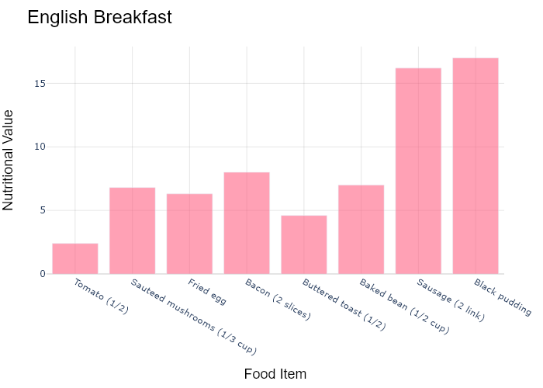

## Performance Metrics

|  |  |  |  |
| --- | --- | --- | --- |
| Task | Model Used | Description | Time Taken (s) |
| Processing Image to JSON | Gemini Vision Pro (default) | Time taken to convert the uploaded image to JSON format | 19.62 |
| Updating JSON | ChatGPT 3.5 (Default) | Time taken to update the JSON with new data | 0.00 |
| Plotting Updated JSON | N/A | Time taken to plot the updated JSON | 0.20 |

# Test Run



Figure: D:/Research Internship/Charts/Comparison/png\bar.png

## Prompt Used

Task: Extract detailed information from a given graph image and generate JSON files (`data.json`, `layout.json`, and `config.json`) compatible with Plotly. Use the specified delimiters to wrap each JSON section.  
  
### Instructions:  
  
#### Graph Analysis:  
  
1. **Identify and categorize** the plot types present in the graph. Include both simple and complex plots:  
 - Simple plots: `scatter`, `bar`, `pie`, `line`, `area`  
 - Complex plots: `stacked bar`, `scatter3d`, `surface`.  
 Confirm the presence of each plot type. Ensure that area plots are identified with `"type": "area"`.  
  
2. **Extract data points** for each plot type:  
 - For `scatter`, `line`, and `area` plots: Extract `x` and `y` values.  
 - For `bar` and `stacked bar` plots: Extract `x` (categories) and `y` values.  
 - For `pie` charts: Extract `labels` and `values`.  
 - For `scatter3d` and `surface` plots: Extract `x`, `y`, and `z` values.  
  
3. **Note any multiple plots** on the same figure and their configurations:  
 - For stacked plots, identify the stacking order and group.  
 - For area charts, ensure `fill` is specified correctly.  
  
#### Generate `data.json`:  
  
For each plot, include details such as:  
- **type**: The type of plot (e.g., `"scatter"`, `"bar"`, `"pie"`, `"area"`, `"scatter3d"`, `"surface"`).  
 - For area charts, use `"type": "scatter"` and specify `"fill"`.  
- **x**, **y**, and **z** (if applicable): Arrays of data points for the `x`, `y`, and `z` axes.  
- **labels** and **values** for pie charts.  
- **mode**: For line and scatter plots (e.g., `"markers"`, `"lines"`, `"markers+lines"`).  
- **name**: Legend entry for the plot.  
- **marker**: Properties such as color, size, and symbol for markers.  
- **line**: Properties such as color, width, and dash style for lines.  
- **text**: Hover text for each data point.  
- **hoverinfo**: Information displayed on hover (e.g., `"x+y+text"`).  
- **fill**: For area charts, specify the fill (e.g., `"tozeroy"`, `"tonexty"`).  
- **fillcolor**: The color used to fill the area under the line.  
- **stackgroup**: For stacked bar charts, specify the group for stacking.  
  
#### Generate `layout.json`:  
  
Include details such as:  
- **title**: The title of the graph, including text and font properties.  
- **xaxis** and **yaxis**: Configuration including title, range, grid properties, and tick settings.  
- **zaxis**: Configuration for 3D plots including title, range, and grid properties.  
- **legend**: Properties including orientation and positioning.  
- **margin**: Values for left, right, bottom, top, and padding.  
- **plot_bgcolor** and **paper_bgcolor**: Background colors of the plot area and paper.  
- **scene**: For 3D plots, configuration for the 3D scene, including camera angles, lighting, and aspect ratio.  
  
#### Generate `config.json`:  
  
Include configuration settings such as:  
- **responsive**: Whether the graph is responsive.  
- **displayModeBar**: Whether the mode bar is displayed.  
- **modeBarButtonsToRemove**: List of mode bar buttons to remove.  
- **scrollZoom**: Whether scrolling zoom is enabled.  
  
#### Generate `<csv>`:  
  
Include CSV data formatted as follows:  
```csv  
x,y  
1,4  
2,5  
3,6  
```  
Replace x,y, 1,4, 2,5, and 3,6 with actual data extracted from the graph image.  
  
Output Format:  
Wrap each JSON output in specific XML-like tags:  
  
<data> ... </data>  
<layout> ... </layout>  
<config> ... </config>  
<csv> ... </csv>  
Make sure to follow the JSON formatting guidelines:  
  
Double Quotes for Keys and Strings: Ensure all keys and string values in JSON are enclosed in double quotes.  
No Trailing Commas: Remove any trailing commas after the last element in arrays or objects.  
Example Output:  
  
<data>  
[  
 {  
 "type": "scatter",  
 "x": [1, 2, 3],  
 "y": [4, 5, 6],  
 "mode": "markers+lines",  
 "name": "Line Plot",  
 "marker": {  
 "color": "rgba(75, 192, 192, 0.6)",  
 "size": 8  
 },  
 "line": {  
 "color": "rgba(75, 192, 192, 1)",  
 "width": 2  
 }  
 },  
 {  
 "type": "area",  
 "x": [1, 2, 3, 4, 5, 6, 7, 8, 9, 10, 11, 12],  
 "y": [400, 430, 550, 620, 580, 600, 630, 700, 670, 630, 600, 500],  
 "name": "Housing",  
 "marker": {  
 "color": "rgba(255, 159, 64, 0.8)"  
 },  
 "line": {  
 "color": "rgba(255, 159, 64, 1)",  
 "width": 2  
 }  
 },  
  
 {  
 "type": "bar",  
 "x": ["A", "B", "C"],  
 "y": [10, 15, 13],  
 "name": "Bar Chart",  
 "marker": {  
 "color": "rgba(255, 99, 132, 0.6)"  
 },  
 "hoverinfo": "x+y+text"  
 },  
 {  
 "type": "scatter",  
 "x": [1, 2, 3],  
 "y": [6, 7, 8],  
 "mode": "lines",  
 "fill": "tozeroy",  
 "name": "Area Chart",  
 "line": {  
 "color": "rgba(54, 162, 235, 1)",  
 "width": 2  
 },  
 "fillcolor": "rgba(54, 162, 235, 0.5)"  
 },  
 {  
 "type": "scatter3d",  
 "x": [1, 2, 3],  
 "y": [4, 5, 6],  
 "z": [7, 8, 9],  
 "mode": "markers",  
 "name": "3D Scatter Plot",  
 "marker": {  
 "color": "rgba(255, 159, 64, 0.8)",  
 "size": 5  
 },  
 "hoverinfo": "x+y+z+text"  
 },  
 {  
 "type": "surface",  
 "z": [  
 [10, 10.625, 12.5, 15.625, 20],  
 [5.625, 6.25, 8.125, 11.25, 15.625],  
 [0, 1.25, 3.125, 6.25, 10.625]  
 ],  
 "name": "Surface Plot",  
 "colorscale": "Viridis",  
 "hoverinfo": "z+name"  
 }  
]  
</data>  
<layout>  
{  
 "title": {  
 "text": "Complex Graph Example",  
 "font": {  
 "family": "Arial, sans-serif",  
 "size": 24,  
 "color": "#000000"  
 }  
 },  
 "xaxis": {  
 "title": {  
 "text": "X Axis",  
 "font": {  
 "family": "Arial, sans-serif",  
 "size": 18,  
 "color": "#000000"  
 }  
 },  
 "showgrid": true,  
 "gridcolor": "rgba(0, 0, 0, 0.1)",  
 "zeroline": true,  
 "zerolinecolor": "rgba(0, 0, 0, 0.1)"  
 },  
 "yaxis": {  
 "title": {  
 "text": "Y Axis",  
 "font": {  
 "family": "Arial, sans-serif",  
 "size": 18,  
 "color": "#000000"  
 }  
 },  
 "showgrid": true,  
 "gridcolor": "rgba(0, 0, 0, 0.1)",  
 "zeroline": true,  
 "zerolinecolor": "rgba(0, 0, 0, 0.1)"  
 },  
 "legend": {  
 "orientation": "h",  
 "x": 0.5,  
 "xanchor": "center",  
 "y": -0.2,  
 "font": {  
 "family": "Arial, sans-serif",  
 "size": 12,  
 "color": "#000000"  
 }  
 },  
 "margin": {  
 "l": 60,  
 "r": 30,  
 "b": 60,  
 "t": 60  
 },  
 "plot_bgcolor": "#ffffff",  
 "paper_bgcolor": "#ffffff",  
 "scene": {  
 "xaxis": {"title": "X Axis"},  
 "yaxis": {"title": "Y Axis"},  
 "zaxis": {"title": "Z Axis"}  
 }  
}  
</layout>  
<config>  
{  
 "responsive": true,  
 "displayModeBar": true,  
 "modeBarButtonsToRemove": ["toImage"],  
 "scrollZoom": true  
}  
</config>  
<csv>  
x,y  
1,4  
2,5  
3,6  
</csv>

## Extracted JSON

### data

[  
 {  
 "type": "bar",  
 "x": [  
 "Tomato (1/2)",  
 "Sauteed mushrooms (1/3 cup)",  
 "Fried egg",  
 "Bacon (2 slices)",  
 "Buttered toast (1/2)",  
 "Baked bean (1/2 cup)",  
 "Sausage (2 link)",  
 "Black pudding"  
 ],  
 "y": [  
 2.4,  
 6.8,  
 6.3,  
 8,  
 4.6,  
 7,  
 16.2,  
 17  
 ],  
 "name": "Nutritional Information",  
 "marker": {  
 "color": "rgba(255, 99, 132, 0.6)"  
 },  
 "hoverinfo": "x+y+text"  
 }  
]

### layout

{  
 "title": {  
 "text": "English Breakfast",  
 "font": {  
 "family": "Arial, sans-serif",  
 "size": 24,  
 "color": "#000000"  
 }  
 },  
 "xaxis": {  
 "title": {  
 "text": "Food Item",  
 "font": {  
 "family": "Arial, sans-serif",  
 "size": 18,  
 "color": "#000000"  
 }  
 },  
 "showgrid": true,  
 "gridcolor": "rgba(0, 0, 0, 0.1)",  
 "zeroline": true,  
 "zerolinecolor": "rgba(0, 0, 0, 0.1)"  
 },  
 "yaxis": {  
 "title": {  
 "text": "Nutritional Value",  
 "font": {  
 "family": "Arial, sans-serif",  
 "size": 18,  
 "color": "#000000"  
 }  
 },  
 "showgrid": true,  
 "gridcolor": "rgba(0, 0, 0, 0.1)",  
 "zeroline": true,  
 "zerolinecolor": "rgba(0, 0, 0, 0.1)"  
 },  
 "legend": {  
 "orientation": "h",  
 "x": 0.5,  
 "xanchor": "center",  
 "y": -0.2,  
 "font": {  
 "family": "Arial, sans-serif",  
 "size": 12,  
 "color": "#000000"  
 }  
 },  
 "margin": {  
 "l": 60,  
 "r": 30,  
 "b": 60,  
 "t": 60  
 },  
 "plot_bgcolor": "#ffffff",  
 "paper_bgcolor": "#ffffff"  
}

### config

{  
 "responsive": true,  
 "displayModeBar": true,  
 "modeBarButtonsToRemove": [  
 "toImage"  
 ],  
 "scrollZoom": true  
}

## Updated JSON

### updated_data

[  
 {  
 "type": "bar",  
 "x": [  
 "Tomato (1/2)",  
 "Sauteed mushrooms (1/3 cup)",  
 "Fried egg",  
 "Bacon (2 slices)",  
 "Buttered toast (1/2)",  
 "Baked bean (1/2 cup)",  
 "Sausage (2 link)",  
 "Black pudding"  
 ],  
 "y": [  
 2.4,  
 6.8,  
 6.3,  
 8,  
 4.6,  
 7,  
 16.2,  
 17  
 ],  
 "name": "Nutritional Information",  
 "marker": {  
 "color": "rgba(255, 99, 132, 0.6)"  
 },  
 "hoverinfo": "x+y+text"  
 }  
]

### updated_layout

{  
 "title": {  
 "text": "English Breakfast",  
 "font": {  
 "family": "Arial, sans-serif",  
 "size": 24,  
 "color": "#000000"  
 }  
 },  
 "xaxis": {  
 "title": {  
 "text": "Food Item",  
 "font": {  
 "family": "Arial, sans-serif",  
 "size": 18,  
 "color": "#000000"  
 }  
 },  
 "showgrid": true,  
 "gridcolor": "rgba(0, 0, 0, 0.1)",  
 "zeroline": true,  
 "zerolinecolor": "rgba(0, 0, 0, 0.1)"  
 },  
 "yaxis": {  
 "title": {  
 "text": "Nutritional Value",  
 "font": {  
 "family": "Arial, sans-serif",  
 "size": 18,  
 "color": "#000000"  
 }  
 },  
 "showgrid": true,  
 "gridcolor": "rgba(0, 0, 0, 0.1)",  
 "zeroline": true,  
 "zerolinecolor": "rgba(0, 0, 0, 0.1)"  
 },  
 "legend": {  
 "orientation": "h",  
 "x": 0.5,  
 "xanchor": "center",  
 "y": -0.2,  
 "font": {  
 "family": "Arial, sans-serif",  
 "size": 12,  
 "color": "#000000"  
 }  
 },  
 "margin": {  
 "l": 60,  
 "r": 30,  
 "b": 60,  
 "t": 60  
 },  
 "plot_bgcolor": "#ffffff",  
 "paper_bgcolor": "#ffffff"  
}

### updated_config

{  
 "responsive": true,  
 "displayModeBar": true,  
 "modeBarButtonsToRemove": [  
 "toImage"  
 ],  
 "scrollZoom": true  
}

## Updated Chart



## Performance Metrics

|  |  |  |  |
| --- | --- | --- | --- |
| Task | Model Used | Description | Time Taken (s) |
| Processing Image to JSON | Gemini Vision Pro (default) | Time taken to convert the uploaded image to JSON format | 19.66 |
| Updating JSON | ChatGPT 3.5 (Default) | Time taken to update the JSON with new data | 0.00 |
| Plotting Updated JSON | N/A | Time taken to plot the updated JSON | 0.12 |

# Test Run

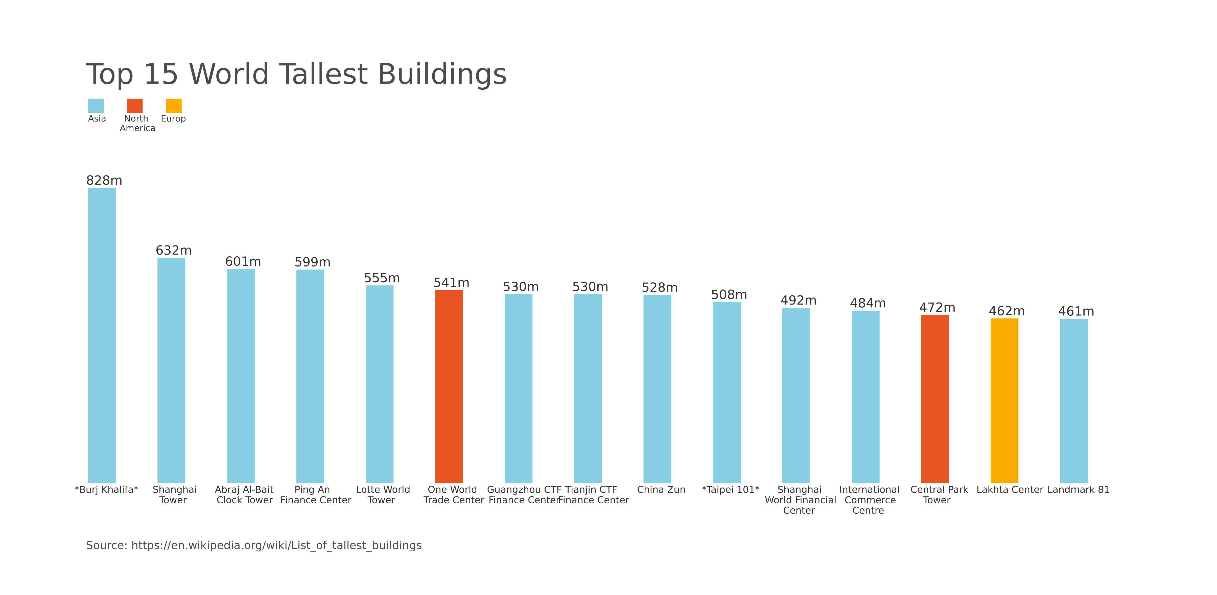

Figure: Charts/Comparison/jpg/column_vertical_chart.jpg

## Prompt Used

Task: Extract detailed information from a given graph image and generate JSON files (`data.json`, `layout.json`, and `config.json`) compatible with Plotly. Use the specified delimiters to wrap each JSON section.  
  
### Instructions:  
  
#### Graph Analysis:  
  
1. **Identify and categorize** the plot types present in the graph. Include both simple and complex plots:  
 - Simple plots: `scatter`, `bar`, `pie`, `line`, `area`  
 - Complex plots: `stacked bar`, `scatter3d`, `surface`.  
 Confirm the presence of each plot type. Ensure that area plots are identified with `"type": "area"`.  
  
2. **Extract data points** for each plot type:  
 - For `scatter`, `line`, and `area` plots: Extract `x` and `y` values.  
 - For `bar` and `stacked bar` plots: Extract `x` (categories) and `y` values.  
 - For `pie` charts: Extract `labels` and `values`.  
 - For `scatter3d` and `surface` plots: Extract `x`, `y`, and `z` values.  
  
3. **Note any multiple plots** on the same figure and their configurations:  
 - For stacked plots, identify the stacking order and group.  
 - For area charts, ensure `fill` is specified correctly.  
  
#### Generate `data.json`:  
  
For each plot, include details such as:  
- **type**: The type of plot (e.g., `"scatter"`, `"bar"`, `"pie"`, `"area"`, `"scatter3d"`, `"surface"`).  
 - For area charts, use `"type": "scatter"` and specify `"fill"`.  
- **x**, **y**, and **z** (if applicable): Arrays of data points for the `x`, `y`, and `z` axes.  
- **labels** and **values** for pie charts.  
- **mode**: For line and scatter plots (e.g., `"markers"`, `"lines"`, `"markers+lines"`).  
- **name**: Legend entry for the plot.  
- **marker**: Properties such as color, size, and symbol for markers.  
- **line**: Properties such as color, width, and dash style for lines.  
- **text**: Hover text for each data point.  
- **hoverinfo**: Information displayed on hover (e.g., `"x+y+text"`).  
- **fill**: For area charts, specify the fill (e.g., `"tozeroy"`, `"tonexty"`).  
- **fillcolor**: The color used to fill the area under the line.  
- **stackgroup**: For stacked bar charts, specify the group for stacking.  
  
#### Generate `layout.json`:  
  
Include details such as:  
- **title**: The title of the graph, including text and font properties.  
- **xaxis** and **yaxis**: Configuration including title, range, grid properties, and tick settings.  
- **zaxis**: Configuration for 3D plots including title, range, and grid properties.  
- **legend**: Properties including orientation and positioning.  
- **margin**: Values for left, right, bottom, top, and padding.  
- **plot_bgcolor** and **paper_bgcolor**: Background colors of the plot area and paper.  
- **scene**: For 3D plots, configuration for the 3D scene, including camera angles, lighting, and aspect ratio.  
  
#### Generate `config.json`:  
  
Include configuration settings such as:  
- **responsive**: Whether the graph is responsive.  
- **displayModeBar**: Whether the mode bar is displayed.  
- **modeBarButtonsToRemove**: List of mode bar buttons to remove.  
- **scrollZoom**: Whether scrolling zoom is enabled.  
  
#### Generate `<csv>`:  
  
Include CSV data formatted as follows:  
```csv  
x,y  
1,4  
2,5  
3,6  
```  
Replace x,y, 1,4, 2,5, and 3,6 with actual data extracted from the graph image.  
  
Output Format:  
Wrap each JSON output in specific XML-like tags:  
  
<data> ... </data>  
<layout> ... </layout>  
<config> ... </config>  
<csv> ... </csv>  
Make sure to follow the JSON formatting guidelines:  
  
Double Quotes for Keys and Strings: Ensure all keys and string values in JSON are enclosed in double quotes.  
No Trailing Commas: Remove any trailing commas after the last element in arrays or objects.  
Example Output:  
  
<data>  
[  
 {  
 "type": "scatter",  
 "x": [1, 2, 3],  
 "y": [4, 5, 6],  
 "mode": "markers+lines",  
 "name": "Line Plot",  
 "marker": {  
 "color": "rgba(75, 192, 192, 0.6)",  
 "size": 8  
 },  
 "line": {  
 "color": "rgba(75, 192, 192, 1)",  
 "width": 2  
 }  
 },  
 {  
 "type": "area",  
 "x": [1, 2, 3, 4, 5, 6, 7, 8, 9, 10, 11, 12],  
 "y": [400, 430, 550, 620, 580, 600, 630, 700, 670, 630, 600, 500],  
 "name": "Housing",  
 "marker": {  
 "color": "rgba(255, 159, 64, 0.8)"  
 },  
 "line": {  
 "color": "rgba(255, 159, 64, 1)",  
 "width": 2  
 }  
 },  
  
 {  
 "type": "bar",  
 "x": ["A", "B", "C"],  
 "y": [10, 15, 13],  
 "name": "Bar Chart",  
 "marker": {  
 "color": "rgba(255, 99, 132, 0.6)"  
 },  
 "hoverinfo": "x+y+text"  
 },  
 {  
 "type": "scatter",  
 "x": [1, 2, 3],  
 "y": [6, 7, 8],  
 "mode": "lines",  
 "fill": "tozeroy",  
 "name": "Area Chart",  
 "line": {  
 "color": "rgba(54, 162, 235, 1)",  
 "width": 2  
 },  
 "fillcolor": "rgba(54, 162, 235, 0.5)"  
 },  
 {  
 "type": "scatter3d",  
 "x": [1, 2, 3],  
 "y": [4, 5, 6],  
 "z": [7, 8, 9],  
 "mode": "markers",  
 "name": "3D Scatter Plot",  
 "marker": {  
 "color": "rgba(255, 159, 64, 0.8)",  
 "size": 5  
 },  
 "hoverinfo": "x+y+z+text"  
 },  
 {  
 "type": "surface",  
 "z": [  
 [10, 10.625, 12.5, 15.625, 20],  
 [5.625, 6.25, 8.125, 11.25, 15.625],  
 [0, 1.25, 3.125, 6.25, 10.625]  
 ],  
 "name": "Surface Plot",  
 "colorscale": "Viridis",  
 "hoverinfo": "z+name"  
 }  
]  
</data>  
<layout>  
{  
 "title": {  
 "text": "Complex Graph Example",  
 "font": {  
 "family": "Arial, sans-serif",  
 "size": 24,  
 "color": "#000000"  
 }  
 },  
 "xaxis": {  
 "title": {  
 "text": "X Axis",  
 "font": {  
 "family": "Arial, sans-serif",  
 "size": 18,  
 "color": "#000000"  
 }  
 },  
 "showgrid": true,  
 "gridcolor": "rgba(0, 0, 0, 0.1)",  
 "zeroline": true,  
 "zerolinecolor": "rgba(0, 0, 0, 0.1)"  
 },  
 "yaxis": {  
 "title": {  
 "text": "Y Axis",  
 "font": {  
 "family": "Arial, sans-serif",  
 "size": 18,  
 "color": "#000000"  
 }  
 },  
 "showgrid": true,  
 "gridcolor": "rgba(0, 0, 0, 0.1)",  
 "zeroline": true,  
 "zerolinecolor": "rgba(0, 0, 0, 0.1)"  
 },  
 "legend": {  
 "orientation": "h",  
 "x": 0.5,  
 "xanchor": "center",  
 "y": -0.2,  
 "font": {  
 "family": "Arial, sans-serif",  
 "size": 12,  
 "color": "#000000"  
 }  
 },  
 "margin": {  
 "l": 60,  
 "r": 30,  
 "b": 60,  
 "t": 60  
 },  
 "plot_bgcolor": "#ffffff",  
 "paper_bgcolor": "#ffffff",  
 "scene": {  
 "xaxis": {"title": "X Axis"},  
 "yaxis": {"title": "Y Axis"},  
 "zaxis": {"title": "Z Axis"}  
 }  
}  
</layout>  
<config>  
{  
 "responsive": true,  
 "displayModeBar": true,  
 "modeBarButtonsToRemove": ["toImage"],  
 "scrollZoom": true  
}  
</config>  
<csv>  
x,y  
1,4  
2,5  
3,6  
</csv>

## Extracted JSON

### data

[  
 {  
 "type": "bar",  
 "x": [  
 "Burj Khalifa",  
 "Abraj Al-Bait Tower",  
 "Ping An Finance Center",  
 "One World Trade Center",  
 "Guangzhou CTF Finance Center",  
 "China Zun",  
 "Taipei 101",  
 "Shanghai World Financial Center",  
 "International Commerce Centre",  
 "Central Park Tower",  
 "Lakhta Center",  
 "Landmark 81"  
 ],  
 "y": [  
 828,  
 632,  
 599,  
 541,  
 530,  
 528,  
 508,  
 492,  
 484,  
 472,  
 462,  
 461  
 ],  
 "name": "Tallest Buildings",  
 "marker": {  
 "color": [  
 "rgba(255, 99, 132, 0.6)",  
 "rgba(255, 99, 132, 0.6)",  
 "rgba(255, 99, 132, 0.6)",  
 "rgba(255, 99, 132, 0.6)",  
 "rgba(255, 99, 132, 0.6)",  
 "rgba(255, 99, 132, 0.6)",  
 "rgba(255, 99, 132, 0.6)",  
 "rgba(255, 99, 132, 0.6)",  
 "rgba(255, 99, 132, 0.6)",  
 "rgba(255, 99, 132, 0.6)",  
 "rgba(255, 99, 132, 0.6)",  
 "rgba(255, 99, 132, 0.6)"  
 ]  
 },  
 "hoverinfo": "x+y+text"  
 }  
]

### layout

{  
 "title": {  
 "text": "Top 15 World Tallest Buildings",  
 "font": {  
 "family": "Arial, sans-serif",  
 "size": 24,  
 "color": "#000000"  
 }  
 },  
 "xaxis": {  
 "title": {  
 "text": "Building Name",  
 "font": {  
 "family": "Arial, sans-serif",  
 "size": 18,  
 "color": "#000000"  
 }  
 },  
 "showgrid": false,  
 "zeroline": false  
 },  
 "yaxis": {  
 "title": {  
 "text": "Height (m)",  
 "font": {  
 "family": "Arial, sans-serif",  
 "size": 18,  
 "color": "#000000"  
 }  
 },  
 "showgrid": true,  
 "gridcolor": "rgba(0, 0, 0, 0.1)",  
 "zeroline": true,  
 "zerolinecolor": "rgba(0, 0, 0, 0.1)"  
 },  
 "legend": {  
 "orientation": "h",  
 "x": 0.5,  
 "xanchor": "center",  
 "y": -0.2,  
 "font": {  
 "family": "Arial, sans-serif",  
 "size": 12,  
 "color": "#000000"  
 }  
 },  
 "margin": {  
 "l": 60,  
 "r": 30,  
 "b": 60,  
 "t": 60  
 },  
 "plot_bgcolor": "#ffffff",  
 "paper_bgcolor": "#ffffff"  
}

### config

{  
 "responsive": true,  
 "displayModeBar": true,  
 "modeBarButtonsToRemove": [  
 "toImage"  
 ],  
 "scrollZoom": true  
}

## Updated JSON

### updated_data

[  
 {  
 "type": "bar",  
 "x": [  
 "Burj Khalifa",  
 "Abraj Al-Bait Tower",  
 "Ping An Finance Center",  
 "One World Trade Center",  
 "Guangzhou CTF Finance Center",  
 "China Zun",  
 "Taipei 101",  
 "Shanghai World Financial Center",  
 "International Commerce Centre",  
 "Central Park Tower",  
 "Lakhta Center",  
 "Landmark 81"  
 ],  
 "y": [  
 828,  
 632,  
 599,  
 541,  
 530,  
 528,  
 508,  
 492,  
 484,  
 472,  
 462,  
 461  
 ],  
 "name": "Tallest Buildings",  
 "marker": {  
 "color": [  
 "rgba(255, 99, 132, 0.6)",  
 "rgba(255, 99, 132, 0.6)",  
 "rgba(255, 99, 132, 0.6)",  
 "rgba(255, 99, 132, 0.6)",  
 "rgba(255, 99, 132, 0.6)",  
 "rgba(255, 99, 132, 0.6)",  
 "rgba(255, 99, 132, 0.6)",  
 "rgba(255, 99, 132, 0.6)",  
 "rgba(255, 99, 132, 0.6)",  
 "rgba(255, 99, 132, 0.6)",  
 "rgba(255, 99, 132, 0.6)",  
 "rgba(255, 99, 132, 0.6)"  
 ]  
 },  
 "hoverinfo": "x+y+text"  
 }  
]

### updated_layout

{  
 "title": {  
 "text": "Top 15 World Tallest Buildings",  
 "font": {  
 "family": "Arial, sans-serif",  
 "size": 24,  
 "color": "#000000"  
 }  
 },  
 "xaxis": {  
 "title": {  
 "text": "Building Name",  
 "font": {  
 "family": "Arial, sans-serif",  
 "size": 18,  
 "color": "#000000"  
 }  
 },  
 "showgrid": false,  
 "zeroline": false  
 },  
 "yaxis": {  
 "title": {  
 "text": "Height (m)",  
 "font": {  
 "family": "Arial, sans-serif",  
 "size": 18,  
 "color": "#000000"  
 }  
 },  
 "showgrid": true,  
 "gridcolor": "rgba(0, 0, 0, 0.1)",  
 "zeroline": true,  
 "zerolinecolor": "rgba(0, 0, 0, 0.1)"  
 },  
 "legend": {  
 "orientation": "h",  
 "x": 0.5,  
 "xanchor": "center",  
 "y": -0.2,  
 "font": {  
 "family": "Arial, sans-serif",  
 "size": 12,  
 "color": "#000000"  
 }  
 },  
 "margin": {  
 "l": 60,  
 "r": 30,  
 "b": 60,  
 "t": 60  
 },  
 "plot_bgcolor": "#ffffff",  
 "paper_bgcolor": "#ffffff"  
}

### updated_config

{  
 "responsive": true,  
 "displayModeBar": true,  
 "modeBarButtonsToRemove": [  
 "toImage"  
 ],  
 "scrollZoom": true  
}

## Updated Chart

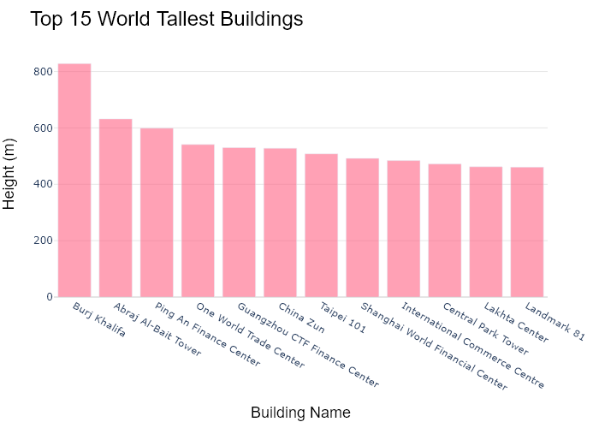

## Performance Metrics

|  |  |  |  |
| --- | --- | --- | --- |
| Task | Model Used | Description | Time Taken (s) |
| Processing Image to JSON | Gemini Vision Pro (default) | Time taken to convert the uploaded image to JSON format | 23.23 |
| Updating JSON | ChatGPT 3.5 (Default) | Time taken to update the JSON with new data | 0.00 |
| Plotting Updated JSON | N/A | Time taken to plot the updated JSON | 0.26 |

# Test Run

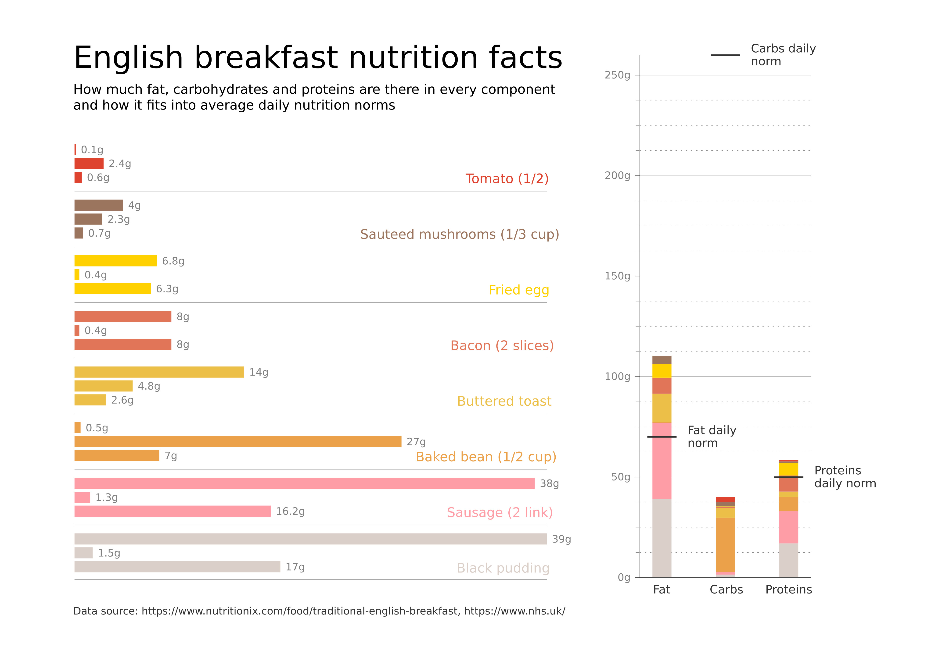

Figure: D:/Research Internship/Charts/Comparison/jpg\bar.jpg

## Prompt Used

Task: Extract detailed information from a given graph image and generate JSON files (`data.json`, `layout.json`, and `config.json`) compatible with Plotly. Use the specified delimiters to wrap each JSON section.  
  
### Instructions:  
  
#### Graph Analysis:  
  
1. **Identify and categorize** the plot types present in the graph. Include both simple and complex plots:  
 - Simple plots: `scatter`, `bar`, `pie`, `line`, `area`  
 - Complex plots: `stacked bar`, `scatter3d`, `surface`.  
 Confirm the presence of each plot type. Ensure that area plots are identified with `"type": "area"`.  
  
2. **Extract data points** for each plot type:  
 - For `scatter`, `line`, and `area` plots: Extract `x` and `y` values.  
 - For `bar` and `stacked bar` plots: Extract `x` (categories) and `y` values.  
 - For `pie` charts: Extract `labels` and `values`.  
 - For `scatter3d` and `surface` plots: Extract `x`, `y`, and `z` values.  
  
3. **Note any multiple plots** on the same figure and their configurations:  
 - For stacked plots, identify the stacking order and group.  
 - For area charts, ensure `fill` is specified correctly.  
  
#### Generate `data.json`:  
  
For each plot, include details such as:  
- **type**: The type of plot (e.g., `"scatter"`, `"bar"`, `"pie"`, `"area"`, `"scatter3d"`, `"surface"`).  
 - For area charts, use `"type": "scatter"` and specify `"fill"`.  
- **x**, **y**, and **z** (if applicable): Arrays of data points for the `x`, `y`, and `z` axes.  
- **labels** and **values** for pie charts.  
- **mode**: For line and scatter plots (e.g., `"markers"`, `"lines"`, `"markers+lines"`).  
- **name**: Legend entry for the plot.  
- **marker**: Properties such as color, size, and symbol for markers.  
- **line**: Properties such as color, width, and dash style for lines.  
- **text**: Hover text for each data point.  
- **hoverinfo**: Information displayed on hover (e.g., `"x+y+text"`).  
- **fill**: For area charts, specify the fill (e.g., `"tozeroy"`, `"tonexty"`).  
- **fillcolor**: The color used to fill the area under the line.  
- **stackgroup**: For stacked bar charts, specify the group for stacking.  
  
#### Generate `layout.json`:  
  
Include details such as:  
- **title**: The title of the graph, including text and font properties.  
- **xaxis** and **yaxis**: Configuration including title, range, grid properties, and tick settings.  
- **zaxis**: Configuration for 3D plots including title, range, and grid properties.  
- **legend**: Properties including orientation and positioning.  
- **margin**: Values for left, right, bottom, top, and padding.  
- **plot_bgcolor** and **paper_bgcolor**: Background colors of the plot area and paper.  
- **scene**: For 3D plots, configuration for the 3D scene, including camera angles, lighting, and aspect ratio.  
  
#### Generate `config.json`:  
  
Include configuration settings such as:  
- **responsive**: Whether the graph is responsive.  
- **displayModeBar**: Whether the mode bar is displayed.  
- **modeBarButtonsToRemove**: List of mode bar buttons to remove.  
- **scrollZoom**: Whether scrolling zoom is enabled.  
  
#### Generate `<csv>`:  
  
Include CSV data formatted as follows:  
```csv  
x,y  
1,4  
2,5  
3,6  
```  
Replace x,y, 1,4, 2,5, and 3,6 with actual data extracted from the graph image.  
  
Output Format:  
Wrap each JSON output in specific XML-like tags:  
  
<data> ... </data>  
<layout> ... </layout>  
<config> ... </config>  
<csv> ... </csv>  
Make sure to follow the JSON formatting guidelines:  
  
Double Quotes for Keys and Strings: Ensure all keys and string values in JSON are enclosed in double quotes.  
No Trailing Commas: Remove any trailing commas after the last element in arrays or objects.  
Example Output:  
  
<data>  
[  
 {  
 "type": "scatter",  
 "x": [1, 2, 3],  
 "y": [4, 5, 6],  
 "mode": "markers+lines",  
 "name": "Line Plot",  
 "marker": {  
 "color": "rgba(75, 192, 192, 0.6)",  
 "size": 8  
 },  
 "line": {  
 "color": "rgba(75, 192, 192, 1)",  
 "width": 2  
 }  
 },  
 {  
 "type": "area",  
 "x": [1, 2, 3, 4, 5, 6, 7, 8, 9, 10, 11, 12],  
 "y": [400, 430, 550, 620, 580, 600, 630, 700, 670, 630, 600, 500],  
 "name": "Housing",  
 "marker": {  
 "color": "rgba(255, 159, 64, 0.8)"  
 },  
 "line": {  
 "color": "rgba(255, 159, 64, 1)",  
 "width": 2  
 }  
 },  
  
 {  
 "type": "bar",  
 "x": ["A", "B", "C"],  
 "y": [10, 15, 13],  
 "name": "Bar Chart",  
 "marker": {  
 "color": "rgba(255, 99, 132, 0.6)"  
 },  
 "hoverinfo": "x+y+text"  
 },  
 {  
 "type": "scatter",  
 "x": [1, 2, 3],  
 "y": [6, 7, 8],  
 "mode": "lines",  
 "fill": "tozeroy",  
 "name": "Area Chart",  
 "line": {  
 "color": "rgba(54, 162, 235, 1)",  
 "width": 2  
 },  
 "fillcolor": "rgba(54, 162, 235, 0.5)"  
 },  
 {  
 "type": "scatter3d",  
 "x": [1, 2, 3],  
 "y": [4, 5, 6],  
 "z": [7, 8, 9],  
 "mode": "markers",  
 "name": "3D Scatter Plot",  
 "marker": {  
 "color": "rgba(255, 159, 64, 0.8)",  
 "size": 5  
 },  
 "hoverinfo": "x+y+z+text"  
 },  
 {  
 "type": "surface",  
 "z": [  
 [10, 10.625, 12.5, 15.625, 20],  
 [5.625, 6.25, 8.125, 11.25, 15.625],  
 [0, 1.25, 3.125, 6.25, 10.625]  
 ],  
 "name": "Surface Plot",  
 "colorscale": "Viridis",  
 "hoverinfo": "z+name"  
 }  
]  
</data>  
<layout>  
{  
 "title": {  
 "text": "Complex Graph Example",  
 "font": {  
 "family": "Arial, sans-serif",  
 "size": 24,  
 "color": "#000000"  
 }  
 },  
 "xaxis": {  
 "title": {  
 "text": "X Axis",  
 "font": {  
 "family": "Arial, sans-serif",  
 "size": 18,  
 "color": "#000000"  
 }  
 },  
 "showgrid": true,  
 "gridcolor": "rgba(0, 0, 0, 0.1)",  
 "zeroline": true,  
 "zerolinecolor": "rgba(0, 0, 0, 0.1)"  
 },  
 "yaxis": {  
 "title": {  
 "text": "Y Axis",  
 "font": {  
 "family": "Arial, sans-serif",  
 "size": 18,  
 "color": "#000000"  
 }  
 },  
 "showgrid": true,  
 "gridcolor": "rgba(0, 0, 0, 0.1)",  
 "zeroline": true,  
 "zerolinecolor": "rgba(0, 0, 0, 0.1)"  
 },  
 "legend": {  
 "orientation": "h",  
 "x": 0.5,  
 "xanchor": "center",  
 "y": -0.2,  
 "font": {  
 "family": "Arial, sans-serif",  
 "size": 12,  
 "color": "#000000"  
 }  
 },  
 "margin": {  
 "l": 60,  
 "r": 30,  
 "b": 60,  
 "t": 60  
 },  
 "plot_bgcolor": "#ffffff",  
 "paper_bgcolor": "#ffffff",  
 "scene": {  
 "xaxis": {"title": "X Axis"},  
 "yaxis": {"title": "Y Axis"},  
 "zaxis": {"title": "Z Axis"}  
 }  
}  
</layout>  
<config>  
{  
 "responsive": true,  
 "displayModeBar": true,  
 "modeBarButtonsToRemove": ["toImage"],  
 "scrollZoom": true  
}  
</config>  
<csv>  
x,y  
1,4  
2,5  
3,6  
</csv>

## Extracted JSON

### data

[  
 {  
 "type": "bar",  
 "x": [  
 "Tomato (1/2)",  
 "Sauteed mushrooms (1/3 cup)",  
 "Fried egg",  
 "Bacon (2 slices)",  
 "Buttered toast",  
 "Baked bean (1/2 cup)",  
 "Sausage (2 link)",  
 "Black pudding"  
 ],  
 "y": [  
 2.6,  
 2.3,  
 6.3,  
 8,  
 4.8,  
 27,  
 38,  
 17  
 ],  
 "name": "English Breakfast Nutrition",  
 "marker": {  
 "color": "rgba(255, 159, 64, 0.6)"  
 },  
 "hoverinfo": "x+y+text"  
 }  
]

### layout

{  
 "title": {  
 "text": "English Breakfast Nutrition Facts",  
 "font": {  
 "family": "Arial, sans-serif",  
 "size": 24,  
 "color": "#000000"  
 }  
 },  
 "xaxis": {  
 "title": {  
 "text": "Food Item",  
 "font": {  
 "family": "Arial, sans-serif",  
 "size": 18,  
 "color": "#000000"  
 }  
 },  
 "showgrid": true,  
 "gridcolor": "rgba(0, 0, 0, 0.1)",  
 "zeroline": true,  
 "zerolinecolor": "rgba(0, 0, 0, 0.1)"  
 },  
 "yaxis": {  
 "title": {  
 "text": "Nutrition Value",  
 "font": {  
 "family": "Arial, sans-serif",  
 "size": 18,  
 "color": "#000000"  
 }  
 },  
 "showgrid": true,  
 "gridcolor": "rgba(0, 0, 0, 0.1)",  
 "zeroline": true,  
 "zerolinecolor": "rgba(0, 0, 0, 0.1)"  
 },  
 "legend": {  
 "orientation": "h",  
 "x": 0.5,  
 "xanchor": "center",  
 "y": -0.2,  
 "font": {  
 "family": "Arial, sans-serif",  
 "size": 12,  
 "color": "#000000"  
 }  
 },  
 "margin": {  
 "l": 60,  
 "r": 30,  
 "b": 60,  
 "t": 60  
 },  
 "plot_bgcolor": "#ffffff",  
 "paper_bgcolor": "#ffffff"  
}

### config

{  
 "responsive": true,  
 "displayModeBar": true,  
 "modeBarButtonsToRemove": [  
 "toImage"  
 ],  
 "scrollZoom": true  
}

## Updated JSON

### updated_data

[  
 {  
 "type": "bar",  
 "x": [  
 "Tomato (1/2)",  
 "Sauteed mushrooms (1/3 cup)",  
 "Fried egg",  
 "Bacon (2 slices)",  
 "Buttered toast",  
 "Baked bean (1/2 cup)",  
 "Sausage (2 link)",  
 "Black pudding"  
 ],  
 "y": [  
 2.6,  
 2.3,  
 6.3,  
 8,  
 4.8,  
 27,  
 38,  
 17  
 ],  
 "name": "English Breakfast Nutrition",  
 "marker": {  
 "color": "rgba(255, 159, 64, 0.6)"  
 },  
 "hoverinfo": "x+y+text"  
 }  
]

### updated_layout

{  
 "title": {  
 "text": "English Breakfast Nutrition Facts",  
 "font": {  
 "family": "Arial, sans-serif",  
 "size": 24,  
 "color": "#000000"  
 }  
 },  
 "xaxis": {  
 "title": {  
 "text": "Food Item",  
 "font": {  
 "family": "Arial, sans-serif",  
 "size": 18,  
 "color": "#000000"  
 }  
 },  
 "showgrid": true,  
 "gridcolor": "rgba(0, 0, 0, 0.1)",  
 "zeroline": true,  
 "zerolinecolor": "rgba(0, 0, 0, 0.1)"  
 },  
 "yaxis": {  
 "title": {  
 "text": "Nutrition Value",  
 "font": {  
 "family": "Arial, sans-serif",  
 "size": 18,  
 "color": "#000000"  
 }  
 },  
 "showgrid": true,  
 "gridcolor": "rgba(0, 0, 0, 0.1)",  
 "zeroline": true,  
 "zerolinecolor": "rgba(0, 0, 0, 0.1)"  
 },  
 "legend": {  
 "orientation": "h",  
 "x": 0.5,  
 "xanchor": "center",  
 "y": -0.2,  
 "font": {  
 "family": "Arial, sans-serif",  
 "size": 12,  
 "color": "#000000"  
 }  
 },  
 "margin": {  
 "l": 60,  
 "r": 30,  
 "b": 60,  
 "t": 60  
 },  
 "plot_bgcolor": "#ffffff",  
 "paper_bgcolor": "#ffffff"  
}

### updated_config

{  
 "responsive": true,  
 "displayModeBar": true,  
 "modeBarButtonsToRemove": [  
 "toImage"  
 ],  
 "scrollZoom": true  
}

## Updated Chart

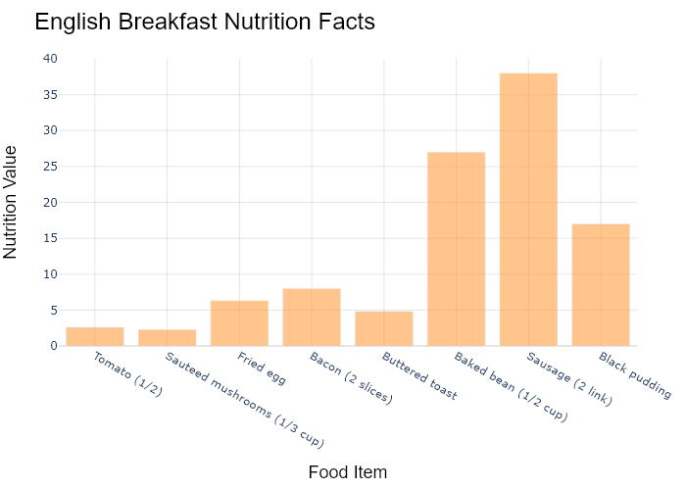

## Performance Metrics

|  |  |  |  |
| --- | --- | --- | --- |
| Task | Model Used | Description | Time Taken (s) |
| Processing Image to JSON | Gemini Vision Pro (default) | Time taken to convert the uploaded image to JSON format | 20.35 |
| Updating JSON | ChatGPT 3.5 (Default) | Time taken to update the JSON with new data | 0.00 |
| Plotting Updated JSON | N/A | Time taken to plot the updated JSON | 0.21 |

# Test Run

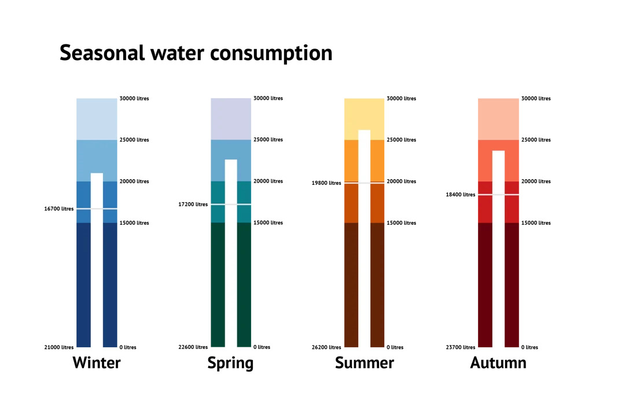

Figure: D:/Research Internship/Charts/Comparison/jpg\bullet.jpg

## Prompt Used

Task: Extract detailed information from a given graph image and generate JSON files (`data.json`, `layout.json`, and `config.json`) compatible with Plotly. Use the specified delimiters to wrap each JSON section.  
  
### Instructions:  
  
#### Graph Analysis:  
  
1. **Identify and categorize** the plot types present in the graph. Include both simple and complex plots:  
 - Simple plots: `scatter`, `bar`, `pie`, `line`, `area`  
 - Complex plots: `stacked bar`, `scatter3d`, `surface`.  
 Confirm the presence of each plot type. Ensure that area plots are identified with `"type": "area"`.  
  
2. **Extract data points** for each plot type:  
 - For `scatter`, `line`, and `area` plots: Extract `x` and `y` values.  
 - For `bar` and `stacked bar` plots: Extract `x` (categories) and `y` values.  
 - For `pie` charts: Extract `labels` and `values`.  
 - For `scatter3d` and `surface` plots: Extract `x`, `y`, and `z` values.  
  
3. **Note any multiple plots** on the same figure and their configurations:  
 - For stacked plots, identify the stacking order and group.  
 - For area charts, ensure `fill` is specified correctly.  
  
#### Generate `data.json`:  
  
For each plot, include details such as:  
- **type**: The type of plot (e.g., `"scatter"`, `"bar"`, `"pie"`, `"area"`, `"scatter3d"`, `"surface"`).  
 - For area charts, use `"type": "scatter"` and specify `"fill"`.  
- **x**, **y**, and **z** (if applicable): Arrays of data points for the `x`, `y`, and `z` axes.  
- **labels** and **values** for pie charts.  
- **mode**: For line and scatter plots (e.g., `"markers"`, `"lines"`, `"markers+lines"`).  
- **name**: Legend entry for the plot.  
- **marker**: Properties such as color, size, and symbol for markers.  
- **line**: Properties such as color, width, and dash style for lines.  
- **text**: Hover text for each data point.  
- **hoverinfo**: Information displayed on hover (e.g., `"x+y+text"`).  
- **fill**: For area charts, specify the fill (e.g., `"tozeroy"`, `"tonexty"`).  
- **fillcolor**: The color used to fill the area under the line.  
- **stackgroup**: For stacked bar charts, specify the group for stacking.  
  
#### Generate `layout.json`:  
  
Include details such as:  
- **title**: The title of the graph, including text and font properties.  
- **xaxis** and **yaxis**: Configuration including title, range, grid properties, and tick settings.  
- **zaxis**: Configuration for 3D plots including title, range, and grid properties.  
- **legend**: Properties including orientation and positioning.  
- **margin**: Values for left, right, bottom, top, and padding.  
- **plot_bgcolor** and **paper_bgcolor**: Background colors of the plot area and paper.  
- **scene**: For 3D plots, configuration for the 3D scene, including camera angles, lighting, and aspect ratio.  
  
#### Generate `config.json`:  
  
Include configuration settings such as:  
- **responsive**: Whether the graph is responsive.  
- **displayModeBar**: Whether the mode bar is displayed.  
- **modeBarButtonsToRemove**: List of mode bar buttons to remove.  
- **scrollZoom**: Whether scrolling zoom is enabled.  
  
#### Generate `<csv>`:  
  
Include CSV data formatted as follows:  
```csv  
x,y  
1,4  
2,5  
3,6  
```  
Replace x,y, 1,4, 2,5, and 3,6 with actual data extracted from the graph image.  
  
Output Format:  
Wrap each JSON output in specific XML-like tags:  
  
<data> ... </data>  
<layout> ... </layout>  
<config> ... </config>  
<csv> ... </csv>  
Make sure to follow the JSON formatting guidelines:  
  
Double Quotes for Keys and Strings: Ensure all keys and string values in JSON are enclosed in double quotes.  
No Trailing Commas: Remove any trailing commas after the last element in arrays or objects.  
Example Output:  
  
<data>  
[  
 {  
 "type": "scatter",  
 "x": [1, 2, 3],  
 "y": [4, 5, 6],  
 "mode": "markers+lines",  
 "name": "Line Plot",  
 "marker": {  
 "color": "rgba(75, 192, 192, 0.6)",  
 "size": 8  
 },  
 "line": {  
 "color": "rgba(75, 192, 192, 1)",  
 "width": 2  
 }  
 },  
 {  
 "type": "area",  
 "x": [1, 2, 3, 4, 5, 6, 7, 8, 9, 10, 11, 12],  
 "y": [400, 430, 550, 620, 580, 600, 630, 700, 670, 630, 600, 500],  
 "name": "Housing",  
 "marker": {  
 "color": "rgba(255, 159, 64, 0.8)"  
 },  
 "line": {  
 "color": "rgba(255, 159, 64, 1)",  
 "width": 2  
 }  
 },  
  
 {  
 "type": "bar",  
 "x": ["A", "B", "C"],  
 "y": [10, 15, 13],  
 "name": "Bar Chart",  
 "marker": {  
 "color": "rgba(255, 99, 132, 0.6)"  
 },  
 "hoverinfo": "x+y+text"  
 },  
 {  
 "type": "scatter",  
 "x": [1, 2, 3],  
 "y": [6, 7, 8],  
 "mode": "lines",  
 "fill": "tozeroy",  
 "name": "Area Chart",  
 "line": {  
 "color": "rgba(54, 162, 235, 1)",  
 "width": 2  
 },  
 "fillcolor": "rgba(54, 162, 235, 0.5)"  
 },  
 {  
 "type": "scatter3d",  
 "x": [1, 2, 3],  
 "y": [4, 5, 6],  
 "z": [7, 8, 9],  
 "mode": "markers",  
 "name": "3D Scatter Plot",  
 "marker": {  
 "color": "rgba(255, 159, 64, 0.8)",  
 "size": 5  
 },  
 "hoverinfo": "x+y+z+text"  
 },  
 {  
 "type": "surface",  
 "z": [  
 [10, 10.625, 12.5, 15.625, 20],  
 [5.625, 6.25, 8.125, 11.25, 15.625],  
 [0, 1.25, 3.125, 6.25, 10.625]  
 ],  
 "name": "Surface Plot",  
 "colorscale": "Viridis",  
 "hoverinfo": "z+name"  
 }  
]  
</data>  
<layout>  
{  
 "title": {  
 "text": "Complex Graph Example",  
 "font": {  
 "family": "Arial, sans-serif",  
 "size": 24,  
 "color": "#000000"  
 }  
 },  
 "xaxis": {  
 "title": {  
 "text": "X Axis",  
 "font": {  
 "family": "Arial, sans-serif",  
 "size": 18,  
 "color": "#000000"  
 }  
 },  
 "showgrid": true,  
 "gridcolor": "rgba(0, 0, 0, 0.1)",  
 "zeroline": true,  
 "zerolinecolor": "rgba(0, 0, 0, 0.1)"  
 },  
 "yaxis": {  
 "title": {  
 "text": "Y Axis",  
 "font": {  
 "family": "Arial, sans-serif",  
 "size": 18,  
 "color": "#000000"  
 }  
 },  
 "showgrid": true,  
 "gridcolor": "rgba(0, 0, 0, 0.1)",  
 "zeroline": true,  
 "zerolinecolor": "rgba(0, 0, 0, 0.1)"  
 },  
 "legend": {  
 "orientation": "h",  
 "x": 0.5,  
 "xanchor": "center",  
 "y": -0.2,  
 "font": {  
 "family": "Arial, sans-serif",  
 "size": 12,  
 "color": "#000000"  
 }  
 },  
 "margin": {  
 "l": 60,  
 "r": 30,  
 "b": 60,  
 "t": 60  
 },  
 "plot_bgcolor": "#ffffff",  
 "paper_bgcolor": "#ffffff",  
 "scene": {  
 "xaxis": {"title": "X Axis"},  
 "yaxis": {"title": "Y Axis"},  
 "zaxis": {"title": "Z Axis"}  
 }  
}  
</layout>  
<config>  
{  
 "responsive": true,  
 "displayModeBar": true,  
 "modeBarButtonsToRemove": ["toImage"],  
 "scrollZoom": true  
}  
</config>  
<csv>  
x,y  
1,4  
2,5  
3,6  
</csv>

## Extracted JSON

### data

[  
 {  
 "type": "bar",  
 "x": [  
 "Winter",  
 "Spring",  
 "Summer",  
 "Autumn"  
 ],  
 "y": [  
 17200,  
 22600,  
 0,  
 23700  
 ],  
 "name": "Seasonal Water Consumption",  
 "marker": {  
 "color": [  
 "rgba(0, 116, 217, 0.6)",  
 "rgba(255, 127, 14, 0.6)",  
 "rgba(255, 255, 0, 0.6)",  
 "rgba(215, 48, 39, 0.6)"  
 ]  
 },  
 "hoverinfo": "x+y+name"  
 }  
]

### layout

{  
 "title": {  
 "text": "Seasonal Water Consumption",  
 "font": {  
 "family": "Arial, sans-serif",  
 "size": 24,  
 "color": "#000000"  
 }  
 },  
 "xaxis": {  
 "title": {  
 "text": "Season",  
 "font": {  
 "family": "Arial, sans-serif",  
 "size": 18,  
 "color": "#000000"  
 }  
 },  
 "tickangle": -45  
 },  
 "yaxis": {  
 "title": {  
 "text": "Water Consumed (Litres)",  
 "font": {  
 "family": "Arial, sans-serif",  
 "size": 18,  
 "color": "#000000"  
 }  
 }  
 },  
 "legend": {  
 "orientation": "h",  
 "x": 0.5,  
 "xanchor": "center",  
 "y": -0.2,  
 "font": {  
 "family": "Arial, sans-serif",  
 "size": 12,  
 "color": "#000000"  
 }  
 },  
 "margin": {  
 "l": 60,  
 "r": 30,  
 "b": 60,  
 "t": 60  
 },  
 "plot_bgcolor": "#ffffff",  
 "paper_bgcolor": "#ffffff"  
}

### config

{  
 "responsive": true,  
 "displayModeBar": true,  
 "modeBarButtonsToRemove": [  
 "toImage"  
 ],  
 "scrollZoom": true  
}

## Updated JSON

### updated_data

[  
 {  
 "type": "bar",  
 "x": [  
 "Winter",  
 "Spring",  
 "Summer",  
 "Autumn"  
 ],  
 "y": [  
 17200,  
 22600,  
 0,  
 23700  
 ],  
 "name": "Seasonal Water Consumption",  
 "marker": {  
 "color": [  
 "rgba(0, 116, 217, 0.6)",  
 "rgba(255, 127, 14, 0.6)",  
 "rgba(255, 255, 0, 0.6)",  
 "rgba(215, 48, 39, 0.6)"  
 ]  
 },  
 "hoverinfo": "x+y+name"  
 }  
]

### updated_layout

{  
 "title": {  
 "text": "Seasonal Water Consumption",  
 "font": {  
 "family": "Arial, sans-serif",  
 "size": 24,  
 "color": "#000000"  
 }  
 },  
 "xaxis": {  
 "title": {  
 "text": "Season",  
 "font": {  
 "family": "Arial, sans-serif",  
 "size": 18,  
 "color": "#000000"  
 }  
 },  
 "tickangle": -45  
 },  
 "yaxis": {  
 "title": {  
 "text": "Water Consumed (Litres)",  
 "font": {  
 "family": "Arial, sans-serif",  
 "size": 18,  
 "color": "#000000"  
 }  
 }  
 },  
 "legend": {  
 "orientation": "h",  
 "x": 0.5,  
 "xanchor": "center",  
 "y": -0.2,  
 "font": {  
 "family": "Arial, sans-serif",  
 "size": 12,  
 "color": "#000000"  
 }  
 },  
 "margin": {  
 "l": 60,  
 "r": 30,  
 "b": 60,  
 "t": 60  
 },  
 "plot_bgcolor": "#ffffff",  
 "paper_bgcolor": "#ffffff"  
}

### updated_config

{  
 "responsive": true,  
 "displayModeBar": true,  
 "modeBarButtonsToRemove": [  
 "toImage"  
 ],  
 "scrollZoom": true  
}

## Updated Chart

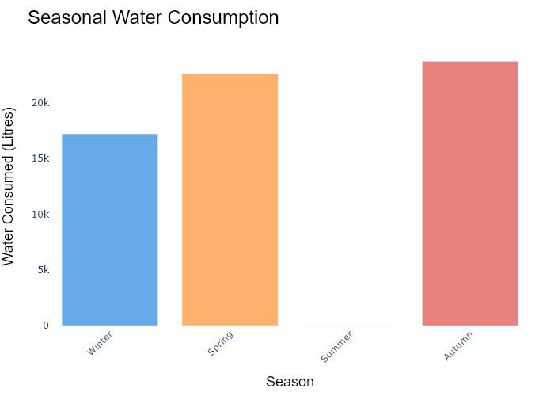

## Performance Metrics

|  |  |  |  |
| --- | --- | --- | --- |
| Task | Model Used | Description | Time Taken (s) |
| Processing Image to JSON | Gemini Vision Pro (default) | Time taken to convert the uploaded image to JSON format | 16.58 |
| Updating JSON | ChatGPT 3.5 (Default) | Time taken to update the JSON with new data | 0.00 |
| Plotting Updated JSON | N/A | Time taken to plot the updated JSON | 0.27 |

# Test Run

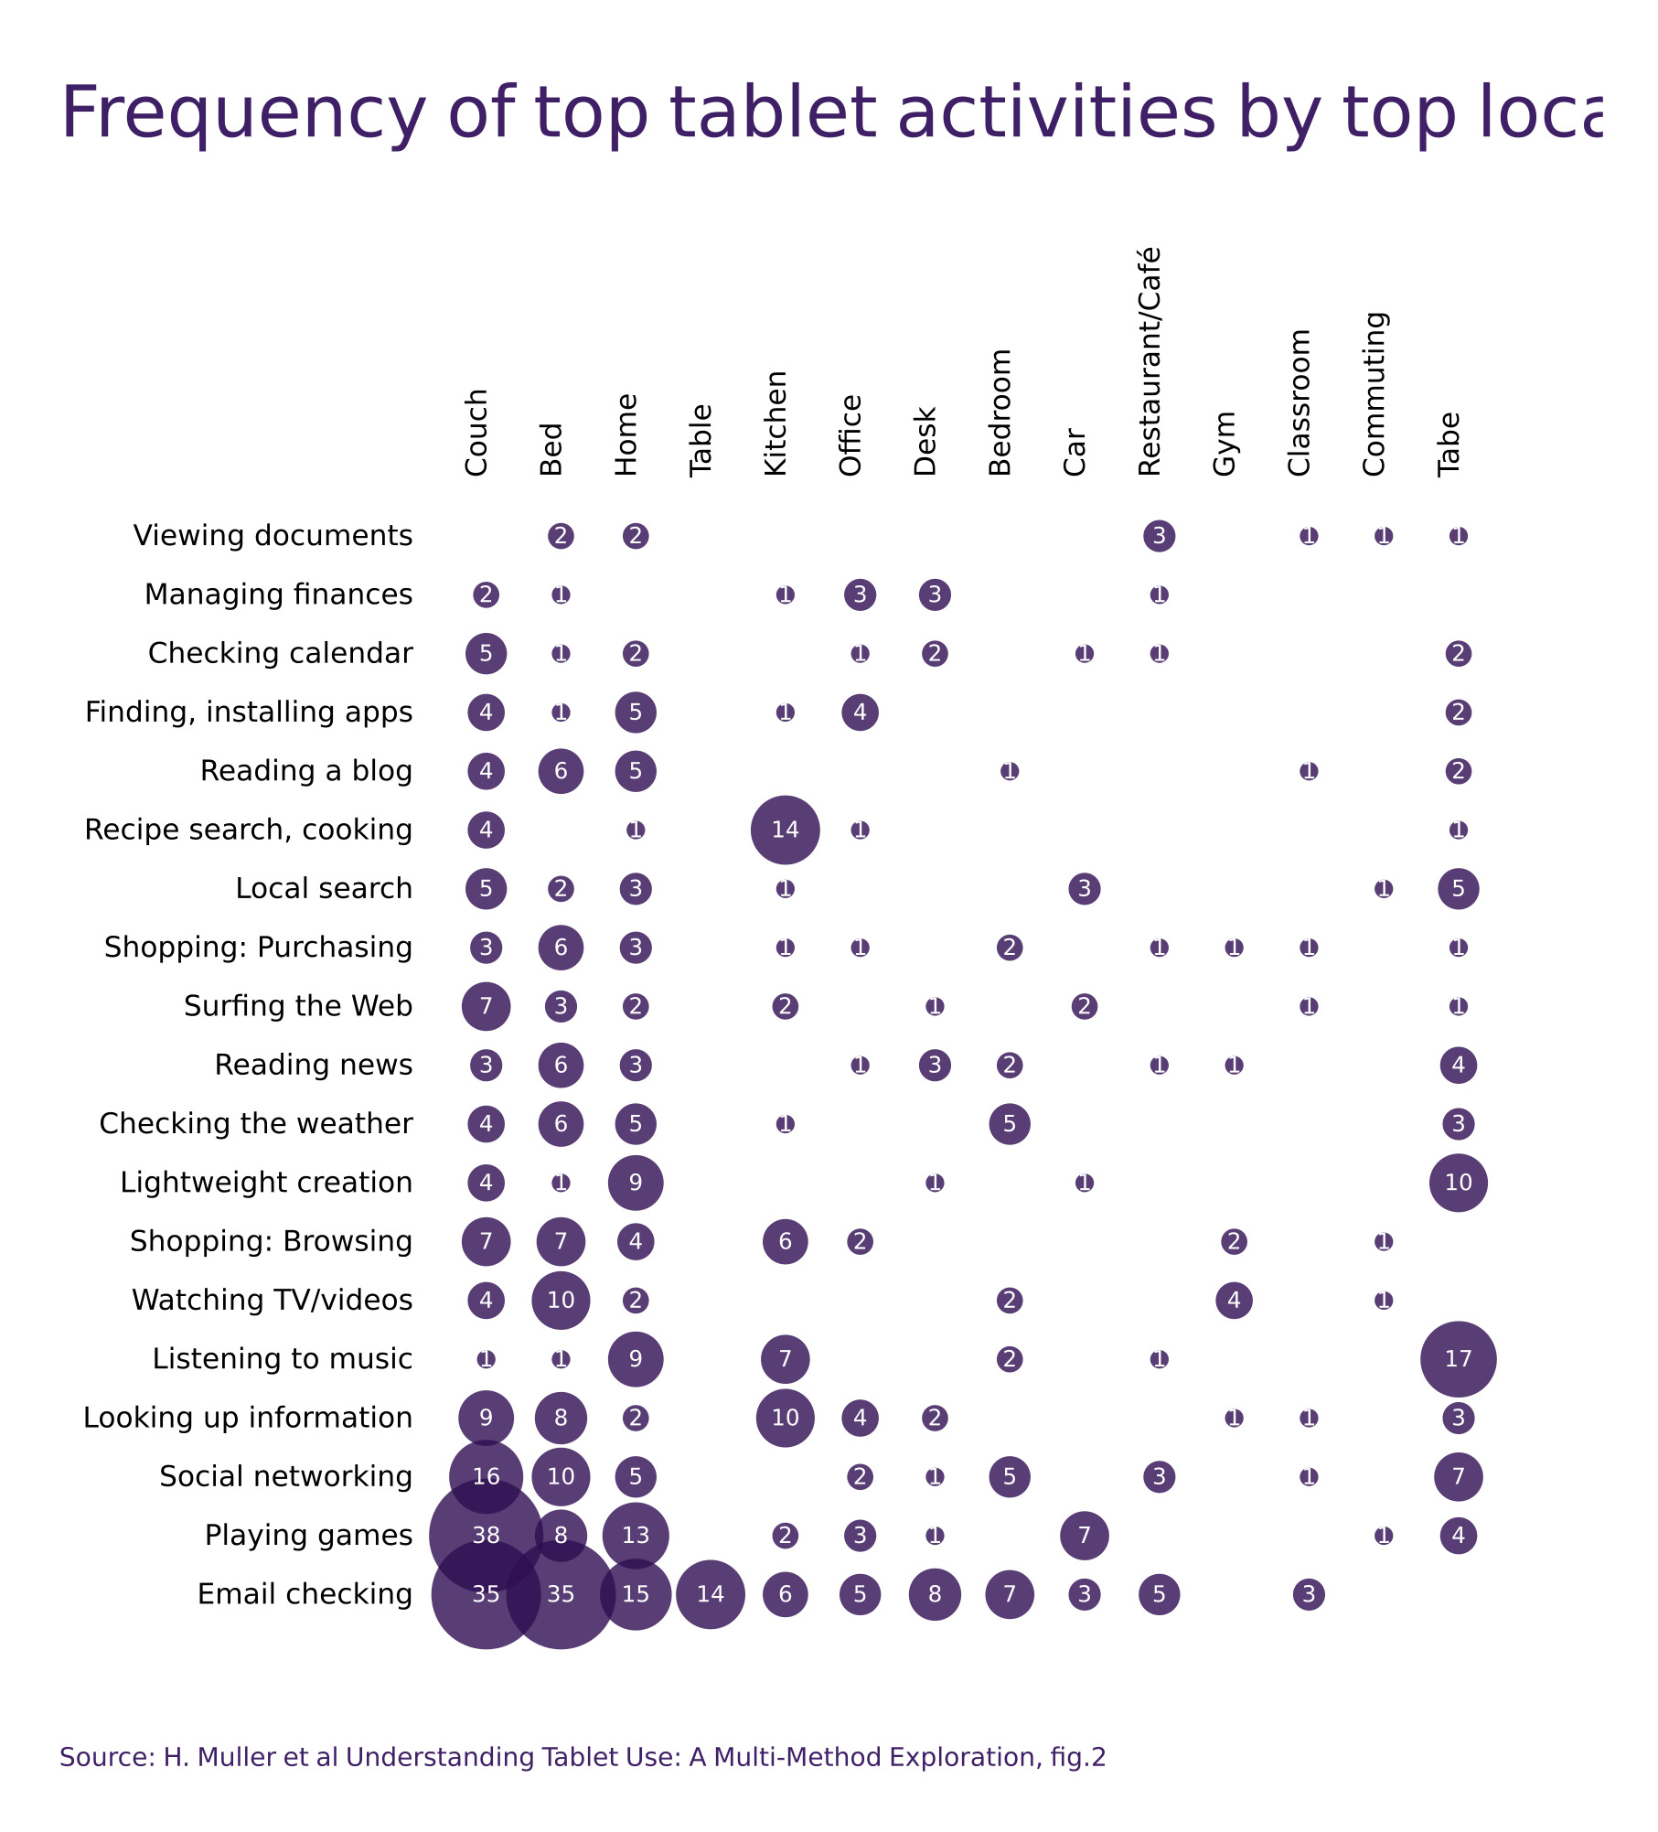

Figure: D:/Research Internship/Charts/Comparison/jpg\categorical_scatter_plot.jpg

## Prompt Used

Task: Extract detailed information from a given graph image and generate JSON files (`data.json`, `layout.json`, and `config.json`) compatible with Plotly. Use the specified delimiters to wrap each JSON section.  
  
### Instructions:  
  
#### Graph Analysis:  
  
1. **Identify and categorize** the plot types present in the graph. Include both simple and complex plots:  
 - Simple plots: `scatter`, `bar`, `pie`, `line`, `area`  
 - Complex plots: `stacked bar`, `scatter3d`, `surface`.  
 Confirm the presence of each plot type. Ensure that area plots are identified with `"type": "area"`.  
  
2. **Extract data points** for each plot type:  
 - For `scatter`, `line`, and `area` plots: Extract `x` and `y` values.  
 - For `bar` and `stacked bar` plots: Extract `x` (categories) and `y` values.  
 - For `pie` charts: Extract `labels` and `values`.  
 - For `scatter3d` and `surface` plots: Extract `x`, `y`, and `z` values.  
  
3. **Note any multiple plots** on the same figure and their configurations:  
 - For stacked plots, identify the stacking order and group.  
 - For area charts, ensure `fill` is specified correctly.  
  
#### Generate `data.json`:  
  
For each plot, include details such as:  
- **type**: The type of plot (e.g., `"scatter"`, `"bar"`, `"pie"`, `"area"`, `"scatter3d"`, `"surface"`).  
 - For area charts, use `"type": "scatter"` and specify `"fill"`.  
- **x**, **y**, and **z** (if applicable): Arrays of data points for the `x`, `y`, and `z` axes.  
- **labels** and **values** for pie charts.  
- **mode**: For line and scatter plots (e.g., `"markers"`, `"lines"`, `"markers+lines"`).  
- **name**: Legend entry for the plot.  
- **marker**: Properties such as color, size, and symbol for markers.  
- **line**: Properties such as color, width, and dash style for lines.  
- **text**: Hover text for each data point.  
- **hoverinfo**: Information displayed on hover (e.g., `"x+y+text"`).  
- **fill**: For area charts, specify the fill (e.g., `"tozeroy"`, `"tonexty"`).  
- **fillcolor**: The color used to fill the area under the line.  
- **stackgroup**: For stacked bar charts, specify the group for stacking.  
  
#### Generate `layout.json`:  
  
Include details such as:  
- **title**: The title of the graph, including text and font properties.  
- **xaxis** and **yaxis**: Configuration including title, range, grid properties, and tick settings.  
- **zaxis**: Configuration for 3D plots including title, range, and grid properties.  
- **legend**: Properties including orientation and positioning.  
- **margin**: Values for left, right, bottom, top, and padding.  
- **plot_bgcolor** and **paper_bgcolor**: Background colors of the plot area and paper.  
- **scene**: For 3D plots, configuration for the 3D scene, including camera angles, lighting, and aspect ratio.  
  
#### Generate `config.json`:  
  
Include configuration settings such as:  
- **responsive**: Whether the graph is responsive.  
- **displayModeBar**: Whether the mode bar is displayed.  
- **modeBarButtonsToRemove**: List of mode bar buttons to remove.  
- **scrollZoom**: Whether scrolling zoom is enabled.  
  
#### Generate `<csv>`:  
  
Include CSV data formatted as follows:  
```csv  
x,y  
1,4  
2,5  
3,6  
```  
Replace x,y, 1,4, 2,5, and 3,6 with actual data extracted from the graph image.  
  
Output Format:  
Wrap each JSON output in specific XML-like tags:  
  
<data> ... </data>  
<layout> ... </layout>  
<config> ... </config>  
<csv> ... </csv>  
Make sure to follow the JSON formatting guidelines:  
  
Double Quotes for Keys and Strings: Ensure all keys and string values in JSON are enclosed in double quotes.  
No Trailing Commas: Remove any trailing commas after the last element in arrays or objects.  
Example Output:  
  
<data>  
[  
 {  
 "type": "scatter",  
 "x": [1, 2, 3],  
 "y": [4, 5, 6],  
 "mode": "markers+lines",  
 "name": "Line Plot",  
 "marker": {  
 "color": "rgba(75, 192, 192, 0.6)",  
 "size": 8  
 },  
 "line": {  
 "color": "rgba(75, 192, 192, 1)",  
 "width": 2  
 }  
 },  
 {  
 "type": "area",  
 "x": [1, 2, 3, 4, 5, 6, 7, 8, 9, 10, 11, 12],  
 "y": [400, 430, 550, 620, 580, 600, 630, 700, 670, 630, 600, 500],  
 "name": "Housing",  
 "marker": {  
 "color": "rgba(255, 159, 64, 0.8)"  
 },  
 "line": {  
 "color": "rgba(255, 159, 64, 1)",  
 "width": 2  
 }  
 },  
  
 {  
 "type": "bar",  
 "x": ["A", "B", "C"],  
 "y": [10, 15, 13],  
 "name": "Bar Chart",  
 "marker": {  
 "color": "rgba(255, 99, 132, 0.6)"  
 },  
 "hoverinfo": "x+y+text"  
 },  
 {  
 "type": "scatter",  
 "x": [1, 2, 3],  
 "y": [6, 7, 8],  
 "mode": "lines",  
 "fill": "tozeroy",  
 "name": "Area Chart",  
 "line": {  
 "color": "rgba(54, 162, 235, 1)",  
 "width": 2  
 },  
 "fillcolor": "rgba(54, 162, 235, 0.5)"  
 },  
 {  
 "type": "scatter3d",  
 "x": [1, 2, 3],  
 "y": [4, 5, 6],  
 "z": [7, 8, 9],  
 "mode": "markers",  
 "name": "3D Scatter Plot",  
 "marker": {  
 "color": "rgba(255, 159, 64, 0.8)",  
 "size": 5  
 },  
 "hoverinfo": "x+y+z+text"  
 },  
 {  
 "type": "surface",  
 "z": [  
 [10, 10.625, 12.5, 15.625, 20],  
 [5.625, 6.25, 8.125, 11.25, 15.625],  
 [0, 1.25, 3.125, 6.25, 10.625]  
 ],  
 "name": "Surface Plot",  
 "colorscale": "Viridis",  
 "hoverinfo": "z+name"  
 }  
]  
</data>  
<layout>  
{  
 "title": {  
 "text": "Complex Graph Example",  
 "font": {  
 "family": "Arial, sans-serif",  
 "size": 24,  
 "color": "#000000"  
 }  
 },  
 "xaxis": {  
 "title": {  
 "text": "X Axis",  
 "font": {  
 "family": "Arial, sans-serif",  
 "size": 18,  
 "color": "#000000"  
 }  
 },  
 "showgrid": true,  
 "gridcolor": "rgba(0, 0, 0, 0.1)",  
 "zeroline": true,  
 "zerolinecolor": "rgba(0, 0, 0, 0.1)"  
 },  
 "yaxis": {  
 "title": {  
 "text": "Y Axis",  
 "font": {  
 "family": "Arial, sans-serif",  
 "size": 18,  
 "color": "#000000"  
 }  
 },  
 "showgrid": true,  
 "gridcolor": "rgba(0, 0, 0, 0.1)",  
 "zeroline": true,  
 "zerolinecolor": "rgba(0, 0, 0, 0.1)"  
 },  
 "legend": {  
 "orientation": "h",  
 "x": 0.5,  
 "xanchor": "center",  
 "y": -0.2,  
 "font": {  
 "family": "Arial, sans-serif",  
 "size": 12,  
 "color": "#000000"  
 }  
 },  
 "margin": {  
 "l": 60,  
 "r": 30,  
 "b": 60,  
 "t": 60  
 },  
 "plot_bgcolor": "#ffffff",  
 "paper_bgcolor": "#ffffff",  
 "scene": {  
 "xaxis": {"title": "X Axis"},  
 "yaxis": {"title": "Y Axis"},  
 "zaxis": {"title": "Z Axis"}  
 }  
}  
</layout>  
<config>  
{  
 "responsive": true,  
 "displayModeBar": true,  
 "modeBarButtonsToRemove": ["toImage"],  
 "scrollZoom": true  
}  
</config>  
<csv>  
x,y  
1,4  
2,5  
3,6  
</csv>

## Extracted JSON

### data

[  
 {  
 "type": "scatter",  
 "x": [  
 "Couch",  
 "Bed",  
 "Home",  
 "Kitchen",  
 "Office",  
 "Bedroom",  
 "Restaurant/Cafe",  
 "Classroom",  
 "Commuting",  
 "Table"  
 ],  
 "y": [  
 2,  
 2,  
 2,  
 3,  
 3,  
 3,  
 3,  
 0,  
 0,  
 2  
 ],  
 "name": "Viewing documents",  
 "marker": {  
 "color": "rgba(255, 159, 64, 0.6)",  
 "size": 12  
 },  
 "hoverinfo": "x+y+text"  
 },  
 {  
 "type": "scatter",  
 "x": [  
 "Couch",  
 "Bed",  
 "Home",  
 "Kitchen",  
 "Office",  
 "Bedroom",  
 "Restaurant/Cafe",  
 "Classroom",  
 "Commuting",  
 "Table"  
 ],  
 "y": [  
 5,  
 0,  
 2,  
 3,  
 3,  
 2,  
 5,  
 0,  
 0,  
 2  
 ],  
 "name": "Managing finances",  
 "marker": {  
 "color": "rgba(255, 159, 64, 0.6)",  
 "size": 12  
 },  
 "hoverinfo": "x+y+text"  
 },  
 {  
 "type": "scatter",  
 "x": [  
 "Couch",  
 "Bed",  
 "Home",  
 "Kitchen",  
 "Office",  
 "Bedroom",  
 "Restaurant/Cafe",  
 "Classroom",  
 "Commuting",  
 "Table"  
 ],  
 "y": [  
 4,  
 6,  
 5,  
 4,  
 4,  
 4,  
 2,  
 5,  
 2,  
 2  
 ],  
 "name": "Finding, installing apps",  
 "marker": {  
 "color": "rgba(255, 159, 64, 0.6)",  
 "size": 12  
 },  
 "hoverinfo": "x+y+text"  
 },  
 {  
 "type": "scatter",  
 "x": [  
 "Couch",  
 "Bed",  
 "Home",  
 "Kitchen",  
 "Office",  
 "Bedroom",  
 "Restaurant/Cafe",  
 "Classroom",  
 "Commuting",  
 "Table"  
 ],  
 "y": [  
 4,  
 6,  
 5,  
 3,  
 4,  
 3,  
 5,  
 0,  
 0,  
 2  
 ],  
 "name": "Reading a blog",  
 "marker": {  
 "color": "rgba(255, 159, 64, 0.6)",  
 "size": 12  
 },  
 "hoverinfo": "x+y+text"  
 },  
 {  
 "type": "scatter",  
 "x": [  
 "Couch",  
 "Bed",  
 "Home",  
 "Kitchen",  
 "Office",  
 "Bedroom",  
 "Restaurant/Cafe",  
 "Classroom",  
 "Commuting",  
 "Table"  
 ],  
 "y": [  
 5,  
 2,  
 3,  
 3,  
 3,  
 3,  
 3,  
 0,  
 0,  
 5  
 ],  
 "name": "Recipe search, cooking",  
 "marker": {  
 "color": "rgba(255, 159, 64, 0.6)",  
 "size": 12  
 },  
 "hoverinfo": "x+y+text"  
 },  
 {  
 "type": "scatter",  
 "x": [  
 "Couch",  
 "Bed",  
 "Home",  
 "Kitchen",  
 "Office",  
 "Bedroom",  
 "Restaurant/Cafe",  
 "Classroom",  
 "Commuting",  
 "Table"  
 ],  
 "y": [  
 4,  
 2,  
 5,  
 14,  
 2,  
 2,  
 3,  
 0,  
 0,  
 5  
 ],  
 "name": "Local search",  
 "marker": {  
 "color": "rgba(255, 159, 64, 0.6)",  
 "size": 12  
 },  
 "hoverinfo": "x+y+text"  
 },  
 {  
 "type": "scatter",  
 "x": [  
 "Couch",  
 "Bed",  
 "Home",  
 "Kitchen",  
 "Office",  
 "Bedroom",  
 "Restaurant/Cafe",  
 "Classroom",  
 "Commuting",  
 "Table"  
 ],  
 "y": [  
 3,  
 6,  
 3,  
 2,  
 2,  
 3,  
 2,  
 0,  
 0,  
 4  
 ],  
 "name": "Shopping: Purchasing",  
 "marker": {  
 "color": "rgba(255, 159, 64, 0.6)",  
 "size": 12  
 },  
 "hoverinfo": "x+y+text"  
 },  
 {  
 "type": "scatter",  
 "x": [  
 "Couch",  
 "Bed",  
 "Home",  
 "Kitchen",  
 "Office",  
 "Bedroom",  
 "Restaurant/Cafe",  
 "Classroom",  
 "Commuting",  
 "Table"  
 ],  
 "y": [  
 7,  
 3,  
 6,  
 2,  
 3,  
 5,  
 3,  
 3,  
 3,  
 10  
 ],  
 "name": "Surfing the Web",  
 "marker": {  
 "color": "rgba(255, 159, 64, 0.6)",  
 "size": 12  
 },  
 "hoverinfo": "x+y+text"  
 },  
 {  
 "type": "scatter",  
 "x": [  
 "Couch",  
 "Bed",  
 "Home",  
 "Kitchen",  
 "Office",  
 "Bedroom",  
 "Restaurant/Cafe",  
 "Classroom",  
 "Commuting",  
 "Table"  
 ],  
 "y": [  
 3,  
 4,  
 5,  
 3,  
 3,  
 2,  
 5,  
 0,  
 0,  
 3  
 ],  
 "name": "Reading news",  
 "marker": {  
 "color": "rgba(255, 159, 64, 0.6)",  
 "size": 12  
 },  
 "hoverinfo": "x+y+text"  
 },  
 {  
 "type": "scatter",  
 "x": [  
 "Couch",  
 "Bed",  
 "Home",  
 "Kitchen",  
 "Office",  
 "Bedroom",  
 "Restaurant/Cafe",  
 "Classroom",  
 "Commuting",  
 "Table"  
 ],  
 "y": [  
 4,  
 7,  
 9,  
 6,  
 2,  
 9,  
 2,  
 0,  
 0,  
 10  
 ],  
 "name": "Lightweight creation",  
 "marker": {  
 "color": "rgba(255, 159, 64, 0.6)",  
 "size": 12  
 },  
 "hoverinfo": "x+y+text"  
 },  
 {  
 "type": "scatter",  
 "x": [  
 "Couch",  
 "Bed",  
 "Home",  
 "Kitchen",  
 "Office",  
 "Bedroom",  
 "Restaurant/Cafe",  
 "Classroom",  
 "Commuting",  
 "Table"  
 ],  
 "y": [  
 4,  
 10,  
 2,  
 7,  
 2,  
 2,  
 2,  
 0,  
 0,  
 17  
 ],  
 "name": "Watching TV/videos",  
 "marker": {  
 "color": "rgba(255, 159, 64, 0.6)",  
 "size": 12  
 },  
 "hoverinfo": "x+y+text"  
 },  
 {  
 "type": "scatter",  
 "x": [  
 "Couch",  
 "Bed",  
 "Home",  
 "Kitchen",  
 "Office",  
 "Bedroom",  
 "Restaurant/Cafe",  
 "Classroom",  
 "Commuting",  
 "Table"  
 ],  
 "y": [  
 9,  
 8,  
 5,  
 10,  
 2,  
 4,  
 5,  
 3,  
 3,  
 7  
 ],  
 "name": "Looking up information",  
 "marker": {  
 "color": "rgba(255, 159, 64, 0.6)",  
 "size": 12  
 },  
 "hoverinfo": "x+y+text"  
 },  
 {  
 "type": "scatter",  
 "x": [  
 "Couch",  
 "Bed",  
 "Home",  
 "Kitchen",  
 "Office",  
 "Bedroom",  
 "Restaurant/Cafe",  
 "Classroom",  
 "Commuting",  
 "Table"  
 ],  
 "y": [  
 16,  
 10,  
 8,  
 13,  
 6,  
 5,  
 7,  
 3,  
 3,  
 4  
 ],  
 "name": "Social networking",  
 "marker": {  
 "color": "rgba(255, 159, 64, 0.6)",  
 "size": 12  
 },  
 "hoverinfo": "x+y+text"  
 },  
 {  
 "type": "scatter",  
 "x": [  
 "Couch",  
 "Bed",  
 "Home",  
 "Kitchen",  
 "Office",  
 "Bedroom",  
 "Restaurant/Cafe",  
 "Classroom",  
 "Commuting",  
 "Table"  
 ],  
 "y": [  
 38,  
 35,  
 13,  
 6,  
 5,  
 8,  
 7,  
 3,  
 3,  
 4  
 ],  
 "name": "Playing games",  
 "marker": {  
 "color": "rgba(255, 159, 64, 0.6)",  
 "size": 12  
 },  
 "hoverinfo": "x+y+text"  
 },  
 {  
 "type": "scatter",  
 "x": [  
 "Couch",  
 "Bed",  
 "Home",  
 "Kitchen",  
 "Office",  
 "Bedroom",  
 "Restaurant/Cafe",  
 "Classroom",  
 "Commuting",  
 "Table"  
 ],  
 "y": [  
 35,  
 38,  
 15,  
 2,  
 3,  
 7,  
 3,  
 0,  
 0,  
 4  
 ],  
 "name": "Email checking",  
 "marker": {  
 "color": "rgba(255, 159, 64, 0.6)",  
 "size": 12  
 },  
 "hoverinfo": "x+y+text"  
 }  
]

### layout

{  
 "title": {  
 "text": "Frequency of Tablet Activities by Top Locations",  
 "font": {  
 "family": "Arial, sans-serif",  
 "size": 24,  
 "color": "#000000"  
 }  
 },  
 "xaxis": {  
 "title": {  
 "text": "Location",  
 "font": {  
 "family": "Arial, sans-serif",  
 "size": 18,  
 "color": "#000000"  
 }  
 },  
 "tickangle": -45,  
 "showgrid": true,  
 "gridcolor": "rgba(0, 0, 0, 0.1)",  
 "zeroline": true,  
 "zerolinecolor": "rgba(0, 0, 0, 0.1)"  
 },  
 "yaxis": {  
 "title": {  
 "text": "Frequency",  
 "font": {  
 "family": "Arial, sans-serif",  
 "size": 18,  
 "color": "#000000"  
 }  
 },  
 "showgrid": true,  
 "gridcolor": "rgba(0, 0, 0, 0.1)",  
 "zeroline": true,  
 "zerolinecolor": "rgba(0, 0, 0, 0.1)"  
 },  
 "legend": {  
 "orientation": "h",  
 "x": 0.5,  
 "xanchor": "center",  
 "y": -0.2,  
 "font": {  
 "family": "Arial, sans-serif",  
 "size": 12,  
 "color": "#000000"  
 }  
 },  
 "margin": {  
 "l": 60,  
 "r": 30,  
 "b": 60,  
 "t": 60  
 },  
 "plot_bgcolor": "#ffffff",  
 "paper_bgcolor": "#ffffff"  
}

### config

{  
 "responsive": true,  
 "displayModeBar": true,  
 "modeBarButtonsToRemove": [  
 "toImage"  
 ],  
 "scrollZoom": true  
}

## Updated JSON

### updated_data

[  
 {  
 "type": "scatter",  
 "x": [  
 "Couch",  
 "Bed",  
 "Home",  
 "Kitchen",  
 "Office",  
 "Bedroom",  
 "Restaurant/Cafe",  
 "Classroom",  
 "Commuting",  
 "Table"  
 ],  
 "y": [  
 2,  
 2,  
 2,  
 3,  
 3,  
 3,  
 3,  
 0,  
 0,  
 2  
 ],  
 "name": "Viewing documents",  
 "marker": {  
 "color": "rgba(255, 159, 64, 0.6)",  
 "size": 12  
 },  
 "hoverinfo": "x+y+text"  
 },  
 {  
 "type": "scatter",  
 "x": [  
 "Couch",  
 "Bed",  
 "Home",  
 "Kitchen",  
 "Office",  
 "Bedroom",  
 "Restaurant/Cafe",  
 "Classroom",  
 "Commuting",  
 "Table"  
 ],  
 "y": [  
 5,  
 0,  
 2,  
 3,  
 3,  
 2,  
 5,  
 0,  
 0,  
 2  
 ],  
 "name": "Managing finances",  
 "marker": {  
 "color": "rgba(255, 159, 64, 0.6)",  
 "size": 12  
 },  
 "hoverinfo": "x+y+text"  
 },  
 {  
 "type": "scatter",  
 "x": [  
 "Couch",  
 "Bed",  
 "Home",  
 "Kitchen",  
 "Office",  
 "Bedroom",  
 "Restaurant/Cafe",  
 "Classroom",  
 "Commuting",  
 "Table"  
 ],  
 "y": [  
 4,  
 6,  
 5,  
 4,  
 4,  
 4,  
 2,  
 5,  
 2,  
 2  
 ],  
 "name": "Finding, installing apps",  
 "marker": {  
 "color": "rgba(255, 159, 64, 0.6)",  
 "size": 12  
 },  
 "hoverinfo": "x+y+text"  
 },  
 {  
 "type": "scatter",  
 "x": [  
 "Couch",  
 "Bed",  
 "Home",  
 "Kitchen",  
 "Office",  
 "Bedroom",  
 "Restaurant/Cafe",  
 "Classroom",  
 "Commuting",  
 "Table"  
 ],  
 "y": [  
 4,  
 6,  
 5,  
 3,  
 4,  
 3,  
 5,  
 0,  
 0,  
 2  
 ],  
 "name": "Reading a blog",  
 "marker": {  
 "color": "rgba(255, 159, 64, 0.6)",  
 "size": 12  
 },  
 "hoverinfo": "x+y+text"  
 },  
 {  
 "type": "scatter",  
 "x": [  
 "Couch",  
 "Bed",  
 "Home",  
 "Kitchen",  
 "Office",  
 "Bedroom",  
 "Restaurant/Cafe",  
 "Classroom",  
 "Commuting",  
 "Table"  
 ],  
 "y": [  
 5,  
 2,  
 3,  
 3,  
 3,  
 3,  
 3,  
 0,  
 0,  
 5  
 ],  
 "name": "Recipe search, cooking",  
 "marker": {  
 "color": "rgba(255, 159, 64, 0.6)",  
 "size": 12  
 },  
 "hoverinfo": "x+y+text"  
 },  
 {  
 "type": "scatter",  
 "x": [  
 "Couch",  
 "Bed",  
 "Home",  
 "Kitchen",  
 "Office",  
 "Bedroom",  
 "Restaurant/Cafe",  
 "Classroom",  
 "Commuting",  
 "Table"  
 ],  
 "y": [  
 4,  
 2,  
 5,  
 14,  
 2,  
 2,  
 3,  
 0,  
 0,  
 5  
 ],  
 "name": "Local search",  
 "marker": {  
 "color": "rgba(255, 159, 64, 0.6)",  
 "size": 12  
 },  
 "hoverinfo": "x+y+text"  
 },  
 {  
 "type": "scatter",  
 "x": [  
 "Couch",  
 "Bed",  
 "Home",  
 "Kitchen",  
 "Office",  
 "Bedroom",  
 "Restaurant/Cafe",  
 "Classroom",  
 "Commuting",  
 "Table"  
 ],  
 "y": [  
 3,  
 6,  
 3,  
 2,  
 2,  
 3,  
 2,  
 0,  
 0,  
 4  
 ],  
 "name": "Shopping: Purchasing",  
 "marker": {  
 "color": "rgba(255, 159, 64, 0.6)",  
 "size": 12  
 },  
 "hoverinfo": "x+y+text"  
 },  
 {  
 "type": "scatter",  
 "x": [  
 "Couch",  
 "Bed",  
 "Home",  
 "Kitchen",  
 "Office",  
 "Bedroom",  
 "Restaurant/Cafe",  
 "Classroom",  
 "Commuting",  
 "Table"  
 ],  
 "y": [  
 7,  
 3,  
 6,  
 2,  
 3,  
 5,  
 3,  
 3,  
 3,  
 10  
 ],  
 "name": "Surfing the Web",  
 "marker": {  
 "color": "rgba(255, 159, 64, 0.6)",  
 "size": 12  
 },  
 "hoverinfo": "x+y+text"  
 },  
 {  
 "type": "scatter",  
 "x": [  
 "Couch",  
 "Bed",  
 "Home",  
 "Kitchen",  
 "Office",  
 "Bedroom",  
 "Restaurant/Cafe",  
 "Classroom",  
 "Commuting",  
 "Table"  
 ],  
 "y": [  
 3,  
 4,  
 5,  
 3,  
 3,  
 2,  
 5,  
 0,  
 0,  
 3  
 ],  
 "name": "Reading news",  
 "marker": {  
 "color": "rgba(255, 159, 64, 0.6)",  
 "size": 12  
 },  
 "hoverinfo": "x+y+text"  
 },  
 {  
 "type": "scatter",  
 "x": [  
 "Couch",  
 "Bed",  
 "Home",  
 "Kitchen",  
 "Office",  
 "Bedroom",  
 "Restaurant/Cafe",  
 "Classroom",  
 "Commuting",  
 "Table"  
 ],  
 "y": [  
 4,  
 7,  
 9,  
 6,  
 2,  
 9,  
 2,  
 0,  
 0,  
 10  
 ],  
 "name": "Lightweight creation",  
 "marker": {  
 "color": "rgba(255, 159, 64, 0.6)",  
 "size": 12  
 },  
 "hoverinfo": "x+y+text"  
 },  
 {  
 "type": "scatter",  
 "x": [  
 "Couch",  
 "Bed",  
 "Home",  
 "Kitchen",  
 "Office",  
 "Bedroom",  
 "Restaurant/Cafe",  
 "Classroom",  
 "Commuting",  
 "Table"  
 ],  
 "y": [  
 4,  
 10,  
 2,  
 7,  
 2,  
 2,  
 2,  
 0,  
 0,  
 17  
 ],  
 "name": "Watching TV/videos",  
 "marker": {  
 "color": "rgba(255, 159, 64, 0.6)",  
 "size": 12  
 },  
 "hoverinfo": "x+y+text"  
 },  
 {  
 "type": "scatter",  
 "x": [  
 "Couch",  
 "Bed",  
 "Home",  
 "Kitchen",  
 "Office",  
 "Bedroom",  
 "Restaurant/Cafe",  
 "Classroom",  
 "Commuting",  
 "Table"  
 ],  
 "y": [  
 9,  
 8,  
 5,  
 10,  
 2,  
 4,  
 5,  
 3,  
 3,  
 7  
 ],  
 "name": "Looking up information",  
 "marker": {  
 "color": "rgba(255, 159, 64, 0.6)",  
 "size": 12  
 },  
 "hoverinfo": "x+y+text"  
 },  
 {  
 "type": "scatter",  
 "x": [  
 "Couch",  
 "Bed",  
 "Home",  
 "Kitchen",  
 "Office",  
 "Bedroom",  
 "Restaurant/Cafe",  
 "Classroom",  
 "Commuting",  
 "Table"  
 ],  
 "y": [  
 16,  
 10,  
 8,  
 13,  
 6,  
 5,  
 7,  
 3,  
 3,  
 4  
 ],  
 "name": "Social networking",  
 "marker": {  
 "color": "rgba(255, 159, 64, 0.6)",  
 "size": 12  
 },  
 "hoverinfo": "x+y+text"  
 },  
 {  
 "type": "scatter",  
 "x": [  
 "Couch",  
 "Bed",  
 "Home",  
 "Kitchen",  
 "Office",  
 "Bedroom",  
 "Restaurant/Cafe",  
 "Classroom",  
 "Commuting",  
 "Table"  
 ],  
 "y": [  
 38,  
 35,  
 13,  
 6,  
 5,  
 8,  
 7,  
 3,  
 3,  
 4  
 ],  
 "name": "Playing games",  
 "marker": {  
 "color": "rgba(255, 159, 64, 0.6)",  
 "size": 12  
 },  
 "hoverinfo": "x+y+text"  
 },  
 {  
 "type": "scatter",  
 "x": [  
 "Couch",  
 "Bed",  
 "Home",  
 "Kitchen",  
 "Office",  
 "Bedroom",  
 "Restaurant/Cafe",  
 "Classroom",  
 "Commuting",  
 "Table"  
 ],  
 "y": [  
 35,  
 38,  
 15,  
 2,  
 3,  
 7,  
 3,  
 0,  
 0,  
 4  
 ],  
 "name": "Email checking",  
 "marker": {  
 "color": "rgba(255, 159, 64, 0.6)",  
 "size": 12  
 },  
 "hoverinfo": "x+y+text"  
 }  
]

### updated_layout

{  
 "title": {  
 "text": "Frequency of Tablet Activities by Top Locations",  
 "font": {  
 "family": "Arial, sans-serif",  
 "size": 24,  
 "color": "#000000"  
 }  
 },  
 "xaxis": {  
 "title": {  
 "text": "Location",  
 "font": {  
 "family": "Arial, sans-serif",  
 "size": 18,  
 "color": "#000000"  
 }  
 },  
 "tickangle": -45,  
 "showgrid": true,  
 "gridcolor": "rgba(0, 0, 0, 0.1)",  
 "zeroline": true,  
 "zerolinecolor": "rgba(0, 0, 0, 0.1)"  
 },  
 "yaxis": {  
 "title": {  
 "text": "Frequency",  
 "font": {  
 "family": "Arial, sans-serif",  
 "size": 18,  
 "color": "#000000"  
 }  
 },  
 "showgrid": true,  
 "gridcolor": "rgba(0, 0, 0, 0.1)",  
 "zeroline": true,  
 "zerolinecolor": "rgba(0, 0, 0, 0.1)"  
 },  
 "legend": {  
 "orientation": "h",  
 "x": 0.5,  
 "xanchor": "center",  
 "y": -0.2,  
 "font": {  
 "family": "Arial, sans-serif",  
 "size": 12,  
 "color": "#000000"  
 }  
 },  
 "margin": {  
 "l": 60,  
 "r": 30,  
 "b": 60,  
 "t": 60  
 },  
 "plot_bgcolor": "#ffffff",  
 "paper_bgcolor": "#ffffff"  
}

### updated_config

{  
 "responsive": true,  
 "displayModeBar": true,  
 "modeBarButtonsToRemove": [  
 "toImage"  
 ],  
 "scrollZoom": true  
}

## Updated Chart

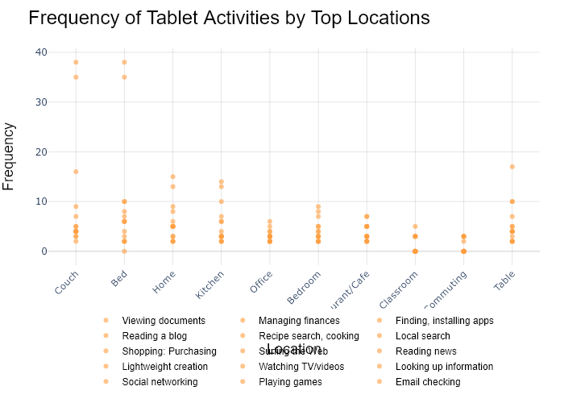

## Performance Metrics

|  |  |  |  |
| --- | --- | --- | --- |
| Task | Model Used | Description | Time Taken (s) |
| Processing Image to JSON | Gemini Vision Pro (default) | Time taken to convert the uploaded image to JSON format | 57.27 |
| Updating JSON | ChatGPT 3.5 (Default) | Time taken to update the JSON with new data | 0.00 |
| Plotting Updated JSON | N/A | Time taken to plot the updated JSON | 0.60 |

# Test Run



Figure: D:/Research Internship/Charts/Comparison/jpg\column_vertical_chart.jpg

## Prompt Used

Task: Extract detailed information from a given graph image and generate JSON files (`data.json`, `layout.json`, and `config.json`) compatible with Plotly. Use the specified delimiters to wrap each JSON section.  
  
### Instructions:  
  
#### Graph Analysis:  
  
1. **Identify and categorize** the plot types present in the graph. Include both simple and complex plots:  
 - Simple plots: `scatter`, `bar`, `pie`, `line`, `area`  
 - Complex plots: `stacked bar`, `scatter3d`, `surface`.  
 Confirm the presence of each plot type. Ensure that area plots are identified with `"type": "area"`.  
  
2. **Extract data points** for each plot type:  
 - For `scatter`, `line`, and `area` plots: Extract `x` and `y` values.  
 - For `bar` and `stacked bar` plots: Extract `x` (categories) and `y` values.  
 - For `pie` charts: Extract `labels` and `values`.  
 - For `scatter3d` and `surface` plots: Extract `x`, `y`, and `z` values.  
  
3. **Note any multiple plots** on the same figure and their configurations:  
 - For stacked plots, identify the stacking order and group.  
 - For area charts, ensure `fill` is specified correctly.  
  
#### Generate `data.json`:  
  
For each plot, include details such as:  
- **type**: The type of plot (e.g., `"scatter"`, `"bar"`, `"pie"`, `"area"`, `"scatter3d"`, `"surface"`).  
 - For area charts, use `"type": "scatter"` and specify `"fill"`.  
- **x**, **y**, and **z** (if applicable): Arrays of data points for the `x`, `y`, and `z` axes.  
- **labels** and **values** for pie charts.  
- **mode**: For line and scatter plots (e.g., `"markers"`, `"lines"`, `"markers+lines"`).  
- **name**: Legend entry for the plot.  
- **marker**: Properties such as color, size, and symbol for markers.  
- **line**: Properties such as color, width, and dash style for lines.  
- **text**: Hover text for each data point.  
- **hoverinfo**: Information displayed on hover (e.g., `"x+y+text"`).  
- **fill**: For area charts, specify the fill (e.g., `"tozeroy"`, `"tonexty"`).  
- **fillcolor**: The color used to fill the area under the line.  
- **stackgroup**: For stacked bar charts, specify the group for stacking.  
  
#### Generate `layout.json`:  
  
Include details such as:  
- **title**: The title of the graph, including text and font properties.  
- **xaxis** and **yaxis**: Configuration including title, range, grid properties, and tick settings.  
- **zaxis**: Configuration for 3D plots including title, range, and grid properties.  
- **legend**: Properties including orientation and positioning.  
- **margin**: Values for left, right, bottom, top, and padding.  
- **plot_bgcolor** and **paper_bgcolor**: Background colors of the plot area and paper.  
- **scene**: For 3D plots, configuration for the 3D scene, including camera angles, lighting, and aspect ratio.  
  
#### Generate `config.json`:  
  
Include configuration settings such as:  
- **responsive**: Whether the graph is responsive.  
- **displayModeBar**: Whether the mode bar is displayed.  
- **modeBarButtonsToRemove**: List of mode bar buttons to remove.  
- **scrollZoom**: Whether scrolling zoom is enabled.  
  
#### Generate `<csv>`:  
  
Include CSV data formatted as follows:  
```csv  
x,y  
1,4  
2,5  
3,6  
```  
Replace x,y, 1,4, 2,5, and 3,6 with actual data extracted from the graph image.  
  
Output Format:  
Wrap each JSON output in specific XML-like tags:  
  
<data> ... </data>  
<layout> ... </layout>  
<config> ... </config>  
<csv> ... </csv>  
Make sure to follow the JSON formatting guidelines:  
  
Double Quotes for Keys and Strings: Ensure all keys and string values in JSON are enclosed in double quotes.  
No Trailing Commas: Remove any trailing commas after the last element in arrays or objects.  
Example Output:  
  
<data>  
[  
 {  
 "type": "scatter",  
 "x": [1, 2, 3],  
 "y": [4, 5, 6],  
 "mode": "markers+lines",  
 "name": "Line Plot",  
 "marker": {  
 "color": "rgba(75, 192, 192, 0.6)",  
 "size": 8  
 },  
 "line": {  
 "color": "rgba(75, 192, 192, 1)",  
 "width": 2  
 }  
 },  
 {  
 "type": "area",  
 "x": [1, 2, 3, 4, 5, 6, 7, 8, 9, 10, 11, 12],  
 "y": [400, 430, 550, 620, 580, 600, 630, 700, 670, 630, 600, 500],  
 "name": "Housing",  
 "marker": {  
 "color": "rgba(255, 159, 64, 0.8)"  
 },  
 "line": {  
 "color": "rgba(255, 159, 64, 1)",  
 "width": 2  
 }  
 },  
  
 {  
 "type": "bar",  
 "x": ["A", "B", "C"],  
 "y": [10, 15, 13],  
 "name": "Bar Chart",  
 "marker": {  
 "color": "rgba(255, 99, 132, 0.6)"  
 },  
 "hoverinfo": "x+y+text"  
 },  
 {  
 "type": "scatter",  
 "x": [1, 2, 3],  
 "y": [6, 7, 8],  
 "mode": "lines",  
 "fill": "tozeroy",  
 "name": "Area Chart",  
 "line": {  
 "color": "rgba(54, 162, 235, 1)",  
 "width": 2  
 },  
 "fillcolor": "rgba(54, 162, 235, 0.5)"  
 },  
 {  
 "type": "scatter3d",  
 "x": [1, 2, 3],  
 "y": [4, 5, 6],  
 "z": [7, 8, 9],  
 "mode": "markers",  
 "name": "3D Scatter Plot",  
 "marker": {  
 "color": "rgba(255, 159, 64, 0.8)",  
 "size": 5  
 },  
 "hoverinfo": "x+y+z+text"  
 },  
 {  
 "type": "surface",  
 "z": [  
 [10, 10.625, 12.5, 15.625, 20],  
 [5.625, 6.25, 8.125, 11.25, 15.625],  
 [0, 1.25, 3.125, 6.25, 10.625]  
 ],  
 "name": "Surface Plot",  
 "colorscale": "Viridis",  
 "hoverinfo": "z+name"  
 }  
]  
</data>  
<layout>  
{  
 "title": {  
 "text": "Complex Graph Example",  
 "font": {  
 "family": "Arial, sans-serif",  
 "size": 24,  
 "color": "#000000"  
 }  
 },  
 "xaxis": {  
 "title": {  
 "text": "X Axis",  
 "font": {  
 "family": "Arial, sans-serif",  
 "size": 18,  
 "color": "#000000"  
 }  
 },  
 "showgrid": true,  
 "gridcolor": "rgba(0, 0, 0, 0.1)",  
 "zeroline": true,  
 "zerolinecolor": "rgba(0, 0, 0, 0.1)"  
 },  
 "yaxis": {  
 "title": {  
 "text": "Y Axis",  
 "font": {  
 "family": "Arial, sans-serif",  
 "size": 18,  
 "color": "#000000"  
 }  
 },  
 "showgrid": true,  
 "gridcolor": "rgba(0, 0, 0, 0.1)",  
 "zeroline": true,  
 "zerolinecolor": "rgba(0, 0, 0, 0.1)"  
 },  
 "legend": {  
 "orientation": "h",  
 "x": 0.5,  
 "xanchor": "center",  
 "y": -0.2,  
 "font": {  
 "family": "Arial, sans-serif",  
 "size": 12,  
 "color": "#000000"  
 }  
 },  
 "margin": {  
 "l": 60,  
 "r": 30,  
 "b": 60,  
 "t": 60  
 },  
 "plot_bgcolor": "#ffffff",  
 "paper_bgcolor": "#ffffff",  
 "scene": {  
 "xaxis": {"title": "X Axis"},  
 "yaxis": {"title": "Y Axis"},  
 "zaxis": {"title": "Z Axis"}  
 }  
}  
</layout>  
<config>  
{  
 "responsive": true,  
 "displayModeBar": true,  
 "modeBarButtonsToRemove": ["toImage"],  
 "scrollZoom": true  
}  
</config>  
<csv>  
x,y  
1,4  
2,5  
3,6  
</csv>

## Extracted JSON

### data

[  
 {  
 "type": "bar",  
 "x": [  
 "Burj Khalifa",  
 "Abraj Al-Bait Tower",  
 "Ping An Finance Center",  
 "One World Trade Center",  
 "Guangzhou CTF Finance Center",  
 "China Zun",  
 "Taipei 101",  
 "Shanghai World Financial Center",  
 "International Commerce Centre",  
 "Central Park Tower",  
 "Lakhta Center",  
 "Landmark 81"  
 ],  
 "y": [  
 828,  
 632,  
 599,  
 541,  
 530,  
 528,  
 508,  
 492,  
 484,  
 472,  
 462,  
 461  
 ],  
 "name": "Tallest Buildings",  
 "marker": {  
 "color": [  
 "rgba(255, 99, 132, 0.6)",  
 "rgba(255, 99, 132, 0.6)",  
 "rgba(255, 99, 132, 0.6)",  
 "rgba(255, 99, 132, 0.6)",  
 "rgba(255, 99, 132, 0.6)",  
 "rgba(255, 99, 132, 0.6)",  
 "rgba(255, 99, 132, 0.6)",  
 "rgba(255, 99, 132, 0.6)",  
 "rgba(255, 99, 132, 0.6)",  
 "rgba(255, 99, 132, 0.6)",  
 "rgba(255, 99, 132, 0.6)",  
 "rgba(255, 99, 132, 0.6)"  
 ]  
 },  
 "hoverinfo": "x+y+text"  
 }  
]

### layout

{  
 "title": {  
 "text": "Top 15 World Tallest Buildings",  
 "font": {  
 "family": "Arial, sans-serif",  
 "size": 24,  
 "color": "#000000"  
 }  
 },  
 "xaxis": {  
 "title": {  
 "text": "Building Name",  
 "font": {  
 "family": "Arial, sans-serif",  
 "size": 18,  
 "color": "#000000"  
 }  
 },  
 "showgrid": false,  
 "zeroline": false  
 },  
 "yaxis": {  
 "title": {  
 "text": "Height (m)",  
 "font": {  
 "family": "Arial, sans-serif",  
 "size": 18,  
 "color": "#000000"  
 }  
 },  
 "showgrid": true,  
 "gridcolor": "rgba(0, 0, 0, 0.1)",  
 "zeroline": true,  
 "zerolinecolor": "rgba(0, 0, 0, 0.1)"  
 },  
 "legend": {  
 "orientation": "h",  
 "x": 0.5,  
 "xanchor": "center",  
 "y": -0.2,  
 "font": {  
 "family": "Arial, sans-serif",  
 "size": 12,  
 "color": "#000000"  
 }  
 },  
 "margin": {  
 "l": 60,  
 "r": 30,  
 "b": 60,  
 "t": 60  
 },  
 "plot_bgcolor": "#ffffff",  
 "paper_bgcolor": "#ffffff"  
}

### config

{  
 "responsive": true,  
 "displayModeBar": true,  
 "modeBarButtonsToRemove": [  
 "toImage"  
 ],  
 "scrollZoom": true  
}

## Updated JSON

### updated_data

[  
 {  
 "type": "bar",  
 "x": [  
 "Burj Khalifa",  
 "Abraj Al-Bait Tower",  
 "Ping An Finance Center",  
 "One World Trade Center",  
 "Guangzhou CTF Finance Center",  
 "China Zun",  
 "Taipei 101",  
 "Shanghai World Financial Center",  
 "International Commerce Centre",  
 "Central Park Tower",  
 "Lakhta Center",  
 "Landmark 81"  
 ],  
 "y": [  
 828,  
 632,  
 599,  
 541,  
 530,  
 528,  
 508,  
 492,  
 484,  
 472,  
 462,  
 461  
 ],  
 "name": "Tallest Buildings",  
 "marker": {  
 "color": [  
 "rgba(255, 99, 132, 0.6)",  
 "rgba(255, 99, 132, 0.6)",  
 "rgba(255, 99, 132, 0.6)",  
 "rgba(255, 99, 132, 0.6)",  
 "rgba(255, 99, 132, 0.6)",  
 "rgba(255, 99, 132, 0.6)",  
 "rgba(255, 99, 132, 0.6)",  
 "rgba(255, 99, 132, 0.6)",  
 "rgba(255, 99, 132, 0.6)",  
 "rgba(255, 99, 132, 0.6)",  
 "rgba(255, 99, 132, 0.6)",  
 "rgba(255, 99, 132, 0.6)"  
 ]  
 },  
 "hoverinfo": "x+y+text"  
 }  
]

### updated_layout

{  
 "title": {  
 "text": "Top 15 World Tallest Buildings",  
 "font": {  
 "family": "Arial, sans-serif",  
 "size": 24,  
 "color": "#000000"  
 }  
 },  
 "xaxis": {  
 "title": {  
 "text": "Building Name",  
 "font": {  
 "family": "Arial, sans-serif",  
 "size": 18,  
 "color": "#000000"  
 }  
 },  
 "showgrid": false,  
 "zeroline": false  
 },  
 "yaxis": {  
 "title": {  
 "text": "Height (m)",  
 "font": {  
 "family": "Arial, sans-serif",  
 "size": 18,  
 "color": "#000000"  
 }  
 },  
 "showgrid": true,  
 "gridcolor": "rgba(0, 0, 0, 0.1)",  
 "zeroline": true,  
 "zerolinecolor": "rgba(0, 0, 0, 0.1)"  
 },  
 "legend": {  
 "orientation": "h",  
 "x": 0.5,  
 "xanchor": "center",  
 "y": -0.2,  
 "font": {  
 "family": "Arial, sans-serif",  
 "size": 12,  
 "color": "#000000"  
 }  
 },  
 "margin": {  
 "l": 60,  
 "r": 30,  
 "b": 60,  
 "t": 60  
 },  
 "plot_bgcolor": "#ffffff",  
 "paper_bgcolor": "#ffffff"  
}

### updated_config

{  
 "responsive": true,  
 "displayModeBar": true,  
 "modeBarButtonsToRemove": [  
 "toImage"  
 ],  
 "scrollZoom": true  
}

## Updated Chart



## Performance Metrics

|  |  |  |  |
| --- | --- | --- | --- |
| Task | Model Used | Description | Time Taken (s) |
| Processing Image to JSON | Gemini Vision Pro (default) | Time taken to convert the uploaded image to JSON format | 22.79 |
| Updating JSON | ChatGPT 3.5 (Default) | Time taken to update the JSON with new data | 0.00 |
| Plotting Updated JSON | N/A | Time taken to plot the updated JSON | 0.19 |

# Test Run

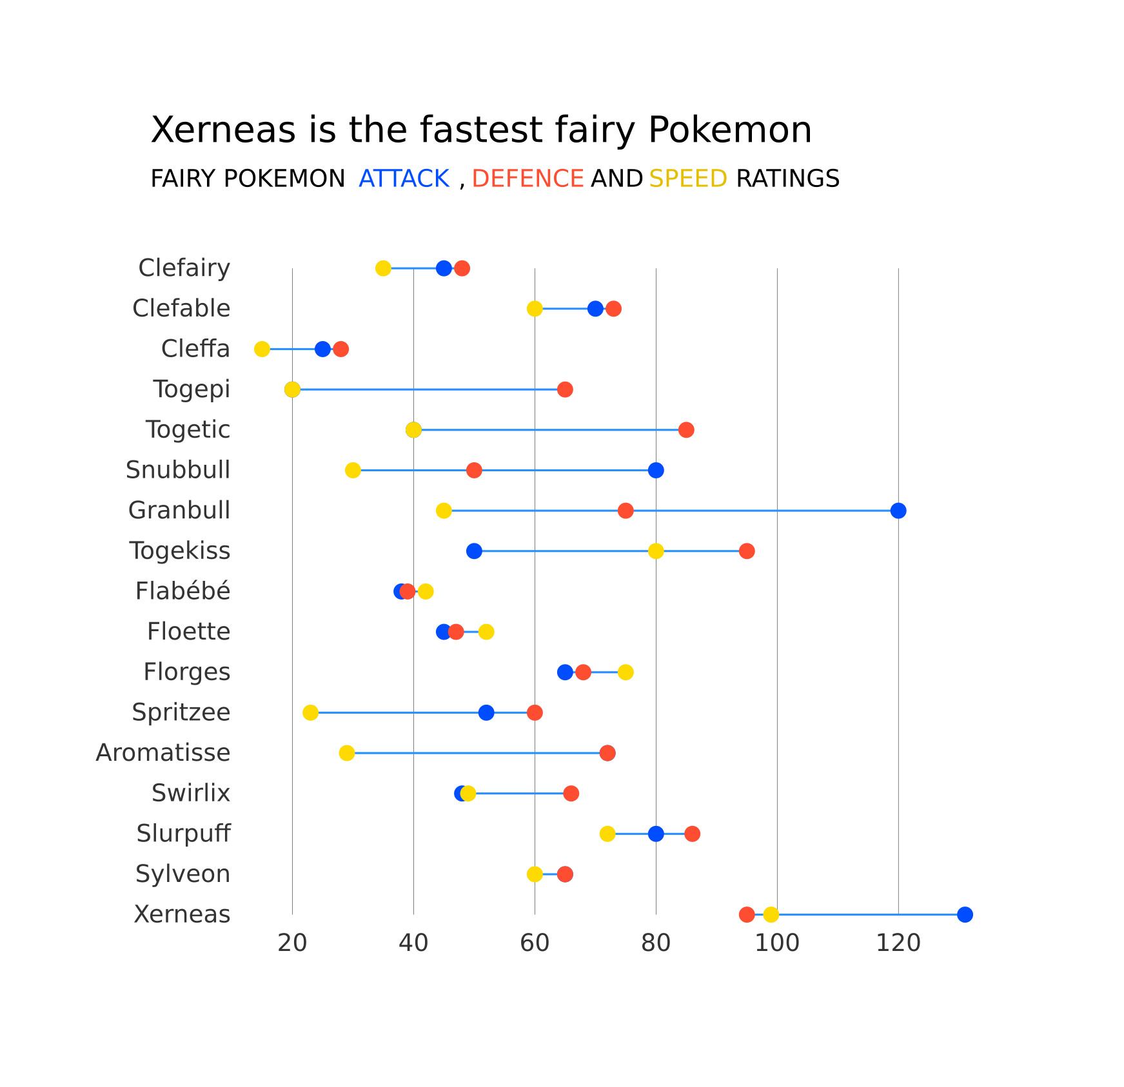

Figure: D:/Research Internship/Charts/Comparison/jpg\dot.jpg

## Prompt Used

Task: Extract detailed information from a given graph image and generate JSON files (`data.json`, `layout.json`, and `config.json`) compatible with Plotly. Use the specified delimiters to wrap each JSON section.  
  
### Instructions:  
  
#### Graph Analysis:  
  
1. **Identify and categorize** the plot types present in the graph. Include both simple and complex plots:  
 - Simple plots: `scatter`, `bar`, `pie`, `line`, `area`  
 - Complex plots: `stacked bar`, `scatter3d`, `surface`.  
 Confirm the presence of each plot type. Ensure that area plots are identified with `"type": "area"`.  
  
2. **Extract data points** for each plot type:  
 - For `scatter`, `line`, and `area` plots: Extract `x` and `y` values.  
 - For `bar` and `stacked bar` plots: Extract `x` (categories) and `y` values.  
 - For `pie` charts: Extract `labels` and `values`.  
 - For `scatter3d` and `surface` plots: Extract `x`, `y`, and `z` values.  
  
3. **Note any multiple plots** on the same figure and their configurations:  
 - For stacked plots, identify the stacking order and group.  
 - For area charts, ensure `fill` is specified correctly.  
  
#### Generate `data.json`:  
  
For each plot, include details such as:  
- **type**: The type of plot (e.g., `"scatter"`, `"bar"`, `"pie"`, `"area"`, `"scatter3d"`, `"surface"`).  
 - For area charts, use `"type": "scatter"` and specify `"fill"`.  
- **x**, **y**, and **z** (if applicable): Arrays of data points for the `x`, `y`, and `z` axes.  
- **labels** and **values** for pie charts.  
- **mode**: For line and scatter plots (e.g., `"markers"`, `"lines"`, `"markers+lines"`).  
- **name**: Legend entry for the plot.  
- **marker**: Properties such as color, size, and symbol for markers.  
- **line**: Properties such as color, width, and dash style for lines.  
- **text**: Hover text for each data point.  
- **hoverinfo**: Information displayed on hover (e.g., `"x+y+text"`).  
- **fill**: For area charts, specify the fill (e.g., `"tozeroy"`, `"tonexty"`).  
- **fillcolor**: The color used to fill the area under the line.  
- **stackgroup**: For stacked bar charts, specify the group for stacking.  
  
#### Generate `layout.json`:  
  
Include details such as:  
- **title**: The title of the graph, including text and font properties.  
- **xaxis** and **yaxis**: Configuration including title, range, grid properties, and tick settings.  
- **zaxis**: Configuration for 3D plots including title, range, and grid properties.  
- **legend**: Properties including orientation and positioning.  
- **margin**: Values for left, right, bottom, top, and padding.  
- **plot_bgcolor** and **paper_bgcolor**: Background colors of the plot area and paper.  
- **scene**: For 3D plots, configuration for the 3D scene, including camera angles, lighting, and aspect ratio.  
  
#### Generate `config.json`:  
  
Include configuration settings such as:  
- **responsive**: Whether the graph is responsive.  
- **displayModeBar**: Whether the mode bar is displayed.  
- **modeBarButtonsToRemove**: List of mode bar buttons to remove.  
- **scrollZoom**: Whether scrolling zoom is enabled.  
  
#### Generate `<csv>`:  
  
Include CSV data formatted as follows:  
```csv  
x,y  
1,4  
2,5  
3,6  
```  
Replace x,y, 1,4, 2,5, and 3,6 with actual data extracted from the graph image.  
  
Output Format:  
Wrap each JSON output in specific XML-like tags:  
  
<data> ... </data>  
<layout> ... </layout>  
<config> ... </config>  
<csv> ... </csv>  
Make sure to follow the JSON formatting guidelines:  
  
Double Quotes for Keys and Strings: Ensure all keys and string values in JSON are enclosed in double quotes.  
No Trailing Commas: Remove any trailing commas after the last element in arrays or objects.  
Example Output:  
  
<data>  
[  
 {  
 "type": "scatter",  
 "x": [1, 2, 3],  
 "y": [4, 5, 6],  
 "mode": "markers+lines",  
 "name": "Line Plot",  
 "marker": {  
 "color": "rgba(75, 192, 192, 0.6)",  
 "size": 8  
 },  
 "line": {  
 "color": "rgba(75, 192, 192, 1)",  
 "width": 2  
 }  
 },  
 {  
 "type": "area",  
 "x": [1, 2, 3, 4, 5, 6, 7, 8, 9, 10, 11, 12],  
 "y": [400, 430, 550, 620, 580, 600, 630, 700, 670, 630, 600, 500],  
 "name": "Housing",  
 "marker": {  
 "color": "rgba(255, 159, 64, 0.8)"  
 },  
 "line": {  
 "color": "rgba(255, 159, 64, 1)",  
 "width": 2  
 }  
 },  
  
 {  
 "type": "bar",  
 "x": ["A", "B", "C"],  
 "y": [10, 15, 13],  
 "name": "Bar Chart",  
 "marker": {  
 "color": "rgba(255, 99, 132, 0.6)"  
 },  
 "hoverinfo": "x+y+text"  
 },  
 {  
 "type": "scatter",  
 "x": [1, 2, 3],  
 "y": [6, 7, 8],  
 "mode": "lines",  
 "fill": "tozeroy",  
 "name": "Area Chart",  
 "line": {  
 "color": "rgba(54, 162, 235, 1)",  
 "width": 2  
 },  
 "fillcolor": "rgba(54, 162, 235, 0.5)"  
 },  
 {  
 "type": "scatter3d",  
 "x": [1, 2, 3],  
 "y": [4, 5, 6],  
 "z": [7, 8, 9],  
 "mode": "markers",  
 "name": "3D Scatter Plot",  
 "marker": {  
 "color": "rgba(255, 159, 64, 0.8)",  
 "size": 5  
 },  
 "hoverinfo": "x+y+z+text"  
 },  
 {  
 "type": "surface",  
 "z": [  
 [10, 10.625, 12.5, 15.625, 20],  
 [5.625, 6.25, 8.125, 11.25, 15.625],  
 [0, 1.25, 3.125, 6.25, 10.625]  
 ],  
 "name": "Surface Plot",  
 "colorscale": "Viridis",  
 "hoverinfo": "z+name"  
 }  
]  
</data>  
<layout>  
{  
 "title": {  
 "text": "Complex Graph Example",  
 "font": {  
 "family": "Arial, sans-serif",  
 "size": 24,  
 "color": "#000000"  
 }  
 },  
 "xaxis": {  
 "title": {  
 "text": "X Axis",  
 "font": {  
 "family": "Arial, sans-serif",  
 "size": 18,  
 "color": "#000000"  
 }  
 },  
 "showgrid": true,  
 "gridcolor": "rgba(0, 0, 0, 0.1)",  
 "zeroline": true,  
 "zerolinecolor": "rgba(0, 0, 0, 0.1)"  
 },  
 "yaxis": {  
 "title": {  
 "text": "Y Axis",  
 "font": {  
 "family": "Arial, sans-serif",  
 "size": 18,  
 "color": "#000000"  
 }  
 },  
 "showgrid": true,  
 "gridcolor": "rgba(0, 0, 0, 0.1)",  
 "zeroline": true,  
 "zerolinecolor": "rgba(0, 0, 0, 0.1)"  
 },  
 "legend": {  
 "orientation": "h",  
 "x": 0.5,  
 "xanchor": "center",  
 "y": -0.2,  
 "font": {  
 "family": "Arial, sans-serif",  
 "size": 12,  
 "color": "#000000"  
 }  
 },  
 "margin": {  
 "l": 60,  
 "r": 30,  
 "b": 60,  
 "t": 60  
 },  
 "plot_bgcolor": "#ffffff",  
 "paper_bgcolor": "#ffffff",  
 "scene": {  
 "xaxis": {"title": "X Axis"},  
 "yaxis": {"title": "Y Axis"},  
 "zaxis": {"title": "Z Axis"}  
 }  
}  
</layout>  
<config>  
{  
 "responsive": true,  
 "displayModeBar": true,  
 "modeBarButtonsToRemove": ["toImage"],  
 "scrollZoom": true  
}  
</config>  
<csv>  
x,y  
1,4  
2,5  
3,6  
</csv>

## Extracted JSON

### data

[  
 {  
 "type": "bar",  
 "x": [  
 "Clefairy",  
 "Clefable",  
 "Togepi",  
 "Togetic",  
 "Snubbull",  
 "Granbull",  
 "Togekiss",  
 "Flab\u00e9b\u00e9",  
 "Floette",  
 "Florges",  
 "Spritzzee",  
 "Aromatisse",  
 "Swirlix",  
 "Slurpuff",  
 "Sylveon",  
 "Xerneas"  
 ],  
 "y": [  
 55,  
 70,  
 35,  
 40,  
 60,  
 75,  
 55,  
 45,  
 50,  
 75,  
 50,  
 70,  
 40,  
 65,  
 65,  
 99  
 ],  
 "name": "Attack",  
 "marker": {  
 "color": "rgba(255, 99, 132, 0.6)"  
 },  
 "hoverinfo": "x+y+text"  
 },  
 {  
 "type": "bar",  
 "x": [  
 "Clefairy",  
 "Clefable",  
 "Togepi",  
 "Togetic",  
 "Snubbull",  
 "Granbull",  
 "Togekiss",  
 "Flab\u00e9b\u00e9",  
 "Floette",  
 "Florges",  
 "Spritzzee",  
 "Aromatisse",  
 "Swirlix",  
 "Slurpuff",  
 "Sylveon",  
 "Xerneas"  
 ],  
 "y": [  
 70,  
 85,  
 55,  
 65,  
 80,  
 100,  
 95,  
 70,  
 75,  
 80,  
 70,  
 80,  
 65,  
 85,  
 65,  
 99  
 ],  
 "name": "Defense",  
 "marker": {  
 "color": "rgba(54, 162, 235, 0.6)"  
 },  
 "hoverinfo": "x+y+text"  
 },  
 {  
 "type": "bar",  
 "x": [  
 "Clefairy",  
 "Clefable",  
 "Togepi",  
 "Togetic",  
 "Snubbull",  
 "Granbull",  
 "Togekiss",  
 "Flab\u00e9b\u00e9",  
 "Floette",  
 "Florges",  
 "Spritzzee",  
 "Aromatisse",  
 "Swirlix",  
 "Slurpuff",  
 "Sylveon",  
 "Xerneas"  
 ],  
 "y": [  
 35,  
 35,  
 40,  
 50,  
 50,  
 50,  
 55,  
 30,  
 35,  
 40,  
 50,  
 40,  
 40,  
 75,  
 65,  
 99  
 ],  
 "name": "Speed",  
 "marker": {  
 "color": "rgba(255, 159, 64, 0.6)"  
 },  
 "hoverinfo": "x+y+text"  
 }  
]

### layout

{  
 "title": {  
 "text": "Xerneas is the fastest fairy Pokemon",  
 "font": {  
 "family": "Arial, sans-serif",  
 "size": 24,  
 "color": "#000000"  
 }  
 },  
 "xaxis": {  
 "title": {  
 "text": "Fairy Pokemon",  
 "font": {  
 "family": "Arial, sans-serif",  
 "size": 18,  
 "color": "#000000"  
 }  
 },  
 "showgrid": true,  
 "gridcolor": "rgba(0, 0, 0, 0.1)",  
 "zeroline": true,  
 "zerolinecolor": "rgba(0, 0, 0, 0.1)"  
 },  
 "yaxis": {  
 "title": {  
 "text": "Attack, Defense and Speed Ratings",  
 "font": {  
 "family": "Arial, sans-serif",  
 "size": 18,  
 "color": "#000000"  
 }  
 },  
 "showgrid": true,  
 "gridcolor": "rgba(0, 0, 0, 0.1)",  
 "zeroline": true,  
 "zerolinecolor": "rgba(0, 0, 0, 0.1)"  
 },  
 "legend": {  
 "orientation": "h",  
 "x": 0.5,  
 "xanchor": "center",  
 "y": -0.2,  
 "font": {  
 "family": "Arial, sans-serif",  
 "size": 12,  
 "color": "#000000"  
 }  
 },  
 "margin": {  
 "l": 60,  
 "r": 30,  
 "b": 60,  
 "t": 60  
 },  
 "plot_bgcolor": "#ffffff",  
 "paper_bgcolor": "#ffffff"  
}

### config

{  
 "responsive": true,  
 "displayModeBar": true,  
 "modeBarButtonsToRemove": [  
 "toImage"  
 ],  
 "scrollZoom": true  
}

## Updated JSON

### updated_data

[  
 {  
 "type": "bar",  
 "x": [  
 "Clefairy",  
 "Clefable",  
 "Togepi",  
 "Togetic",  
 "Snubbull",  
 "Granbull",  
 "Togekiss",  
 "Flab\u00e9b\u00e9",  
 "Floette",  
 "Florges",  
 "Spritzzee",  
 "Aromatisse",  
 "Swirlix",  
 "Slurpuff",  
 "Sylveon",  
 "Xerneas"  
 ],  
 "y": [  
 55,  
 70,  
 35,  
 40,  
 60,  
 75,  
 55,  
 45,  
 50,  
 75,  
 50,  
 70,  
 40,  
 65,  
 65,  
 99  
 ],  
 "name": "Attack",  
 "marker": {  
 "color": "rgba(255, 99, 132, 0.6)"  
 },  
 "hoverinfo": "x+y+text"  
 },  
 {  
 "type": "bar",  
 "x": [  
 "Clefairy",  
 "Clefable",  
 "Togepi",  
 "Togetic",  
 "Snubbull",  
 "Granbull",  
 "Togekiss",  
 "Flab\u00e9b\u00e9",  
 "Floette",  
 "Florges",  
 "Spritzzee",  
 "Aromatisse",  
 "Swirlix",  
 "Slurpuff",  
 "Sylveon",  
 "Xerneas"  
 ],  
 "y": [  
 70,  
 85,  
 55,  
 65,  
 80,  
 100,  
 95,  
 70,  
 75,  
 80,  
 70,  
 80,  
 65,  
 85,  
 65,  
 99  
 ],  
 "name": "Defense",  
 "marker": {  
 "color": "rgba(54, 162, 235, 0.6)"  
 },  
 "hoverinfo": "x+y+text"  
 },  
 {  
 "type": "bar",  
 "x": [  
 "Clefairy",  
 "Clefable",  
 "Togepi",  
 "Togetic",  
 "Snubbull",  
 "Granbull",  
 "Togekiss",  
 "Flab\u00e9b\u00e9",  
 "Floette",  
 "Florges",  
 "Spritzzee",  
 "Aromatisse",  
 "Swirlix",  
 "Slurpuff",  
 "Sylveon",  
 "Xerneas"  
 ],  
 "y": [  
 35,  
 35,  
 40,  
 50,  
 50,  
 50,  
 55,  
 30,  
 35,  
 40,  
 50,  
 40,  
 40,  
 75,  
 65,  
 99  
 ],  
 "name": "Speed",  
 "marker": {  
 "color": "rgba(255, 159, 64, 0.6)"  
 },  
 "hoverinfo": "x+y+text"  
 }  
]

### updated_layout

{  
 "title": {  
 "text": "Xerneas is the fastest fairy Pokemon",  
 "font": {  
 "family": "Arial, sans-serif",  
 "size": 24,  
 "color": "#000000"  
 }  
 },  
 "xaxis": {  
 "title": {  
 "text": "Fairy Pokemon",  
 "font": {  
 "family": "Arial, sans-serif",  
 "size": 18,  
 "color": "#000000"  
 }  
 },  
 "showgrid": true,  
 "gridcolor": "rgba(0, 0, 0, 0.1)",  
 "zeroline": true,  
 "zerolinecolor": "rgba(0, 0, 0, 0.1)"  
 },  
 "yaxis": {  
 "title": {  
 "text": "Attack, Defense and Speed Ratings",  
 "font": {  
 "family": "Arial, sans-serif",  
 "size": 18,  
 "color": "#000000"  
 }  
 },  
 "showgrid": true,  
 "gridcolor": "rgba(0, 0, 0, 0.1)",  
 "zeroline": true,  
 "zerolinecolor": "rgba(0, 0, 0, 0.1)"  
 },  
 "legend": {  
 "orientation": "h",  
 "x": 0.5,  
 "xanchor": "center",  
 "y": -0.2,  
 "font": {  
 "family": "Arial, sans-serif",  
 "size": 12,  
 "color": "#000000"  
 }  
 },  
 "margin": {  
 "l": 60,  
 "r": 30,  
 "b": 60,  
 "t": 60  
 },  
 "plot_bgcolor": "#ffffff",  
 "paper_bgcolor": "#ffffff"  
}

### updated_config

{  
 "responsive": true,  
 "displayModeBar": true,  
 "modeBarButtonsToRemove": [  
 "toImage"  
 ],  
 "scrollZoom": true  
}

## Updated Chart

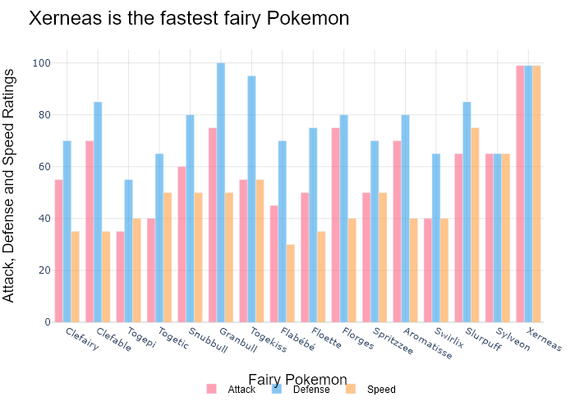

## Performance Metrics

|  |  |  |  |
| --- | --- | --- | --- |
| Task | Model Used | Description | Time Taken (s) |
| Processing Image to JSON | Gemini Vision Pro (default) | Time taken to convert the uploaded image to JSON format | 27.10 |
| Updating JSON | ChatGPT 3.5 (Default) | Time taken to update the JSON with new data | 0.00 |
| Plotting Updated JSON | N/A | Time taken to plot the updated JSON | 0.25 |

# Test Run

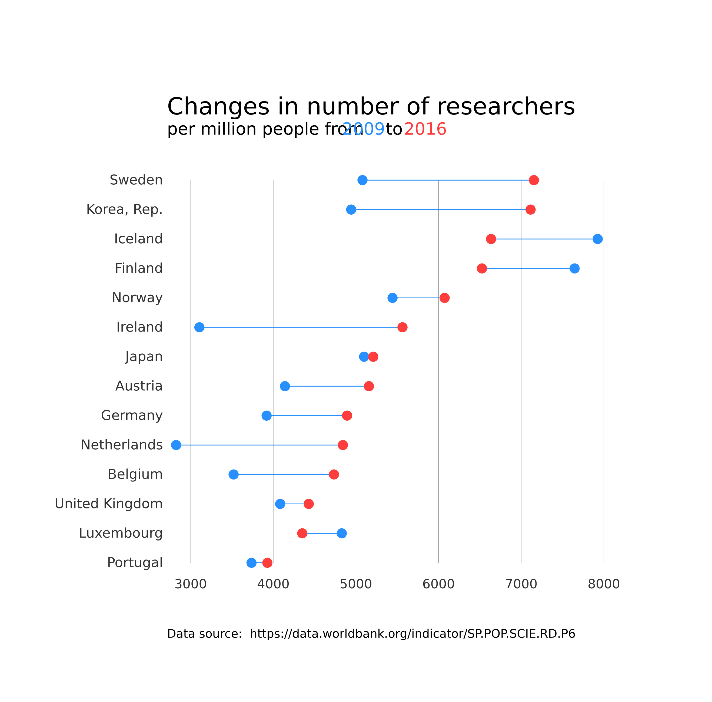

Figure: D:/Research Internship/Charts/Comparison/jpg\dumble.jpg

## Prompt Used

Task: Extract detailed information from a given graph image and generate JSON files (`data.json`, `layout.json`, and `config.json`) compatible with Plotly. Use the specified delimiters to wrap each JSON section.  
  
### Instructions:  
  
#### Graph Analysis:  
  
1. **Identify and categorize** the plot types present in the graph. Include both simple and complex plots:  
 - Simple plots: `scatter`, `bar`, `pie`, `line`, `area`  
 - Complex plots: `stacked bar`, `scatter3d`, `surface`.  
 Confirm the presence of each plot type. Ensure that area plots are identified with `"type": "area"`.  
  
2. **Extract data points** for each plot type:  
 - For `scatter`, `line`, and `area` plots: Extract `x` and `y` values.  
 - For `bar` and `stacked bar` plots: Extract `x` (categories) and `y` values.  
 - For `pie` charts: Extract `labels` and `values`.  
 - For `scatter3d` and `surface` plots: Extract `x`, `y`, and `z` values.  
  
3. **Note any multiple plots** on the same figure and their configurations:  
 - For stacked plots, identify the stacking order and group.  
 - For area charts, ensure `fill` is specified correctly.  
  
#### Generate `data.json`:  
  
For each plot, include details such as:  
- **type**: The type of plot (e.g., `"scatter"`, `"bar"`, `"pie"`, `"area"`, `"scatter3d"`, `"surface"`).  
 - For area charts, use `"type": "scatter"` and specify `"fill"`.  
- **x**, **y**, and **z** (if applicable): Arrays of data points for the `x`, `y`, and `z` axes.  
- **labels** and **values** for pie charts.  
- **mode**: For line and scatter plots (e.g., `"markers"`, `"lines"`, `"markers+lines"`).  
- **name**: Legend entry for the plot.  
- **marker**: Properties such as color, size, and symbol for markers.  
- **line**: Properties such as color, width, and dash style for lines.  
- **text**: Hover text for each data point.  
- **hoverinfo**: Information displayed on hover (e.g., `"x+y+text"`).  
- **fill**: For area charts, specify the fill (e.g., `"tozeroy"`, `"tonexty"`).  
- **fillcolor**: The color used to fill the area under the line.  
- **stackgroup**: For stacked bar charts, specify the group for stacking.  
  
#### Generate `layout.json`:  
  
Include details such as:  
- **title**: The title of the graph, including text and font properties.  
- **xaxis** and **yaxis**: Configuration including title, range, grid properties, and tick settings.  
- **zaxis**: Configuration for 3D plots including title, range, and grid properties.  
- **legend**: Properties including orientation and positioning.  
- **margin**: Values for left, right, bottom, top, and padding.  
- **plot_bgcolor** and **paper_bgcolor**: Background colors of the plot area and paper.  
- **scene**: For 3D plots, configuration for the 3D scene, including camera angles, lighting, and aspect ratio.  
  
#### Generate `config.json`:  
  
Include configuration settings such as:  
- **responsive**: Whether the graph is responsive.  
- **displayModeBar**: Whether the mode bar is displayed.  
- **modeBarButtonsToRemove**: List of mode bar buttons to remove.  
- **scrollZoom**: Whether scrolling zoom is enabled.  
  
#### Generate `<csv>`:  
  
Include CSV data formatted as follows:  
```csv  
x,y  
1,4  
2,5  
3,6  
```  
Replace x,y, 1,4, 2,5, and 3,6 with actual data extracted from the graph image.  
  
Output Format:  
Wrap each JSON output in specific XML-like tags:  
  
<data> ... </data>  
<layout> ... </layout>  
<config> ... </config>  
<csv> ... </csv>  
Make sure to follow the JSON formatting guidelines:  
  
Double Quotes for Keys and Strings: Ensure all keys and string values in JSON are enclosed in double quotes.  
No Trailing Commas: Remove any trailing commas after the last element in arrays or objects.  
Example Output:  
  
<data>  
[  
 {  
 "type": "scatter",  
 "x": [1, 2, 3],  
 "y": [4, 5, 6],  
 "mode": "markers+lines",  
 "name": "Line Plot",  
 "marker": {  
 "color": "rgba(75, 192, 192, 0.6)",  
 "size": 8  
 },  
 "line": {  
 "color": "rgba(75, 192, 192, 1)",  
 "width": 2  
 }  
 },  
 {  
 "type": "area",  
 "x": [1, 2, 3, 4, 5, 6, 7, 8, 9, 10, 11, 12],  
 "y": [400, 430, 550, 620, 580, 600, 630, 700, 670, 630, 600, 500],  
 "name": "Housing",  
 "marker": {  
 "color": "rgba(255, 159, 64, 0.8)"  
 },  
 "line": {  
 "color": "rgba(255, 159, 64, 1)",  
 "width": 2  
 }  
 },  
  
 {  
 "type": "bar",  
 "x": ["A", "B", "C"],  
 "y": [10, 15, 13],  
 "name": "Bar Chart",  
 "marker": {  
 "color": "rgba(255, 99, 132, 0.6)"  
 },  
 "hoverinfo": "x+y+text"  
 },  
 {  
 "type": "scatter",  
 "x": [1, 2, 3],  
 "y": [6, 7, 8],  
 "mode": "lines",  
 "fill": "tozeroy",  
 "name": "Area Chart",  
 "line": {  
 "color": "rgba(54, 162, 235, 1)",  
 "width": 2  
 },  
 "fillcolor": "rgba(54, 162, 235, 0.5)"  
 },  
 {  
 "type": "scatter3d",  
 "x": [1, 2, 3],  
 "y": [4, 5, 6],  
 "z": [7, 8, 9],  
 "mode": "markers",  
 "name": "3D Scatter Plot",  
 "marker": {  
 "color": "rgba(255, 159, 64, 0.8)",  
 "size": 5  
 },  
 "hoverinfo": "x+y+z+text"  
 },  
 {  
 "type": "surface",  
 "z": [  
 [10, 10.625, 12.5, 15.625, 20],  
 [5.625, 6.25, 8.125, 11.25, 15.625],  
 [0, 1.25, 3.125, 6.25, 10.625]  
 ],  
 "name": "Surface Plot",  
 "colorscale": "Viridis",  
 "hoverinfo": "z+name"  
 }  
]  
</data>  
<layout>  
{  
 "title": {  
 "text": "Complex Graph Example",  
 "font": {  
 "family": "Arial, sans-serif",  
 "size": 24,  
 "color": "#000000"  
 }  
 },  
 "xaxis": {  
 "title": {  
 "text": "X Axis",  
 "font": {  
 "family": "Arial, sans-serif",  
 "size": 18,  
 "color": "#000000"  
 }  
 },  
 "showgrid": true,  
 "gridcolor": "rgba(0, 0, 0, 0.1)",  
 "zeroline": true,  
 "zerolinecolor": "rgba(0, 0, 0, 0.1)"  
 },  
 "yaxis": {  
 "title": {  
 "text": "Y Axis",  
 "font": {  
 "family": "Arial, sans-serif",  
 "size": 18,  
 "color": "#000000"  
 }  
 },  
 "showgrid": true,  
 "gridcolor": "rgba(0, 0, 0, 0.1)",  
 "zeroline": true,  
 "zerolinecolor": "rgba(0, 0, 0, 0.1)"  
 },  
 "legend": {  
 "orientation": "h",  
 "x": 0.5,  
 "xanchor": "center",  
 "y": -0.2,  
 "font": {  
 "family": "Arial, sans-serif",  
 "size": 12,  
 "color": "#000000"  
 }  
 },  
 "margin": {  
 "l": 60,  
 "r": 30,  
 "b": 60,  
 "t": 60  
 },  
 "plot_bgcolor": "#ffffff",  
 "paper_bgcolor": "#ffffff",  
 "scene": {  
 "xaxis": {"title": "X Axis"},  
 "yaxis": {"title": "Y Axis"},  
 "zaxis": {"title": "Z Axis"}  
 }  
}  
</layout>  
<config>  
{  
 "responsive": true,  
 "displayModeBar": true,  
 "modeBarButtonsToRemove": ["toImage"],  
 "scrollZoom": true  
}  
</config>  
<csv>  
x,y  
1,4  
2,5  
3,6  
</csv>

## Extracted JSON

### data

[  
 {  
 "type": "bar",  
 "x": [  
 "Sweden",  
 "Korea, Rep.",  
 "Iceland",  
 "Finland",  
 "Norway",  
 "Ireland",  
 "Japan",  
 "Austria",  
 "Germany",  
 "Netherlands",  
 "Belgium",  
 "United Kingdom",  
 "Luxembourg",  
 "Portugal"  
 ],  
 "y": [  
 7200,  
 7100,  
 6900,  
 6800,  
 6700,  
 6600,  
 6500,  
 6400,  
 6300,  
 6200,  
 6100,  
 6000,  
 5900,  
 5800  
 ],  
 "name": "Researchers per million people",  
 "marker": {  
 "color": "rgba(55, 128, 191, 0.6)"  
 },  
 "hoverinfo": "x+y+text"  
 },  
 {  
 "type": "bar",  
 "x": [  
 "Sweden",  
 "Korea, Rep.",  
 "Iceland",  
 "Finland",  
 "Norway",  
 "Ireland",  
 "Japan",  
 "Austria",  
 "Germany",  
 "Netherlands",  
 "Belgium",  
 "United Kingdom",  
 "Luxembourg",  
 "Portugal"  
 ],  
 "y": [  
 8200,  
 8100,  
 8000,  
 7900,  
 7800,  
 7700,  
 7600,  
 7500,  
 7400,  
 7300,  
 7200,  
 7100,  
 7000,  
 6900  
 ],  
 "name": "Researchers per million people",  
 "marker": {  
 "color": "rgba(255, 127, 14, 0.6)"  
 },  
 "hoverinfo": "x+y+text"  
 }  
]

### layout

{  
 "title": {  
 "text": "Changes in number of researchers per million people from 2009 to 2016",  
 "font": {  
 "family": "Arial, sans-serif",  
 "size": 24,  
 "color": "#000000"  
 }  
 },  
 "xaxis": {  
 "title": {  
 "text": "Country",  
 "font": {  
 "family": "Arial, sans-serif",  
 "size": 18,  
 "color": "#000000"  
 }  
 },  
 "tickangle": -45,  
 "showgrid": true,  
 "gridcolor": "rgba(0, 0, 0, 0.1)",  
 "zeroline": true,  
 "zerolinecolor": "rgba(0, 0, 0, 0.1)"  
 },  
 "yaxis": {  
 "title": {  
 "text": "Researchers per million people",  
 "font": {  
 "family": "Arial, sans-serif",  
 "size": 18,  
 "color": "#000000"  
 }  
 },  
 "showgrid": true,  
 "gridcolor": "rgba(0, 0, 0, 0.1)",  
 "zeroline": true,  
 "zerolinecolor": "rgba(0, 0, 0, 0.1)"  
 },  
 "legend": {  
 "orientation": "h",  
 "x": 0.5,  
 "xanchor": "center",  
 "y": -0.2,  
 "font": {  
 "family": "Arial, sans-serif",  
 "size": 12,  
 "color": "#000000"  
 }  
 },  
 "margin": {  
 "l": 60,  
 "r": 30,  
 "b": 60,  
 "t": 60  
 },  
 "plot_bgcolor": "#ffffff",  
 "paper_bgcolor": "#ffffff"  
}

### config

{  
 "responsive": true,  
 "displayModeBar": true,  
 "modeBarButtonsToRemove": [  
 "toImage"  
 ],  
 "scrollZoom": true  
}

## Updated JSON

### updated_data

[  
 {  
 "type": "bar",  
 "x": [  
 "Sweden",  
 "Korea, Rep.",  
 "Iceland",  
 "Finland",  
 "Norway",  
 "Ireland",  
 "Japan",  
 "Austria",  
 "Germany",  
 "Netherlands",  
 "Belgium",  
 "United Kingdom",  
 "Luxembourg",  
 "Portugal"  
 ],  
 "y": [  
 7200,  
 7100,  
 6900,  
 6800,  
 6700,  
 6600,  
 6500,  
 6400,  
 6300,  
 6200,  
 6100,  
 6000,  
 5900,  
 5800  
 ],  
 "name": "Researchers per million people",  
 "marker": {  
 "color": "rgba(55, 128, 191, 0.6)"  
 },  
 "hoverinfo": "x+y+text"  
 },  
 {  
 "type": "bar",  
 "x": [  
 "Sweden",  
 "Korea, Rep.",  
 "Iceland",  
 "Finland",  
 "Norway",  
 "Ireland",  
 "Japan",  
 "Austria",  
 "Germany",  
 "Netherlands",  
 "Belgium",  
 "United Kingdom",  
 "Luxembourg",  
 "Portugal"  
 ],  
 "y": [  
 8200,  
 8100,  
 8000,  
 7900,  
 7800,  
 7700,  
 7600,  
 7500,  
 7400,  
 7300,  
 7200,  
 7100,  
 7000,  
 6900  
 ],  
 "name": "Researchers per million people",  
 "marker": {  
 "color": "rgba(255, 127, 14, 0.6)"  
 },  
 "hoverinfo": "x+y+text"  
 }  
]

### updated_layout

{  
 "title": {  
 "text": "Changes in number of researchers per million people from 2009 to 2016",  
 "font": {  
 "family": "Arial, sans-serif",  
 "size": 24,  
 "color": "#000000"  
 }  
 },  
 "xaxis": {  
 "title": {  
 "text": "Country",  
 "font": {  
 "family": "Arial, sans-serif",  
 "size": 18,  
 "color": "#000000"  
 }  
 },  
 "tickangle": -45,  
 "showgrid": true,  
 "gridcolor": "rgba(0, 0, 0, 0.1)",  
 "zeroline": true,  
 "zerolinecolor": "rgba(0, 0, 0, 0.1)"  
 },  
 "yaxis": {  
 "title": {  
 "text": "Researchers per million people",  
 "font": {  
 "family": "Arial, sans-serif",  
 "size": 18,  
 "color": "#000000"  
 }  
 },  
 "showgrid": true,  
 "gridcolor": "rgba(0, 0, 0, 0.1)",  
 "zeroline": true,  
 "zerolinecolor": "rgba(0, 0, 0, 0.1)"  
 },  
 "legend": {  
 "orientation": "h",  
 "x": 0.5,  
 "xanchor": "center",  
 "y": -0.2,  
 "font": {  
 "family": "Arial, sans-serif",  
 "size": 12,  
 "color": "#000000"  
 }  
 },  
 "margin": {  
 "l": 60,  
 "r": 30,  
 "b": 60,  
 "t": 60  
 },  
 "plot_bgcolor": "#ffffff",  
 "paper_bgcolor": "#ffffff"  
}

### updated_config

{  
 "responsive": true,  
 "displayModeBar": true,  
 "modeBarButtonsToRemove": [  
 "toImage"  
 ],  
 "scrollZoom": true  
}

## Updated Chart

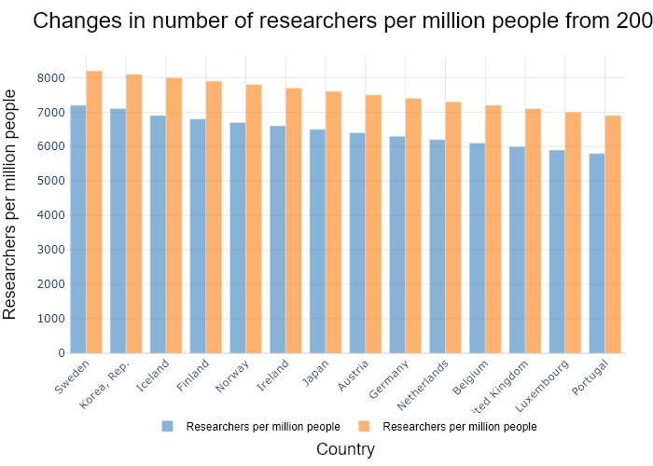

## Performance Metrics

|  |  |  |  |
| --- | --- | --- | --- |
| Task | Model Used | Description | Time Taken (s) |
| Processing Image to JSON | Gemini Vision Pro (default) | Time taken to convert the uploaded image to JSON format | 25.18 |
| Updating JSON | ChatGPT 3.5 (Default) | Time taken to update the JSON with new data | 0.00 |
| Plotting Updated JSON | N/A | Time taken to plot the updated JSON | 0.24 |

# Test Run



Figure: Charts/Comparison/jpg/column_vertical_chart.jpg

## Prompt Used

## Task: Extract Detailed Information from a Given Graph Image  
  
You will analyze a graph image and generate corresponding Plotly-compatible JSON files (`data.json`, `layout.json`, and `config.json`). Follow the structured steps and specific XML-like delimiters for each JSON section as outlined below.  
  
### Instructions:  
  
#### Graph Analysis:  
  
1. **Identify and Categorize Plot Types**:  
 - Recognize and categorize the plot types present in the graph image. Include both simple and complex plots, listed below:  
 - **Comparison Charts**:  
 - `bar`: Bar Chart  
 - `bar` (with vertical bars): Column Chart  
 - `bar` (grouped): Grouped Bar/Column Chart  
 - `scatter` (with lines connecting to points): Lollipop Chart  
 - `indicator` (with gauge): Bullet Chart  
 - `scatter`: Dot Plot  
 - `scatter` (with lines connecting different points): Dumbbell Chart  
 - `scatter` (or custom SVG): Pictogram  
 - `scatter` or `bar` with a range: Range Chart  
 - `barpolar`: Radial Bar Chart  
 - `parcoords`: Parallel Coordinates  
 - `scatterpolar`: Radar Chart  
 - `barpolar` (with segments): Nightingale Chart  
 - `waterfall`: Waterfall Chart  
 - `heatmap` (with color scale): Matrix Chart  
 - `various charts in small multiples`: Small Multiples  
 - `text` (frequency-based size): Word Cloud  
 - `scatter` (with lines indicating change): Slope Chart  
 - `table`: Table Chart  
 - `scatter`: Categorical Scatter Plot  
 - `scatter` (with four quadrants): Quadrant Chart  
 - **Correlation Charts**:  
 - `heatmap`: Heatmap  
 - `scatter` (with size): Bubble Chart  
 - `scatter`: Scatter Plot  
 - `scatter` (with lines connecting points): Connected Scatter Plot  
 - `hexbin`: Hexagonal Binning  
 - `contour`: Contour Plot  
 - **Part-to-Whole & Hierarchical Charts**:  
 - `bar` (stacked): Stacked Bar/Column Chart  
 - `bar` (with diverging sections): Diverging Bar Chart  
 - `bar` (mirrored pairs): Population Pyramid  
 - `scatter` (or custom symbols in a grid): Icon Array  
 - `waffle`: Waffle Chart  
 - `pie`: Pie Chart  
 - `pie` (with hole): Donut Chart  
 - `pie` (half-circle): Semi-circle Donut Chart  
 - `bar` (variable width): Marimekko Chart  
 - `treemap`: Treemap  
 - `treemap` (circular): Circular Treemap  
 - `treemap` (convex shape): Convex Treemap  
 - `sunburst`: Sunburst Chart  
 - `funnel` or `pyramid`: Funnel & Pyramid Chart  
 - `dendrogram`: Dendrogram  
 - `venn`: Venn Diagram  
 - `euler`: Euler Diagram  
 - `indicator` (circular gauge): Circular Gauge  
 - **Data Over Time (Temporal) Charts**:  
 - `scatter` (filled area under curve): Area Chart  
 - `scatter` (filled stacked areas): Stacked Area Chart  
 - `scatter` (smoothed filled areas): Stream Graph  
 - `scatter` (indicating ranking change): Bump Chart  
 - `scatter` (with filled area): Bump Area Chart  
 - `scatter`: Line Chart  
 - `scatter` (with smoothed lines): Spline Chart  
 - `scatter` (with stepped lines): Step Line Chart  
 - `candlestick`: Candlestick Chart  
 - `gantt`: Gantt Chart  
 - `scatter` (encoded lines): Barcode Chart  
 - `ohlc`: OHLC Chart  
 - **Distribution Charts**:  
 - `densitymapbox` or `histogram`: Density Plot  
 - `ridge`: Ridgeline Plot  
 - `horizon`: Horizon Chart  
 - `histogram`: Histogram  
 - `radial_histogram`: Radial Histogram  
 - `scatter` (with distribution): Strip Plot  
 - `scatter` (with jitter): Jitter Plot  
 - `heatmap`: One-dimensional Heatmap  
 - `scatter` (with tightly packed points): Beeswarm Chart  
 - `box`: Box Chart  
 - `violin`: Violin Plot  
 - **Geospatial & Other Charts**:  
 - `densitymapbox`: Geographic Heatmap  
 - `choropleth`: Choropleth Map  
 - `scattermapbox`: Tile Map  
 - `chord`: Chord Diagram  
 - `arc`: Arc Diagram  
 - `sankey`: Sankey  
 - `network`: Network Diagram  
 - `flowchart`: Flowchart  
  
2. **Extract Data Points** for Each Plot Type:  
 - Gather the data points for each identified plot type.  
 - For `scatter`, `line`, and `area` plots: Extract `x` and `y` values.  
 - For `bar` and `stacked bar` plots: Extract `x` (categories) and `y` values.  
 - For `pie` charts: Extract `labels` and `values`.  
 - For `scatter3d`, `surface`, and other 3D plots: Extract `x`, `y`, and `z` values.  
  
3. **Identify Multiple Plots** on the Same Figure:  
 - Note any combinations or overlays of multiple plot types on the same figure and their configurations, such as stacked plots or multiple area fills.  
  
#### Generate JSON and CSV Outputs:  
  
Follow the JSON formatting guidelines and wrap each section in the specified XML-like tags.  
  
1. **Generate `data.json`**:  
 - Include detailed information for each plot type:  
 - `type`: Specify the plot type (e.g., `"scatter"`, `"bar"`, `"pie"`, `"area"`, `"scatter3d"`, `"surface"`).  
 - For area charts, use `"type": "scatter"` and specify `"fill"`.  
 - `x`, `y`, and `z` (if applicable): Arrays of data points for each axis.  
 - `labels` and `values` for pie charts.  
 - `mode`: Specify for line and scatter plots (e.g., `"markers"`, `"lines"`, `"markers+lines"`).  
 - `name`: Legend entry for the plot.  
 - `marker`: Properties such as color, size, and symbol.  
 - `line`: Properties such as color, width, and dash style.  
 - `text`: Hover text for each data point.  
 - `hoverinfo`: Information displayed on hover (e.g., `"x+y+text"`).  
 - `fill`: For area charts, specify the fill (e.g., `"tozeroy"`, `"tonexty"`).  
 - `fillcolor`: The color used to fill the area.  
 - `stackgroup`: For stacked bar charts, specify the stacking group.  
  
2. **Generate `layout.json`**:  
 - Define the layout properties:  
 - `title`: Text and font properties for the graph title.  
 - `xaxis` and `yaxis`: Configuration for axis titles, ranges, grids, and ticks.  
 - `zaxis`: Configuration for 3D plots including title, range, and grid.  
 - `legend`: Properties for legend orientation and positioning.  
 - `margin`: Margins for left, right, bottom, top, and padding.  
 - `plot_bgcolor` and `paper_bgcolor`: Background colors.  
 - `scene`: Configuration for 3D scenes, including camera angles and aspect ratio.  
  
3. **Generate `config.json`**:  
 - Include settings such as:  
 - `responsive`: Whether the graph is responsive.  
 - `displayModeBar`: Whether the mode bar is shown.  
 - `modeBarButtonsToRemove`: List of mode bar buttons to remove.  
 - `scrollZoom`: Whether scrolling zoom is enabled.  
  
4. **Generate `<csv>`**:  
 - Format the CSV data as follows:  
 ```csv  
 x,y  
 1,4  
 2,5  
 3,6  
 ```  
 - Replace `x`, `y`, `1`, `4`, `2`, `5`, and `3`, `6` with the actual data from the graph image.  
  
### Output Format:  
  
Wrap each JSON output in the specified XML-like tags:  
  
- `<data> ... </data>`  
- `<layout> ... </layout>`  
- `<config> ... </config>`  
- `<csv> ... </csv>`  
  
Ensure the JSON format follows these rules:  
- Use double quotes for all keys and string values.  
- Do not include trailing commas in arrays or objects.  
  
### Example Output:  
  
```xml  
<data>  
[  
 {  
 "type": "scatter",  
 "x": [1, 2, 3],  
 "y": [4, 5, 6],  
 "mode": "markers+lines",  
 "name": "Line Plot",  
 "marker": {  
 "color": "rgba(75, 192, 192, 0.6)",  
 "size": 8  
 },  
 "line": {  
 "color": "rgba(75, 192, 192  
  
, 1)",  
 "width": 2  
 }  
 },  
 {  
 "type": "area",  
 "x": [1, 2, 3, 4, 5, 6, 7, 8, 9, 10, 11, 12],  
 "y": [400, 430, 550, 620, 580, 600, 630, 700, 670, 630, 600, 500],  
 "name": "Housing",  
 "marker": {  
 "color": "rgba(255, 159, 64, 0.8)"  
 },  
 "line": {  
 "color": "rgba(255, 159, 64, 1)",  
 "width": 2  
 }  
 },  
 {  
 "type": "bar",  
 "x": ["A", "B", "C"],  
 "y": [10, 15, 13],  
 "name": "Bar Chart",  
 "marker": {  
 "color": "rgba(255, 99, 132, 0.6)"  
 },  
 "hoverinfo": "x+y+text"  
 },  
 {  
 "type": "scatter",  
 "x": [1, 2, 3],  
 "y": [6, 7, 8],  
 "mode": "lines",  
 "fill": "tozeroy",  
 "name": "Area Chart",  
 "line": {  
 "color": "rgba(54, 162, 235, 1)",  
 "width": 2  
 },  
 "fillcolor": "rgba(54, 162, 235, 0.5)"  
 },  
 {  
 "type": "scatter3d",  
 "x": [1, 2, 3],  
 "y": [4, 5, 6],  
 "z": [7, 8, 9],  
 "mode": "markers",  
 "name": "3D Scatter Plot",  
 "marker": {  
 "color": "rgba(255, 159, 64, 0.8)",  
 "size": 5  
 },  
 "hoverinfo": "x+y+z+text"  
 },  
 {  
 "type": "surface",  
 "z": [  
 [10, 10.625, 12.5, 15.625, 20],  
 [5.625, 6.25, 8.125, 11.25, 15.625],  
 [0, 1.25, 3.125, 6.25, 10.625]  
 ],  
 "name": "Surface Plot",  
 "colorscale": "Viridis",  
 "hoverinfo": "z+name"  
 }  
]  
</data>  
<layout>  
{  
 "title": {  
 "text": "Complex Graph Example",  
 "font": {  
 "family": "Arial, sans-serif",  
 "size": 24,  
 "color": "#000000"  
 }  
 },  
 "xaxis": {  
 "title": {  
 "text": "X Axis",  
 "font": {  
 "family": "Arial, sans-serif",  
 "size": 18,  
 "color": "#000000"  
 }  
 },  
 "showgrid": true,  
 "gridcolor": "rgba(0, 0, 0, 0.1)",  
 "zeroline": true,  
 "zerolinecolor": "rgba(0, 0, 0, 0.1)"  
 },  
 "yaxis": {  
 "title": {  
 "text": "Y Axis",  
 "font": {  
 "family": "Arial, sans-serif",  
 "size": 18,  
 "color": "#000000"  
 }  
 },  
 "showgrid": true,  
 "gridcolor": "rgba(0, 0, 0, 0.1)",  
 "zeroline": true,  
 "zerolinecolor": "rgba(0, 0, 0, 0.1)"  
 },  
 "legend": {  
 "orientation": "h",  
 "x": 0.5,  
 "xanchor": "center",  
 "y": -0.2,  
 "font": {  
 "family": "Arial, sans-serif",  
 "size": 12,  
 "color": "#000000"  
 }  
 },  
 "margin": {  
 "l": 60,  
 "r": 30,  
 "b": 60,  
 "t": 60  
 },  
 "plot_bgcolor": "#ffffff",  
 "paper_bgcolor": "#ffffff",  
 "scene": {  
 "xaxis": {"title": "X Axis"},  
 "yaxis": {"title": "Y Axis"},  
 "zaxis": {"title": "Z Axis"}  
 }  
}  
</layout>  
<config>  
{  
 "responsive": true,  
 "displayModeBar": true,  
 "modeBarButtonsToRemove": ["toImage"],  
 "scrollZoom": true  
}  
</config>  
<csv>  
x,y  
1,4  
2,5  
3,6  
</csv>  
```

## Extracted JSON

### data

[  
 {  
 "type": "bar",  
 "x": [  
 "Burj Khalifa",  
 "Abraj Al-Bait Tower",  
 "Ping An Finance Center",  
 "One World Trade Center",  
 "Guangzhou CTF Finance Center",  
 "China Zun",  
 "Taipei 101",  
 "Shanghai World Financial Center",  
 "International Commerce Centre",  
 "Central Park Tower",  
 "Lakhta Center",  
 "Landmark 81"  
 ],  
 "y": [  
 828,  
 632,  
 599,  
 541,  
 530,  
 528,  
 508,  
 492,  
 484,  
 472,  
 462,  
 461  
 ],  
 "name": "Tallest Buildings",  
 "marker": {  
 "color": "rgba(55, 128, 191, 0.6)"  
 },  
 "hoverinfo": "x+y+text"  
 }  
]

### layout

{  
 "title": {  
 "text": "Top 15 World Tallest Buildings",  
 "font": {  
 "family": "Arial, sans-serif",  
 "size": 24,  
 "color": "#000000"  
 }  
 },  
 "xaxis": {  
 "title": {  
 "text": "Building Name",  
 "font": {  
 "family": "Arial, sans-serif",  
 "size": 18,  
 "color": "#000000"  
 }  
 },  
 "showgrid": false,  
 "zeroline": false  
 },  
 "yaxis": {  
 "title": {  
 "text": "Height (m)",  
 "font": {  
 "family": "Arial, sans-serif",  
 "size": 18,  
 "color": "#000000"  
 }  
 },  
 "showgrid": true,  
 "gridcolor": "rgba(0, 0, 0, 0.1)",  
 "zeroline": false  
 },  
 "legend": {  
 "orientation": "h",  
 "x": 0.5,  
 "xanchor": "center",  
 "y": -0.2,  
 "font": {  
 "family": "Arial, sans-serif",  
 "size": 12,  
 "color": "#000000"  
 }  
 },  
 "margin": {  
 "l": 60,  
 "r": 30,  
 "b": 60,  
 "t": 60  
 },  
 "plot_bgcolor": "#ffffff",  
 "paper_bgcolor": "#ffffff"  
}

### config

{  
 "responsive": true,  
 "displayModeBar": true,  
 "modeBarButtonsToRemove": [  
 "toImage"  
 ],  
 "scrollZoom": true  
}

## Updated JSON

### updated_data

[  
 {  
 "type": "bar",  
 "x": [  
 "Burj Khalifa",  
 "Abraj Al-Bait Tower",  
 "Ping An Finance Center",  
 "One World Trade Center",  
 "Guangzhou CTF Finance Center",  
 "China Zun",  
 "Taipei 101",  
 "Shanghai World Financial Center",  
 "International Commerce Centre",  
 "Central Park Tower",  
 "Lakhta Center",  
 "Landmark 81"  
 ],  
 "y": [  
 828,  
 632,  
 599,  
 541,  
 530,  
 528,  
 508,  
 492,  
 484,  
 472,  
 462,  
 461  
 ],  
 "name": "Tallest Buildings",  
 "marker": {  
 "color": "rgba(55, 128, 191, 0.6)"  
 },  
 "hoverinfo": "x+y+text"  
 }  
]

### updated_layout

{  
 "title": {  
 "text": "Top 15 World Tallest Buildings",  
 "font": {  
 "family": "Arial, sans-serif",  
 "size": 24,  
 "color": "#000000"  
 }  
 },  
 "xaxis": {  
 "title": {  
 "text": "Building Name",  
 "font": {  
 "family": "Arial, sans-serif",  
 "size": 18,  
 "color": "#000000"  
 }  
 },  
 "showgrid": false,  
 "zeroline": false  
 },  
 "yaxis": {  
 "title": {  
 "text": "Height (m)",  
 "font": {  
 "family": "Arial, sans-serif",  
 "size": 18,  
 "color": "#000000"  
 }  
 },  
 "showgrid": true,  
 "gridcolor": "rgba(0, 0, 0, 0.1)",  
 "zeroline": false  
 },  
 "legend": {  
 "orientation": "h",  
 "x": 0.5,  
 "xanchor": "center",  
 "y": -0.2,  
 "font": {  
 "family": "Arial, sans-serif",  
 "size": 12,  
 "color": "#000000"  
 }  
 },  
 "margin": {  
 "l": 60,  
 "r": 30,  
 "b": 60,  
 "t": 60  
 },  
 "plot_bgcolor": "#ffffff",  
 "paper_bgcolor": "#ffffff"  
}

### updated_config

{  
 "responsive": true,  
 "displayModeBar": true,  
 "modeBarButtonsToRemove": [  
 "toImage"  
 ],  
 "scrollZoom": true  
}

## Updated Chart

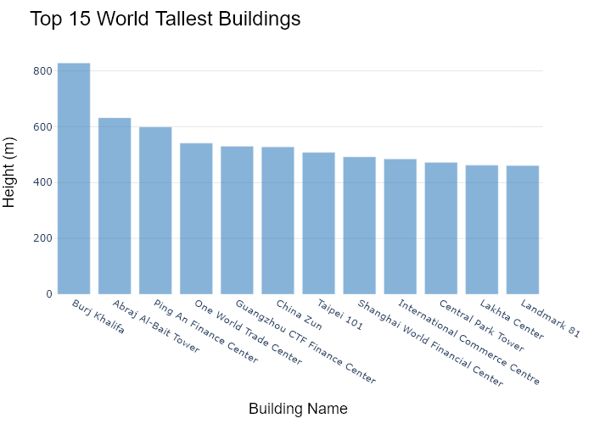

## Performance Metrics

|  |  |  |  |
| --- | --- | --- | --- |
| Task | Model Used | Description | Time Taken (s) |
| Processing Image to JSON | Gemini Vision Pro (default) | Time taken to convert the uploaded image to JSON format | 20.54 |
| Updating JSON | ChatGPT 3.5 (Default) | Time taken to update the JSON with new data | 0.00 |
| Plotting Updated JSON | N/A | Time taken to plot the updated JSON | 0.24 |

# Test Run



Figure: Charts/Comparison/jpg/bullet.jpg

## Prompt Used

## Task: Extract Detailed Information from a Given Graph Image  
  
You will analyze a graph image and generate corresponding Plotly-compatible JSON files (`data.json`, `layout.json`, and `config.json`). Follow the structured steps and specific XML-like delimiters for each JSON section as outlined below.  
  
### Instructions:  
  
#### Graph Analysis:  
  
1. **Identify and Categorize Plot Types**:  
 - Recognize and categorize the plot types present in the graph image. Include both simple and complex plots, listed below:  
 - **Comparison Charts**:  
 - `bar`: Bar Chart  
 - `bar` (with vertical bars): Column Chart  
 - `bar` (grouped): Grouped Bar/Column Chart  
 - `scatter` (with lines connecting to points): Lollipop Chart  
 - `indicator` (with gauge): Bullet Chart  
 - `scatter`: Dot Plot  
 - `scatter` (with lines connecting different points): Dumbbell Chart  
 - `scatter` (or custom SVG): Pictogram  
 - `scatter` or `bar` with a range: Range Chart  
 - `barpolar`: Radial Bar Chart  
 - `parcoords`: Parallel Coordinates  
 - `scatterpolar`: Radar Chart  
 - `barpolar` (with segments): Nightingale Chart  
 - `waterfall`: Waterfall Chart  
 - `heatmap` (with color scale): Matrix Chart  
 - `various charts in small multiples`: Small Multiples  
 - `text` (frequency-based size): Word Cloud  
 - `scatter` (with lines indicating change): Slope Chart  
 - `table`: Table Chart  
 - `scatter`: Categorical Scatter Plot  
 - `scatter` (with four quadrants): Quadrant Chart  
 - **Correlation Charts**:  
 - `heatmap`: Heatmap  
 - `scatter` (with size): Bubble Chart  
 - `scatter`: Scatter Plot  
 - `scatter` (with lines connecting points): Connected Scatter Plot  
 - `hexbin`: Hexagonal Binning  
 - `contour`: Contour Plot  
 - **Part-to-Whole & Hierarchical Charts**:  
 - `bar` (stacked): Stacked Bar/Column Chart  
 - `bar` (with diverging sections): Diverging Bar Chart  
 - `bar` (mirrored pairs): Population Pyramid  
 - `scatter` (or custom symbols in a grid): Icon Array  
 - `waffle`: Waffle Chart  
 - `pie`: Pie Chart  
 - `pie` (with hole): Donut Chart  
 - `pie` (half-circle): Semi-circle Donut Chart  
 - `bar` (variable width): Marimekko Chart  
 - `treemap`: Treemap  
 - `treemap` (circular): Circular Treemap  
 - `treemap` (convex shape): Convex Treemap  
 - `sunburst`: Sunburst Chart  
 - `funnel` or `pyramid`: Funnel & Pyramid Chart  
 - `dendrogram`: Dendrogram  
 - `venn`: Venn Diagram  
 - `euler`: Euler Diagram  
 - `indicator` (circular gauge): Circular Gauge  
 - **Data Over Time (Temporal) Charts**:  
 - `scatter` (filled area under curve): Area Chart  
 - `scatter` (filled stacked areas): Stacked Area Chart  
 - `scatter` (smoothed filled areas): Stream Graph  
 - `scatter` (indicating ranking change): Bump Chart  
 - `scatter` (with filled area): Bump Area Chart  
 - `scatter`: Line Chart  
 - `scatter` (with smoothed lines): Spline Chart  
 - `scatter` (with stepped lines): Step Line Chart  
 - `candlestick`: Candlestick Chart  
 - `gantt`: Gantt Chart  
 - `scatter` (encoded lines): Barcode Chart  
 - `ohlc`: OHLC Chart  
 - **Distribution Charts**:  
 - `densitymapbox` or `histogram`: Density Plot  
 - `ridge`: Ridgeline Plot  
 - `horizon`: Horizon Chart  
 - `histogram`: Histogram  
 - `radial_histogram`: Radial Histogram  
 - `scatter` (with distribution): Strip Plot  
 - `scatter` (with jitter): Jitter Plot  
 - `heatmap`: One-dimensional Heatmap  
 - `scatter` (with tightly packed points): Beeswarm Chart  
 - `box`: Box Chart  
 - `violin`: Violin Plot  
 - **Geospatial & Other Charts**:  
 - `densitymapbox`: Geographic Heatmap  
 - `choropleth`: Choropleth Map  
 - `scattermapbox`: Tile Map  
 - `chord`: Chord Diagram  
 - `arc`: Arc Diagram  
 - `sankey`: Sankey  
 - `network`: Network Diagram  
 - `flowchart`: Flowchart  
  
2. **Extract Data Points** for Each Plot Type:  
 - Gather the data points for each identified plot type.  
 - For `scatter`, `line`, and `area` plots: Extract `x` and `y` values.  
 - For `bar` and `stacked bar` plots: Extract `x` (categories) and `y` values.  
 - For `pie` charts: Extract `labels` and `values`.  
 - For `scatter3d`, `surface`, and other 3D plots: Extract `x`, `y`, and `z` values.  
  
3. **Identify Multiple Plots** on the Same Figure:  
 - Note any combinations or overlays of multiple plot types on the same figure and their configurations, such as stacked plots or multiple area fills.  
  
#### Generate JSON and CSV Outputs:  
  
Follow the JSON formatting guidelines and wrap each section in the specified XML-like tags.  
  
1. **Generate `data.json`**:  
 - Include detailed information for each plot type:  
 - `type`: Specify the plot type (e.g., `"scatter"`, `"bar"`, `"pie"`, `"area"`, `"scatter3d"`, `"surface"`).  
 - For area charts, use `"type": "scatter"` and specify `"fill"`.  
 - `x`, `y`, and `z` (if applicable): Arrays of data points for each axis.  
 - `labels` and `values` for pie charts.  
 - `mode`: Specify for line and scatter plots (e.g., `"markers"`, `"lines"`, `"markers+lines"`).  
 - `name`: Legend entry for the plot.  
 - `marker`: Properties such as color, size, and symbol.  
 - `line`: Properties such as color, width, and dash style.  
 - `text`: Hover text for each data point.  
 - `hoverinfo`: Information displayed on hover (e.g., `"x+y+text"`).  
 - `fill`: For area charts, specify the fill (e.g., `"tozeroy"`, `"tonexty"`).  
 - `fillcolor`: The color used to fill the area.  
 - `stackgroup`: For stacked bar charts, specify the stacking group.  
  
2. **Generate `layout.json`**:  
 - Define the layout properties:  
 - `title`: Text and font properties for the graph title.  
 - `xaxis` and `yaxis`: Configuration for axis titles, ranges, grids, and ticks.  
 - `zaxis`: Configuration for 3D plots including title, range, and grid.  
 - `legend`: Properties for legend orientation and positioning.  
 - `margin`: Margins for left, right, bottom, top, and padding.  
 - `plot_bgcolor` and `paper_bgcolor`: Background colors.  
 - `scene`: Configuration for 3D scenes, including camera angles and aspect ratio.  
  
3. **Generate `config.json`**:  
 - Include settings such as:  
 - `responsive`: Whether the graph is responsive.  
 - `displayModeBar`: Whether the mode bar is shown.  
 - `modeBarButtonsToRemove`: List of mode bar buttons to remove.  
 - `scrollZoom`: Whether scrolling zoom is enabled.  
  
4. **Generate `<csv>`**:  
 - Format the CSV data as follows:  
 ```csv  
 x,y  
 1,4  
 2,5  
 3,6  
 ```  
 - Replace `x`, `y`, `1`, `4`, `2`, `5`, and `3`, `6` with the actual data from the graph image.  
  
### Output Format:  
  
Wrap each JSON output in the specified XML-like tags:  
  
- `<data> ... </data>`  
- `<layout> ... </layout>`  
- `<config> ... </config>`  
- `<csv> ... </csv>`  
  
Ensure the JSON format follows these rules:  
- Use double quotes for all keys and string values.  
- Do not include trailing commas in arrays or objects.  
  
### Example Output:  
  
```xml  
<data>  
[  
 {  
 "type": "scatter",  
 "x": [1, 2, 3],  
 "y": [4, 5, 6],  
 "mode": "markers+lines",  
 "name": "Line Plot",  
 "marker": {  
 "color": "rgba(75, 192, 192, 0.6)",  
 "size": 8  
 },  
 "line": {  
 "color": "rgba(75, 192, 192  
  
, 1)",  
 "width": 2  
 }  
 },  
 {  
 "type": "area",  
 "x": [1, 2, 3, 4, 5, 6, 7, 8, 9, 10, 11, 12],  
 "y": [400, 430, 550, 620, 580, 600, 630, 700, 670, 630, 600, 500],  
 "name": "Housing",  
 "marker": {  
 "color": "rgba(255, 159, 64, 0.8)"  
 },  
 "line": {  
 "color": "rgba(255, 159, 64, 1)",  
 "width": 2  
 }  
 },  
 {  
 "type": "bar",  
 "x": ["A", "B", "C"],  
 "y": [10, 15, 13],  
 "name": "Bar Chart",  
 "marker": {  
 "color": "rgba(255, 99, 132, 0.6)"  
 },  
 "hoverinfo": "x+y+text"  
 },  
 {  
 "type": "scatter",  
 "x": [1, 2, 3],  
 "y": [6, 7, 8],  
 "mode": "lines",  
 "fill": "tozeroy",  
 "name": "Area Chart",  
 "line": {  
 "color": "rgba(54, 162, 235, 1)",  
 "width": 2  
 },  
 "fillcolor": "rgba(54, 162, 235, 0.5)"  
 },  
 {  
 "type": "scatter3d",  
 "x": [1, 2, 3],  
 "y": [4, 5, 6],  
 "z": [7, 8, 9],  
 "mode": "markers",  
 "name": "3D Scatter Plot",  
 "marker": {  
 "color": "rgba(255, 159, 64, 0.8)",  
 "size": 5  
 },  
 "hoverinfo": "x+y+z+text"  
 },  
 {  
 "type": "surface",  
 "z": [  
 [10, 10.625, 12.5, 15.625, 20],  
 [5.625, 6.25, 8.125, 11.25, 15.625],  
 [0, 1.25, 3.125, 6.25, 10.625]  
 ],  
 "name": "Surface Plot",  
 "colorscale": "Viridis",  
 "hoverinfo": "z+name"  
 }  
]  
</data>  
<layout>  
{  
 "title": {  
 "text": "Complex Graph Example",  
 "font": {  
 "family": "Arial, sans-serif",  
 "size": 24,  
 "color": "#000000"  
 }  
 },  
 "xaxis": {  
 "title": {  
 "text": "X Axis",  
 "font": {  
 "family": "Arial, sans-serif",  
 "size": 18,  
 "color": "#000000"  
 }  
 },  
 "showgrid": true,  
 "gridcolor": "rgba(0, 0, 0, 0.1)",  
 "zeroline": true,  
 "zerolinecolor": "rgba(0, 0, 0, 0.1)"  
 },  
 "yaxis": {  
 "title": {  
 "text": "Y Axis",  
 "font": {  
 "family": "Arial, sans-serif",  
 "size": 18,  
 "color": "#000000"  
 }  
 },  
 "showgrid": true,  
 "gridcolor": "rgba(0, 0, 0, 0.1)",  
 "zeroline": true,  
 "zerolinecolor": "rgba(0, 0, 0, 0.1)"  
 },  
 "legend": {  
 "orientation": "h",  
 "x": 0.5,  
 "xanchor": "center",  
 "y": -0.2,  
 "font": {  
 "family": "Arial, sans-serif",  
 "size": 12,  
 "color": "#000000"  
 }  
 },  
 "margin": {  
 "l": 60,  
 "r": 30,  
 "b": 60,  
 "t": 60  
 },  
 "plot_bgcolor": "#ffffff",  
 "paper_bgcolor": "#ffffff",  
 "scene": {  
 "xaxis": {"title": "X Axis"},  
 "yaxis": {"title": "Y Axis"},  
 "zaxis": {"title": "Z Axis"}  
 }  
}  
</layout>  
<config>  
{  
 "responsive": true,  
 "displayModeBar": true,  
 "modeBarButtonsToRemove": ["toImage"],  
 "scrollZoom": true  
}  
</config>  
<csv>  
x,y  
1,4  
2,5  
3,6  
</csv>  
```

## Extracted JSON

### data

[  
 {  
 "type": "bar",  
 "x": [  
 "Winter",  
 "Spring",  
 "Summer",  
 "Autumn"  
 ],  
 "y": [  
 17200,  
 22600,  
 0,  
 23700  
 ],  
 "name": "Seasonal Water Consumption",  
 "marker": {  
 "color": [  
 "rgba(26, 118, 255, 0.6)",  
 "rgba(55, 128, 191, 0.6)",  
 "rgba(255, 127, 14, 0.6)",  
 "rgba(255, 65, 54, 0.6)"  
 ]  
 },  
 "hoverinfo": "x+y"  
 }  
]

### layout

{  
 "title": {  
 "text": "Seasonal Water Consumption",  
 "font": {  
 "family": "Arial, sans-serif",  
 "size": 24,  
 "color": "#000000"  
 }  
 },  
 "xaxis": {  
 "title": {  
 "text": "Season",  
 "font": {  
 "family": "Arial, sans-serif",  
 "size": 18,  
 "color": "#000000"  
 }  
 },  
 "showgrid": false,  
 "zeroline": false  
 },  
 "yaxis": {  
 "title": {  
 "text": "Litres",  
 "font": {  
 "family": "Arial, sans-serif",  
 "size": 18,  
 "color": "#000000"  
 }  
 },  
 "showgrid": true,  
 "gridcolor": "rgba(0, 0, 0, 0.1)",  
 "zeroline": false  
 },  
 "legend": {  
 "orientation": "h",  
 "x": 0.5,  
 "xanchor": "center",  
 "y": -0.2,  
 "font": {  
 "family": "Arial, sans-serif",  
 "size": 12,  
 "color": "#000000"  
 }  
 },  
 "margin": {  
 "l": 60,  
 "r": 30,  
 "b": 60,  
 "t": 60  
 },  
 "plot_bgcolor": "#ffffff",  
 "paper_bgcolor": "#ffffff"  
}

### config

{  
 "responsive": true,  
 "displayModeBar": true,  
 "modeBarButtonsToRemove": [  
 "toImage"  
 ],  
 "scrollZoom": true  
}

## Updated JSON

### updated_data

[  
 {  
 "type": "bar",  
 "x": [  
 "Winter",  
 "Spring",  
 "Summer",  
 "Autumn"  
 ],  
 "y": [  
 17200,  
 22600,  
 0,  
 23700  
 ],  
 "name": "Seasonal Water Consumption",  
 "marker": {  
 "color": [  
 "rgba(26, 118, 255, 0.6)",  
 "rgba(55, 128, 191, 0.6)",  
 "rgba(255, 127, 14, 0.6)",  
 "rgba(255, 65, 54, 0.6)"  
 ]  
 },  
 "hoverinfo": "x+y"  
 }  
]

### updated_layout

{  
 "title": {  
 "text": "Seasonal Water Consumption",  
 "font": {  
 "family": "Arial, sans-serif",  
 "size": 24,  
 "color": "#000000"  
 }  
 },  
 "xaxis": {  
 "title": {  
 "text": "Season",  
 "font": {  
 "family": "Arial, sans-serif",  
 "size": 18,  
 "color": "#000000"  
 }  
 },  
 "showgrid": false,  
 "zeroline": false  
 },  
 "yaxis": {  
 "title": {  
 "text": "Litres",  
 "font": {  
 "family": "Arial, sans-serif",  
 "size": 18,  
 "color": "#000000"  
 }  
 },  
 "showgrid": true,  
 "gridcolor": "rgba(0, 0, 0, 0.1)",  
 "zeroline": false  
 },  
 "legend": {  
 "orientation": "h",  
 "x": 0.5,  
 "xanchor": "center",  
 "y": -0.2,  
 "font": {  
 "family": "Arial, sans-serif",  
 "size": 12,  
 "color": "#000000"  
 }  
 },  
 "margin": {  
 "l": 60,  
 "r": 30,  
 "b": 60,  
 "t": 60  
 },  
 "plot_bgcolor": "#ffffff",  
 "paper_bgcolor": "#ffffff"  
}

### updated_config

{  
 "responsive": true,  
 "displayModeBar": true,  
 "modeBarButtonsToRemove": [  
 "toImage"  
 ],  
 "scrollZoom": true  
}

## Updated Chart

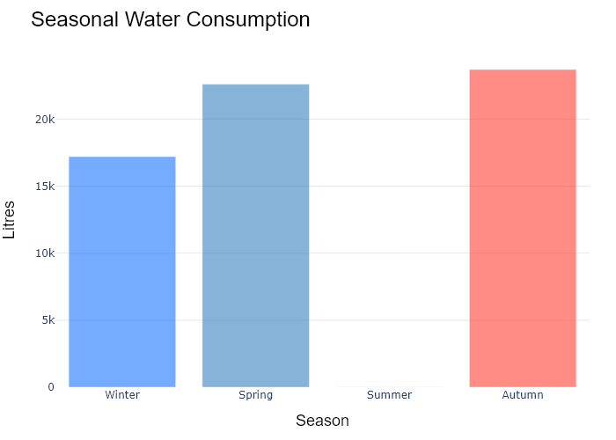

## Performance Metrics

|  |  |  |  |
| --- | --- | --- | --- |
| Task | Model Used | Description | Time Taken (s) |
| Processing Image to JSON | Gemini Vision Pro (default) | Time taken to convert the uploaded image to JSON format | 17.26 |
| Updating JSON | ChatGPT 3.5 (Default) | Time taken to update the JSON with new data | 0.00 |
| Plotting Updated JSON | N/A | Time taken to plot the updated JSON | 0.17 |

# Test Run



Figure: Charts\Comparison\jpg\categorical_scatter_plot.jpg

## Prompt Used

## Task: Extract Detailed Information from a Given Graph Image  
  
You will analyze a graph image and generate corresponding Plotly-compatible JSON files (`data.json`, `layout.json`, and `config.json`). Follow the structured steps and specific XML-like delimiters for each JSON section as outlined below.  
  
### Instructions:  
  
#### Graph Analysis:  
  
1. **Identify and Categorize Plot Types**:  
 - Recognize and categorize the plot types present in the graph image. Include both simple and complex plots, listed below:  
 - **Comparison Charts**:  
 - `bar`: Bar Chart  
 - `bar` (with vertical bars): Column Chart  
 - `bar` (grouped): Grouped Bar/Column Chart  
 - `scatter` (with lines connecting to points): Lollipop Chart  
 - `indicator` (with gauge): Bullet Chart  
 - `scatter`: Dot Plot  
 - `scatter` (with lines connecting different points): Dumbbell Chart  
 - `scatter` (or custom SVG): Pictogram  
 - `scatter` or `bar` with a range: Range Chart  
 - `barpolar`: Radial Bar Chart  
 - `parcoords`: Parallel Coordinates  
 - `scatterpolar`: Radar Chart  
 - `barpolar` (with segments): Nightingale Chart  
 - `waterfall`: Waterfall Chart  
 - `heatmap` (with color scale): Matrix Chart  
 - `various charts in small multiples`: Small Multiples  
 - `text` (frequency-based size): Word Cloud  
 - `scatter` (with lines indicating change): Slope Chart  
 - `table`: Table Chart  
 - `scatter`: Categorical Scatter Plot  
 - `scatter` (with four quadrants): Quadrant Chart  
 - **Correlation Charts**:  
 - `heatmap`: Heatmap  
 - `scatter` (with size): Bubble Chart  
 - `scatter`: Scatter Plot  
 - `scatter` (with lines connecting points): Connected Scatter Plot  
 - `hexbin`: Hexagonal Binning  
 - `contour`: Contour Plot  
 - **Part-to-Whole & Hierarchical Charts**:  
 - `bar` (stacked): Stacked Bar/Column Chart  
 - `bar` (with diverging sections): Diverging Bar Chart  
 - `bar` (mirrored pairs): Population Pyramid  
 - `scatter` (or custom symbols in a grid): Icon Array  
 - `waffle`: Waffle Chart  
 - `pie`: Pie Chart  
 - `pie` (with hole): Donut Chart  
 - `pie` (half-circle): Semi-circle Donut Chart  
 - `bar` (variable width): Marimekko Chart  
 - `treemap`: Treemap  
 - `treemap` (circular): Circular Treemap  
 - `treemap` (convex shape): Convex Treemap  
 - `sunburst`: Sunburst Chart  
 - `funnel` or `pyramid`: Funnel & Pyramid Chart  
 - `dendrogram`: Dendrogram  
 - `venn`: Venn Diagram  
 - `euler`: Euler Diagram  
 - `indicator` (circular gauge): Circular Gauge  
 - **Data Over Time (Temporal) Charts**:  
 - `scatter` (filled area under curve): Area Chart  
 - `scatter` (filled stacked areas): Stacked Area Chart  
 - `scatter` (smoothed filled areas): Stream Graph  
 - `scatter` (indicating ranking change): Bump Chart  
 - `scatter` (with filled area): Bump Area Chart  
 - `scatter`: Line Chart  
 - `scatter` (with smoothed lines): Spline Chart  
 - `scatter` (with stepped lines): Step Line Chart  
 - `candlestick`: Candlestick Chart  
 - `gantt`: Gantt Chart  
 - `scatter` (encoded lines): Barcode Chart  
 - `ohlc`: OHLC Chart  
 - **Distribution Charts**:  
 - `densitymapbox` or `histogram`: Density Plot  
 - `ridge`: Ridgeline Plot  
 - `horizon`: Horizon Chart  
 - `histogram`: Histogram  
 - `radial_histogram`: Radial Histogram  
 - `scatter` (with distribution): Strip Plot  
 - `scatter` (with jitter): Jitter Plot  
 - `heatmap`: One-dimensional Heatmap  
 - `scatter` (with tightly packed points): Beeswarm Chart  
 - `box`: Box Chart  
 - `violin`: Violin Plot  
 - **Geospatial & Other Charts**:  
 - `densitymapbox`: Geographic Heatmap  
 - `choropleth`: Choropleth Map  
 - `scattermapbox`: Tile Map  
 - `chord`: Chord Diagram  
 - `arc`: Arc Diagram  
 - `sankey`: Sankey  
 - `network`: Network Diagram  
 - `flowchart`: Flowchart  
  
2. **Extract Data Points** for Each Plot Type:  
 - Gather the data points for each identified plot type.  
 - For `scatter`, `line`, and `area` plots: Extract `x` and `y` values.  
 - For `bar` and `stacked bar` plots: Extract `x` (categories) and `y` values.  
 - For `pie` charts: Extract `labels` and `values`.  
 - For `scatter3d`, `surface`, and other 3D plots: Extract `x`, `y`, and `z` values.  
  
3. **Identify Multiple Plots** on the Same Figure:  
 - Note any combinations or overlays of multiple plot types on the same figure and their configurations, such as stacked plots or multiple area fills.  
  
#### Generate JSON and CSV Outputs:  
  
Follow the JSON formatting guidelines and wrap each section in the specified XML-like tags.  
  
1. **Generate `data.json`**:  
 - Include detailed information for each plot type:  
 - `type`: Specify the plot type (e.g., `"scatter"`, `"bar"`, `"pie"`, `"area"`, `"scatter3d"`, `"surface"`).  
 - For area charts, use `"type": "scatter"` and specify `"fill"`.  
 - `x`, `y`, and `z` (if applicable): Arrays of data points for each axis.  
 - `labels` and `values` for pie charts.  
 - `mode`: Specify for line and scatter plots (e.g., `"markers"`, `"lines"`, `"markers+lines"`).  
 - `name`: Legend entry for the plot.  
 - `marker`: Properties such as color, size, and symbol.  
 - `line`: Properties such as color, width, and dash style.  
 - `text`: Hover text for each data point.  
 - `hoverinfo`: Information displayed on hover (e.g., `"x+y+text"`).  
 - `fill`: For area charts, specify the fill (e.g., `"tozeroy"`, `"tonexty"`).  
 - `fillcolor`: The color used to fill the area.  
 - `stackgroup`: For stacked bar charts, specify the stacking group.  
  
2. **Generate `layout.json`**:  
 - Define the layout properties:  
 - `title`: Text and font properties for the graph title.  
 - `xaxis` and `yaxis`: Configuration for axis titles, ranges, grids, and ticks.  
 - `zaxis`: Configuration for 3D plots including title, range, and grid.  
 - `legend`: Properties for legend orientation and positioning.  
 - `margin`: Margins for left, right, bottom, top, and padding.  
 - `plot_bgcolor` and `paper_bgcolor`: Background colors.  
 - `scene`: Configuration for 3D scenes, including camera angles and aspect ratio.  
  
3. **Generate `config.json`**:  
 - Include settings such as:  
 - `responsive`: Whether the graph is responsive.  
 - `displayModeBar`: Whether the mode bar is shown.  
 - `modeBarButtonsToRemove`: List of mode bar buttons to remove.  
 - `scrollZoom`: Whether scrolling zoom is enabled.  
  
4. **Generate `<csv>`**:  
 - Format the CSV data as follows:  
 ```csv  
 x,y  
 1,4  
 2,5  
 3,6  
 ```  
 - Replace `x`, `y`, `1`, `4`, `2`, `5`, and `3`, `6` with the actual data from the graph image.  
  
### Output Format:  
  
Wrap each JSON output in the specified XML-like tags:  
  
- `<data> ... </data>`  
- `<layout> ... </layout>`  
- `<config> ... </config>`  
- `<csv> ... </csv>`  
  
Ensure the JSON format follows these rules:  
- Use double quotes for all keys and string values.  
- Do not include trailing commas in arrays or objects.  
  
### Example Output:  
  
```xml  
<data>  
[  
 {  
 "type": "scatter",  
 "x": [1, 2, 3],  
 "y": [4, 5, 6],  
 "mode": "markers+lines",  
 "name": "Line Plot",  
 "marker": {  
 "color": "rgba(75, 192, 192, 0.6)",  
 "size": 8  
 },  
 "line": {  
 "color": "rgba(75, 192, 192  
  
, 1)",  
 "width": 2  
 }  
 },  
 {  
 "type": "area",  
 "x": [1, 2, 3, 4, 5, 6, 7, 8, 9, 10, 11, 12],  
 "y": [400, 430, 550, 620, 580, 600, 630, 700, 670, 630, 600, 500],  
 "name": "Housing",  
 "marker": {  
 "color": "rgba(255, 159, 64, 0.8)"  
 },  
 "line": {  
 "color": "rgba(255, 159, 64, 1)",  
 "width": 2  
 }  
 },  
 {  
 "type": "bar",  
 "x": ["A", "B", "C"],  
 "y": [10, 15, 13],  
 "name": "Bar Chart",  
 "marker": {  
 "color": "rgba(255, 99, 132, 0.6)"  
 },  
 "hoverinfo": "x+y+text"  
 },  
 {  
 "type": "scatter",  
 "x": [1, 2, 3],  
 "y": [6, 7, 8],  
 "mode": "lines",  
 "fill": "tozeroy",  
 "name": "Area Chart",  
 "line": {  
 "color": "rgba(54, 162, 235, 1)",  
 "width": 2  
 },  
 "fillcolor": "rgba(54, 162, 235, 0.5)"  
 },  
 {  
 "type": "scatter3d",  
 "x": [1, 2, 3],  
 "y": [4, 5, 6],  
 "z": [7, 8, 9],  
 "mode": "markers",  
 "name": "3D Scatter Plot",  
 "marker": {  
 "color": "rgba(255, 159, 64, 0.8)",  
 "size": 5  
 },  
 "hoverinfo": "x+y+z+text"  
 },  
 {  
 "type": "surface",  
 "z": [  
 [10, 10.625, 12.5, 15.625, 20],  
 [5.625, 6.25, 8.125, 11.25, 15.625],  
 [0, 1.25, 3.125, 6.25, 10.625]  
 ],  
 "name": "Surface Plot",  
 "colorscale": "Viridis",  
 "hoverinfo": "z+name"  
 }  
]  
</data>  
<layout>  
{  
 "title": {  
 "text": "Complex Graph Example",  
 "font": {  
 "family": "Arial, sans-serif",  
 "size": 24,  
 "color": "#000000"  
 }  
 },  
 "xaxis": {  
 "title": {  
 "text": "X Axis",  
 "font": {  
 "family": "Arial, sans-serif",  
 "size": 18,  
 "color": "#000000"  
 }  
 },  
 "showgrid": true,  
 "gridcolor": "rgba(0, 0, 0, 0.1)",  
 "zeroline": true,  
 "zerolinecolor": "rgba(0, 0, 0, 0.1)"  
 },  
 "yaxis": {  
 "title": {  
 "text": "Y Axis",  
 "font": {  
 "family": "Arial, sans-serif",  
 "size": 18,  
 "color": "#000000"  
 }  
 },  
 "showgrid": true,  
 "gridcolor": "rgba(0, 0, 0, 0.1)",  
 "zeroline": true,  
 "zerolinecolor": "rgba(0, 0, 0, 0.1)"  
 },  
 "legend": {  
 "orientation": "h",  
 "x": 0.5,  
 "xanchor": "center",  
 "y": -0.2,  
 "font": {  
 "family": "Arial, sans-serif",  
 "size": 12,  
 "color": "#000000"  
 }  
 },  
 "margin": {  
 "l": 60,  
 "r": 30,  
 "b": 60,  
 "t": 60  
 },  
 "plot_bgcolor": "#ffffff",  
 "paper_bgcolor": "#ffffff",  
 "scene": {  
 "xaxis": {"title": "X Axis"},  
 "yaxis": {"title": "Y Axis"},  
 "zaxis": {"title": "Z Axis"}  
 }  
}  
</layout>  
<config>  
{  
 "responsive": true,  
 "displayModeBar": true,  
 "modeBarButtonsToRemove": ["toImage"],  
 "scrollZoom": true  
}  
</config>  
<csv>  
x,y  
1,4  
2,5  
3,6  
</csv>  
```

## Extracted JSON

### data

[  
 {  
 "type": "scatter",  
 "x": [  
 "Couch",  
 "Bed",  
 "Home",  
 "Kitchen",  
 "Office",  
 "Bedroom",  
 "Restaurant/Cafe",  
 "Classroom",  
 "Commuting",  
 "Table"  
 ],  
 "y": [  
 2,  
 2,  
 2,  
 3,  
 3,  
 3,  
 3,  
 0,  
 0,  
 2  
 ],  
 "mode": "markers",  
 "name": "Frequency of Tablet Activities by Top Locations",  
 "marker": {  
 "color": "rgba(158, 192, 229, 0.8)",  
 "size": 12  
 },  
 "text": [  
 "Viewing documents",  
 "Managing finances",  
 "Checking calendar",  
 "Finding, installing apps",  
 "Reading a blog",  
 "Recipe search, cooking",  
 "Local search",  
 "Shopping: Purchasing",  
 "Surfing the Web",  
 "Reading news",  
 "Checking weather",  
 "Lightweight creation",  
 "Watching TV/videos",  
 "Listening to music",  
 "Looking up information",  
 "Social networking",  
 "Playing games",  
 "Email checking"  
 ],  
 "hoverinfo": "text"  
 }  
]

### layout

{  
 "title": {  
 "text": "Frequency of Tablet Activities by Top Locations",  
 "font": {  
 "family": "Arial, sans-serif",  
 "size": 24,  
 "color": "#000000"  
 }  
 },  
 "xaxis": {  
 "title": {  
 "text": "Location",  
 "font": {  
 "family": "Arial, sans-serif",  
 "size": 18,  
 "color": "#000000"  
 }  
 },  
 "showgrid": false,  
 "zeroline": false  
 },  
 "yaxis": {  
 "title": {  
 "text": "Frequency",  
 "font": {  
 "family": "Arial, sans-serif",  
 "size": 18,  
 "color": "#000000"  
 }  
 },  
 "showgrid": false,  
 "zeroline": false  
 },  
 "margin": {  
 "l": 60,  
 "r": 30,  
 "b": 60,  
 "t": 60  
 },  
 "plot_bgcolor": "#ffffff",  
 "paper_bgcolor": "#ffffff"  
}

### config

{  
 "responsive": true,  
 "displayModeBar": true,  
 "modeBarButtonsToRemove": [  
 "toImage"  
 ],  
 "scrollZoom": true  
}

## Updated JSON

### updated_data

[  
 {  
 "type": "scatter",  
 "x": [  
 "Couch",  
 "Bed",  
 "Home",  
 "Kitchen",  
 "Office",  
 "Bedroom",  
 "Restaurant/Cafe",  
 "Classroom",  
 "Commuting",  
 "Table"  
 ],  
 "y": [  
 2,  
 2,  
 2,  
 3,  
 3,  
 3,  
 3,  
 0,  
 0,  
 2  
 ],  
 "mode": "markers",  
 "name": "Frequency of Tablet Activities by Top Locations",  
 "marker": {  
 "color": "rgba(158, 192, 229, 0.8)",  
 "size": 12  
 },  
 "text": [  
 "Viewing documents",  
 "Managing finances",  
 "Checking calendar",  
 "Finding, installing apps",  
 "Reading a blog",  
 "Recipe search, cooking",  
 "Local search",  
 "Shopping: Purchasing",  
 "Surfing the Web",  
 "Reading news",  
 "Checking weather",  
 "Lightweight creation",  
 "Watching TV/videos",  
 "Listening to music",  
 "Looking up information",  
 "Social networking",  
 "Playing games",  
 "Email checking"  
 ],  
 "hoverinfo": "text"  
 }  
]

### updated_layout

{  
 "title": {  
 "text": "Frequency of Tablet Activities by Top Locations",  
 "font": {  
 "family": "Arial, sans-serif",  
 "size": 24,  
 "color": "#000000"  
 }  
 },  
 "xaxis": {  
 "title": {  
 "text": "Location",  
 "font": {  
 "family": "Arial, sans-serif",  
 "size": 18,  
 "color": "#000000"  
 }  
 },  
 "showgrid": false,  
 "zeroline": false  
 },  
 "yaxis": {  
 "title": {  
 "text": "Frequency",  
 "font": {  
 "family": "Arial, sans-serif",  
 "size": 18,  
 "color": "#000000"  
 }  
 },  
 "showgrid": false,  
 "zeroline": false  
 },  
 "margin": {  
 "l": 60,  
 "r": 30,  
 "b": 60,  
 "t": 60  
 },  
 "plot_bgcolor": "#ffffff",  
 "paper_bgcolor": "#ffffff"  
}

### updated_config

{  
 "responsive": true,  
 "displayModeBar": true,  
 "modeBarButtonsToRemove": [  
 "toImage"  
 ],  
 "scrollZoom": true  
}

## Updated Chart

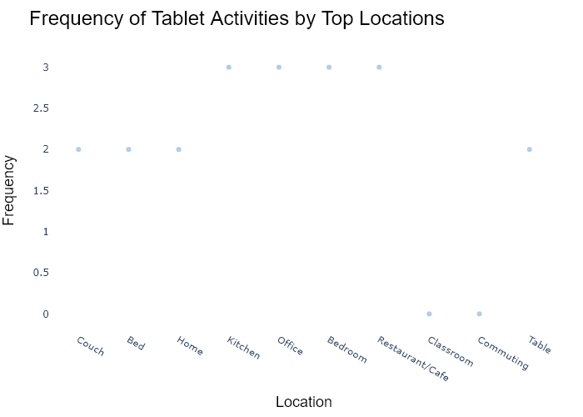

## Performance Metrics

|  |  |  |  |
| --- | --- | --- | --- |
| Task | Model Used | Description | Time Taken (s) |
| Processing Image to JSON | Gemini Vision Pro (default) | Time taken to convert the uploaded image to JSON format | 18.86 |
| Updating JSON | ChatGPT 3.5 (Default) | Time taken to update the JSON with new data | 0.00 |
| Plotting Updated JSON | N/A | Time taken to plot the updated JSON | 0.23 |

# Test Run



Figure: Charts/Comparison/jpg/dot.jpg

## Prompt Used

## Task: Extract Detailed Information from a Given Graph Image  
  
You will analyze a graph image and generate corresponding Plotly-compatible JSON files (`data.json`, `layout.json`, and `config.json`). Follow the structured steps and specific XML-like delimiters for each JSON section as outlined below.  
  
### Instructions:  
  
#### Graph Analysis:  
  
1. **Identify and Categorize Plot Types**:  
 - Recognize and categorize the plot types present in the graph image. Include both simple and complex plots, listed below:  
 - **Comparison Charts**:  
 - `bar`: Bar Chart  
 - `bar` (with vertical bars): Column Chart  
 - `bar` (grouped): Grouped Bar/Column Chart  
 - `scatter` (with lines connecting to points): Lollipop Chart  
 - `indicator` (with gauge): Bullet Chart  
 - `scatter`: Dot Plot  
 - `scatter` (with lines connecting different points): Dumbbell Chart  
 - `scatter` (or custom SVG): Pictogram  
 - `scatter` or `bar` with a range: Range Chart  
 - `barpolar`: Radial Bar Chart  
 - `parcoords`: Parallel Coordinates  
 - `scatterpolar`: Radar Chart  
 - `barpolar` (with segments): Nightingale Chart  
 - `waterfall`: Waterfall Chart  
 - `heatmap` (with color scale): Matrix Chart  
 - `various charts in small multiples`: Small Multiples  
 - `text` (frequency-based size): Word Cloud  
 - `scatter` (with lines indicating change): Slope Chart  
 - `table`: Table Chart  
 - `scatter`: Categorical Scatter Plot  
 - `scatter` (with four quadrants): Quadrant Chart  
 - **Correlation Charts**:  
 - `heatmap`: Heatmap  
 - `scatter` (with size): Bubble Chart  
 - `scatter`: Scatter Plot  
 - `scatter` (with lines connecting points): Connected Scatter Plot  
 - `hexbin`: Hexagonal Binning  
 - `contour`: Contour Plot  
 - **Part-to-Whole & Hierarchical Charts**:  
 - `bar` (stacked): Stacked Bar/Column Chart  
 - `bar` (with diverging sections): Diverging Bar Chart  
 - `bar` (mirrored pairs): Population Pyramid  
 - `scatter` (or custom symbols in a grid): Icon Array  
 - `waffle`: Waffle Chart  
 - `pie`: Pie Chart  
 - `pie` (with hole): Donut Chart  
 - `pie` (half-circle): Semi-circle Donut Chart  
 - `bar` (variable width): Marimekko Chart  
 - `treemap`: Treemap  
 - `treemap` (circular): Circular Treemap  
 - `treemap` (convex shape): Convex Treemap  
 - `sunburst`: Sunburst Chart  
 - `funnel` or `pyramid`: Funnel & Pyramid Chart  
 - `dendrogram`: Dendrogram  
 - `venn`: Venn Diagram  
 - `euler`: Euler Diagram  
 - `indicator` (circular gauge): Circular Gauge  
 - **Data Over Time (Temporal) Charts**:  
 - `scatter` (filled area under curve): Area Chart  
 - `scatter` (filled stacked areas): Stacked Area Chart  
 - `scatter` (smoothed filled areas): Stream Graph  
 - `scatter` (indicating ranking change): Bump Chart  
 - `scatter` (with filled area): Bump Area Chart  
 - `scatter`: Line Chart  
 - `scatter` (with smoothed lines): Spline Chart  
 - `scatter` (with stepped lines): Step Line Chart  
 - `candlestick`: Candlestick Chart  
 - `gantt`: Gantt Chart  
 - `scatter` (encoded lines): Barcode Chart  
 - `ohlc`: OHLC Chart  
 - **Distribution Charts**:  
 - `densitymapbox` or `histogram`: Density Plot  
 - `ridge`: Ridgeline Plot  
 - `horizon`: Horizon Chart  
 - `histogram`: Histogram  
 - `radial_histogram`: Radial Histogram  
 - `scatter` (with distribution): Strip Plot  
 - `scatter` (with jitter): Jitter Plot  
 - `heatmap`: One-dimensional Heatmap  
 - `scatter` (with tightly packed points): Beeswarm Chart  
 - `box`: Box Chart  
 - `violin`: Violin Plot  
 - **Geospatial & Other Charts**:  
 - `densitymapbox`: Geographic Heatmap  
 - `choropleth`: Choropleth Map  
 - `scattermapbox`: Tile Map  
 - `chord`: Chord Diagram  
 - `arc`: Arc Diagram  
 - `sankey`: Sankey  
 - `network`: Network Diagram  
 - `flowchart`: Flowchart  
  
2. **Extract Data Points** for Each Plot Type:  
 - Gather the data points for each identified plot type.  
 - For `scatter`, `line`, and `area` plots: Extract `x` and `y` values.  
 - For `bar` and `stacked bar` plots: Extract `x` (categories) and `y` values.  
 - For `pie` charts: Extract `labels` and `values`.  
 - For `scatter3d`, `surface`, and other 3D plots: Extract `x`, `y`, and `z` values.  
  
3. **Identify Multiple Plots** on the Same Figure:  
 - Note any combinations or overlays of multiple plot types on the same figure and their configurations, such as stacked plots or multiple area fills.  
  
#### Generate JSON and CSV Outputs:  
  
Follow the JSON formatting guidelines and wrap each section in the specified XML-like tags.  
  
1. **Generate `data.json`**:  
 - Include detailed information for each plot type:  
 - `type`: Specify the plot type (e.g., `"scatter"`, `"bar"`, `"pie"`, `"area"`, `"scatter3d"`, `"surface"`).  
 - For area charts, use `"type": "scatter"` and specify `"fill"`.  
 - `x`, `y`, and `z` (if applicable): Arrays of data points for each axis.  
 - `labels` and `values` for pie charts.  
 - `mode`: Specify for line and scatter plots (e.g., `"markers"`, `"lines"`, `"markers+lines"`).  
 - `name`: Legend entry for the plot.  
 - `marker`: Properties such as color, size, and symbol.  
 - `line`: Properties such as color, width, and dash style.  
 - `text`: Hover text for each data point.  
 - `hoverinfo`: Information displayed on hover (e.g., `"x+y+text"`).  
 - `fill`: For area charts, specify the fill (e.g., `"tozeroy"`, `"tonexty"`).  
 - `fillcolor`: The color used to fill the area.  
 - `stackgroup`: For stacked bar charts, specify the stacking group.  
  
2. **Generate `layout.json`**:  
 - Define the layout properties:  
 - `title`: Text and font properties for the graph title.  
 - `xaxis` and `yaxis`: Configuration for axis titles, ranges, grids, and ticks.  
 - `zaxis`: Configuration for 3D plots including title, range, and grid.  
 - `legend`: Properties for legend orientation and positioning.  
 - `margin`: Margins for left, right, bottom, top, and padding.  
 - `plot_bgcolor` and `paper_bgcolor`: Background colors.  
 - `scene`: Configuration for 3D scenes, including camera angles and aspect ratio.  
  
3. **Generate `config.json`**:  
 - Include settings such as:  
 - `responsive`: Whether the graph is responsive.  
 - `displayModeBar`: Whether the mode bar is shown.  
 - `modeBarButtonsToRemove`: List of mode bar buttons to remove.  
 - `scrollZoom`: Whether scrolling zoom is enabled.  
  
4. **Generate `<csv>`**:  
 - Format the CSV data as follows:  
 ```csv  
 x,y  
 1,4  
 2,5  
 3,6  
 ```  
 - Replace `x`, `y`, `1`, `4`, `2`, `5`, and `3`, `6` with the actual data from the graph image.  
  
### Output Format:  
  
Wrap each JSON output in the specified XML-like tags:  
  
- `<data> ... </data>`  
- `<layout> ... </layout>`  
- `<config> ... </config>`  
- `<csv> ... </csv>`  
  
Ensure the JSON format follows these rules:  
- Use double quotes for all keys and string values.  
- Do not include trailing commas in arrays or objects.  
  
### Example Output:  
  
```xml  
<data>  
[  
 {  
 "type": "scatter",  
 "x": [1, 2, 3],  
 "y": [4, 5, 6],  
 "mode": "markers+lines",  
 "name": "Line Plot",  
 "marker": {  
 "color": "rgba(75, 192, 192, 0.6)",  
 "size": 8  
 },  
 "line": {  
 "color": "rgba(75, 192, 192  
  
, 1)",  
 "width": 2  
 }  
 },  
 {  
 "type": "area",  
 "x": [1, 2, 3, 4, 5, 6, 7, 8, 9, 10, 11, 12],  
 "y": [400, 430, 550, 620, 580, 600, 630, 700, 670, 630, 600, 500],  
 "name": "Housing",  
 "marker": {  
 "color": "rgba(255, 159, 64, 0.8)"  
 },  
 "line": {  
 "color": "rgba(255, 159, 64, 1)",  
 "width": 2  
 }  
 },  
 {  
 "type": "bar",  
 "x": ["A", "B", "C"],  
 "y": [10, 15, 13],  
 "name": "Bar Chart",  
 "marker": {  
 "color": "rgba(255, 99, 132, 0.6)"  
 },  
 "hoverinfo": "x+y+text"  
 },  
 {  
 "type": "scatter",  
 "x": [1, 2, 3],  
 "y": [6, 7, 8],  
 "mode": "lines",  
 "fill": "tozeroy",  
 "name": "Area Chart",  
 "line": {  
 "color": "rgba(54, 162, 235, 1)",  
 "width": 2  
 },  
 "fillcolor": "rgba(54, 162, 235, 0.5)"  
 },  
 {  
 "type": "scatter3d",  
 "x": [1, 2, 3],  
 "y": [4, 5, 6],  
 "z": [7, 8, 9],  
 "mode": "markers",  
 "name": "3D Scatter Plot",  
 "marker": {  
 "color": "rgba(255, 159, 64, 0.8)",  
 "size": 5  
 },  
 "hoverinfo": "x+y+z+text"  
 },  
 {  
 "type": "surface",  
 "z": [  
 [10, 10.625, 12.5, 15.625, 20],  
 [5.625, 6.25, 8.125, 11.25, 15.625],  
 [0, 1.25, 3.125, 6.25, 10.625]  
 ],  
 "name": "Surface Plot",  
 "colorscale": "Viridis",  
 "hoverinfo": "z+name"  
 }  
]  
</data>  
<layout>  
{  
 "title": {  
 "text": "Complex Graph Example",  
 "font": {  
 "family": "Arial, sans-serif",  
 "size": 24,  
 "color": "#000000"  
 }  
 },  
 "xaxis": {  
 "title": {  
 "text": "X Axis",  
 "font": {  
 "family": "Arial, sans-serif",  
 "size": 18,  
 "color": "#000000"  
 }  
 },  
 "showgrid": true,  
 "gridcolor": "rgba(0, 0, 0, 0.1)",  
 "zeroline": true,  
 "zerolinecolor": "rgba(0, 0, 0, 0.1)"  
 },  
 "yaxis": {  
 "title": {  
 "text": "Y Axis",  
 "font": {  
 "family": "Arial, sans-serif",  
 "size": 18,  
 "color": "#000000"  
 }  
 },  
 "showgrid": true,  
 "gridcolor": "rgba(0, 0, 0, 0.1)",  
 "zeroline": true,  
 "zerolinecolor": "rgba(0, 0, 0, 0.1)"  
 },  
 "legend": {  
 "orientation": "h",  
 "x": 0.5,  
 "xanchor": "center",  
 "y": -0.2,  
 "font": {  
 "family": "Arial, sans-serif",  
 "size": 12,  
 "color": "#000000"  
 }  
 },  
 "margin": {  
 "l": 60,  
 "r": 30,  
 "b": 60,  
 "t": 60  
 },  
 "plot_bgcolor": "#ffffff",  
 "paper_bgcolor": "#ffffff",  
 "scene": {  
 "xaxis": {"title": "X Axis"},  
 "yaxis": {"title": "Y Axis"},  
 "zaxis": {"title": "Z Axis"}  
 }  
}  
</layout>  
<config>  
{  
 "responsive": true,  
 "displayModeBar": true,  
 "modeBarButtonsToRemove": ["toImage"],  
 "scrollZoom": true  
}  
</config>  
<csv>  
x,y  
1,4  
2,5  
3,6  
</csv>  
```

## Extracted JSON

### data

[  
 {  
 "type": "bar",  
 "x": [  
 "Clefairy",  
 "Clefable",  
 "Togepi",  
 "Togetic",  
 "Snubbull",  
 "Granbull",  
 "Togekiss",  
 "Flab\u00e9b\u00e9",  
 "Floette",  
 "Florges",  
 "Spritzzee",  
 "Aromatisse",  
 "Swirlix",  
 "Slurpuff",  
 "Sylveon",  
 "Xerneas"  
 ],  
 "y": [  
 55,  
 70,  
 40,  
 65,  
 60,  
 120,  
 80,  
 40,  
 50,  
 75,  
 55,  
 70,  
 40,  
 80,  
 65,  
 99  
 ],  
 "name": "Attack",  
 "marker": {  
 "color": "rgba(255, 159, 64, 0.6)"  
 },  
 "hoverinfo": "x+y+text"  
 },  
 {  
 "type": "bar",  
 "x": [  
 "Clefairy",  
 "Clefable",  
 "Togepi",  
 "Togetic",  
 "Snubbull",  
 "Granbull",  
 "Togekiss",  
 "Flab\u00e9b\u00e9",  
 "Floette",  
 "Florges",  
 "Spritzzee",  
 "Aromatisse",  
 "Swirlix",  
 "Slurpuff",  
 "Sylveon",  
 "Xerneas"  
 ],  
 "y": [  
 45,  
 80,  
 35,  
 40,  
 40,  
 75,  
 50,  
 35,  
 40,  
 60,  
 50,  
 80,  
 35,  
 60,  
 65,  
 99  
 ],  
 "name": "Defense",  
 "marker": {  
 "color": "rgba(54, 162, 235, 0.6)"  
 },  
 "hoverinfo": "x+y+text"  
 },  
 {  
 "type": "bar",  
 "x": [  
 "Clefairy",  
 "Clefable",  
 "Togepi",  
 "Togetic",  
 "Snubbull",  
 "Granbull",  
 "Togekiss",  
 "Flab\u00e9b\u00e9",  
 "Floette",  
 "Florges",  
 "Spritzzee",  
 "Aromatisse",  
 "Swirlix",  
 "Slurpuff",  
 "Sylveon",  
 "Xerneas"  
 ],  
 "y": [  
 35,  
 60,  
 45,  
 80,  
 50,  
 50,  
 35,  
 40,  
 35,  
 60,  
 55,  
 40,  
 45,  
 70,  
 65,  
 99  
 ],  
 "name": "Speed",  
 "marker": {  
 "color": "rgba(255, 99, 132, 0.6)"  
 },  
 "hoverinfo": "x+y+text"  
 }  
]

### layout

{  
 "title": {  
 "text": "Xerneas is the fastest fairy Pokemon",  
 "font": {  
 "family": "Arial, sans-serif",  
 "size": 24,  
 "color": "#000000"  
 }  
 },  
 "xaxis": {  
 "title": {  
 "text": "Fairy Pokemon",  
 "font": {  
 "family": "Arial, sans-serif",  
 "size": 18,  
 "color": "#000000"  
 }  
 },  
 "showgrid": true,  
 "gridcolor": "rgba(0, 0, 0, 0.1)",  
 "zeroline": true,  
 "zerolinecolor": "rgba(0, 0, 0, 0.1)"  
 },  
 "yaxis": {  
 "title": {  
 "text": "Attack, Defense and Speed Ratings",  
 "font": {  
 "family": "Arial, sans-serif",  
 "size": 18,  
 "color": "#000000"  
 }  
 },  
 "showgrid": true,  
 "gridcolor": "rgba(0, 0, 0, 0.1)",  
 "zeroline": true,  
 "zerolinecolor": "rgba(0, 0, 0, 0.1)"  
 },  
 "legend": {  
 "orientation": "h",  
 "x": 0.5,  
 "xanchor": "center",  
 "y": -0.2,  
 "font": {  
 "family": "Arial, sans-serif",  
 "size": 12,  
 "color": "#000000"  
 }  
 },  
 "margin": {  
 "l": 60,  
 "r": 30,  
 "b": 60,  
 "t": 60  
 },  
 "plot_bgcolor": "#ffffff",  
 "paper_bgcolor": "#ffffff"  
}

### config

{  
 "responsive": true,  
 "displayModeBar": true,  
 "modeBarButtonsToRemove": [  
 "toImage"  
 ],  
 "scrollZoom": true  
}

## Updated JSON

### updated_data

[  
 {  
 "type": "bar",  
 "x": [  
 "Clefairy",  
 "Clefable",  
 "Togepi",  
 "Togetic",  
 "Snubbull",  
 "Granbull",  
 "Togekiss",  
 "Flab\u00e9b\u00e9",  
 "Floette",  
 "Florges",  
 "Spritzzee",  
 "Aromatisse",  
 "Swirlix",  
 "Slurpuff",  
 "Sylveon",  
 "Xerneas"  
 ],  
 "y": [  
 55,  
 70,  
 40,  
 65,  
 60,  
 120,  
 80,  
 40,  
 50,  
 75,  
 55,  
 70,  
 40,  
 80,  
 65,  
 99  
 ],  
 "name": "Attack",  
 "marker": {  
 "color": "rgba(255, 159, 64, 0.6)"  
 },  
 "hoverinfo": "x+y+text"  
 },  
 {  
 "type": "bar",  
 "x": [  
 "Clefairy",  
 "Clefable",  
 "Togepi",  
 "Togetic",  
 "Snubbull",  
 "Granbull",  
 "Togekiss",  
 "Flab\u00e9b\u00e9",  
 "Floette",  
 "Florges",  
 "Spritzzee",  
 "Aromatisse",  
 "Swirlix",  
 "Slurpuff",  
 "Sylveon",  
 "Xerneas"  
 ],  
 "y": [  
 45,  
 80,  
 35,  
 40,  
 40,  
 75,  
 50,  
 35,  
 40,  
 60,  
 50,  
 80,  
 35,  
 60,  
 65,  
 99  
 ],  
 "name": "Defense",  
 "marker": {  
 "color": "rgba(54, 162, 235, 0.6)"  
 },  
 "hoverinfo": "x+y+text"  
 },  
 {  
 "type": "bar",  
 "x": [  
 "Clefairy",  
 "Clefable",  
 "Togepi",  
 "Togetic",  
 "Snubbull",  
 "Granbull",  
 "Togekiss",  
 "Flab\u00e9b\u00e9",  
 "Floette",  
 "Florges",  
 "Spritzzee",  
 "Aromatisse",  
 "Swirlix",  
 "Slurpuff",  
 "Sylveon",  
 "Xerneas"  
 ],  
 "y": [  
 35,  
 60,  
 45,  
 80,  
 50,  
 50,  
 35,  
 40,  
 35,  
 60,  
 55,  
 40,  
 45,  
 70,  
 65,  
 99  
 ],  
 "name": "Speed",  
 "marker": {  
 "color": "rgba(255, 99, 132, 0.6)"  
 },  
 "hoverinfo": "x+y+text"  
 }  
]

### updated_layout

{  
 "title": {  
 "text": "Xerneas is the fastest fairy Pokemon",  
 "font": {  
 "family": "Arial, sans-serif",  
 "size": 24,  
 "color": "#000000"  
 }  
 },  
 "xaxis": {  
 "title": {  
 "text": "Fairy Pokemon",  
 "font": {  
 "family": "Arial, sans-serif",  
 "size": 18,  
 "color": "#000000"  
 }  
 },  
 "showgrid": true,  
 "gridcolor": "rgba(0, 0, 0, 0.1)",  
 "zeroline": true,  
 "zerolinecolor": "rgba(0, 0, 0, 0.1)"  
 },  
 "yaxis": {  
 "title": {  
 "text": "Attack, Defense and Speed Ratings",  
 "font": {  
 "family": "Arial, sans-serif",  
 "size": 18,  
 "color": "#000000"  
 }  
 },  
 "showgrid": true,  
 "gridcolor": "rgba(0, 0, 0, 0.1)",  
 "zeroline": true,  
 "zerolinecolor": "rgba(0, 0, 0, 0.1)"  
 },  
 "legend": {  
 "orientation": "h",  
 "x": 0.5,  
 "xanchor": "center",  
 "y": -0.2,  
 "font": {  
 "family": "Arial, sans-serif",  
 "size": 12,  
 "color": "#000000"  
 }  
 },  
 "margin": {  
 "l": 60,  
 "r": 30,  
 "b": 60,  
 "t": 60  
 },  
 "plot_bgcolor": "#ffffff",  
 "paper_bgcolor": "#ffffff"  
}

### updated_config

{  
 "responsive": true,  
 "displayModeBar": true,  
 "modeBarButtonsToRemove": [  
 "toImage"  
 ],  
 "scrollZoom": true  
}

## Updated Chart

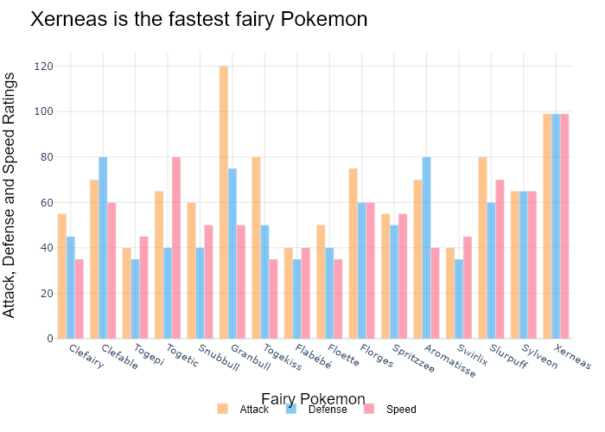

## Performance Metrics

|  |  |  |  |
| --- | --- | --- | --- |
| Task | Model Used | Description | Time Taken (s) |
| Processing Image to JSON | Gemini Vision Pro (default) | Time taken to convert the uploaded image to JSON format | 27.20 |
| Updating JSON | ChatGPT 3.5 (Default) | Time taken to update the JSON with new data | 0.00 |
| Plotting Updated JSON | N/A | Time taken to plot the updated JSON | 0.23 |

# Test Run



Figure: Charts/Comparison/jpg/dumble.jpg

## Prompt Used

## Task: Extract Detailed Information from a Given Graph Image  
  
You will analyze a graph image and generate corresponding Plotly-compatible JSON files (`data.json`, `layout.json`, and `config.json`). Follow the structured steps and specific XML-like delimiters for each JSON section as outlined below.  
  
### Instructions:  
  
#### Graph Analysis:  
  
1. **Identify and Categorize Plot Types**:  
 - Recognize and categorize the plot types present in the graph image. Include both simple and complex plots, listed below:  
 - **Comparison Charts**:  
 - `bar`: Bar Chart  
 - `bar` (with vertical bars): Column Chart  
 - `bar` (grouped): Grouped Bar/Column Chart  
 - `scatter` (with lines connecting to points): Lollipop Chart  
 - `indicator` (with gauge): Bullet Chart  
 - `scatter`: Dot Plot  
 - `scatter` (with lines connecting different points): Dumbbell Chart  
 - `scatter` (or custom SVG): Pictogram  
 - `scatter` or `bar` with a range: Range Chart  
 - `barpolar`: Radial Bar Chart  
 - `parcoords`: Parallel Coordinates  
 - `scatterpolar`: Radar Chart  
 - `barpolar` (with segments): Nightingale Chart  
 - `waterfall`: Waterfall Chart  
 - `heatmap` (with color scale): Matrix Chart  
 - `various charts in small multiples`: Small Multiples  
 - `text` (frequency-based size): Word Cloud  
 - `scatter` (with lines indicating change): Slope Chart  
 - `table`: Table Chart  
 - `scatter`: Categorical Scatter Plot  
 - `scatter` (with four quadrants): Quadrant Chart  
 - **Correlation Charts**:  
 - `heatmap`: Heatmap  
 - `scatter` (with size): Bubble Chart  
 - `scatter`: Scatter Plot  
 - `scatter` (with lines connecting points): Connected Scatter Plot  
 - `hexbin`: Hexagonal Binning  
 - `contour`: Contour Plot  
 - **Part-to-Whole & Hierarchical Charts**:  
 - `bar` (stacked): Stacked Bar/Column Chart  
 - `bar` (with diverging sections): Diverging Bar Chart  
 - `bar` (mirrored pairs): Population Pyramid  
 - `scatter` (or custom symbols in a grid): Icon Array  
 - `waffle`: Waffle Chart  
 - `pie`: Pie Chart  
 - `pie` (with hole): Donut Chart  
 - `pie` (half-circle): Semi-circle Donut Chart  
 - `bar` (variable width): Marimekko Chart  
 - `treemap`: Treemap  
 - `treemap` (circular): Circular Treemap  
 - `treemap` (convex shape): Convex Treemap  
 - `sunburst`: Sunburst Chart  
 - `funnel` or `pyramid`: Funnel & Pyramid Chart  
 - `dendrogram`: Dendrogram  
 - `venn`: Venn Diagram  
 - `euler`: Euler Diagram  
 - `indicator` (circular gauge): Circular Gauge  
 - **Data Over Time (Temporal) Charts**:  
 - `scatter` (filled area under curve): Area Chart  
 - `scatter` (filled stacked areas): Stacked Area Chart  
 - `scatter` (smoothed filled areas): Stream Graph  
 - `scatter` (indicating ranking change): Bump Chart  
 - `scatter` (with filled area): Bump Area Chart  
 - `scatter`: Line Chart  
 - `scatter` (with smoothed lines): Spline Chart  
 - `scatter` (with stepped lines): Step Line Chart  
 - `candlestick`: Candlestick Chart  
 - `gantt`: Gantt Chart  
 - `scatter` (encoded lines): Barcode Chart  
 - `ohlc`: OHLC Chart  
 - **Distribution Charts**:  
 - `densitymapbox` or `histogram`: Density Plot  
 - `ridge`: Ridgeline Plot  
 - `horizon`: Horizon Chart  
 - `histogram`: Histogram  
 - `radial_histogram`: Radial Histogram  
 - `scatter` (with distribution): Strip Plot  
 - `scatter` (with jitter): Jitter Plot  
 - `heatmap`: One-dimensional Heatmap  
 - `scatter` (with tightly packed points): Beeswarm Chart  
 - `box`: Box Chart  
 - `violin`: Violin Plot  
 - **Geospatial & Other Charts**:  
 - `densitymapbox`: Geographic Heatmap  
 - `choropleth`: Choropleth Map  
 - `scattermapbox`: Tile Map  
 - `chord`: Chord Diagram  
 - `arc`: Arc Diagram  
 - `sankey`: Sankey  
 - `network`: Network Diagram  
 - `flowchart`: Flowchart  
  
2. **Extract Data Points** for Each Plot Type:  
 - Gather the data points for each identified plot type.  
 - For `scatter`, `line`, and `area` plots: Extract `x` and `y` values.  
 - For `bar` and `stacked bar` plots: Extract `x` (categories) and `y` values.  
 - For `pie` charts: Extract `labels` and `values`.  
 - For `scatter3d`, `surface`, and other 3D plots: Extract `x`, `y`, and `z` values.  
  
3. **Identify Multiple Plots** on the Same Figure:  
 - Note any combinations or overlays of multiple plot types on the same figure and their configurations, such as stacked plots or multiple area fills.  
  
#### Generate JSON and CSV Outputs:  
  
Follow the JSON formatting guidelines and wrap each section in the specified XML-like tags.  
  
1. **Generate `data.json`**:  
 - Include detailed information for each plot type:  
 - `type`: Specify the plot type (e.g., `"scatter"`, `"bar"`, `"pie"`, `"area"`, `"scatter3d"`, `"surface"`).  
 - For area charts, use `"type": "scatter"` and specify `"fill"`.  
 - `x`, `y`, and `z` (if applicable): Arrays of data points for each axis.  
 - `labels` and `values` for pie charts.  
 - `mode`: Specify for line and scatter plots (e.g., `"markers"`, `"lines"`, `"markers+lines"`).  
 - `name`: Legend entry for the plot.  
 - `marker`: Properties such as color, size, and symbol.  
 - `line`: Properties such as color, width, and dash style.  
 - `text`: Hover text for each data point.  
 - `hoverinfo`: Information displayed on hover (e.g., `"x+y+text"`).  
 - `fill`: For area charts, specify the fill (e.g., `"tozeroy"`, `"tonexty"`).  
 - `fillcolor`: The color used to fill the area.  
 - `stackgroup`: For stacked bar charts, specify the stacking group.  
  
2. **Generate `layout.json`**:  
 - Define the layout properties:  
 - `title`: Text and font properties for the graph title.  
 - `xaxis` and `yaxis`: Configuration for axis titles, ranges, grids, and ticks.  
 - `zaxis`: Configuration for 3D plots including title, range, and grid.  
 - `legend`: Properties for legend orientation and positioning.  
 - `margin`: Margins for left, right, bottom, top, and padding.  
 - `plot_bgcolor` and `paper_bgcolor`: Background colors.  
 - `scene`: Configuration for 3D scenes, including camera angles and aspect ratio.  
  
3. **Generate `config.json`**:  
 - Include settings such as:  
 - `responsive`: Whether the graph is responsive.  
 - `displayModeBar`: Whether the mode bar is shown.  
 - `modeBarButtonsToRemove`: List of mode bar buttons to remove.  
 - `scrollZoom`: Whether scrolling zoom is enabled.  
  
4. **Generate `<csv>`**:  
 - Format the CSV data as follows:  
 ```csv  
 x,y  
 1,4  
 2,5  
 3,6  
 ```  
 - Replace `x`, `y`, `1`, `4`, `2`, `5`, and `3`, `6` with the actual data from the graph image.  
  
### Output Format:  
  
Wrap each JSON output in the specified XML-like tags:  
  
- `<data> ... </data>`  
- `<layout> ... </layout>`  
- `<config> ... </config>`  
- `<csv> ... </csv>`  
  
Ensure the JSON format follows these rules:  
- Use double quotes for all keys and string values.  
- Do not include trailing commas in arrays or objects.  
  
### Example Output:  
  
```xml  
<data>  
[  
 {  
 "type": "scatter",  
 "x": [1, 2, 3],  
 "y": [4, 5, 6],  
 "mode": "markers+lines",  
 "name": "Line Plot",  
 "marker": {  
 "color": "rgba(75, 192, 192, 0.6)",  
 "size": 8  
 },  
 "line": {  
 "color": "rgba(75, 192, 192  
  
, 1)",  
 "width": 2  
 }  
 },  
 {  
 "type": "area",  
 "x": [1, 2, 3, 4, 5, 6, 7, 8, 9, 10, 11, 12],  
 "y": [400, 430, 550, 620, 580, 600, 630, 700, 670, 630, 600, 500],  
 "name": "Housing",  
 "marker": {  
 "color": "rgba(255, 159, 64, 0.8)"  
 },  
 "line": {  
 "color": "rgba(255, 159, 64, 1)",  
 "width": 2  
 }  
 },  
 {  
 "type": "bar",  
 "x": ["A", "B", "C"],  
 "y": [10, 15, 13],  
 "name": "Bar Chart",  
 "marker": {  
 "color": "rgba(255, 99, 132, 0.6)"  
 },  
 "hoverinfo": "x+y+text"  
 },  
 {  
 "type": "scatter",  
 "x": [1, 2, 3],  
 "y": [6, 7, 8],  
 "mode": "lines",  
 "fill": "tozeroy",  
 "name": "Area Chart",  
 "line": {  
 "color": "rgba(54, 162, 235, 1)",  
 "width": 2  
 },  
 "fillcolor": "rgba(54, 162, 235, 0.5)"  
 },  
 {  
 "type": "scatter3d",  
 "x": [1, 2, 3],  
 "y": [4, 5, 6],  
 "z": [7, 8, 9],  
 "mode": "markers",  
 "name": "3D Scatter Plot",  
 "marker": {  
 "color": "rgba(255, 159, 64, 0.8)",  
 "size": 5  
 },  
 "hoverinfo": "x+y+z+text"  
 },  
 {  
 "type": "surface",  
 "z": [  
 [10, 10.625, 12.5, 15.625, 20],  
 [5.625, 6.25, 8.125, 11.25, 15.625],  
 [0, 1.25, 3.125, 6.25, 10.625]  
 ],  
 "name": "Surface Plot",  
 "colorscale": "Viridis",  
 "hoverinfo": "z+name"  
 }  
]  
</data>  
<layout>  
{  
 "title": {  
 "text": "Complex Graph Example",  
 "font": {  
 "family": "Arial, sans-serif",  
 "size": 24,  
 "color": "#000000"  
 }  
 },  
 "xaxis": {  
 "title": {  
 "text": "X Axis",  
 "font": {  
 "family": "Arial, sans-serif",  
 "size": 18,  
 "color": "#000000"  
 }  
 },  
 "showgrid": true,  
 "gridcolor": "rgba(0, 0, 0, 0.1)",  
 "zeroline": true,  
 "zerolinecolor": "rgba(0, 0, 0, 0.1)"  
 },  
 "yaxis": {  
 "title": {  
 "text": "Y Axis",  
 "font": {  
 "family": "Arial, sans-serif",  
 "size": 18,  
 "color": "#000000"  
 }  
 },  
 "showgrid": true,  
 "gridcolor": "rgba(0, 0, 0, 0.1)",  
 "zeroline": true,  
 "zerolinecolor": "rgba(0, 0, 0, 0.1)"  
 },  
 "legend": {  
 "orientation": "h",  
 "x": 0.5,  
 "xanchor": "center",  
 "y": -0.2,  
 "font": {  
 "family": "Arial, sans-serif",  
 "size": 12,  
 "color": "#000000"  
 }  
 },  
 "margin": {  
 "l": 60,  
 "r": 30,  
 "b": 60,  
 "t": 60  
 },  
 "plot_bgcolor": "#ffffff",  
 "paper_bgcolor": "#ffffff",  
 "scene": {  
 "xaxis": {"title": "X Axis"},  
 "yaxis": {"title": "Y Axis"},  
 "zaxis": {"title": "Z Axis"}  
 }  
}  
</layout>  
<config>  
{  
 "responsive": true,  
 "displayModeBar": true,  
 "modeBarButtonsToRemove": ["toImage"],  
 "scrollZoom": true  
}  
</config>  
<csv>  
x,y  
1,4  
2,5  
3,6  
</csv>  
```

## Extracted JSON

### data

[  
 {  
 "type": "bar",  
 "x": [  
 "Sweden",  
 "Korea, Rep.",  
 "Iceland",  
 "Finland",  
 "Norway",  
 "Ireland",  
 "Japan",  
 "Austria",  
 "Germany",  
 "Netherlands",  
 "Belgium",  
 "United Kingdom",  
 "Luxembourg",  
 "Portugal"  
 ],  
 "y": [  
 7500,  
 7300,  
 7200,  
 7000,  
 6800,  
 6500,  
 6300,  
 6200,  
 6100,  
 5900,  
 5800,  
 5700,  
 5600,  
 5500  
 ],  
 "name": "Researchers per million people",  
 "marker": {  
 "color": "rgba(55, 128, 191, 0.6)"  
 },  
 "hoverinfo": "x+y"  
 },  
 {  
 "type": "bar",  
 "x": [  
 "Sweden",  
 "Korea, Rep.",  
 "Iceland",  
 "Finland",  
 "Norway",  
 "Ireland",  
 "Japan",  
 "Austria",  
 "Germany",  
 "Netherlands",  
 "Belgium",  
 "United Kingdom",  
 "Luxembourg",  
 "Portugal"  
 ],  
 "y": [  
 8000,  
 7800,  
 7700,  
 7500,  
 7300,  
 7000,  
 6800,  
 6700,  
 6500,  
 6300,  
 6200,  
 6000,  
 5900,  
 5800  
 ],  
 "name": "Researchers per million people",  
 "marker": {  
 "color": "rgba(255, 127, 14, 0.6)"  
 },  
 "hoverinfo": "x+y"  
 }  
]

### layout

{  
 "title": {  
 "text": "Changes in number of researchers per million people from 2009 to 2016",  
 "font": {  
 "family": "Arial, sans-serif",  
 "size": 24,  
 "color": "#000000"  
 }  
 },  
 "xaxis": {  
 "title": {  
 "text": "Country",  
 "font": {  
 "family": "Arial, sans-serif",  
 "size": 18,  
 "color": "#000000"  
 }  
 },  
 "tickangle": -45,  
 "showgrid": false,  
 "zeroline": false  
 },  
 "yaxis": {  
 "title": {  
 "text": "Researchers per million people",  
 "font": {  
 "family": "Arial, sans-serif",  
 "size": 18,  
 "color": "#000000"  
 }  
 },  
 "showgrid": true,  
 "gridcolor": "rgba(0, 0, 0, 0.1)",  
 "zeroline": true,  
 "zerolinecolor": "rgba(0, 0, 0, 0.1)"  
 },  
 "legend": {  
 "orientation": "h",  
 "x": 0.5,  
 "xanchor": "center",  
 "y": -0.2,  
 "font": {  
 "family": "Arial, sans-serif",  
 "size": 12,  
 "color": "#000000"  
 }  
 },  
 "margin": {  
 "l": 60,  
 "r": 30,  
 "b": 60,  
 "t": 60  
 },  
 "plot_bgcolor": "#ffffff",  
 "paper_bgcolor": "#ffffff"  
}

### config

{  
 "responsive": true,  
 "displayModeBar": true,  
 "modeBarButtonsToRemove": [  
 "toImage"  
 ],  
 "scrollZoom": true  
}

## Updated JSON

### updated_data

[  
 {  
 "type": "bar",  
 "x": [  
 "Sweden",  
 "Korea, Rep.",  
 "Iceland",  
 "Finland",  
 "Norway",  
 "Ireland",  
 "Japan",  
 "Austria",  
 "Germany",  
 "Netherlands",  
 "Belgium",  
 "United Kingdom",  
 "Luxembourg",  
 "Portugal"  
 ],  
 "y": [  
 7500,  
 7300,  
 7200,  
 7000,  
 6800,  
 6500,  
 6300,  
 6200,  
 6100,  
 5900,  
 5800,  
 5700,  
 5600,  
 5500  
 ],  
 "name": "Researchers per million people",  
 "marker": {  
 "color": "rgba(55, 128, 191, 0.6)"  
 },  
 "hoverinfo": "x+y"  
 },  
 {  
 "type": "bar",  
 "x": [  
 "Sweden",  
 "Korea, Rep.",  
 "Iceland",  
 "Finland",  
 "Norway",  
 "Ireland",  
 "Japan",  
 "Austria",  
 "Germany",  
 "Netherlands",  
 "Belgium",  
 "United Kingdom",  
 "Luxembourg",  
 "Portugal"  
 ],  
 "y": [  
 8000,  
 7800,  
 7700,  
 7500,  
 7300,  
 7000,  
 6800,  
 6700,  
 6500,  
 6300,  
 6200,  
 6000,  
 5900,  
 5800  
 ],  
 "name": "Researchers per million people",  
 "marker": {  
 "color": "rgba(255, 127, 14, 0.6)"  
 },  
 "hoverinfo": "x+y"  
 }  
]

### updated_layout

{  
 "title": {  
 "text": "Changes in number of researchers per million people from 2009 to 2016",  
 "font": {  
 "family": "Arial, sans-serif",  
 "size": 24,  
 "color": "#000000"  
 }  
 },  
 "xaxis": {  
 "title": {  
 "text": "Country",  
 "font": {  
 "family": "Arial, sans-serif",  
 "size": 18,  
 "color": "#000000"  
 }  
 },  
 "tickangle": -45,  
 "showgrid": false,  
 "zeroline": false  
 },  
 "yaxis": {  
 "title": {  
 "text": "Researchers per million people",  
 "font": {  
 "family": "Arial, sans-serif",  
 "size": 18,  
 "color": "#000000"  
 }  
 },  
 "showgrid": true,  
 "gridcolor": "rgba(0, 0, 0, 0.1)",  
 "zeroline": true,  
 "zerolinecolor": "rgba(0, 0, 0, 0.1)"  
 },  
 "legend": {  
 "orientation": "h",  
 "x": 0.5,  
 "xanchor": "center",  
 "y": -0.2,  
 "font": {  
 "family": "Arial, sans-serif",  
 "size": 12,  
 "color": "#000000"  
 }  
 },  
 "margin": {  
 "l": 60,  
 "r": 30,  
 "b": 60,  
 "t": 60  
 },  
 "plot_bgcolor": "#ffffff",  
 "paper_bgcolor": "#ffffff"  
}

### updated_config

{  
 "responsive": true,  
 "displayModeBar": true,  
 "modeBarButtonsToRemove": [  
 "toImage"  
 ],  
 "scrollZoom": true  
}

## Updated Chart

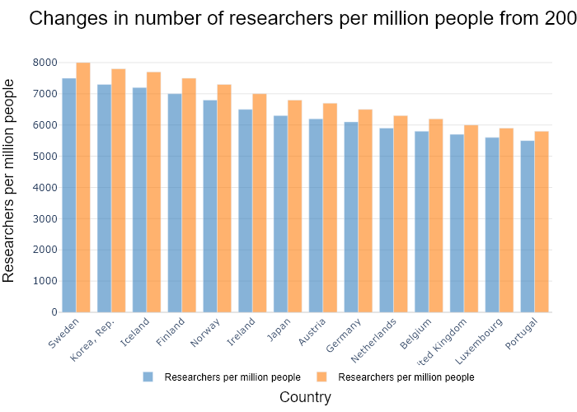

## Performance Metrics

|  |  |  |  |
| --- | --- | --- | --- |
| Task | Model Used | Description | Time Taken (s) |
| Processing Image to JSON | Gemini Vision Pro (default) | Time taken to convert the uploaded image to JSON format | 22.71 |
| Updating JSON | ChatGPT 3.5 (Default) | Time taken to update the JSON with new data | 0.00 |
| Plotting Updated JSON | N/A | Time taken to plot the updated JSON | 0.22 |

# Test Run

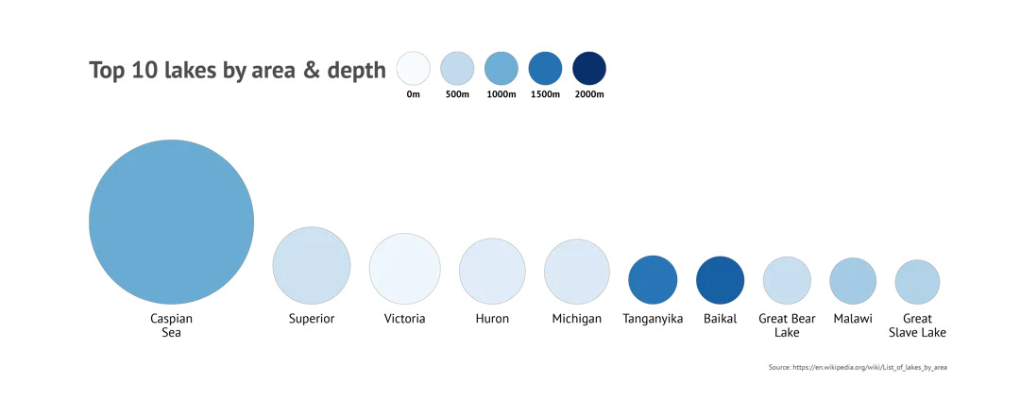

Figure: Charts/Comparison/jpg/icon.jpg

## Prompt Used

## Task: Extract Detailed Information from a Given Graph Image  
  
You will analyze a graph image and generate corresponding Plotly-compatible JSON files (`data.json`, `layout.json`, and `config.json`). Follow the structured steps and specific XML-like delimiters for each JSON section as outlined below.  
  
### Instructions:  
  
#### Graph Analysis:  
  
1. **Identify and Categorize Plot Types**:  
 - Recognize and categorize the plot types present in the graph image. Include both simple and complex plots, listed below:  
 - **Comparison Charts**:  
 - `bar`: Bar Chart  
 - `bar` (with vertical bars): Column Chart  
 - `bar` (grouped): Grouped Bar/Column Chart  
 - `scatter` (with lines connecting to points): Lollipop Chart  
 - `indicator` (with gauge): Bullet Chart  
 - `scatter`: Dot Plot  
 - `scatter` (with lines connecting different points): Dumbbell Chart  
 - `scatter` (or custom SVG): Pictogram  
 - `scatter` or `bar` with a range: Range Chart  
 - `barpolar`: Radial Bar Chart  
 - `parcoords`: Parallel Coordinates  
 - `scatterpolar`: Radar Chart  
 - `barpolar` (with segments): Nightingale Chart  
 - `waterfall`: Waterfall Chart  
 - `heatmap` (with color scale): Matrix Chart  
 - `various charts in small multiples`: Small Multiples  
 - `text` (frequency-based size): Word Cloud  
 - `scatter` (with lines indicating change): Slope Chart  
 - `table`: Table Chart  
 - `scatter`: Categorical Scatter Plot  
 - `scatter` (with four quadrants): Quadrant Chart  
 - **Correlation Charts**:  
 - `heatmap`: Heatmap  
 - `scatter` (with size): Bubble Chart  
 - `scatter`: Scatter Plot  
 - `scatter` (with lines connecting points): Connected Scatter Plot  
 - `hexbin`: Hexagonal Binning  
 - `contour`: Contour Plot  
 - **Part-to-Whole & Hierarchical Charts**:  
 - `bar` (stacked): Stacked Bar/Column Chart  
 - `bar` (with diverging sections): Diverging Bar Chart  
 - `bar` (mirrored pairs): Population Pyramid  
 - `scatter` (or custom symbols in a grid): Icon Array  
 - `waffle`: Waffle Chart  
 - `pie`: Pie Chart  
 - `pie` (with hole): Donut Chart  
 - `pie` (half-circle): Semi-circle Donut Chart  
 - `bar` (variable width): Marimekko Chart  
 - `treemap`: Treemap  
 - `treemap` (circular): Circular Treemap  
 - `treemap` (convex shape): Convex Treemap  
 - `sunburst`: Sunburst Chart  
 - `funnel` or `pyramid`: Funnel & Pyramid Chart  
 - `dendrogram`: Dendrogram  
 - `venn`: Venn Diagram  
 - `euler`: Euler Diagram  
 - `indicator` (circular gauge): Circular Gauge  
 - **Data Over Time (Temporal) Charts**:  
 - `scatter` (filled area under curve): Area Chart  
 - `scatter` (filled stacked areas): Stacked Area Chart  
 - `scatter` (smoothed filled areas): Stream Graph  
 - `scatter` (indicating ranking change): Bump Chart  
 - `scatter` (with filled area): Bump Area Chart  
 - `scatter`: Line Chart  
 - `scatter` (with smoothed lines): Spline Chart  
 - `scatter` (with stepped lines): Step Line Chart  
 - `candlestick`: Candlestick Chart  
 - `gantt`: Gantt Chart  
 - `scatter` (encoded lines): Barcode Chart  
 - `ohlc`: OHLC Chart  
 - **Distribution Charts**:  
 - `densitymapbox` or `histogram`: Density Plot  
 - `ridge`: Ridgeline Plot  
 - `horizon`: Horizon Chart  
 - `histogram`: Histogram  
 - `radial_histogram`: Radial Histogram  
 - `scatter` (with distribution): Strip Plot  
 - `scatter` (with jitter): Jitter Plot  
 - `heatmap`: One-dimensional Heatmap  
 - `scatter` (with tightly packed points): Beeswarm Chart  
 - `box`: Box Chart  
 - `violin`: Violin Plot  
 - **Geospatial & Other Charts**:  
 - `densitymapbox`: Geographic Heatmap  
 - `choropleth`: Choropleth Map  
 - `scattermapbox`: Tile Map  
 - `chord`: Chord Diagram  
 - `arc`: Arc Diagram  
 - `sankey`: Sankey  
 - `network`: Network Diagram  
 - `flowchart`: Flowchart  
  
2. **Extract Data Points** for Each Plot Type:  
 - Gather the data points for each identified plot type.  
 - For `scatter`, `line`, and `area` plots: Extract `x` and `y` values.  
 - For `bar` and `stacked bar` plots: Extract `x` (categories) and `y` values.  
 - For `pie` charts: Extract `labels` and `values`.  
 - For `scatter3d`, `surface`, and other 3D plots: Extract `x`, `y`, and `z` values.  
  
3. **Identify Multiple Plots** on the Same Figure:  
 - Note any combinations or overlays of multiple plot types on the same figure and their configurations, such as stacked plots or multiple area fills.  
  
#### Generate JSON and CSV Outputs:  
  
Follow the JSON formatting guidelines and wrap each section in the specified XML-like tags.  
  
1. **Generate `data.json`**:  
 - Include detailed information for each plot type:  
 - `type`: Specify the plot type (e.g., `"scatter"`, `"bar"`, `"pie"`, `"area"`, `"scatter3d"`, `"surface"`).  
 - For area charts, use `"type": "scatter"` and specify `"fill"`.  
 - `x`, `y`, and `z` (if applicable): Arrays of data points for each axis.  
 - `labels` and `values` for pie charts.  
 - `mode`: Specify for line and scatter plots (e.g., `"markers"`, `"lines"`, `"markers+lines"`).  
 - `name`: Legend entry for the plot.  
 - `marker`: Properties such as color, size, and symbol.  
 - `line`: Properties such as color, width, and dash style.  
 - `text`: Hover text for each data point.  
 - `hoverinfo`: Information displayed on hover (e.g., `"x+y+text"`).  
 - `fill`: For area charts, specify the fill (e.g., `"tozeroy"`, `"tonexty"`).  
 - `fillcolor`: The color used to fill the area.  
 - `stackgroup`: For stacked bar charts, specify the stacking group.  
  
2. **Generate `layout.json`**:  
 - Define the layout properties:  
 - `title`: Text and font properties for the graph title.  
 - `xaxis` and `yaxis`: Configuration for axis titles, ranges, grids, and ticks.  
 - `zaxis`: Configuration for 3D plots including title, range, and grid.  
 - `legend`: Properties for legend orientation and positioning.  
 - `margin`: Margins for left, right, bottom, top, and padding.  
 - `plot_bgcolor` and `paper_bgcolor`: Background colors.  
 - `scene`: Configuration for 3D scenes, including camera angles and aspect ratio.  
  
3. **Generate `config.json`**:  
 - Include settings such as:  
 - `responsive`: Whether the graph is responsive.  
 - `displayModeBar`: Whether the mode bar is shown.  
 - `modeBarButtonsToRemove`: List of mode bar buttons to remove.  
 - `scrollZoom`: Whether scrolling zoom is enabled.  
  
4. **Generate `<csv>`**:  
 - Format the CSV data as follows:  
 ```csv  
 x,y  
 1,4  
 2,5  
 3,6  
 ```  
 - Replace `x`, `y`, `1`, `4`, `2`, `5`, and `3`, `6` with the actual data from the graph image.  
  
### Output Format:  
  
Wrap each JSON output in the specified XML-like tags:  
  
- `<data> ... </data>`  
- `<layout> ... </layout>`  
- `<config> ... </config>`  
- `<csv> ... </csv>`  
  
Ensure the JSON format follows these rules:  
- Use double quotes for all keys and string values.  
- Do not include trailing commas in arrays or objects.  
  
### Example Output:  
  
```xml  
<data>  
[  
 {  
 "type": "scatter",  
 "x": [1, 2, 3],  
 "y": [4, 5, 6],  
 "mode": "markers+lines",  
 "name": "Line Plot",  
 "marker": {  
 "color": "rgba(75, 192, 192, 0.6)",  
 "size": 8  
 },  
 "line": {  
 "color": "rgba(75, 192, 192  
  
, 1)",  
 "width": 2  
 }  
 },  
 {  
 "type": "area",  
 "x": [1, 2, 3, 4, 5, 6, 7, 8, 9, 10, 11, 12],  
 "y": [400, 430, 550, 620, 580, 600, 630, 700, 670, 630, 600, 500],  
 "name": "Housing",  
 "marker": {  
 "color": "rgba(255, 159, 64, 0.8)"  
 },  
 "line": {  
 "color": "rgba(255, 159, 64, 1)",  
 "width": 2  
 }  
 },  
 {  
 "type": "bar",  
 "x": ["A", "B", "C"],  
 "y": [10, 15, 13],  
 "name": "Bar Chart",  
 "marker": {  
 "color": "rgba(255, 99, 132, 0.6)"  
 },  
 "hoverinfo": "x+y+text"  
 },  
 {  
 "type": "scatter",  
 "x": [1, 2, 3],  
 "y": [6, 7, 8],  
 "mode": "lines",  
 "fill": "tozeroy",  
 "name": "Area Chart",  
 "line": {  
 "color": "rgba(54, 162, 235, 1)",  
 "width": 2  
 },  
 "fillcolor": "rgba(54, 162, 235, 0.5)"  
 },  
 {  
 "type": "scatter3d",  
 "x": [1, 2, 3],  
 "y": [4, 5, 6],  
 "z": [7, 8, 9],  
 "mode": "markers",  
 "name": "3D Scatter Plot",  
 "marker": {  
 "color": "rgba(255, 159, 64, 0.8)",  
 "size": 5  
 },  
 "hoverinfo": "x+y+z+text"  
 },  
 {  
 "type": "surface",  
 "z": [  
 [10, 10.625, 12.5, 15.625, 20],  
 [5.625, 6.25, 8.125, 11.25, 15.625],  
 [0, 1.25, 3.125, 6.25, 10.625]  
 ],  
 "name": "Surface Plot",  
 "colorscale": "Viridis",  
 "hoverinfo": "z+name"  
 }  
]  
</data>  
<layout>  
{  
 "title": {  
 "text": "Complex Graph Example",  
 "font": {  
 "family": "Arial, sans-serif",  
 "size": 24,  
 "color": "#000000"  
 }  
 },  
 "xaxis": {  
 "title": {  
 "text": "X Axis",  
 "font": {  
 "family": "Arial, sans-serif",  
 "size": 18,  
 "color": "#000000"  
 }  
 },  
 "showgrid": true,  
 "gridcolor": "rgba(0, 0, 0, 0.1)",  
 "zeroline": true,  
 "zerolinecolor": "rgba(0, 0, 0, 0.1)"  
 },  
 "yaxis": {  
 "title": {  
 "text": "Y Axis",  
 "font": {  
 "family": "Arial, sans-serif",  
 "size": 18,  
 "color": "#000000"  
 }  
 },  
 "showgrid": true,  
 "gridcolor": "rgba(0, 0, 0, 0.1)",  
 "zeroline": true,  
 "zerolinecolor": "rgba(0, 0, 0, 0.1)"  
 },  
 "legend": {  
 "orientation": "h",  
 "x": 0.5,  
 "xanchor": "center",  
 "y": -0.2,  
 "font": {  
 "family": "Arial, sans-serif",  
 "size": 12,  
 "color": "#000000"  
 }  
 },  
 "margin": {  
 "l": 60,  
 "r": 30,  
 "b": 60,  
 "t": 60  
 },  
 "plot_bgcolor": "#ffffff",  
 "paper_bgcolor": "#ffffff",  
 "scene": {  
 "xaxis": {"title": "X Axis"},  
 "yaxis": {"title": "Y Axis"},  
 "zaxis": {"title": "Z Axis"}  
 }  
}  
</layout>  
<config>  
{  
 "responsive": true,  
 "displayModeBar": true,  
 "modeBarButtonsToRemove": ["toImage"],  
 "scrollZoom": true  
}  
</config>  
<csv>  
x,y  
1,4  
2,5  
3,6  
</csv>  
```

## Extracted JSON

### data

[  
 {  
 "type": "scatter",  
 "x": [  
 "USA",  
 "China",  
 "India",  
 "Japan",  
 "Russia",  
 "Mexico",  
 "Germany",  
 "UK",  
 "France",  
 "Brazil"  
 ],  
 "y": [  
 19.46,  
 14.12,  
 13.54,  
 6.11,  
 5.95,  
 5.54,  
 4.52,  
 4.49,  
 4.45,  
 4.31  
 ],  
 "mode": "markers",  
 "name": "Top 10 Countries by GDP",  
 "marker": {  
 "color": "rgba(255, 159, 64, 0.8)",  
 "size": 12  
 },  
 "hoverinfo": "x+y+text"  
 }  
]

### layout

{  
 "title": {  
 "text": "Top 10 Countries by GDP",  
 "font": {  
 "family": "Arial, sans-serif",  
 "size": 24,  
 "color": "#000000"  
 }  
 },  
 "xaxis": {  
 "title": {  
 "text": "Country",  
 "font": {  
 "family": "Arial, sans-serif",  
 "size": 18,  
 "color": "#000000"  
 }  
 },  
 "showgrid": false,  
 "zeroline": false  
 },  
 "yaxis": {  
 "title": {  
 "text": "GDP (Trillions of US$)",  
 "font": {  
 "family": "Arial, sans-serif",  
 "size": 18,  
 "color": "#000000"  
 }  
 },  
 "showgrid": false,  
 "zeroline": false  
 },  
 "legend": {  
 "orientation": "h",  
 "x": 0.5,  
 "xanchor": "center",  
 "y": -0.2,  
 "font": {  
 "family": "Arial, sans-serif",  
 "size": 12,  
 "color": "#000000"  
 }  
 },  
 "margin": {  
 "l": 60,  
 "r": 30,  
 "b": 60,  
 "t": 60  
 },  
 "plot_bgcolor": "#ffffff",  
 "paper_bgcolor": "#ffffff"  
}

### config

{  
 "responsive": true,  
 "displayModeBar": true,  
 "modeBarButtonsToRemove": [  
 "toImage"  
 ],  
 "scrollZoom": true  
}

## Updated JSON

### updated_data

[  
 {  
 "type": "scatter",  
 "x": [  
 "USA",  
 "China",  
 "India",  
 "Japan",  
 "Russia",  
 "Mexico",  
 "Germany",  
 "UK",  
 "France",  
 "Brazil"  
 ],  
 "y": [  
 19.46,  
 14.12,  
 13.54,  
 6.11,  
 5.95,  
 5.54,  
 4.52,  
 4.49,  
 4.45,  
 4.31  
 ],  
 "mode": "markers",  
 "name": "Top 10 Countries by GDP",  
 "marker": {  
 "color": "rgba(255, 159, 64, 0.8)",  
 "size": 12  
 },  
 "hoverinfo": "x+y+text"  
 }  
]

### updated_layout

{  
 "title": {  
 "text": "Top 10 Countries by GDP",  
 "font": {  
 "family": "Arial, sans-serif",  
 "size": 24,  
 "color": "#000000"  
 }  
 },  
 "xaxis": {  
 "title": {  
 "text": "Country",  
 "font": {  
 "family": "Arial, sans-serif",  
 "size": 18,  
 "color": "#000000"  
 }  
 },  
 "showgrid": false,  
 "zeroline": false  
 },  
 "yaxis": {  
 "title": {  
 "text": "GDP (Trillions of US$)",  
 "font": {  
 "family": "Arial, sans-serif",  
 "size": 18,  
 "color": "#000000"  
 }  
 },  
 "showgrid": false,  
 "zeroline": false  
 },  
 "legend": {  
 "orientation": "h",  
 "x": 0.5,  
 "xanchor": "center",  
 "y": -0.2,  
 "font": {  
 "family": "Arial, sans-serif",  
 "size": 12,  
 "color": "#000000"  
 }  
 },  
 "margin": {  
 "l": 60,  
 "r": 30,  
 "b": 60,  
 "t": 60  
 },  
 "plot_bgcolor": "#ffffff",  
 "paper_bgcolor": "#ffffff"  
}

### updated_config

{  
 "responsive": true,  
 "displayModeBar": true,  
 "modeBarButtonsToRemove": [  
 "toImage"  
 ],  
 "scrollZoom": true  
}

## Updated Chart

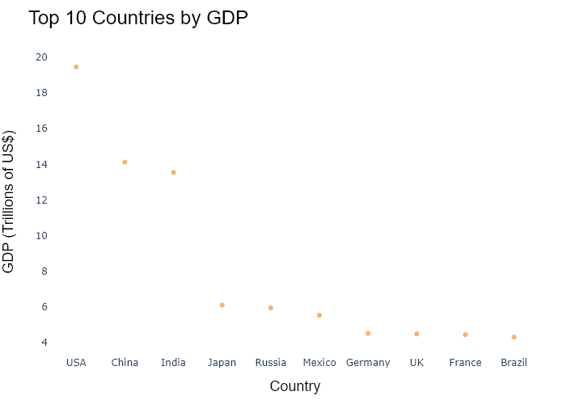

## Performance Metrics

|  |  |  |  |
| --- | --- | --- | --- |
| Task | Model Used | Description | Time Taken (s) |
| Processing Image to JSON | Gemini Vision Pro (default) | Time taken to convert the uploaded image to JSON format | 17.92 |
| Updating JSON | ChatGPT 3.5 (Default) | Time taken to update the JSON with new data | 0.00 |
| Plotting Updated JSON | N/A | Time taken to plot the updated JSON | 0.19 |

# Test Run



Figure: Charts/Comparison/jpg/lattice_chart.jpg

## Prompt Used

## Task: Extract Detailed Information from a Given Graph Image  
  
You will analyze a graph image and generate corresponding Plotly-compatible JSON files (`data.json`, `layout.json`, and `config.json`). Follow the structured steps and specific XML-like delimiters for each JSON section as outlined below.  
  
### Instructions:  
  
#### Graph Analysis:  
  
1. **Identify and Categorize Plot Types**:  
 - Recognize and categorize the plot types present in the graph image. Include both simple and complex plots, listed below:  
 - **Comparison Charts**:  
 - `bar`: Bar Chart  
 - `bar` (with vertical bars): Column Chart  
 - `bar` (grouped): Grouped Bar/Column Chart  
 - `scatter` (with lines connecting to points): Lollipop Chart  
 - `indicator` (with gauge): Bullet Chart  
 - `scatter`: Dot Plot  
 - `scatter` (with lines connecting different points): Dumbbell Chart  
 - `scatter` (or custom SVG): Pictogram  
 - `scatter` or `bar` with a range: Range Chart  
 - `barpolar`: Radial Bar Chart  
 - `parcoords`: Parallel Coordinates  
 - `scatterpolar`: Radar Chart  
 - `barpolar` (with segments): Nightingale Chart  
 - `waterfall`: Waterfall Chart  
 - `heatmap` (with color scale): Matrix Chart  
 - `various charts in small multiples`: Small Multiples  
 - `text` (frequency-based size): Word Cloud  
 - `scatter` (with lines indicating change): Slope Chart  
 - `table`: Table Chart  
 - `scatter`: Categorical Scatter Plot  
 - `scatter` (with four quadrants): Quadrant Chart  
 - **Correlation Charts**:  
 - `heatmap`: Heatmap  
 - `scatter` (with size): Bubble Chart  
 - `scatter`: Scatter Plot  
 - `scatter` (with lines connecting points): Connected Scatter Plot  
 - `hexbin`: Hexagonal Binning  
 - `contour`: Contour Plot  
 - **Part-to-Whole & Hierarchical Charts**:  
 - `bar` (stacked): Stacked Bar/Column Chart  
 - `bar` (with diverging sections): Diverging Bar Chart  
 - `bar` (mirrored pairs): Population Pyramid  
 - `scatter` (or custom symbols in a grid): Icon Array  
 - `waffle`: Waffle Chart  
 - `pie`: Pie Chart  
 - `pie` (with hole): Donut Chart  
 - `pie` (half-circle): Semi-circle Donut Chart  
 - `bar` (variable width): Marimekko Chart  
 - `treemap`: Treemap  
 - `treemap` (circular): Circular Treemap  
 - `treemap` (convex shape): Convex Treemap  
 - `sunburst`: Sunburst Chart  
 - `funnel` or `pyramid`: Funnel & Pyramid Chart  
 - `dendrogram`: Dendrogram  
 - `venn`: Venn Diagram  
 - `euler`: Euler Diagram  
 - `indicator` (circular gauge): Circular Gauge  
 - **Data Over Time (Temporal) Charts**:  
 - `scatter` (filled area under curve): Area Chart  
 - `scatter` (filled stacked areas): Stacked Area Chart  
 - `scatter` (smoothed filled areas): Stream Graph  
 - `scatter` (indicating ranking change): Bump Chart  
 - `scatter` (with filled area): Bump Area Chart  
 - `scatter`: Line Chart  
 - `scatter` (with smoothed lines): Spline Chart  
 - `scatter` (with stepped lines): Step Line Chart  
 - `candlestick`: Candlestick Chart  
 - `gantt`: Gantt Chart  
 - `scatter` (encoded lines): Barcode Chart  
 - `ohlc`: OHLC Chart  
 - **Distribution Charts**:  
 - `densitymapbox` or `histogram`: Density Plot  
 - `ridge`: Ridgeline Plot  
 - `horizon`: Horizon Chart  
 - `histogram`: Histogram  
 - `radial_histogram`: Radial Histogram  
 - `scatter` (with distribution): Strip Plot  
 - `scatter` (with jitter): Jitter Plot  
 - `heatmap`: One-dimensional Heatmap  
 - `scatter` (with tightly packed points): Beeswarm Chart  
 - `box`: Box Chart  
 - `violin`: Violin Plot  
 - **Geospatial & Other Charts**:  
 - `densitymapbox`: Geographic Heatmap  
 - `choropleth`: Choropleth Map  
 - `scattermapbox`: Tile Map  
 - `chord`: Chord Diagram  
 - `arc`: Arc Diagram  
 - `sankey`: Sankey  
 - `network`: Network Diagram  
 - `flowchart`: Flowchart  
  
2. **Extract Data Points** for Each Plot Type:  
 - Gather the data points for each identified plot type.  
 - For `scatter`, `line`, and `area` plots: Extract `x` and `y` values.  
 - For `bar` and `stacked bar` plots: Extract `x` (categories) and `y` values.  
 - For `pie` charts: Extract `labels` and `values`.  
 - For `scatter3d`, `surface`, and other 3D plots: Extract `x`, `y`, and `z` values.  
  
3. **Identify Multiple Plots** on the Same Figure:  
 - Note any combinations or overlays of multiple plot types on the same figure and their configurations, such as stacked plots or multiple area fills.  
  
#### Generate JSON and CSV Outputs:  
  
Follow the JSON formatting guidelines and wrap each section in the specified XML-like tags.  
  
1. **Generate `data.json`**:  
 - Include detailed information for each plot type:  
 - `type`: Specify the plot type (e.g., `"scatter"`, `"bar"`, `"pie"`, `"area"`, `"scatter3d"`, `"surface"`).  
 - For area charts, use `"type": "scatter"` and specify `"fill"`.  
 - `x`, `y`, and `z` (if applicable): Arrays of data points for each axis.  
 - `labels` and `values` for pie charts.  
 - `mode`: Specify for line and scatter plots (e.g., `"markers"`, `"lines"`, `"markers+lines"`).  
 - `name`: Legend entry for the plot.  
 - `marker`: Properties such as color, size, and symbol.  
 - `line`: Properties such as color, width, and dash style.  
 - `text`: Hover text for each data point.  
 - `hoverinfo`: Information displayed on hover (e.g., `"x+y+text"`).  
 - `fill`: For area charts, specify the fill (e.g., `"tozeroy"`, `"tonexty"`).  
 - `fillcolor`: The color used to fill the area.  
 - `stackgroup`: For stacked bar charts, specify the stacking group.  
  
2. **Generate `layout.json`**:  
 - Define the layout properties:  
 - `title`: Text and font properties for the graph title.  
 - `xaxis` and `yaxis`: Configuration for axis titles, ranges, grids, and ticks.  
 - `zaxis`: Configuration for 3D plots including title, range, and grid.  
 - `legend`: Properties for legend orientation and positioning.  
 - `margin`: Margins for left, right, bottom, top, and padding.  
 - `plot_bgcolor` and `paper_bgcolor`: Background colors.  
 - `scene`: Configuration for 3D scenes, including camera angles and aspect ratio.  
  
3. **Generate `config.json`**:  
 - Include settings such as:  
 - `responsive`: Whether the graph is responsive.  
 - `displayModeBar`: Whether the mode bar is shown.  
 - `modeBarButtonsToRemove`: List of mode bar buttons to remove.  
 - `scrollZoom`: Whether scrolling zoom is enabled.  
  
4. **Generate `<csv>`**:  
 - Format the CSV data as follows:  
 ```csv  
 x,y  
 1,4  
 2,5  
 3,6  
 ```  
 - Replace `x`, `y`, `1`, `4`, `2`, `5`, and `3`, `6` with the actual data from the graph image.  
  
### Output Format:  
  
Wrap each JSON output in the specified XML-like tags:  
  
- `<data> ... </data>`  
- `<layout> ... </layout>`  
- `<config> ... </config>`  
- `<csv> ... </csv>`  
  
Ensure the JSON format follows these rules:  
- Use double quotes for all keys and string values.  
- Do not include trailing commas in arrays or objects.  
  
### Example Output:  
  
```xml  
<data>  
[  
 {  
 "type": "scatter",  
 "x": [1, 2, 3],  
 "y": [4, 5, 6],  
 "mode": "markers+lines",  
 "name": "Line Plot",  
 "marker": {  
 "color": "rgba(75, 192, 192, 0.6)",  
 "size": 8  
 },  
 "line": {  
 "color": "rgba(75, 192, 192  
  
, 1)",  
 "width": 2  
 }  
 },  
 {  
 "type": "area",  
 "x": [1, 2, 3, 4, 5, 6, 7, 8, 9, 10, 11, 12],  
 "y": [400, 430, 550, 620, 580, 600, 630, 700, 670, 630, 600, 500],  
 "name": "Housing",  
 "marker": {  
 "color": "rgba(255, 159, 64, 0.8)"  
 },  
 "line": {  
 "color": "rgba(255, 159, 64, 1)",  
 "width": 2  
 }  
 },  
 {  
 "type": "bar",  
 "x": ["A", "B", "C"],  
 "y": [10, 15, 13],  
 "name": "Bar Chart",  
 "marker": {  
 "color": "rgba(255, 99, 132, 0.6)"  
 },  
 "hoverinfo": "x+y+text"  
 },  
 {  
 "type": "scatter",  
 "x": [1, 2, 3],  
 "y": [6, 7, 8],  
 "mode": "lines",  
 "fill": "tozeroy",  
 "name": "Area Chart",  
 "line": {  
 "color": "rgba(54, 162, 235, 1)",  
 "width": 2  
 },  
 "fillcolor": "rgba(54, 162, 235, 0.5)"  
 },  
 {  
 "type": "scatter3d",  
 "x": [1, 2, 3],  
 "y": [4, 5, 6],  
 "z": [7, 8, 9],  
 "mode": "markers",  
 "name": "3D Scatter Plot",  
 "marker": {  
 "color": "rgba(255, 159, 64, 0.8)",  
 "size": 5  
 },  
 "hoverinfo": "x+y+z+text"  
 },  
 {  
 "type": "surface",  
 "z": [  
 [10, 10.625, 12.5, 15.625, 20],  
 [5.625, 6.25, 8.125, 11.25, 15.625],  
 [0, 1.25, 3.125, 6.25, 10.625]  
 ],  
 "name": "Surface Plot",  
 "colorscale": "Viridis",  
 "hoverinfo": "z+name"  
 }  
]  
</data>  
<layout>  
{  
 "title": {  
 "text": "Complex Graph Example",  
 "font": {  
 "family": "Arial, sans-serif",  
 "size": 24,  
 "color": "#000000"  
 }  
 },  
 "xaxis": {  
 "title": {  
 "text": "X Axis",  
 "font": {  
 "family": "Arial, sans-serif",  
 "size": 18,  
 "color": "#000000"  
 }  
 },  
 "showgrid": true,  
 "gridcolor": "rgba(0, 0, 0, 0.1)",  
 "zeroline": true,  
 "zerolinecolor": "rgba(0, 0, 0, 0.1)"  
 },  
 "yaxis": {  
 "title": {  
 "text": "Y Axis",  
 "font": {  
 "family": "Arial, sans-serif",  
 "size": 18,  
 "color": "#000000"  
 }  
 },  
 "showgrid": true,  
 "gridcolor": "rgba(0, 0, 0, 0.1)",  
 "zeroline": true,  
 "zerolinecolor": "rgba(0, 0, 0, 0.1)"  
 },  
 "legend": {  
 "orientation": "h",  
 "x": 0.5,  
 "xanchor": "center",  
 "y": -0.2,  
 "font": {  
 "family": "Arial, sans-serif",  
 "size": 12,  
 "color": "#000000"  
 }  
 },  
 "margin": {  
 "l": 60,  
 "r": 30,  
 "b": 60,  
 "t": 60  
 },  
 "plot_bgcolor": "#ffffff",  
 "paper_bgcolor": "#ffffff",  
 "scene": {  
 "xaxis": {"title": "X Axis"},  
 "yaxis": {"title": "Y Axis"},  
 "zaxis": {"title": "Z Axis"}  
 }  
}  
</layout>  
<config>  
{  
 "responsive": true,  
 "displayModeBar": true,  
 "modeBarButtonsToRemove": ["toImage"],  
 "scrollZoom": true  
}  
</config>  
<csv>  
x,y  
1,4  
2,5  
3,6  
</csv>  
```

## Extracted JSON

### data

[  
 {  
 "type": "bar",  
 "x": [  
 "Argentina",  
 "Australia",  
 "Brazil",  
 "Britain",  
 "Canada",  
 "Chile",  
 "China",  
 "Colombia",  
 "Czech Republic",  
 "Denmark",  
 "Egypt",  
 "Euro area",  
 "Hong Kong",  
 "Hungary",  
 "India",  
 "Indonesia",  
 "Israel",  
 "Japan",  
 "Malaysia",  
 "Mexico",  
 "Netherlands",  
 "New Zealand",  
 "Norway",  
 "Pakistan",  
 "Philippines",  
 "Poland",  
 "Russia",  
 "Saudi Arabia",  
 "Singapore",  
 "South Africa",  
 "South Korea",  
 "Sweden",  
 "Switzerland",  
 "Taiwan",  
 "Thailand",  
 "Turkey",  
 "United States"  
 ],  
 "y": [  
 3.11,  
 4.83,  
 3.03,  
 4.31,  
 4.45,  
 3.29,  
 3.05,  
 2.94,  
 3.57,  
 5.0,  
 2.79,  
 4.22,  
 4.53,  
 3.32,  
 2.77,  
 2.84,  
 4.27,  
 4.18,  
 3.11,  
 3.06,  
 4.25,  
 5.79,  
 2.75,  
 2.81,  
 3.28,  
 3.12,  
 3.58,  
 5.14,  
 2.93,  
 3.95,  
 4.75,  
 5.85,  
 3.64,  
 2.97,  
 3.05,  
 5.08  
 ],  
 "name": "Big Mac Index",  
 "marker": {  
 "color": "rgba(255, 159, 64, 0.6)"  
 },  
 "hoverinfo": "x+y+text"  
 }  
]

### layout

{  
 "title": {  
 "text": "Big Mac Index",  
 "font": {  
 "family": "Arial, sans-serif",  
 "size": 24,  
 "color": "#000000"  
 }  
 },  
 "xaxis": {  
 "title": {  
 "text": "Country",  
 "font": {  
 "family": "Arial, sans-serif",  
 "size": 18,  
 "color": "#000000"  
 }  
 },  
 "showgrid": true,  
 "gridcolor": "rgba(0, 0, 0, 0.1)",  
 "zeroline": true,  
 "zerolinecolor": "rgba(0, 0, 0, 0.1)"  
 },  
 "yaxis": {  
 "title": {  
 "text": "Price",  
 "font": {  
 "family": "Arial, sans-serif",  
 "size": 18,  
 "color": "#000000"  
 }  
 },  
 "showgrid": true,  
 "gridcolor": "rgba(0, 0, 0, 0.1)",  
 "zeroline": true,  
 "zerolinecolor": "rgba(0, 0, 0, 0.1)"  
 },  
 "legend": {  
 "orientation": "h",  
 "x": 0.5,  
 "xanchor": "center",  
 "y": -0.2,  
 "font": {  
 "family": "Arial, sans-serif",  
 "size": 12,  
 "color": "#000000"  
 }  
 },  
 "margin": {  
 "l": 60,  
 "r": 30,  
 "b": 60,  
 "t": 60  
 },  
 "plot_bgcolor": "#ffffff",  
 "paper_bgcolor": "#ffffff"  
}

### config

{  
 "responsive": true,  
 "displayModeBar": true,  
 "modeBarButtonsToRemove": [  
 "toImage"  
 ],  
 "scrollZoom": true  
}

## Updated JSON

### updated_data

[  
 {  
 "type": "bar",  
 "x": [  
 "Argentina",  
 "Australia",  
 "Brazil",  
 "Britain",  
 "Canada",  
 "Chile",  
 "China",  
 "Colombia",  
 "Czech Republic",  
 "Denmark",  
 "Egypt",  
 "Euro area",  
 "Hong Kong",  
 "Hungary",  
 "India",  
 "Indonesia",  
 "Israel",  
 "Japan",  
 "Malaysia",  
 "Mexico",  
 "Netherlands",  
 "New Zealand",  
 "Norway",  
 "Pakistan",  
 "Philippines",  
 "Poland",  
 "Russia",  
 "Saudi Arabia",  
 "Singapore",  
 "South Africa",  
 "South Korea",  
 "Sweden",  
 "Switzerland",  
 "Taiwan",  
 "Thailand",  
 "Turkey",  
 "United States"  
 ],  
 "y": [  
 3.11,  
 4.83,  
 3.03,  
 4.31,  
 4.45,  
 3.29,  
 3.05,  
 2.94,  
 3.57,  
 5.0,  
 2.79,  
 4.22,  
 4.53,  
 3.32,  
 2.77,  
 2.84,  
 4.27,  
 4.18,  
 3.11,  
 3.06,  
 4.25,  
 5.79,  
 2.75,  
 2.81,  
 3.28,  
 3.12,  
 3.58,  
 5.14,  
 2.93,  
 3.95,  
 4.75,  
 5.85,  
 3.64,  
 2.97,  
 3.05,  
 5.08  
 ],  
 "name": "Big Mac Index",  
 "marker": {  
 "color": "rgba(255, 159, 64, 0.6)"  
 },  
 "hoverinfo": "x+y+text"  
 }  
]

### updated_layout

{  
 "title": {  
 "text": "Big Mac Index",  
 "font": {  
 "family": "Arial, sans-serif",  
 "size": 24,  
 "color": "#000000"  
 }  
 },  
 "xaxis": {  
 "title": {  
 "text": "Country",  
 "font": {  
 "family": "Arial, sans-serif",  
 "size": 18,  
 "color": "#000000"  
 }  
 },  
 "showgrid": true,  
 "gridcolor": "rgba(0, 0, 0, 0.1)",  
 "zeroline": true,  
 "zerolinecolor": "rgba(0, 0, 0, 0.1)"  
 },  
 "yaxis": {  
 "title": {  
 "text": "Price",  
 "font": {  
 "family": "Arial, sans-serif",  
 "size": 18,  
 "color": "#000000"  
 }  
 },  
 "showgrid": true,  
 "gridcolor": "rgba(0, 0, 0, 0.1)",  
 "zeroline": true,  
 "zerolinecolor": "rgba(0, 0, 0, 0.1)"  
 },  
 "legend": {  
 "orientation": "h",  
 "x": 0.5,  
 "xanchor": "center",  
 "y": -0.2,  
 "font": {  
 "family": "Arial, sans-serif",  
 "size": 12,  
 "color": "#000000"  
 }  
 },  
 "margin": {  
 "l": 60,  
 "r": 30,  
 "b": 60,  
 "t": 60  
 },  
 "plot_bgcolor": "#ffffff",  
 "paper_bgcolor": "#ffffff"  
}

### updated_config

{  
 "responsive": true,  
 "displayModeBar": true,  
 "modeBarButtonsToRemove": [  
 "toImage"  
 ],  
 "scrollZoom": true  
}

## Updated Chart

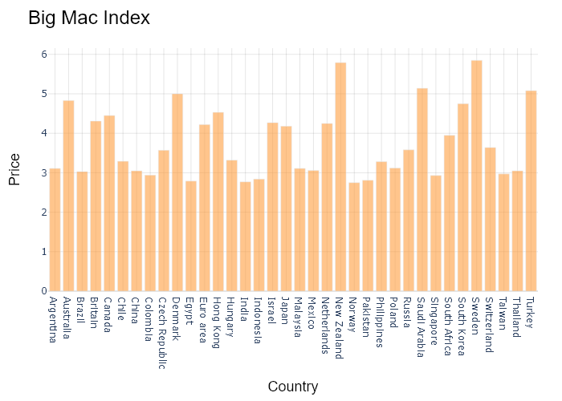

## Performance Metrics

|  |  |  |  |
| --- | --- | --- | --- |
| Task | Model Used | Description | Time Taken (s) |
| Processing Image to JSON | Gemini Vision Pro (default) | Time taken to convert the uploaded image to JSON format | 29.65 |
| Updating JSON | ChatGPT 3.5 (Default) | Time taken to update the JSON with new data | 0.00 |
| Plotting Updated JSON | N/A | Time taken to plot the updated JSON | 0.25 |

# Test Run

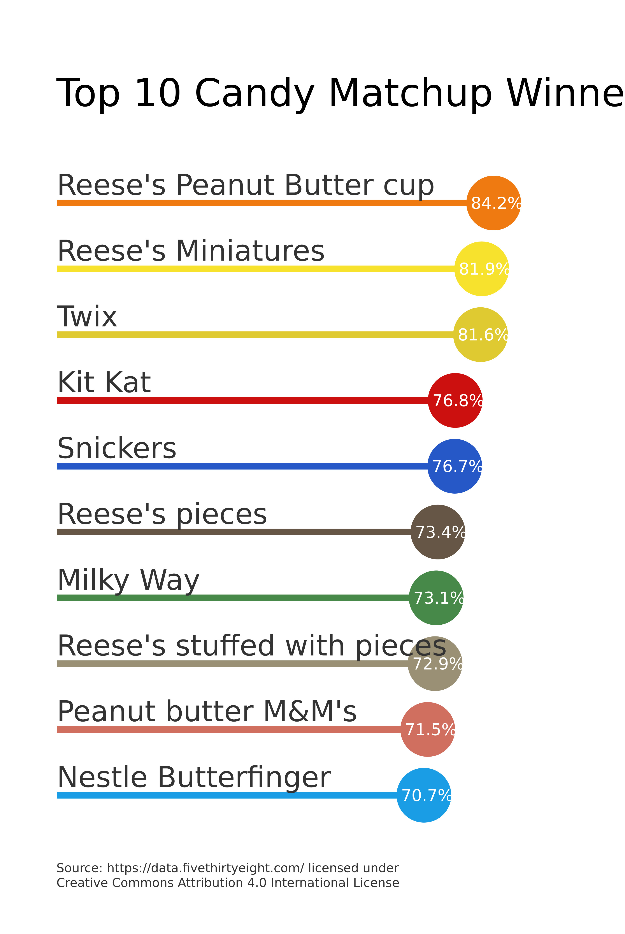

Figure: Charts/Comparison/jpg/lollipop.jpg

## Prompt Used

## Task: Extract Detailed Information from a Given Graph Image  
  
You will analyze a graph image and generate corresponding Plotly-compatible JSON files (`data.json`, `layout.json`, and `config.json`). Follow the structured steps and specific XML-like delimiters for each JSON section as outlined below.  
  
### Instructions:  
  
#### Graph Analysis:  
  
1. **Identify and Categorize Plot Types**:  
 - Recognize and categorize the plot types present in the graph image. Include both simple and complex plots, listed below:  
 - **Comparison Charts**:  
 - `bar`: Bar Chart  
 - `bar` (with vertical bars): Column Chart  
 - `bar` (grouped): Grouped Bar/Column Chart  
 - `scatter` (with lines connecting to points): Lollipop Chart  
 - `indicator` (with gauge): Bullet Chart  
 - `scatter`: Dot Plot  
 - `scatter` (with lines connecting different points): Dumbbell Chart  
 - `scatter` (or custom SVG): Pictogram  
 - `scatter` or `bar` with a range: Range Chart  
 - `barpolar`: Radial Bar Chart  
 - `parcoords`: Parallel Coordinates  
 - `scatterpolar`: Radar Chart  
 - `barpolar` (with segments): Nightingale Chart  
 - `waterfall`: Waterfall Chart  
 - `heatmap` (with color scale): Matrix Chart  
 - `various charts in small multiples`: Small Multiples  
 - `text` (frequency-based size): Word Cloud  
 - `scatter` (with lines indicating change): Slope Chart  
 - `table`: Table Chart  
 - `scatter`: Categorical Scatter Plot  
 - `scatter` (with four quadrants): Quadrant Chart  
 - **Correlation Charts**:  
 - `heatmap`: Heatmap  
 - `scatter` (with size): Bubble Chart  
 - `scatter`: Scatter Plot  
 - `scatter` (with lines connecting points): Connected Scatter Plot  
 - `hexbin`: Hexagonal Binning  
 - `contour`: Contour Plot  
 - **Part-to-Whole & Hierarchical Charts**:  
 - `bar` (stacked): Stacked Bar/Column Chart  
 - `bar` (with diverging sections): Diverging Bar Chart  
 - `bar` (mirrored pairs): Population Pyramid  
 - `scatter` (or custom symbols in a grid): Icon Array  
 - `waffle`: Waffle Chart  
 - `pie`: Pie Chart  
 - `pie` (with hole): Donut Chart  
 - `pie` (half-circle): Semi-circle Donut Chart  
 - `bar` (variable width): Marimekko Chart  
 - `treemap`: Treemap  
 - `treemap` (circular): Circular Treemap  
 - `treemap` (convex shape): Convex Treemap  
 - `sunburst`: Sunburst Chart  
 - `funnel` or `pyramid`: Funnel & Pyramid Chart  
 - `dendrogram`: Dendrogram  
 - `venn`: Venn Diagram  
 - `euler`: Euler Diagram  
 - `indicator` (circular gauge): Circular Gauge  
 - **Data Over Time (Temporal) Charts**:  
 - `scatter` (filled area under curve): Area Chart  
 - `scatter` (filled stacked areas): Stacked Area Chart  
 - `scatter` (smoothed filled areas): Stream Graph  
 - `scatter` (indicating ranking change): Bump Chart  
 - `scatter` (with filled area): Bump Area Chart  
 - `scatter`: Line Chart  
 - `scatter` (with smoothed lines): Spline Chart  
 - `scatter` (with stepped lines): Step Line Chart  
 - `candlestick`: Candlestick Chart  
 - `gantt`: Gantt Chart  
 - `scatter` (encoded lines): Barcode Chart  
 - `ohlc`: OHLC Chart  
 - **Distribution Charts**:  
 - `densitymapbox` or `histogram`: Density Plot  
 - `ridge`: Ridgeline Plot  
 - `horizon`: Horizon Chart  
 - `histogram`: Histogram  
 - `radial_histogram`: Radial Histogram  
 - `scatter` (with distribution): Strip Plot  
 - `scatter` (with jitter): Jitter Plot  
 - `heatmap`: One-dimensional Heatmap  
 - `scatter` (with tightly packed points): Beeswarm Chart  
 - `box`: Box Chart  
 - `violin`: Violin Plot  
 - **Geospatial & Other Charts**:  
 - `densitymapbox`: Geographic Heatmap  
 - `choropleth`: Choropleth Map  
 - `scattermapbox`: Tile Map  
 - `chord`: Chord Diagram  
 - `arc`: Arc Diagram  
 - `sankey`: Sankey  
 - `network`: Network Diagram  
 - `flowchart`: Flowchart  
  
2. **Extract Data Points** for Each Plot Type:  
 - Gather the data points for each identified plot type.  
 - For `scatter`, `line`, and `area` plots: Extract `x` and `y` values.  
 - For `bar` and `stacked bar` plots: Extract `x` (categories) and `y` values.  
 - For `pie` charts: Extract `labels` and `values`.  
 - For `scatter3d`, `surface`, and other 3D plots: Extract `x`, `y`, and `z` values.  
  
3. **Identify Multiple Plots** on the Same Figure:  
 - Note any combinations or overlays of multiple plot types on the same figure and their configurations, such as stacked plots or multiple area fills.  
  
#### Generate JSON and CSV Outputs:  
  
Follow the JSON formatting guidelines and wrap each section in the specified XML-like tags.  
  
1. **Generate `data.json`**:  
 - Include detailed information for each plot type:  
 - `type`: Specify the plot type (e.g., `"scatter"`, `"bar"`, `"pie"`, `"area"`, `"scatter3d"`, `"surface"`).  
 - For area charts, use `"type": "scatter"` and specify `"fill"`.  
 - `x`, `y`, and `z` (if applicable): Arrays of data points for each axis.  
 - `labels` and `values` for pie charts.  
 - `mode`: Specify for line and scatter plots (e.g., `"markers"`, `"lines"`, `"markers+lines"`).  
 - `name`: Legend entry for the plot.  
 - `marker`: Properties such as color, size, and symbol.  
 - `line`: Properties such as color, width, and dash style.  
 - `text`: Hover text for each data point.  
 - `hoverinfo`: Information displayed on hover (e.g., `"x+y+text"`).  
 - `fill`: For area charts, specify the fill (e.g., `"tozeroy"`, `"tonexty"`).  
 - `fillcolor`: The color used to fill the area.  
 - `stackgroup`: For stacked bar charts, specify the stacking group.  
  
2. **Generate `layout.json`**:  
 - Define the layout properties:  
 - `title`: Text and font properties for the graph title.  
 - `xaxis` and `yaxis`: Configuration for axis titles, ranges, grids, and ticks.  
 - `zaxis`: Configuration for 3D plots including title, range, and grid.  
 - `legend`: Properties for legend orientation and positioning.  
 - `margin`: Margins for left, right, bottom, top, and padding.  
 - `plot_bgcolor` and `paper_bgcolor`: Background colors.  
 - `scene`: Configuration for 3D scenes, including camera angles and aspect ratio.  
  
3. **Generate `config.json`**:  
 - Include settings such as:  
 - `responsive`: Whether the graph is responsive.  
 - `displayModeBar`: Whether the mode bar is shown.  
 - `modeBarButtonsToRemove`: List of mode bar buttons to remove.  
 - `scrollZoom`: Whether scrolling zoom is enabled.  
  
4. **Generate `<csv>`**:  
 - Format the CSV data as follows:  
 ```csv  
 x,y  
 1,4  
 2,5  
 3,6  
 ```  
 - Replace `x`, `y`, `1`, `4`, `2`, `5`, and `3`, `6` with the actual data from the graph image.  
  
### Output Format:  
  
Wrap each JSON output in the specified XML-like tags:  
  
- `<data> ... </data>`  
- `<layout> ... </layout>`  
- `<config> ... </config>`  
- `<csv> ... </csv>`  
  
Ensure the JSON format follows these rules:  
- Use double quotes for all keys and string values.  
- Do not include trailing commas in arrays or objects.  
  
### Example Output:  
  
```xml  
<data>  
[  
 {  
 "type": "scatter",  
 "x": [1, 2, 3],  
 "y": [4, 5, 6],  
 "mode": "markers+lines",  
 "name": "Line Plot",  
 "marker": {  
 "color": "rgba(75, 192, 192, 0.6)",  
 "size": 8  
 },  
 "line": {  
 "color": "rgba(75, 192, 192  
  
, 1)",  
 "width": 2  
 }  
 },  
 {  
 "type": "area",  
 "x": [1, 2, 3, 4, 5, 6, 7, 8, 9, 10, 11, 12],  
 "y": [400, 430, 550, 620, 580, 600, 630, 700, 670, 630, 600, 500],  
 "name": "Housing",  
 "marker": {  
 "color": "rgba(255, 159, 64, 0.8)"  
 },  
 "line": {  
 "color": "rgba(255, 159, 64, 1)",  
 "width": 2  
 }  
 },  
 {  
 "type": "bar",  
 "x": ["A", "B", "C"],  
 "y": [10, 15, 13],  
 "name": "Bar Chart",  
 "marker": {  
 "color": "rgba(255, 99, 132, 0.6)"  
 },  
 "hoverinfo": "x+y+text"  
 },  
 {  
 "type": "scatter",  
 "x": [1, 2, 3],  
 "y": [6, 7, 8],  
 "mode": "lines",  
 "fill": "tozeroy",  
 "name": "Area Chart",  
 "line": {  
 "color": "rgba(54, 162, 235, 1)",  
 "width": 2  
 },  
 "fillcolor": "rgba(54, 162, 235, 0.5)"  
 },  
 {  
 "type": "scatter3d",  
 "x": [1, 2, 3],  
 "y": [4, 5, 6],  
 "z": [7, 8, 9],  
 "mode": "markers",  
 "name": "3D Scatter Plot",  
 "marker": {  
 "color": "rgba(255, 159, 64, 0.8)",  
 "size": 5  
 },  
 "hoverinfo": "x+y+z+text"  
 },  
 {  
 "type": "surface",  
 "z": [  
 [10, 10.625, 12.5, 15.625, 20],  
 [5.625, 6.25, 8.125, 11.25, 15.625],  
 [0, 1.25, 3.125, 6.25, 10.625]  
 ],  
 "name": "Surface Plot",  
 "colorscale": "Viridis",  
 "hoverinfo": "z+name"  
 }  
]  
</data>  
<layout>  
{  
 "title": {  
 "text": "Complex Graph Example",  
 "font": {  
 "family": "Arial, sans-serif",  
 "size": 24,  
 "color": "#000000"  
 }  
 },  
 "xaxis": {  
 "title": {  
 "text": "X Axis",  
 "font": {  
 "family": "Arial, sans-serif",  
 "size": 18,  
 "color": "#000000"  
 }  
 },  
 "showgrid": true,  
 "gridcolor": "rgba(0, 0, 0, 0.1)",  
 "zeroline": true,  
 "zerolinecolor": "rgba(0, 0, 0, 0.1)"  
 },  
 "yaxis": {  
 "title": {  
 "text": "Y Axis",  
 "font": {  
 "family": "Arial, sans-serif",  
 "size": 18,  
 "color": "#000000"  
 }  
 },  
 "showgrid": true,  
 "gridcolor": "rgba(0, 0, 0, 0.1)",  
 "zeroline": true,  
 "zerolinecolor": "rgba(0, 0, 0, 0.1)"  
 },  
 "legend": {  
 "orientation": "h",  
 "x": 0.5,  
 "xanchor": "center",  
 "y": -0.2,  
 "font": {  
 "family": "Arial, sans-serif",  
 "size": 12,  
 "color": "#000000"  
 }  
 },  
 "margin": {  
 "l": 60,  
 "r": 30,  
 "b": 60,  
 "t": 60  
 },  
 "plot_bgcolor": "#ffffff",  
 "paper_bgcolor": "#ffffff",  
 "scene": {  
 "xaxis": {"title": "X Axis"},  
 "yaxis": {"title": "Y Axis"},  
 "zaxis": {"title": "Z Axis"}  
 }  
}  
</layout>  
<config>  
{  
 "responsive": true,  
 "displayModeBar": true,  
 "modeBarButtonsToRemove": ["toImage"],  
 "scrollZoom": true  
}  
</config>  
<csv>  
x,y  
1,4  
2,5  
3,6  
</csv>  
```

## Extracted JSON

### data

[  
 {  
 "type": "bar",  
 "x": [  
 "Reeses Peanut Butter Cup",  
 "Reeses Miniatures",  
 "Twix",  
 "Kit Kat",  
 "Snickers",  
 "Reeses Pieces",  
 "Milky Way",  
 "Reeses Stuffed with Pieces",  
 "Peanut Butter M&M's",  
 "Nestle Butterfinger"  
 ],  
 "y": [  
 84.2,  
 81.9,  
 81.6,  
 76.8,  
 76.7,  
 73.4,  
 73.1,  
 72.9,  
 71.5,  
 70.7  
 ],  
 "name": "Top 10 Candy Matchup Winners",  
 "marker": {  
 "color": [  
 "#FFCCBB",  
 "#FFCCBB",  
 "#FFCCBB",  
 "#FF6666",  
 "#66CDAA",  
 "#FFCCBB",  
 "#66CDAA",  
 "#66CDAA",  
 "#66CDAA",  
 "#FF6666"  
 ]  
 },  
 "hoverinfo": "x+y"  
 }  
]

### layout

{  
 "title": {  
 "text": "Top 10 Candy Matchup Winners",  
 "font": {  
 "family": "Arial, sans-serif",  
 "size": 24,  
 "color": "#000000"  
 }  
 },  
 "xaxis": {  
 "title": {  
 "text": "Candy",  
 "font": {  
 "family": "Arial, sans-serif",  
 "size": 18,  
 "color": "#000000"  
 }  
 },  
 "tickfont": {  
 "family": "Arial, sans-serif",  
 "size": 12,  
 "color": "#000000"  
 },  
 "showgrid": false,  
 "zeroline": false  
 },  
 "yaxis": {  
 "title": {  
 "text": "Matchup Percentage",  
 "font": {  
 "family": "Arial, sans-serif",  
 "size": 18,  
 "color": "#000000"  
 }  
 },  
 "tickfont": {  
 "family": "Arial, sans-serif",  
 "size": 12,  
 "color": "#000000"  
 },  
 "showgrid": false,  
 "zeroline": false  
 },  
 "legend": {  
 "orientation": "h",  
 "x": 0.5,  
 "xanchor": "center",  
 "y": -0.2,  
 "font": {  
 "family": "Arial, sans-serif",  
 "size": 12,  
 "color": "#000000"  
 }  
 },  
 "margin": {  
 "l": 60,  
 "r": 30,  
 "b": 60,  
 "t": 60  
 },  
 "plot_bgcolor": "#ffffff",  
 "paper_bgcolor": "#ffffff"  
}

### config

{  
 "responsive": true,  
 "displayModeBar": true,  
 "modeBarButtonsToRemove": [  
 "toImage"  
 ],  
 "scrollZoom": true  
}

## Updated JSON

### updated_data

[  
 {  
 "type": "bar",  
 "x": [  
 "Reeses Peanut Butter Cup",  
 "Reeses Miniatures",  
 "Twix",  
 "Kit Kat",  
 "Snickers",  
 "Reeses Pieces",  
 "Milky Way",  
 "Reeses Stuffed with Pieces",  
 "Peanut Butter M&M's",  
 "Nestle Butterfinger"  
 ],  
 "y": [  
 84.2,  
 81.9,  
 81.6,  
 76.8,  
 76.7,  
 73.4,  
 73.1,  
 72.9,  
 71.5,  
 70.7  
 ],  
 "name": "Top 10 Candy Matchup Winners",  
 "marker": {  
 "color": [  
 "#FFCCBB",  
 "#FFCCBB",  
 "#FFCCBB",  
 "#FF6666",  
 "#66CDAA",  
 "#FFCCBB",  
 "#66CDAA",  
 "#66CDAA",  
 "#66CDAA",  
 "#FF6666"  
 ]  
 },  
 "hoverinfo": "x+y"  
 }  
]

### updated_layout

{  
 "title": {  
 "text": "Top 10 Candy Matchup Winners",  
 "font": {  
 "family": "Arial, sans-serif",  
 "size": 24,  
 "color": "#000000"  
 }  
 },  
 "xaxis": {  
 "title": {  
 "text": "Candy",  
 "font": {  
 "family": "Arial, sans-serif",  
 "size": 18,  
 "color": "#000000"  
 }  
 },  
 "tickfont": {  
 "family": "Arial, sans-serif",  
 "size": 12,  
 "color": "#000000"  
 },  
 "showgrid": false,  
 "zeroline": false  
 },  
 "yaxis": {  
 "title": {  
 "text": "Matchup Percentage",  
 "font": {  
 "family": "Arial, sans-serif",  
 "size": 18,  
 "color": "#000000"  
 }  
 },  
 "tickfont": {  
 "family": "Arial, sans-serif",  
 "size": 12,  
 "color": "#000000"  
 },  
 "showgrid": false,  
 "zeroline": false  
 },  
 "legend": {  
 "orientation": "h",  
 "x": 0.5,  
 "xanchor": "center",  
 "y": -0.2,  
 "font": {  
 "family": "Arial, sans-serif",  
 "size": 12,  
 "color": "#000000"  
 }  
 },  
 "margin": {  
 "l": 60,  
 "r": 30,  
 "b": 60,  
 "t": 60  
 },  
 "plot_bgcolor": "#ffffff",  
 "paper_bgcolor": "#ffffff"  
}

### updated_config

{  
 "responsive": true,  
 "displayModeBar": true,  
 "modeBarButtonsToRemove": [  
 "toImage"  
 ],  
 "scrollZoom": true  
}

## Updated Chart

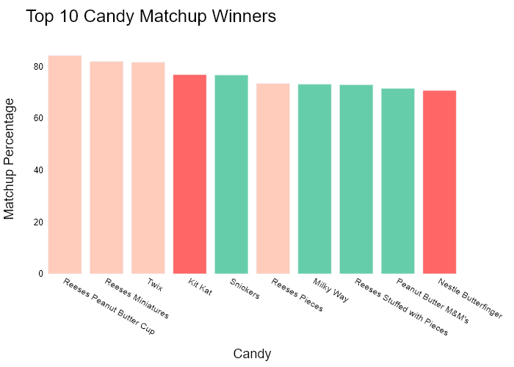

## Performance Metrics

|  |  |  |  |
| --- | --- | --- | --- |
| Task | Model Used | Description | Time Taken (s) |
| Processing Image to JSON | Gemini Vision Pro (default) | Time taken to convert the uploaded image to JSON format | 22.13 |
| Updating JSON | ChatGPT 3.5 (Default) | Time taken to update the JSON with new data | 0.00 |
| Plotting Updated JSON | N/A | Time taken to plot the updated JSON | 0.50 |

# Test Run

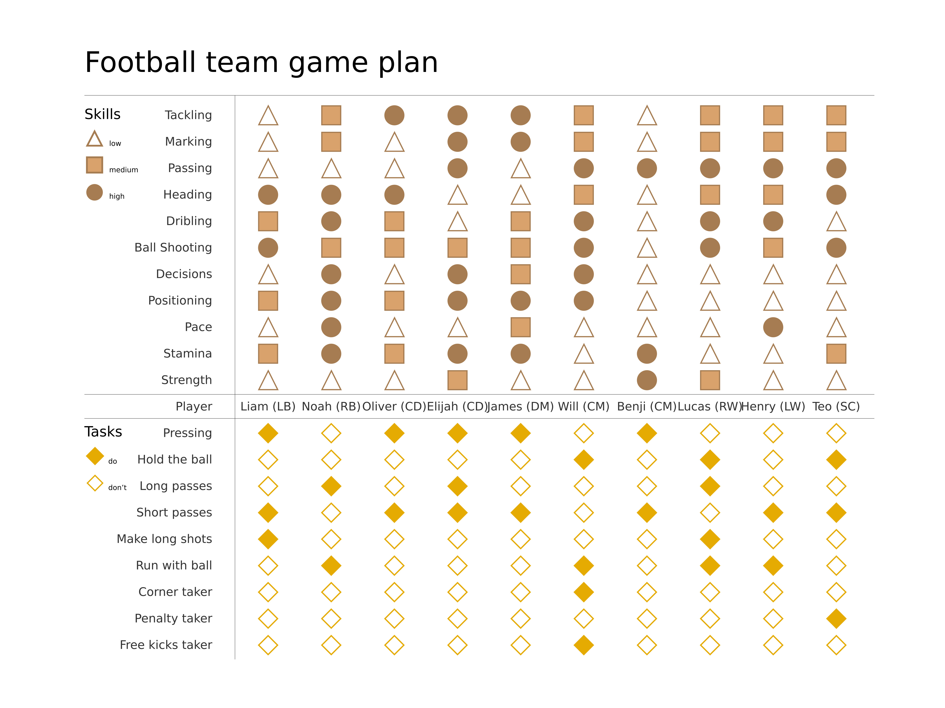

Figure: Charts/Comparison/jpg/matrix_diagram.jpg

## Prompt Used

## Task: Extract Detailed Information from a Given Graph Image  
  
You will analyze a graph image and generate corresponding Plotly-compatible JSON files (`data.json`, `layout.json`, and `config.json`). Follow the structured steps and specific XML-like delimiters for each JSON section as outlined below.  
  
### Instructions:  
  
#### Graph Analysis:  
  
1. **Identify and Categorize Plot Types**:  
 - Recognize and categorize the plot types present in the graph image. Include both simple and complex plots, listed below:  
 - **Comparison Charts**:  
 - `bar`: Bar Chart  
 - `bar` (with vertical bars): Column Chart  
 - `bar` (grouped): Grouped Bar/Column Chart  
 - `scatter` (with lines connecting to points): Lollipop Chart  
 - `indicator` (with gauge): Bullet Chart  
 - `scatter`: Dot Plot  
 - `scatter` (with lines connecting different points): Dumbbell Chart  
 - `scatter` (or custom SVG): Pictogram  
 - `scatter` or `bar` with a range: Range Chart  
 - `barpolar`: Radial Bar Chart  
 - `parcoords`: Parallel Coordinates  
 - `scatterpolar`: Radar Chart  
 - `barpolar` (with segments): Nightingale Chart  
 - `waterfall`: Waterfall Chart  
 - `heatmap` (with color scale): Matrix Chart  
 - `various charts in small multiples`: Small Multiples  
 - `text` (frequency-based size): Word Cloud  
 - `scatter` (with lines indicating change): Slope Chart  
 - `table`: Table Chart  
 - `scatter`: Categorical Scatter Plot  
 - `scatter` (with four quadrants): Quadrant Chart  
 - **Correlation Charts**:  
 - `heatmap`: Heatmap  
 - `scatter` (with size): Bubble Chart  
 - `scatter`: Scatter Plot  
 - `scatter` (with lines connecting points): Connected Scatter Plot  
 - `hexbin`: Hexagonal Binning  
 - `contour`: Contour Plot  
 - **Part-to-Whole & Hierarchical Charts**:  
 - `bar` (stacked): Stacked Bar/Column Chart  
 - `bar` (with diverging sections): Diverging Bar Chart  
 - `bar` (mirrored pairs): Population Pyramid  
 - `scatter` (or custom symbols in a grid): Icon Array  
 - `waffle`: Waffle Chart  
 - `pie`: Pie Chart  
 - `pie` (with hole): Donut Chart  
 - `pie` (half-circle): Semi-circle Donut Chart  
 - `bar` (variable width): Marimekko Chart  
 - `treemap`: Treemap  
 - `treemap` (circular): Circular Treemap  
 - `treemap` (convex shape): Convex Treemap  
 - `sunburst`: Sunburst Chart  
 - `funnel` or `pyramid`: Funnel & Pyramid Chart  
 - `dendrogram`: Dendrogram  
 - `venn`: Venn Diagram  
 - `euler`: Euler Diagram  
 - `indicator` (circular gauge): Circular Gauge  
 - **Data Over Time (Temporal) Charts**:  
 - `scatter` (filled area under curve): Area Chart  
 - `scatter` (filled stacked areas): Stacked Area Chart  
 - `scatter` (smoothed filled areas): Stream Graph  
 - `scatter` (indicating ranking change): Bump Chart  
 - `scatter` (with filled area): Bump Area Chart  
 - `scatter`: Line Chart  
 - `scatter` (with smoothed lines): Spline Chart  
 - `scatter` (with stepped lines): Step Line Chart  
 - `candlestick`: Candlestick Chart  
 - `gantt`: Gantt Chart  
 - `scatter` (encoded lines): Barcode Chart  
 - `ohlc`: OHLC Chart  
 - **Distribution Charts**:  
 - `densitymapbox` or `histogram`: Density Plot  
 - `ridge`: Ridgeline Plot  
 - `horizon`: Horizon Chart  
 - `histogram`: Histogram  
 - `radial_histogram`: Radial Histogram  
 - `scatter` (with distribution): Strip Plot  
 - `scatter` (with jitter): Jitter Plot  
 - `heatmap`: One-dimensional Heatmap  
 - `scatter` (with tightly packed points): Beeswarm Chart  
 - `box`: Box Chart  
 - `violin`: Violin Plot  
 - **Geospatial & Other Charts**:  
 - `densitymapbox`: Geographic Heatmap  
 - `choropleth`: Choropleth Map  
 - `scattermapbox`: Tile Map  
 - `chord`: Chord Diagram  
 - `arc`: Arc Diagram  
 - `sankey`: Sankey  
 - `network`: Network Diagram  
 - `flowchart`: Flowchart  
  
2. **Extract Data Points** for Each Plot Type:  
 - Gather the data points for each identified plot type.  
 - For `scatter`, `line`, and `area` plots: Extract `x` and `y` values.  
 - For `bar` and `stacked bar` plots: Extract `x` (categories) and `y` values.  
 - For `pie` charts: Extract `labels` and `values`.  
 - For `scatter3d`, `surface`, and other 3D plots: Extract `x`, `y`, and `z` values.  
  
3. **Identify Multiple Plots** on the Same Figure:  
 - Note any combinations or overlays of multiple plot types on the same figure and their configurations, such as stacked plots or multiple area fills.  
  
#### Generate JSON and CSV Outputs:  
  
Follow the JSON formatting guidelines and wrap each section in the specified XML-like tags.  
  
1. **Generate `data.json`**:  
 - Include detailed information for each plot type:  
 - `type`: Specify the plot type (e.g., `"scatter"`, `"bar"`, `"pie"`, `"area"`, `"scatter3d"`, `"surface"`).  
 - For area charts, use `"type": "scatter"` and specify `"fill"`.  
 - `x`, `y`, and `z` (if applicable): Arrays of data points for each axis.  
 - `labels` and `values` for pie charts.  
 - `mode`: Specify for line and scatter plots (e.g., `"markers"`, `"lines"`, `"markers+lines"`).  
 - `name`: Legend entry for the plot.  
 - `marker`: Properties such as color, size, and symbol.  
 - `line`: Properties such as color, width, and dash style.  
 - `text`: Hover text for each data point.  
 - `hoverinfo`: Information displayed on hover (e.g., `"x+y+text"`).  
 - `fill`: For area charts, specify the fill (e.g., `"tozeroy"`, `"tonexty"`).  
 - `fillcolor`: The color used to fill the area.  
 - `stackgroup`: For stacked bar charts, specify the stacking group.  
  
2. **Generate `layout.json`**:  
 - Define the layout properties:  
 - `title`: Text and font properties for the graph title.  
 - `xaxis` and `yaxis`: Configuration for axis titles, ranges, grids, and ticks.  
 - `zaxis`: Configuration for 3D plots including title, range, and grid.  
 - `legend`: Properties for legend orientation and positioning.  
 - `margin`: Margins for left, right, bottom, top, and padding.  
 - `plot_bgcolor` and `paper_bgcolor`: Background colors.  
 - `scene`: Configuration for 3D scenes, including camera angles and aspect ratio.  
  
3. **Generate `config.json`**:  
 - Include settings such as:  
 - `responsive`: Whether the graph is responsive.  
 - `displayModeBar`: Whether the mode bar is shown.  
 - `modeBarButtonsToRemove`: List of mode bar buttons to remove.  
 - `scrollZoom`: Whether scrolling zoom is enabled.  
  
4. **Generate `<csv>`**:  
 - Format the CSV data as follows:  
 ```csv  
 x,y  
 1,4  
 2,5  
 3,6  
 ```  
 - Replace `x`, `y`, `1`, `4`, `2`, `5`, and `3`, `6` with the actual data from the graph image.  
  
### Output Format:  
  
Wrap each JSON output in the specified XML-like tags:  
  
- `<data> ... </data>`  
- `<layout> ... </layout>`  
- `<config> ... </config>`  
- `<csv> ... </csv>`  
  
Ensure the JSON format follows these rules:  
- Use double quotes for all keys and string values.  
- Do not include trailing commas in arrays or objects.  
  
### Example Output:  
  
```xml  
<data>  
[  
 {  
 "type": "scatter",  
 "x": [1, 2, 3],  
 "y": [4, 5, 6],  
 "mode": "markers+lines",  
 "name": "Line Plot",  
 "marker": {  
 "color": "rgba(75, 192, 192, 0.6)",  
 "size": 8  
 },  
 "line": {  
 "color": "rgba(75, 192, 192  
  
, 1)",  
 "width": 2  
 }  
 },  
 {  
 "type": "area",  
 "x": [1, 2, 3, 4, 5, 6, 7, 8, 9, 10, 11, 12],  
 "y": [400, 430, 550, 620, 580, 600, 630, 700, 670, 630, 600, 500],  
 "name": "Housing",  
 "marker": {  
 "color": "rgba(255, 159, 64, 0.8)"  
 },  
 "line": {  
 "color": "rgba(255, 159, 64, 1)",  
 "width": 2  
 }  
 },  
 {  
 "type": "bar",  
 "x": ["A", "B", "C"],  
 "y": [10, 15, 13],  
 "name": "Bar Chart",  
 "marker": {  
 "color": "rgba(255, 99, 132, 0.6)"  
 },  
 "hoverinfo": "x+y+text"  
 },  
 {  
 "type": "scatter",  
 "x": [1, 2, 3],  
 "y": [6, 7, 8],  
 "mode": "lines",  
 "fill": "tozeroy",  
 "name": "Area Chart",  
 "line": {  
 "color": "rgba(54, 162, 235, 1)",  
 "width": 2  
 },  
 "fillcolor": "rgba(54, 162, 235, 0.5)"  
 },  
 {  
 "type": "scatter3d",  
 "x": [1, 2, 3],  
 "y": [4, 5, 6],  
 "z": [7, 8, 9],  
 "mode": "markers",  
 "name": "3D Scatter Plot",  
 "marker": {  
 "color": "rgba(255, 159, 64, 0.8)",  
 "size": 5  
 },  
 "hoverinfo": "x+y+z+text"  
 },  
 {  
 "type": "surface",  
 "z": [  
 [10, 10.625, 12.5, 15.625, 20],  
 [5.625, 6.25, 8.125, 11.25, 15.625],  
 [0, 1.25, 3.125, 6.25, 10.625]  
 ],  
 "name": "Surface Plot",  
 "colorscale": "Viridis",  
 "hoverinfo": "z+name"  
 }  
]  
</data>  
<layout>  
{  
 "title": {  
 "text": "Complex Graph Example",  
 "font": {  
 "family": "Arial, sans-serif",  
 "size": 24,  
 "color": "#000000"  
 }  
 },  
 "xaxis": {  
 "title": {  
 "text": "X Axis",  
 "font": {  
 "family": "Arial, sans-serif",  
 "size": 18,  
 "color": "#000000"  
 }  
 },  
 "showgrid": true,  
 "gridcolor": "rgba(0, 0, 0, 0.1)",  
 "zeroline": true,  
 "zerolinecolor": "rgba(0, 0, 0, 0.1)"  
 },  
 "yaxis": {  
 "title": {  
 "text": "Y Axis",  
 "font": {  
 "family": "Arial, sans-serif",  
 "size": 18,  
 "color": "#000000"  
 }  
 },  
 "showgrid": true,  
 "gridcolor": "rgba(0, 0, 0, 0.1)",  
 "zeroline": true,  
 "zerolinecolor": "rgba(0, 0, 0, 0.1)"  
 },  
 "legend": {  
 "orientation": "h",  
 "x": 0.5,  
 "xanchor": "center",  
 "y": -0.2,  
 "font": {  
 "family": "Arial, sans-serif",  
 "size": 12,  
 "color": "#000000"  
 }  
 },  
 "margin": {  
 "l": 60,  
 "r": 30,  
 "b": 60,  
 "t": 60  
 },  
 "plot_bgcolor": "#ffffff",  
 "paper_bgcolor": "#ffffff",  
 "scene": {  
 "xaxis": {"title": "X Axis"},  
 "yaxis": {"title": "Y Axis"},  
 "zaxis": {"title": "Z Axis"}  
 }  
}  
</layout>  
<config>  
{  
 "responsive": true,  
 "displayModeBar": true,  
 "modeBarButtonsToRemove": ["toImage"],  
 "scrollZoom": true  
}  
</config>  
<csv>  
x,y  
1,4  
2,5  
3,6  
</csv>  
```

## Extracted JSON

### data

[  
 {  
 "type": "bar",  
 "x": [  
 "Liam",  
 "Noah",  
 "Oliver",  
 "Elijah",  
 "James",  
 "Benji",  
 "Lucas",  
 "Henry",  
 "Theo",  
 "SC"  
 ],  
 "y": [  
 4,  
 3,  
 4,  
 4,  
 4,  
 4,  
 4,  
 4,  
 4,  
 4  
 ],  
 "name": "Tackling",  
 "marker": {  
 "color": "rgba(255, 99, 132, 0.6)"  
 },  
 "hoverinfo": "x+y+text"  
 },  
 {  
 "type": "bar",  
 "x": [  
 "Liam",  
 "Noah",  
 "Oliver",  
 "Elijah",  
 "James",  
 "Benji",  
 "Lucas",  
 "Henry",  
 "Theo",  
 "SC"  
 ],  
 "y": [  
 3,  
 3,  
 4,  
 3,  
 3,  
 3,  
 3,  
 3,  
 3,  
 3  
 ],  
 "name": "Marking",  
 "marker": {  
 "color": "rgba(255, 99, 132, 0.6)"  
 },  
 "hoverinfo": "x+y+text"  
 },  
 {  
 "type": "bar",  
 "x": [  
 "Liam",  
 "Noah",  
 "Oliver",  
 "Elijah",  
 "James",  
 "Benji",  
 "Lucas",  
 "Henry",  
 "Theo",  
 "SC"  
 ],  
 "y": [  
 4,  
 3,  
 4,  
 4,  
 4,  
 4,  
 4,  
 4,  
 4,  
 4  
 ],  
 "name": "Passing",  
 "marker": {  
 "color": "rgba(255, 99, 132, 0.6)"  
 },  
 "hoverinfo": "x+y+text"  
 },  
 {  
 "type": "bar",  
 "x": [  
 "Liam",  
 "Noah",  
 "Oliver",  
 "Elijah",  
 "James",  
 "Benji",  
 "Lucas",  
 "Henry",  
 "Theo",  
 "SC"  
 ],  
 "y": [  
 3,  
 3,  
 3,  
 3,  
 3,  
 3,  
 3,  
 3,  
 3,  
 3  
 ],  
 "name": "Heading",  
 "marker": {  
 "color": "rgba(255, 99, 132, 0.6)"  
 },  
 "hoverinfo": "x+y+text"  
 },  
 {  
 "type": "bar",  
 "x": [  
 "Liam",  
 "Noah",  
 "Oliver",  
 "Elijah",  
 "James",  
 "Benji",  
 "Lucas",  
 "Henry",  
 "Theo",  
 "SC"  
 ],  
 "y": [  
 2,  
 2,  
 3,  
 2,  
 2,  
 2,  
 2,  
 2,  
 2,  
 2  
 ],  
 "name": "Ball Shooting",  
 "marker": {  
 "color": "rgba(255, 99, 132, 0.6)"  
 },  
 "hoverinfo": "x+y+text"  
 },  
 {  
 "type": "bar",  
 "x": [  
 "Liam",  
 "Noah",  
 "Oliver",  
 "Elijah",  
 "James",  
 "Benji",  
 "Lucas",  
 "Henry",  
 "Theo",  
 "SC"  
 ],  
 "y": [  
 4,  
 4,  
 4,  
 4,  
 4,  
 4,  
 4,  
 4,  
 4,  
 4  
 ],  
 "name": "Dribbling",  
 "marker": {  
 "color": "rgba(255, 99, 132, 0.6)"  
 },  
 "hoverinfo": "x+y+text"  
 },  
 {  
 "type": "bar",  
 "x": [  
 "Liam",  
 "Noah",  
 "Oliver",  
 "Elijah",  
 "James",  
 "Benji",  
 "Lucas",  
 "Henry",  
 "Theo",  
 "SC"  
 ],  
 "y": [  
 4,  
 4,  
 4,  
 4,  
 4,  
 4,  
 4,  
 4,  
 4,  
 4  
 ],  
 "name": "Decisions",  
 "marker": {  
 "color": "rgba(255, 99, 132, 0.6)"  
 },  
 "hoverinfo": "x+y+text"  
 },  
 {  
 "type": "bar",  
 "x": [  
 "Liam",  
 "Noah",  
 "Oliver",  
 "Elijah",  
 "James",  
 "Benji",  
 "Lucas",  
 "Henry",  
 "Theo",  
 "SC"  
 ],  
 "y": [  
 3,  
 3,  
 3,  
 3,  
 3,  
 3,  
 3,  
 3,  
 3,  
 3  
 ],  
 "name": "Positioning",  
 "marker": {  
 "color": "rgba(255, 99, 132, 0.6)"  
 },  
 "hoverinfo": "x+y+text"  
 },  
 {  
 "type": "bar",  
 "x": [  
 "Liam",  
 "Noah",  
 "Oliver",  
 "Elijah",  
 "James",  
 "Benji",  
 "Lucas",  
 "Henry",  
 "Theo",  
 "SC"  
 ],  
 "y": [  
 2,  
 2,  
 2,  
 2,  
 2,  
 2,  
 2,  
 2,  
 2,  
 2  
 ],  
 "name": "Pace",  
 "marker": {  
 "color": "rgba(255, 99, 132, 0.6)"  
 },  
 "hoverinfo": "x+y+text"  
 },  
 {  
 "type": "bar",  
 "x": [  
 "Liam",  
 "Noah",  
 "Oliver",  
 "Elijah",  
 "James",  
 "Benji",  
 "Lucas",  
 "Henry",  
 "Theo",  
 "SC"  
 ],  
 "y": [  
 3,  
 3,  
 3,  
 3,  
 3,  
 3,  
 3,  
 3,  
 3,  
 3  
 ],  
 "name": "Stamina",  
 "marker": {  
 "color": "rgba(255, 99, 132, 0.6)"  
 },  
 "hoverinfo": "x+y+text"  
 },  
 {  
 "type": "bar",  
 "x": [  
 "Liam",  
 "Noah",  
 "Oliver",  
 "Elijah",  
 "James",  
 "Benji",  
 "Lucas",  
 "Henry",  
 "Theo",  
 "SC"  
 ],  
 "y": [  
 4,  
 4,  
 4,  
 4,  
 4,  
 4,  
 4,  
 4,  
 4,  
 4  
 ],  
 "name": "Strength",  
 "marker": {  
 "color": "rgba(255, 99, 132, 0.6)"  
 },  
 "hoverinfo": "x+y+text"  
 },  
 {  
 "type": "scatter",  
 "x": [  
 "Liam",  
 "Noah",  
 "Oliver",  
 "Elijah",  
 "James",  
 "Benji",  
 "Lucas",  
 "Henry",  
 "Theo",  
 "SC"  
 ],  
 "y": [  
 4,  
 3,  
 4,  
 4,  
 4,  
 4,  
 4,  
 4,  
 4,  
 4  
 ],  
 "mode": "markers",  
 "name": "Pressing",  
 "marker": {  
 "color": "rgba(255, 99, 132, 0.6)",  
 "size": 10  
 },  
 "hoverinfo": "x+y+text"  
 },  
 {  
 "type": "scatter",  
 "x": [  
 "Liam",  
 "Noah",  
 "Oliver",  
 "Elijah",  
 "James",  
 "Benji",  
 "Lucas",  
 "Henry",  
 "Theo",  
 "SC"  
 ],  
 "y": [  
 3,  
 3,  
 4,  
 3,  
 3,  
 3,  
 3,  
 3,  
 3,  
 3  
 ],  
 "mode": "markers",  
 "name": "Hold the ball",  
 "marker": {  
 "color": "rgba(255, 99, 132, 0.6)",  
 "size": 10  
 },  
 "hoverinfo": "x+y+text"  
 },  
 {  
 "type": "scatter",  
 "x": [  
 "Liam",  
 "Noah",  
 "Oliver",  
 "Elijah",  
 "James",  
 "Benji",  
 "Lucas",  
 "Henry",  
 "Theo",  
 "SC"  
 ],  
 "y": [  
 4,  
 3,  
 4,  
 4,  
 4,  
 4,  
 4,  
 4,  
 4,  
 4  
 ],  
 "mode": "markers",  
 "name": "Short passes",  
 "marker": {  
 "color": "rgba(255, 99, 132, 0.6)",  
 "size": 10  
 },  
 "hoverinfo": "x+y+text"  
 },  
 {  
 "type": "scatter",  
 "x": [  
 "Liam",  
 "Noah",  
 "Oliver",  
 "Elijah",  
 "James",  
 "Benji",  
 "Lucas",  
 "Henry",  
 "Theo",  
 "SC"  
 ],  
 "y": [  
 3,  
 3,  
 3,  
 3,  
 3,  
 3,  
 3,  
 3,  
 3,  
 3  
 ],  
 "mode": "markers",  
 "name": "Make long shots",  
 "marker": {  
 "color": "rgba(255, 99, 132, 0.6)",  
 "size": 10  
 },  
 "hoverinfo": "x+y+text"  
 },  
 {  
 "type": "scatter",  
 "x": [  
 "Liam",  
 "Noah",  
 "Oliver",  
 "Elijah",  
 "James",  
 "Benji",  
 "Lucas",  
 "Henry",  
 "Theo",  
 "SC"  
 ],  
 "y": [  
 2,  
 2,  
 2,  
 2,  
 2,  
 2,  
 2,  
 2,  
 2,  
 2  
 ],  
 "mode": "markers",  
 "name": "Run with ball",  
 "marker": {  
 "color": "rgba(255, 99, 132, 0.6)",  
 "size": 10  
 },  
 "hoverinfo": "x+y+text"  
 },  
 {  
 "type": "scatter",  
 "x": [  
 "Liam",  
 "Noah",  
 "Oliver",  
 "Elijah",  
 "James",  
 "Benji",  
 "Lucas",  
 "Henry",  
 "Theo",  
 "SC"  
 ],  
 "y": [  
 3,  
 3,  
 3,  
 3,  
 3,  
 3,  
 3,  
 3,  
 3,  
 3  
 ],  
 "mode": "markers",  
 "name": "Corner taker",  
 "marker": {  
 "color": "rgba(255, 99, 132, 0.6)",  
 "size": 10  
 },  
 "hoverinfo": "x+y+text"  
 },  
 {  
 "type": "scatter",  
 "x": [  
 "Liam",  
 "Noah",  
 "Oliver",  
 "Elijah",  
 "James",  
 "Benji",  
 "Lucas",  
 "Henry",  
 "Theo",  
 "SC"  
 ],  
 "y": [  
 2,  
 2,  
 2,  
 2,  
 2,  
 2,  
 2,  
 2,  
 2,  
 2  
 ],  
 "mode": "markers",  
 "name": "Penalty taker",  
 "marker": {  
 "color": "rgba(255, 99, 132, 0.6)",  
 "size": 10  
 },  
 "hoverinfo": "x+y+text"  
 },  
 {  
 "type": "scatter",  
 "x": [  
 "Liam",  
 "Noah",  
 "Oliver",  
 "Elijah",  
 "James",  
 "Benji",  
 "Lucas",  
 "Henry",  
 "Theo",  
 "SC"  
 ],  
 "y": [  
 3,  
 3,  
 3,  
 3,  
 3,  
 3,  
 3,  
 3,  
 3,  
 3  
 ],  
 "mode": "markers",  
 "name": "Free kicks taker",  
 "marker": {  
 "color": "rgba(255, 99, 132, 0.6)",  
 "size": 10  
 },  
 "hoverinfo": "x+y+text"  
 }  
]

### layout

{  
 "title": {  
 "text": "Football Team Game Plan",  
 "font": {  
 "family": "Arial, sans-serif",  
 "size": 24,  
 "color": "#000000"  
 }  
 },  
 "xaxis": {  
 "title": {  
 "text": "Skills",  
 "font": {  
 "family": "Arial, sans-serif",  
 "size": 18,  
 "color": "#000000"  
 }  
 },  
 "showgrid": true,  
 "gridcolor": "rgba(0, 0, 0, 0.1)",  
 "zeroline": true,  
 "zerolinecolor": "rgba(0, 0, 0, 0.1)"  
 },  
 "yaxis": {  
 "title": {  
 "text": "Tasks",  
 "font": {  
 "family": "Arial, sans-serif",  
 "size": 18,  
 "color": "#000000"  
 }  
 },  
 "showgrid": true,  
 "gridcolor": "rgba(0, 0, 0, 0.1)",  
 "zeroline": true,  
 "zerolinecolor": "rgba(0, 0, 0, 0.1)"  
 },  
 "legend": {  
 "orientation": "h",  
 "x": 0.5,  
 "xanchor": "center",  
 "y": -0.2,  
 "font": {  
 "family": "Arial, sans-serif",  
 "size": 12,  
 "color": "#000000"  
 }  
 },  
 "margin": {  
 "l": 60,  
 "r": 30,  
 "b": 60,  
 "t": 60  
 },  
 "plot_bgcolor": "#ffffff",  
 "paper_bgcolor": "#ffffff"  
}

### config

{  
 "responsive": true,  
 "displayModeBar": true,  
 "modeBarButtonsToRemove": [  
 "toImage"  
 ],  
 "scrollZoom": true  
}

## Updated JSON

### updated_data

[  
 {  
 "type": "bar",  
 "x": [  
 "Liam",  
 "Noah",  
 "Oliver",  
 "Elijah",  
 "James",  
 "Benji",  
 "Lucas",  
 "Henry",  
 "Theo",  
 "SC"  
 ],  
 "y": [  
 4,  
 3,  
 4,  
 4,  
 4,  
 4,  
 4,  
 4,  
 4,  
 4  
 ],  
 "name": "Tackling",  
 "marker": {  
 "color": "rgba(255, 99, 132, 0.6)"  
 },  
 "hoverinfo": "x+y+text"  
 },  
 {  
 "type": "bar",  
 "x": [  
 "Liam",  
 "Noah",  
 "Oliver",  
 "Elijah",  
 "James",  
 "Benji",  
 "Lucas",  
 "Henry",  
 "Theo",  
 "SC"  
 ],  
 "y": [  
 3,  
 3,  
 4,  
 3,  
 3,  
 3,  
 3,  
 3,  
 3,  
 3  
 ],  
 "name": "Marking",  
 "marker": {  
 "color": "rgba(255, 99, 132, 0.6)"  
 },  
 "hoverinfo": "x+y+text"  
 },  
 {  
 "type": "bar",  
 "x": [  
 "Liam",  
 "Noah",  
 "Oliver",  
 "Elijah",  
 "James",  
 "Benji",  
 "Lucas",  
 "Henry",  
 "Theo",  
 "SC"  
 ],  
 "y": [  
 4,  
 3,  
 4,  
 4,  
 4,  
 4,  
 4,  
 4,  
 4,  
 4  
 ],  
 "name": "Passing",  
 "marker": {  
 "color": "rgba(255, 99, 132, 0.6)"  
 },  
 "hoverinfo": "x+y+text"  
 },  
 {  
 "type": "bar",  
 "x": [  
 "Liam",  
 "Noah",  
 "Oliver",  
 "Elijah",  
 "James",  
 "Benji",  
 "Lucas",  
 "Henry",  
 "Theo",  
 "SC"  
 ],  
 "y": [  
 3,  
 3,  
 3,  
 3,  
 3,  
 3,  
 3,  
 3,  
 3,  
 3  
 ],  
 "name": "Heading",  
 "marker": {  
 "color": "rgba(255, 99, 132, 0.6)"  
 },  
 "hoverinfo": "x+y+text"  
 },  
 {  
 "type": "bar",  
 "x": [  
 "Liam",  
 "Noah",  
 "Oliver",  
 "Elijah",  
 "James",  
 "Benji",  
 "Lucas",  
 "Henry",  
 "Theo",  
 "SC"  
 ],  
 "y": [  
 2,  
 2,  
 3,  
 2,  
 2,  
 2,  
 2,  
 2,  
 2,  
 2  
 ],  
 "name": "Ball Shooting",  
 "marker": {  
 "color": "rgba(255, 99, 132, 0.6)"  
 },  
 "hoverinfo": "x+y+text"  
 },  
 {  
 "type": "bar",  
 "x": [  
 "Liam",  
 "Noah",  
 "Oliver",  
 "Elijah",  
 "James",  
 "Benji",  
 "Lucas",  
 "Henry",  
 "Theo",  
 "SC"  
 ],  
 "y": [  
 4,  
 4,  
 4,  
 4,  
 4,  
 4,  
 4,  
 4,  
 4,  
 4  
 ],  
 "name": "Dribbling",  
 "marker": {  
 "color": "rgba(255, 99, 132, 0.6)"  
 },  
 "hoverinfo": "x+y+text"  
 },  
 {  
 "type": "bar",  
 "x": [  
 "Liam",  
 "Noah",  
 "Oliver",  
 "Elijah",  
 "James",  
 "Benji",  
 "Lucas",  
 "Henry",  
 "Theo",  
 "SC"  
 ],  
 "y": [  
 4,  
 4,  
 4,  
 4,  
 4,  
 4,  
 4,  
 4,  
 4,  
 4  
 ],  
 "name": "Decisions",  
 "marker": {  
 "color": "rgba(255, 99, 132, 0.6)"  
 },  
 "hoverinfo": "x+y+text"  
 },  
 {  
 "type": "bar",  
 "x": [  
 "Liam",  
 "Noah",  
 "Oliver",  
 "Elijah",  
 "James",  
 "Benji",  
 "Lucas",  
 "Henry",  
 "Theo",  
 "SC"  
 ],  
 "y": [  
 3,  
 3,  
 3,  
 3,  
 3,  
 3,  
 3,  
 3,  
 3,  
 3  
 ],  
 "name": "Positioning",  
 "marker": {  
 "color": "rgba(255, 99, 132, 0.6)"  
 },  
 "hoverinfo": "x+y+text"  
 },  
 {  
 "type": "bar",  
 "x": [  
 "Liam",  
 "Noah",  
 "Oliver",  
 "Elijah",  
 "James",  
 "Benji",  
 "Lucas",  
 "Henry",  
 "Theo",  
 "SC"  
 ],  
 "y": [  
 2,  
 2,  
 2,  
 2,  
 2,  
 2,  
 2,  
 2,  
 2,  
 2  
 ],  
 "name": "Pace",  
 "marker": {  
 "color": "rgba(255, 99, 132, 0.6)"  
 },  
 "hoverinfo": "x+y+text"  
 },  
 {  
 "type": "bar",  
 "x": [  
 "Liam",  
 "Noah",  
 "Oliver",  
 "Elijah",  
 "James",  
 "Benji",  
 "Lucas",  
 "Henry",  
 "Theo",  
 "SC"  
 ],  
 "y": [  
 3,  
 3,  
 3,  
 3,  
 3,  
 3,  
 3,  
 3,  
 3,  
 3  
 ],  
 "name": "Stamina",  
 "marker": {  
 "color": "rgba(255, 99, 132, 0.6)"  
 },  
 "hoverinfo": "x+y+text"  
 },  
 {  
 "type": "bar",  
 "x": [  
 "Liam",  
 "Noah",  
 "Oliver",  
 "Elijah",  
 "James",  
 "Benji",  
 "Lucas",  
 "Henry",  
 "Theo",  
 "SC"  
 ],  
 "y": [  
 4,  
 4,  
 4,  
 4,  
 4,  
 4,  
 4,  
 4,  
 4,  
 4  
 ],  
 "name": "Strength",  
 "marker": {  
 "color": "rgba(255, 99, 132, 0.6)"  
 },  
 "hoverinfo": "x+y+text"  
 },  
 {  
 "type": "scatter",  
 "x": [  
 "Liam",  
 "Noah",  
 "Oliver",  
 "Elijah",  
 "James",  
 "Benji",  
 "Lucas",  
 "Henry",  
 "Theo",  
 "SC"  
 ],  
 "y": [  
 4,  
 3,  
 4,  
 4,  
 4,  
 4,  
 4,  
 4,  
 4,  
 4  
 ],  
 "mode": "markers",  
 "name": "Pressing",  
 "marker": {  
 "color": "rgba(255, 99, 132, 0.6)",  
 "size": 10  
 },  
 "hoverinfo": "x+y+text"  
 },  
 {  
 "type": "scatter",  
 "x": [  
 "Liam",  
 "Noah",  
 "Oliver",  
 "Elijah",  
 "James",  
 "Benji",  
 "Lucas",  
 "Henry",  
 "Theo",  
 "SC"  
 ],  
 "y": [  
 3,  
 3,  
 4,  
 3,  
 3,  
 3,  
 3,  
 3,  
 3,  
 3  
 ],  
 "mode": "markers",  
 "name": "Hold the ball",  
 "marker": {  
 "color": "rgba(255, 99, 132, 0.6)",  
 "size": 10  
 },  
 "hoverinfo": "x+y+text"  
 },  
 {  
 "type": "scatter",  
 "x": [  
 "Liam",  
 "Noah",  
 "Oliver",  
 "Elijah",  
 "James",  
 "Benji",  
 "Lucas",  
 "Henry",  
 "Theo",  
 "SC"  
 ],  
 "y": [  
 4,  
 3,  
 4,  
 4,  
 4,  
 4,  
 4,  
 4,  
 4,  
 4  
 ],  
 "mode": "markers",  
 "name": "Short passes",  
 "marker": {  
 "color": "rgba(255, 99, 132, 0.6)",  
 "size": 10  
 },  
 "hoverinfo": "x+y+text"  
 },  
 {  
 "type": "scatter",  
 "x": [  
 "Liam",  
 "Noah",  
 "Oliver",  
 "Elijah",  
 "James",  
 "Benji",  
 "Lucas",  
 "Henry",  
 "Theo",  
 "SC"  
 ],  
 "y": [  
 3,  
 3,  
 3,  
 3,  
 3,  
 3,  
 3,  
 3,  
 3,  
 3  
 ],  
 "mode": "markers",  
 "name": "Make long shots",  
 "marker": {  
 "color": "rgba(255, 99, 132, 0.6)",  
 "size": 10  
 },  
 "hoverinfo": "x+y+text"  
 },  
 {  
 "type": "scatter",  
 "x": [  
 "Liam",  
 "Noah",  
 "Oliver",  
 "Elijah",  
 "James",  
 "Benji",  
 "Lucas",  
 "Henry",  
 "Theo",  
 "SC"  
 ],  
 "y": [  
 2,  
 2,  
 2,  
 2,  
 2,  
 2,  
 2,  
 2,  
 2,  
 2  
 ],  
 "mode": "markers",  
 "name": "Run with ball",  
 "marker": {  
 "color": "rgba(255, 99, 132, 0.6)",  
 "size": 10  
 },  
 "hoverinfo": "x+y+text"  
 },  
 {  
 "type": "scatter",  
 "x": [  
 "Liam",  
 "Noah",  
 "Oliver",  
 "Elijah",  
 "James",  
 "Benji",  
 "Lucas",  
 "Henry",  
 "Theo",  
 "SC"  
 ],  
 "y": [  
 3,  
 3,  
 3,  
 3,  
 3,  
 3,  
 3,  
 3,  
 3,  
 3  
 ],  
 "mode": "markers",  
 "name": "Corner taker",  
 "marker": {  
 "color": "rgba(255, 99, 132, 0.6)",  
 "size": 10  
 },  
 "hoverinfo": "x+y+text"  
 },  
 {  
 "type": "scatter",  
 "x": [  
 "Liam",  
 "Noah",  
 "Oliver",  
 "Elijah",  
 "James",  
 "Benji",  
 "Lucas",  
 "Henry",  
 "Theo",  
 "SC"  
 ],  
 "y": [  
 2,  
 2,  
 2,  
 2,  
 2,  
 2,  
 2,  
 2,  
 2,  
 2  
 ],  
 "mode": "markers",  
 "name": "Penalty taker",  
 "marker": {  
 "color": "rgba(255, 99, 132, 0.6)",  
 "size": 10  
 },  
 "hoverinfo": "x+y+text"  
 },  
 {  
 "type": "scatter",  
 "x": [  
 "Liam",  
 "Noah",  
 "Oliver",  
 "Elijah",  
 "James",  
 "Benji",  
 "Lucas",  
 "Henry",  
 "Theo",  
 "SC"  
 ],  
 "y": [  
 3,  
 3,  
 3,  
 3,  
 3,  
 3,  
 3,  
 3,  
 3,  
 3  
 ],  
 "mode": "markers",  
 "name": "Free kicks taker",  
 "marker": {  
 "color": "rgba(255, 99, 132, 0.6)",  
 "size": 10  
 },  
 "hoverinfo": "x+y+text"  
 }  
]

### updated_layout

{  
 "title": {  
 "text": "Football Team Game Plan",  
 "font": {  
 "family": "Arial, sans-serif",  
 "size": 24,  
 "color": "#000000"  
 }  
 },  
 "xaxis": {  
 "title": {  
 "text": "Skills",  
 "font": {  
 "family": "Arial, sans-serif",  
 "size": 18,  
 "color": "#000000"  
 }  
 },  
 "showgrid": true,  
 "gridcolor": "rgba(0, 0, 0, 0.1)",  
 "zeroline": true,  
 "zerolinecolor": "rgba(0, 0, 0, 0.1)"  
 },  
 "yaxis": {  
 "title": {  
 "text": "Tasks",  
 "font": {  
 "family": "Arial, sans-serif",  
 "size": 18,  
 "color": "#000000"  
 }  
 },  
 "showgrid": true,  
 "gridcolor": "rgba(0, 0, 0, 0.1)",  
 "zeroline": true,  
 "zerolinecolor": "rgba(0, 0, 0, 0.1)"  
 },  
 "legend": {  
 "orientation": "h",  
 "x": 0.5,  
 "xanchor": "center",  
 "y": -0.2,  
 "font": {  
 "family": "Arial, sans-serif",  
 "size": 12,  
 "color": "#000000"  
 }  
 },  
 "margin": {  
 "l": 60,  
 "r": 30,  
 "b": 60,  
 "t": 60  
 },  
 "plot_bgcolor": "#ffffff",  
 "paper_bgcolor": "#ffffff"  
}

### updated_config

{  
 "responsive": true,  
 "displayModeBar": true,  
 "modeBarButtonsToRemove": [  
 "toImage"  
 ],  
 "scrollZoom": true  
}

## Updated Chart

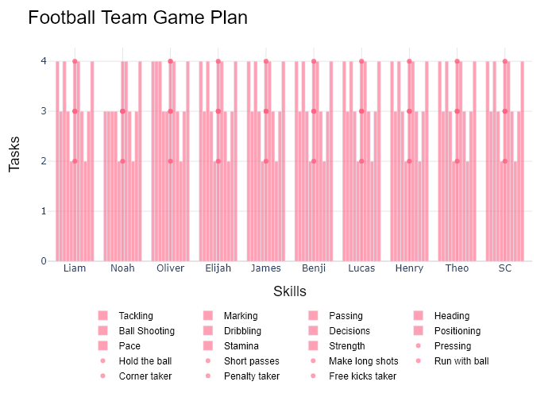

## Performance Metrics

|  |  |  |  |
| --- | --- | --- | --- |
| Task | Model Used | Description | Time Taken (s) |
| Processing Image to JSON | Gemini Vision Pro (default) | Time taken to convert the uploaded image to JSON format | 56.99 |
| Updating JSON | ChatGPT 3.5 (Default) | Time taken to update the JSON with new data | 0.00 |
| Plotting Updated JSON | N/A | Time taken to plot the updated JSON | 0.44 |

# Test Run

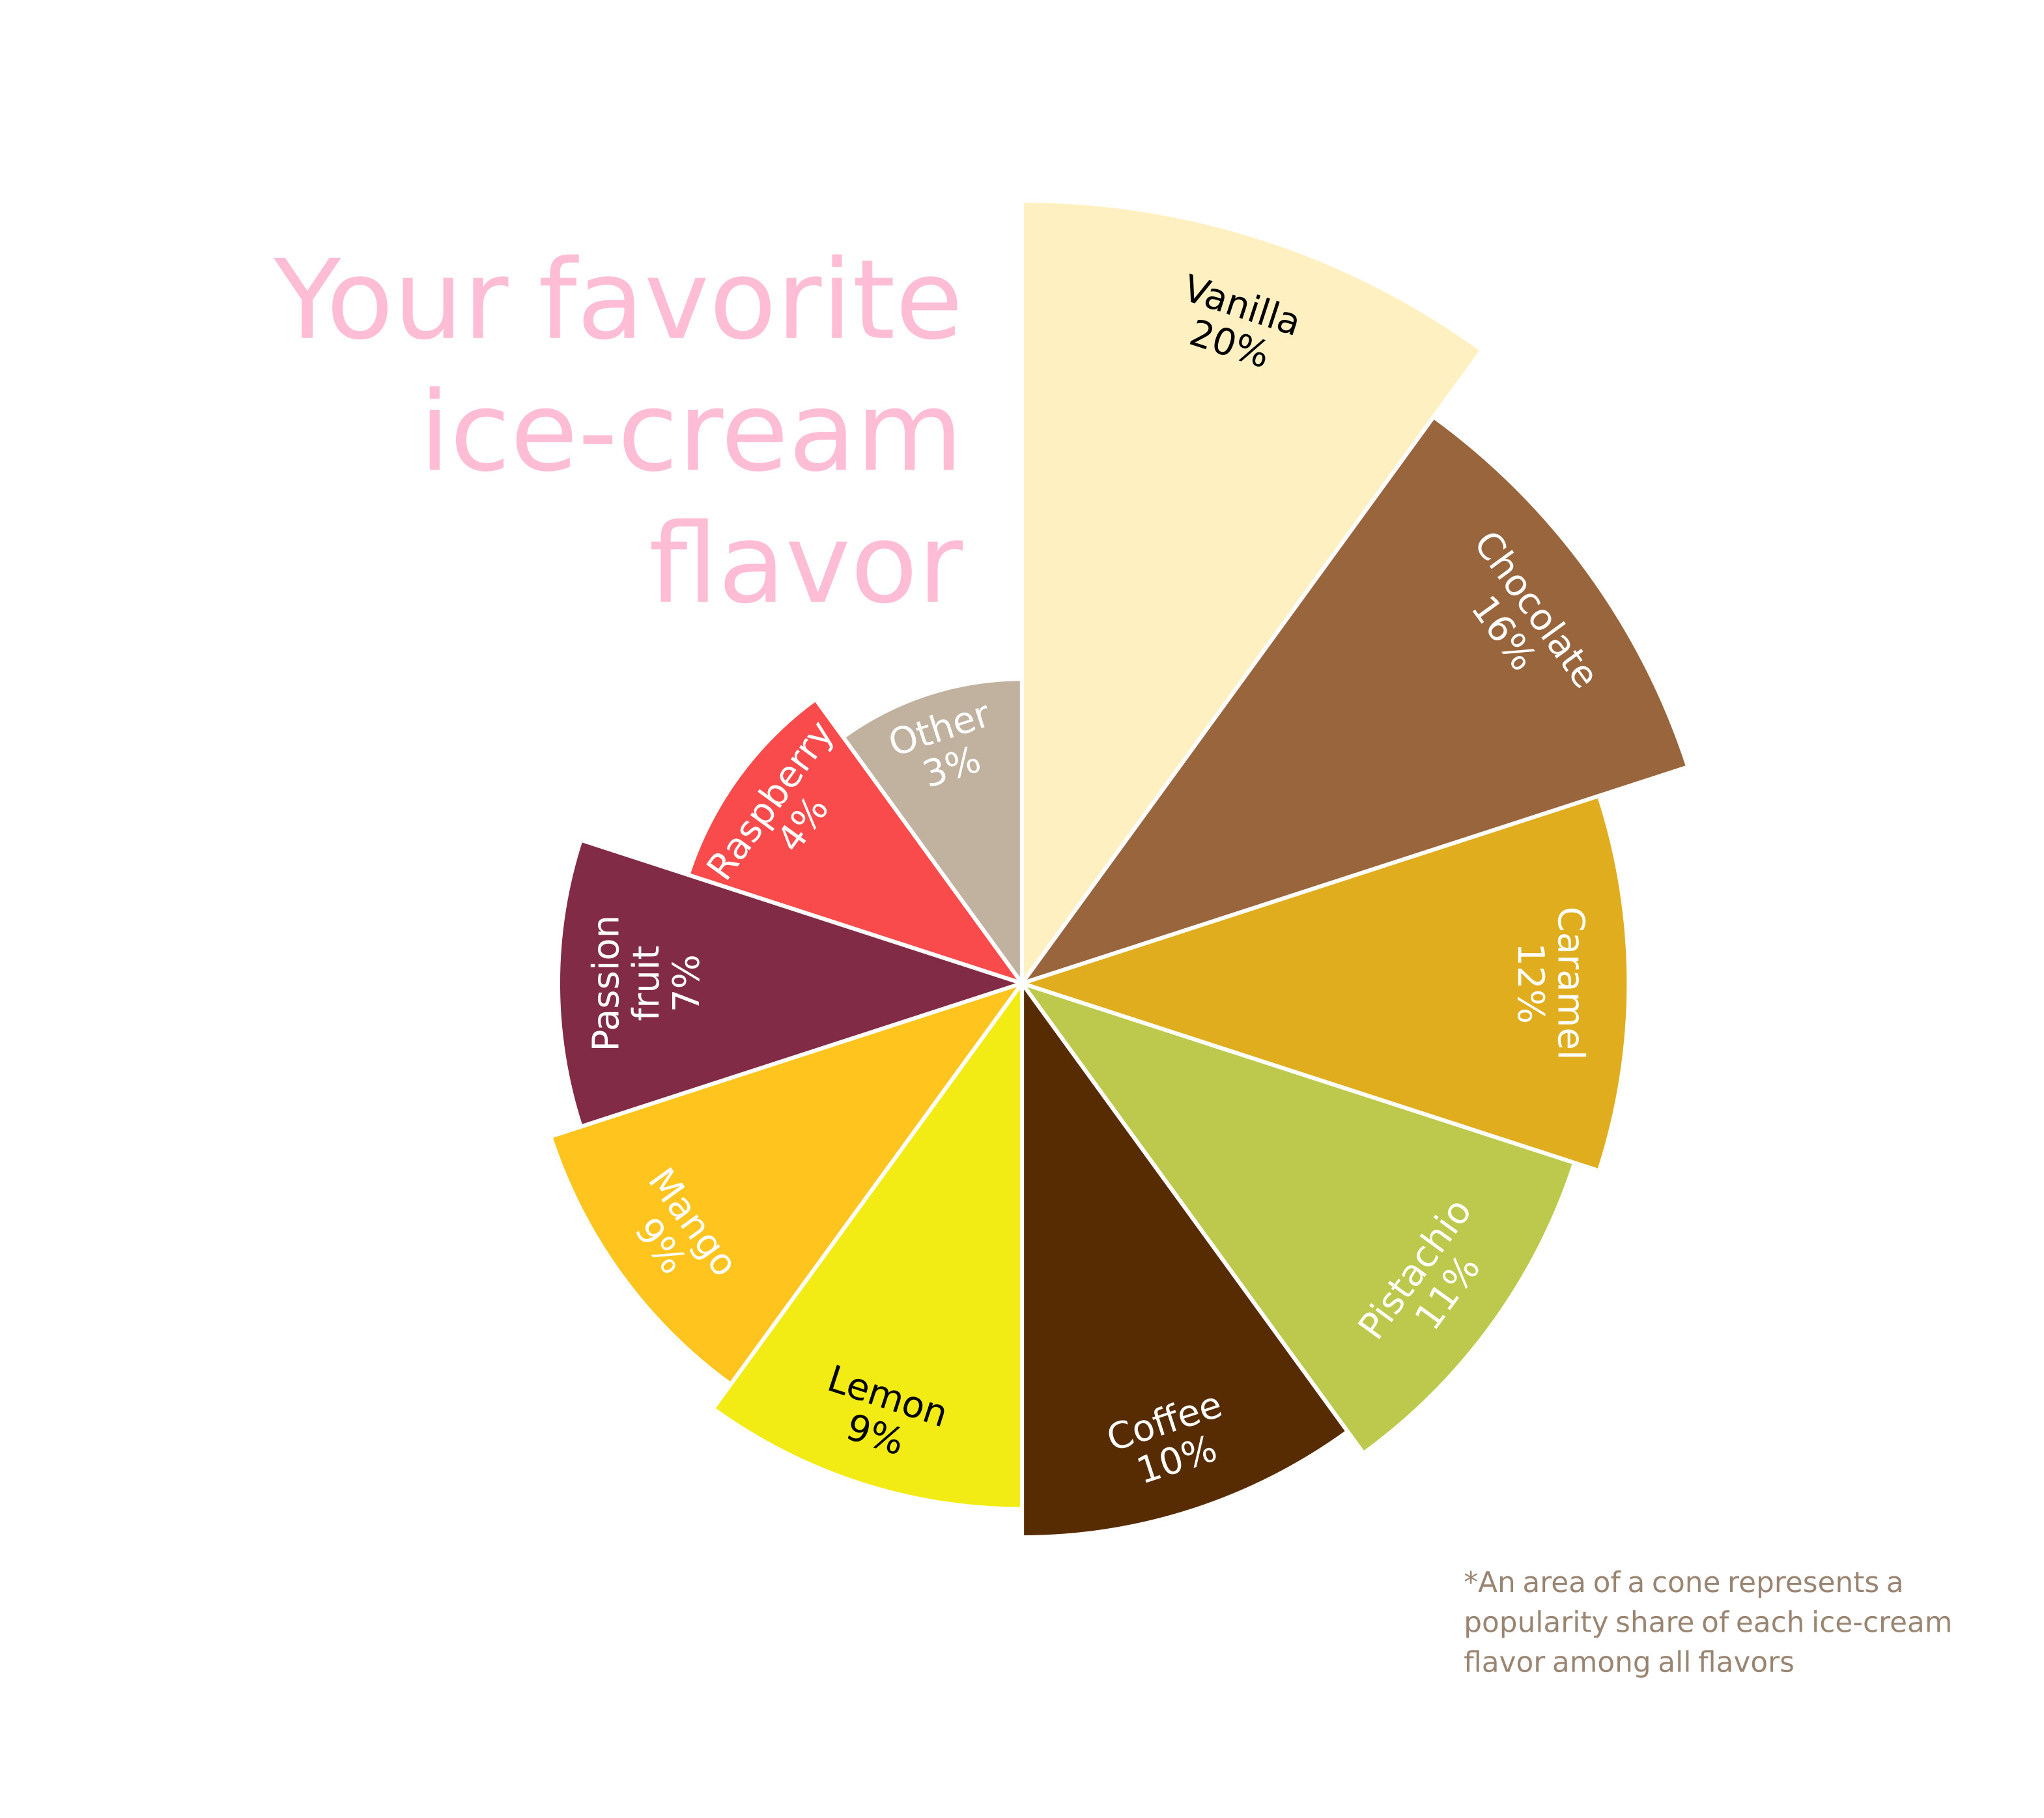

Figure: Charts/Comparison/jpg/nightingale.jpg

## Prompt Used

## Task: Extract Detailed Information from a Given Graph Image  
  
You will analyze a graph image and generate corresponding Plotly-compatible JSON files (`data.json`, `layout.json`, and `config.json`). Follow the structured steps and specific XML-like delimiters for each JSON section as outlined below.  
  
### Instructions:  
  
#### Graph Analysis:  
  
1. **Identify and Categorize Plot Types**:  
 - Recognize and categorize the plot types present in the graph image. Include both simple and complex plots, listed below:  
 - **Comparison Charts**:  
 - `bar`: Bar Chart  
 - `bar` (with vertical bars): Column Chart  
 - `bar` (grouped): Grouped Bar/Column Chart  
 - `scatter` (with lines connecting to points): Lollipop Chart  
 - `indicator` (with gauge): Bullet Chart  
 - `scatter`: Dot Plot  
 - `scatter` (with lines connecting different points): Dumbbell Chart  
 - `scatter` (or custom SVG): Pictogram  
 - `scatter` or `bar` with a range: Range Chart  
 - `barpolar`: Radial Bar Chart  
 - `parcoords`: Parallel Coordinates  
 - `scatterpolar`: Radar Chart  
 - `barpolar` (with segments): Nightingale Chart  
 - `waterfall`: Waterfall Chart  
 - `heatmap` (with color scale): Matrix Chart  
 - `various charts in small multiples`: Small Multiples  
 - `text` (frequency-based size): Word Cloud  
 - `scatter` (with lines indicating change): Slope Chart  
 - `table`: Table Chart  
 - `scatter`: Categorical Scatter Plot  
 - `scatter` (with four quadrants): Quadrant Chart  
 - **Correlation Charts**:  
 - `heatmap`: Heatmap  
 - `scatter` (with size): Bubble Chart  
 - `scatter`: Scatter Plot  
 - `scatter` (with lines connecting points): Connected Scatter Plot  
 - `hexbin`: Hexagonal Binning  
 - `contour`: Contour Plot  
 - **Part-to-Whole & Hierarchical Charts**:  
 - `bar` (stacked): Stacked Bar/Column Chart  
 - `bar` (with diverging sections): Diverging Bar Chart  
 - `bar` (mirrored pairs): Population Pyramid  
 - `scatter` (or custom symbols in a grid): Icon Array  
 - `waffle`: Waffle Chart  
 - `pie`: Pie Chart  
 - `pie` (with hole): Donut Chart  
 - `pie` (half-circle): Semi-circle Donut Chart  
 - `bar` (variable width): Marimekko Chart  
 - `treemap`: Treemap  
 - `treemap` (circular): Circular Treemap  
 - `treemap` (convex shape): Convex Treemap  
 - `sunburst`: Sunburst Chart  
 - `funnel` or `pyramid`: Funnel & Pyramid Chart  
 - `dendrogram`: Dendrogram  
 - `venn`: Venn Diagram  
 - `euler`: Euler Diagram  
 - `indicator` (circular gauge): Circular Gauge  
 - **Data Over Time (Temporal) Charts**:  
 - `scatter` (filled area under curve): Area Chart  
 - `scatter` (filled stacked areas): Stacked Area Chart  
 - `scatter` (smoothed filled areas): Stream Graph  
 - `scatter` (indicating ranking change): Bump Chart  
 - `scatter` (with filled area): Bump Area Chart  
 - `scatter`: Line Chart  
 - `scatter` (with smoothed lines): Spline Chart  
 - `scatter` (with stepped lines): Step Line Chart  
 - `candlestick`: Candlestick Chart  
 - `gantt`: Gantt Chart  
 - `scatter` (encoded lines): Barcode Chart  
 - `ohlc`: OHLC Chart  
 - **Distribution Charts**:  
 - `densitymapbox` or `histogram`: Density Plot  
 - `ridge`: Ridgeline Plot  
 - `horizon`: Horizon Chart  
 - `histogram`: Histogram  
 - `radial_histogram`: Radial Histogram  
 - `scatter` (with distribution): Strip Plot  
 - `scatter` (with jitter): Jitter Plot  
 - `heatmap`: One-dimensional Heatmap  
 - `scatter` (with tightly packed points): Beeswarm Chart  
 - `box`: Box Chart  
 - `violin`: Violin Plot  
 - **Geospatial & Other Charts**:  
 - `densitymapbox`: Geographic Heatmap  
 - `choropleth`: Choropleth Map  
 - `scattermapbox`: Tile Map  
 - `chord`: Chord Diagram  
 - `arc`: Arc Diagram  
 - `sankey`: Sankey  
 - `network`: Network Diagram  
 - `flowchart`: Flowchart  
  
2. **Extract Data Points** for Each Plot Type:  
 - Gather the data points for each identified plot type.  
 - For `scatter`, `line`, and `area` plots: Extract `x` and `y` values.  
 - For `bar` and `stacked bar` plots: Extract `x` (categories) and `y` values.  
 - For `pie` charts: Extract `labels` and `values`.  
 - For `scatter3d`, `surface`, and other 3D plots: Extract `x`, `y`, and `z` values.  
  
3. **Identify Multiple Plots** on the Same Figure:  
 - Note any combinations or overlays of multiple plot types on the same figure and their configurations, such as stacked plots or multiple area fills.  
  
#### Generate JSON and CSV Outputs:  
  
Follow the JSON formatting guidelines and wrap each section in the specified XML-like tags.  
  
1. **Generate `data.json`**:  
 - Include detailed information for each plot type:  
 - `type`: Specify the plot type (e.g., `"scatter"`, `"bar"`, `"pie"`, `"area"`, `"scatter3d"`, `"surface"`).  
 - For area charts, use `"type": "scatter"` and specify `"fill"`.  
 - `x`, `y`, and `z` (if applicable): Arrays of data points for each axis.  
 - `labels` and `values` for pie charts.  
 - `mode`: Specify for line and scatter plots (e.g., `"markers"`, `"lines"`, `"markers+lines"`).  
 - `name`: Legend entry for the plot.  
 - `marker`: Properties such as color, size, and symbol.  
 - `line`: Properties such as color, width, and dash style.  
 - `text`: Hover text for each data point.  
 - `hoverinfo`: Information displayed on hover (e.g., `"x+y+text"`).  
 - `fill`: For area charts, specify the fill (e.g., `"tozeroy"`, `"tonexty"`).  
 - `fillcolor`: The color used to fill the area.  
 - `stackgroup`: For stacked bar charts, specify the stacking group.  
  
2. **Generate `layout.json`**:  
 - Define the layout properties:  
 - `title`: Text and font properties for the graph title.  
 - `xaxis` and `yaxis`: Configuration for axis titles, ranges, grids, and ticks.  
 - `zaxis`: Configuration for 3D plots including title, range, and grid.  
 - `legend`: Properties for legend orientation and positioning.  
 - `margin`: Margins for left, right, bottom, top, and padding.  
 - `plot_bgcolor` and `paper_bgcolor`: Background colors.  
 - `scene`: Configuration for 3D scenes, including camera angles and aspect ratio.  
  
3. **Generate `config.json`**:  
 - Include settings such as:  
 - `responsive`: Whether the graph is responsive.  
 - `displayModeBar`: Whether the mode bar is shown.  
 - `modeBarButtonsToRemove`: List of mode bar buttons to remove.  
 - `scrollZoom`: Whether scrolling zoom is enabled.  
  
4. **Generate `<csv>`**:  
 - Format the CSV data as follows:  
 ```csv  
 x,y  
 1,4  
 2,5  
 3,6  
 ```  
 - Replace `x`, `y`, `1`, `4`, `2`, `5`, and `3`, `6` with the actual data from the graph image.  
  
### Output Format:  
  
Wrap each JSON output in the specified XML-like tags:  
  
- `<data> ... </data>`  
- `<layout> ... </layout>`  
- `<config> ... </config>`  
- `<csv> ... </csv>`  
  
Ensure the JSON format follows these rules:  
- Use double quotes for all keys and string values.  
- Do not include trailing commas in arrays or objects.  
  
### Example Output:  
  
```xml  
<data>  
[  
 {  
 "type": "scatter",  
 "x": [1, 2, 3],  
 "y": [4, 5, 6],  
 "mode": "markers+lines",  
 "name": "Line Plot",  
 "marker": {  
 "color": "rgba(75, 192, 192, 0.6)",  
 "size": 8  
 },  
 "line": {  
 "color": "rgba(75, 192, 192  
  
, 1)",  
 "width": 2  
 }  
 },  
 {  
 "type": "area",  
 "x": [1, 2, 3, 4, 5, 6, 7, 8, 9, 10, 11, 12],  
 "y": [400, 430, 550, 620, 580, 600, 630, 700, 670, 630, 600, 500],  
 "name": "Housing",  
 "marker": {  
 "color": "rgba(255, 159, 64, 0.8)"  
 },  
 "line": {  
 "color": "rgba(255, 159, 64, 1)",  
 "width": 2  
 }  
 },  
 {  
 "type": "bar",  
 "x": ["A", "B", "C"],  
 "y": [10, 15, 13],  
 "name": "Bar Chart",  
 "marker": {  
 "color": "rgba(255, 99, 132, 0.6)"  
 },  
 "hoverinfo": "x+y+text"  
 },  
 {  
 "type": "scatter",  
 "x": [1, 2, 3],  
 "y": [6, 7, 8],  
 "mode": "lines",  
 "fill": "tozeroy",  
 "name": "Area Chart",  
 "line": {  
 "color": "rgba(54, 162, 235, 1)",  
 "width": 2  
 },  
 "fillcolor": "rgba(54, 162, 235, 0.5)"  
 },  
 {  
 "type": "scatter3d",  
 "x": [1, 2, 3],  
 "y": [4, 5, 6],  
 "z": [7, 8, 9],  
 "mode": "markers",  
 "name": "3D Scatter Plot",  
 "marker": {  
 "color": "rgba(255, 159, 64, 0.8)",  
 "size": 5  
 },  
 "hoverinfo": "x+y+z+text"  
 },  
 {  
 "type": "surface",  
 "z": [  
 [10, 10.625, 12.5, 15.625, 20],  
 [5.625, 6.25, 8.125, 11.25, 15.625],  
 [0, 1.25, 3.125, 6.25, 10.625]  
 ],  
 "name": "Surface Plot",  
 "colorscale": "Viridis",  
 "hoverinfo": "z+name"  
 }  
]  
</data>  
<layout>  
{  
 "title": {  
 "text": "Complex Graph Example",  
 "font": {  
 "family": "Arial, sans-serif",  
 "size": 24,  
 "color": "#000000"  
 }  
 },  
 "xaxis": {  
 "title": {  
 "text": "X Axis",  
 "font": {  
 "family": "Arial, sans-serif",  
 "size": 18,  
 "color": "#000000"  
 }  
 },  
 "showgrid": true,  
 "gridcolor": "rgba(0, 0, 0, 0.1)",  
 "zeroline": true,  
 "zerolinecolor": "rgba(0, 0, 0, 0.1)"  
 },  
 "yaxis": {  
 "title": {  
 "text": "Y Axis",  
 "font": {  
 "family": "Arial, sans-serif",  
 "size": 18,  
 "color": "#000000"  
 }  
 },  
 "showgrid": true,  
 "gridcolor": "rgba(0, 0, 0, 0.1)",  
 "zeroline": true,  
 "zerolinecolor": "rgba(0, 0, 0, 0.1)"  
 },  
 "legend": {  
 "orientation": "h",  
 "x": 0.5,  
 "xanchor": "center",  
 "y": -0.2,  
 "font": {  
 "family": "Arial, sans-serif",  
 "size": 12,  
 "color": "#000000"  
 }  
 },  
 "margin": {  
 "l": 60,  
 "r": 30,  
 "b": 60,  
 "t": 60  
 },  
 "plot_bgcolor": "#ffffff",  
 "paper_bgcolor": "#ffffff",  
 "scene": {  
 "xaxis": {"title": "X Axis"},  
 "yaxis": {"title": "Y Axis"},  
 "zaxis": {"title": "Z Axis"}  
 }  
}  
</layout>  
<config>  
{  
 "responsive": true,  
 "displayModeBar": true,  
 "modeBarButtonsToRemove": ["toImage"],  
 "scrollZoom": true  
}  
</config>  
<csv>  
x,y  
1,4  
2,5  
3,6  
</csv>  
```

## Extracted JSON

### data

[  
 {  
 "type": "pie",  
 "labels": [  
 "Vanilla",  
 "Chocolate",  
 "Caramel",  
 "Pistachio",  
 "Coffee",  
 "Lemon",  
 "Mango",  
 "Passion fruit",  
 "Raspberry",  
 "Other"  
 ],  
 "values": [  
 20,  
 16,  
 12,  
 11,  
 10,  
 9,  
 9,  
 7,  
 4,  
 3  
 ]  
 }  
]

### layout

{  
 "title": {  
 "text": "Your favorite ice-cream flavor",  
 "font": {  
 "family": "Arial, sans-serif",  
 "size": 24,  
 "color": "#000000"  
 }  
 },  
 "legend": {  
 "orientation": "h",  
 "x": 0.5,  
 "xanchor": "center",  
 "y": -0.2,  
 "font": {  
 "family": "Arial, sans-serif",  
 "size": 12,  
 "color": "#000000"  
 }  
 },  
 "margin": {  
 "l": 60,  
 "r": 30,  
 "b": 60,  
 "t": 60  
 },  
 "plot_bgcolor": "#ffffff",  
 "paper_bgcolor": "#ffffff"  
}

### config

{  
 "responsive": true,  
 "displayModeBar": true,  
 "modeBarButtonsToRemove": [  
 "toImage"  
 ],  
 "scrollZoom": true  
}

## Updated JSON

### updated_data

[  
 {  
 "type": "pie",  
 "labels": [  
 "Vanilla",  
 "Chocolate",  
 "Caramel",  
 "Pistachio",  
 "Coffee",  
 "Lemon",  
 "Mango",  
 "Passion fruit",  
 "Raspberry",  
 "Other"  
 ],  
 "values": [  
 20,  
 16,  
 12,  
 11,  
 10,  
 9,  
 9,  
 7,  
 4,  
 3  
 ]  
 }  
]

### updated_layout

{  
 "title": {  
 "text": "Your favorite ice-cream flavor",  
 "font": {  
 "family": "Arial, sans-serif",  
 "size": 24,  
 "color": "#000000"  
 }  
 },  
 "legend": {  
 "orientation": "h",  
 "x": 0.5,  
 "xanchor": "center",  
 "y": -0.2,  
 "font": {  
 "family": "Arial, sans-serif",  
 "size": 12,  
 "color": "#000000"  
 }  
 },  
 "margin": {  
 "l": 60,  
 "r": 30,  
 "b": 60,  
 "t": 60  
 },  
 "plot_bgcolor": "#ffffff",  
 "paper_bgcolor": "#ffffff"  
}

### updated_config

{  
 "responsive": true,  
 "displayModeBar": true,  
 "modeBarButtonsToRemove": [  
 "toImage"  
 ],  
 "scrollZoom": true  
}

## Updated Chart

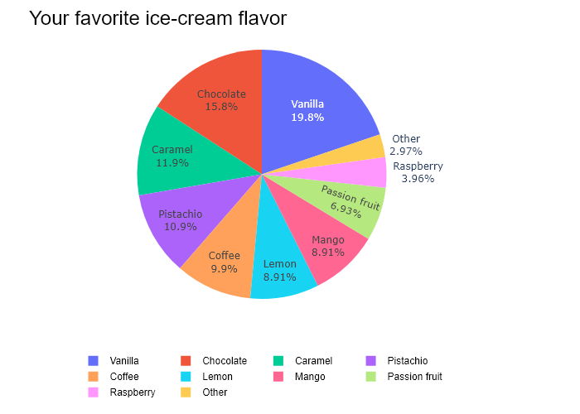

## Performance Metrics

|  |  |  |  |
| --- | --- | --- | --- |
| Task | Model Used | Description | Time Taken (s) |
| Processing Image to JSON | Gemini Vision Pro (default) | Time taken to convert the uploaded image to JSON format | 13.87 |
| Updating JSON | ChatGPT 3.5 (Default) | Time taken to update the JSON with new data | 0.00 |
| Plotting Updated JSON | N/A | Time taken to plot the updated JSON | 0.50 |

# Test Run

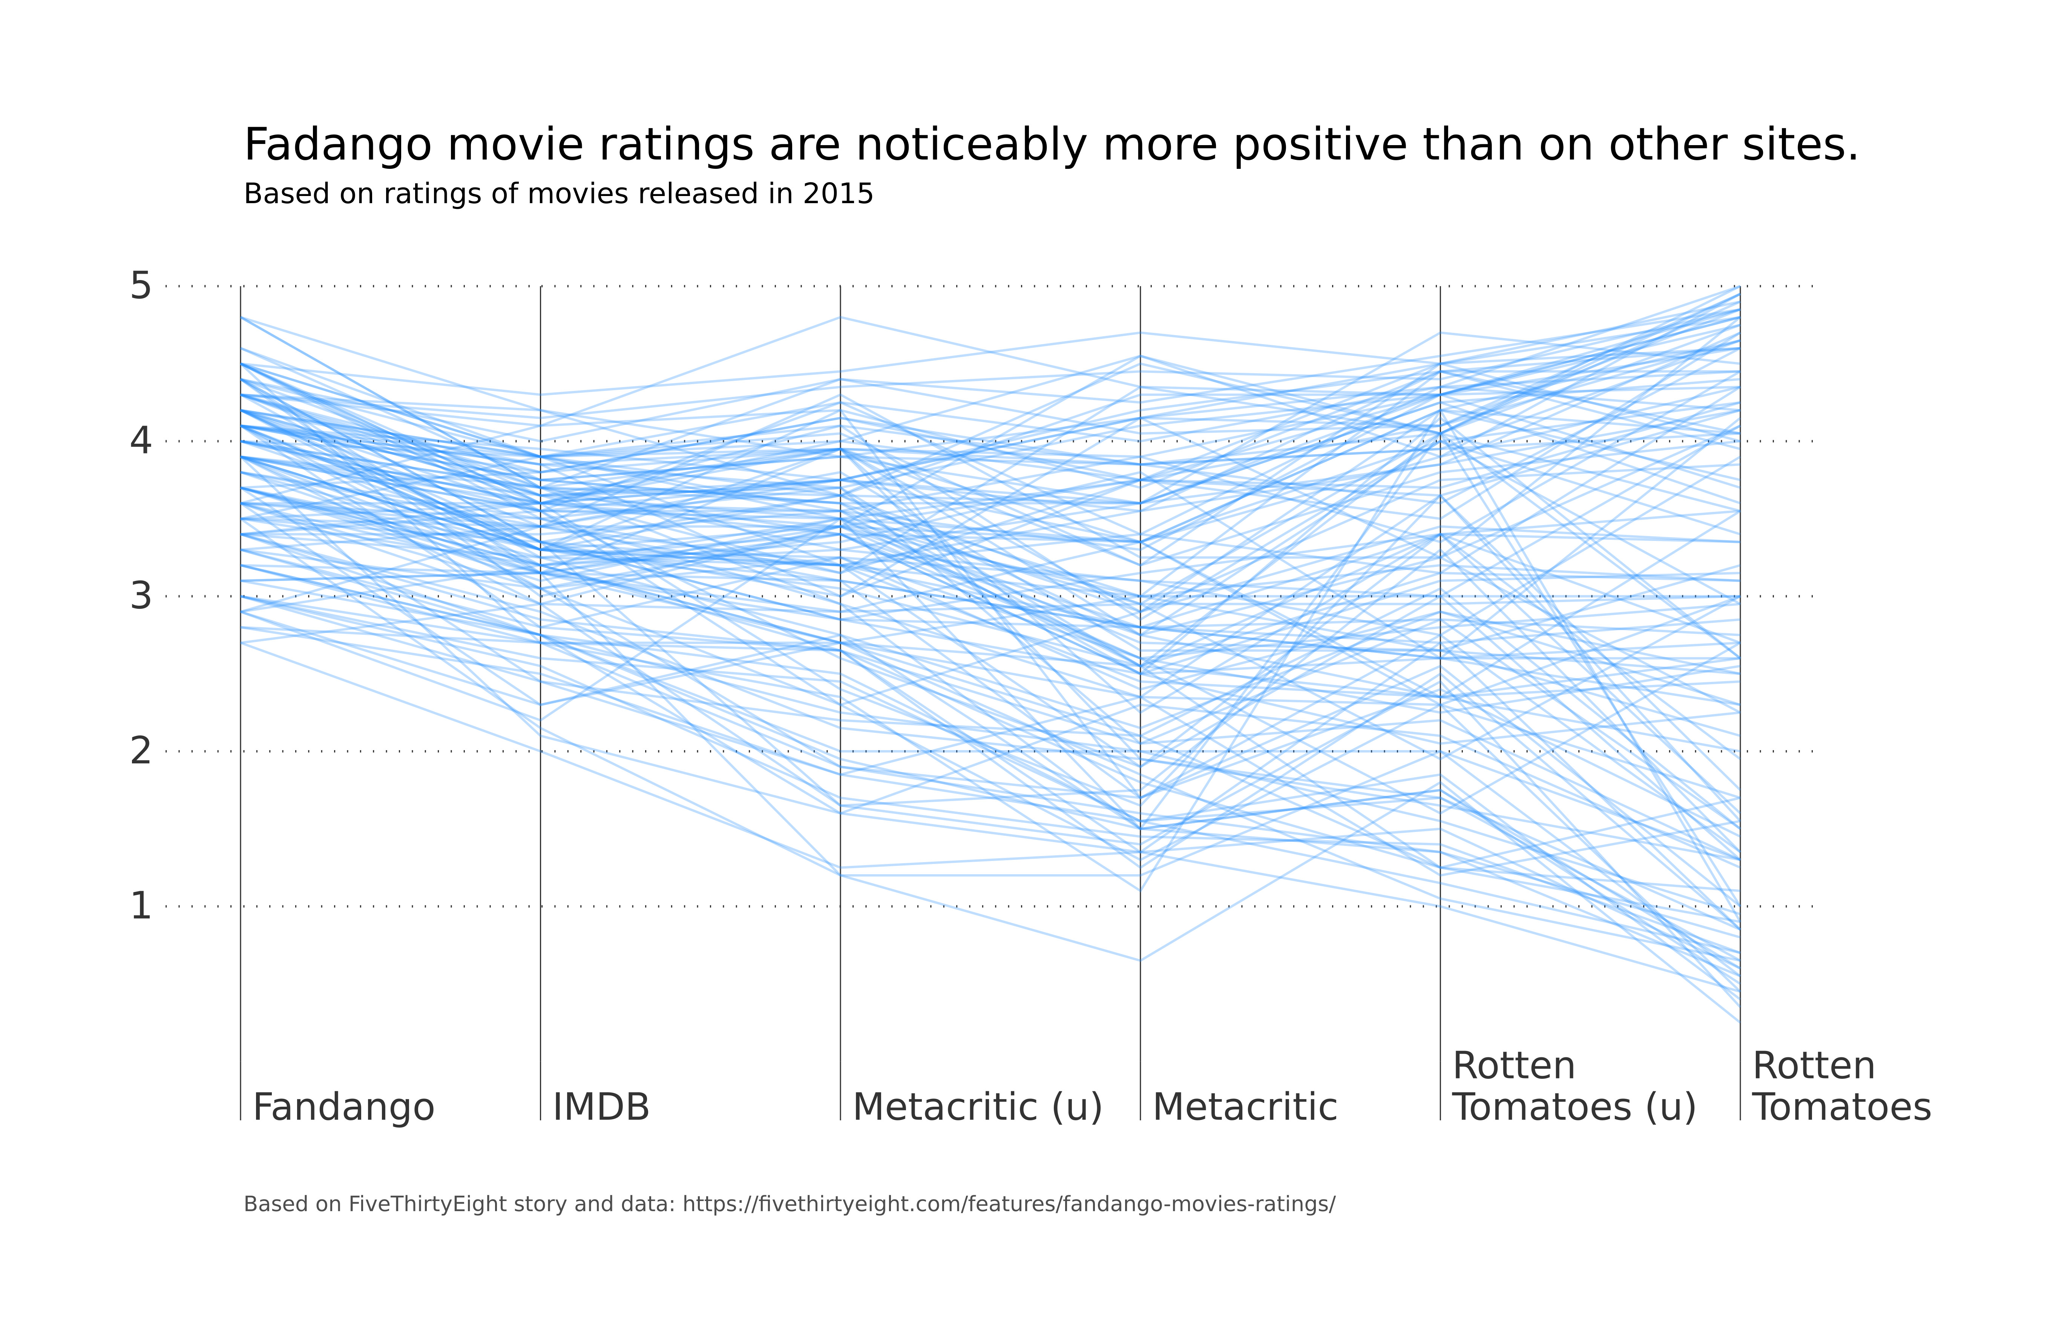

Figure: Charts/Comparison/jpg/parallel_plot.jpg

## Prompt Used

## Task: Extract Detailed Information from a Given Graph Image  
  
You will analyze a graph image and generate corresponding Plotly-compatible JSON files (`data.json`, `layout.json`, and `config.json`). Follow the structured steps and specific XML-like delimiters for each JSON section as outlined below.  
  
### Instructions:  
  
#### Graph Analysis:  
  
1. **Identify and Categorize Plot Types**:  
 - Recognize and categorize the plot types present in the graph image. Include both simple and complex plots, listed below:  
 - **Comparison Charts**:  
 - `bar`: Bar Chart  
 - `bar` (with vertical bars): Column Chart  
 - `bar` (grouped): Grouped Bar/Column Chart  
 - `scatter` (with lines connecting to points): Lollipop Chart  
 - `indicator` (with gauge): Bullet Chart  
 - `scatter`: Dot Plot  
 - `scatter` (with lines connecting different points): Dumbbell Chart  
 - `scatter` (or custom SVG): Pictogram  
 - `scatter` or `bar` with a range: Range Chart  
 - `barpolar`: Radial Bar Chart  
 - `parcoords`: Parallel Coordinates  
 - `scatterpolar`: Radar Chart  
 - `barpolar` (with segments): Nightingale Chart  
 - `waterfall`: Waterfall Chart  
 - `heatmap` (with color scale): Matrix Chart  
 - `various charts in small multiples`: Small Multiples  
 - `text` (frequency-based size): Word Cloud  
 - `scatter` (with lines indicating change): Slope Chart  
 - `table`: Table Chart  
 - `scatter`: Categorical Scatter Plot  
 - `scatter` (with four quadrants): Quadrant Chart  
 - **Correlation Charts**:  
 - `heatmap`: Heatmap  
 - `scatter` (with size): Bubble Chart  
 - `scatter`: Scatter Plot  
 - `scatter` (with lines connecting points): Connected Scatter Plot  
 - `hexbin`: Hexagonal Binning  
 - `contour`: Contour Plot  
 - **Part-to-Whole & Hierarchical Charts**:  
 - `bar` (stacked): Stacked Bar/Column Chart  
 - `bar` (with diverging sections): Diverging Bar Chart  
 - `bar` (mirrored pairs): Population Pyramid  
 - `scatter` (or custom symbols in a grid): Icon Array  
 - `waffle`: Waffle Chart  
 - `pie`: Pie Chart  
 - `pie` (with hole): Donut Chart  
 - `pie` (half-circle): Semi-circle Donut Chart  
 - `bar` (variable width): Marimekko Chart  
 - `treemap`: Treemap  
 - `treemap` (circular): Circular Treemap  
 - `treemap` (convex shape): Convex Treemap  
 - `sunburst`: Sunburst Chart  
 - `funnel` or `pyramid`: Funnel & Pyramid Chart  
 - `dendrogram`: Dendrogram  
 - `venn`: Venn Diagram  
 - `euler`: Euler Diagram  
 - `indicator` (circular gauge): Circular Gauge  
 - **Data Over Time (Temporal) Charts**:  
 - `scatter` (filled area under curve): Area Chart  
 - `scatter` (filled stacked areas): Stacked Area Chart  
 - `scatter` (smoothed filled areas): Stream Graph  
 - `scatter` (indicating ranking change): Bump Chart  
 - `scatter` (with filled area): Bump Area Chart  
 - `scatter`: Line Chart  
 - `scatter` (with smoothed lines): Spline Chart  
 - `scatter` (with stepped lines): Step Line Chart  
 - `candlestick`: Candlestick Chart  
 - `gantt`: Gantt Chart  
 - `scatter` (encoded lines): Barcode Chart  
 - `ohlc`: OHLC Chart  
 - **Distribution Charts**:  
 - `densitymapbox` or `histogram`: Density Plot  
 - `ridge`: Ridgeline Plot  
 - `horizon`: Horizon Chart  
 - `histogram`: Histogram  
 - `radial_histogram`: Radial Histogram  
 - `scatter` (with distribution): Strip Plot  
 - `scatter` (with jitter): Jitter Plot  
 - `heatmap`: One-dimensional Heatmap  
 - `scatter` (with tightly packed points): Beeswarm Chart  
 - `box`: Box Chart  
 - `violin`: Violin Plot  
 - **Geospatial & Other Charts**:  
 - `densitymapbox`: Geographic Heatmap  
 - `choropleth`: Choropleth Map  
 - `scattermapbox`: Tile Map  
 - `chord`: Chord Diagram  
 - `arc`: Arc Diagram  
 - `sankey`: Sankey  
 - `network`: Network Diagram  
 - `flowchart`: Flowchart  
  
2. **Extract Data Points** for Each Plot Type:  
 - Gather the data points for each identified plot type.  
 - For `scatter`, `line`, and `area` plots: Extract `x` and `y` values.  
 - For `bar` and `stacked bar` plots: Extract `x` (categories) and `y` values.  
 - For `pie` charts: Extract `labels` and `values`.  
 - For `scatter3d`, `surface`, and other 3D plots: Extract `x`, `y`, and `z` values.  
  
3. **Identify Multiple Plots** on the Same Figure:  
 - Note any combinations or overlays of multiple plot types on the same figure and their configurations, such as stacked plots or multiple area fills.  
  
#### Generate JSON and CSV Outputs:  
  
Follow the JSON formatting guidelines and wrap each section in the specified XML-like tags.  
  
1. **Generate `data.json`**:  
 - Include detailed information for each plot type:  
 - `type`: Specify the plot type (e.g., `"scatter"`, `"bar"`, `"pie"`, `"area"`, `"scatter3d"`, `"surface"`).  
 - For area charts, use `"type": "scatter"` and specify `"fill"`.  
 - `x`, `y`, and `z` (if applicable): Arrays of data points for each axis.  
 - `labels` and `values` for pie charts.  
 - `mode`: Specify for line and scatter plots (e.g., `"markers"`, `"lines"`, `"markers+lines"`).  
 - `name`: Legend entry for the plot.  
 - `marker`: Properties such as color, size, and symbol.  
 - `line`: Properties such as color, width, and dash style.  
 - `text`: Hover text for each data point.  
 - `hoverinfo`: Information displayed on hover (e.g., `"x+y+text"`).  
 - `fill`: For area charts, specify the fill (e.g., `"tozeroy"`, `"tonexty"`).  
 - `fillcolor`: The color used to fill the area.  
 - `stackgroup`: For stacked bar charts, specify the stacking group.  
  
2. **Generate `layout.json`**:  
 - Define the layout properties:  
 - `title`: Text and font properties for the graph title.  
 - `xaxis` and `yaxis`: Configuration for axis titles, ranges, grids, and ticks.  
 - `zaxis`: Configuration for 3D plots including title, range, and grid.  
 - `legend`: Properties for legend orientation and positioning.  
 - `margin`: Margins for left, right, bottom, top, and padding.  
 - `plot_bgcolor` and `paper_bgcolor`: Background colors.  
 - `scene`: Configuration for 3D scenes, including camera angles and aspect ratio.  
  
3. **Generate `config.json`**:  
 - Include settings such as:  
 - `responsive`: Whether the graph is responsive.  
 - `displayModeBar`: Whether the mode bar is shown.  
 - `modeBarButtonsToRemove`: List of mode bar buttons to remove.  
 - `scrollZoom`: Whether scrolling zoom is enabled.  
  
4. **Generate `<csv>`**:  
 - Format the CSV data as follows:  
 ```csv  
 x,y  
 1,4  
 2,5  
 3,6  
 ```  
 - Replace `x`, `y`, `1`, `4`, `2`, `5`, and `3`, `6` with the actual data from the graph image.  
  
### Output Format:  
  
Wrap each JSON output in the specified XML-like tags:  
  
- `<data> ... </data>`  
- `<layout> ... </layout>`  
- `<config> ... </config>`  
- `<csv> ... </csv>`  
  
Ensure the JSON format follows these rules:  
- Use double quotes for all keys and string values.  
- Do not include trailing commas in arrays or objects.  
  
### Example Output:  
  
```xml  
<data>  
[  
 {  
 "type": "scatter",  
 "x": [1, 2, 3],  
 "y": [4, 5, 6],  
 "mode": "markers+lines",  
 "name": "Line Plot",  
 "marker": {  
 "color": "rgba(75, 192, 192, 0.6)",  
 "size": 8  
 },  
 "line": {  
 "color": "rgba(75, 192, 192  
  
, 1)",  
 "width": 2  
 }  
 },  
 {  
 "type": "area",  
 "x": [1, 2, 3, 4, 5, 6, 7, 8, 9, 10, 11, 12],  
 "y": [400, 430, 550, 620, 580, 600, 630, 700, 670, 630, 600, 500],  
 "name": "Housing",  
 "marker": {  
 "color": "rgba(255, 159, 64, 0.8)"  
 },  
 "line": {  
 "color": "rgba(255, 159, 64, 1)",  
 "width": 2  
 }  
 },  
 {  
 "type": "bar",  
 "x": ["A", "B", "C"],  
 "y": [10, 15, 13],  
 "name": "Bar Chart",  
 "marker": {  
 "color": "rgba(255, 99, 132, 0.6)"  
 },  
 "hoverinfo": "x+y+text"  
 },  
 {  
 "type": "scatter",  
 "x": [1, 2, 3],  
 "y": [6, 7, 8],  
 "mode": "lines",  
 "fill": "tozeroy",  
 "name": "Area Chart",  
 "line": {  
 "color": "rgba(54, 162, 235, 1)",  
 "width": 2  
 },  
 "fillcolor": "rgba(54, 162, 235, 0.5)"  
 },  
 {  
 "type": "scatter3d",  
 "x": [1, 2, 3],  
 "y": [4, 5, 6],  
 "z": [7, 8, 9],  
 "mode": "markers",  
 "name": "3D Scatter Plot",  
 "marker": {  
 "color": "rgba(255, 159, 64, 0.8)",  
 "size": 5  
 },  
 "hoverinfo": "x+y+z+text"  
 },  
 {  
 "type": "surface",  
 "z": [  
 [10, 10.625, 12.5, 15.625, 20],  
 [5.625, 6.25, 8.125, 11.25, 15.625],  
 [0, 1.25, 3.125, 6.25, 10.625]  
 ],  
 "name": "Surface Plot",  
 "colorscale": "Viridis",  
 "hoverinfo": "z+name"  
 }  
]  
</data>  
<layout>  
{  
 "title": {  
 "text": "Complex Graph Example",  
 "font": {  
 "family": "Arial, sans-serif",  
 "size": 24,  
 "color": "#000000"  
 }  
 },  
 "xaxis": {  
 "title": {  
 "text": "X Axis",  
 "font": {  
 "family": "Arial, sans-serif",  
 "size": 18,  
 "color": "#000000"  
 }  
 },  
 "showgrid": true,  
 "gridcolor": "rgba(0, 0, 0, 0.1)",  
 "zeroline": true,  
 "zerolinecolor": "rgba(0, 0, 0, 0.1)"  
 },  
 "yaxis": {  
 "title": {  
 "text": "Y Axis",  
 "font": {  
 "family": "Arial, sans-serif",  
 "size": 18,  
 "color": "#000000"  
 }  
 },  
 "showgrid": true,  
 "gridcolor": "rgba(0, 0, 0, 0.1)",  
 "zeroline": true,  
 "zerolinecolor": "rgba(0, 0, 0, 0.1)"  
 },  
 "legend": {  
 "orientation": "h",  
 "x": 0.5,  
 "xanchor": "center",  
 "y": -0.2,  
 "font": {  
 "family": "Arial, sans-serif",  
 "size": 12,  
 "color": "#000000"  
 }  
 },  
 "margin": {  
 "l": 60,  
 "r": 30,  
 "b": 60,  
 "t": 60  
 },  
 "plot_bgcolor": "#ffffff",  
 "paper_bgcolor": "#ffffff",  
 "scene": {  
 "xaxis": {"title": "X Axis"},  
 "yaxis": {"title": "Y Axis"},  
 "zaxis": {"title": "Z Axis"}  
 }  
}  
</layout>  
<config>  
{  
 "responsive": true,  
 "displayModeBar": true,  
 "modeBarButtonsToRemove": ["toImage"],  
 "scrollZoom": true  
}  
</config>  
<csv>  
x,y  
1,4  
2,5  
3,6  
</csv>  
```

## Extracted JSON

### data

[  
 {  
 "type": "scatter",  
 "x": [  
 "Fandango",  
 "IMDb",  
 "Metacritic (u)",  
 "Metacritic",  
 "Rotten Tomatoes (u)",  
 "Rotten Tomatoes"  
 ],  
 "y": [  
 4.5,  
 3.9,  
 3.7,  
 3.3,  
 3.2,  
 1.3  
 ],  
 "mode": "lines+markers",  
 "name": "Fandango",  
 "marker": {  
 "color": "rgba(255, 159, 64, 0.8)"  
 },  
 "line": {  
 "color": "rgba(255, 159, 64, 1)",  
 "width": 2  
 }  
 }  
]

### layout

{  
 "title": {  
 "text": "Fandango movie ratings are noticeably more positive than on other sites.",  
 "font": {  
 "family": "Arial, sans-serif",  
 "size": 24,  
 "color": "#000000"  
 }  
 },  
 "xaxis": {  
 "title": {  
 "text": "Site",  
 "font": {  
 "family": "Arial, sans-serif",  
 "size": 18,  
 "color": "#000000"  
 }  
 },  
 "showgrid": false,  
 "zeroline": false  
 },  
 "yaxis": {  
 "title": {  
 "text": "Rating",  
 "font": {  
 "family": "Arial, sans-serif",  
 "size": 18,  
 "color": "#000000"  
 }  
 },  
 "showgrid": true,  
 "gridcolor": "rgba(0, 0, 0, 0.1)",  
 "zeroline": true,  
 "zerolinecolor": "rgba(0, 0, 0, 0.1)"  
 },  
 "legend": {  
 "orientation": "h",  
 "x": 0.5,  
 "xanchor": "center",  
 "y": -0.2,  
 "font": {  
 "family": "Arial, sans-serif",  
 "size": 12,  
 "color": "#000000"  
 }  
 },  
 "margin": {  
 "l": 60,  
 "r": 30,  
 "b": 60,  
 "t": 60  
 },  
 "plot_bgcolor": "#ffffff",  
 "paper_bgcolor": "#ffffff"  
}

### config

{  
 "responsive": true,  
 "displayModeBar": true,  
 "modeBarButtonsToRemove": [  
 "toImage"  
 ],  
 "scrollZoom": true  
}

## Updated JSON

### updated_data

[  
 {  
 "type": "scatter",  
 "x": [  
 "Fandango",  
 "IMDb",  
 "Metacritic (u)",  
 "Metacritic",  
 "Rotten Tomatoes (u)",  
 "Rotten Tomatoes"  
 ],  
 "y": [  
 4.5,  
 3.9,  
 3.7,  
 3.3,  
 3.2,  
 1.3  
 ],  
 "mode": "lines+markers",  
 "name": "Fandango",  
 "marker": {  
 "color": "rgba(255, 159, 64, 0.8)"  
 },  
 "line": {  
 "color": "rgba(255, 159, 64, 1)",  
 "width": 2  
 }  
 }  
]

### updated_layout

{  
 "title": {  
 "text": "Fandango movie ratings are noticeably more positive than on other sites.",  
 "font": {  
 "family": "Arial, sans-serif",  
 "size": 24,  
 "color": "#000000"  
 }  
 },  
 "xaxis": {  
 "title": {  
 "text": "Site",  
 "font": {  
 "family": "Arial, sans-serif",  
 "size": 18,  
 "color": "#000000"  
 }  
 },  
 "showgrid": false,  
 "zeroline": false  
 },  
 "yaxis": {  
 "title": {  
 "text": "Rating",  
 "font": {  
 "family": "Arial, sans-serif",  
 "size": 18,  
 "color": "#000000"  
 }  
 },  
 "showgrid": true,  
 "gridcolor": "rgba(0, 0, 0, 0.1)",  
 "zeroline": true,  
 "zerolinecolor": "rgba(0, 0, 0, 0.1)"  
 },  
 "legend": {  
 "orientation": "h",  
 "x": 0.5,  
 "xanchor": "center",  
 "y": -0.2,  
 "font": {  
 "family": "Arial, sans-serif",  
 "size": 12,  
 "color": "#000000"  
 }  
 },  
 "margin": {  
 "l": 60,  
 "r": 30,  
 "b": 60,  
 "t": 60  
 },  
 "plot_bgcolor": "#ffffff",  
 "paper_bgcolor": "#ffffff"  
}

### updated_config

{  
 "responsive": true,  
 "displayModeBar": true,  
 "modeBarButtonsToRemove": [  
 "toImage"  
 ],  
 "scrollZoom": true  
}

## Updated Chart

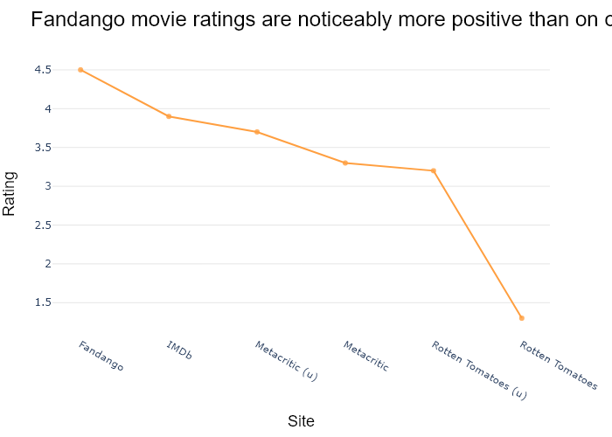

## Performance Metrics

|  |  |  |  |
| --- | --- | --- | --- |
| Task | Model Used | Description | Time Taken (s) |
| Processing Image to JSON | Gemini Vision Pro (default) | Time taken to convert the uploaded image to JSON format | 20.31 |
| Updating JSON | ChatGPT 3.5 (Default) | Time taken to update the JSON with new data | 0.00 |
| Plotting Updated JSON | N/A | Time taken to plot the updated JSON | 0.40 |

# Test Run

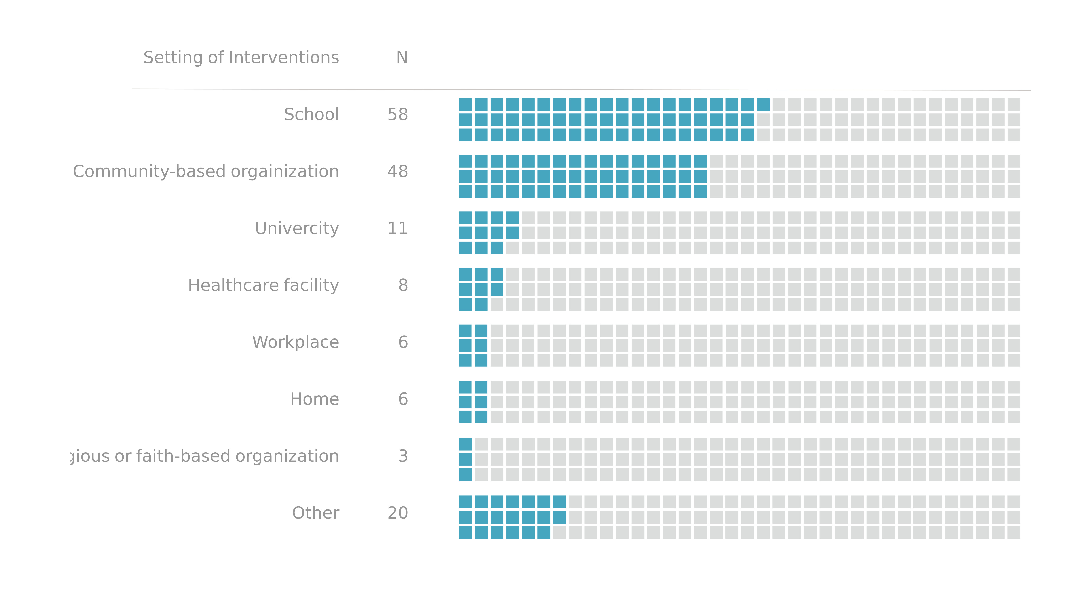

Figure: Charts/Comparison/jpg/pictogram.jpg

## Prompt Used

## Task: Extract Detailed Information from a Given Graph Image  
  
You will analyze a graph image and generate corresponding Plotly-compatible JSON files (`data.json`, `layout.json`, and `config.json`). Follow the structured steps and specific XML-like delimiters for each JSON section as outlined below.  
  
### Instructions:  
  
#### Graph Analysis:  
  
1. **Identify and Categorize Plot Types**:  
 - Recognize and categorize the plot types present in the graph image. Include both simple and complex plots, listed below:  
 - **Comparison Charts**:  
 - `bar`: Bar Chart  
 - `bar` (with vertical bars): Column Chart  
 - `bar` (grouped): Grouped Bar/Column Chart  
 - `scatter` (with lines connecting to points): Lollipop Chart  
 - `indicator` (with gauge): Bullet Chart  
 - `scatter`: Dot Plot  
 - `scatter` (with lines connecting different points): Dumbbell Chart  
 - `scatter` (or custom SVG): Pictogram  
 - `scatter` or `bar` with a range: Range Chart  
 - `barpolar`: Radial Bar Chart  
 - `parcoords`: Parallel Coordinates  
 - `scatterpolar`: Radar Chart  
 - `barpolar` (with segments): Nightingale Chart  
 - `waterfall`: Waterfall Chart  
 - `heatmap` (with color scale): Matrix Chart  
 - `various charts in small multiples`: Small Multiples  
 - `text` (frequency-based size): Word Cloud  
 - `scatter` (with lines indicating change): Slope Chart  
 - `table`: Table Chart  
 - `scatter`: Categorical Scatter Plot  
 - `scatter` (with four quadrants): Quadrant Chart  
 - **Correlation Charts**:  
 - `heatmap`: Heatmap  
 - `scatter` (with size): Bubble Chart  
 - `scatter`: Scatter Plot  
 - `scatter` (with lines connecting points): Connected Scatter Plot  
 - `hexbin`: Hexagonal Binning  
 - `contour`: Contour Plot  
 - **Part-to-Whole & Hierarchical Charts**:  
 - `bar` (stacked): Stacked Bar/Column Chart  
 - `bar` (with diverging sections): Diverging Bar Chart  
 - `bar` (mirrored pairs): Population Pyramid  
 - `scatter` (or custom symbols in a grid): Icon Array  
 - `waffle`: Waffle Chart  
 - `pie`: Pie Chart  
 - `pie` (with hole): Donut Chart  
 - `pie` (half-circle): Semi-circle Donut Chart  
 - `bar` (variable width): Marimekko Chart  
 - `treemap`: Treemap  
 - `treemap` (circular): Circular Treemap  
 - `treemap` (convex shape): Convex Treemap  
 - `sunburst`: Sunburst Chart  
 - `funnel` or `pyramid`: Funnel & Pyramid Chart  
 - `dendrogram`: Dendrogram  
 - `venn`: Venn Diagram  
 - `euler`: Euler Diagram  
 - `indicator` (circular gauge): Circular Gauge  
 - **Data Over Time (Temporal) Charts**:  
 - `scatter` (filled area under curve): Area Chart  
 - `scatter` (filled stacked areas): Stacked Area Chart  
 - `scatter` (smoothed filled areas): Stream Graph  
 - `scatter` (indicating ranking change): Bump Chart  
 - `scatter` (with filled area): Bump Area Chart  
 - `scatter`: Line Chart  
 - `scatter` (with smoothed lines): Spline Chart  
 - `scatter` (with stepped lines): Step Line Chart  
 - `candlestick`: Candlestick Chart  
 - `gantt`: Gantt Chart  
 - `scatter` (encoded lines): Barcode Chart  
 - `ohlc`: OHLC Chart  
 - **Distribution Charts**:  
 - `densitymapbox` or `histogram`: Density Plot  
 - `ridge`: Ridgeline Plot  
 - `horizon`: Horizon Chart  
 - `histogram`: Histogram  
 - `radial_histogram`: Radial Histogram  
 - `scatter` (with distribution): Strip Plot  
 - `scatter` (with jitter): Jitter Plot  
 - `heatmap`: One-dimensional Heatmap  
 - `scatter` (with tightly packed points): Beeswarm Chart  
 - `box`: Box Chart  
 - `violin`: Violin Plot  
 - **Geospatial & Other Charts**:  
 - `densitymapbox`: Geographic Heatmap  
 - `choropleth`: Choropleth Map  
 - `scattermapbox`: Tile Map  
 - `chord`: Chord Diagram  
 - `arc`: Arc Diagram  
 - `sankey`: Sankey  
 - `network`: Network Diagram  
 - `flowchart`: Flowchart  
  
2. **Extract Data Points** for Each Plot Type:  
 - Gather the data points for each identified plot type.  
 - For `scatter`, `line`, and `area` plots: Extract `x` and `y` values.  
 - For `bar` and `stacked bar` plots: Extract `x` (categories) and `y` values.  
 - For `pie` charts: Extract `labels` and `values`.  
 - For `scatter3d`, `surface`, and other 3D plots: Extract `x`, `y`, and `z` values.  
  
3. **Identify Multiple Plots** on the Same Figure:  
 - Note any combinations or overlays of multiple plot types on the same figure and their configurations, such as stacked plots or multiple area fills.  
  
#### Generate JSON and CSV Outputs:  
  
Follow the JSON formatting guidelines and wrap each section in the specified XML-like tags.  
  
1. **Generate `data.json`**:  
 - Include detailed information for each plot type:  
 - `type`: Specify the plot type (e.g., `"scatter"`, `"bar"`, `"pie"`, `"area"`, `"scatter3d"`, `"surface"`).  
 - For area charts, use `"type": "scatter"` and specify `"fill"`.  
 - `x`, `y`, and `z` (if applicable): Arrays of data points for each axis.  
 - `labels` and `values` for pie charts.  
 - `mode`: Specify for line and scatter plots (e.g., `"markers"`, `"lines"`, `"markers+lines"`).  
 - `name`: Legend entry for the plot.  
 - `marker`: Properties such as color, size, and symbol.  
 - `line`: Properties such as color, width, and dash style.  
 - `text`: Hover text for each data point.  
 - `hoverinfo`: Information displayed on hover (e.g., `"x+y+text"`).  
 - `fill`: For area charts, specify the fill (e.g., `"tozeroy"`, `"tonexty"`).  
 - `fillcolor`: The color used to fill the area.  
 - `stackgroup`: For stacked bar charts, specify the stacking group.  
  
2. **Generate `layout.json`**:  
 - Define the layout properties:  
 - `title`: Text and font properties for the graph title.  
 - `xaxis` and `yaxis`: Configuration for axis titles, ranges, grids, and ticks.  
 - `zaxis`: Configuration for 3D plots including title, range, and grid.  
 - `legend`: Properties for legend orientation and positioning.  
 - `margin`: Margins for left, right, bottom, top, and padding.  
 - `plot_bgcolor` and `paper_bgcolor`: Background colors.  
 - `scene`: Configuration for 3D scenes, including camera angles and aspect ratio.  
  
3. **Generate `config.json`**:  
 - Include settings such as:  
 - `responsive`: Whether the graph is responsive.  
 - `displayModeBar`: Whether the mode bar is shown.  
 - `modeBarButtonsToRemove`: List of mode bar buttons to remove.  
 - `scrollZoom`: Whether scrolling zoom is enabled.  
  
4. **Generate `<csv>`**:  
 - Format the CSV data as follows:  
 ```csv  
 x,y  
 1,4  
 2,5  
 3,6  
 ```  
 - Replace `x`, `y`, `1`, `4`, `2`, `5`, and `3`, `6` with the actual data from the graph image.  
  
### Output Format:  
  
Wrap each JSON output in the specified XML-like tags:  
  
- `<data> ... </data>`  
- `<layout> ... </layout>`  
- `<config> ... </config>`  
- `<csv> ... </csv>`  
  
Ensure the JSON format follows these rules:  
- Use double quotes for all keys and string values.  
- Do not include trailing commas in arrays or objects.  
  
### Example Output:  
  
```xml  
<data>  
[  
 {  
 "type": "scatter",  
 "x": [1, 2, 3],  
 "y": [4, 5, 6],  
 "mode": "markers+lines",  
 "name": "Line Plot",  
 "marker": {  
 "color": "rgba(75, 192, 192, 0.6)",  
 "size": 8  
 },  
 "line": {  
 "color": "rgba(75, 192, 192  
  
, 1)",  
 "width": 2  
 }  
 },  
 {  
 "type": "area",  
 "x": [1, 2, 3, 4, 5, 6, 7, 8, 9, 10, 11, 12],  
 "y": [400, 430, 550, 620, 580, 600, 630, 700, 670, 630, 600, 500],  
 "name": "Housing",  
 "marker": {  
 "color": "rgba(255, 159, 64, 0.8)"  
 },  
 "line": {  
 "color": "rgba(255, 159, 64, 1)",  
 "width": 2  
 }  
 },  
 {  
 "type": "bar",  
 "x": ["A", "B", "C"],  
 "y": [10, 15, 13],  
 "name": "Bar Chart",  
 "marker": {  
 "color": "rgba(255, 99, 132, 0.6)"  
 },  
 "hoverinfo": "x+y+text"  
 },  
 {  
 "type": "scatter",  
 "x": [1, 2, 3],  
 "y": [6, 7, 8],  
 "mode": "lines",  
 "fill": "tozeroy",  
 "name": "Area Chart",  
 "line": {  
 "color": "rgba(54, 162, 235, 1)",  
 "width": 2  
 },  
 "fillcolor": "rgba(54, 162, 235, 0.5)"  
 },  
 {  
 "type": "scatter3d",  
 "x": [1, 2, 3],  
 "y": [4, 5, 6],  
 "z": [7, 8, 9],  
 "mode": "markers",  
 "name": "3D Scatter Plot",  
 "marker": {  
 "color": "rgba(255, 159, 64, 0.8)",  
 "size": 5  
 },  
 "hoverinfo": "x+y+z+text"  
 },  
 {  
 "type": "surface",  
 "z": [  
 [10, 10.625, 12.5, 15.625, 20],  
 [5.625, 6.25, 8.125, 11.25, 15.625],  
 [0, 1.25, 3.125, 6.25, 10.625]  
 ],  
 "name": "Surface Plot",  
 "colorscale": "Viridis",  
 "hoverinfo": "z+name"  
 }  
]  
</data>  
<layout>  
{  
 "title": {  
 "text": "Complex Graph Example",  
 "font": {  
 "family": "Arial, sans-serif",  
 "size": 24,  
 "color": "#000000"  
 }  
 },  
 "xaxis": {  
 "title": {  
 "text": "X Axis",  
 "font": {  
 "family": "Arial, sans-serif",  
 "size": 18,  
 "color": "#000000"  
 }  
 },  
 "showgrid": true,  
 "gridcolor": "rgba(0, 0, 0, 0.1)",  
 "zeroline": true,  
 "zerolinecolor": "rgba(0, 0, 0, 0.1)"  
 },  
 "yaxis": {  
 "title": {  
 "text": "Y Axis",  
 "font": {  
 "family": "Arial, sans-serif",  
 "size": 18,  
 "color": "#000000"  
 }  
 },  
 "showgrid": true,  
 "gridcolor": "rgba(0, 0, 0, 0.1)",  
 "zeroline": true,  
 "zerolinecolor": "rgba(0, 0, 0, 0.1)"  
 },  
 "legend": {  
 "orientation": "h",  
 "x": 0.5,  
 "xanchor": "center",  
 "y": -0.2,  
 "font": {  
 "family": "Arial, sans-serif",  
 "size": 12,  
 "color": "#000000"  
 }  
 },  
 "margin": {  
 "l": 60,  
 "r": 30,  
 "b": 60,  
 "t": 60  
 },  
 "plot_bgcolor": "#ffffff",  
 "paper_bgcolor": "#ffffff",  
 "scene": {  
 "xaxis": {"title": "X Axis"},  
 "yaxis": {"title": "Y Axis"},  
 "zaxis": {"title": "Z Axis"}  
 }  
}  
</layout>  
<config>  
{  
 "responsive": true,  
 "displayModeBar": true,  
 "modeBarButtonsToRemove": ["toImage"],  
 "scrollZoom": true  
}  
</config>  
<csv>  
x,y  
1,4  
2,5  
3,6  
</csv>  
```

## Extracted JSON

### data

[  
 {  
 "type": "bar",  
 "x": [  
 "School",  
 "Community-based organization",  
 "University",  
 "Healthcare facility",  
 "Workplace",  
 "Home",  
 "Religious or faith-based organization",  
 "Other"  
 ],  
 "y": [  
 58,  
 48,  
 11,  
 8,  
 6,  
 6,  
 3,  
 20  
 ],  
 "name": "Interventions by Setting",  
 "marker": {  
 "color": "rgba(55, 128, 191, 0.8)"  
 },  
 "hoverinfo": "x+y"  
 }  
]

### layout

{  
 "title": {  
 "text": "Interventions by Setting",  
 "font": {  
 "family": "Arial, sans-serif",  
 "size": 24,  
 "color": "#000000"  
 }  
 },  
 "xaxis": {  
 "title": {  
 "text": "Setting",  
 "font": {  
 "family": "Arial, sans-serif",  
 "size": 18,  
 "color": "#000000"  
 }  
 },  
 "tickangle": -45,  
 "showgrid": true,  
 "gridcolor": "rgba(0, 0, 0, 0.1)",  
 "zeroline": true,  
 "zerolinecolor": "rgba(0, 0, 0, 0.1)"  
 },  
 "yaxis": {  
 "title": {  
 "text": "Number of Interventions",  
 "font": {  
 "family": "Arial, sans-serif",  
 "size": 18,  
 "color": "#000000"  
 }  
 },  
 "showgrid": true,  
 "gridcolor": "rgba(0, 0, 0, 0.1)",  
 "zeroline": true,  
 "zerolinecolor": "rgba(0, 0, 0, 0.1)"  
 },  
 "legend": {  
 "orientation": "h",  
 "x": 0.5,  
 "xanchor": "center",  
 "y": -0.2,  
 "font": {  
 "family": "Arial, sans-serif",  
 "size": 12,  
 "color": "#000000"  
 }  
 },  
 "margin": {  
 "l": 60,  
 "r": 30,  
 "b": 60,  
 "t": 60  
 },  
 "plot_bgcolor": "#ffffff",  
 "paper_bgcolor": "#ffffff"  
}

### config

{  
 "responsive": true,  
 "displayModeBar": true,  
 "modeBarButtonsToRemove": [  
 "toImage"  
 ],  
 "scrollZoom": true  
}

## Updated JSON

### updated_data

[  
 {  
 "type": "bar",  
 "x": [  
 "School",  
 "Community-based organization",  
 "University",  
 "Healthcare facility",  
 "Workplace",  
 "Home",  
 "Religious or faith-based organization",  
 "Other"  
 ],  
 "y": [  
 58,  
 48,  
 11,  
 8,  
 6,  
 6,  
 3,  
 20  
 ],  
 "name": "Interventions by Setting",  
 "marker": {  
 "color": "rgba(55, 128, 191, 0.8)"  
 },  
 "hoverinfo": "x+y"  
 }  
]

### updated_layout

{  
 "title": {  
 "text": "Interventions by Setting",  
 "font": {  
 "family": "Arial, sans-serif",  
 "size": 24,  
 "color": "#000000"  
 }  
 },  
 "xaxis": {  
 "title": {  
 "text": "Setting",  
 "font": {  
 "family": "Arial, sans-serif",  
 "size": 18,  
 "color": "#000000"  
 }  
 },  
 "tickangle": -45,  
 "showgrid": true,  
 "gridcolor": "rgba(0, 0, 0, 0.1)",  
 "zeroline": true,  
 "zerolinecolor": "rgba(0, 0, 0, 0.1)"  
 },  
 "yaxis": {  
 "title": {  
 "text": "Number of Interventions",  
 "font": {  
 "family": "Arial, sans-serif",  
 "size": 18,  
 "color": "#000000"  
 }  
 },  
 "showgrid": true,  
 "gridcolor": "rgba(0, 0, 0, 0.1)",  
 "zeroline": true,  
 "zerolinecolor": "rgba(0, 0, 0, 0.1)"  
 },  
 "legend": {  
 "orientation": "h",  
 "x": 0.5,  
 "xanchor": "center",  
 "y": -0.2,  
 "font": {  
 "family": "Arial, sans-serif",  
 "size": 12,  
 "color": "#000000"  
 }  
 },  
 "margin": {  
 "l": 60,  
 "r": 30,  
 "b": 60,  
 "t": 60  
 },  
 "plot_bgcolor": "#ffffff",  
 "paper_bgcolor": "#ffffff"  
}

### updated_config

{  
 "responsive": true,  
 "displayModeBar": true,  
 "modeBarButtonsToRemove": [  
 "toImage"  
 ],  
 "scrollZoom": true  
}

## Updated Chart

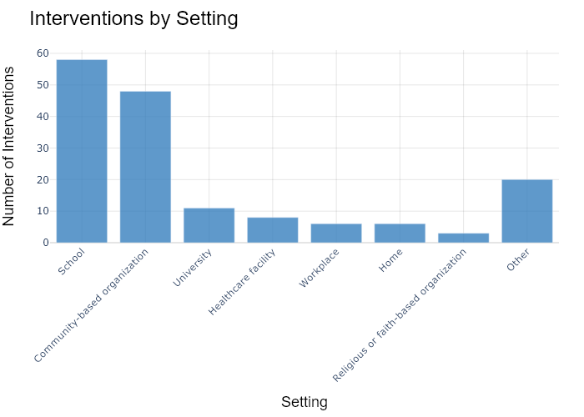

## Performance Metrics

|  |  |  |  |
| --- | --- | --- | --- |
| Task | Model Used | Description | Time Taken (s) |
| Processing Image to JSON | Gemini Vision Pro (default) | Time taken to convert the uploaded image to JSON format | 19.53 |
| Updating JSON | ChatGPT 3.5 (Default) | Time taken to update the JSON with new data | 0.00 |
| Plotting Updated JSON | N/A | Time taken to plot the updated JSON | 0.24 |

# Test Run

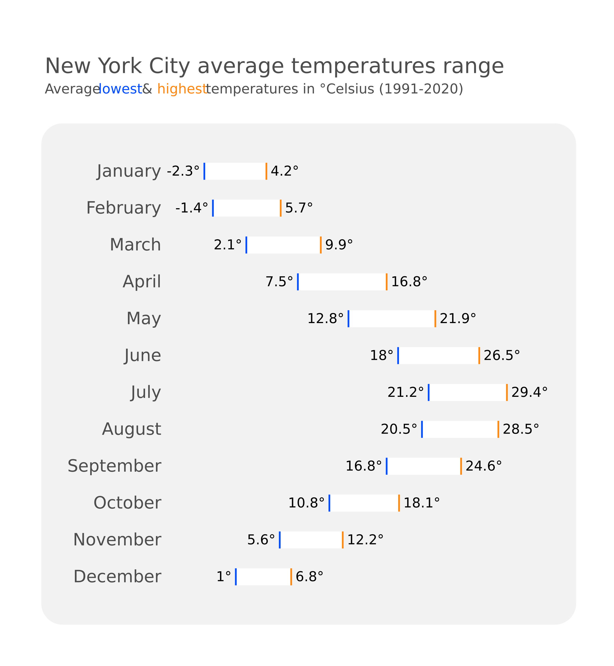

Figure: Charts/Comparison/jpg/range_plot.jpg

## Prompt Used

## Task: Extract Detailed Information from a Given Graph Image  
  
You will analyze a graph image and generate corresponding Plotly-compatible JSON files (`data.json`, `layout.json`, and `config.json`). Follow the structured steps and specific XML-like delimiters for each JSON section as outlined below.  
  
### Instructions:  
  
#### Graph Analysis:  
  
1. **Identify and Categorize Plot Types**:  
 - Recognize and categorize the plot types present in the graph image. Include both simple and complex plots, listed below:  
 - **Comparison Charts**:  
 - `bar`: Bar Chart  
 - `bar` (with vertical bars): Column Chart  
 - `bar` (grouped): Grouped Bar/Column Chart  
 - `scatter` (with lines connecting to points): Lollipop Chart  
 - `indicator` (with gauge): Bullet Chart  
 - `scatter`: Dot Plot  
 - `scatter` (with lines connecting different points): Dumbbell Chart  
 - `scatter` (or custom SVG): Pictogram  
 - `scatter` or `bar` with a range: Range Chart  
 - `barpolar`: Radial Bar Chart  
 - `parcoords`: Parallel Coordinates  
 - `scatterpolar`: Radar Chart  
 - `barpolar` (with segments): Nightingale Chart  
 - `waterfall`: Waterfall Chart  
 - `heatmap` (with color scale): Matrix Chart  
 - `various charts in small multiples`: Small Multiples  
 - `text` (frequency-based size): Word Cloud  
 - `scatter` (with lines indicating change): Slope Chart  
 - `table`: Table Chart  
 - `scatter`: Categorical Scatter Plot  
 - `scatter` (with four quadrants): Quadrant Chart  
 - **Correlation Charts**:  
 - `heatmap`: Heatmap  
 - `scatter` (with size): Bubble Chart  
 - `scatter`: Scatter Plot  
 - `scatter` (with lines connecting points): Connected Scatter Plot  
 - `hexbin`: Hexagonal Binning  
 - `contour`: Contour Plot  
 - **Part-to-Whole & Hierarchical Charts**:  
 - `bar` (stacked): Stacked Bar/Column Chart  
 - `bar` (with diverging sections): Diverging Bar Chart  
 - `bar` (mirrored pairs): Population Pyramid  
 - `scatter` (or custom symbols in a grid): Icon Array  
 - `waffle`: Waffle Chart  
 - `pie`: Pie Chart  
 - `pie` (with hole): Donut Chart  
 - `pie` (half-circle): Semi-circle Donut Chart  
 - `bar` (variable width): Marimekko Chart  
 - `treemap`: Treemap  
 - `treemap` (circular): Circular Treemap  
 - `treemap` (convex shape): Convex Treemap  
 - `sunburst`: Sunburst Chart  
 - `funnel` or `pyramid`: Funnel & Pyramid Chart  
 - `dendrogram`: Dendrogram  
 - `venn`: Venn Diagram  
 - `euler`: Euler Diagram  
 - `indicator` (circular gauge): Circular Gauge  
 - **Data Over Time (Temporal) Charts**:  
 - `scatter` (filled area under curve): Area Chart  
 - `scatter` (filled stacked areas): Stacked Area Chart  
 - `scatter` (smoothed filled areas): Stream Graph  
 - `scatter` (indicating ranking change): Bump Chart  
 - `scatter` (with filled area): Bump Area Chart  
 - `scatter`: Line Chart  
 - `scatter` (with smoothed lines): Spline Chart  
 - `scatter` (with stepped lines): Step Line Chart  
 - `candlestick`: Candlestick Chart  
 - `gantt`: Gantt Chart  
 - `scatter` (encoded lines): Barcode Chart  
 - `ohlc`: OHLC Chart  
 - **Distribution Charts**:  
 - `densitymapbox` or `histogram`: Density Plot  
 - `ridge`: Ridgeline Plot  
 - `horizon`: Horizon Chart  
 - `histogram`: Histogram  
 - `radial_histogram`: Radial Histogram  
 - `scatter` (with distribution): Strip Plot  
 - `scatter` (with jitter): Jitter Plot  
 - `heatmap`: One-dimensional Heatmap  
 - `scatter` (with tightly packed points): Beeswarm Chart  
 - `box`: Box Chart  
 - `violin`: Violin Plot  
 - **Geospatial & Other Charts**:  
 - `densitymapbox`: Geographic Heatmap  
 - `choropleth`: Choropleth Map  
 - `scattermapbox`: Tile Map  
 - `chord`: Chord Diagram  
 - `arc`: Arc Diagram  
 - `sankey`: Sankey  
 - `network`: Network Diagram  
 - `flowchart`: Flowchart  
  
2. **Extract Data Points** for Each Plot Type:  
 - Gather the data points for each identified plot type.  
 - For `scatter`, `line`, and `area` plots: Extract `x` and `y` values.  
 - For `bar` and `stacked bar` plots: Extract `x` (categories) and `y` values.  
 - For `pie` charts: Extract `labels` and `values`.  
 - For `scatter3d`, `surface`, and other 3D plots: Extract `x`, `y`, and `z` values.  
  
3. **Identify Multiple Plots** on the Same Figure:  
 - Note any combinations or overlays of multiple plot types on the same figure and their configurations, such as stacked plots or multiple area fills.  
  
#### Generate JSON and CSV Outputs:  
  
Follow the JSON formatting guidelines and wrap each section in the specified XML-like tags.  
  
1. **Generate `data.json`**:  
 - Include detailed information for each plot type:  
 - `type`: Specify the plot type (e.g., `"scatter"`, `"bar"`, `"pie"`, `"area"`, `"scatter3d"`, `"surface"`).  
 - For area charts, use `"type": "scatter"` and specify `"fill"`.  
 - `x`, `y`, and `z` (if applicable): Arrays of data points for each axis.  
 - `labels` and `values` for pie charts.  
 - `mode`: Specify for line and scatter plots (e.g., `"markers"`, `"lines"`, `"markers+lines"`).  
 - `name`: Legend entry for the plot.  
 - `marker`: Properties such as color, size, and symbol.  
 - `line`: Properties such as color, width, and dash style.  
 - `text`: Hover text for each data point.  
 - `hoverinfo`: Information displayed on hover (e.g., `"x+y+text"`).  
 - `fill`: For area charts, specify the fill (e.g., `"tozeroy"`, `"tonexty"`).  
 - `fillcolor`: The color used to fill the area.  
 - `stackgroup`: For stacked bar charts, specify the stacking group.  
  
2. **Generate `layout.json`**:  
 - Define the layout properties:  
 - `title`: Text and font properties for the graph title.  
 - `xaxis` and `yaxis`: Configuration for axis titles, ranges, grids, and ticks.  
 - `zaxis`: Configuration for 3D plots including title, range, and grid.  
 - `legend`: Properties for legend orientation and positioning.  
 - `margin`: Margins for left, right, bottom, top, and padding.  
 - `plot_bgcolor` and `paper_bgcolor`: Background colors.  
 - `scene`: Configuration for 3D scenes, including camera angles and aspect ratio.  
  
3. **Generate `config.json`**:  
 - Include settings such as:  
 - `responsive`: Whether the graph is responsive.  
 - `displayModeBar`: Whether the mode bar is shown.  
 - `modeBarButtonsToRemove`: List of mode bar buttons to remove.  
 - `scrollZoom`: Whether scrolling zoom is enabled.  
  
4. **Generate `<csv>`**:  
 - Format the CSV data as follows:  
 ```csv  
 x,y  
 1,4  
 2,5  
 3,6  
 ```  
 - Replace `x`, `y`, `1`, `4`, `2`, `5`, and `3`, `6` with the actual data from the graph image.  
  
### Output Format:  
  
Wrap each JSON output in the specified XML-like tags:  
  
- `<data> ... </data>`  
- `<layout> ... </layout>`  
- `<config> ... </config>`  
- `<csv> ... </csv>`  
  
Ensure the JSON format follows these rules:  
- Use double quotes for all keys and string values.  
- Do not include trailing commas in arrays or objects.  
  
### Example Output:  
  
```xml  
<data>  
[  
 {  
 "type": "scatter",  
 "x": [1, 2, 3],  
 "y": [4, 5, 6],  
 "mode": "markers+lines",  
 "name": "Line Plot",  
 "marker": {  
 "color": "rgba(75, 192, 192, 0.6)",  
 "size": 8  
 },  
 "line": {  
 "color": "rgba(75, 192, 192  
  
, 1)",  
 "width": 2  
 }  
 },  
 {  
 "type": "area",  
 "x": [1, 2, 3, 4, 5, 6, 7, 8, 9, 10, 11, 12],  
 "y": [400, 430, 550, 620, 580, 600, 630, 700, 670, 630, 600, 500],  
 "name": "Housing",  
 "marker": {  
 "color": "rgba(255, 159, 64, 0.8)"  
 },  
 "line": {  
 "color": "rgba(255, 159, 64, 1)",  
 "width": 2  
 }  
 },  
 {  
 "type": "bar",  
 "x": ["A", "B", "C"],  
 "y": [10, 15, 13],  
 "name": "Bar Chart",  
 "marker": {  
 "color": "rgba(255, 99, 132, 0.6)"  
 },  
 "hoverinfo": "x+y+text"  
 },  
 {  
 "type": "scatter",  
 "x": [1, 2, 3],  
 "y": [6, 7, 8],  
 "mode": "lines",  
 "fill": "tozeroy",  
 "name": "Area Chart",  
 "line": {  
 "color": "rgba(54, 162, 235, 1)",  
 "width": 2  
 },  
 "fillcolor": "rgba(54, 162, 235, 0.5)"  
 },  
 {  
 "type": "scatter3d",  
 "x": [1, 2, 3],  
 "y": [4, 5, 6],  
 "z": [7, 8, 9],  
 "mode": "markers",  
 "name": "3D Scatter Plot",  
 "marker": {  
 "color": "rgba(255, 159, 64, 0.8)",  
 "size": 5  
 },  
 "hoverinfo": "x+y+z+text"  
 },  
 {  
 "type": "surface",  
 "z": [  
 [10, 10.625, 12.5, 15.625, 20],  
 [5.625, 6.25, 8.125, 11.25, 15.625],  
 [0, 1.25, 3.125, 6.25, 10.625]  
 ],  
 "name": "Surface Plot",  
 "colorscale": "Viridis",  
 "hoverinfo": "z+name"  
 }  
]  
</data>  
<layout>  
{  
 "title": {  
 "text": "Complex Graph Example",  
 "font": {  
 "family": "Arial, sans-serif",  
 "size": 24,  
 "color": "#000000"  
 }  
 },  
 "xaxis": {  
 "title": {  
 "text": "X Axis",  
 "font": {  
 "family": "Arial, sans-serif",  
 "size": 18,  
 "color": "#000000"  
 }  
 },  
 "showgrid": true,  
 "gridcolor": "rgba(0, 0, 0, 0.1)",  
 "zeroline": true,  
 "zerolinecolor": "rgba(0, 0, 0, 0.1)"  
 },  
 "yaxis": {  
 "title": {  
 "text": "Y Axis",  
 "font": {  
 "family": "Arial, sans-serif",  
 "size": 18,  
 "color": "#000000"  
 }  
 },  
 "showgrid": true,  
 "gridcolor": "rgba(0, 0, 0, 0.1)",  
 "zeroline": true,  
 "zerolinecolor": "rgba(0, 0, 0, 0.1)"  
 },  
 "legend": {  
 "orientation": "h",  
 "x": 0.5,  
 "xanchor": "center",  
 "y": -0.2,  
 "font": {  
 "family": "Arial, sans-serif",  
 "size": 12,  
 "color": "#000000"  
 }  
 },  
 "margin": {  
 "l": 60,  
 "r": 30,  
 "b": 60,  
 "t": 60  
 },  
 "plot_bgcolor": "#ffffff",  
 "paper_bgcolor": "#ffffff",  
 "scene": {  
 "xaxis": {"title": "X Axis"},  
 "yaxis": {"title": "Y Axis"},  
 "zaxis": {"title": "Z Axis"}  
 }  
}  
</layout>  
<config>  
{  
 "responsive": true,  
 "displayModeBar": true,  
 "modeBarButtonsToRemove": ["toImage"],  
 "scrollZoom": true  
}  
</config>  
<csv>  
x,y  
1,4  
2,5  
3,6  
</csv>  
```

## Extracted JSON

### data

[  
 {  
 "type": "scatter",  
 "x": [  
 "January",  
 "February",  
 "March",  
 "April",  
 "May",  
 "June",  
 "July",  
 "August",  
 "September",  
 "October",  
 "November",  
 "December"  
 ],  
 "y": [  
 -2.3,  
 -1.4,  
 2.1,  
 7.5,  
 12.8,  
 18,  
 21.2,  
 20.5,  
 16.8,  
 10.8,  
 5.6,  
 1  
 ],  
 "mode": "lines",  
 "name": "Average Low Temperature",  
 "line": {  
 "color": "rgba(255, 159, 64, 1)",  
 "width": 2  
 }  
 },  
 {  
 "type": "scatter",  
 "x": [  
 "January",  
 "February",  
 "March",  
 "April",  
 "May",  
 "June",  
 "July",  
 "August",  
 "September",  
 "October",  
 "November",  
 "December"  
 ],  
 "y": [  
 4.2,  
 5.7,  
 9.9,  
 16.8,  
 21.9,  
 26.5,  
 29.4,  
 28.5,  
 24.6,  
 18.1,  
 12.2,  
 6.8  
 ],  
 "mode": "lines",  
 "name": "Average High Temperature",  
 "line": {  
 "color": "rgba(54, 162, 235, 1)",  
 "width": 2  
 }  
 }  
]

### layout

{  
 "title": {  
 "text": "New York City Average Temperatures",  
 "font": {  
 "family": "Arial, sans-serif",  
 "size": 24,  
 "color": "#000000"  
 }  
 },  
 "xaxis": {  
 "title": {  
 "text": "Months",  
 "font": {  
 "family": "Arial, sans-serif",  
 "size": 18,  
 "color": "#000000"  
 }  
 },  
 "showgrid": true,  
 "gridcolor": "rgba(0, 0, 0, 0.1)",  
 "zeroline": true,  
 "zerolinecolor": "rgba(0, 0, 0, 0.1)"  
 },  
 "yaxis": {  
 "title": {  
 "text": "Temperature (\u00b0C)",  
 "font": {  
 "family": "Arial, sans-serif",  
 "size": 18,  
 "color": "#000000"  
 }  
 },  
 "showgrid": true,  
 "gridcolor": "rgba(0, 0, 0, 0.1)",  
 "zeroline": true,  
 "zerolinecolor": "rgba(0, 0, 0, 0.1)"  
 },  
 "legend": {  
 "orientation": "h",  
 "x": 0.5,  
 "xanchor": "center",  
 "y": -0.2,  
 "font": {  
 "family": "Arial, sans-serif",  
 "size": 12,  
 "color": "#000000"  
 }  
 },  
 "margin": {  
 "l": 60,  
 "r": 30,  
 "b": 60,  
 "t": 60  
 },  
 "plot_bgcolor": "#ffffff",  
 "paper_bgcolor": "#ffffff"  
}

### config

{  
 "responsive": true,  
 "displayModeBar": true,  
 "modeBarButtonsToRemove": [  
 "toImage"  
 ],  
 "scrollZoom": true  
}

## Updated JSON

### updated_data

[  
 {  
 "type": "scatter",  
 "x": [  
 "January",  
 "February",  
 "March",  
 "April",  
 "May",  
 "June",  
 "July",  
 "August",  
 "September",  
 "October",  
 "November",  
 "December"  
 ],  
 "y": [  
 -2.3,  
 -1.4,  
 2.1,  
 7.5,  
 12.8,  
 18,  
 21.2,  
 20.5,  
 16.8,  
 10.8,  
 5.6,  
 1  
 ],  
 "mode": "lines",  
 "name": "Average Low Temperature",  
 "line": {  
 "color": "rgba(255, 159, 64, 1)",  
 "width": 2  
 }  
 },  
 {  
 "type": "scatter",  
 "x": [  
 "January",  
 "February",  
 "March",  
 "April",  
 "May",  
 "June",  
 "July",  
 "August",  
 "September",  
 "October",  
 "November",  
 "December"  
 ],  
 "y": [  
 4.2,  
 5.7,  
 9.9,  
 16.8,  
 21.9,  
 26.5,  
 29.4,  
 28.5,  
 24.6,  
 18.1,  
 12.2,  
 6.8  
 ],  
 "mode": "lines",  
 "name": "Average High Temperature",  
 "line": {  
 "color": "rgba(54, 162, 235, 1)",  
 "width": 2  
 }  
 }  
]

### updated_layout

{  
 "title": {  
 "text": "New York City Average Temperatures",  
 "font": {  
 "family": "Arial, sans-serif",  
 "size": 24,  
 "color": "#000000"  
 }  
 },  
 "xaxis": {  
 "title": {  
 "text": "Months",  
 "font": {  
 "family": "Arial, sans-serif",  
 "size": 18,  
 "color": "#000000"  
 }  
 },  
 "showgrid": true,  
 "gridcolor": "rgba(0, 0, 0, 0.1)",  
 "zeroline": true,  
 "zerolinecolor": "rgba(0, 0, 0, 0.1)"  
 },  
 "yaxis": {  
 "title": {  
 "text": "Temperature (\u00b0C)",  
 "font": {  
 "family": "Arial, sans-serif",  
 "size": 18,  
 "color": "#000000"  
 }  
 },  
 "showgrid": true,  
 "gridcolor": "rgba(0, 0, 0, 0.1)",  
 "zeroline": true,  
 "zerolinecolor": "rgba(0, 0, 0, 0.1)"  
 },  
 "legend": {  
 "orientation": "h",  
 "x": 0.5,  
 "xanchor": "center",  
 "y": -0.2,  
 "font": {  
 "family": "Arial, sans-serif",  
 "size": 12,  
 "color": "#000000"  
 }  
 },  
 "margin": {  
 "l": 60,  
 "r": 30,  
 "b": 60,  
 "t": 60  
 },  
 "plot_bgcolor": "#ffffff",  
 "paper_bgcolor": "#ffffff"  
}

### updated_config

{  
 "responsive": true,  
 "displayModeBar": true,  
 "modeBarButtonsToRemove": [  
 "toImage"  
 ],  
 "scrollZoom": true  
}

## Updated Chart

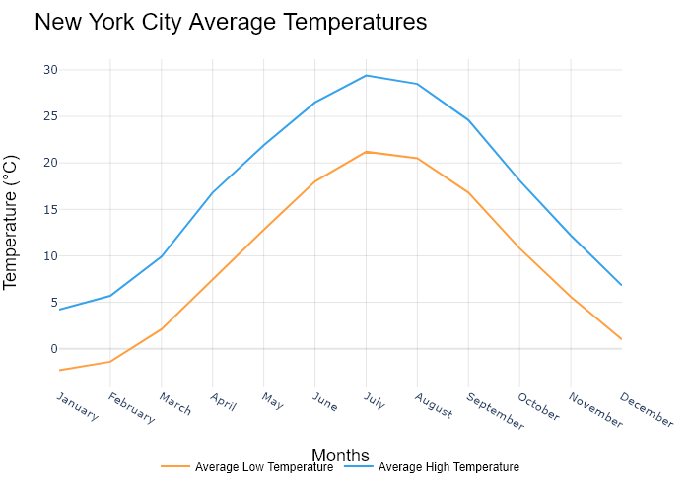

## Performance Metrics

|  |  |  |  |
| --- | --- | --- | --- |
| Task | Model Used | Description | Time Taken (s) |
| Processing Image to JSON | Gemini Vision Pro (default) | Time taken to convert the uploaded image to JSON format | 24.61 |
| Updating JSON | ChatGPT 3.5 (Default) | Time taken to update the JSON with new data | 0.00 |
| Plotting Updated JSON | N/A | Time taken to plot the updated JSON | 0.22 |

# Test Run

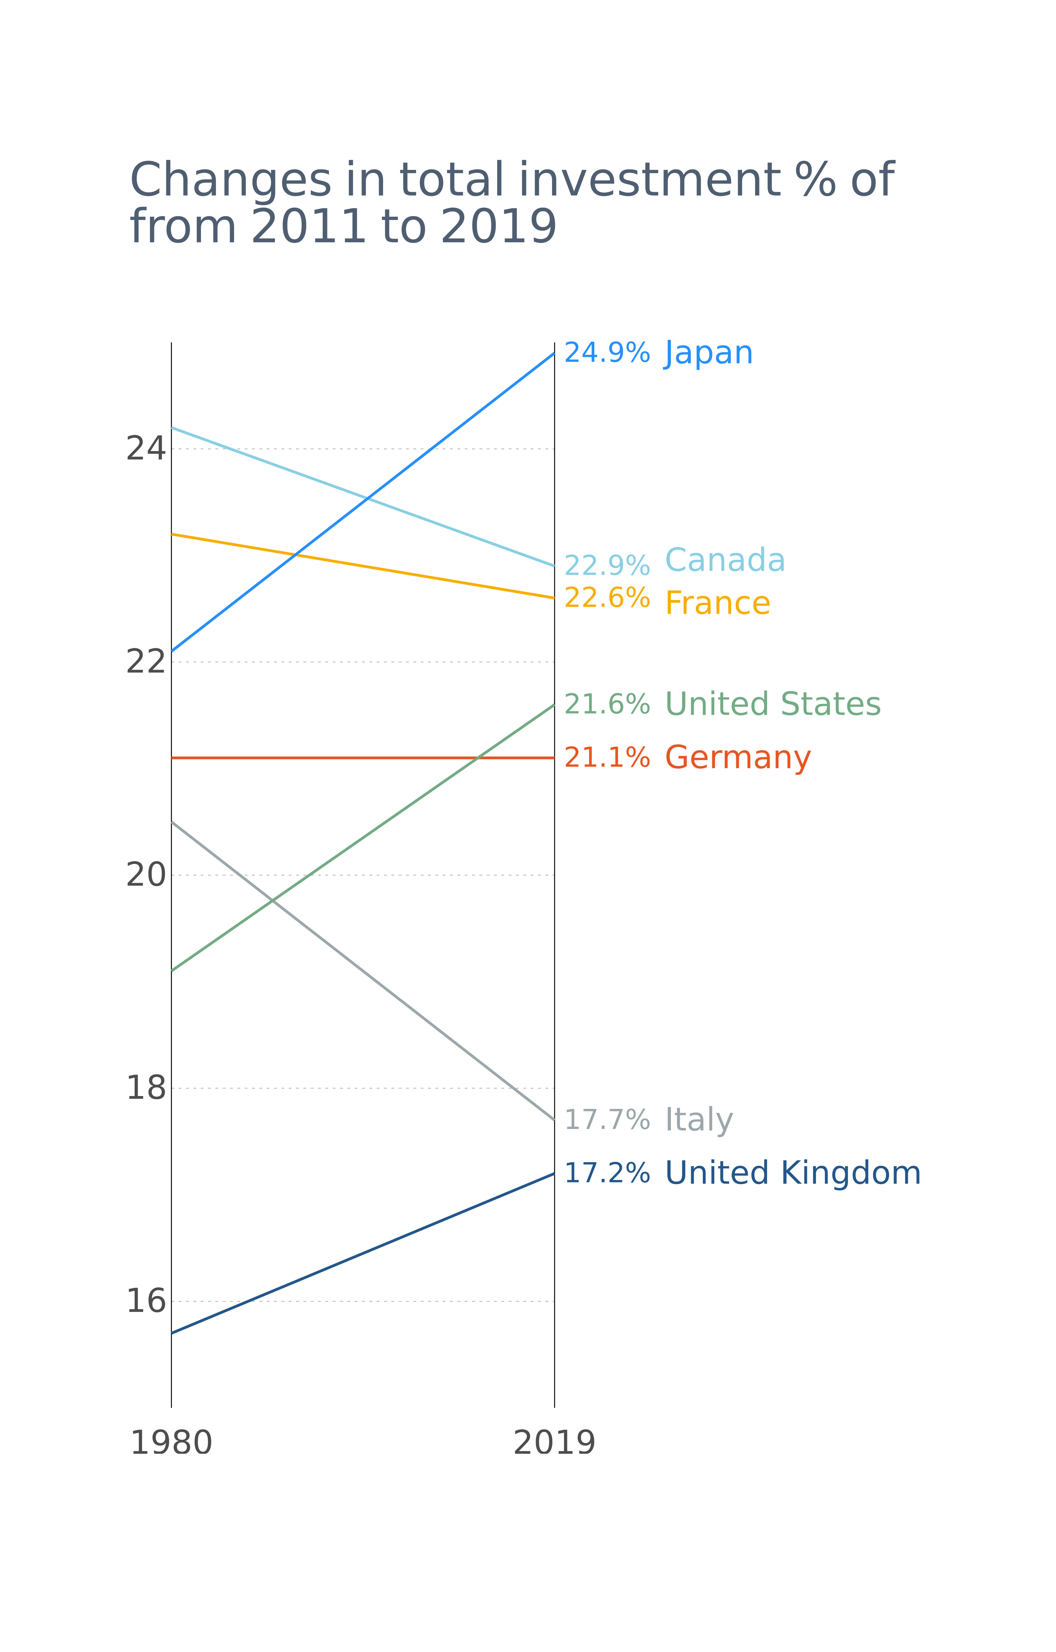

Figure: Charts/Comparison/jpg/slope_chart.jpg

## Prompt Used

## Task: Extract Detailed Information from a Given Graph Image  
  
You will analyze a graph image and generate corresponding Plotly-compatible JSON files (`data.json`, `layout.json`, and `config.json`). Follow the structured steps and specific XML-like delimiters for each JSON section as outlined below.  
  
### Instructions:  
  
#### Graph Analysis:  
  
1. **Identify and Categorize Plot Types**:  
 - Recognize and categorize the plot types present in the graph image. Include both simple and complex plots, listed below:  
 - **Comparison Charts**:  
 - `bar`: Bar Chart  
 - `bar` (with vertical bars): Column Chart  
 - `bar` (grouped): Grouped Bar/Column Chart  
 - `scatter` (with lines connecting to points): Lollipop Chart  
 - `indicator` (with gauge): Bullet Chart  
 - `scatter`: Dot Plot  
 - `scatter` (with lines connecting different points): Dumbbell Chart  
 - `scatter` (or custom SVG): Pictogram  
 - `scatter` or `bar` with a range: Range Chart  
 - `barpolar`: Radial Bar Chart  
 - `parcoords`: Parallel Coordinates  
 - `scatterpolar`: Radar Chart  
 - `barpolar` (with segments): Nightingale Chart  
 - `waterfall`: Waterfall Chart  
 - `heatmap` (with color scale): Matrix Chart  
 - `various charts in small multiples`: Small Multiples  
 - `text` (frequency-based size): Word Cloud  
 - `scatter` (with lines indicating change): Slope Chart  
 - `table`: Table Chart  
 - `scatter`: Categorical Scatter Plot  
 - `scatter` (with four quadrants): Quadrant Chart  
 - **Correlation Charts**:  
 - `heatmap`: Heatmap  
 - `scatter` (with size): Bubble Chart  
 - `scatter`: Scatter Plot  
 - `scatter` (with lines connecting points): Connected Scatter Plot  
 - `hexbin`: Hexagonal Binning  
 - `contour`: Contour Plot  
 - **Part-to-Whole & Hierarchical Charts**:  
 - `bar` (stacked): Stacked Bar/Column Chart  
 - `bar` (with diverging sections): Diverging Bar Chart  
 - `bar` (mirrored pairs): Population Pyramid  
 - `scatter` (or custom symbols in a grid): Icon Array  
 - `waffle`: Waffle Chart  
 - `pie`: Pie Chart  
 - `pie` (with hole): Donut Chart  
 - `pie` (half-circle): Semi-circle Donut Chart  
 - `bar` (variable width): Marimekko Chart  
 - `treemap`: Treemap  
 - `treemap` (circular): Circular Treemap  
 - `treemap` (convex shape): Convex Treemap  
 - `sunburst`: Sunburst Chart  
 - `funnel` or `pyramid`: Funnel & Pyramid Chart  
 - `dendrogram`: Dendrogram  
 - `venn`: Venn Diagram  
 - `euler`: Euler Diagram  
 - `indicator` (circular gauge): Circular Gauge  
 - **Data Over Time (Temporal) Charts**:  
 - `scatter` (filled area under curve): Area Chart  
 - `scatter` (filled stacked areas): Stacked Area Chart  
 - `scatter` (smoothed filled areas): Stream Graph  
 - `scatter` (indicating ranking change): Bump Chart  
 - `scatter` (with filled area): Bump Area Chart  
 - `scatter`: Line Chart  
 - `scatter` (with smoothed lines): Spline Chart  
 - `scatter` (with stepped lines): Step Line Chart  
 - `candlestick`: Candlestick Chart  
 - `gantt`: Gantt Chart  
 - `scatter` (encoded lines): Barcode Chart  
 - `ohlc`: OHLC Chart  
 - **Distribution Charts**:  
 - `densitymapbox` or `histogram`: Density Plot  
 - `ridge`: Ridgeline Plot  
 - `horizon`: Horizon Chart  
 - `histogram`: Histogram  
 - `radial_histogram`: Radial Histogram  
 - `scatter` (with distribution): Strip Plot  
 - `scatter` (with jitter): Jitter Plot  
 - `heatmap`: One-dimensional Heatmap  
 - `scatter` (with tightly packed points): Beeswarm Chart  
 - `box`: Box Chart  
 - `violin`: Violin Plot  
 - **Geospatial & Other Charts**:  
 - `densitymapbox`: Geographic Heatmap  
 - `choropleth`: Choropleth Map  
 - `scattermapbox`: Tile Map  
 - `chord`: Chord Diagram  
 - `arc`: Arc Diagram  
 - `sankey`: Sankey  
 - `network`: Network Diagram  
 - `flowchart`: Flowchart  
  
2. **Extract Data Points** for Each Plot Type:  
 - Gather the data points for each identified plot type.  
 - For `scatter`, `line`, and `area` plots: Extract `x` and `y` values.  
 - For `bar` and `stacked bar` plots: Extract `x` (categories) and `y` values.  
 - For `pie` charts: Extract `labels` and `values`.  
 - For `scatter3d`, `surface`, and other 3D plots: Extract `x`, `y`, and `z` values.  
  
3. **Identify Multiple Plots** on the Same Figure:  
 - Note any combinations or overlays of multiple plot types on the same figure and their configurations, such as stacked plots or multiple area fills.  
  
#### Generate JSON and CSV Outputs:  
  
Follow the JSON formatting guidelines and wrap each section in the specified XML-like tags.  
  
1. **Generate `data.json`**:  
 - Include detailed information for each plot type:  
 - `type`: Specify the plot type (e.g., `"scatter"`, `"bar"`, `"pie"`, `"area"`, `"scatter3d"`, `"surface"`).  
 - For area charts, use `"type": "scatter"` and specify `"fill"`.  
 - `x`, `y`, and `z` (if applicable): Arrays of data points for each axis.  
 - `labels` and `values` for pie charts.  
 - `mode`: Specify for line and scatter plots (e.g., `"markers"`, `"lines"`, `"markers+lines"`).  
 - `name`: Legend entry for the plot.  
 - `marker`: Properties such as color, size, and symbol.  
 - `line`: Properties such as color, width, and dash style.  
 - `text`: Hover text for each data point.  
 - `hoverinfo`: Information displayed on hover (e.g., `"x+y+text"`).  
 - `fill`: For area charts, specify the fill (e.g., `"tozeroy"`, `"tonexty"`).  
 - `fillcolor`: The color used to fill the area.  
 - `stackgroup`: For stacked bar charts, specify the stacking group.  
  
2. **Generate `layout.json`**:  
 - Define the layout properties:  
 - `title`: Text and font properties for the graph title.  
 - `xaxis` and `yaxis`: Configuration for axis titles, ranges, grids, and ticks.  
 - `zaxis`: Configuration for 3D plots including title, range, and grid.  
 - `legend`: Properties for legend orientation and positioning.  
 - `margin`: Margins for left, right, bottom, top, and padding.  
 - `plot_bgcolor` and `paper_bgcolor`: Background colors.  
 - `scene`: Configuration for 3D scenes, including camera angles and aspect ratio.  
  
3. **Generate `config.json`**:  
 - Include settings such as:  
 - `responsive`: Whether the graph is responsive.  
 - `displayModeBar`: Whether the mode bar is shown.  
 - `modeBarButtonsToRemove`: List of mode bar buttons to remove.  
 - `scrollZoom`: Whether scrolling zoom is enabled.  
  
4. **Generate `<csv>`**:  
 - Format the CSV data as follows:  
 ```csv  
 x,y  
 1,4  
 2,5  
 3,6  
 ```  
 - Replace `x`, `y`, `1`, `4`, `2`, `5`, and `3`, `6` with the actual data from the graph image.  
  
### Output Format:  
  
Wrap each JSON output in the specified XML-like tags:  
  
- `<data> ... </data>`  
- `<layout> ... </layout>`  
- `<config> ... </config>`  
- `<csv> ... </csv>`  
  
Ensure the JSON format follows these rules:  
- Use double quotes for all keys and string values.  
- Do not include trailing commas in arrays or objects.  
  
### Example Output:  
  
```xml  
<data>  
[  
 {  
 "type": "scatter",  
 "x": [1, 2, 3],  
 "y": [4, 5, 6],  
 "mode": "markers+lines",  
 "name": "Line Plot",  
 "marker": {  
 "color": "rgba(75, 192, 192, 0.6)",  
 "size": 8  
 },  
 "line": {  
 "color": "rgba(75, 192, 192  
  
, 1)",  
 "width": 2  
 }  
 },  
 {  
 "type": "area",  
 "x": [1, 2, 3, 4, 5, 6, 7, 8, 9, 10, 11, 12],  
 "y": [400, 430, 550, 620, 580, 600, 630, 700, 670, 630, 600, 500],  
 "name": "Housing",  
 "marker": {  
 "color": "rgba(255, 159, 64, 0.8)"  
 },  
 "line": {  
 "color": "rgba(255, 159, 64, 1)",  
 "width": 2  
 }  
 },  
 {  
 "type": "bar",  
 "x": ["A", "B", "C"],  
 "y": [10, 15, 13],  
 "name": "Bar Chart",  
 "marker": {  
 "color": "rgba(255, 99, 132, 0.6)"  
 },  
 "hoverinfo": "x+y+text"  
 },  
 {  
 "type": "scatter",  
 "x": [1, 2, 3],  
 "y": [6, 7, 8],  
 "mode": "lines",  
 "fill": "tozeroy",  
 "name": "Area Chart",  
 "line": {  
 "color": "rgba(54, 162, 235, 1)",  
 "width": 2  
 },  
 "fillcolor": "rgba(54, 162, 235, 0.5)"  
 },  
 {  
 "type": "scatter3d",  
 "x": [1, 2, 3],  
 "y": [4, 5, 6],  
 "z": [7, 8, 9],  
 "mode": "markers",  
 "name": "3D Scatter Plot",  
 "marker": {  
 "color": "rgba(255, 159, 64, 0.8)",  
 "size": 5  
 },  
 "hoverinfo": "x+y+z+text"  
 },  
 {  
 "type": "surface",  
 "z": [  
 [10, 10.625, 12.5, 15.625, 20],  
 [5.625, 6.25, 8.125, 11.25, 15.625],  
 [0, 1.25, 3.125, 6.25, 10.625]  
 ],  
 "name": "Surface Plot",  
 "colorscale": "Viridis",  
 "hoverinfo": "z+name"  
 }  
]  
</data>  
<layout>  
{  
 "title": {  
 "text": "Complex Graph Example",  
 "font": {  
 "family": "Arial, sans-serif",  
 "size": 24,  
 "color": "#000000"  
 }  
 },  
 "xaxis": {  
 "title": {  
 "text": "X Axis",  
 "font": {  
 "family": "Arial, sans-serif",  
 "size": 18,  
 "color": "#000000"  
 }  
 },  
 "showgrid": true,  
 "gridcolor": "rgba(0, 0, 0, 0.1)",  
 "zeroline": true,  
 "zerolinecolor": "rgba(0, 0, 0, 0.1)"  
 },  
 "yaxis": {  
 "title": {  
 "text": "Y Axis",  
 "font": {  
 "family": "Arial, sans-serif",  
 "size": 18,  
 "color": "#000000"  
 }  
 },  
 "showgrid": true,  
 "gridcolor": "rgba(0, 0, 0, 0.1)",  
 "zeroline": true,  
 "zerolinecolor": "rgba(0, 0, 0, 0.1)"  
 },  
 "legend": {  
 "orientation": "h",  
 "x": 0.5,  
 "xanchor": "center",  
 "y": -0.2,  
 "font": {  
 "family": "Arial, sans-serif",  
 "size": 12,  
 "color": "#000000"  
 }  
 },  
 "margin": {  
 "l": 60,  
 "r": 30,  
 "b": 60,  
 "t": 60  
 },  
 "plot_bgcolor": "#ffffff",  
 "paper_bgcolor": "#ffffff",  
 "scene": {  
 "xaxis": {"title": "X Axis"},  
 "yaxis": {"title": "Y Axis"},  
 "zaxis": {"title": "Z Axis"}  
 }  
}  
</layout>  
<config>  
{  
 "responsive": true,  
 "displayModeBar": true,  
 "modeBarButtonsToRemove": ["toImage"],  
 "scrollZoom": true  
}  
</config>  
<csv>  
x,y  
1,4  
2,5  
3,6  
</csv>  
```

## Extracted JSON

### data

[  
 {  
 "type": "bar",  
 "x": [  
 "A",  
 "B",  
 "C"  
 ],  
 "y": [  
 10,  
 15,  
 13  
 ],  
 "name": "Bar Chart",  
 "marker": {  
 "color": "rgba(255, 99, 132, 0.6)"  
 },  
 "hoverinfo": "x+y+text"  
 },  
 {  
 "type": "scatter",  
 "x": [  
 1,  
 2,  
 3  
 ],  
 "y": [  
 6,  
 7,  
 8  
 ],  
 "mode": "lines",  
 "fill": "tozeroy",  
 "name": "Area Chart",  
 "line": {  
 "color": "rgba(54, 162, 235, 1)",  
 "width": 2  
 },  
 "fillcolor": "rgba(54, 162, 235, 0.5)"  
 },  
 {  
 "type": "scatter",  
 "x": [  
 1,  
 2,  
 3  
 ],  
 "y": [  
 4,  
 5,  
 6  
 ],  
 "mode": "markers+lines",  
 "name": "Line Plot",  
 "marker": {  
 "color": "rgba(75, 192, 192, 0.6)",  
 "size": 8  
 },  
 "line": {  
 "color": "rgba(75, 192, 192, 1)",  
 "width": 2  
 }  
 }  
]

### layout

{  
 "title": {  
 "text": "Complex Graph Example",  
 "font": {  
 "family": "Arial, sans-serif",  
 "size": 24,  
 "color": "#000000"  
 }  
 },  
 "xaxis": {  
 "title": {  
 "text": "X Axis",  
 "font": {  
 "family": "Arial, sans-serif",  
 "size": 18,  
 "color": "#000000"  
 }  
 },  
 "showgrid": true,  
 "gridcolor": "rgba(0, 0, 0, 0.1)",  
 "zeroline": true,  
 "zerolinecolor": "rgba(0, 0, 0, 0.1)"  
 },  
 "yaxis": {  
 "title": {  
 "text": "Y Axis",  
 "font": {  
 "family": "Arial, sans-serif",  
 "size": 18,  
 "color": "#000000"  
 }  
 },  
 "showgrid": true,  
 "gridcolor": "rgba(0, 0, 0, 0.1)",  
 "zeroline": true,  
 "zerolinecolor": "rgba(0, 0, 0, 0.1)"  
 },  
 "legend": {  
 "orientation": "h",  
 "x": 0.5,  
 "xanchor": "center",  
 "y": -0.2,  
 "font": {  
 "family": "Arial, sans-serif",  
 "size": 12,  
 "color": "#000000"  
 }  
 },  
 "margin": {  
 "l": 60,  
 "r": 30,  
 "b": 60,  
 "t": 60  
 },  
 "plot_bgcolor": "#ffffff",  
 "paper_bgcolor": "#ffffff"  
}

### config

{  
 "responsive": true,  
 "displayModeBar": true,  
 "modeBarButtonsToRemove": [  
 "toImage"  
 ],  
 "scrollZoom": true  
}

## Updated JSON

### updated_data

[  
 {  
 "type": "bar",  
 "x": [  
 "A",  
 "B",  
 "C"  
 ],  
 "y": [  
 10,  
 15,  
 13  
 ],  
 "name": "Bar Chart",  
 "marker": {  
 "color": "rgba(255, 99, 132, 0.6)"  
 },  
 "hoverinfo": "x+y+text"  
 },  
 {  
 "type": "scatter",  
 "x": [  
 1,  
 2,  
 3  
 ],  
 "y": [  
 6,  
 7,  
 8  
 ],  
 "mode": "lines",  
 "fill": "tozeroy",  
 "name": "Area Chart",  
 "line": {  
 "color": "rgba(54, 162, 235, 1)",  
 "width": 2  
 },  
 "fillcolor": "rgba(54, 162, 235, 0.5)"  
 },  
 {  
 "type": "scatter",  
 "x": [  
 1,  
 2,  
 3  
 ],  
 "y": [  
 4,  
 5,  
 6  
 ],  
 "mode": "markers+lines",  
 "name": "Line Plot",  
 "marker": {  
 "color": "rgba(75, 192, 192, 0.6)",  
 "size": 8  
 },  
 "line": {  
 "color": "rgba(75, 192, 192, 1)",  
 "width": 2  
 }  
 }  
]

### updated_layout

{  
 "title": {  
 "text": "Complex Graph Example",  
 "font": {  
 "family": "Arial, sans-serif",  
 "size": 24,  
 "color": "#000000"  
 }  
 },  
 "xaxis": {  
 "title": {  
 "text": "X Axis",  
 "font": {  
 "family": "Arial, sans-serif",  
 "size": 18,  
 "color": "#000000"  
 }  
 },  
 "showgrid": true,  
 "gridcolor": "rgba(0, 0, 0, 0.1)",  
 "zeroline": true,  
 "zerolinecolor": "rgba(0, 0, 0, 0.1)"  
 },  
 "yaxis": {  
 "title": {  
 "text": "Y Axis",  
 "font": {  
 "family": "Arial, sans-serif",  
 "size": 18,  
 "color": "#000000"  
 }  
 },  
 "showgrid": true,  
 "gridcolor": "rgba(0, 0, 0, 0.1)",  
 "zeroline": true,  
 "zerolinecolor": "rgba(0, 0, 0, 0.1)"  
 },  
 "legend": {  
 "orientation": "h",  
 "x": 0.5,  
 "xanchor": "center",  
 "y": -0.2,  
 "font": {  
 "family": "Arial, sans-serif",  
 "size": 12,  
 "color": "#000000"  
 }  
 },  
 "margin": {  
 "l": 60,  
 "r": 30,  
 "b": 60,  
 "t": 60  
 },  
 "plot_bgcolor": "#ffffff",  
 "paper_bgcolor": "#ffffff"  
}

### updated_config

{  
 "responsive": true,  
 "displayModeBar": true,  
 "modeBarButtonsToRemove": [  
 "toImage"  
 ],  
 "scrollZoom": true  
}

## Updated Chart

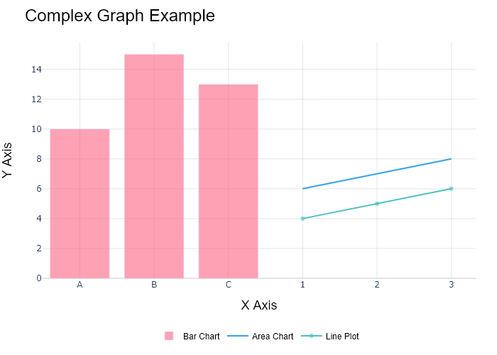

## Performance Metrics

|  |  |  |  |
| --- | --- | --- | --- |
| Task | Model Used | Description | Time Taken (s) |
| Processing Image to JSON | Gemini Vision Pro (default) | Time taken to convert the uploaded image to JSON format | 22.35 |
| Updating JSON | ChatGPT 3.5 (Default) | Time taken to update the JSON with new data | 0.00 |
| Plotting Updated JSON | N/A | Time taken to plot the updated JSON | 0.19 |

# Test Run

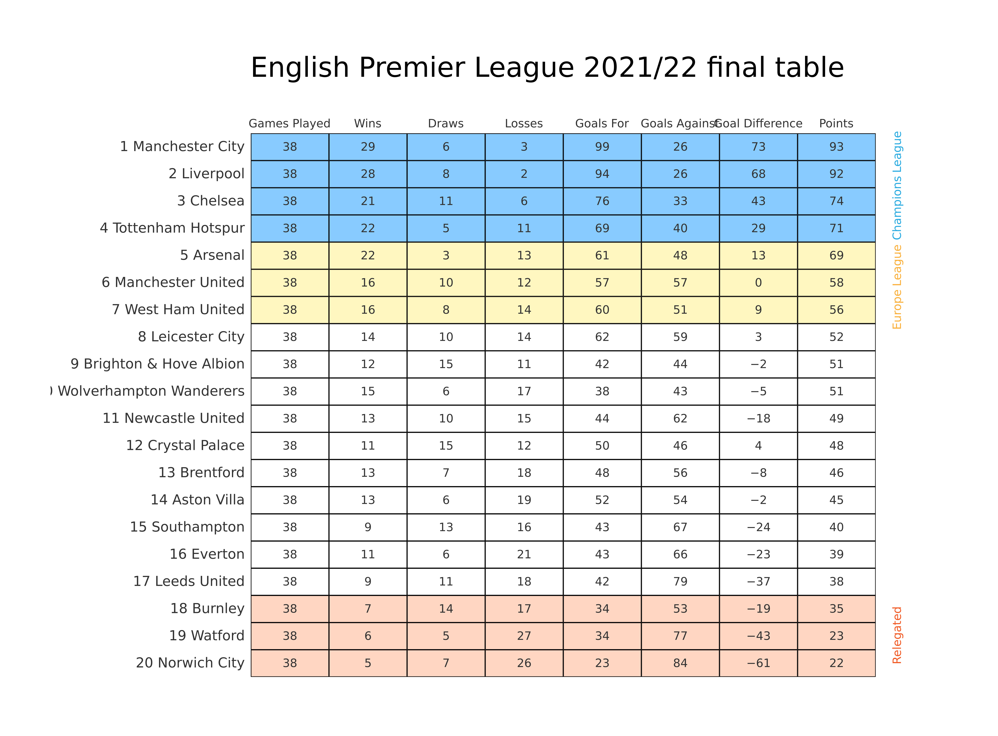

Figure: Charts/Comparison/jpg/table_chart.jpg

## Prompt Used

## Task: Extract Detailed Information from a Given Graph Image  
  
You will analyze a graph image and generate corresponding Plotly-compatible JSON files (`data.json`, `layout.json`, and `config.json`). Follow the structured steps and specific XML-like delimiters for each JSON section as outlined below.  
  
### Instructions:  
  
#### Graph Analysis:  
  
1. **Identify and Categorize Plot Types**:  
 - Recognize and categorize the plot types present in the graph image. Include both simple and complex plots, listed below:  
 - **Comparison Charts**:  
 - `bar`: Bar Chart  
 - `bar` (with vertical bars): Column Chart  
 - `bar` (grouped): Grouped Bar/Column Chart  
 - `scatter` (with lines connecting to points): Lollipop Chart  
 - `indicator` (with gauge): Bullet Chart  
 - `scatter`: Dot Plot  
 - `scatter` (with lines connecting different points): Dumbbell Chart  
 - `scatter` (or custom SVG): Pictogram  
 - `scatter` or `bar` with a range: Range Chart  
 - `barpolar`: Radial Bar Chart  
 - `parcoords`: Parallel Coordinates  
 - `scatterpolar`: Radar Chart  
 - `barpolar` (with segments): Nightingale Chart  
 - `waterfall`: Waterfall Chart  
 - `heatmap` (with color scale): Matrix Chart  
 - `various charts in small multiples`: Small Multiples  
 - `text` (frequency-based size): Word Cloud  
 - `scatter` (with lines indicating change): Slope Chart  
 - `table`: Table Chart  
 - `scatter`: Categorical Scatter Plot  
 - `scatter` (with four quadrants): Quadrant Chart  
 - **Correlation Charts**:  
 - `heatmap`: Heatmap  
 - `scatter` (with size): Bubble Chart  
 - `scatter`: Scatter Plot  
 - `scatter` (with lines connecting points): Connected Scatter Plot  
 - `hexbin`: Hexagonal Binning  
 - `contour`: Contour Plot  
 - **Part-to-Whole & Hierarchical Charts**:  
 - `bar` (stacked): Stacked Bar/Column Chart  
 - `bar` (with diverging sections): Diverging Bar Chart  
 - `bar` (mirrored pairs): Population Pyramid  
 - `scatter` (or custom symbols in a grid): Icon Array  
 - `waffle`: Waffle Chart  
 - `pie`: Pie Chart  
 - `pie` (with hole): Donut Chart  
 - `pie` (half-circle): Semi-circle Donut Chart  
 - `bar` (variable width): Marimekko Chart  
 - `treemap`: Treemap  
 - `treemap` (circular): Circular Treemap  
 - `treemap` (convex shape): Convex Treemap  
 - `sunburst`: Sunburst Chart  
 - `funnel` or `pyramid`: Funnel & Pyramid Chart  
 - `dendrogram`: Dendrogram  
 - `venn`: Venn Diagram  
 - `euler`: Euler Diagram  
 - `indicator` (circular gauge): Circular Gauge  
 - **Data Over Time (Temporal) Charts**:  
 - `scatter` (filled area under curve): Area Chart  
 - `scatter` (filled stacked areas): Stacked Area Chart  
 - `scatter` (smoothed filled areas): Stream Graph  
 - `scatter` (indicating ranking change): Bump Chart  
 - `scatter` (with filled area): Bump Area Chart  
 - `scatter`: Line Chart  
 - `scatter` (with smoothed lines): Spline Chart  
 - `scatter` (with stepped lines): Step Line Chart  
 - `candlestick`: Candlestick Chart  
 - `gantt`: Gantt Chart  
 - `scatter` (encoded lines): Barcode Chart  
 - `ohlc`: OHLC Chart  
 - **Distribution Charts**:  
 - `densitymapbox` or `histogram`: Density Plot  
 - `ridge`: Ridgeline Plot  
 - `horizon`: Horizon Chart  
 - `histogram`: Histogram  
 - `radial_histogram`: Radial Histogram  
 - `scatter` (with distribution): Strip Plot  
 - `scatter` (with jitter): Jitter Plot  
 - `heatmap`: One-dimensional Heatmap  
 - `scatter` (with tightly packed points): Beeswarm Chart  
 - `box`: Box Chart  
 - `violin`: Violin Plot  
 - **Geospatial & Other Charts**:  
 - `densitymapbox`: Geographic Heatmap  
 - `choropleth`: Choropleth Map  
 - `scattermapbox`: Tile Map  
 - `chord`: Chord Diagram  
 - `arc`: Arc Diagram  
 - `sankey`: Sankey  
 - `network`: Network Diagram  
 - `flowchart`: Flowchart  
  
2. **Extract Data Points** for Each Plot Type:  
 - Gather the data points for each identified plot type.  
 - For `scatter`, `line`, and `area` plots: Extract `x` and `y` values.  
 - For `bar` and `stacked bar` plots: Extract `x` (categories) and `y` values.  
 - For `pie` charts: Extract `labels` and `values`.  
 - For `scatter3d`, `surface`, and other 3D plots: Extract `x`, `y`, and `z` values.  
  
3. **Identify Multiple Plots** on the Same Figure:  
 - Note any combinations or overlays of multiple plot types on the same figure and their configurations, such as stacked plots or multiple area fills.  
  
#### Generate JSON and CSV Outputs:  
  
Follow the JSON formatting guidelines and wrap each section in the specified XML-like tags.  
  
1. **Generate `data.json`**:  
 - Include detailed information for each plot type:  
 - `type`: Specify the plot type (e.g., `"scatter"`, `"bar"`, `"pie"`, `"area"`, `"scatter3d"`, `"surface"`).  
 - For area charts, use `"type": "scatter"` and specify `"fill"`.  
 - `x`, `y`, and `z` (if applicable): Arrays of data points for each axis.  
 - `labels` and `values` for pie charts.  
 - `mode`: Specify for line and scatter plots (e.g., `"markers"`, `"lines"`, `"markers+lines"`).  
 - `name`: Legend entry for the plot.  
 - `marker`: Properties such as color, size, and symbol.  
 - `line`: Properties such as color, width, and dash style.  
 - `text`: Hover text for each data point.  
 - `hoverinfo`: Information displayed on hover (e.g., `"x+y+text"`).  
 - `fill`: For area charts, specify the fill (e.g., `"tozeroy"`, `"tonexty"`).  
 - `fillcolor`: The color used to fill the area.  
 - `stackgroup`: For stacked bar charts, specify the stacking group.  
  
2. **Generate `layout.json`**:  
 - Define the layout properties:  
 - `title`: Text and font properties for the graph title.  
 - `xaxis` and `yaxis`: Configuration for axis titles, ranges, grids, and ticks.  
 - `zaxis`: Configuration for 3D plots including title, range, and grid.  
 - `legend`: Properties for legend orientation and positioning.  
 - `margin`: Margins for left, right, bottom, top, and padding.  
 - `plot_bgcolor` and `paper_bgcolor`: Background colors.  
 - `scene`: Configuration for 3D scenes, including camera angles and aspect ratio.  
  
3. **Generate `config.json`**:  
 - Include settings such as:  
 - `responsive`: Whether the graph is responsive.  
 - `displayModeBar`: Whether the mode bar is shown.  
 - `modeBarButtonsToRemove`: List of mode bar buttons to remove.  
 - `scrollZoom`: Whether scrolling zoom is enabled.  
  
4. **Generate `<csv>`**:  
 - Format the CSV data as follows:  
 ```csv  
 x,y  
 1,4  
 2,5  
 3,6  
 ```  
 - Replace `x`, `y`, `1`, `4`, `2`, `5`, and `3`, `6` with the actual data from the graph image.  
  
### Output Format:  
  
Wrap each JSON output in the specified XML-like tags:  
  
- `<data> ... </data>`  
- `<layout> ... </layout>`  
- `<config> ... </config>`  
- `<csv> ... </csv>`  
  
Ensure the JSON format follows these rules:  
- Use double quotes for all keys and string values.  
- Do not include trailing commas in arrays or objects.  
  
### Example Output:  
  
```xml  
<data>  
[  
 {  
 "type": "scatter",  
 "x": [1, 2, 3],  
 "y": [4, 5, 6],  
 "mode": "markers+lines",  
 "name": "Line Plot",  
 "marker": {  
 "color": "rgba(75, 192, 192, 0.6)",  
 "size": 8  
 },  
 "line": {  
 "color": "rgba(75, 192, 192  
  
, 1)",  
 "width": 2  
 }  
 },  
 {  
 "type": "area",  
 "x": [1, 2, 3, 4, 5, 6, 7, 8, 9, 10, 11, 12],  
 "y": [400, 430, 550, 620, 580, 600, 630, 700, 670, 630, 600, 500],  
 "name": "Housing",  
 "marker": {  
 "color": "rgba(255, 159, 64, 0.8)"  
 },  
 "line": {  
 "color": "rgba(255, 159, 64, 1)",  
 "width": 2  
 }  
 },  
 {  
 "type": "bar",  
 "x": ["A", "B", "C"],  
 "y": [10, 15, 13],  
 "name": "Bar Chart",  
 "marker": {  
 "color": "rgba(255, 99, 132, 0.6)"  
 },  
 "hoverinfo": "x+y+text"  
 },  
 {  
 "type": "scatter",  
 "x": [1, 2, 3],  
 "y": [6, 7, 8],  
 "mode": "lines",  
 "fill": "tozeroy",  
 "name": "Area Chart",  
 "line": {  
 "color": "rgba(54, 162, 235, 1)",  
 "width": 2  
 },  
 "fillcolor": "rgba(54, 162, 235, 0.5)"  
 },  
 {  
 "type": "scatter3d",  
 "x": [1, 2, 3],  
 "y": [4, 5, 6],  
 "z": [7, 8, 9],  
 "mode": "markers",  
 "name": "3D Scatter Plot",  
 "marker": {  
 "color": "rgba(255, 159, 64, 0.8)",  
 "size": 5  
 },  
 "hoverinfo": "x+y+z+text"  
 },  
 {  
 "type": "surface",  
 "z": [  
 [10, 10.625, 12.5, 15.625, 20],  
 [5.625, 6.25, 8.125, 11.25, 15.625],  
 [0, 1.25, 3.125, 6.25, 10.625]  
 ],  
 "name": "Surface Plot",  
 "colorscale": "Viridis",  
 "hoverinfo": "z+name"  
 }  
]  
</data>  
<layout>  
{  
 "title": {  
 "text": "Complex Graph Example",  
 "font": {  
 "family": "Arial, sans-serif",  
 "size": 24,  
 "color": "#000000"  
 }  
 },  
 "xaxis": {  
 "title": {  
 "text": "X Axis",  
 "font": {  
 "family": "Arial, sans-serif",  
 "size": 18,  
 "color": "#000000"  
 }  
 },  
 "showgrid": true,  
 "gridcolor": "rgba(0, 0, 0, 0.1)",  
 "zeroline": true,  
 "zerolinecolor": "rgba(0, 0, 0, 0.1)"  
 },  
 "yaxis": {  
 "title": {  
 "text": "Y Axis",  
 "font": {  
 "family": "Arial, sans-serif",  
 "size": 18,  
 "color": "#000000"  
 }  
 },  
 "showgrid": true,  
 "gridcolor": "rgba(0, 0, 0, 0.1)",  
 "zeroline": true,  
 "zerolinecolor": "rgba(0, 0, 0, 0.1)"  
 },  
 "legend": {  
 "orientation": "h",  
 "x": 0.5,  
 "xanchor": "center",  
 "y": -0.2,  
 "font": {  
 "family": "Arial, sans-serif",  
 "size": 12,  
 "color": "#000000"  
 }  
 },  
 "margin": {  
 "l": 60,  
 "r": 30,  
 "b": 60,  
 "t": 60  
 },  
 "plot_bgcolor": "#ffffff",  
 "paper_bgcolor": "#ffffff",  
 "scene": {  
 "xaxis": {"title": "X Axis"},  
 "yaxis": {"title": "Y Axis"},  
 "zaxis": {"title": "Z Axis"}  
 }  
}  
</layout>  
<config>  
{  
 "responsive": true,  
 "displayModeBar": true,  
 "modeBarButtonsToRemove": ["toImage"],  
 "scrollZoom": true  
}  
</config>  
<csv>  
x,y  
1,4  
2,5  
3,6  
</csv>  
```

## Extracted JSON

### data

[  
 {  
 "type": "bar",  
 "x": [  
 "Manchester City",  
 "Liverpool",  
 "Chelsea",  
 "Tottenham Hotspur",  
 "Arsenal",  
 "Manchester United",  
 "West Ham United",  
 "Leicester City",  
 "Brighton & Hove Albion",  
 "Wolverhampton Wanderers",  
 "Newcastle United",  
 "Crystal Palace",  
 "Aston Villa",  
 "Brentford",  
 "Southampton",  
 "Everton",  
 "Leeds United",  
 "Burnley",  
 "Watford",  
 "Norwich City"  
 ],  
 "y": [  
 93,  
 92,  
 74,  
 69,  
 69,  
 56,  
 56,  
 52,  
 51,  
 51,  
 49,  
 48,  
 46,  
 45,  
 40,  
 39,  
 38,  
 35,  
 22,  
 22  
 ],  
 "name": "Games Played"  
 },  
 {  
 "type": "bar",  
 "x": [  
 "Manchester City",  
 "Liverpool",  
 "Chelsea",  
 "Tottenham Hotspur",  
 "Arsenal",  
 "Manchester United",  
 "West Ham United",  
 "Leicester City",  
 "Brighton & Hove Albion",  
 "Wolverhampton Wanderers",  
 "Newcastle United",  
 "Crystal Palace",  
 "Aston Villa",  
 "Brentford",  
 "Southampton",  
 "Everton",  
 "Leeds United",  
 "Burnley",  
 "Watford",  
 "Norwich City"  
 ],  
 "y": [  
 28,  
 28,  
 21,  
 22,  
 22,  
 16,  
 16,  
 14,  
 14,  
 15,  
 11,  
 11,  
 13,  
 13,  
 9,  
 9,  
 9,  
 7,  
 5,  
 5  
 ],  
 "name": "Wins"  
 },  
 {  
 "type": "bar",  
 "x": [  
 "Manchester City",  
 "Liverpool",  
 "Chelsea",  
 "Tottenham Hotspur",  
 "Arsenal",  
 "Manchester United",  
 "West Ham United",  
 "Leicester City",  
 "Brighton & Hove Albion",  
 "Wolverhampton Wanderers",  
 "Newcastle United",  
 "Crystal Palace",  
 "Aston Villa",  
 "Brentford",  
 "Southampton",  
 "Everton",  
 "Leeds United",  
 "Burnley",  
 "Watford",  
 "Norwich City"  
 ],  
 "y": [  
 8,  
 6,  
 11,  
 3,  
 5,  
 10,  
 8,  
 10,  
 10,  
 6,  
 15,  
 10,  
 7,  
 6,  
 13,  
 11,  
 6,  
 14,  
 7,  
 7  
 ],  
 "name": "Draws"  
 },  
 {  
 "type": "bar",  
 "x": [  
 "Manchester City",  
 "Liverpool",  
 "Chelsea",  
 "Tottenham Hotspur",  
 "Arsenal",  
 "Manchester United",  
 "West Ham United",  
 "Leicester City",  
 "Brighton & Hove Albion",  
 "Wolverhampton Wanderers",  
 "Newcastle United",  
 "Crystal Palace",  
 "Aston Villa",  
 "Brentford",  
 "Southampton",  
 "Everton",  
 "Leeds United",  
 "Burnley",  
 "Watford",  
 "Norwich City"  
 ],  
 "y": [  
 2,  
 3,  
 6,  
 11,  
 13,  
 14,  
 12,  
 14,  
 14,  
 17,  
 12,  
 15,  
 18,  
 19,  
 21,  
 18,  
 21,  
 27,  
 26,  
 26  
 ],  
 "name": "Losses"  
 },  
 {  
 "type": "bar",  
 "x": [  
 "Manchester City",  
 "Liverpool",  
 "Chelsea",  
 "Tottenham Hotspur",  
 "Arsenal",  
 "Manchester United",  
 "West Ham United",  
 "Leicester City",  
 "Brighton & Hove Albion",  
 "Wolverhampton Wanderers",  
 "Newcastle United",  
 "Crystal Palace",  
 "Aston Villa",  
 "Brentford",  
 "Southampton",  
 "Everton",  
 "Leeds United",  
 "Burnley",  
 "Watford",  
 "Norwich City"  
 ],  
 "y": [  
 99,  
 94,  
 76,  
 69,  
 61,  
 57,  
 60,  
 62,  
 42,  
 38,  
 50,  
 44,  
 48,  
 52,  
 43,  
 42,  
 34,  
 34,  
 23,  
 23  
 ],  
 "name": "Goals For"  
 },  
 {  
 "type": "bar",  
 "x": [  
 "Manchester City",  
 "Liverpool",  
 "Chelsea",  
 "Tottenham Hotspur",  
 "Arsenal",  
 "Manchester United",  
 "West Ham United",  
 "Leicester City",  
 "Brighton & Hove Albion",  
 "Wolverhampton Wanderers",  
 "Newcastle United",  
 "Crystal Palace",  
 "Aston Villa",  
 "Brentford",  
 "Southampton",  
 "Everton",  
 "Leeds United",  
 "Burnley",  
 "Watford",  
 "Norwich City"  
 ],  
 "y": [  
 26,  
 26,  
 43,  
 40,  
 46,  
 51,  
 57,  
 59,  
 53,  
 43,  
 46,  
 62,  
 56,  
 54,  
 67,  
 79,  
 66,  
 77,  
 84,  
 84  
 ],  
 "name": "Goals Against"  
 },  
 {  
 "type": "bar",  
 "x": [  
 "Manchester City",  
 "Liverpool",  
 "Chelsea",  
 "Tottenham Hotspur",  
 "Arsenal",  
 "Manchester United",  
 "West Ham United",  
 "Leicester City",  
 "Brighton & Hove Albion",  
 "Wolverhampton Wanderers",  
 "Newcastle United",  
 "Crystal Palace",  
 "Aston Villa",  
 "Brentford",  
 "Southampton",  
 "Everton",  
 "Leeds United",  
 "Burnley",  
 "Watford",  
 "Norwich City"  
 ],  
 "y": [  
 73,  
 68,  
 33,  
 29,  
 13,  
 9,  
 3,  
 3,  
 -3,  
 -5,  
 -18,  
 -4,  
 -8,  
 -2,  
 -24,  
 -37,  
 -23,  
 -43,  
 -61,  
 -61  
 ],  
 "name": "Goal Difference"  
 },  
 {  
 "type": "bar",  
 "x": [  
 "Manchester City",  
 "Liverpool",  
 "Chelsea",  
 "Tottenham Hotspur",  
 "Arsenal",  
 "Manchester United",  
 "West Ham United",  
 "Leicester City",  
 "Brighton & Hove Albion",  
 "Wolverhampton Wanderers",  
 "Newcastle United",  
 "Crystal Palace",  
 "Aston Villa",  
 "Brentford",  
 "Southampton",  
 "Everton",  
 "Leeds United",  
 "Burnley",  
 "Watford",  
 "Norwich City"  
 ],  
 "y": [  
 93,  
 92,  
 74,  
 69,  
 69,  
 56,  
 56,  
 52,  
 51,  
 51,  
 49,  
 48,  
 46,  
 45,  
 40,  
 39,  
 38,  
 35,  
 22,  
 22  
 ],  
 "name": "Points"  
 }  
]

### layout

{  
 "title": {  
 "text": "English Premier League 2021/22 Final Table",  
 "font": {  
 "family": "Arial, sans-serif",  
 "size": 24,  
 "color": "#000000"  
 }  
 },  
 "xaxis": {  
 "title": {  
 "text": "Teams",  
 "font": {  
 "family": "Arial, sans-serif",  
 "size": 18,  
 "color": "#000000"  
 }  
 },  
 "showgrid": true,  
 "gridcolor": "rgba(0, 0, 0, 0.1)",  
 "zeroline": true,  
 "zerolinecolor": "rgba(0, 0, 0, 0.1)"  
 },  
 "yaxis": {  
 "title": {  
 "text": "Values",  
 "font": {  
 "family": "Arial, sans-serif",  
 "size": 18,  
 "color": "#000000"  
 }  
 },  
 "showgrid": true,  
 "gridcolor": "rgba(0, 0, 0, 0.1)",  
 "zeroline": true,  
 "zerolinecolor": "rgba(0, 0, 0, 0.1)"  
 },  
 "legend": {  
 "orientation": "h",  
 "x": 0.5,  
 "xanchor": "center",  
 "y": -0.2,  
 "font": {  
 "family": "Arial, sans-serif",  
 "size": 12,  
 "color": "#000000"  
 }  
 },  
 "margin": {  
 "l": 60,  
 "r": 30,  
 "b": 60,  
 "t": 60  
 },  
 "plot_bgcolor": "#ffffff",  
 "paper_bgcolor": "#ffffff"  
}

### config

{  
 "responsive": true,  
 "displayModeBar": true,  
 "modeBarButtonsToRemove": [  
 "toImage"  
 ],  
 "scrollZoom": true  
}

## Updated JSON

### updated_data

[  
 {  
 "type": "bar",  
 "x": [  
 "Manchester City",  
 "Liverpool",  
 "Chelsea",  
 "Tottenham Hotspur",  
 "Arsenal",  
 "Manchester United",  
 "West Ham United",  
 "Leicester City",  
 "Brighton & Hove Albion",  
 "Wolverhampton Wanderers",  
 "Newcastle United",  
 "Crystal Palace",  
 "Aston Villa",  
 "Brentford",  
 "Southampton",  
 "Everton",  
 "Leeds United",  
 "Burnley",  
 "Watford",  
 "Norwich City"  
 ],  
 "y": [  
 93,  
 92,  
 74,  
 69,  
 69,  
 56,  
 56,  
 52,  
 51,  
 51,  
 49,  
 48,  
 46,  
 45,  
 40,  
 39,  
 38,  
 35,  
 22,  
 22  
 ],  
 "name": "Games Played"  
 },  
 {  
 "type": "bar",  
 "x": [  
 "Manchester City",  
 "Liverpool",  
 "Chelsea",  
 "Tottenham Hotspur",  
 "Arsenal",  
 "Manchester United",  
 "West Ham United",  
 "Leicester City",  
 "Brighton & Hove Albion",  
 "Wolverhampton Wanderers",  
 "Newcastle United",  
 "Crystal Palace",  
 "Aston Villa",  
 "Brentford",  
 "Southampton",  
 "Everton",  
 "Leeds United",  
 "Burnley",  
 "Watford",  
 "Norwich City"  
 ],  
 "y": [  
 28,  
 28,  
 21,  
 22,  
 22,  
 16,  
 16,  
 14,  
 14,  
 15,  
 11,  
 11,  
 13,  
 13,  
 9,  
 9,  
 9,  
 7,  
 5,  
 5  
 ],  
 "name": "Wins"  
 },  
 {  
 "type": "bar",  
 "x": [  
 "Manchester City",  
 "Liverpool",  
 "Chelsea",  
 "Tottenham Hotspur",  
 "Arsenal",  
 "Manchester United",  
 "West Ham United",  
 "Leicester City",  
 "Brighton & Hove Albion",  
 "Wolverhampton Wanderers",  
 "Newcastle United",  
 "Crystal Palace",  
 "Aston Villa",  
 "Brentford",  
 "Southampton",  
 "Everton",  
 "Leeds United",  
 "Burnley",  
 "Watford",  
 "Norwich City"  
 ],  
 "y": [  
 8,  
 6,  
 11,  
 3,  
 5,  
 10,  
 8,  
 10,  
 10,  
 6,  
 15,  
 10,  
 7,  
 6,  
 13,  
 11,  
 6,  
 14,  
 7,  
 7  
 ],  
 "name": "Draws"  
 },  
 {  
 "type": "bar",  
 "x": [  
 "Manchester City",  
 "Liverpool",  
 "Chelsea",  
 "Tottenham Hotspur",  
 "Arsenal",  
 "Manchester United",  
 "West Ham United",  
 "Leicester City",  
 "Brighton & Hove Albion",  
 "Wolverhampton Wanderers",  
 "Newcastle United",  
 "Crystal Palace",  
 "Aston Villa",  
 "Brentford",  
 "Southampton",  
 "Everton",  
 "Leeds United",  
 "Burnley",  
 "Watford",  
 "Norwich City"  
 ],  
 "y": [  
 2,  
 3,  
 6,  
 11,  
 13,  
 14,  
 12,  
 14,  
 14,  
 17,  
 12,  
 15,  
 18,  
 19,  
 21,  
 18,  
 21,  
 27,  
 26,  
 26  
 ],  
 "name": "Losses"  
 },  
 {  
 "type": "bar",  
 "x": [  
 "Manchester City",  
 "Liverpool",  
 "Chelsea",  
 "Tottenham Hotspur",  
 "Arsenal",  
 "Manchester United",  
 "West Ham United",  
 "Leicester City",  
 "Brighton & Hove Albion",  
 "Wolverhampton Wanderers",  
 "Newcastle United",  
 "Crystal Palace",  
 "Aston Villa",  
 "Brentford",  
 "Southampton",  
 "Everton",  
 "Leeds United",  
 "Burnley",  
 "Watford",  
 "Norwich City"  
 ],  
 "y": [  
 99,  
 94,  
 76,  
 69,  
 61,  
 57,  
 60,  
 62,  
 42,  
 38,  
 50,  
 44,  
 48,  
 52,  
 43,  
 42,  
 34,  
 34,  
 23,  
 23  
 ],  
 "name": "Goals For"  
 },  
 {  
 "type": "bar",  
 "x": [  
 "Manchester City",  
 "Liverpool",  
 "Chelsea",  
 "Tottenham Hotspur",  
 "Arsenal",  
 "Manchester United",  
 "West Ham United",  
 "Leicester City",  
 "Brighton & Hove Albion",  
 "Wolverhampton Wanderers",  
 "Newcastle United",  
 "Crystal Palace",  
 "Aston Villa",  
 "Brentford",  
 "Southampton",  
 "Everton",  
 "Leeds United",  
 "Burnley",  
 "Watford",  
 "Norwich City"  
 ],  
 "y": [  
 26,  
 26,  
 43,  
 40,  
 46,  
 51,  
 57,  
 59,  
 53,  
 43,  
 46,  
 62,  
 56,  
 54,  
 67,  
 79,  
 66,  
 77,  
 84,  
 84  
 ],  
 "name": "Goals Against"  
 },  
 {  
 "type": "bar",  
 "x": [  
 "Manchester City",  
 "Liverpool",  
 "Chelsea",  
 "Tottenham Hotspur",  
 "Arsenal",  
 "Manchester United",  
 "West Ham United",  
 "Leicester City",  
 "Brighton & Hove Albion",  
 "Wolverhampton Wanderers",  
 "Newcastle United",  
 "Crystal Palace",  
 "Aston Villa",  
 "Brentford",  
 "Southampton",  
 "Everton",  
 "Leeds United",  
 "Burnley",  
 "Watford",  
 "Norwich City"  
 ],  
 "y": [  
 73,  
 68,  
 33,  
 29,  
 13,  
 9,  
 3,  
 3,  
 -3,  
 -5,  
 -18,  
 -4,  
 -8,  
 -2,  
 -24,  
 -37,  
 -23,  
 -43,  
 -61,  
 -61  
 ],  
 "name": "Goal Difference"  
 },  
 {  
 "type": "bar",  
 "x": [  
 "Manchester City",  
 "Liverpool",  
 "Chelsea",  
 "Tottenham Hotspur",  
 "Arsenal",  
 "Manchester United",  
 "West Ham United",  
 "Leicester City",  
 "Brighton & Hove Albion",  
 "Wolverhampton Wanderers",  
 "Newcastle United",  
 "Crystal Palace",  
 "Aston Villa",  
 "Brentford",  
 "Southampton",  
 "Everton",  
 "Leeds United",  
 "Burnley",  
 "Watford",  
 "Norwich City"  
 ],  
 "y": [  
 93,  
 92,  
 74,  
 69,  
 69,  
 56,  
 56,  
 52,  
 51,  
 51,  
 49,  
 48,  
 46,  
 45,  
 40,  
 39,  
 38,  
 35,  
 22,  
 22  
 ],  
 "name": "Points"  
 }  
]

### updated_layout

{  
 "title": {  
 "text": "English Premier League 2021/22 Final Table",  
 "font": {  
 "family": "Arial, sans-serif",  
 "size": 24,  
 "color": "#000000"  
 }  
 },  
 "xaxis": {  
 "title": {  
 "text": "Teams",  
 "font": {  
 "family": "Arial, sans-serif",  
 "size": 18,  
 "color": "#000000"  
 }  
 },  
 "showgrid": true,  
 "gridcolor": "rgba(0, 0, 0, 0.1)",  
 "zeroline": true,  
 "zerolinecolor": "rgba(0, 0, 0, 0.1)"  
 },  
 "yaxis": {  
 "title": {  
 "text": "Values",  
 "font": {  
 "family": "Arial, sans-serif",  
 "size": 18,  
 "color": "#000000"  
 }  
 },  
 "showgrid": true,  
 "gridcolor": "rgba(0, 0, 0, 0.1)",  
 "zeroline": true,  
 "zerolinecolor": "rgba(0, 0, 0, 0.1)"  
 },  
 "legend": {  
 "orientation": "h",  
 "x": 0.5,  
 "xanchor": "center",  
 "y": -0.2,  
 "font": {  
 "family": "Arial, sans-serif",  
 "size": 12,  
 "color": "#000000"  
 }  
 },  
 "margin": {  
 "l": 60,  
 "r": 30,  
 "b": 60,  
 "t": 60  
 },  
 "plot_bgcolor": "#ffffff",  
 "paper_bgcolor": "#ffffff"  
}

### updated_config

{  
 "responsive": true,  
 "displayModeBar": true,  
 "modeBarButtonsToRemove": [  
 "toImage"  
 ],  
 "scrollZoom": true  
}

## Updated Chart

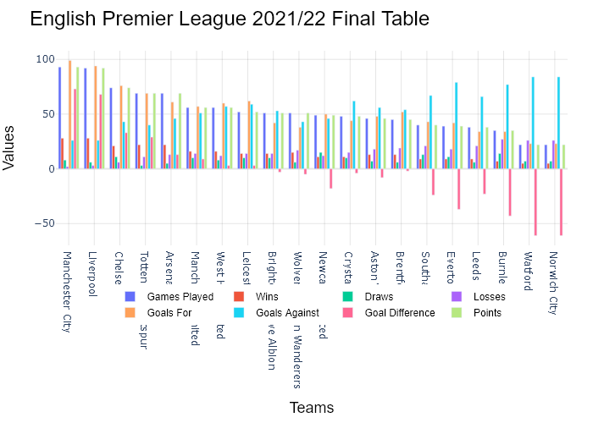

## Performance Metrics

|  |  |  |  |
| --- | --- | --- | --- |
| Task | Model Used | Description | Time Taken (s) |
| Processing Image to JSON | Gemini Vision Pro (default) | Time taken to convert the uploaded image to JSON format | 54.49 |
| Updating JSON | ChatGPT 3.5 (Default) | Time taken to update the JSON with new data | 0.00 |
| Plotting Updated JSON | N/A | Time taken to plot the updated JSON | 0.49 |

# Test Run

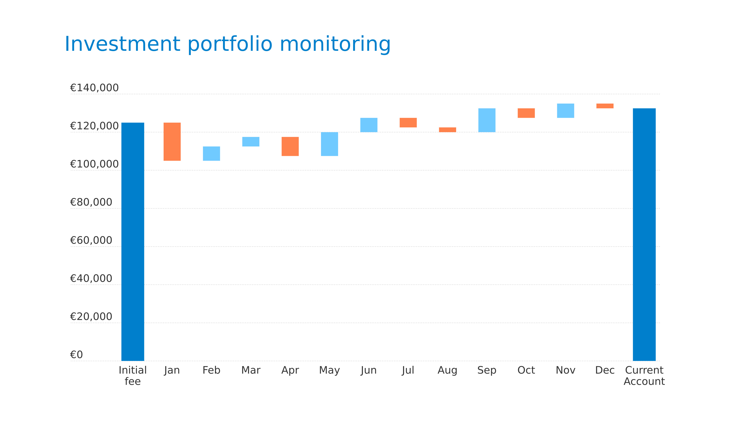

Figure: Charts/Comparison/jpg/waterfall.jpg

## Prompt Used

## Task: Extract Detailed Information from a Given Graph Image  
  
You will analyze a graph image and generate corresponding Plotly-compatible JSON files (`data.json`, `layout.json`, and `config.json`). Follow the structured steps and specific XML-like delimiters for each JSON section as outlined below.  
  
### Instructions:  
  
#### Graph Analysis:  
  
1. **Identify and Categorize Plot Types**:  
 - Recognize and categorize the plot types present in the graph image. Include both simple and complex plots, listed below:  
 - **Comparison Charts**:  
 - `bar`: Bar Chart  
 - `bar` (with vertical bars): Column Chart  
 - `bar` (grouped): Grouped Bar/Column Chart  
 - `scatter` (with lines connecting to points): Lollipop Chart  
 - `indicator` (with gauge): Bullet Chart  
 - `scatter`: Dot Plot  
 - `scatter` (with lines connecting different points): Dumbbell Chart  
 - `scatter` (or custom SVG): Pictogram  
 - `scatter` or `bar` with a range: Range Chart  
 - `barpolar`: Radial Bar Chart  
 - `parcoords`: Parallel Coordinates  
 - `scatterpolar`: Radar Chart  
 - `barpolar` (with segments): Nightingale Chart  
 - `waterfall`: Waterfall Chart  
 - `heatmap` (with color scale): Matrix Chart  
 - `various charts in small multiples`: Small Multiples  
 - `text` (frequency-based size): Word Cloud  
 - `scatter` (with lines indicating change): Slope Chart  
 - `table`: Table Chart  
 - `scatter`: Categorical Scatter Plot  
 - `scatter` (with four quadrants): Quadrant Chart  
 - **Correlation Charts**:  
 - `heatmap`: Heatmap  
 - `scatter` (with size): Bubble Chart  
 - `scatter`: Scatter Plot  
 - `scatter` (with lines connecting points): Connected Scatter Plot  
 - `hexbin`: Hexagonal Binning  
 - `contour`: Contour Plot  
 - **Part-to-Whole & Hierarchical Charts**:  
 - `bar` (stacked): Stacked Bar/Column Chart  
 - `bar` (with diverging sections): Diverging Bar Chart  
 - `bar` (mirrored pairs): Population Pyramid  
 - `scatter` (or custom symbols in a grid): Icon Array  
 - `waffle`: Waffle Chart  
 - `pie`: Pie Chart  
 - `pie` (with hole): Donut Chart  
 - `pie` (half-circle): Semi-circle Donut Chart  
 - `bar` (variable width): Marimekko Chart  
 - `treemap`: Treemap  
 - `treemap` (circular): Circular Treemap  
 - `treemap` (convex shape): Convex Treemap  
 - `sunburst`: Sunburst Chart  
 - `funnel` or `pyramid`: Funnel & Pyramid Chart  
 - `dendrogram`: Dendrogram  
 - `venn`: Venn Diagram  
 - `euler`: Euler Diagram  
 - `indicator` (circular gauge): Circular Gauge  
 - **Data Over Time (Temporal) Charts**:  
 - `scatter` (filled area under curve): Area Chart  
 - `scatter` (filled stacked areas): Stacked Area Chart  
 - `scatter` (smoothed filled areas): Stream Graph  
 - `scatter` (indicating ranking change): Bump Chart  
 - `scatter` (with filled area): Bump Area Chart  
 - `scatter`: Line Chart  
 - `scatter` (with smoothed lines): Spline Chart  
 - `scatter` (with stepped lines): Step Line Chart  
 - `candlestick`: Candlestick Chart  
 - `gantt`: Gantt Chart  
 - `scatter` (encoded lines): Barcode Chart  
 - `ohlc`: OHLC Chart  
 - **Distribution Charts**:  
 - `densitymapbox` or `histogram`: Density Plot  
 - `ridge`: Ridgeline Plot  
 - `horizon`: Horizon Chart  
 - `histogram`: Histogram  
 - `radial_histogram`: Radial Histogram  
 - `scatter` (with distribution): Strip Plot  
 - `scatter` (with jitter): Jitter Plot  
 - `heatmap`: One-dimensional Heatmap  
 - `scatter` (with tightly packed points): Beeswarm Chart  
 - `box`: Box Chart  
 - `violin`: Violin Plot  
 - **Geospatial & Other Charts**:  
 - `densitymapbox`: Geographic Heatmap  
 - `choropleth`: Choropleth Map  
 - `scattermapbox`: Tile Map  
 - `chord`: Chord Diagram  
 - `arc`: Arc Diagram  
 - `sankey`: Sankey  
 - `network`: Network Diagram  
 - `flowchart`: Flowchart  
  
2. **Extract Data Points** for Each Plot Type:  
 - Gather the data points for each identified plot type.  
 - For `scatter`, `line`, and `area` plots: Extract `x` and `y` values.  
 - For `bar` and `stacked bar` plots: Extract `x` (categories) and `y` values.  
 - For `pie` charts: Extract `labels` and `values`.  
 - For `scatter3d`, `surface`, and other 3D plots: Extract `x`, `y`, and `z` values.  
  
3. **Identify Multiple Plots** on the Same Figure:  
 - Note any combinations or overlays of multiple plot types on the same figure and their configurations, such as stacked plots or multiple area fills.  
  
#### Generate JSON and CSV Outputs:  
  
Follow the JSON formatting guidelines and wrap each section in the specified XML-like tags.  
  
1. **Generate `data.json`**:  
 - Include detailed information for each plot type:  
 - `type`: Specify the plot type (e.g., `"scatter"`, `"bar"`, `"pie"`, `"area"`, `"scatter3d"`, `"surface"`).  
 - For area charts, use `"type": "scatter"` and specify `"fill"`.  
 - `x`, `y`, and `z` (if applicable): Arrays of data points for each axis.  
 - `labels` and `values` for pie charts.  
 - `mode`: Specify for line and scatter plots (e.g., `"markers"`, `"lines"`, `"markers+lines"`).  
 - `name`: Legend entry for the plot.  
 - `marker`: Properties such as color, size, and symbol.  
 - `line`: Properties such as color, width, and dash style.  
 - `text`: Hover text for each data point.  
 - `hoverinfo`: Information displayed on hover (e.g., `"x+y+text"`).  
 - `fill`: For area charts, specify the fill (e.g., `"tozeroy"`, `"tonexty"`).  
 - `fillcolor`: The color used to fill the area.  
 - `stackgroup`: For stacked bar charts, specify the stacking group.  
  
2. **Generate `layout.json`**:  
 - Define the layout properties:  
 - `title`: Text and font properties for the graph title.  
 - `xaxis` and `yaxis`: Configuration for axis titles, ranges, grids, and ticks.  
 - `zaxis`: Configuration for 3D plots including title, range, and grid.  
 - `legend`: Properties for legend orientation and positioning.  
 - `margin`: Margins for left, right, bottom, top, and padding.  
 - `plot_bgcolor` and `paper_bgcolor`: Background colors.  
 - `scene`: Configuration for 3D scenes, including camera angles and aspect ratio.  
  
3. **Generate `config.json`**:  
 - Include settings such as:  
 - `responsive`: Whether the graph is responsive.  
 - `displayModeBar`: Whether the mode bar is shown.  
 - `modeBarButtonsToRemove`: List of mode bar buttons to remove.  
 - `scrollZoom`: Whether scrolling zoom is enabled.  
  
4. **Generate `<csv>`**:  
 - Format the CSV data as follows:  
 ```csv  
 x,y  
 1,4  
 2,5  
 3,6  
 ```  
 - Replace `x`, `y`, `1`, `4`, `2`, `5`, and `3`, `6` with the actual data from the graph image.  
  
### Output Format:  
  
Wrap each JSON output in the specified XML-like tags:  
  
- `<data> ... </data>`  
- `<layout> ... </layout>`  
- `<config> ... </config>`  
- `<csv> ... </csv>`  
  
Ensure the JSON format follows these rules:  
- Use double quotes for all keys and string values.  
- Do not include trailing commas in arrays or objects.  
  
### Example Output:  
  
```xml  
<data>  
[  
 {  
 "type": "scatter",  
 "x": [1, 2, 3],  
 "y": [4, 5, 6],  
 "mode": "markers+lines",  
 "name": "Line Plot",  
 "marker": {  
 "color": "rgba(75, 192, 192, 0.6)",  
 "size": 8  
 },  
 "line": {  
 "color": "rgba(75, 192, 192  
  
, 1)",  
 "width": 2  
 }  
 },  
 {  
 "type": "area",  
 "x": [1, 2, 3, 4, 5, 6, 7, 8, 9, 10, 11, 12],  
 "y": [400, 430, 550, 620, 580, 600, 630, 700, 670, 630, 600, 500],  
 "name": "Housing",  
 "marker": {  
 "color": "rgba(255, 159, 64, 0.8)"  
 },  
 "line": {  
 "color": "rgba(255, 159, 64, 1)",  
 "width": 2  
 }  
 },  
 {  
 "type": "bar",  
 "x": ["A", "B", "C"],  
 "y": [10, 15, 13],  
 "name": "Bar Chart",  
 "marker": {  
 "color": "rgba(255, 99, 132, 0.6)"  
 },  
 "hoverinfo": "x+y+text"  
 },  
 {  
 "type": "scatter",  
 "x": [1, 2, 3],  
 "y": [6, 7, 8],  
 "mode": "lines",  
 "fill": "tozeroy",  
 "name": "Area Chart",  
 "line": {  
 "color": "rgba(54, 162, 235, 1)",  
 "width": 2  
 },  
 "fillcolor": "rgba(54, 162, 235, 0.5)"  
 },  
 {  
 "type": "scatter3d",  
 "x": [1, 2, 3],  
 "y": [4, 5, 6],  
 "z": [7, 8, 9],  
 "mode": "markers",  
 "name": "3D Scatter Plot",  
 "marker": {  
 "color": "rgba(255, 159, 64, 0.8)",  
 "size": 5  
 },  
 "hoverinfo": "x+y+z+text"  
 },  
 {  
 "type": "surface",  
 "z": [  
 [10, 10.625, 12.5, 15.625, 20],  
 [5.625, 6.25, 8.125, 11.25, 15.625],  
 [0, 1.25, 3.125, 6.25, 10.625]  
 ],  
 "name": "Surface Plot",  
 "colorscale": "Viridis",  
 "hoverinfo": "z+name"  
 }  
]  
</data>  
<layout>  
{  
 "title": {  
 "text": "Complex Graph Example",  
 "font": {  
 "family": "Arial, sans-serif",  
 "size": 24,  
 "color": "#000000"  
 }  
 },  
 "xaxis": {  
 "title": {  
 "text": "X Axis",  
 "font": {  
 "family": "Arial, sans-serif",  
 "size": 18,  
 "color": "#000000"  
 }  
 },  
 "showgrid": true,  
 "gridcolor": "rgba(0, 0, 0, 0.1)",  
 "zeroline": true,  
 "zerolinecolor": "rgba(0, 0, 0, 0.1)"  
 },  
 "yaxis": {  
 "title": {  
 "text": "Y Axis",  
 "font": {  
 "family": "Arial, sans-serif",  
 "size": 18,  
 "color": "#000000"  
 }  
 },  
 "showgrid": true,  
 "gridcolor": "rgba(0, 0, 0, 0.1)",  
 "zeroline": true,  
 "zerolinecolor": "rgba(0, 0, 0, 0.1)"  
 },  
 "legend": {  
 "orientation": "h",  
 "x": 0.5,  
 "xanchor": "center",  
 "y": -0.2,  
 "font": {  
 "family": "Arial, sans-serif",  
 "size": 12,  
 "color": "#000000"  
 }  
 },  
 "margin": {  
 "l": 60,  
 "r": 30,  
 "b": 60,  
 "t": 60  
 },  
 "plot_bgcolor": "#ffffff",  
 "paper_bgcolor": "#ffffff",  
 "scene": {  
 "xaxis": {"title": "X Axis"},  
 "yaxis": {"title": "Y Axis"},  
 "zaxis": {"title": "Z Axis"}  
 }  
}  
</layout>  
<config>  
{  
 "responsive": true,  
 "displayModeBar": true,  
 "modeBarButtonsToRemove": ["toImage"],  
 "scrollZoom": true  
}  
</config>  
<csv>  
x,y  
1,4  
2,5  
3,6  
</csv>  
```

## Extracted JSON

### data

[  
 {  
 "type": "bar",  
 "x": [  
 "Jan",  
 "Feb",  
 "Mar",  
 "Apr",  
 "May",  
 "Jun",  
 "Jul",  
 "Aug",  
 "Sep",  
 "Oct",  
 "Nov",  
 "Dec"  
 ],  
 "y": [  
 120000,  
 100000,  
 110000,  
 105000,  
 120000,  
 115000,  
 125000,  
 120000,  
 130000,  
 125000,  
 135000,  
 140000  
 ],  
 "name": "Investment Portfolio",  
 "marker": {  
 "color": "rgba(255, 159, 64, 0.8)"  
 },  
 "hoverinfo": "x+y+text"  
 }  
]

### layout

{  
 "title": {  
 "text": "Investment Portfolio Monitoring",  
 "font": {  
 "family": "Arial, sans-serif",  
 "size": 24,  
 "color": "#000000"  
 }  
 },  
 "xaxis": {  
 "title": {  
 "text": "Months",  
 "font": {  
 "family": "Arial, sans-serif",  
 "size": 18,  
 "color": "#000000"  
 }  
 },  
 "showgrid": true,  
 "gridcolor": "rgba(0, 0, 0, 0.1)",  
 "zeroline": true,  
 "zerolinecolor": "rgba(0, 0, 0, 0.1)"  
 },  
 "yaxis": {  
 "title": {  
 "text": "Amount",  
 "font": {  
 "family": "Arial, sans-serif",  
 "size": 18,  
 "color": "#000000"  
 }  
 },  
 "showgrid": true,  
 "gridcolor": "rgba(0, 0, 0, 0.1)",  
 "zeroline": true,  
 "zerolinecolor": "rgba(0, 0, 0, 0.1)"  
 },  
 "legend": {  
 "orientation": "h",  
 "x": 0.5,  
 "xanchor": "center",  
 "y": -0.2,  
 "font": {  
 "family": "Arial, sans-serif",  
 "size": 12,  
 "color": "#000000"  
 }  
 },  
 "margin": {  
 "l": 60,  
 "r": 30,  
 "b": 60,  
 "t": 60  
 },  
 "plot_bgcolor": "#ffffff",  
 "paper_bgcolor": "#ffffff"  
}

### config

{  
 "responsive": true,  
 "displayModeBar": true,  
 "modeBarButtonsToRemove": [  
 "toImage"  
 ],  
 "scrollZoom": true  
}

## Updated JSON

### updated_data

[  
 {  
 "type": "bar",  
 "x": [  
 "Jan",  
 "Feb",  
 "Mar",  
 "Apr",  
 "May",  
 "Jun",  
 "Jul",  
 "Aug",  
 "Sep",  
 "Oct",  
 "Nov",  
 "Dec"  
 ],  
 "y": [  
 120000,  
 100000,  
 110000,  
 105000,  
 120000,  
 115000,  
 125000,  
 120000,  
 130000,  
 125000,  
 135000,  
 140000  
 ],  
 "name": "Investment Portfolio",  
 "marker": {  
 "color": "rgba(255, 159, 64, 0.8)"  
 },  
 "hoverinfo": "x+y+text"  
 }  
]

### updated_layout

{  
 "title": {  
 "text": "Investment Portfolio Monitoring",  
 "font": {  
 "family": "Arial, sans-serif",  
 "size": 24,  
 "color": "#000000"  
 }  
 },  
 "xaxis": {  
 "title": {  
 "text": "Months",  
 "font": {  
 "family": "Arial, sans-serif",  
 "size": 18,  
 "color": "#000000"  
 }  
 },  
 "showgrid": true,  
 "gridcolor": "rgba(0, 0, 0, 0.1)",  
 "zeroline": true,  
 "zerolinecolor": "rgba(0, 0, 0, 0.1)"  
 },  
 "yaxis": {  
 "title": {  
 "text": "Amount",  
 "font": {  
 "family": "Arial, sans-serif",  
 "size": 18,  
 "color": "#000000"  
 }  
 },  
 "showgrid": true,  
 "gridcolor": "rgba(0, 0, 0, 0.1)",  
 "zeroline": true,  
 "zerolinecolor": "rgba(0, 0, 0, 0.1)"  
 },  
 "legend": {  
 "orientation": "h",  
 "x": 0.5,  
 "xanchor": "center",  
 "y": -0.2,  
 "font": {  
 "family": "Arial, sans-serif",  
 "size": 12,  
 "color": "#000000"  
 }  
 },  
 "margin": {  
 "l": 60,  
 "r": 30,  
 "b": 60,  
 "t": 60  
 },  
 "plot_bgcolor": "#ffffff",  
 "paper_bgcolor": "#ffffff"  
}

### updated_config

{  
 "responsive": true,  
 "displayModeBar": true,  
 "modeBarButtonsToRemove": [  
 "toImage"  
 ],  
 "scrollZoom": true  
}

## Updated Chart

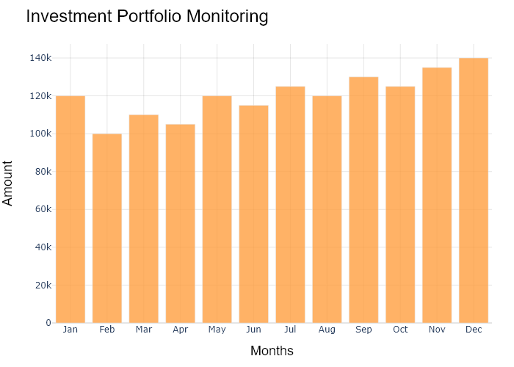

## Performance Metrics

|  |  |  |  |
| --- | --- | --- | --- |
| Task | Model Used | Description | Time Taken (s) |
| Processing Image to JSON | Gemini Vision Pro (default) | Time taken to convert the uploaded image to JSON format | 20.36 |
| Updating JSON | ChatGPT 3.5 (Default) | Time taken to update the JSON with new data | 0.00 |
| Plotting Updated JSON | N/A | Time taken to plot the updated JSON | 0.23 |

# Test Run

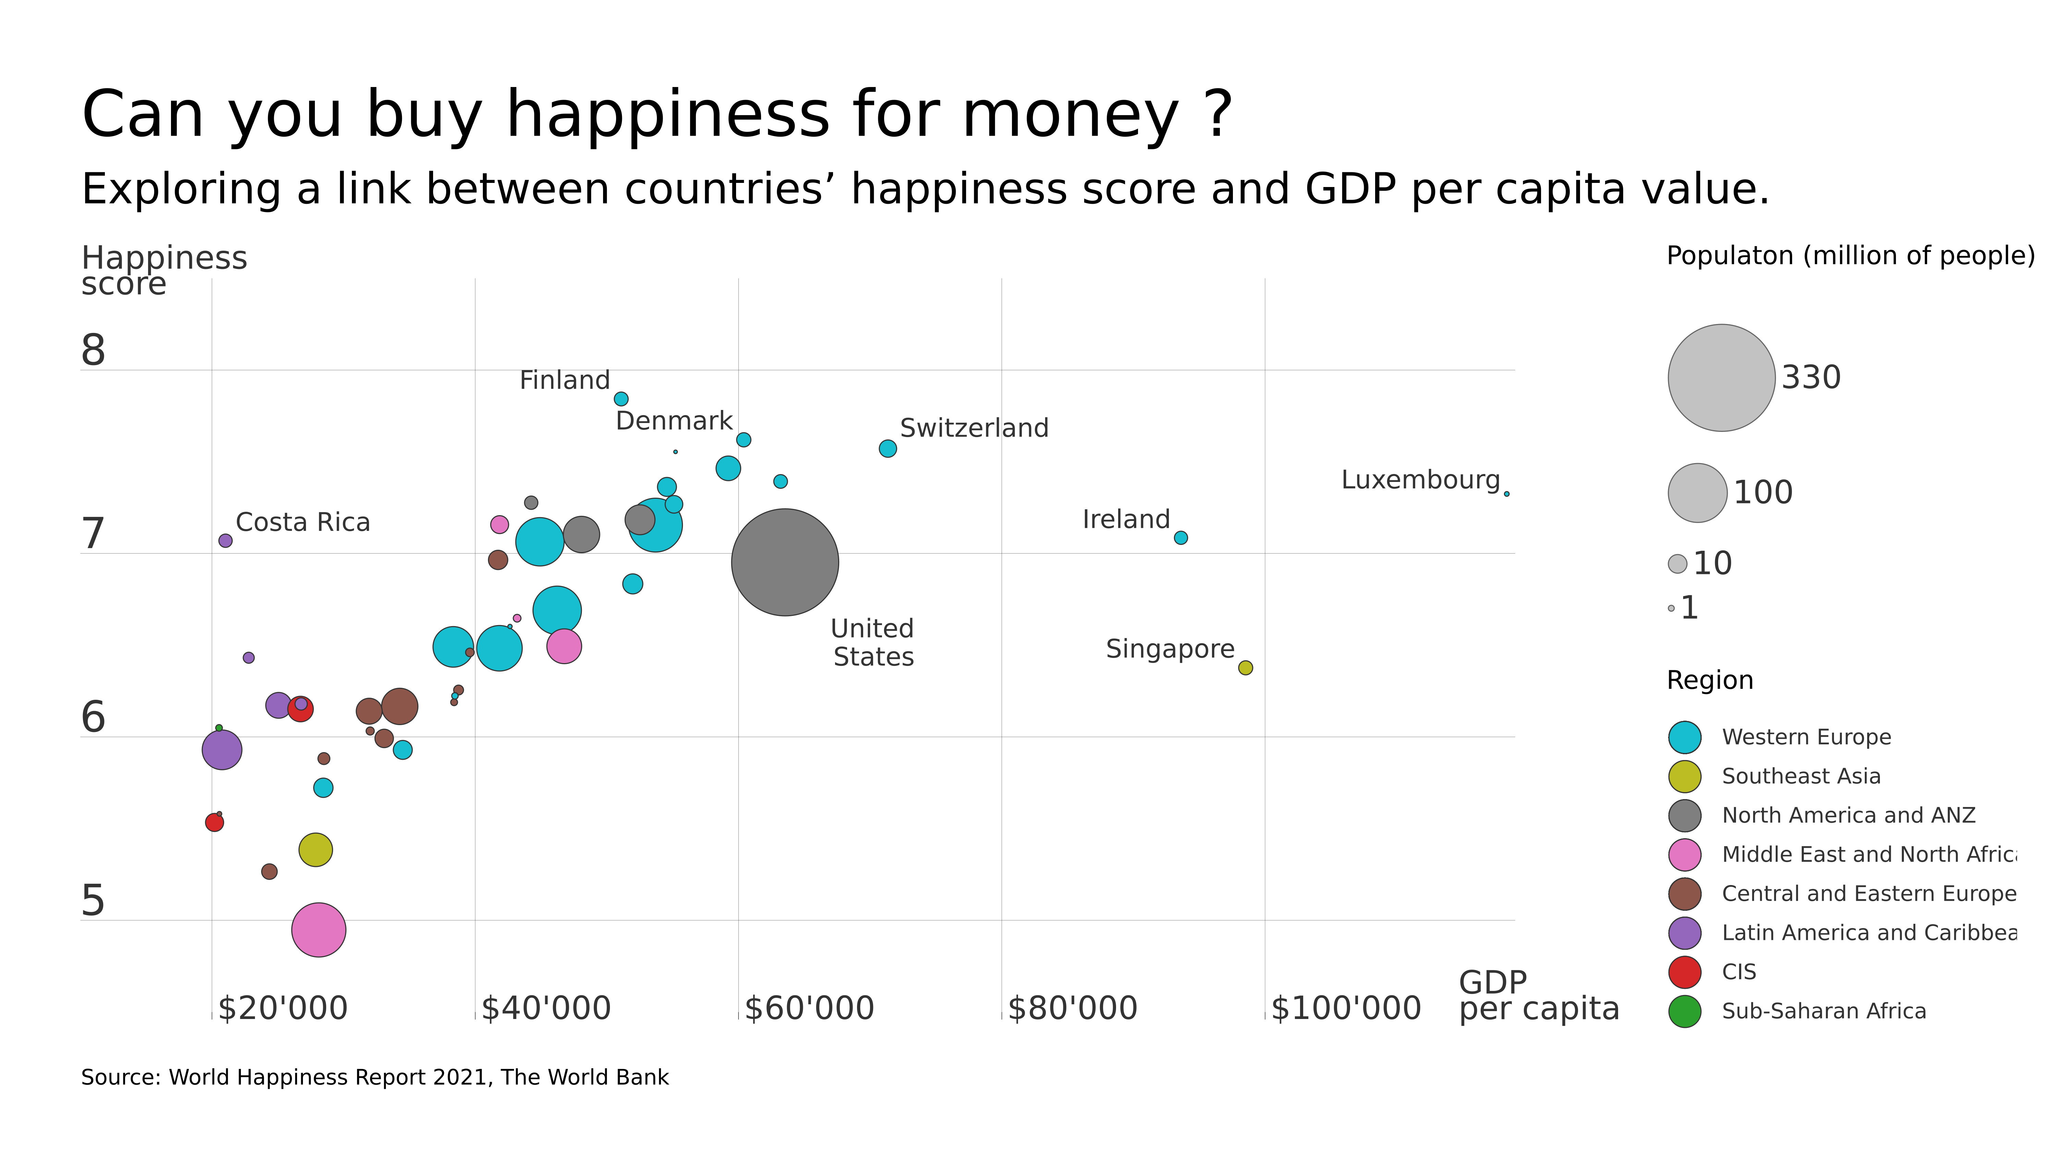

Figure: D:\Research Internship\Charts\Correlation\jpg\bubble.jpg

## Prompt Used

## Task: Extract Detailed Information from a Given Graph Image  
  
You will analyze a graph image and generate corresponding Plotly-compatible JSON files (`data.json`, `layout.json`, and `config.json`). Follow the structured steps and specific XML-like delimiters for each JSON section as outlined below.  
  
### Instructions:  
  
#### Graph Analysis:  
  
1. **Identify and Categorize Plot Types**:  
 - Recognize and categorize the plot types present in the graph image. Include both simple and complex plots, listed below:  
 - **Comparison Charts**:  
 - `bar`: Bar Chart  
 - `bar` (with vertical bars): Column Chart  
 - `bar` (grouped): Grouped Bar/Column Chart  
 - `scatter` (with lines connecting to points): Lollipop Chart  
 - `indicator` (with gauge): Bullet Chart  
 - `scatter`: Dot Plot  
 - `scatter` (with lines connecting different points): Dumbbell Chart  
 - `scatter` (or custom SVG): Pictogram  
 - `scatter` or `bar` with a range: Range Chart  
 - `barpolar`: Radial Bar Chart  
 - `parcoords`: Parallel Coordinates  
 - `scatterpolar`: Radar Chart  
 - `barpolar` (with segments): Nightingale Chart  
 - `waterfall`: Waterfall Chart  
 - `heatmap` (with color scale): Matrix Chart  
 - `various charts in small multiples`: Small Multiples  
 - `text` (frequency-based size): Word Cloud  
 - `scatter` (with lines indicating change): Slope Chart  
 - `table`: Table Chart  
 - `scatter`: Categorical Scatter Plot  
 - `scatter` (with four quadrants): Quadrant Chart  
 - **Correlation Charts**:  
 - `heatmap`: Heatmap  
 - `scatter` (with size): Bubble Chart  
 - `scatter`: Scatter Plot  
 - `scatter` (with lines connecting points): Connected Scatter Plot  
 - `hexbin`: Hexagonal Binning  
 - `contour`: Contour Plot  
 - **Part-to-Whole & Hierarchical Charts**:  
 - `bar` (stacked): Stacked Bar/Column Chart  
 - `bar` (with diverging sections): Diverging Bar Chart  
 - `bar` (mirrored pairs): Population Pyramid  
 - `scatter` (or custom symbols in a grid): Icon Array  
 - `waffle`: Waffle Chart  
 - `pie`: Pie Chart  
 - `pie` (with hole): Donut Chart  
 - `pie` (half-circle): Semi-circle Donut Chart  
 - `bar` (variable width): Marimekko Chart  
 - `treemap`: Treemap  
 - `treemap` (circular): Circular Treemap  
 - `treemap` (convex shape): Convex Treemap  
 - `sunburst`: Sunburst Chart  
 - `funnel` or `pyramid`: Funnel & Pyramid Chart  
 - `dendrogram`: Dendrogram  
 - `venn`: Venn Diagram  
 - `euler`: Euler Diagram  
 - `indicator` (circular gauge): Circular Gauge  
 - **Data Over Time (Temporal) Charts**:  
 - `scatter` (filled area under curve): Area Chart  
 - `scatter` (filled stacked areas): Stacked Area Chart  
 - `scatter` (smoothed filled areas): Stream Graph  
 - `scatter` (indicating ranking change): Bump Chart  
 - `scatter` (with filled area): Bump Area Chart  
 - `scatter`: Line Chart  
 - `scatter` (with smoothed lines): Spline Chart  
 - `scatter` (with stepped lines): Step Line Chart  
 - `candlestick`: Candlestick Chart  
 - `gantt`: Gantt Chart  
 - `scatter` (encoded lines): Barcode Chart  
 - `ohlc`: OHLC Chart  
 - **Distribution Charts**:  
 - `densitymapbox` or `histogram`: Density Plot  
 - `ridge`: Ridgeline Plot  
 - `horizon`: Horizon Chart  
 - `histogram`: Histogram  
 - `radial_histogram`: Radial Histogram  
 - `scatter` (with distribution): Strip Plot  
 - `scatter` (with jitter): Jitter Plot  
 - `heatmap`: One-dimensional Heatmap  
 - `scatter` (with tightly packed points): Beeswarm Chart  
 - `box`: Box Chart  
 - `violin`: Violin Plot  
 - **Geospatial & Other Charts**:  
 - `densitymapbox`: Geographic Heatmap  
 - `choropleth`: Choropleth Map  
 - `scattermapbox`: Tile Map  
 - `chord`: Chord Diagram  
 - `arc`: Arc Diagram  
 - `sankey`: Sankey  
 - `network`: Network Diagram  
 - `flowchart`: Flowchart  
  
2. **Extract Data Points** for Each Plot Type:  
 - Gather the data points for each identified plot type.  
 - For `scatter`, `line`, and `area` plots: Extract `x` and `y` values.  
 - For `bar` and `stacked bar` plots: Extract `x` (categories) and `y` values.  
 - For `pie` charts: Extract `labels` and `values`.  
 - For `scatter3d`, `surface`, and other 3D plots: Extract `x`, `y`, and `z` values.  
  
3. **Identify Multiple Plots** on the Same Figure:  
 - Note any combinations or overlays of multiple plot types on the same figure and their configurations, such as stacked plots or multiple area fills.  
  
#### Generate JSON and CSV Outputs:  
  
Follow the JSON formatting guidelines and wrap each section in the specified XML-like tags.  
  
1. **Generate `data.json`**:  
 - Include detailed information for each plot type:  
 - `type`: Specify the plot type (e.g., `"scatter"`, `"bar"`, `"pie"`, `"area"`, `"scatter3d"`, `"surface"`).  
 - For area charts, use `"type": "scatter"` and specify `"fill"`.  
 - `x`, `y`, and `z` (if applicable): Arrays of data points for each axis.  
 - `labels` and `values` for pie charts.  
 - `mode`: Specify for line and scatter plots (e.g., `"markers"`, `"lines"`, `"markers+lines"`).  
 - `name`: Legend entry for the plot.  
 - `marker`: Properties such as color, size, and symbol.  
 - `line`: Properties such as color, width, and dash style.  
 - `text`: Hover text for each data point.  
 - `hoverinfo`: Information displayed on hover (e.g., `"x+y+text"`).  
 - `fill`: For area charts, specify the fill (e.g., `"tozeroy"`, `"tonexty"`).  
 - `fillcolor`: The color used to fill the area.  
 - `stackgroup`: For stacked bar charts, specify the stacking group.  
  
2. **Generate `layout.json`**:  
 - Define the layout properties:  
 - `title`: Text and font properties for the graph title.  
 - `xaxis` and `yaxis`: Configuration for axis titles, ranges, grids, and ticks.  
 - `zaxis`: Configuration for 3D plots including title, range, and grid.  
 - `legend`: Properties for legend orientation and positioning.  
 - `margin`: Margins for left, right, bottom, top, and padding.  
 - `plot_bgcolor` and `paper_bgcolor`: Background colors.  
 - `scene`: Configuration for 3D scenes, including camera angles and aspect ratio.  
  
3. **Generate `config.json`**:  
 - Include settings such as:  
 - `responsive`: Whether the graph is responsive.  
 - `displayModeBar`: Whether the mode bar is shown.  
 - `modeBarButtonsToRemove`: List of mode bar buttons to remove.  
 - `scrollZoom`: Whether scrolling zoom is enabled.  
  
4. **Generate `<csv>`**:  
 - Format the CSV data as follows:  
 ```csv  
 x,y  
 1,4  
 2,5  
 3,6  
 ```  
 - Replace `x`, `y`, `1`, `4`, `2`, `5`, and `3`, `6` with the actual data from the graph image.  
  
### Output Format:  
  
Wrap each JSON output in the specified XML-like tags:  
  
- `<data> ... </data>`  
- `<layout> ... </layout>`  
- `<config> ... </config>`  
- `<csv> ... </csv>`  
  
Ensure the JSON format follows these rules:  
- Use double quotes for all keys and string values.  
- Do not include trailing commas in arrays or objects.  
  
### Example Output:  
  
```xml  
<data>  
[  
 {  
 "type": "scatter",  
 "x": [1, 2, 3],  
 "y": [4, 5, 6],  
 "mode": "markers+lines",  
 "name": "Line Plot",  
 "marker": {  
 "color": "rgba(75, 192, 192, 0.6)",  
 "size": 8  
 },  
 "line": {  
 "color": "rgba(75, 192, 192  
  
, 1)",  
 "width": 2  
 }  
 },  
 {  
 "type": "area",  
 "x": [1, 2, 3, 4, 5, 6, 7, 8, 9, 10, 11, 12],  
 "y": [400, 430, 550, 620, 580, 600, 630, 700, 670, 630, 600, 500],  
 "name": "Housing",  
 "marker": {  
 "color": "rgba(255, 159, 64, 0.8)"  
 },  
 "line": {  
 "color": "rgba(255, 159, 64, 1)",  
 "width": 2  
 }  
 },  
 {  
 "type": "bar",  
 "x": ["A", "B", "C"],  
 "y": [10, 15, 13],  
 "name": "Bar Chart",  
 "marker": {  
 "color": "rgba(255, 99, 132, 0.6)"  
 },  
 "hoverinfo": "x+y+text"  
 },  
 {  
 "type": "scatter",  
 "x": [1, 2, 3],  
 "y": [6, 7, 8],  
 "mode": "lines",  
 "fill": "tozeroy",  
 "name": "Area Chart",  
 "line": {  
 "color": "rgba(54, 162, 235, 1)",  
 "width": 2  
 },  
 "fillcolor": "rgba(54, 162, 235, 0.5)"  
 },  
 {  
 "type": "scatter3d",  
 "x": [1, 2, 3],  
 "y": [4, 5, 6],  
 "z": [7, 8, 9],  
 "mode": "markers",  
 "name": "3D Scatter Plot",  
 "marker": {  
 "color": "rgba(255, 159, 64, 0.8)",  
 "size": 5  
 },  
 "hoverinfo": "x+y+z+text"  
 },  
 {  
 "type": "surface",  
 "z": [  
 [10, 10.625, 12.5, 15.625, 20],  
 [5.625, 6.25, 8.125, 11.25, 15.625],  
 [0, 1.25, 3.125, 6.25, 10.625]  
 ],  
 "name": "Surface Plot",  
 "colorscale": "Viridis",  
 "hoverinfo": "z+name"  
 }  
]  
</data>  
<layout>  
{  
 "title": {  
 "text": "Complex Graph Example",  
 "font": {  
 "family": "Arial, sans-serif",  
 "size": 24,  
 "color": "#000000"  
 }  
 },  
 "xaxis": {  
 "title": {  
 "text": "X Axis",  
 "font": {  
 "family": "Arial, sans-serif",  
 "size": 18,  
 "color": "#000000"  
 }  
 },  
 "showgrid": true,  
 "gridcolor": "rgba(0, 0, 0, 0.1)",  
 "zeroline": true,  
 "zerolinecolor": "rgba(0, 0, 0, 0.1)"  
 },  
 "yaxis": {  
 "title": {  
 "text": "Y Axis",  
 "font": {  
 "family": "Arial, sans-serif",  
 "size": 18,  
 "color": "#000000"  
 }  
 },  
 "showgrid": true,  
 "gridcolor": "rgba(0, 0, 0, 0.1)",  
 "zeroline": true,  
 "zerolinecolor": "rgba(0, 0, 0, 0.1)"  
 },  
 "legend": {  
 "orientation": "h",  
 "x": 0.5,  
 "xanchor": "center",  
 "y": -0.2,  
 "font": {  
 "family": "Arial, sans-serif",  
 "size": 12,  
 "color": "#000000"  
 }  
 },  
 "margin": {  
 "l": 60,  
 "r": 30,  
 "b": 60,  
 "t": 60  
 },  
 "plot_bgcolor": "#ffffff",  
 "paper_bgcolor": "#ffffff",  
 "scene": {  
 "xaxis": {"title": "X Axis"},  
 "yaxis": {"title": "Y Axis"},  
 "zaxis": {"title": "Z Axis"}  
 }  
}  
</layout>  
<config>  
{  
 "responsive": true,  
 "displayModeBar": true,  
 "modeBarButtonsToRemove": ["toImage"],  
 "scrollZoom": true  
}  
</config>  
<csv>  
x,y  
1,4  
2,5  
3,6  
</csv>  
```

## Extracted JSON

### data

[  
 {  
 "type": "scatter",  
 "x": [  
 20000,  
 25000,  
 30000,  
 35000,  
 40000,  
 45000,  
 50000,  
 55000,  
 60000,  
 65000,  
 70000,  
 75000,  
 80000,  
 85000,  
 90000,  
 95000,  
 100000  
 ],  
 "y": [  
 5.5,  
 5.8,  
 6.1,  
 6.4,  
 6.7,  
 6.8,  
 6.9,  
 7,  
 7.1,  
 7.2,  
 7.3,  
 7.4,  
 7.5,  
 7.6,  
 7.7,  
 7.8,  
 7.9  
 ],  
 "mode": "markers",  
 "name": "Happiness vs GDP",  
 "marker": {  
 "color": "rgba(111, 168, 220, 0.8)",  
 "size": 10  
 },  
 "hoverinfo": "text"  
 },  
 {  
 "type": "scatter",  
 "x": [  
 20000,  
 25000,  
 30000,  
 35000,  
 40000,  
 45000,  
 50000,  
 55000,  
 60000,  
 65000,  
 70000,  
 75000,  
 80000,  
 85000,  
 90000,  
 95000,  
 100000  
 ],  
 "y": [  
 330,  
 100,  
 100,  
 100,  
 100,  
 100,  
 100,  
 100,  
 100,  
 100,  
 100,  
 100,  
 100,  
 100,  
 100,  
 100,  
 100  
 ],  
 "mode": "markers",  
 "name": "Population",  
 "marker": {  
 "color": "rgba(255, 159, 64, 0.8)",  
 "size": 10  
 },  
 "hoverinfo": "text"  
 }  
]

### layout

{  
 "title": {  
 "text": "Can You Buy Happiness for Money?",  
 "font": {  
 "family": "Arial, sans-serif",  
 "size": 24,  
 "color": "#000000"  
 }  
 },  
 "xaxis": {  
 "title": {  
 "text": "GDP per Capita",  
 "font": {  
 "family": "Arial, sans-serif",  
 "size": 18,  
 "color": "#000000"  
 }  
 },  
 "showgrid": true,  
 "gridcolor": "rgba(0, 0, 0, 0.1)",  
 "zeroline": true,  
 "zerolinecolor": "rgba(0, 0, 0, 0.1)"  
 },  
 "yaxis": {  
 "title": {  
 "text": "Happiness Score",  
 "font": {  
 "family": "Arial, sans-serif",  
 "size": 18,  
 "color": "#000000"  
 }  
 },  
 "showgrid": true,  
 "gridcolor": "rgba(0, 0, 0, 0.1)",  
 "zeroline": true,  
 "zerolinecolor": "rgba(0, 0, 0, 0.1)"  
 },  
 "legend": {  
 "orientation": "h",  
 "x": 0.5,  
 "xanchor": "center",  
 "y": -0.2,  
 "font": {  
 "family": "Arial, sans-serif",  
 "size": 12,  
 "color": "#000000"  
 }  
 },  
 "margin": {  
 "l": 60,  
 "r": 30,  
 "b": 60,  
 "t": 60  
 },  
 "plot_bgcolor": "#ffffff",  
 "paper_bgcolor": "#ffffff"  
}

### config

{  
 "responsive": true,  
 "displayModeBar": true,  
 "modeBarButtonsToRemove": [  
 "toImage"  
 ],  
 "scrollZoom": true  
}

## Updated JSON

### updated_data

[  
 {  
 "type": "scatter",  
 "x": [  
 20000,  
 25000,  
 30000,  
 35000,  
 40000,  
 45000,  
 50000,  
 55000,  
 60000,  
 65000,  
 70000,  
 75000,  
 80000,  
 85000,  
 90000,  
 95000,  
 100000  
 ],  
 "y": [  
 5.5,  
 5.8,  
 6.1,  
 6.4,  
 6.7,  
 6.8,  
 6.9,  
 7,  
 7.1,  
 7.2,  
 7.3,  
 7.4,  
 7.5,  
 7.6,  
 7.7,  
 7.8,  
 7.9  
 ],  
 "mode": "markers",  
 "name": "Happiness vs GDP",  
 "marker": {  
 "color": "rgba(111, 168, 220, 0.8)",  
 "size": 10  
 },  
 "hoverinfo": "text"  
 },  
 {  
 "type": "scatter",  
 "x": [  
 20000,  
 25000,  
 30000,  
 35000,  
 40000,  
 45000,  
 50000,  
 55000,  
 60000,  
 65000,  
 70000,  
 75000,  
 80000,  
 85000,  
 90000,  
 95000,  
 100000  
 ],  
 "y": [  
 330,  
 100,  
 100,  
 100,  
 100,  
 100,  
 100,  
 100,  
 100,  
 100,  
 100,  
 100,  
 100,  
 100,  
 100,  
 100,  
 100  
 ],  
 "mode": "markers",  
 "name": "Population",  
 "marker": {  
 "color": "rgba(255, 159, 64, 0.8)",  
 "size": 10  
 },  
 "hoverinfo": "text"  
 }  
]

### updated_layout

{  
 "title": {  
 "text": "Can You Buy Happiness for Money?",  
 "font": {  
 "family": "Arial, sans-serif",  
 "size": 24,  
 "color": "#000000"  
 }  
 },  
 "xaxis": {  
 "title": {  
 "text": "GDP per Capita",  
 "font": {  
 "family": "Arial, sans-serif",  
 "size": 18,  
 "color": "#000000"  
 }  
 },  
 "showgrid": true,  
 "gridcolor": "rgba(0, 0, 0, 0.1)",  
 "zeroline": true,  
 "zerolinecolor": "rgba(0, 0, 0, 0.1)"  
 },  
 "yaxis": {  
 "title": {  
 "text": "Happiness Score",  
 "font": {  
 "family": "Arial, sans-serif",  
 "size": 18,  
 "color": "#000000"  
 }  
 },  
 "showgrid": true,  
 "gridcolor": "rgba(0, 0, 0, 0.1)",  
 "zeroline": true,  
 "zerolinecolor": "rgba(0, 0, 0, 0.1)"  
 },  
 "legend": {  
 "orientation": "h",  
 "x": 0.5,  
 "xanchor": "center",  
 "y": -0.2,  
 "font": {  
 "family": "Arial, sans-serif",  
 "size": 12,  
 "color": "#000000"  
 }  
 },  
 "margin": {  
 "l": 60,  
 "r": 30,  
 "b": 60,  
 "t": 60  
 },  
 "plot_bgcolor": "#ffffff",  
 "paper_bgcolor": "#ffffff"  
}

### updated_config

{  
 "responsive": true,  
 "displayModeBar": true,  
 "modeBarButtonsToRemove": [  
 "toImage"  
 ],  
 "scrollZoom": true  
}

## Updated Chart

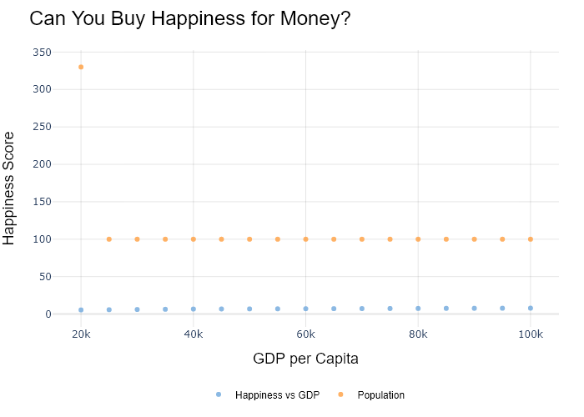

## Performance Metrics

|  |  |  |  |
| --- | --- | --- | --- |
| Task | Model Used | Description | Time Taken (s) |
| Processing Image to JSON | Gemini Vision Pro (default) | Time taken to convert the uploaded image to JSON format | 30.33 |
| Updating JSON | ChatGPT 3.5 (Default) | Time taken to update the JSON with new data | 0.00 |
| Plotting Updated JSON | N/A | Time taken to plot the updated JSON | 0.22 |

# Test Run

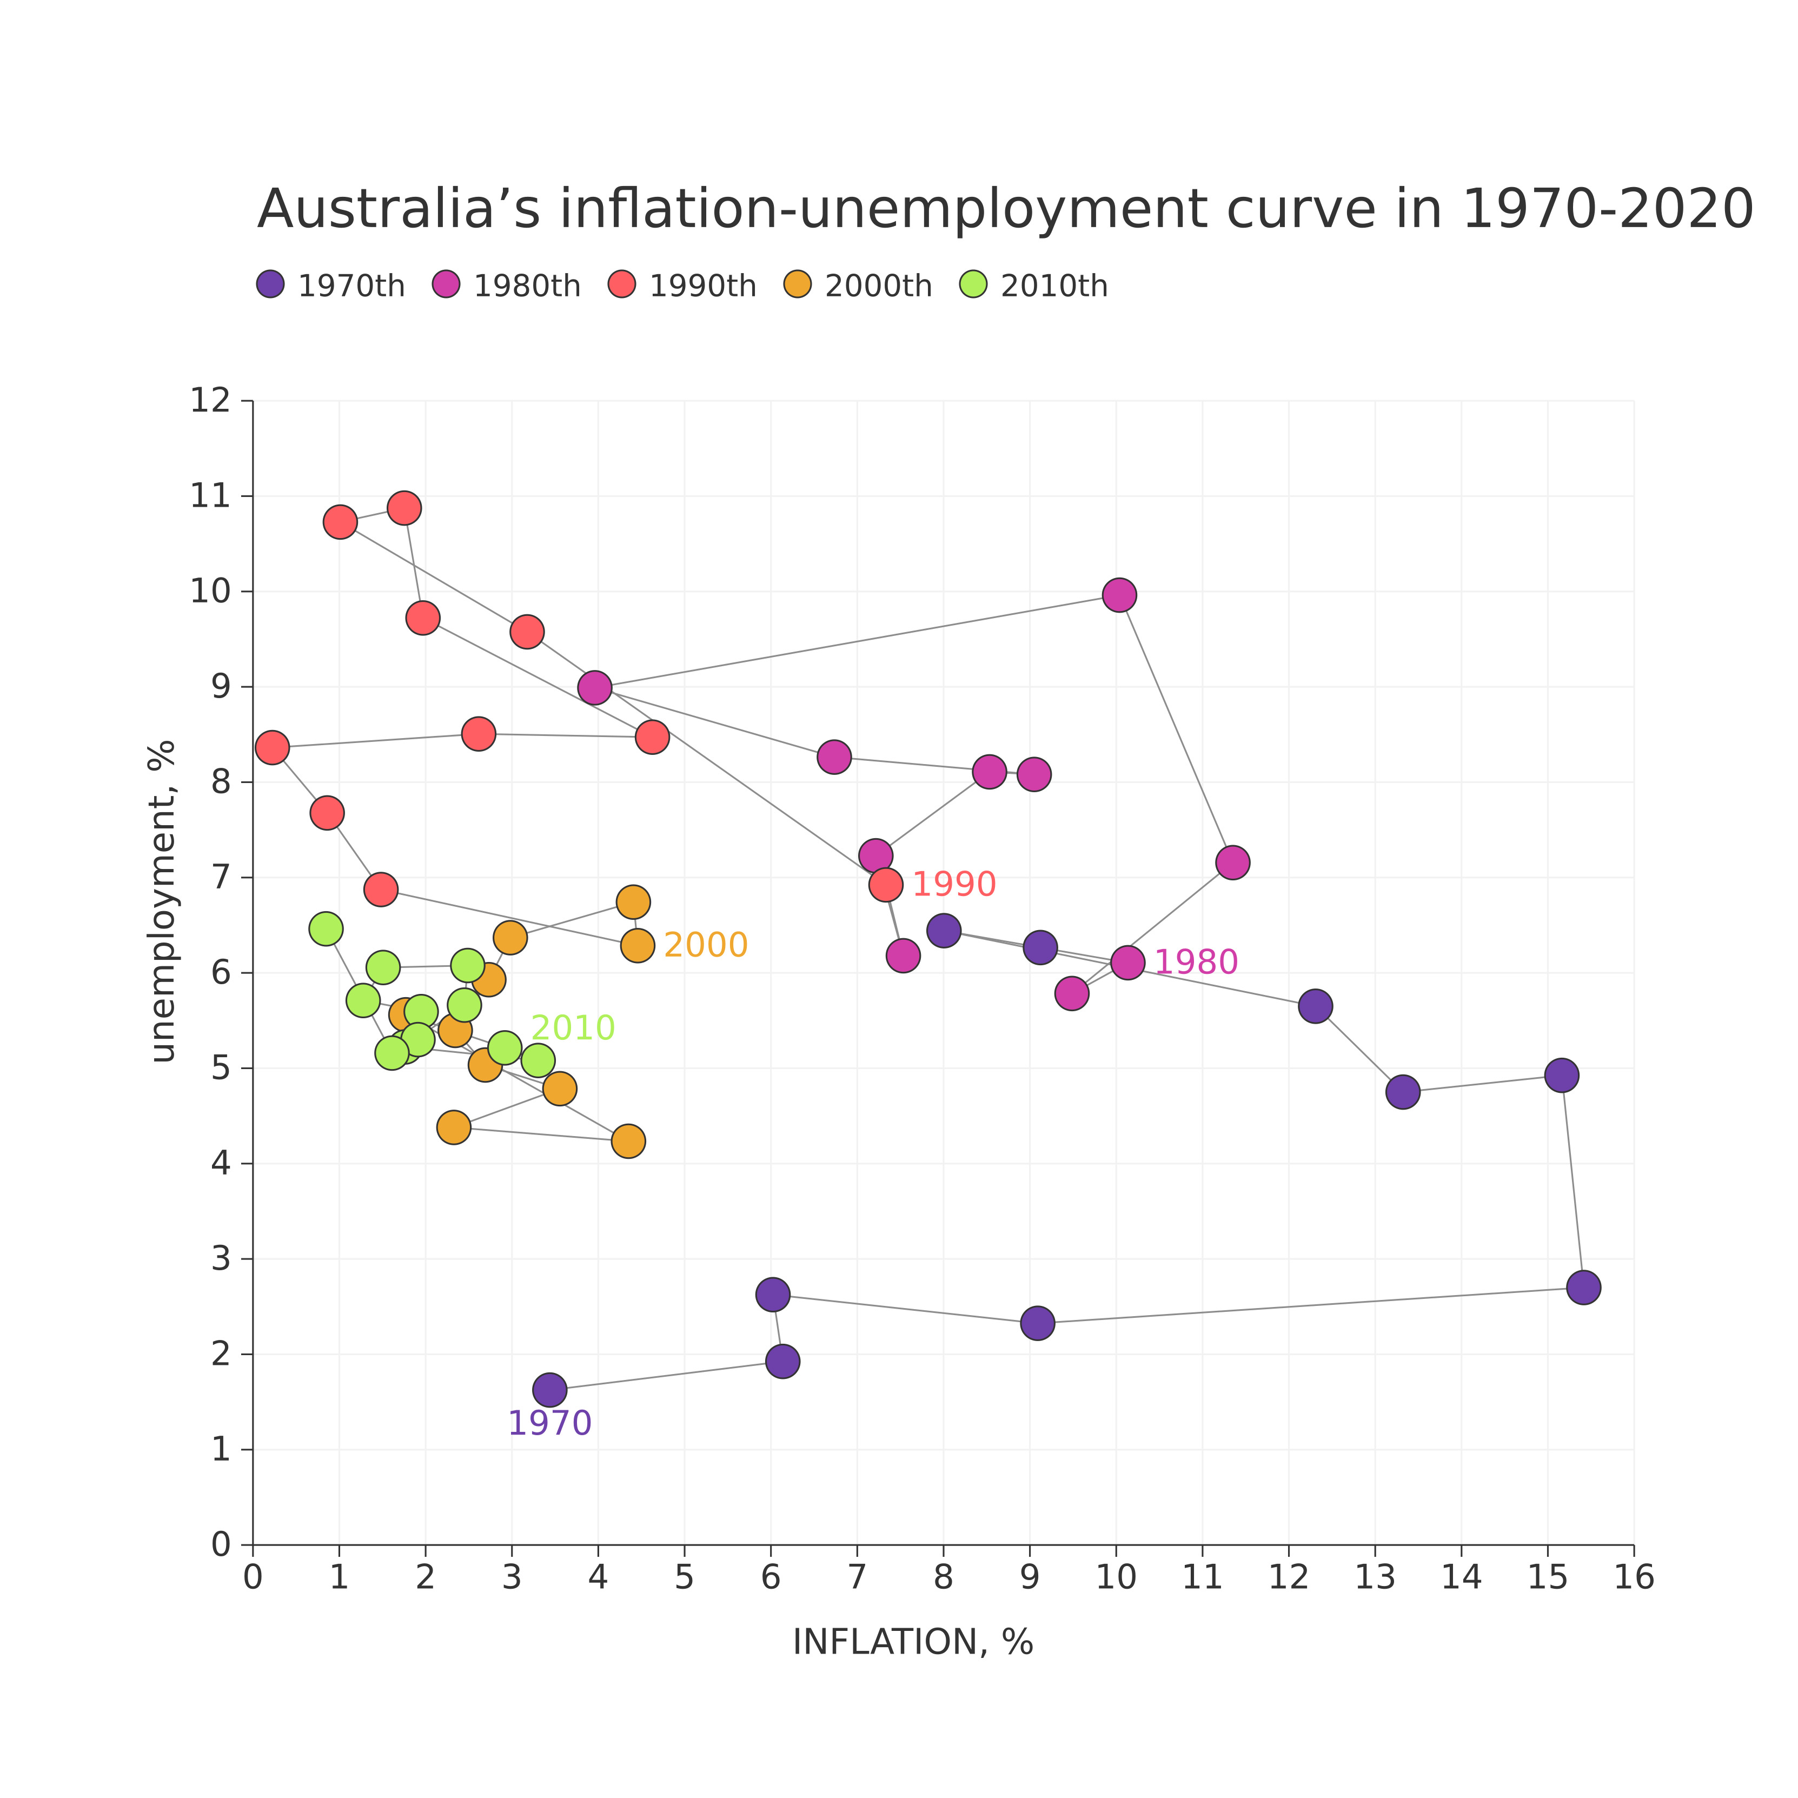

Figure: D:\Research Internship\Charts\Correlation\jpg\connected_scatter.jpg

## Prompt Used

## Task: Extract Detailed Information from a Given Graph Image  
  
You will analyze a graph image and generate corresponding Plotly-compatible JSON files (`data.json`, `layout.json`, and `config.json`). Follow the structured steps and specific XML-like delimiters for each JSON section as outlined below.  
  
### Instructions:  
  
#### Graph Analysis:  
  
1. **Identify and Categorize Plot Types**:  
 - Recognize and categorize the plot types present in the graph image. Include both simple and complex plots, listed below:  
 - **Comparison Charts**:  
 - `bar`: Bar Chart  
 - `bar` (with vertical bars): Column Chart  
 - `bar` (grouped): Grouped Bar/Column Chart  
 - `scatter` (with lines connecting to points): Lollipop Chart  
 - `indicator` (with gauge): Bullet Chart  
 - `scatter`: Dot Plot  
 - `scatter` (with lines connecting different points): Dumbbell Chart  
 - `scatter` (or custom SVG): Pictogram  
 - `scatter` or `bar` with a range: Range Chart  
 - `barpolar`: Radial Bar Chart  
 - `parcoords`: Parallel Coordinates  
 - `scatterpolar`: Radar Chart  
 - `barpolar` (with segments): Nightingale Chart  
 - `waterfall`: Waterfall Chart  
 - `heatmap` (with color scale): Matrix Chart  
 - `various charts in small multiples`: Small Multiples  
 - `text` (frequency-based size): Word Cloud  
 - `scatter` (with lines indicating change): Slope Chart  
 - `table`: Table Chart  
 - `scatter`: Categorical Scatter Plot  
 - `scatter` (with four quadrants): Quadrant Chart  
 - **Correlation Charts**:  
 - `heatmap`: Heatmap  
 - `scatter` (with size): Bubble Chart  
 - `scatter`: Scatter Plot  
 - `scatter` (with lines connecting points): Connected Scatter Plot  
 - `hexbin`: Hexagonal Binning  
 - `contour`: Contour Plot  
 - **Part-to-Whole & Hierarchical Charts**:  
 - `bar` (stacked): Stacked Bar/Column Chart  
 - `bar` (with diverging sections): Diverging Bar Chart  
 - `bar` (mirrored pairs): Population Pyramid  
 - `scatter` (or custom symbols in a grid): Icon Array  
 - `waffle`: Waffle Chart  
 - `pie`: Pie Chart  
 - `pie` (with hole): Donut Chart  
 - `pie` (half-circle): Semi-circle Donut Chart  
 - `bar` (variable width): Marimekko Chart  
 - `treemap`: Treemap  
 - `treemap` (circular): Circular Treemap  
 - `treemap` (convex shape): Convex Treemap  
 - `sunburst`: Sunburst Chart  
 - `funnel` or `pyramid`: Funnel & Pyramid Chart  
 - `dendrogram`: Dendrogram  
 - `venn`: Venn Diagram  
 - `euler`: Euler Diagram  
 - `indicator` (circular gauge): Circular Gauge  
 - **Data Over Time (Temporal) Charts**:  
 - `scatter` (filled area under curve): Area Chart  
 - `scatter` (filled stacked areas): Stacked Area Chart  
 - `scatter` (smoothed filled areas): Stream Graph  
 - `scatter` (indicating ranking change): Bump Chart  
 - `scatter` (with filled area): Bump Area Chart  
 - `scatter`: Line Chart  
 - `scatter` (with smoothed lines): Spline Chart  
 - `scatter` (with stepped lines): Step Line Chart  
 - `candlestick`: Candlestick Chart  
 - `gantt`: Gantt Chart  
 - `scatter` (encoded lines): Barcode Chart  
 - `ohlc`: OHLC Chart  
 - **Distribution Charts**:  
 - `densitymapbox` or `histogram`: Density Plot  
 - `ridge`: Ridgeline Plot  
 - `horizon`: Horizon Chart  
 - `histogram`: Histogram  
 - `radial_histogram`: Radial Histogram  
 - `scatter` (with distribution): Strip Plot  
 - `scatter` (with jitter): Jitter Plot  
 - `heatmap`: One-dimensional Heatmap  
 - `scatter` (with tightly packed points): Beeswarm Chart  
 - `box`: Box Chart  
 - `violin`: Violin Plot  
 - **Geospatial & Other Charts**:  
 - `densitymapbox`: Geographic Heatmap  
 - `choropleth`: Choropleth Map  
 - `scattermapbox`: Tile Map  
 - `chord`: Chord Diagram  
 - `arc`: Arc Diagram  
 - `sankey`: Sankey  
 - `network`: Network Diagram  
 - `flowchart`: Flowchart  
  
2. **Extract Data Points** for Each Plot Type:  
 - Gather the data points for each identified plot type.  
 - For `scatter`, `line`, and `area` plots: Extract `x` and `y` values.  
 - For `bar` and `stacked bar` plots: Extract `x` (categories) and `y` values.  
 - For `pie` charts: Extract `labels` and `values`.  
 - For `scatter3d`, `surface`, and other 3D plots: Extract `x`, `y`, and `z` values.  
  
3. **Identify Multiple Plots** on the Same Figure:  
 - Note any combinations or overlays of multiple plot types on the same figure and their configurations, such as stacked plots or multiple area fills.  
  
#### Generate JSON and CSV Outputs:  
  
Follow the JSON formatting guidelines and wrap each section in the specified XML-like tags.  
  
1. **Generate `data.json`**:  
 - Include detailed information for each plot type:  
 - `type`: Specify the plot type (e.g., `"scatter"`, `"bar"`, `"pie"`, `"area"`, `"scatter3d"`, `"surface"`).  
 - For area charts, use `"type": "scatter"` and specify `"fill"`.  
 - `x`, `y`, and `z` (if applicable): Arrays of data points for each axis.  
 - `labels` and `values` for pie charts.  
 - `mode`: Specify for line and scatter plots (e.g., `"markers"`, `"lines"`, `"markers+lines"`).  
 - `name`: Legend entry for the plot.  
 - `marker`: Properties such as color, size, and symbol.  
 - `line`: Properties such as color, width, and dash style.  
 - `text`: Hover text for each data point.  
 - `hoverinfo`: Information displayed on hover (e.g., `"x+y+text"`).  
 - `fill`: For area charts, specify the fill (e.g., `"tozeroy"`, `"tonexty"`).  
 - `fillcolor`: The color used to fill the area.  
 - `stackgroup`: For stacked bar charts, specify the stacking group.  
  
2. **Generate `layout.json`**:  
 - Define the layout properties:  
 - `title`: Text and font properties for the graph title.  
 - `xaxis` and `yaxis`: Configuration for axis titles, ranges, grids, and ticks.  
 - `zaxis`: Configuration for 3D plots including title, range, and grid.  
 - `legend`: Properties for legend orientation and positioning.  
 - `margin`: Margins for left, right, bottom, top, and padding.  
 - `plot_bgcolor` and `paper_bgcolor`: Background colors.  
 - `scene`: Configuration for 3D scenes, including camera angles and aspect ratio.  
  
3. **Generate `config.json`**:  
 - Include settings such as:  
 - `responsive`: Whether the graph is responsive.  
 - `displayModeBar`: Whether the mode bar is shown.  
 - `modeBarButtonsToRemove`: List of mode bar buttons to remove.  
 - `scrollZoom`: Whether scrolling zoom is enabled.  
  
4. **Generate `<csv>`**:  
 - Format the CSV data as follows:  
 ```csv  
 x,y  
 1,4  
 2,5  
 3,6  
 ```  
 - Replace `x`, `y`, `1`, `4`, `2`, `5`, and `3`, `6` with the actual data from the graph image.  
  
### Output Format:  
  
Wrap each JSON output in the specified XML-like tags:  
  
- `<data> ... </data>`  
- `<layout> ... </layout>`  
- `<config> ... </config>`  
- `<csv> ... </csv>`  
  
Ensure the JSON format follows these rules:  
- Use double quotes for all keys and string values.  
- Do not include trailing commas in arrays or objects.  
  
### Example Output:  
  
```xml  
<data>  
[  
 {  
 "type": "scatter",  
 "x": [1, 2, 3],  
 "y": [4, 5, 6],  
 "mode": "markers+lines",  
 "name": "Line Plot",  
 "marker": {  
 "color": "rgba(75, 192, 192, 0.6)",  
 "size": 8  
 },  
 "line": {  
 "color": "rgba(75, 192, 192  
  
, 1)",  
 "width": 2  
 }  
 },  
 {  
 "type": "area",  
 "x": [1, 2, 3, 4, 5, 6, 7, 8, 9, 10, 11, 12],  
 "y": [400, 430, 550, 620, 580, 600, 630, 700, 670, 630, 600, 500],  
 "name": "Housing",  
 "marker": {  
 "color": "rgba(255, 159, 64, 0.8)"  
 },  
 "line": {  
 "color": "rgba(255, 159, 64, 1)",  
 "width": 2  
 }  
 },  
 {  
 "type": "bar",  
 "x": ["A", "B", "C"],  
 "y": [10, 15, 13],  
 "name": "Bar Chart",  
 "marker": {  
 "color": "rgba(255, 99, 132, 0.6)"  
 },  
 "hoverinfo": "x+y+text"  
 },  
 {  
 "type": "scatter",  
 "x": [1, 2, 3],  
 "y": [6, 7, 8],  
 "mode": "lines",  
 "fill": "tozeroy",  
 "name": "Area Chart",  
 "line": {  
 "color": "rgba(54, 162, 235, 1)",  
 "width": 2  
 },  
 "fillcolor": "rgba(54, 162, 235, 0.5)"  
 },  
 {  
 "type": "scatter3d",  
 "x": [1, 2, 3],  
 "y": [4, 5, 6],  
 "z": [7, 8, 9],  
 "mode": "markers",  
 "name": "3D Scatter Plot",  
 "marker": {  
 "color": "rgba(255, 159, 64, 0.8)",  
 "size": 5  
 },  
 "hoverinfo": "x+y+z+text"  
 },  
 {  
 "type": "surface",  
 "z": [  
 [10, 10.625, 12.5, 15.625, 20],  
 [5.625, 6.25, 8.125, 11.25, 15.625],  
 [0, 1.25, 3.125, 6.25, 10.625]  
 ],  
 "name": "Surface Plot",  
 "colorscale": "Viridis",  
 "hoverinfo": "z+name"  
 }  
]  
</data>  
<layout>  
{  
 "title": {  
 "text": "Complex Graph Example",  
 "font": {  
 "family": "Arial, sans-serif",  
 "size": 24,  
 "color": "#000000"  
 }  
 },  
 "xaxis": {  
 "title": {  
 "text": "X Axis",  
 "font": {  
 "family": "Arial, sans-serif",  
 "size": 18,  
 "color": "#000000"  
 }  
 },  
 "showgrid": true,  
 "gridcolor": "rgba(0, 0, 0, 0.1)",  
 "zeroline": true,  
 "zerolinecolor": "rgba(0, 0, 0, 0.1)"  
 },  
 "yaxis": {  
 "title": {  
 "text": "Y Axis",  
 "font": {  
 "family": "Arial, sans-serif",  
 "size": 18,  
 "color": "#000000"  
 }  
 },  
 "showgrid": true,  
 "gridcolor": "rgba(0, 0, 0, 0.1)",  
 "zeroline": true,  
 "zerolinecolor": "rgba(0, 0, 0, 0.1)"  
 },  
 "legend": {  
 "orientation": "h",  
 "x": 0.5,  
 "xanchor": "center",  
 "y": -0.2,  
 "font": {  
 "family": "Arial, sans-serif",  
 "size": 12,  
 "color": "#000000"  
 }  
 },  
 "margin": {  
 "l": 60,  
 "r": 30,  
 "b": 60,  
 "t": 60  
 },  
 "plot_bgcolor": "#ffffff",  
 "paper_bgcolor": "#ffffff",  
 "scene": {  
 "xaxis": {"title": "X Axis"},  
 "yaxis": {"title": "Y Axis"},  
 "zaxis": {"title": "Z Axis"}  
 }  
}  
</layout>  
<config>  
{  
 "responsive": true,  
 "displayModeBar": true,  
 "modeBarButtonsToRemove": ["toImage"],  
 "scrollZoom": true  
}  
</config>  
<csv>  
x,y  
1,4  
2,5  
3,6  
</csv>  
```

## Extracted JSON

### data

[  
 {  
 "type": "scatter",  
 "x": [  
 1,  
 2,  
 3,  
 4,  
 5,  
 6,  
 7,  
 8,  
 9,  
 10,  
 11,  
 12,  
 13,  
 14,  
 15,  
 16  
 ],  
 "y": [  
 6.5,  
 7.2,  
 9.0,  
 6.8,  
 5.5,  
 6.0,  
 6.2,  
 7.5,  
 6.8,  
 7.2,  
 7.0,  
 6.0,  
 5.0,  
 4.5,  
 3.5,  
 3.0  
 ],  
 "mode": "lines",  
 "name": "Line Plot",  
 "line": {  
 "color": "rgba(75, 192, 192, 1)",  
 "width": 2  
 }  
 },  
 {  
 "type": "scatter",  
 "x": [  
 1,  
 2,  
 3,  
 4,  
 5,  
 6,  
 7,  
 8,  
 9,  
 10,  
 11,  
 12,  
 13,  
 14,  
 15,  
 16  
 ],  
 "y": [  
 5.0,  
 5.5,  
 7.5,  
 5.5,  
 4.5,  
 5.0,  
 5.2,  
 6.5,  
 5.8,  
 6.2,  
 6.0,  
 5.0,  
 4.0,  
 3.5,  
 2.5,  
 2.0  
 ],  
 "mode": "lines",  
 "name": "Line Plot",  
 "line": {  
 "color": "rgba(255, 159, 64, 1)",  
 "width": 2  
 }  
 },  
 {  
 "type": "scatter",  
 "x": [  
 1,  
 2,  
 3,  
 4,  
 5,  
 6,  
 7,  
 8,  
 9,  
 10,  
 11,  
 12,  
 13,  
 14,  
 15,  
 16  
 ],  
 "y": [  
 4.0,  
 4.5,  
 6.5,  
 4.5,  
 3.5,  
 4.0,  
 4.2,  
 5.5,  
 4.8,  
 5.2,  
 5.0,  
 4.0,  
 3.0,  
 2.5,  
 1.5,  
 1.0  
 ],  
 "mode": "lines",  
 "name": "Line Plot",  
 "line": {  
 "color": "rgba(54, 162, 235, 1)",  
 "width": 2  
 }  
 }  
]

### layout

{  
 "title": {  
 "text": "Australia's Inflation-Unemployment Curve in 1970-2020",  
 "font": {  
 "family": "Arial, sans-serif",  
 "size": 24,  
 "color": "#000000"  
 }  
 },  
 "xaxis": {  
 "title": {  
 "text": "Inflation, %",  
 "font": {  
 "family": "Arial, sans-serif",  
 "size": 18,  
 "color": "#000000"  
 }  
 },  
 "showgrid": true,  
 "gridcolor": "rgba(0, 0, 0, 0.1)",  
 "zeroline": true,  
 "zerolinecolor": "rgba(0, 0, 0, 0.1)"  
 },  
 "yaxis": {  
 "title": {  
 "text": "Unemployment, %",  
 "font": {  
 "family": "Arial, sans-serif",  
 "size": 18,  
 "color": "#000000"  
 }  
 },  
 "showgrid": true,  
 "gridcolor": "rgba(0, 0, 0, 0.1)",  
 "zeroline": true,  
 "zerolinecolor": "rgba(0, 0, 0, 0.1)"  
 },  
 "legend": {  
 "orientation": "h",  
 "x": 0.5,  
 "xanchor": "center",  
 "y": -0.2,  
 "font": {  
 "family": "Arial, sans-serif",  
 "size": 12,  
 "color": "#000000"  
 }  
 },  
 "margin": {  
 "l": 60,  
 "r": 30,  
 "b": 60,  
 "t": 60  
 },  
 "plot_bgcolor": "#ffffff",  
 "paper_bgcolor": "#ffffff"  
}

### config

{  
 "responsive": true,  
 "displayModeBar": true,  
 "modeBarButtonsToRemove": [  
 "toImage"  
 ],  
 "scrollZoom": true  
}

## Updated JSON

### updated_data

[  
 {  
 "type": "scatter",  
 "x": [  
 1,  
 2,  
 3,  
 4,  
 5,  
 6,  
 7,  
 8,  
 9,  
 10,  
 11,  
 12,  
 13,  
 14,  
 15,  
 16  
 ],  
 "y": [  
 6.5,  
 7.2,  
 9.0,  
 6.8,  
 5.5,  
 6.0,  
 6.2,  
 7.5,  
 6.8,  
 7.2,  
 7.0,  
 6.0,  
 5.0,  
 4.5,  
 3.5,  
 3.0  
 ],  
 "mode": "lines",  
 "name": "Line Plot",  
 "line": {  
 "color": "rgba(75, 192, 192, 1)",  
 "width": 2  
 }  
 },  
 {  
 "type": "scatter",  
 "x": [  
 1,  
 2,  
 3,  
 4,  
 5,  
 6,  
 7,  
 8,  
 9,  
 10,  
 11,  
 12,  
 13,  
 14,  
 15,  
 16  
 ],  
 "y": [  
 5.0,  
 5.5,  
 7.5,  
 5.5,  
 4.5,  
 5.0,  
 5.2,  
 6.5,  
 5.8,  
 6.2,  
 6.0,  
 5.0,  
 4.0,  
 3.5,  
 2.5,  
 2.0  
 ],  
 "mode": "lines",  
 "name": "Line Plot",  
 "line": {  
 "color": "rgba(255, 159, 64, 1)",  
 "width": 2  
 }  
 },  
 {  
 "type": "scatter",  
 "x": [  
 1,  
 2,  
 3,  
 4,  
 5,  
 6,  
 7,  
 8,  
 9,  
 10,  
 11,  
 12,  
 13,  
 14,  
 15,  
 16  
 ],  
 "y": [  
 4.0,  
 4.5,  
 6.5,  
 4.5,  
 3.5,  
 4.0,  
 4.2,  
 5.5,  
 4.8,  
 5.2,  
 5.0,  
 4.0,  
 3.0,  
 2.5,  
 1.5,  
 1.0  
 ],  
 "mode": "lines",  
 "name": "Line Plot",  
 "line": {  
 "color": "rgba(54, 162, 235, 1)",  
 "width": 2  
 }  
 }  
]

### updated_layout

{  
 "title": {  
 "text": "Australia's Inflation-Unemployment Curve in 1970-2020",  
 "font": {  
 "family": "Arial, sans-serif",  
 "size": 24,  
 "color": "#000000"  
 }  
 },  
 "xaxis": {  
 "title": {  
 "text": "Inflation, %",  
 "font": {  
 "family": "Arial, sans-serif",  
 "size": 18,  
 "color": "#000000"  
 }  
 },  
 "showgrid": true,  
 "gridcolor": "rgba(0, 0, 0, 0.1)",  
 "zeroline": true,  
 "zerolinecolor": "rgba(0, 0, 0, 0.1)"  
 },  
 "yaxis": {  
 "title": {  
 "text": "Unemployment, %",  
 "font": {  
 "family": "Arial, sans-serif",  
 "size": 18,  
 "color": "#000000"  
 }  
 },  
 "showgrid": true,  
 "gridcolor": "rgba(0, 0, 0, 0.1)",  
 "zeroline": true,  
 "zerolinecolor": "rgba(0, 0, 0, 0.1)"  
 },  
 "legend": {  
 "orientation": "h",  
 "x": 0.5,  
 "xanchor": "center",  
 "y": -0.2,  
 "font": {  
 "family": "Arial, sans-serif",  
 "size": 12,  
 "color": "#000000"  
 }  
 },  
 "margin": {  
 "l": 60,  
 "r": 30,  
 "b": 60,  
 "t": 60  
 },  
 "plot_bgcolor": "#ffffff",  
 "paper_bgcolor": "#ffffff"  
}

### updated_config

{  
 "responsive": true,  
 "displayModeBar": true,  
 "modeBarButtonsToRemove": [  
 "toImage"  
 ],  
 "scrollZoom": true  
}

## Updated Chart

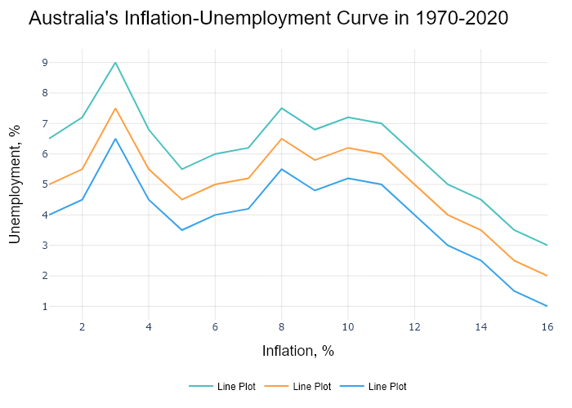

## Performance Metrics

|  |  |  |  |
| --- | --- | --- | --- |
| Task | Model Used | Description | Time Taken (s) |
| Processing Image to JSON | Gemini Vision Pro (default) | Time taken to convert the uploaded image to JSON format | 27.73 |
| Updating JSON | ChatGPT 3.5 (Default) | Time taken to update the JSON with new data | 0.00 |
| Plotting Updated JSON | N/A | Time taken to plot the updated JSON | 0.19 |

# Test Run

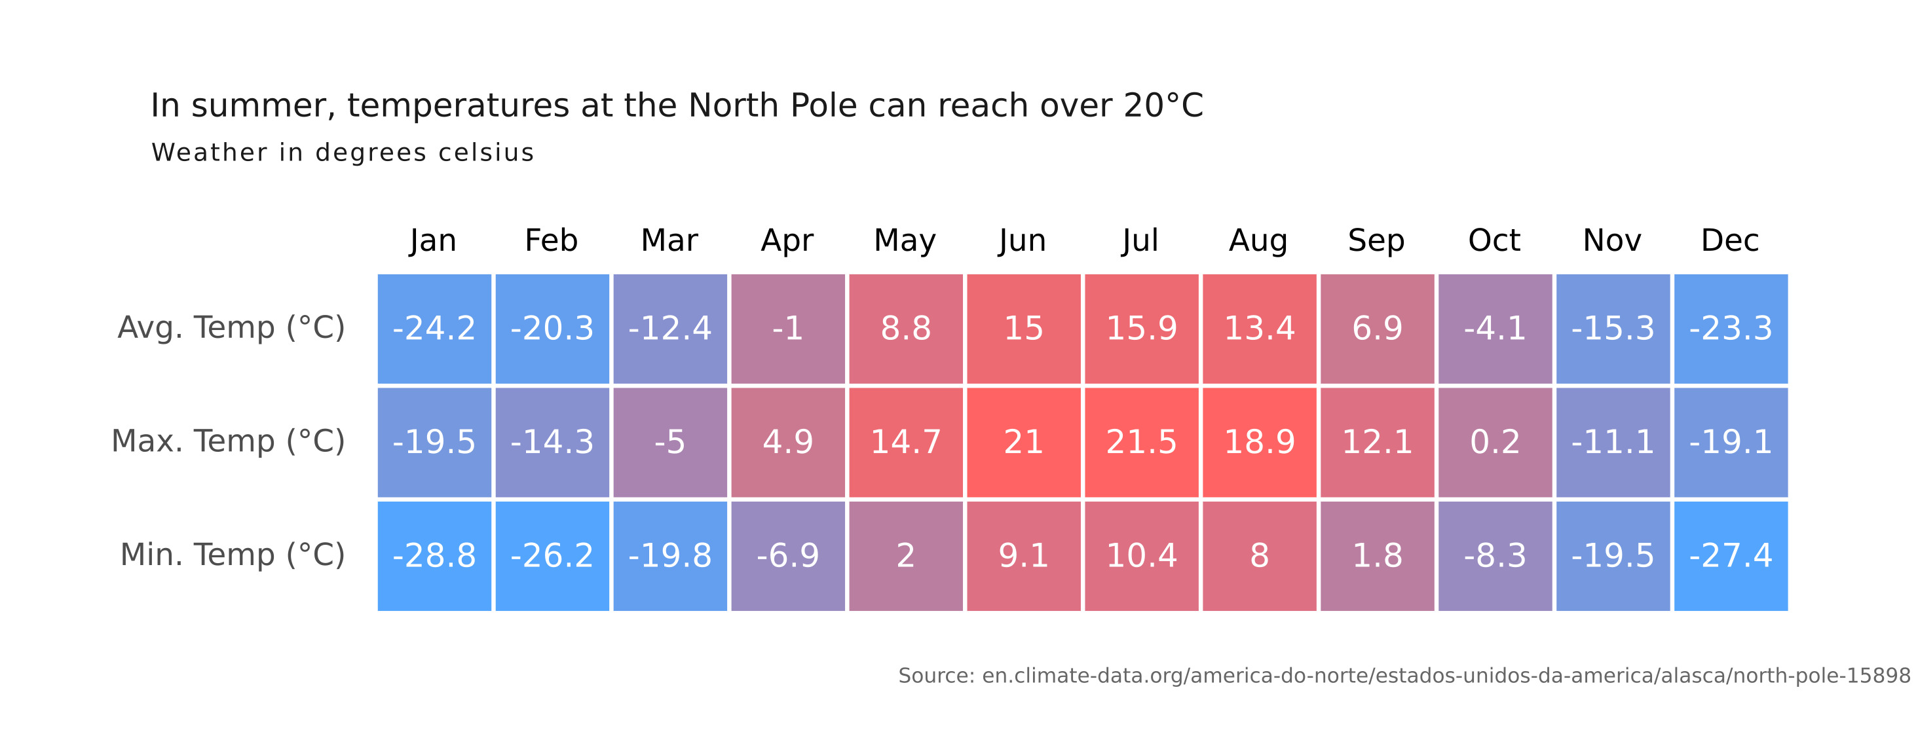

Figure: D:\Research Internship\Charts\Correlation\jpg\heatmap.jpg

## Prompt Used

## Task: Extract Detailed Information from a Given Graph Image  
  
You will analyze a graph image and generate corresponding Plotly-compatible JSON files (`data.json`, `layout.json`, and `config.json`). Follow the structured steps and specific XML-like delimiters for each JSON section as outlined below.  
  
### Instructions:  
  
#### Graph Analysis:  
  
1. **Identify and Categorize Plot Types**:  
 - Recognize and categorize the plot types present in the graph image. Include both simple and complex plots, listed below:  
 - **Comparison Charts**:  
 - `bar`: Bar Chart  
 - `bar` (with vertical bars): Column Chart  
 - `bar` (grouped): Grouped Bar/Column Chart  
 - `scatter` (with lines connecting to points): Lollipop Chart  
 - `indicator` (with gauge): Bullet Chart  
 - `scatter`: Dot Plot  
 - `scatter` (with lines connecting different points): Dumbbell Chart  
 - `scatter` (or custom SVG): Pictogram  
 - `scatter` or `bar` with a range: Range Chart  
 - `barpolar`: Radial Bar Chart  
 - `parcoords`: Parallel Coordinates  
 - `scatterpolar`: Radar Chart  
 - `barpolar` (with segments): Nightingale Chart  
 - `waterfall`: Waterfall Chart  
 - `heatmap` (with color scale): Matrix Chart  
 - `various charts in small multiples`: Small Multiples  
 - `text` (frequency-based size): Word Cloud  
 - `scatter` (with lines indicating change): Slope Chart  
 - `table`: Table Chart  
 - `scatter`: Categorical Scatter Plot  
 - `scatter` (with four quadrants): Quadrant Chart  
 - **Correlation Charts**:  
 - `heatmap`: Heatmap  
 - `scatter` (with size): Bubble Chart  
 - `scatter`: Scatter Plot  
 - `scatter` (with lines connecting points): Connected Scatter Plot  
 - `hexbin`: Hexagonal Binning  
 - `contour`: Contour Plot  
 - **Part-to-Whole & Hierarchical Charts**:  
 - `bar` (stacked): Stacked Bar/Column Chart  
 - `bar` (with diverging sections): Diverging Bar Chart  
 - `bar` (mirrored pairs): Population Pyramid  
 - `scatter` (or custom symbols in a grid): Icon Array  
 - `waffle`: Waffle Chart  
 - `pie`: Pie Chart  
 - `pie` (with hole): Donut Chart  
 - `pie` (half-circle): Semi-circle Donut Chart  
 - `bar` (variable width): Marimekko Chart  
 - `treemap`: Treemap  
 - `treemap` (circular): Circular Treemap  
 - `treemap` (convex shape): Convex Treemap  
 - `sunburst`: Sunburst Chart  
 - `funnel` or `pyramid`: Funnel & Pyramid Chart  
 - `dendrogram`: Dendrogram  
 - `venn`: Venn Diagram  
 - `euler`: Euler Diagram  
 - `indicator` (circular gauge): Circular Gauge  
 - **Data Over Time (Temporal) Charts**:  
 - `scatter` (filled area under curve): Area Chart  
 - `scatter` (filled stacked areas): Stacked Area Chart  
 - `scatter` (smoothed filled areas): Stream Graph  
 - `scatter` (indicating ranking change): Bump Chart  
 - `scatter` (with filled area): Bump Area Chart  
 - `scatter`: Line Chart  
 - `scatter` (with smoothed lines): Spline Chart  
 - `scatter` (with stepped lines): Step Line Chart  
 - `candlestick`: Candlestick Chart  
 - `gantt`: Gantt Chart  
 - `scatter` (encoded lines): Barcode Chart  
 - `ohlc`: OHLC Chart  
 - **Distribution Charts**:  
 - `densitymapbox` or `histogram`: Density Plot  
 - `ridge`: Ridgeline Plot  
 - `horizon`: Horizon Chart  
 - `histogram`: Histogram  
 - `radial_histogram`: Radial Histogram  
 - `scatter` (with distribution): Strip Plot  
 - `scatter` (with jitter): Jitter Plot  
 - `heatmap`: One-dimensional Heatmap  
 - `scatter` (with tightly packed points): Beeswarm Chart  
 - `box`: Box Chart  
 - `violin`: Violin Plot  
 - **Geospatial & Other Charts**:  
 - `densitymapbox`: Geographic Heatmap  
 - `choropleth`: Choropleth Map  
 - `scattermapbox`: Tile Map  
 - `chord`: Chord Diagram  
 - `arc`: Arc Diagram  
 - `sankey`: Sankey  
 - `network`: Network Diagram  
 - `flowchart`: Flowchart  
  
2. **Extract Data Points** for Each Plot Type:  
 - Gather the data points for each identified plot type.  
 - For `scatter`, `line`, and `area` plots: Extract `x` and `y` values.  
 - For `bar` and `stacked bar` plots: Extract `x` (categories) and `y` values.  
 - For `pie` charts: Extract `labels` and `values`.  
 - For `scatter3d`, `surface`, and other 3D plots: Extract `x`, `y`, and `z` values.  
  
3. **Identify Multiple Plots** on the Same Figure:  
 - Note any combinations or overlays of multiple plot types on the same figure and their configurations, such as stacked plots or multiple area fills.  
  
#### Generate JSON and CSV Outputs:  
  
Follow the JSON formatting guidelines and wrap each section in the specified XML-like tags.  
  
1. **Generate `data.json`**:  
 - Include detailed information for each plot type:  
 - `type`: Specify the plot type (e.g., `"scatter"`, `"bar"`, `"pie"`, `"area"`, `"scatter3d"`, `"surface"`).  
 - For area charts, use `"type": "scatter"` and specify `"fill"`.  
 - `x`, `y`, and `z` (if applicable): Arrays of data points for each axis.  
 - `labels` and `values` for pie charts.  
 - `mode`: Specify for line and scatter plots (e.g., `"markers"`, `"lines"`, `"markers+lines"`).  
 - `name`: Legend entry for the plot.  
 - `marker`: Properties such as color, size, and symbol.  
 - `line`: Properties such as color, width, and dash style.  
 - `text`: Hover text for each data point.  
 - `hoverinfo`: Information displayed on hover (e.g., `"x+y+text"`).  
 - `fill`: For area charts, specify the fill (e.g., `"tozeroy"`, `"tonexty"`).  
 - `fillcolor`: The color used to fill the area.  
 - `stackgroup`: For stacked bar charts, specify the stacking group.  
  
2. **Generate `layout.json`**:  
 - Define the layout properties:  
 - `title`: Text and font properties for the graph title.  
 - `xaxis` and `yaxis`: Configuration for axis titles, ranges, grids, and ticks.  
 - `zaxis`: Configuration for 3D plots including title, range, and grid.  
 - `legend`: Properties for legend orientation and positioning.  
 - `margin`: Margins for left, right, bottom, top, and padding.  
 - `plot_bgcolor` and `paper_bgcolor`: Background colors.  
 - `scene`: Configuration for 3D scenes, including camera angles and aspect ratio.  
  
3. **Generate `config.json`**:  
 - Include settings such as:  
 - `responsive`: Whether the graph is responsive.  
 - `displayModeBar`: Whether the mode bar is shown.  
 - `modeBarButtonsToRemove`: List of mode bar buttons to remove.  
 - `scrollZoom`: Whether scrolling zoom is enabled.  
  
4. **Generate `<csv>`**:  
 - Format the CSV data as follows:  
 ```csv  
 x,y  
 1,4  
 2,5  
 3,6  
 ```  
 - Replace `x`, `y`, `1`, `4`, `2`, `5`, and `3`, `6` with the actual data from the graph image.  
  
### Output Format:  
  
Wrap each JSON output in the specified XML-like tags:  
  
- `<data> ... </data>`  
- `<layout> ... </layout>`  
- `<config> ... </config>`  
- `<csv> ... </csv>`  
  
Ensure the JSON format follows these rules:  
- Use double quotes for all keys and string values.  
- Do not include trailing commas in arrays or objects.  
  
### Example Output:  
  
```xml  
<data>  
[  
 {  
 "type": "scatter",  
 "x": [1, 2, 3],  
 "y": [4, 5, 6],  
 "mode": "markers+lines",  
 "name": "Line Plot",  
 "marker": {  
 "color": "rgba(75, 192, 192, 0.6)",  
 "size": 8  
 },  
 "line": {  
 "color": "rgba(75, 192, 192  
  
, 1)",  
 "width": 2  
 }  
 },  
 {  
 "type": "area",  
 "x": [1, 2, 3, 4, 5, 6, 7, 8, 9, 10, 11, 12],  
 "y": [400, 430, 550, 620, 580, 600, 630, 700, 670, 630, 600, 500],  
 "name": "Housing",  
 "marker": {  
 "color": "rgba(255, 159, 64, 0.8)"  
 },  
 "line": {  
 "color": "rgba(255, 159, 64, 1)",  
 "width": 2  
 }  
 },  
 {  
 "type": "bar",  
 "x": ["A", "B", "C"],  
 "y": [10, 15, 13],  
 "name": "Bar Chart",  
 "marker": {  
 "color": "rgba(255, 99, 132, 0.6)"  
 },  
 "hoverinfo": "x+y+text"  
 },  
 {  
 "type": "scatter",  
 "x": [1, 2, 3],  
 "y": [6, 7, 8],  
 "mode": "lines",  
 "fill": "tozeroy",  
 "name": "Area Chart",  
 "line": {  
 "color": "rgba(54, 162, 235, 1)",  
 "width": 2  
 },  
 "fillcolor": "rgba(54, 162, 235, 0.5)"  
 },  
 {  
 "type": "scatter3d",  
 "x": [1, 2, 3],  
 "y": [4, 5, 6],  
 "z": [7, 8, 9],  
 "mode": "markers",  
 "name": "3D Scatter Plot",  
 "marker": {  
 "color": "rgba(255, 159, 64, 0.8)",  
 "size": 5  
 },  
 "hoverinfo": "x+y+z+text"  
 },  
 {  
 "type": "surface",  
 "z": [  
 [10, 10.625, 12.5, 15.625, 20],  
 [5.625, 6.25, 8.125, 11.25, 15.625],  
 [0, 1.25, 3.125, 6.25, 10.625]  
 ],  
 "name": "Surface Plot",  
 "colorscale": "Viridis",  
 "hoverinfo": "z+name"  
 }  
]  
</data>  
<layout>  
{  
 "title": {  
 "text": "Complex Graph Example",  
 "font": {  
 "family": "Arial, sans-serif",  
 "size": 24,  
 "color": "#000000"  
 }  
 },  
 "xaxis": {  
 "title": {  
 "text": "X Axis",  
 "font": {  
 "family": "Arial, sans-serif",  
 "size": 18,  
 "color": "#000000"  
 }  
 },  
 "showgrid": true,  
 "gridcolor": "rgba(0, 0, 0, 0.1)",  
 "zeroline": true,  
 "zerolinecolor": "rgba(0, 0, 0, 0.1)"  
 },  
 "yaxis": {  
 "title": {  
 "text": "Y Axis",  
 "font": {  
 "family": "Arial, sans-serif",  
 "size": 18,  
 "color": "#000000"  
 }  
 },  
 "showgrid": true,  
 "gridcolor": "rgba(0, 0, 0, 0.1)",  
 "zeroline": true,  
 "zerolinecolor": "rgba(0, 0, 0, 0.1)"  
 },  
 "legend": {  
 "orientation": "h",  
 "x": 0.5,  
 "xanchor": "center",  
 "y": -0.2,  
 "font": {  
 "family": "Arial, sans-serif",  
 "size": 12,  
 "color": "#000000"  
 }  
 },  
 "margin": {  
 "l": 60,  
 "r": 30,  
 "b": 60,  
 "t": 60  
 },  
 "plot_bgcolor": "#ffffff",  
 "paper_bgcolor": "#ffffff",  
 "scene": {  
 "xaxis": {"title": "X Axis"},  
 "yaxis": {"title": "Y Axis"},  
 "zaxis": {"title": "Z Axis"}  
 }  
}  
</layout>  
<config>  
{  
 "responsive": true,  
 "displayModeBar": true,  
 "modeBarButtonsToRemove": ["toImage"],  
 "scrollZoom": true  
}  
</config>  
<csv>  
x,y  
1,4  
2,5  
3,6  
</csv>  
```

## Extracted JSON

### data

[  
 {  
 "type": "scatter",  
 "x": [  
 "Jan",  
 "Feb",  
 "Mar",  
 "Apr",  
 "May",  
 "Jun",  
 "Jul",  
 "Aug",  
 "Sep",  
 "Oct",  
 "Nov",  
 "Dec"  
 ],  
 "y": [  
 -24.2,  
 -20.3,  
 -12.4,  
 -1.0,  
 8.8,  
 15.0,  
 15.9,  
 13.4,  
 6.9,  
 -4.1,  
 -15.3,  
 -23.3  
 ],  
 "mode": "lines+markers",  
 "name": "Average Temperature",  
 "marker": {  
 "color": "rgba(255, 159, 64, 0.8)"  
 },  
 "line": {  
 "color": "rgba(255, 159, 64, 1)",  
 "width": 2  
 }  
 },  
 {  
 "type": "scatter",  
 "x": [  
 "Jan",  
 "Feb",  
 "Mar",  
 "Apr",  
 "May",  
 "Jun",  
 "Jul",  
 "Aug",  
 "Sep",  
 "Oct",  
 "Nov",  
 "Dec"  
 ],  
 "y": [  
 -19.5,  
 -14.3,  
 -5.0,  
 4.9,  
 14.7,  
 21.0,  
 21.5,  
 18.9,  
 12.1,  
 0.2,  
 -11.1,  
 -19.1  
 ],  
 "mode": "lines+markers",  
 "name": "Maximum Temperature",  
 "marker": {  
 "color": "rgba(54, 162, 235, 0.8)"  
 },  
 "line": {  
 "color": "rgba(54, 162, 235, 1)",  
 "width": 2  
 }  
 },  
 {  
 "type": "scatter",  
 "x": [  
 "Jan",  
 "Feb",  
 "Mar",  
 "Apr",  
 "May",  
 "Jun",  
 "Jul",  
 "Aug",  
 "Sep",  
 "Oct",  
 "Nov",  
 "Dec"  
 ],  
 "y": [  
 -28.8,  
 -26.2,  
 -19.8,  
 -6.9,  
 2.0,  
 9.1,  
 10.4,  
 8.0,  
 1.8,  
 -8.3,  
 -19.5,  
 -27.4  
 ],  
 "mode": "lines+markers",  
 "name": "Minimum Temperature",  
 "marker": {  
 "color": "rgba(255, 99, 132, 0.8)"  
 },  
 "line": {  
 "color": "rgba(255, 99, 132, 1)",  
 "width": 2  
 }  
 }  
]

### layout

{  
 "title": {  
 "text": "In summer, temperatures at the North Pole can reach over 20\u00b0C",  
 "font": {  
 "family": "Arial, sans-serif",  
 "size": 24,  
 "color": "#000000"  
 }  
 },  
 "xaxis": {  
 "title": {  
 "text": "Month",  
 "font": {  
 "family": "Arial, sans-serif",  
 "size": 18,  
 "color": "#000000"  
 }  
 },  
 "showgrid": true,  
 "gridcolor": "rgba(0, 0, 0, 0.1)",  
 "zeroline": true,  
 "zerolinecolor": "rgba(0, 0, 0, 0.1)"  
 },  
 "yaxis": {  
 "title": {  
 "text": "Temperature (\u00b0C)",  
 "font": {  
 "family": "Arial, sans-serif",  
 "size": 18,  
 "color": "#000000"  
 }  
 },  
 "showgrid": true,  
 "gridcolor": "rgba(0, 0, 0, 0.1)",  
 "zeroline": true,  
 "zerolinecolor": "rgba(0, 0, 0, 0.1)"  
 },  
 "legend": {  
 "orientation": "h",  
 "x": 0.5,  
 "xanchor": "center",  
 "y": -0.2,  
 "font": {  
 "family": "Arial, sans-serif",  
 "size": 12,  
 "color": "#000000"  
 }  
 },  
 "margin": {  
 "l": 60,  
 "r": 30,  
 "b": 60,  
 "t": 60  
 },  
 "plot_bgcolor": "#ffffff",  
 "paper_bgcolor": "#ffffff"  
}

### config

{  
 "responsive": true,  
 "displayModeBar": true,  
 "modeBarButtonsToRemove": [  
 "toImage"  
 ],  
 "scrollZoom": true  
}

## Updated JSON

### updated_data

[  
 {  
 "type": "scatter",  
 "x": [  
 "Jan",  
 "Feb",  
 "Mar",  
 "Apr",  
 "May",  
 "Jun",  
 "Jul",  
 "Aug",  
 "Sep",  
 "Oct",  
 "Nov",  
 "Dec"  
 ],  
 "y": [  
 -24.2,  
 -20.3,  
 -12.4,  
 -1.0,  
 8.8,  
 15.0,  
 15.9,  
 13.4,  
 6.9,  
 -4.1,  
 -15.3,  
 -23.3  
 ],  
 "mode": "lines+markers",  
 "name": "Average Temperature",  
 "marker": {  
 "color": "rgba(255, 159, 64, 0.8)"  
 },  
 "line": {  
 "color": "rgba(255, 159, 64, 1)",  
 "width": 2  
 }  
 },  
 {  
 "type": "scatter",  
 "x": [  
 "Jan",  
 "Feb",  
 "Mar",  
 "Apr",  
 "May",  
 "Jun",  
 "Jul",  
 "Aug",  
 "Sep",  
 "Oct",  
 "Nov",  
 "Dec"  
 ],  
 "y": [  
 -19.5,  
 -14.3,  
 -5.0,  
 4.9,  
 14.7,  
 21.0,  
 21.5,  
 18.9,  
 12.1,  
 0.2,  
 -11.1,  
 -19.1  
 ],  
 "mode": "lines+markers",  
 "name": "Maximum Temperature",  
 "marker": {  
 "color": "rgba(54, 162, 235, 0.8)"  
 },  
 "line": {  
 "color": "rgba(54, 162, 235, 1)",  
 "width": 2  
 }  
 },  
 {  
 "type": "scatter",  
 "x": [  
 "Jan",  
 "Feb",  
 "Mar",  
 "Apr",  
 "May",  
 "Jun",  
 "Jul",  
 "Aug",  
 "Sep",  
 "Oct",  
 "Nov",  
 "Dec"  
 ],  
 "y": [  
 -28.8,  
 -26.2,  
 -19.8,  
 -6.9,  
 2.0,  
 9.1,  
 10.4,  
 8.0,  
 1.8,  
 -8.3,  
 -19.5,  
 -27.4  
 ],  
 "mode": "lines+markers",  
 "name": "Minimum Temperature",  
 "marker": {  
 "color": "rgba(255, 99, 132, 0.8)"  
 },  
 "line": {  
 "color": "rgba(255, 99, 132, 1)",  
 "width": 2  
 }  
 }  
]

### updated_layout

{  
 "title": {  
 "text": "In summer, temperatures at the North Pole can reach over 20\u00b0C",  
 "font": {  
 "family": "Arial, sans-serif",  
 "size": 24,  
 "color": "#000000"  
 }  
 },  
 "xaxis": {  
 "title": {  
 "text": "Month",  
 "font": {  
 "family": "Arial, sans-serif",  
 "size": 18,  
 "color": "#000000"  
 }  
 },  
 "showgrid": true,  
 "gridcolor": "rgba(0, 0, 0, 0.1)",  
 "zeroline": true,  
 "zerolinecolor": "rgba(0, 0, 0, 0.1)"  
 },  
 "yaxis": {  
 "title": {  
 "text": "Temperature (\u00b0C)",  
 "font": {  
 "family": "Arial, sans-serif",  
 "size": 18,  
 "color": "#000000"  
 }  
 },  
 "showgrid": true,  
 "gridcolor": "rgba(0, 0, 0, 0.1)",  
 "zeroline": true,  
 "zerolinecolor": "rgba(0, 0, 0, 0.1)"  
 },  
 "legend": {  
 "orientation": "h",  
 "x": 0.5,  
 "xanchor": "center",  
 "y": -0.2,  
 "font": {  
 "family": "Arial, sans-serif",  
 "size": 12,  
 "color": "#000000"  
 }  
 },  
 "margin": {  
 "l": 60,  
 "r": 30,  
 "b": 60,  
 "t": 60  
 },  
 "plot_bgcolor": "#ffffff",  
 "paper_bgcolor": "#ffffff"  
}

### updated_config

{  
 "responsive": true,  
 "displayModeBar": true,  
 "modeBarButtonsToRemove": [  
 "toImage"  
 ],  
 "scrollZoom": true  
}

## Updated Chart

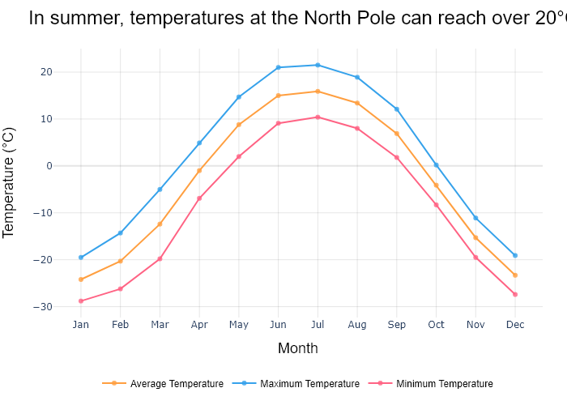

## Performance Metrics

|  |  |  |  |
| --- | --- | --- | --- |
| Task | Model Used | Description | Time Taken (s) |
| Processing Image to JSON | Gemini Vision Pro (default) | Time taken to convert the uploaded image to JSON format | 30.87 |
| Updating JSON | ChatGPT 3.5 (Default) | Time taken to update the JSON with new data | 0.00 |
| Plotting Updated JSON | N/A | Time taken to plot the updated JSON | 0.21 |

# Test Run



Figure: D:\Research Internship\Charts\Correlation\jpg\scatter.jpg

## Prompt Used

## Task: Extract Detailed Information from a Given Graph Image  
  
You will analyze a graph image and generate corresponding Plotly-compatible JSON files (`data.json`, `layout.json`, and `config.json`). Follow the structured steps and specific XML-like delimiters for each JSON section as outlined below.  
  
### Instructions:  
  
#### Graph Analysis:  
  
1. **Identify and Categorize Plot Types**:  
 - Recognize and categorize the plot types present in the graph image. Include both simple and complex plots, listed below:  
 - **Comparison Charts**:  
 - `bar`: Bar Chart  
 - `bar` (with vertical bars): Column Chart  
 - `bar` (grouped): Grouped Bar/Column Chart  
 - `scatter` (with lines connecting to points): Lollipop Chart  
 - `indicator` (with gauge): Bullet Chart  
 - `scatter`: Dot Plot  
 - `scatter` (with lines connecting different points): Dumbbell Chart  
 - `scatter` (or custom SVG): Pictogram  
 - `scatter` or `bar` with a range: Range Chart  
 - `barpolar`: Radial Bar Chart  
 - `parcoords`: Parallel Coordinates  
 - `scatterpolar`: Radar Chart  
 - `barpolar` (with segments): Nightingale Chart  
 - `waterfall`: Waterfall Chart  
 - `heatmap` (with color scale): Matrix Chart  
 - `various charts in small multiples`: Small Multiples  
 - `text` (frequency-based size): Word Cloud  
 - `scatter` (with lines indicating change): Slope Chart  
 - `table`: Table Chart  
 - `scatter`: Categorical Scatter Plot  
 - `scatter` (with four quadrants): Quadrant Chart  
 - **Correlation Charts**:  
 - `heatmap`: Heatmap  
 - `scatter` (with size): Bubble Chart  
 - `scatter`: Scatter Plot  
 - `scatter` (with lines connecting points): Connected Scatter Plot  
 - `hexbin`: Hexagonal Binning  
 - `contour`: Contour Plot  
 - **Part-to-Whole & Hierarchical Charts**:  
 - `bar` (stacked): Stacked Bar/Column Chart  
 - `bar` (with diverging sections): Diverging Bar Chart  
 - `bar` (mirrored pairs): Population Pyramid  
 - `scatter` (or custom symbols in a grid): Icon Array  
 - `waffle`: Waffle Chart  
 - `pie`: Pie Chart  
 - `pie` (with hole): Donut Chart  
 - `pie` (half-circle): Semi-circle Donut Chart  
 - `bar` (variable width): Marimekko Chart  
 - `treemap`: Treemap  
 - `treemap` (circular): Circular Treemap  
 - `treemap` (convex shape): Convex Treemap  
 - `sunburst`: Sunburst Chart  
 - `funnel` or `pyramid`: Funnel & Pyramid Chart  
 - `dendrogram`: Dendrogram  
 - `venn`: Venn Diagram  
 - `euler`: Euler Diagram  
 - `indicator` (circular gauge): Circular Gauge  
 - **Data Over Time (Temporal) Charts**:  
 - `scatter` (filled area under curve): Area Chart  
 - `scatter` (filled stacked areas): Stacked Area Chart  
 - `scatter` (smoothed filled areas): Stream Graph  
 - `scatter` (indicating ranking change): Bump Chart  
 - `scatter` (with filled area): Bump Area Chart  
 - `scatter`: Line Chart  
 - `scatter` (with smoothed lines): Spline Chart  
 - `scatter` (with stepped lines): Step Line Chart  
 - `candlestick`: Candlestick Chart  
 - `gantt`: Gantt Chart  
 - `scatter` (encoded lines): Barcode Chart  
 - `ohlc`: OHLC Chart  
 - **Distribution Charts**:  
 - `densitymapbox` or `histogram`: Density Plot  
 - `ridge`: Ridgeline Plot  
 - `horizon`: Horizon Chart  
 - `histogram`: Histogram  
 - `radial_histogram`: Radial Histogram  
 - `scatter` (with distribution): Strip Plot  
 - `scatter` (with jitter): Jitter Plot  
 - `heatmap`: One-dimensional Heatmap  
 - `scatter` (with tightly packed points): Beeswarm Chart  
 - `box`: Box Chart  
 - `violin`: Violin Plot  
 - **Geospatial & Other Charts**:  
 - `densitymapbox`: Geographic Heatmap  
 - `choropleth`: Choropleth Map  
 - `scattermapbox`: Tile Map  
 - `chord`: Chord Diagram  
 - `arc`: Arc Diagram  
 - `sankey`: Sankey  
 - `network`: Network Diagram  
 - `flowchart`: Flowchart  
  
2. **Extract Data Points** for Each Plot Type:  
 - Gather the data points for each identified plot type.  
 - For `scatter`, `line`, and `area` plots: Extract `x` and `y` values.  
 - For `bar` and `stacked bar` plots: Extract `x` (categories) and `y` values.  
 - For `pie` charts: Extract `labels` and `values`.  
 - For `scatter3d`, `surface`, and other 3D plots: Extract `x`, `y`, and `z` values.  
  
3. **Identify Multiple Plots** on the Same Figure:  
 - Note any combinations or overlays of multiple plot types on the same figure and their configurations, such as stacked plots or multiple area fills.  
  
#### Generate JSON and CSV Outputs:  
  
Follow the JSON formatting guidelines and wrap each section in the specified XML-like tags.  
  
1. **Generate `data.json`**:  
 - Include detailed information for each plot type:  
 - `type`: Specify the plot type (e.g., `"scatter"`, `"bar"`, `"pie"`, `"area"`, `"scatter3d"`, `"surface"`).  
 - For area charts, use `"type": "scatter"` and specify `"fill"`.  
 - `x`, `y`, and `z` (if applicable): Arrays of data points for each axis.  
 - `labels` and `values` for pie charts.  
 - `mode`: Specify for line and scatter plots (e.g., `"markers"`, `"lines"`, `"markers+lines"`).  
 - `name`: Legend entry for the plot.  
 - `marker`: Properties such as color, size, and symbol.  
 - `line`: Properties such as color, width, and dash style.  
 - `text`: Hover text for each data point.  
 - `hoverinfo`: Information displayed on hover (e.g., `"x+y+text"`).  
 - `fill`: For area charts, specify the fill (e.g., `"tozeroy"`, `"tonexty"`).  
 - `fillcolor`: The color used to fill the area.  
 - `stackgroup`: For stacked bar charts, specify the stacking group.  
  
2. **Generate `layout.json`**:  
 - Define the layout properties:  
 - `title`: Text and font properties for the graph title.  
 - `xaxis` and `yaxis`: Configuration for axis titles, ranges, grids, and ticks.  
 - `zaxis`: Configuration for 3D plots including title, range, and grid.  
 - `legend`: Properties for legend orientation and positioning.  
 - `margin`: Margins for left, right, bottom, top, and padding.  
 - `plot_bgcolor` and `paper_bgcolor`: Background colors.  
 - `scene`: Configuration for 3D scenes, including camera angles and aspect ratio.  
  
3. **Generate `config.json`**:  
 - Include settings such as:  
 - `responsive`: Whether the graph is responsive.  
 - `displayModeBar`: Whether the mode bar is shown.  
 - `modeBarButtonsToRemove`: List of mode bar buttons to remove.  
 - `scrollZoom`: Whether scrolling zoom is enabled.  
  
4. **Generate `<csv>`**:  
 - Format the CSV data as follows:  
 ```csv  
 x,y  
 1,4  
 2,5  
 3,6  
 ```  
 - Replace `x`, `y`, `1`, `4`, `2`, `5`, and `3`, `6` with the actual data from the graph image.  
  
### Output Format:  
  
Wrap each JSON output in the specified XML-like tags:  
  
- `<data> ... </data>`  
- `<layout> ... </layout>`  
- `<config> ... </config>`  
- `<csv> ... </csv>`  
  
Ensure the JSON format follows these rules:  
- Use double quotes for all keys and string values.  
- Do not include trailing commas in arrays or objects.  
  
### Example Output:  
  
```xml  
<data>  
[  
 {  
 "type": "scatter",  
 "x": [1, 2, 3],  
 "y": [4, 5, 6],  
 "mode": "markers+lines",  
 "name": "Line Plot",  
 "marker": {  
 "color": "rgba(75, 192, 192, 0.6)",  
 "size": 8  
 },  
 "line": {  
 "color": "rgba(75, 192, 192  
  
, 1)",  
 "width": 2  
 }  
 },  
 {  
 "type": "area",  
 "x": [1, 2, 3, 4, 5, 6, 7, 8, 9, 10, 11, 12],  
 "y": [400, 430, 550, 620, 580, 600, 630, 700, 670, 630, 600, 500],  
 "name": "Housing",  
 "marker": {  
 "color": "rgba(255, 159, 64, 0.8)"  
 },  
 "line": {  
 "color": "rgba(255, 159, 64, 1)",  
 "width": 2  
 }  
 },  
 {  
 "type": "bar",  
 "x": ["A", "B", "C"],  
 "y": [10, 15, 13],  
 "name": "Bar Chart",  
 "marker": {  
 "color": "rgba(255, 99, 132, 0.6)"  
 },  
 "hoverinfo": "x+y+text"  
 },  
 {  
 "type": "scatter",  
 "x": [1, 2, 3],  
 "y": [6, 7, 8],  
 "mode": "lines",  
 "fill": "tozeroy",  
 "name": "Area Chart",  
 "line": {  
 "color": "rgba(54, 162, 235, 1)",  
 "width": 2  
 },  
 "fillcolor": "rgba(54, 162, 235, 0.5)"  
 },  
 {  
 "type": "scatter3d",  
 "x": [1, 2, 3],  
 "y": [4, 5, 6],  
 "z": [7, 8, 9],  
 "mode": "markers",  
 "name": "3D Scatter Plot",  
 "marker": {  
 "color": "rgba(255, 159, 64, 0.8)",  
 "size": 5  
 },  
 "hoverinfo": "x+y+z+text"  
 },  
 {  
 "type": "surface",  
 "z": [  
 [10, 10.625, 12.5, 15.625, 20],  
 [5.625, 6.25, 8.125, 11.25, 15.625],  
 [0, 1.25, 3.125, 6.25, 10.625]  
 ],  
 "name": "Surface Plot",  
 "colorscale": "Viridis",  
 "hoverinfo": "z+name"  
 }  
]  
</data>  
<layout>  
{  
 "title": {  
 "text": "Complex Graph Example",  
 "font": {  
 "family": "Arial, sans-serif",  
 "size": 24,  
 "color": "#000000"  
 }  
 },  
 "xaxis": {  
 "title": {  
 "text": "X Axis",  
 "font": {  
 "family": "Arial, sans-serif",  
 "size": 18,  
 "color": "#000000"  
 }  
 },  
 "showgrid": true,  
 "gridcolor": "rgba(0, 0, 0, 0.1)",  
 "zeroline": true,  
 "zerolinecolor": "rgba(0, 0, 0, 0.1)"  
 },  
 "yaxis": {  
 "title": {  
 "text": "Y Axis",  
 "font": {  
 "family": "Arial, sans-serif",  
 "size": 18,  
 "color": "#000000"  
 }  
 },  
 "showgrid": true,  
 "gridcolor": "rgba(0, 0, 0, 0.1)",  
 "zeroline": true,  
 "zerolinecolor": "rgba(0, 0, 0, 0.1)"  
 },  
 "legend": {  
 "orientation": "h",  
 "x": 0.5,  
 "xanchor": "center",  
 "y": -0.2,  
 "font": {  
 "family": "Arial, sans-serif",  
 "size": 12,  
 "color": "#000000"  
 }  
 },  
 "margin": {  
 "l": 60,  
 "r": 30,  
 "b": 60,  
 "t": 60  
 },  
 "plot_bgcolor": "#ffffff",  
 "paper_bgcolor": "#ffffff",  
 "scene": {  
 "xaxis": {"title": "X Axis"},  
 "yaxis": {"title": "Y Axis"},  
 "zaxis": {"title": "Z Axis"}  
 }  
}  
</layout>  
<config>  
{  
 "responsive": true,  
 "displayModeBar": true,  
 "modeBarButtonsToRemove": ["toImage"],  
 "scrollZoom": true  
}  
</config>  
<csv>  
x,y  
1,4  
2,5  
3,6  
</csv>  
```

## Extracted JSON

### data

[  
 {  
 "type": "scatter",  
 "x": [  
 4,  
 5,  
 6,  
 7,  
 8  
 ],  
 "y": [  
 2.5,  
 3,  
 3.5,  
 4,  
 4.5  
 ],  
 "mode": "markers",  
 "name": "Iris-setosa",  
 "marker": {  
 "color": "rgba(255, 0, 0, 0.8)",  
 "size": 8  
 },  
 "hoverinfo": "x+y+text"  
 },  
 {  
 "type": "scatter",  
 "x": [  
 5,  
 6,  
 7,  
 8,  
 9  
 ],  
 "y": [  
 2,  
 2.5,  
 3,  
 3.5,  
 4  
 ],  
 "mode": "markers",  
 "name": "Iris-versicolor",  
 "marker": {  
 "color": "rgba(0, 0, 255, 0.8)",  
 "size": 8  
 },  
 "hoverinfo": "x+y+text"  
 },  
 {  
 "type": "scatter",  
 "x": [  
 6,  
 7,  
 8,  
 9,  
 10  
 ],  
 "y": [  
 1.5,  
 2,  
 2.5,  
 3,  
 3.5  
 ],  
 "mode": "markers",  
 "name": "Iris-virginica",  
 "marker": {  
 "color": "rgba(0, 255, 0, 0.8)",  
 "size": 8  
 },  
 "hoverinfo": "x+y+text"  
 }  
]

### layout

{  
 "title": {  
 "text": "Iris Flower Sample",  
 "font": {  
 "family": "Arial, sans-serif",  
 "size": 24,  
 "color": "#000000"  
 }  
 },  
 "xaxis": {  
 "title": {  
 "text": "Sepal Length",  
 "font": {  
 "family": "Arial, sans-serif",  
 "size": 18,  
 "color": "#000000"  
 }  
 },  
 "showgrid": true,  
 "gridcolor": "rgba(0, 0, 0, 0.1)",  
 "zeroline": true,  
 "zerolinecolor": "rgba(0, 0, 0, 0.1)"  
 },  
 "yaxis": {  
 "title": {  
 "text": "Sepal Width",  
 "font": {  
 "family": "Arial, sans-serif",  
 "size": 18,  
 "color": "#000000"  
 }  
 },  
 "showgrid": true,  
 "gridcolor": "rgba(0, 0, 0, 0.1)",  
 "zeroline": true,  
 "zerolinecolor": "rgba(0, 0, 0, 0.1)"  
 },  
 "legend": {  
 "orientation": "h",  
 "x": 0.5,  
 "xanchor": "center",  
 "y": -0.2,  
 "font": {  
 "family": "Arial, sans-serif",  
 "size": 12,  
 "color": "#000000"  
 }  
 },  
 "margin": {  
 "l": 60,  
 "r": 30,  
 "b": 60,  
 "t": 60  
 },  
 "plot_bgcolor": "#ffffff",  
 "paper_bgcolor": "#ffffff"  
}

### config

{  
 "responsive": true,  
 "displayModeBar": true,  
 "modeBarButtonsToRemove": [  
 "toImage"  
 ],  
 "scrollZoom": true  
}

## Updated JSON

### updated_data

[  
 {  
 "type": "scatter",  
 "x": [  
 4,  
 5,  
 6,  
 7,  
 8  
 ],  
 "y": [  
 2.5,  
 3,  
 3.5,  
 4,  
 4.5  
 ],  
 "mode": "markers",  
 "name": "Iris-setosa",  
 "marker": {  
 "color": "rgba(255, 0, 0, 0.8)",  
 "size": 8  
 },  
 "hoverinfo": "x+y+text"  
 },  
 {  
 "type": "scatter",  
 "x": [  
 5,  
 6,  
 7,  
 8,  
 9  
 ],  
 "y": [  
 2,  
 2.5,  
 3,  
 3.5,  
 4  
 ],  
 "mode": "markers",  
 "name": "Iris-versicolor",  
 "marker": {  
 "color": "rgba(0, 0, 255, 0.8)",  
 "size": 8  
 },  
 "hoverinfo": "x+y+text"  
 },  
 {  
 "type": "scatter",  
 "x": [  
 6,  
 7,  
 8,  
 9,  
 10  
 ],  
 "y": [  
 1.5,  
 2,  
 2.5,  
 3,  
 3.5  
 ],  
 "mode": "markers",  
 "name": "Iris-virginica",  
 "marker": {  
 "color": "rgba(0, 255, 0, 0.8)",  
 "size": 8  
 },  
 "hoverinfo": "x+y+text"  
 }  
]

### updated_layout

{  
 "title": {  
 "text": "Iris Flower Sample",  
 "font": {  
 "family": "Arial, sans-serif",  
 "size": 24,  
 "color": "#000000"  
 }  
 },  
 "xaxis": {  
 "title": {  
 "text": "Sepal Length",  
 "font": {  
 "family": "Arial, sans-serif",  
 "size": 18,  
 "color": "#000000"  
 }  
 },  
 "showgrid": true,  
 "gridcolor": "rgba(0, 0, 0, 0.1)",  
 "zeroline": true,  
 "zerolinecolor": "rgba(0, 0, 0, 0.1)"  
 },  
 "yaxis": {  
 "title": {  
 "text": "Sepal Width",  
 "font": {  
 "family": "Arial, sans-serif",  
 "size": 18,  
 "color": "#000000"  
 }  
 },  
 "showgrid": true,  
 "gridcolor": "rgba(0, 0, 0, 0.1)",  
 "zeroline": true,  
 "zerolinecolor": "rgba(0, 0, 0, 0.1)"  
 },  
 "legend": {  
 "orientation": "h",  
 "x": 0.5,  
 "xanchor": "center",  
 "y": -0.2,  
 "font": {  
 "family": "Arial, sans-serif",  
 "size": 12,  
 "color": "#000000"  
 }  
 },  
 "margin": {  
 "l": 60,  
 "r": 30,  
 "b": 60,  
 "t": 60  
 },  
 "plot_bgcolor": "#ffffff",  
 "paper_bgcolor": "#ffffff"  
}

### updated_config

{  
 "responsive": true,  
 "displayModeBar": true,  
 "modeBarButtonsToRemove": [  
 "toImage"  
 ],  
 "scrollZoom": true  
}

## Updated Chart

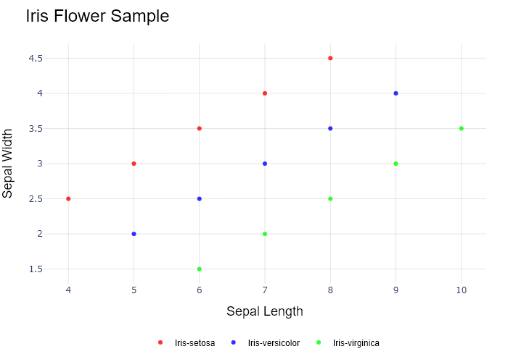

## Performance Metrics

|  |  |  |  |
| --- | --- | --- | --- |
| Task | Model Used | Description | Time Taken (s) |
| Processing Image to JSON | Gemini Vision Pro (default) | Time taken to convert the uploaded image to JSON format | 23.60 |
| Updating JSON | ChatGPT 3.5 (Default) | Time taken to update the JSON with new data | 0.00 |
| Plotting Updated JSON | N/A | Time taken to plot the updated JSON | 0.16 |

# Test Run

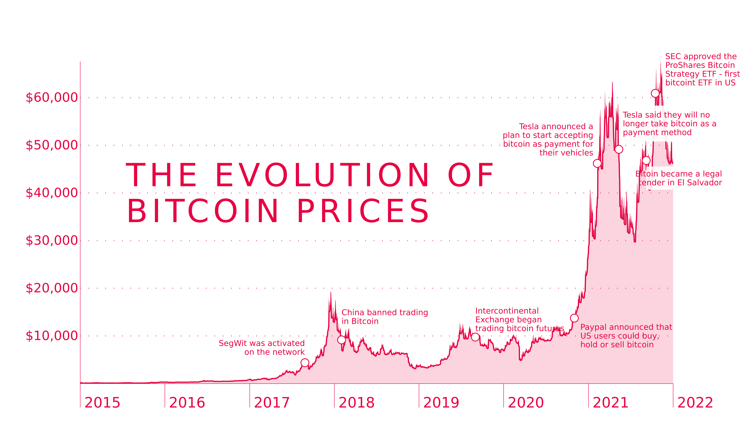

Figure: D:\Research Internship\Charts\Data over time (temporal)\jpg\area_chart.jpg

## Prompt Used

## Task: Extract Detailed Information from a Given Graph Image  
  
You will analyze a graph image and generate corresponding Plotly-compatible JSON files (`data.json`, `layout.json`, and `config.json`). Follow the structured steps and specific XML-like delimiters for each JSON section as outlined below.  
  
### Instructions:  
  
#### Graph Analysis:  
  
1. **Identify and Categorize Plot Types**:  
 - Recognize and categorize the plot types present in the graph image. Include both simple and complex plots, listed below:  
 - **Comparison Charts**:  
 - `bar`: Bar Chart  
 - `bar` (with vertical bars): Column Chart  
 - `bar` (grouped): Grouped Bar/Column Chart  
 - `scatter` (with lines connecting to points): Lollipop Chart  
 - `indicator` (with gauge): Bullet Chart  
 - `scatter`: Dot Plot  
 - `scatter` (with lines connecting different points): Dumbbell Chart  
 - `scatter` (or custom SVG): Pictogram  
 - `scatter` or `bar` with a range: Range Chart  
 - `barpolar`: Radial Bar Chart  
 - `parcoords`: Parallel Coordinates  
 - `scatterpolar`: Radar Chart  
 - `barpolar` (with segments): Nightingale Chart  
 - `waterfall`: Waterfall Chart  
 - `heatmap` (with color scale): Matrix Chart  
 - `various charts in small multiples`: Small Multiples  
 - `text` (frequency-based size): Word Cloud  
 - `scatter` (with lines indicating change): Slope Chart  
 - `table`: Table Chart  
 - `scatter`: Categorical Scatter Plot  
 - `scatter` (with four quadrants): Quadrant Chart  
 - **Correlation Charts**:  
 - `heatmap`: Heatmap  
 - `scatter` (with size): Bubble Chart  
 - `scatter`: Scatter Plot  
 - `scatter` (with lines connecting points): Connected Scatter Plot  
 - `hexbin`: Hexagonal Binning  
 - `contour`: Contour Plot  
 - **Part-to-Whole & Hierarchical Charts**:  
 - `bar` (stacked): Stacked Bar/Column Chart  
 - `bar` (with diverging sections): Diverging Bar Chart  
 - `bar` (mirrored pairs): Population Pyramid  
 - `scatter` (or custom symbols in a grid): Icon Array  
 - `waffle`: Waffle Chart  
 - `pie`: Pie Chart  
 - `pie` (with hole): Donut Chart  
 - `pie` (half-circle): Semi-circle Donut Chart  
 - `bar` (variable width): Marimekko Chart  
 - `treemap`: Treemap  
 - `treemap` (circular): Circular Treemap  
 - `treemap` (convex shape): Convex Treemap  
 - `sunburst`: Sunburst Chart  
 - `funnel` or `pyramid`: Funnel & Pyramid Chart  
 - `dendrogram`: Dendrogram  
 - `venn`: Venn Diagram  
 - `euler`: Euler Diagram  
 - `indicator` (circular gauge): Circular Gauge  
 - **Data Over Time (Temporal) Charts**:  
 - `scatter` (filled area under curve): Area Chart  
 - `scatter` (filled stacked areas): Stacked Area Chart  
 - `scatter` (smoothed filled areas): Stream Graph  
 - `scatter` (indicating ranking change): Bump Chart  
 - `scatter` (with filled area): Bump Area Chart  
 - `scatter`: Line Chart  
 - `scatter` (with smoothed lines): Spline Chart  
 - `scatter` (with stepped lines): Step Line Chart  
 - `candlestick`: Candlestick Chart  
 - `gantt`: Gantt Chart  
 - `scatter` (encoded lines): Barcode Chart  
 - `ohlc`: OHLC Chart  
 - **Distribution Charts**:  
 - `densitymapbox` or `histogram`: Density Plot  
 - `ridge`: Ridgeline Plot  
 - `horizon`: Horizon Chart  
 - `histogram`: Histogram  
 - `radial_histogram`: Radial Histogram  
 - `scatter` (with distribution): Strip Plot  
 - `scatter` (with jitter): Jitter Plot  
 - `heatmap`: One-dimensional Heatmap  
 - `scatter` (with tightly packed points): Beeswarm Chart  
 - `box`: Box Chart  
 - `violin`: Violin Plot  
 - **Geospatial & Other Charts**:  
 - `densitymapbox`: Geographic Heatmap  
 - `choropleth`: Choropleth Map  
 - `scattermapbox`: Tile Map  
 - `chord`: Chord Diagram  
 - `arc`: Arc Diagram  
 - `sankey`: Sankey  
 - `network`: Network Diagram  
 - `flowchart`: Flowchart  
  
2. **Extract Data Points** for Each Plot Type:  
 - Gather the data points for each identified plot type.  
 - For `scatter`, `line`, and `area` plots: Extract `x` and `y` values.  
 - For `bar` and `stacked bar` plots: Extract `x` (categories) and `y` values.  
 - For `pie` charts: Extract `labels` and `values`.  
 - For `scatter3d`, `surface`, and other 3D plots: Extract `x`, `y`, and `z` values.  
  
3. **Identify Multiple Plots** on the Same Figure:  
 - Note any combinations or overlays of multiple plot types on the same figure and their configurations, such as stacked plots or multiple area fills.  
  
#### Generate JSON and CSV Outputs:  
  
Follow the JSON formatting guidelines and wrap each section in the specified XML-like tags.  
  
1. **Generate `data.json`**:  
 - Include detailed information for each plot type:  
 - `type`: Specify the plot type (e.g., `"scatter"`, `"bar"`, `"pie"`, `"area"`, `"scatter3d"`, `"surface"`).  
 - For area charts, use `"type": "scatter"` and specify `"fill"`.  
 - `x`, `y`, and `z` (if applicable): Arrays of data points for each axis.  
 - `labels` and `values` for pie charts.  
 - `mode`: Specify for line and scatter plots (e.g., `"markers"`, `"lines"`, `"markers+lines"`).  
 - `name`: Legend entry for the plot.  
 - `marker`: Properties such as color, size, and symbol.  
 - `line`: Properties such as color, width, and dash style.  
 - `text`: Hover text for each data point.  
 - `hoverinfo`: Information displayed on hover (e.g., `"x+y+text"`).  
 - `fill`: For area charts, specify the fill (e.g., `"tozeroy"`, `"tonexty"`).  
 - `fillcolor`: The color used to fill the area.  
 - `stackgroup`: For stacked bar charts, specify the stacking group.  
  
2. **Generate `layout.json`**:  
 - Define the layout properties:  
 - `title`: Text and font properties for the graph title.  
 - `xaxis` and `yaxis`: Configuration for axis titles, ranges, grids, and ticks.  
 - `zaxis`: Configuration for 3D plots including title, range, and grid.  
 - `legend`: Properties for legend orientation and positioning.  
 - `margin`: Margins for left, right, bottom, top, and padding.  
 - `plot_bgcolor` and `paper_bgcolor`: Background colors.  
 - `scene`: Configuration for 3D scenes, including camera angles and aspect ratio.  
  
3. **Generate `config.json`**:  
 - Include settings such as:  
 - `responsive`: Whether the graph is responsive.  
 - `displayModeBar`: Whether the mode bar is shown.  
 - `modeBarButtonsToRemove`: List of mode bar buttons to remove.  
 - `scrollZoom`: Whether scrolling zoom is enabled.  
  
4. **Generate `<csv>`**:  
 - Format the CSV data as follows:  
 ```csv  
 x,y  
 1,4  
 2,5  
 3,6  
 ```  
 - Replace `x`, `y`, `1`, `4`, `2`, `5`, and `3`, `6` with the actual data from the graph image.  
  
### Output Format:  
  
Wrap each JSON output in the specified XML-like tags:  
  
- `<data> ... </data>`  
- `<layout> ... </layout>`  
- `<config> ... </config>`  
- `<csv> ... </csv>`  
  
Ensure the JSON format follows these rules:  
- Use double quotes for all keys and string values.  
- Do not include trailing commas in arrays or objects.  
  
### Example Output:  
  
```xml  
<data>  
[  
 {  
 "type": "scatter",  
 "x": [1, 2, 3],  
 "y": [4, 5, 6],  
 "mode": "markers+lines",  
 "name": "Line Plot",  
 "marker": {  
 "color": "rgba(75, 192, 192, 0.6)",  
 "size": 8  
 },  
 "line": {  
 "color": "rgba(75, 192, 192  
  
, 1)",  
 "width": 2  
 }  
 },  
 {  
 "type": "area",  
 "x": [1, 2, 3, 4, 5, 6, 7, 8, 9, 10, 11, 12],  
 "y": [400, 430, 550, 620, 580, 600, 630, 700, 670, 630, 600, 500],  
 "name": "Housing",  
 "marker": {  
 "color": "rgba(255, 159, 64, 0.8)"  
 },  
 "line": {  
 "color": "rgba(255, 159, 64, 1)",  
 "width": 2  
 }  
 },  
 {  
 "type": "bar",  
 "x": ["A", "B", "C"],  
 "y": [10, 15, 13],  
 "name": "Bar Chart",  
 "marker": {  
 "color": "rgba(255, 99, 132, 0.6)"  
 },  
 "hoverinfo": "x+y+text"  
 },  
 {  
 "type": "scatter",  
 "x": [1, 2, 3],  
 "y": [6, 7, 8],  
 "mode": "lines",  
 "fill": "tozeroy",  
 "name": "Area Chart",  
 "line": {  
 "color": "rgba(54, 162, 235, 1)",  
 "width": 2  
 },  
 "fillcolor": "rgba(54, 162, 235, 0.5)"  
 },  
 {  
 "type": "scatter3d",  
 "x": [1, 2, 3],  
 "y": [4, 5, 6],  
 "z": [7, 8, 9],  
 "mode": "markers",  
 "name": "3D Scatter Plot",  
 "marker": {  
 "color": "rgba(255, 159, 64, 0.8)",  
 "size": 5  
 },  
 "hoverinfo": "x+y+z+text"  
 },  
 {  
 "type": "surface",  
 "z": [  
 [10, 10.625, 12.5, 15.625, 20],  
 [5.625, 6.25, 8.125, 11.25, 15.625],  
 [0, 1.25, 3.125, 6.25, 10.625]  
 ],  
 "name": "Surface Plot",  
 "colorscale": "Viridis",  
 "hoverinfo": "z+name"  
 }  
]  
</data>  
<layout>  
{  
 "title": {  
 "text": "Complex Graph Example",  
 "font": {  
 "family": "Arial, sans-serif",  
 "size": 24,  
 "color": "#000000"  
 }  
 },  
 "xaxis": {  
 "title": {  
 "text": "X Axis",  
 "font": {  
 "family": "Arial, sans-serif",  
 "size": 18,  
 "color": "#000000"  
 }  
 },  
 "showgrid": true,  
 "gridcolor": "rgba(0, 0, 0, 0.1)",  
 "zeroline": true,  
 "zerolinecolor": "rgba(0, 0, 0, 0.1)"  
 },  
 "yaxis": {  
 "title": {  
 "text": "Y Axis",  
 "font": {  
 "family": "Arial, sans-serif",  
 "size": 18,  
 "color": "#000000"  
 }  
 },  
 "showgrid": true,  
 "gridcolor": "rgba(0, 0, 0, 0.1)",  
 "zeroline": true,  
 "zerolinecolor": "rgba(0, 0, 0, 0.1)"  
 },  
 "legend": {  
 "orientation": "h",  
 "x": 0.5,  
 "xanchor": "center",  
 "y": -0.2,  
 "font": {  
 "family": "Arial, sans-serif",  
 "size": 12,  
 "color": "#000000"  
 }  
 },  
 "margin": {  
 "l": 60,  
 "r": 30,  
 "b": 60,  
 "t": 60  
 },  
 "plot_bgcolor": "#ffffff",  
 "paper_bgcolor": "#ffffff",  
 "scene": {  
 "xaxis": {"title": "X Axis"},  
 "yaxis": {"title": "Y Axis"},  
 "zaxis": {"title": "Z Axis"}  
 }  
}  
</layout>  
<config>  
{  
 "responsive": true,  
 "displayModeBar": true,  
 "modeBarButtonsToRemove": ["toImage"],  
 "scrollZoom": true  
}  
</config>  
<csv>  
x,y  
1,4  
2,5  
3,6  
</csv>  
```

## Extracted JSON

### data

[  
 {  
 "type": "scatter",  
 "x": [  
 "2015-01-01",  
 "2016-01-01",  
 "2017-01-01",  
 "2018-01-01",  
 "2019-01-01",  
 "2020-01-01",  
 "2021-01-01",  
 "2022-01-01"  
 ],  
 "y": [  
 0,  
 5000,  
 10000,  
 5000,  
 15000,  
 40000,  
 60000,  
 30000  
 ],  
 "mode": "lines",  
 "name": "Bitcoin Prices",  
 "line": {  
 "color": "rgba(0, 0, 0, 1)",  
 "width": 2  
 },  
 "hoverinfo": "x+y"  
 }  
]

### layout

{  
 "title": {  
 "text": "The Evolution of Bitcoin Prices",  
 "font": {  
 "family": "Arial, sans-serif",  
 "size": 24,  
 "color": "#000000"  
 }  
 },  
 "xaxis": {  
 "title": {  
 "text": "Date",  
 "font": {  
 "family": "Arial, sans-serif",  
 "size": 18,  
 "color": "#000000"  
 }  
 },  
 "showgrid": true,  
 "gridcolor": "rgba(0, 0, 0, 0.1)",  
 "zeroline": true,  
 "zerolinecolor": "rgba(0, 0, 0, 0.1)"  
 },  
 "yaxis": {  
 "title": {  
 "text": "Price (USD)",  
 "font": {  
 "family": "Arial, sans-serif",  
 "size": 18,  
 "color": "#000000"  
 }  
 },  
 "showgrid": true,  
 "gridcolor": "rgba(0, 0, 0, 0.1)",  
 "zeroline": true,  
 "zerolinecolor": "rgba(0, 0, 0, 0.1)"  
 },  
 "legend": {  
 "orientation": "h",  
 "x": 0.5,  
 "xanchor": "center",  
 "y": -0.2,  
 "font": {  
 "family": "Arial, sans-serif",  
 "size": 12,  
 "color": "#000000"  
 }  
 },  
 "margin": {  
 "l": 60,  
 "r": 30,  
 "b": 60,  
 "t": 60  
 },  
 "plot_bgcolor": "#ffffff",  
 "paper_bgcolor": "#ffffff"  
}

### config

{  
 "responsive": true,  
 "displayModeBar": true,  
 "modeBarButtonsToRemove": [  
 "toImage"  
 ],  
 "scrollZoom": true  
}

## Updated JSON

### updated_data

[  
 {  
 "type": "scatter",  
 "x": [  
 "2015-01-01",  
 "2016-01-01",  
 "2017-01-01",  
 "2018-01-01",  
 "2019-01-01",  
 "2020-01-01",  
 "2021-01-01",  
 "2022-01-01"  
 ],  
 "y": [  
 0,  
 5000,  
 10000,  
 5000,  
 15000,  
 40000,  
 60000,  
 30000  
 ],  
 "mode": "lines",  
 "name": "Bitcoin Prices",  
 "line": {  
 "color": "rgba(0, 0, 0, 1)",  
 "width": 2  
 },  
 "hoverinfo": "x+y"  
 }  
]

### updated_layout

{  
 "title": {  
 "text": "The Evolution of Bitcoin Prices",  
 "font": {  
 "family": "Arial, sans-serif",  
 "size": 24,  
 "color": "#000000"  
 }  
 },  
 "xaxis": {  
 "title": {  
 "text": "Date",  
 "font": {  
 "family": "Arial, sans-serif",  
 "size": 18,  
 "color": "#000000"  
 }  
 },  
 "showgrid": true,  
 "gridcolor": "rgba(0, 0, 0, 0.1)",  
 "zeroline": true,  
 "zerolinecolor": "rgba(0, 0, 0, 0.1)"  
 },  
 "yaxis": {  
 "title": {  
 "text": "Price (USD)",  
 "font": {  
 "family": "Arial, sans-serif",  
 "size": 18,  
 "color": "#000000"  
 }  
 },  
 "showgrid": true,  
 "gridcolor": "rgba(0, 0, 0, 0.1)",  
 "zeroline": true,  
 "zerolinecolor": "rgba(0, 0, 0, 0.1)"  
 },  
 "legend": {  
 "orientation": "h",  
 "x": 0.5,  
 "xanchor": "center",  
 "y": -0.2,  
 "font": {  
 "family": "Arial, sans-serif",  
 "size": 12,  
 "color": "#000000"  
 }  
 },  
 "margin": {  
 "l": 60,  
 "r": 30,  
 "b": 60,  
 "t": 60  
 },  
 "plot_bgcolor": "#ffffff",  
 "paper_bgcolor": "#ffffff"  
}

### updated_config

{  
 "responsive": true,  
 "displayModeBar": true,  
 "modeBarButtonsToRemove": [  
 "toImage"  
 ],  
 "scrollZoom": true  
}

## Updated Chart

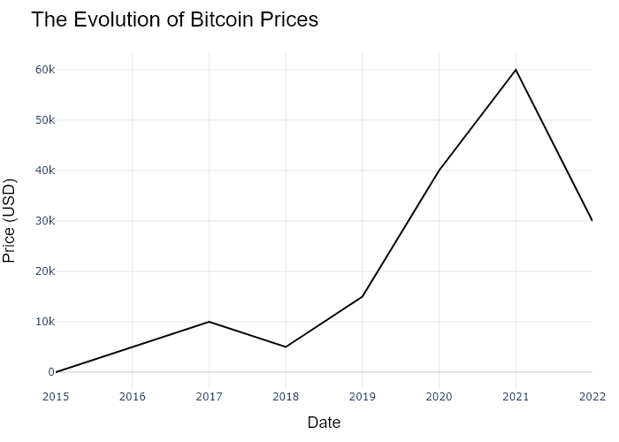

## Performance Metrics

|  |  |  |  |
| --- | --- | --- | --- |
| Task | Model Used | Description | Time Taken (s) |
| Processing Image to JSON | Gemini Vision Pro (default) | Time taken to convert the uploaded image to JSON format | 22.86 |
| Updating JSON | ChatGPT 3.5 (Default) | Time taken to update the JSON with new data | 0.00 |
| Plotting Updated JSON | N/A | Time taken to plot the updated JSON | 0.28 |

# Test Run



Figure: D:\Research Internship\Charts\Data over time (temporal)\jpg\area_chart.jpg

## Prompt Used

## Task: Extract Detailed Information from a Given Graph Image  
  
You will analyze a graph image and generate corresponding Plotly-compatible JSON files (`data.json`, `layout.json`, and `config.json`). Follow the structured steps and specific XML-like delimiters for each JSON section as outlined below.  
  
### Instructions:  
  
#### Graph Analysis:  
  
1. **Identify and Categorize Plot Types**:  
 - Recognize and categorize the plot types present in the graph image. Include both simple and complex plots, listed below:  
 - **Comparison Charts**:  
 - `bar`: Bar Chart  
 - `bar` (with vertical bars): Column Chart  
 - `bar` (grouped): Grouped Bar/Column Chart  
 - `scatter` (with lines connecting to points): Lollipop Chart  
 - `indicator` (with gauge): Bullet Chart  
 - `scatter`: Dot Plot  
 - `scatter` (with lines connecting different points): Dumbbell Chart  
 - `scatter` (or custom SVG): Pictogram  
 - `scatter` or `bar` with a range: Range Chart  
 - `barpolar`: Radial Bar Chart  
 - `parcoords`: Parallel Coordinates  
 - `scatterpolar`: Radar Chart  
 - `barpolar` (with segments): Nightingale Chart  
 - `waterfall`: Waterfall Chart  
 - `heatmap` (with color scale): Matrix Chart  
 - `various charts in small multiples`: Small Multiples  
 - `text` (frequency-based size): Word Cloud  
 - `scatter` (with lines indicating change): Slope Chart  
 - `table`: Table Chart  
 - `scatter`: Categorical Scatter Plot  
 - `scatter` (with four quadrants): Quadrant Chart  
 - **Correlation Charts**:  
 - `heatmap`: Heatmap  
 - `scatter` (with size): Bubble Chart  
 - `scatter`: Scatter Plot  
 - `scatter` (with lines connecting points): Connected Scatter Plot  
 - `hexbin`: Hexagonal Binning  
 - `contour`: Contour Plot  
 - **Part-to-Whole & Hierarchical Charts**:  
 - `bar` (stacked): Stacked Bar/Column Chart  
 - `bar` (with diverging sections): Diverging Bar Chart  
 - `bar` (mirrored pairs): Population Pyramid  
 - `scatter` (or custom symbols in a grid): Icon Array  
 - `waffle`: Waffle Chart  
 - `pie`: Pie Chart  
 - `pie` (with hole): Donut Chart  
 - `pie` (half-circle): Semi-circle Donut Chart  
 - `bar` (variable width): Marimekko Chart  
 - `treemap`: Treemap  
 - `treemap` (circular): Circular Treemap  
 - `treemap` (convex shape): Convex Treemap  
 - `sunburst`: Sunburst Chart  
 - `funnel` or `pyramid`: Funnel & Pyramid Chart  
 - `dendrogram`: Dendrogram  
 - `venn`: Venn Diagram  
 - `euler`: Euler Diagram  
 - `indicator` (circular gauge): Circular Gauge  
 - **Data Over Time (Temporal) Charts**:  
 - `scatter` (filled area under curve): Area Chart  
 - `scatter` (filled stacked areas): Stacked Area Chart  
 - `scatter` (smoothed filled areas): Stream Graph  
 - `scatter` (indicating ranking change): Bump Chart  
 - `scatter` (with filled area): Bump Area Chart  
 - `scatter`: Line Chart  
 - `scatter` (with smoothed lines): Spline Chart  
 - `scatter` (with stepped lines): Step Line Chart  
 - `candlestick`: Candlestick Chart  
 - `gantt`: Gantt Chart  
 - `scatter` (encoded lines): Barcode Chart  
 - `ohlc`: OHLC Chart  
 - **Distribution Charts**:  
 - `densitymapbox` or `histogram`: Density Plot  
 - `ridge`: Ridgeline Plot  
 - `horizon`: Horizon Chart  
 - `histogram`: Histogram  
 - `radial_histogram`: Radial Histogram  
 - `scatter` (with distribution): Strip Plot  
 - `scatter` (with jitter): Jitter Plot  
 - `heatmap`: One-dimensional Heatmap  
 - `scatter` (with tightly packed points): Beeswarm Chart  
 - `box`: Box Chart  
 - `violin`: Violin Plot  
 - **Geospatial & Other Charts**:  
 - `densitymapbox`: Geographic Heatmap  
 - `choropleth`: Choropleth Map  
 - `scattermapbox`: Tile Map  
 - `chord`: Chord Diagram  
 - `arc`: Arc Diagram  
 - `sankey`: Sankey  
 - `network`: Network Diagram  
 - `flowchart`: Flowchart  
  
2. **Extract Data Points** for Each Plot Type:  
 - Gather the data points for each identified plot type.  
 - For `scatter`, `line`, and `area` plots: Extract `x` and `y` values.  
 - For `bar` and `stacked bar` plots: Extract `x` (categories) and `y` values.  
 - For `pie` charts: Extract `labels` and `values`.  
 - For `scatter3d`, `surface`, and other 3D plots: Extract `x`, `y`, and `z` values.  
  
3. **Identify Multiple Plots** on the Same Figure:  
 - Note any combinations or overlays of multiple plot types on the same figure and their configurations, such as stacked plots or multiple area fills.  
  
#### Generate JSON and CSV Outputs:  
  
Follow the JSON formatting guidelines and wrap each section in the specified XML-like tags.  
  
1. **Generate `data.json`**:  
 - Include detailed information for each plot type:  
 - `type`: Specify the plot type (e.g., `"scatter"`, `"bar"`, `"pie"`, `"area"`, `"scatter3d"`, `"surface"`).  
 - For area charts, use `"type": "scatter"` and specify `"fill"`.  
 - `x`, `y`, and `z` (if applicable): Arrays of data points for each axis.  
 - `labels` and `values` for pie charts.  
 - `mode`: Specify for line and scatter plots (e.g., `"markers"`, `"lines"`, `"markers+lines"`).  
 - `name`: Legend entry for the plot.  
 - `marker`: Properties such as color, size, and symbol.  
 - `line`: Properties such as color, width, and dash style.  
 - `text`: Hover text for each data point.  
 - `hoverinfo`: Information displayed on hover (e.g., `"x+y+text"`).  
 - `fill`: For area charts, specify the fill (e.g., `"tozeroy"`, `"tonexty"`).  
 - `fillcolor`: The color used to fill the area.  
 - `stackgroup`: For stacked bar charts, specify the stacking group.  
  
2. **Generate `layout.json`**:  
 - Define the layout properties:  
 - `title`: Text and font properties for the graph title.  
 - `xaxis` and `yaxis`: Configuration for axis titles, ranges, grids, and ticks.  
 - `zaxis`: Configuration for 3D plots including title, range, and grid.  
 - `legend`: Properties for legend orientation and positioning.  
 - `margin`: Margins for left, right, bottom, top, and padding.  
 - `plot_bgcolor` and `paper_bgcolor`: Background colors.  
 - `scene`: Configuration for 3D scenes, including camera angles and aspect ratio.  
  
3. **Generate `config.json`**:  
 - Include settings such as:  
 - `responsive`: Whether the graph is responsive.  
 - `displayModeBar`: Whether the mode bar is shown.  
 - `modeBarButtonsToRemove`: List of mode bar buttons to remove.  
 - `scrollZoom`: Whether scrolling zoom is enabled.  
  
4. **Generate `<csv>`**:  
 - Format the CSV data as follows:  
 ```csv  
 x,y  
 1,4  
 2,5  
 3,6  
 ```  
 - Replace `x`, `y`, `1`, `4`, `2`, `5`, and `3`, `6` with the actual data from the graph image.  
  
### Output Format:  
  
Wrap each JSON output in the specified XML-like tags:  
  
- `<data> ... </data>`  
- `<layout> ... </layout>`  
- `<config> ... </config>`  
- `<csv> ... </csv>`  
  
Ensure the JSON format follows these rules:  
- Use double quotes for all keys and string values.  
- Do not include trailing commas in arrays or objects.  
  
### Example Output:  
  
```xml  
<data>  
[  
 {  
 "type": "scatter",  
 "x": [1, 2, 3],  
 "y": [4, 5, 6],  
 "mode": "markers+lines",  
 "name": "Line Plot",  
 "marker": {  
 "color": "rgba(75, 192, 192, 0.6)",  
 "size": 8  
 },  
 "line": {  
 "color": "rgba(75, 192, 192  
  
, 1)",  
 "width": 2  
 }  
 },  
 {  
 "type": "area",  
 "x": [1, 2, 3, 4, 5, 6, 7, 8, 9, 10, 11, 12],  
 "y": [400, 430, 550, 620, 580, 600, 630, 700, 670, 630, 600, 500],  
 "name": "Housing",  
 "marker": {  
 "color": "rgba(255, 159, 64, 0.8)"  
 },  
 "line": {  
 "color": "rgba(255, 159, 64, 1)",  
 "width": 2  
 }  
 },  
 {  
 "type": "bar",  
 "x": ["A", "B", "C"],  
 "y": [10, 15, 13],  
 "name": "Bar Chart",  
 "marker": {  
 "color": "rgba(255, 99, 132, 0.6)"  
 },  
 "hoverinfo": "x+y+text"  
 },  
 {  
 "type": "scatter",  
 "x": [1, 2, 3],  
 "y": [6, 7, 8],  
 "mode": "lines",  
 "fill": "tozeroy",  
 "name": "Area Chart",  
 "line": {  
 "color": "rgba(54, 162, 235, 1)",  
 "width": 2  
 },  
 "fillcolor": "rgba(54, 162, 235, 0.5)"  
 },  
 {  
 "type": "scatter3d",  
 "x": [1, 2, 3],  
 "y": [4, 5, 6],  
 "z": [7, 8, 9],  
 "mode": "markers",  
 "name": "3D Scatter Plot",  
 "marker": {  
 "color": "rgba(255, 159, 64, 0.8)",  
 "size": 5  
 },  
 "hoverinfo": "x+y+z+text"  
 },  
 {  
 "type": "surface",  
 "z": [  
 [10, 10.625, 12.5, 15.625, 20],  
 [5.625, 6.25, 8.125, 11.25, 15.625],  
 [0, 1.25, 3.125, 6.25, 10.625]  
 ],  
 "name": "Surface Plot",  
 "colorscale": "Viridis",  
 "hoverinfo": "z+name"  
 }  
]  
</data>  
<layout>  
{  
 "title": {  
 "text": "Complex Graph Example",  
 "font": {  
 "family": "Arial, sans-serif",  
 "size": 24,  
 "color": "#000000"  
 }  
 },  
 "xaxis": {  
 "title": {  
 "text": "X Axis",  
 "font": {  
 "family": "Arial, sans-serif",  
 "size": 18,  
 "color": "#000000"  
 }  
 },  
 "showgrid": true,  
 "gridcolor": "rgba(0, 0, 0, 0.1)",  
 "zeroline": true,  
 "zerolinecolor": "rgba(0, 0, 0, 0.1)"  
 },  
 "yaxis": {  
 "title": {  
 "text": "Y Axis",  
 "font": {  
 "family": "Arial, sans-serif",  
 "size": 18,  
 "color": "#000000"  
 }  
 },  
 "showgrid": true,  
 "gridcolor": "rgba(0, 0, 0, 0.1)",  
 "zeroline": true,  
 "zerolinecolor": "rgba(0, 0, 0, 0.1)"  
 },  
 "legend": {  
 "orientation": "h",  
 "x": 0.5,  
 "xanchor": "center",  
 "y": -0.2,  
 "font": {  
 "family": "Arial, sans-serif",  
 "size": 12,  
 "color": "#000000"  
 }  
 },  
 "margin": {  
 "l": 60,  
 "r": 30,  
 "b": 60,  
 "t": 60  
 },  
 "plot_bgcolor": "#ffffff",  
 "paper_bgcolor": "#ffffff",  
 "scene": {  
 "xaxis": {"title": "X Axis"},  
 "yaxis": {"title": "Y Axis"},  
 "zaxis": {"title": "Z Axis"}  
 }  
}  
</layout>  
<config>  
{  
 "responsive": true,  
 "displayModeBar": true,  
 "modeBarButtonsToRemove": ["toImage"],  
 "scrollZoom": true  
}  
</config>  
<csv>  
x,y  
1,4  
2,5  
3,6  
</csv>  
```

## Extracted JSON

### data

[  
 {  
 "type": "scatter",  
 "x": [  
 "2015-01-01",  
 "2016-01-01",  
 "2017-01-01",  
 "2018-01-01",  
 "2019-01-01",  
 "2020-01-01",  
 "2021-01-01",  
 "2022-01-01"  
 ],  
 "y": [  
 0,  
 5000,  
 10000,  
 5000,  
 15000,  
 40000,  
 60000,  
 30000  
 ],  
 "mode": "lines",  
 "name": "Bitcoin Prices",  
 "line": {  
 "color": "rgba(0, 0, 0, 1)",  
 "width": 2  
 },  
 "hoverinfo": "x+y"  
 }  
]

### layout

{  
 "title": {  
 "text": "The Evolution of Bitcoin Prices",  
 "font": {  
 "family": "Arial, sans-serif",  
 "size": 24,  
 "color": "#000000"  
 }  
 },  
 "xaxis": {  
 "title": {  
 "text": "Date",  
 "font": {  
 "family": "Arial, sans-serif",  
 "size": 18,  
 "color": "#000000"  
 }  
 },  
 "showgrid": true,  
 "gridcolor": "rgba(0, 0, 0, 0.1)",  
 "zeroline": true,  
 "zerolinecolor": "rgba(0, 0, 0, 0.1)"  
 },  
 "yaxis": {  
 "title": {  
 "text": "Price (USD)",  
 "font": {  
 "family": "Arial, sans-serif",  
 "size": 18,  
 "color": "#000000"  
 }  
 },  
 "showgrid": true,  
 "gridcolor": "rgba(0, 0, 0, 0.1)",  
 "zeroline": true,  
 "zerolinecolor": "rgba(0, 0, 0, 0.1)"  
 },  
 "legend": {  
 "orientation": "h",  
 "x": 0.5,  
 "xanchor": "center",  
 "y": -0.2,  
 "font": {  
 "family": "Arial, sans-serif",  
 "size": 12,  
 "color": "#000000"  
 }  
 },  
 "margin": {  
 "l": 60,  
 "r": 30,  
 "b": 60,  
 "t": 60  
 },  
 "plot_bgcolor": "#ffffff",  
 "paper_bgcolor": "#ffffff"  
}

### config

{  
 "responsive": true,  
 "displayModeBar": true,  
 "modeBarButtonsToRemove": [  
 "toImage"  
 ],  
 "scrollZoom": true  
}

## Updated JSON

### updated_data

[  
 {  
 "type": "scatter",  
 "x": [  
 "2015-01-01",  
 "2016-01-01",  
 "2017-01-01",  
 "2018-01-01",  
 "2019-01-01",  
 "2020-01-01",  
 "2021-01-01",  
 "2022-01-01"  
 ],  
 "y": [  
 0,  
 5000,  
 10000,  
 5000,  
 15000,  
 40000,  
 60000,  
 30000  
 ],  
 "mode": "lines",  
 "name": "Bitcoin Prices",  
 "line": {  
 "color": "rgba(0, 0, 0, 1)",  
 "width": 2  
 },  
 "hoverinfo": "x+y"  
 }  
]

### updated_layout

{  
 "title": {  
 "text": "The Evolution of Bitcoin Prices",  
 "font": {  
 "family": "Arial, sans-serif",  
 "size": 24,  
 "color": "#000000"  
 }  
 },  
 "xaxis": {  
 "title": {  
 "text": "Date",  
 "font": {  
 "family": "Arial, sans-serif",  
 "size": 18,  
 "color": "#000000"  
 }  
 },  
 "showgrid": true,  
 "gridcolor": "rgba(0, 0, 0, 0.1)",  
 "zeroline": true,  
 "zerolinecolor": "rgba(0, 0, 0, 0.1)"  
 },  
 "yaxis": {  
 "title": {  
 "text": "Price (USD)",  
 "font": {  
 "family": "Arial, sans-serif",  
 "size": 18,  
 "color": "#000000"  
 }  
 },  
 "showgrid": true,  
 "gridcolor": "rgba(0, 0, 0, 0.1)",  
 "zeroline": true,  
 "zerolinecolor": "rgba(0, 0, 0, 0.1)"  
 },  
 "legend": {  
 "orientation": "h",  
 "x": 0.5,  
 "xanchor": "center",  
 "y": -0.2,  
 "font": {  
 "family": "Arial, sans-serif",  
 "size": 12,  
 "color": "#000000"  
 }  
 },  
 "margin": {  
 "l": 60,  
 "r": 30,  
 "b": 60,  
 "t": 60  
 },  
 "plot_bgcolor": "#ffffff",  
 "paper_bgcolor": "#ffffff"  
}

### updated_config

{  
 "responsive": true,  
 "displayModeBar": true,  
 "modeBarButtonsToRemove": [  
 "toImage"  
 ],  
 "scrollZoom": true  
}

## Updated Chart



## Performance Metrics

|  |  |  |  |
| --- | --- | --- | --- |
| Task | Model Used | Description | Time Taken (s) |
| Processing Image to JSON | Gemini Vision Pro (default) | Time taken to convert the uploaded image to JSON format | 22.92 |
| Updating JSON | ChatGPT 3.5 (Default) | Time taken to update the JSON with new data | 0.00 |
| Plotting Updated JSON | N/A | Time taken to plot the updated JSON | 0.17 |

# Test Run



Figure: Charts\Data over time (temporal)\jpg/area_chart.jpg

## Prompt Used

## Task: Extract Detailed Information from a Given Graph Image  
  
You will analyze a graph image and generate corresponding Plotly-compatible JSON files (`data.json`, `layout.json`, and `config.json`). Follow the structured steps and specific XML-like delimiters for each JSON section as outlined below.  
  
### Instructions:  
  
#### Graph Analysis:  
  
1. **Identify and Categorize Plot Types**:  
 - Recognize and categorize the plot types present in the graph image. Include both simple and complex plots, listed below:  
 - **Comparison Charts**:  
 - `bar`: Bar Chart  
 - `bar` (with vertical bars): Column Chart  
 - `bar` (grouped): Grouped Bar/Column Chart  
 - `scatter` (with lines connecting to points): Lollipop Chart  
 - `indicator` (with gauge): Bullet Chart  
 - `scatter`: Dot Plot  
 - `scatter` (with lines connecting different points): Dumbbell Chart  
 - `scatter` (or custom SVG): Pictogram  
 - `scatter` or `bar` with a range: Range Chart  
 - `barpolar`: Radial Bar Chart  
 - `parcoords`: Parallel Coordinates  
 - `scatterpolar`: Radar Chart  
 - `barpolar` (with segments): Nightingale Chart  
 - `waterfall`: Waterfall Chart  
 - `heatmap` (with color scale): Matrix Chart  
 - `various charts in small multiples`: Small Multiples  
 - `text` (frequency-based size): Word Cloud  
 - `scatter` (with lines indicating change): Slope Chart  
 - `table`: Table Chart  
 - `scatter`: Categorical Scatter Plot  
 - `scatter` (with four quadrants): Quadrant Chart  
 - **Correlation Charts**:  
 - `heatmap`: Heatmap  
 - `scatter` (with size): Bubble Chart  
 - `scatter`: Scatter Plot  
 - `scatter` (with lines connecting points): Connected Scatter Plot  
 - `hexbin`: Hexagonal Binning  
 - `contour`: Contour Plot  
 - **Part-to-Whole & Hierarchical Charts**:  
 - `bar` (stacked): Stacked Bar/Column Chart  
 - `bar` (with diverging sections): Diverging Bar Chart  
 - `bar` (mirrored pairs): Population Pyramid  
 - `scatter` (or custom symbols in a grid): Icon Array  
 - `waffle`: Waffle Chart  
 - `pie`: Pie Chart  
 - `pie` (with hole): Donut Chart  
 - `pie` (half-circle): Semi-circle Donut Chart  
 - `bar` (variable width): Marimekko Chart  
 - `treemap`: Treemap  
 - `treemap` (circular): Circular Treemap  
 - `treemap` (convex shape): Convex Treemap  
 - `sunburst`: Sunburst Chart  
 - `funnel` or `pyramid`: Funnel & Pyramid Chart  
 - `dendrogram`: Dendrogram  
 - `venn`: Venn Diagram  
 - `euler`: Euler Diagram  
 - `indicator` (circular gauge): Circular Gauge  
 - **Data Over Time (Temporal) Charts**:  
 - `scatter` (filled area under curve): Area Chart  
 - `scatter` (filled stacked areas): Stacked Area Chart  
 - `scatter` (smoothed filled areas): Stream Graph  
 - `scatter` (indicating ranking change): Bump Chart  
 - `scatter` (with filled area): Bump Area Chart  
 - `scatter`: Line Chart  
 - `scatter` (with smoothed lines): Spline Chart  
 - `scatter` (with stepped lines): Step Line Chart  
 - `candlestick`: Candlestick Chart  
 - `gantt`: Gantt Chart  
 - `scatter` (encoded lines): Barcode Chart  
 - `ohlc`: OHLC Chart  
 - **Distribution Charts**:  
 - `densitymapbox` or `histogram`: Density Plot  
 - `ridge`: Ridgeline Plot  
 - `horizon`: Horizon Chart  
 - `histogram`: Histogram  
 - `radial_histogram`: Radial Histogram  
 - `scatter` (with distribution): Strip Plot  
 - `scatter` (with jitter): Jitter Plot  
 - `heatmap`: One-dimensional Heatmap  
 - `scatter` (with tightly packed points): Beeswarm Chart  
 - `box`: Box Chart  
 - `violin`: Violin Plot  
 - **Geospatial & Other Charts**:  
 - `densitymapbox`: Geographic Heatmap  
 - `choropleth`: Choropleth Map  
 - `scattermapbox`: Tile Map  
 - `chord`: Chord Diagram  
 - `arc`: Arc Diagram  
 - `sankey`: Sankey  
 - `network`: Network Diagram  
 - `flowchart`: Flowchart  
  
2. **Extract Data Points** for Each Plot Type:  
 - Gather the data points for each identified plot type.  
 - For `scatter`, `line`, and `area` plots: Extract `x` and `y` values.  
 - For `bar` and `stacked bar` plots: Extract `x` (categories) and `y` values.  
 - For `pie` charts: Extract `labels` and `values`.  
 - For `scatter3d`, `surface`, and other 3D plots: Extract `x`, `y`, and `z` values.  
  
3. **Identify Multiple Plots** on the Same Figure:  
 - Note any combinations or overlays of multiple plot types on the same figure and their configurations, such as stacked plots or multiple area fills.  
  
#### Generate JSON and CSV Outputs:  
  
Follow the JSON formatting guidelines and wrap each section in the specified XML-like tags.  
  
1. **Generate `data.json`**:  
 - Include detailed information for each plot type:  
 - `type`: Specify the plot type (e.g., `"scatter"`, `"bar"`, `"pie"`, `"area"`, `"scatter3d"`, `"surface"`).  
 - For area charts, use `"type": "scatter"` and specify `"fill"`.  
 - `x`, `y`, and `z` (if applicable): Arrays of data points for each axis.  
 - `labels` and `values` for pie charts.  
 - `mode`: Specify for line and scatter plots (e.g., `"markers"`, `"lines"`, `"markers+lines"`).  
 - `name`: Legend entry for the plot.  
 - `marker`: Properties such as color, size, and symbol.  
 - `line`: Properties such as color, width, and dash style.  
 - `text`: Hover text for each data point.  
 - `hoverinfo`: Information displayed on hover (e.g., `"x+y+text"`).  
 - `fill`: For area charts, specify the fill (e.g., `"tozeroy"`, `"tonexty"`).  
 - `fillcolor`: The color used to fill the area.  
 - `stackgroup`: For stacked bar charts, specify the stacking group.  
  
2. **Generate `layout.json`**:  
 - Define the layout properties:  
 - `title`: Text and font properties for the graph title.  
 - `xaxis` and `yaxis`: Configuration for axis titles, ranges, grids, and ticks.  
 - `zaxis`: Configuration for 3D plots including title, range, and grid.  
 - `legend`: Properties for legend orientation and positioning.  
 - `margin`: Margins for left, right, bottom, top, and padding.  
 - `plot_bgcolor` and `paper_bgcolor`: Background colors.  
 - `scene`: Configuration for 3D scenes, including camera angles and aspect ratio.  
  
3. **Generate `config.json`**:  
 - Include settings such as:  
 - `responsive`: Whether the graph is responsive.  
 - `displayModeBar`: Whether the mode bar is shown.  
 - `modeBarButtonsToRemove`: List of mode bar buttons to remove.  
 - `scrollZoom`: Whether scrolling zoom is enabled.  
  
4. **Generate `<csv>`**:  
 - Format the CSV data as follows:  
 ```csv  
 x,y  
 1,4  
 2,5  
 3,6  
 ```  
 - Replace `x`, `y`, `1`, `4`, `2`, `5`, and `3`, `6` with the actual data from the graph image.  
  
### Output Format:  
  
Wrap each JSON output in the specified XML-like tags:  
  
- `<data> ... </data>`  
- `<layout> ... </layout>`  
- `<config> ... </config>`  
- `<csv> ... </csv>`  
  
Ensure the JSON format follows these rules:  
- Use double quotes for all keys and string values.  
- Do not include trailing commas in arrays or objects.  
  
### Example Output:  
  
```xml  
<data>  
[  
 {  
 "type": "scatter",  
 "x": [1, 2, 3],  
 "y": [4, 5, 6],  
 "mode": "markers+lines",  
 "name": "Line Plot",  
 "marker": {  
 "color": "rgba(75, 192, 192, 0.6)",  
 "size": 8  
 },  
 "line": {  
 "color": "rgba(75, 192, 192  
  
, 1)",  
 "width": 2  
 }  
 },  
 {  
 "type": "area",  
 "x": [1, 2, 3, 4, 5, 6, 7, 8, 9, 10, 11, 12],  
 "y": [400, 430, 550, 620, 580, 600, 630, 700, 670, 630, 600, 500],  
 "name": "Housing",  
 "marker": {  
 "color": "rgba(255, 159, 64, 0.8)"  
 },  
 "line": {  
 "color": "rgba(255, 159, 64, 1)",  
 "width": 2  
 }  
 },  
 {  
 "type": "bar",  
 "x": ["A", "B", "C"],  
 "y": [10, 15, 13],  
 "name": "Bar Chart",  
 "marker": {  
 "color": "rgba(255, 99, 132, 0.6)"  
 },  
 "hoverinfo": "x+y+text"  
 },  
 {  
 "type": "scatter",  
 "x": [1, 2, 3],  
 "y": [6, 7, 8],  
 "mode": "lines",  
 "fill": "tozeroy",  
 "name": "Area Chart",  
 "line": {  
 "color": "rgba(54, 162, 235, 1)",  
 "width": 2  
 },  
 "fillcolor": "rgba(54, 162, 235, 0.5)"  
 },  
 {  
 "type": "scatter3d",  
 "x": [1, 2, 3],  
 "y": [4, 5, 6],  
 "z": [7, 8, 9],  
 "mode": "markers",  
 "name": "3D Scatter Plot",  
 "marker": {  
 "color": "rgba(255, 159, 64, 0.8)",  
 "size": 5  
 },  
 "hoverinfo": "x+y+z+text"  
 },  
 {  
 "type": "surface",  
 "z": [  
 [10, 10.625, 12.5, 15.625, 20],  
 [5.625, 6.25, 8.125, 11.25, 15.625],  
 [0, 1.25, 3.125, 6.25, 10.625]  
 ],  
 "name": "Surface Plot",  
 "colorscale": "Viridis",  
 "hoverinfo": "z+name"  
 }  
]  
</data>  
<layout>  
{  
 "title": {  
 "text": "Complex Graph Example",  
 "font": {  
 "family": "Arial, sans-serif",  
 "size": 24,  
 "color": "#000000"  
 }  
 },  
 "xaxis": {  
 "title": {  
 "text": "X Axis",  
 "font": {  
 "family": "Arial, sans-serif",  
 "size": 18,  
 "color": "#000000"  
 }  
 },  
 "showgrid": true,  
 "gridcolor": "rgba(0, 0, 0, 0.1)",  
 "zeroline": true,  
 "zerolinecolor": "rgba(0, 0, 0, 0.1)"  
 },  
 "yaxis": {  
 "title": {  
 "text": "Y Axis",  
 "font": {  
 "family": "Arial, sans-serif",  
 "size": 18,  
 "color": "#000000"  
 }  
 },  
 "showgrid": true,  
 "gridcolor": "rgba(0, 0, 0, 0.1)",  
 "zeroline": true,  
 "zerolinecolor": "rgba(0, 0, 0, 0.1)"  
 },  
 "legend": {  
 "orientation": "h",  
 "x": 0.5,  
 "xanchor": "center",  
 "y": -0.2,  
 "font": {  
 "family": "Arial, sans-serif",  
 "size": 12,  
 "color": "#000000"  
 }  
 },  
 "margin": {  
 "l": 60,  
 "r": 30,  
 "b": 60,  
 "t": 60  
 },  
 "plot_bgcolor": "#ffffff",  
 "paper_bgcolor": "#ffffff",  
 "scene": {  
 "xaxis": {"title": "X Axis"},  
 "yaxis": {"title": "Y Axis"},  
 "zaxis": {"title": "Z Axis"}  
 }  
}  
</layout>  
<config>  
{  
 "responsive": true,  
 "displayModeBar": true,  
 "modeBarButtonsToRemove": ["toImage"],  
 "scrollZoom": true  
}  
</config>  
<csv>  
x,y  
1,4  
2,5  
3,6  
</csv>  
```

## Extracted JSON

### data

[  
 {  
 "type": "scatter",  
 "x": [  
 "2015-01-01",  
 "2016-01-01",  
 "2017-01-01",  
 "2018-01-01",  
 "2019-01-01",  
 "2020-01-01",  
 "2021-01-01",  
 "2022-01-01"  
 ],  
 "y": [  
 0,  
 5000,  
 10000,  
 5000,  
 15000,  
 40000,  
 60000,  
 30000  
 ],  
 "mode": "lines",  
 "name": "Bitcoin Prices",  
 "line": {  
 "color": "rgba(0, 0, 0, 1)",  
 "width": 2  
 },  
 "hoverinfo": "x+y"  
 }  
]

### layout

{  
 "title": {  
 "text": "The Evolution of Bitcoin Prices",  
 "font": {  
 "family": "Arial, sans-serif",  
 "size": 24,  
 "color": "#000000"  
 }  
 },  
 "xaxis": {  
 "title": {  
 "text": "Date",  
 "font": {  
 "family": "Arial, sans-serif",  
 "size": 18,  
 "color": "#000000"  
 }  
 },  
 "showgrid": true,  
 "gridcolor": "rgba(0, 0, 0, 0.1)",  
 "zeroline": true,  
 "zerolinecolor": "rgba(0, 0, 0, 0.1)"  
 },  
 "yaxis": {  
 "title": {  
 "text": "Price (USD)",  
 "font": {  
 "family": "Arial, sans-serif",  
 "size": 18,  
 "color": "#000000"  
 }  
 },  
 "showgrid": true,  
 "gridcolor": "rgba(0, 0, 0, 0.1)",  
 "zeroline": true,  
 "zerolinecolor": "rgba(0, 0, 0, 0.1)"  
 },  
 "legend": {  
 "orientation": "h",  
 "x": 0.5,  
 "xanchor": "center",  
 "y": -0.2,  
 "font": {  
 "family": "Arial, sans-serif",  
 "size": 12,  
 "color": "#000000"  
 }  
 },  
 "margin": {  
 "l": 60,  
 "r": 30,  
 "b": 60,  
 "t": 60  
 },  
 "plot_bgcolor": "#ffffff",  
 "paper_bgcolor": "#ffffff"  
}

### config

{  
 "responsive": true,  
 "displayModeBar": true,  
 "modeBarButtonsToRemove": [  
 "toImage"  
 ],  
 "scrollZoom": true  
}

## Updated JSON

### updated_data

[  
 {  
 "type": "scatter",  
 "x": [  
 "2015-01-01",  
 "2016-01-01",  
 "2017-01-01",  
 "2018-01-01",  
 "2019-01-01",  
 "2020-01-01",  
 "2021-01-01",  
 "2022-01-01"  
 ],  
 "y": [  
 0,  
 5000,  
 10000,  
 5000,  
 15000,  
 40000,  
 60000,  
 30000  
 ],  
 "mode": "lines",  
 "name": "Bitcoin Prices",  
 "line": {  
 "color": "rgba(0, 0, 0, 1)",  
 "width": 2  
 },  
 "hoverinfo": "x+y"  
 }  
]

### updated_layout

{  
 "title": {  
 "text": "The Evolution of Bitcoin Prices",  
 "font": {  
 "family": "Arial, sans-serif",  
 "size": 24,  
 "color": "#000000"  
 }  
 },  
 "xaxis": {  
 "title": {  
 "text": "Date",  
 "font": {  
 "family": "Arial, sans-serif",  
 "size": 18,  
 "color": "#000000"  
 }  
 },  
 "showgrid": true,  
 "gridcolor": "rgba(0, 0, 0, 0.1)",  
 "zeroline": true,  
 "zerolinecolor": "rgba(0, 0, 0, 0.1)"  
 },  
 "yaxis": {  
 "title": {  
 "text": "Price (USD)",  
 "font": {  
 "family": "Arial, sans-serif",  
 "size": 18,  
 "color": "#000000"  
 }  
 },  
 "showgrid": true,  
 "gridcolor": "rgba(0, 0, 0, 0.1)",  
 "zeroline": true,  
 "zerolinecolor": "rgba(0, 0, 0, 0.1)"  
 },  
 "legend": {  
 "orientation": "h",  
 "x": 0.5,  
 "xanchor": "center",  
 "y": -0.2,  
 "font": {  
 "family": "Arial, sans-serif",  
 "size": 12,  
 "color": "#000000"  
 }  
 },  
 "margin": {  
 "l": 60,  
 "r": 30,  
 "b": 60,  
 "t": 60  
 },  
 "plot_bgcolor": "#ffffff",  
 "paper_bgcolor": "#ffffff"  
}

### updated_config

{  
 "responsive": true,  
 "displayModeBar": true,  
 "modeBarButtonsToRemove": [  
 "toImage"  
 ],  
 "scrollZoom": true  
}

## Updated Chart



## Performance Metrics

|  |  |  |  |
| --- | --- | --- | --- |
| Task | Model Used | Description | Time Taken (s) |
| Processing Image to JSON | Gemini Vision Pro (default) | Time taken to convert the uploaded image to JSON format | 22.59 |
| Updating JSON | ChatGPT 3.5 (Default) | Time taken to update the JSON with new data | 0.00 |
| Plotting Updated JSON | N/A | Time taken to plot the updated JSON | 0.08 |

# Test Run

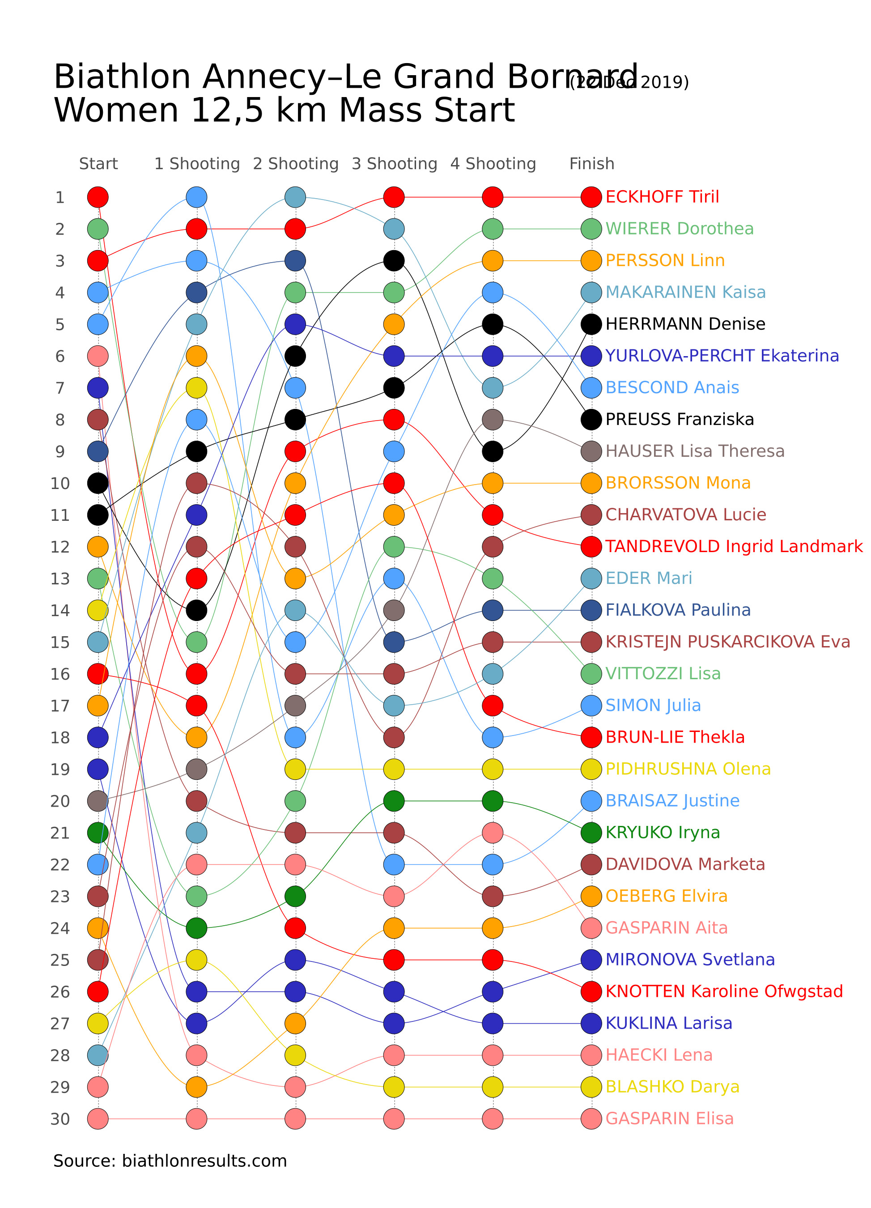

Figure: Charts\Data over time (temporal)\jpg/bump_chart.jpg

## Prompt Used

## Task: Extract Detailed Information from a Given Graph Image  
  
You will analyze a graph image and generate corresponding Plotly-compatible JSON files (`data.json`, `layout.json`, and `config.json`). Follow the structured steps and specific XML-like delimiters for each JSON section as outlined below.  
  
### Instructions:  
  
#### Graph Analysis:  
  
1. **Identify and Categorize Plot Types**:  
 - Recognize and categorize the plot types present in the graph image. Include both simple and complex plots, listed below:  
 - **Comparison Charts**:  
 - `bar`: Bar Chart  
 - `bar` (with vertical bars): Column Chart  
 - `bar` (grouped): Grouped Bar/Column Chart  
 - `scatter` (with lines connecting to points): Lollipop Chart  
 - `indicator` (with gauge): Bullet Chart  
 - `scatter`: Dot Plot  
 - `scatter` (with lines connecting different points): Dumbbell Chart  
 - `scatter` (or custom SVG): Pictogram  
 - `scatter` or `bar` with a range: Range Chart  
 - `barpolar`: Radial Bar Chart  
 - `parcoords`: Parallel Coordinates  
 - `scatterpolar`: Radar Chart  
 - `barpolar` (with segments): Nightingale Chart  
 - `waterfall`: Waterfall Chart  
 - `heatmap` (with color scale): Matrix Chart  
 - `various charts in small multiples`: Small Multiples  
 - `text` (frequency-based size): Word Cloud  
 - `scatter` (with lines indicating change): Slope Chart  
 - `table`: Table Chart  
 - `scatter`: Categorical Scatter Plot  
 - `scatter` (with four quadrants): Quadrant Chart  
 - **Correlation Charts**:  
 - `heatmap`: Heatmap  
 - `scatter` (with size): Bubble Chart  
 - `scatter`: Scatter Plot  
 - `scatter` (with lines connecting points): Connected Scatter Plot  
 - `hexbin`: Hexagonal Binning  
 - `contour`: Contour Plot  
 - **Part-to-Whole & Hierarchical Charts**:  
 - `bar` (stacked): Stacked Bar/Column Chart  
 - `bar` (with diverging sections): Diverging Bar Chart  
 - `bar` (mirrored pairs): Population Pyramid  
 - `scatter` (or custom symbols in a grid): Icon Array  
 - `waffle`: Waffle Chart  
 - `pie`: Pie Chart  
 - `pie` (with hole): Donut Chart  
 - `pie` (half-circle): Semi-circle Donut Chart  
 - `bar` (variable width): Marimekko Chart  
 - `treemap`: Treemap  
 - `treemap` (circular): Circular Treemap  
 - `treemap` (convex shape): Convex Treemap  
 - `sunburst`: Sunburst Chart  
 - `funnel` or `pyramid`: Funnel & Pyramid Chart  
 - `dendrogram`: Dendrogram  
 - `venn`: Venn Diagram  
 - `euler`: Euler Diagram  
 - `indicator` (circular gauge): Circular Gauge  
 - **Data Over Time (Temporal) Charts**:  
 - `scatter` (filled area under curve): Area Chart  
 - `scatter` (filled stacked areas): Stacked Area Chart  
 - `scatter` (smoothed filled areas): Stream Graph  
 - `scatter` (indicating ranking change): Bump Chart  
 - `scatter` (with filled area): Bump Area Chart  
 - `scatter`: Line Chart  
 - `scatter` (with smoothed lines): Spline Chart  
 - `scatter` (with stepped lines): Step Line Chart  
 - `candlestick`: Candlestick Chart  
 - `gantt`: Gantt Chart  
 - `scatter` (encoded lines): Barcode Chart  
 - `ohlc`: OHLC Chart  
 - **Distribution Charts**:  
 - `densitymapbox` or `histogram`: Density Plot  
 - `ridge`: Ridgeline Plot  
 - `horizon`: Horizon Chart  
 - `histogram`: Histogram  
 - `radial_histogram`: Radial Histogram  
 - `scatter` (with distribution): Strip Plot  
 - `scatter` (with jitter): Jitter Plot  
 - `heatmap`: One-dimensional Heatmap  
 - `scatter` (with tightly packed points): Beeswarm Chart  
 - `box`: Box Chart  
 - `violin`: Violin Plot  
 - **Geospatial & Other Charts**:  
 - `densitymapbox`: Geographic Heatmap  
 - `choropleth`: Choropleth Map  
 - `scattermapbox`: Tile Map  
 - `chord`: Chord Diagram  
 - `arc`: Arc Diagram  
 - `sankey`: Sankey  
 - `network`: Network Diagram  
 - `flowchart`: Flowchart  
  
2. **Extract Data Points** for Each Plot Type:  
 - Gather the data points for each identified plot type.  
 - For `scatter`, `line`, and `area` plots: Extract `x` and `y` values.  
 - For `bar` and `stacked bar` plots: Extract `x` (categories) and `y` values.  
 - For `pie` charts: Extract `labels` and `values`.  
 - For `scatter3d`, `surface`, and other 3D plots: Extract `x`, `y`, and `z` values.  
  
3. **Identify Multiple Plots** on the Same Figure:  
 - Note any combinations or overlays of multiple plot types on the same figure and their configurations, such as stacked plots or multiple area fills.  
  
#### Generate JSON and CSV Outputs:  
  
Follow the JSON formatting guidelines and wrap each section in the specified XML-like tags.  
  
1. **Generate `data.json`**:  
 - Include detailed information for each plot type:  
 - `type`: Specify the plot type (e.g., `"scatter"`, `"bar"`, `"pie"`, `"area"`, `"scatter3d"`, `"surface"`).  
 - For area charts, use `"type": "scatter"` and specify `"fill"`.  
 - `x`, `y`, and `z` (if applicable): Arrays of data points for each axis.  
 - `labels` and `values` for pie charts.  
 - `mode`: Specify for line and scatter plots (e.g., `"markers"`, `"lines"`, `"markers+lines"`).  
 - `name`: Legend entry for the plot.  
 - `marker`: Properties such as color, size, and symbol.  
 - `line`: Properties such as color, width, and dash style.  
 - `text`: Hover text for each data point.  
 - `hoverinfo`: Information displayed on hover (e.g., `"x+y+text"`).  
 - `fill`: For area charts, specify the fill (e.g., `"tozeroy"`, `"tonexty"`).  
 - `fillcolor`: The color used to fill the area.  
 - `stackgroup`: For stacked bar charts, specify the stacking group.  
  
2. **Generate `layout.json`**:  
 - Define the layout properties:  
 - `title`: Text and font properties for the graph title.  
 - `xaxis` and `yaxis`: Configuration for axis titles, ranges, grids, and ticks.  
 - `zaxis`: Configuration for 3D plots including title, range, and grid.  
 - `legend`: Properties for legend orientation and positioning.  
 - `margin`: Margins for left, right, bottom, top, and padding.  
 - `plot_bgcolor` and `paper_bgcolor`: Background colors.  
 - `scene`: Configuration for 3D scenes, including camera angles and aspect ratio.  
  
3. **Generate `config.json`**:  
 - Include settings such as:  
 - `responsive`: Whether the graph is responsive.  
 - `displayModeBar`: Whether the mode bar is shown.  
 - `modeBarButtonsToRemove`: List of mode bar buttons to remove.  
 - `scrollZoom`: Whether scrolling zoom is enabled.  
  
4. **Generate `<csv>`**:  
 - Format the CSV data as follows:  
 ```csv  
 x,y  
 1,4  
 2,5  
 3,6  
 ```  
 - Replace `x`, `y`, `1`, `4`, `2`, `5`, and `3`, `6` with the actual data from the graph image.  
  
### Output Format:  
  
Wrap each JSON output in the specified XML-like tags:  
  
- `<data> ... </data>`  
- `<layout> ... </layout>`  
- `<config> ... </config>`  
- `<csv> ... </csv>`  
  
Ensure the JSON format follows these rules:  
- Use double quotes for all keys and string values.  
- Do not include trailing commas in arrays or objects.  
  
### Example Output:  
  
```xml  
<data>  
[  
 {  
 "type": "scatter",  
 "x": [1, 2, 3],  
 "y": [4, 5, 6],  
 "mode": "markers+lines",  
 "name": "Line Plot",  
 "marker": {  
 "color": "rgba(75, 192, 192, 0.6)",  
 "size": 8  
 },  
 "line": {  
 "color": "rgba(75, 192, 192  
  
, 1)",  
 "width": 2  
 }  
 },  
 {  
 "type": "area",  
 "x": [1, 2, 3, 4, 5, 6, 7, 8, 9, 10, 11, 12],  
 "y": [400, 430, 550, 620, 580, 600, 630, 700, 670, 630, 600, 500],  
 "name": "Housing",  
 "marker": {  
 "color": "rgba(255, 159, 64, 0.8)"  
 },  
 "line": {  
 "color": "rgba(255, 159, 64, 1)",  
 "width": 2  
 }  
 },  
 {  
 "type": "bar",  
 "x": ["A", "B", "C"],  
 "y": [10, 15, 13],  
 "name": "Bar Chart",  
 "marker": {  
 "color": "rgba(255, 99, 132, 0.6)"  
 },  
 "hoverinfo": "x+y+text"  
 },  
 {  
 "type": "scatter",  
 "x": [1, 2, 3],  
 "y": [6, 7, 8],  
 "mode": "lines",  
 "fill": "tozeroy",  
 "name": "Area Chart",  
 "line": {  
 "color": "rgba(54, 162, 235, 1)",  
 "width": 2  
 },  
 "fillcolor": "rgba(54, 162, 235, 0.5)"  
 },  
 {  
 "type": "scatter3d",  
 "x": [1, 2, 3],  
 "y": [4, 5, 6],  
 "z": [7, 8, 9],  
 "mode": "markers",  
 "name": "3D Scatter Plot",  
 "marker": {  
 "color": "rgba(255, 159, 64, 0.8)",  
 "size": 5  
 },  
 "hoverinfo": "x+y+z+text"  
 },  
 {  
 "type": "surface",  
 "z": [  
 [10, 10.625, 12.5, 15.625, 20],  
 [5.625, 6.25, 8.125, 11.25, 15.625],  
 [0, 1.25, 3.125, 6.25, 10.625]  
 ],  
 "name": "Surface Plot",  
 "colorscale": "Viridis",  
 "hoverinfo": "z+name"  
 }  
]  
</data>  
<layout>  
{  
 "title": {  
 "text": "Complex Graph Example",  
 "font": {  
 "family": "Arial, sans-serif",  
 "size": 24,  
 "color": "#000000"  
 }  
 },  
 "xaxis": {  
 "title": {  
 "text": "X Axis",  
 "font": {  
 "family": "Arial, sans-serif",  
 "size": 18,  
 "color": "#000000"  
 }  
 },  
 "showgrid": true,  
 "gridcolor": "rgba(0, 0, 0, 0.1)",  
 "zeroline": true,  
 "zerolinecolor": "rgba(0, 0, 0, 0.1)"  
 },  
 "yaxis": {  
 "title": {  
 "text": "Y Axis",  
 "font": {  
 "family": "Arial, sans-serif",  
 "size": 18,  
 "color": "#000000"  
 }  
 },  
 "showgrid": true,  
 "gridcolor": "rgba(0, 0, 0, 0.1)",  
 "zeroline": true,  
 "zerolinecolor": "rgba(0, 0, 0, 0.1)"  
 },  
 "legend": {  
 "orientation": "h",  
 "x": 0.5,  
 "xanchor": "center",  
 "y": -0.2,  
 "font": {  
 "family": "Arial, sans-serif",  
 "size": 12,  
 "color": "#000000"  
 }  
 },  
 "margin": {  
 "l": 60,  
 "r": 30,  
 "b": 60,  
 "t": 60  
 },  
 "plot_bgcolor": "#ffffff",  
 "paper_bgcolor": "#ffffff",  
 "scene": {  
 "xaxis": {"title": "X Axis"},  
 "yaxis": {"title": "Y Axis"},  
 "zaxis": {"title": "Z Axis"}  
 }  
}  
</layout>  
<config>  
{  
 "responsive": true,  
 "displayModeBar": true,  
 "modeBarButtonsToRemove": ["toImage"],  
 "scrollZoom": true  
}  
</config>  
<csv>  
x,y  
1,4  
2,5  
3,6  
</csv>  
```

## Extracted JSON

### data

[  
 {  
 "type": "scatter",  
 "x": [  
 "ECKHOFF Tiril",  
 "WIERER Dorothea",  
 "PERSSON Linn",  
 "MAKARAINEN Kaisa",  
 "HERMANN Denise",  
 "YURLOVA-PERCHT Ekaterina",  
 "BESCOND Anais",  
 "PREUSS Franziska",  
 "HAUSER Lisa Theresa",  
 "BROSSON Mona",  
 "CHARVATOVA Lucie",  
 "EDER Mari",  
 "FIALKOVA Paulina",  
 "KRISTEJN PUSCARICICOVA Eva",  
 "VITOZZI Lisa",  
 "SIMON Julia",  
 "BRUN-LIE Thekla",  
 "PIDHRUSHNA Olena",  
 "BRAISAZ Justine",  
 "KRYUKO Irina",  
 "DAVIDOVA Marketa",  
 "OBERG Elvira",  
 "GASPARIN Aita",  
 "MIRONOVA Svetlana",  
 "KNOTTEN Karoline Ofgstad",  
 "KUKULINA Larisa",  
 "HAEKI Lena",  
 "BLASHKO Darya",  
 "GASPARIN Elisa"  
 ],  
 "y": [  
 1,  
 2,  
 3,  
 4,  
 5,  
 6,  
 7,  
 8,  
 9,  
 10,  
 11,  
 12,  
 13,  
 14,  
 15,  
 16,  
 17,  
 18,  
 19,  
 20,  
 21,  
 22,  
 23,  
 24,  
 25,  
 26,  
 27,  
 28,  
 29,  
 30  
 ],  
 "mode": "markers",  
 "name": "Women 12.5km Mass Start",  
 "marker": {  
 "color": "rgba(128, 128, 128, 0.8)",  
 "size": 10  
 },  
 "hoverinfo": "text"  
 }  
]

### layout

{  
 "title": {  
 "text": "Biathlon Annecy-Le Grand Bornand 2019",  
 "font": {  
 "family": "Arial, sans-serif",  
 "size": 24,  
 "color": "#000000"  
 }  
 },  
 "xaxis": {  
 "title": {  
 "text": "Athletes",  
 "font": {  
 "family": "Arial, sans-serif",  
 "size": 18,  
 "color": "#000000"  
 }  
 },  
 "showgrid": false,  
 "zeroline": false  
 },  
 "yaxis": {  
 "title": {  
 "text": "Finish Position",  
 "font": {  
 "family": "Arial, sans-serif",  
 "size": 18,  
 "color": "#000000"  
 }  
 },  
 "showgrid": false,  
 "zeroline": false  
 },  
 "legend": {  
 "orientation": "h",  
 "x": 0.5,  
 "xanchor": "center",  
 "y": -0.2,  
 "font": {  
 "family": "Arial, sans-serif",  
 "size": 12,  
 "color": "#000000"  
 }  
 },  
 "margin": {  
 "l": 60,  
 "r": 30,  
 "b": 60,  
 "t": 60  
 },  
 "plot_bgcolor": "#ffffff",  
 "paper_bgcolor": "#ffffff"  
}

### config

{  
 "responsive": true,  
 "displayModeBar": true,  
 "modeBarButtonsToRemove": [  
 "toImage"  
 ],  
 "scrollZoom": true  
}

## Updated JSON

### updated_data

[  
 {  
 "type": "scatter",  
 "x": [  
 "ECKHOFF Tiril",  
 "WIERER Dorothea",  
 "PERSSON Linn",  
 "MAKARAINEN Kaisa",  
 "HERMANN Denise",  
 "YURLOVA-PERCHT Ekaterina",  
 "BESCOND Anais",  
 "PREUSS Franziska",  
 "HAUSER Lisa Theresa",  
 "BROSSON Mona",  
 "CHARVATOVA Lucie",  
 "EDER Mari",  
 "FIALKOVA Paulina",  
 "KRISTEJN PUSCARICICOVA Eva",  
 "VITOZZI Lisa",  
 "SIMON Julia",  
 "BRUN-LIE Thekla",  
 "PIDHRUSHNA Olena",  
 "BRAISAZ Justine",  
 "KRYUKO Irina",  
 "DAVIDOVA Marketa",  
 "OBERG Elvira",  
 "GASPARIN Aita",  
 "MIRONOVA Svetlana",  
 "KNOTTEN Karoline Ofgstad",  
 "KUKULINA Larisa",  
 "HAEKI Lena",  
 "BLASHKO Darya",  
 "GASPARIN Elisa"  
 ],  
 "y": [  
 1,  
 2,  
 3,  
 4,  
 5,  
 6,  
 7,  
 8,  
 9,  
 10,  
 11,  
 12,  
 13,  
 14,  
 15,  
 16,  
 17,  
 18,  
 19,  
 20,  
 21,  
 22,  
 23,  
 24,  
 25,  
 26,  
 27,  
 28,  
 29,  
 30  
 ],  
 "mode": "markers",  
 "name": "Women 12.5km Mass Start",  
 "marker": {  
 "color": "rgba(128, 128, 128, 0.8)",  
 "size": 10  
 },  
 "hoverinfo": "text"  
 }  
]

### updated_layout

{  
 "title": {  
 "text": "Biathlon Annecy-Le Grand Bornand 2019",  
 "font": {  
 "family": "Arial, sans-serif",  
 "size": 24,  
 "color": "#000000"  
 }  
 },  
 "xaxis": {  
 "title": {  
 "text": "Athletes",  
 "font": {  
 "family": "Arial, sans-serif",  
 "size": 18,  
 "color": "#000000"  
 }  
 },  
 "showgrid": false,  
 "zeroline": false  
 },  
 "yaxis": {  
 "title": {  
 "text": "Finish Position",  
 "font": {  
 "family": "Arial, sans-serif",  
 "size": 18,  
 "color": "#000000"  
 }  
 },  
 "showgrid": false,  
 "zeroline": false  
 },  
 "legend": {  
 "orientation": "h",  
 "x": 0.5,  
 "xanchor": "center",  
 "y": -0.2,  
 "font": {  
 "family": "Arial, sans-serif",  
 "size": 12,  
 "color": "#000000"  
 }  
 },  
 "margin": {  
 "l": 60,  
 "r": 30,  
 "b": 60,  
 "t": 60  
 },  
 "plot_bgcolor": "#ffffff",  
 "paper_bgcolor": "#ffffff"  
}

### updated_config

{  
 "responsive": true,  
 "displayModeBar": true,  
 "modeBarButtonsToRemove": [  
 "toImage"  
 ],  
 "scrollZoom": true  
}

## Updated Chart

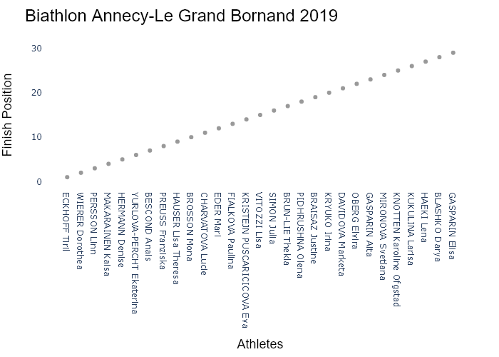

## Performance Metrics

|  |  |  |  |
| --- | --- | --- | --- |
| Task | Model Used | Description | Time Taken (s) |
| Processing Image to JSON | Gemini Vision Pro (default) | Time taken to convert the uploaded image to JSON format | 25.97 |
| Updating JSON | ChatGPT 3.5 (Default) | Time taken to update the JSON with new data | 0.00 |
| Plotting Updated JSON | N/A | Time taken to plot the updated JSON | 0.13 |

# Test Run

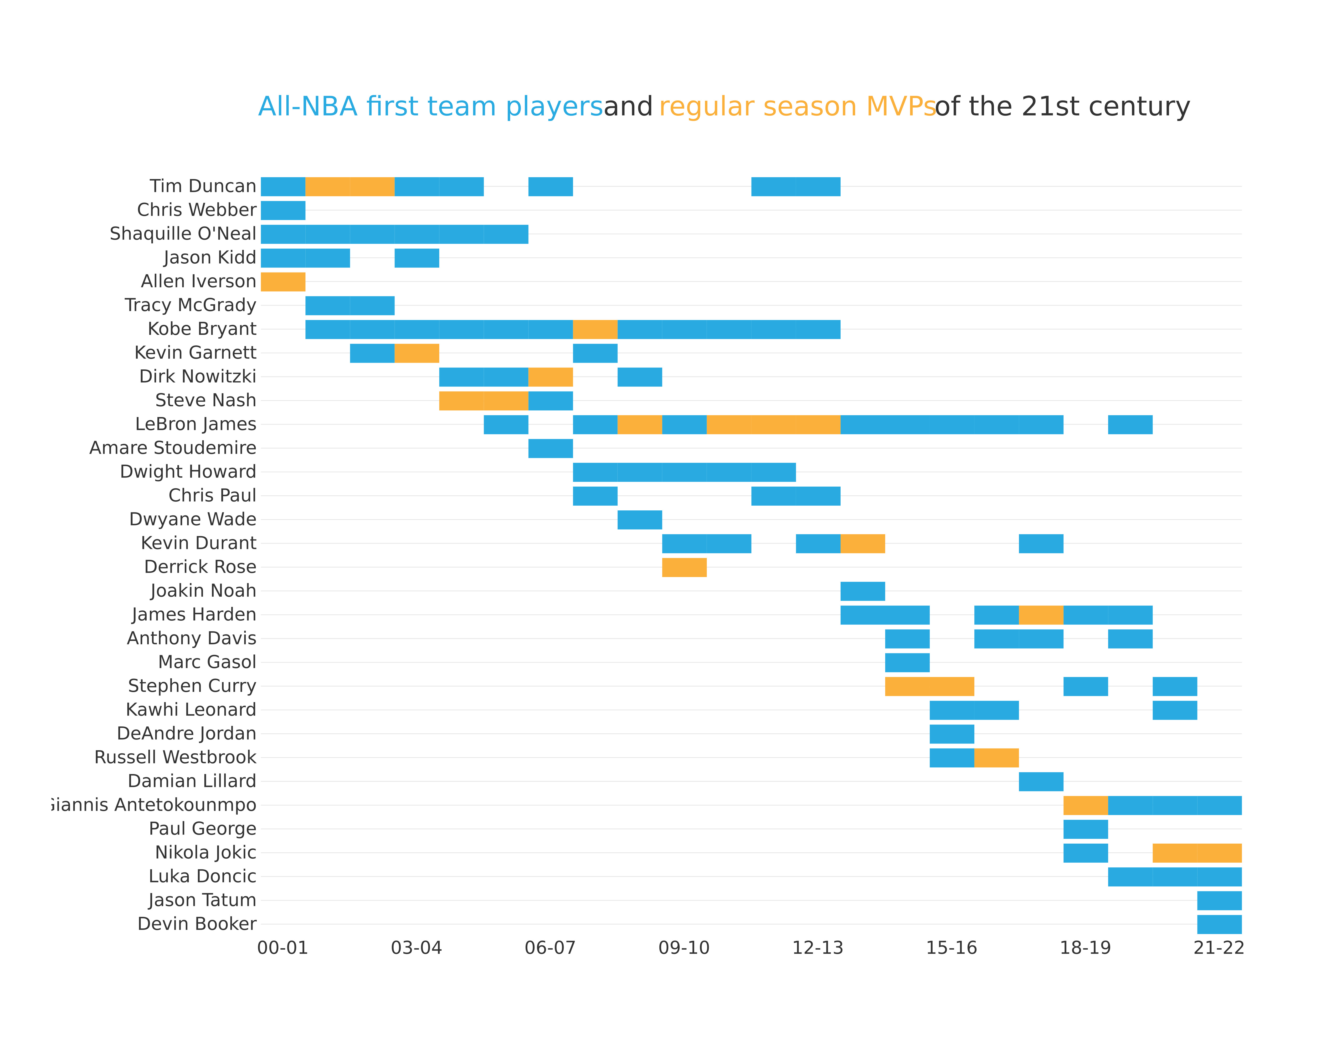

Figure: Charts\Data over time (temporal)\jpg\gantt_chart.jpg

## Prompt Used

## Task: Extract Detailed Information from a Given Graph Image  
  
You will analyze a graph image and generate corresponding Plotly-compatible JSON files (`data.json`, `layout.json`, and `config.json`). Follow the structured steps and specific XML-like delimiters for each JSON section as outlined below.  
  
### Instructions:  
  
#### Graph Analysis:  
  
1. **Identify and Categorize Plot Types**:  
 - Recognize and categorize the plot types present in the graph image. Include both simple and complex plots, listed below:  
 - **Comparison Charts**:  
 - `bar`: Bar Chart  
 - `bar` (with vertical bars): Column Chart  
 - `bar` (grouped): Grouped Bar/Column Chart  
 - `scatter` (with lines connecting to points): Lollipop Chart  
 - `indicator` (with gauge): Bullet Chart  
 - `scatter`: Dot Plot  
 - `scatter` (with lines connecting different points): Dumbbell Chart  
 - `scatter` (or custom SVG): Pictogram  
 - `scatter` or `bar` with a range: Range Chart  
 - `barpolar`: Radial Bar Chart  
 - `parcoords`: Parallel Coordinates  
 - `scatterpolar`: Radar Chart  
 - `barpolar` (with segments): Nightingale Chart  
 - `waterfall`: Waterfall Chart  
 - `heatmap` (with color scale): Matrix Chart  
 - `various charts in small multiples`: Small Multiples  
 - `text` (frequency-based size): Word Cloud  
 - `scatter` (with lines indicating change): Slope Chart  
 - `table`: Table Chart  
 - `scatter`: Categorical Scatter Plot  
 - `scatter` (with four quadrants): Quadrant Chart  
 - **Correlation Charts**:  
 - `heatmap`: Heatmap  
 - `scatter` (with size): Bubble Chart  
 - `scatter`: Scatter Plot  
 - `scatter` (with lines connecting points): Connected Scatter Plot  
 - `hexbin`: Hexagonal Binning  
 - `contour`: Contour Plot  
 - **Part-to-Whole & Hierarchical Charts**:  
 - `bar` (stacked): Stacked Bar/Column Chart  
 - `bar` (with diverging sections): Diverging Bar Chart  
 - `bar` (mirrored pairs): Population Pyramid  
 - `scatter` (or custom symbols in a grid): Icon Array  
 - `waffle`: Waffle Chart  
 - `pie`: Pie Chart  
 - `pie` (with hole): Donut Chart  
 - `pie` (half-circle): Semi-circle Donut Chart  
 - `bar` (variable width): Marimekko Chart  
 - `treemap`: Treemap  
 - `treemap` (circular): Circular Treemap  
 - `treemap` (convex shape): Convex Treemap  
 - `sunburst`: Sunburst Chart  
 - `funnel` or `pyramid`: Funnel & Pyramid Chart  
 - `dendrogram`: Dendrogram  
 - `venn`: Venn Diagram  
 - `euler`: Euler Diagram  
 - `indicator` (circular gauge): Circular Gauge  
 - **Data Over Time (Temporal) Charts**:  
 - `scatter` (filled area under curve): Area Chart  
 - `scatter` (filled stacked areas): Stacked Area Chart  
 - `scatter` (smoothed filled areas): Stream Graph  
 - `scatter` (indicating ranking change): Bump Chart  
 - `scatter` (with filled area): Bump Area Chart  
 - `scatter`: Line Chart  
 - `scatter` (with smoothed lines): Spline Chart  
 - `scatter` (with stepped lines): Step Line Chart  
 - `candlestick`: Candlestick Chart  
 - `gantt`: Gantt Chart  
 - `scatter` (encoded lines): Barcode Chart  
 - `ohlc`: OHLC Chart  
 - **Distribution Charts**:  
 - `densitymapbox` or `histogram`: Density Plot  
 - `ridge`: Ridgeline Plot  
 - `horizon`: Horizon Chart  
 - `histogram`: Histogram  
 - `radial_histogram`: Radial Histogram  
 - `scatter` (with distribution): Strip Plot  
 - `scatter` (with jitter): Jitter Plot  
 - `heatmap`: One-dimensional Heatmap  
 - `scatter` (with tightly packed points): Beeswarm Chart  
 - `box`: Box Chart  
 - `violin`: Violin Plot  
 - **Geospatial & Other Charts**:  
 - `densitymapbox`: Geographic Heatmap  
 - `choropleth`: Choropleth Map  
 - `scattermapbox`: Tile Map  
 - `chord`: Chord Diagram  
 - `arc`: Arc Diagram  
 - `sankey`: Sankey  
 - `network`: Network Diagram  
 - `flowchart`: Flowchart  
  
2. **Extract Data Points** for Each Plot Type:  
 - Gather the data points for each identified plot type.  
 - For `scatter`, `line`, and `area` plots: Extract `x` and `y` values.  
 - For `bar` and `stacked bar` plots: Extract `x` (categories) and `y` values.  
 - For `pie` charts: Extract `labels` and `values`.  
 - For `scatter3d`, `surface`, and other 3D plots: Extract `x`, `y`, and `z` values.  
  
3. **Identify Multiple Plots** on the Same Figure:  
 - Note any combinations or overlays of multiple plot types on the same figure and their configurations, such as stacked plots or multiple area fills.  
  
#### Generate JSON and CSV Outputs:  
  
Follow the JSON formatting guidelines and wrap each section in the specified XML-like tags.  
  
1. **Generate `data.json`**:  
 - Include detailed information for each plot type:  
 - `type`: Specify the plot type (e.g., `"scatter"`, `"bar"`, `"pie"`, `"area"`, `"scatter3d"`, `"surface"`).  
 - For area charts, use `"type": "scatter"` and specify `"fill"`.  
 - `x`, `y`, and `z` (if applicable): Arrays of data points for each axis.  
 - `labels` and `values` for pie charts.  
 - `mode`: Specify for line and scatter plots (e.g., `"markers"`, `"lines"`, `"markers+lines"`).  
 - `name`: Legend entry for the plot.  
 - `marker`: Properties such as color, size, and symbol.  
 - `line`: Properties such as color, width, and dash style.  
 - `text`: Hover text for each data point.  
 - `hoverinfo`: Information displayed on hover (e.g., `"x+y+text"`).  
 - `fill`: For area charts, specify the fill (e.g., `"tozeroy"`, `"tonexty"`).  
 - `fillcolor`: The color used to fill the area.  
 - `stackgroup`: For stacked bar charts, specify the stacking group.  
  
2. **Generate `layout.json`**:  
 - Define the layout properties:  
 - `title`: Text and font properties for the graph title.  
 - `xaxis` and `yaxis`: Configuration for axis titles, ranges, grids, and ticks.  
 - `zaxis`: Configuration for 3D plots including title, range, and grid.  
 - `legend`: Properties for legend orientation and positioning.  
 - `margin`: Margins for left, right, bottom, top, and padding.  
 - `plot_bgcolor` and `paper_bgcolor`: Background colors.  
 - `scene`: Configuration for 3D scenes, including camera angles and aspect ratio.  
  
3. **Generate `config.json`**:  
 - Include settings such as:  
 - `responsive`: Whether the graph is responsive.  
 - `displayModeBar`: Whether the mode bar is shown.  
 - `modeBarButtonsToRemove`: List of mode bar buttons to remove.  
 - `scrollZoom`: Whether scrolling zoom is enabled.  
  
4. **Generate `<csv>`**:  
 - Format the CSV data as follows:  
 ```csv  
 x,y  
 1,4  
 2,5  
 3,6  
 ```  
 - Replace `x`, `y`, `1`, `4`, `2`, `5`, and `3`, `6` with the actual data from the graph image.  
  
### Output Format:  
  
Wrap each JSON output in the specified XML-like tags:  
  
- `<data> ... </data>`  
- `<layout> ... </layout>`  
- `<config> ... </config>`  
- `<csv> ... </csv>`  
  
Ensure the JSON format follows these rules:  
- Use double quotes for all keys and string values.  
- Do not include trailing commas in arrays or objects.  
  
### Example Output:  
  
```xml  
<data>  
[  
 {  
 "type": "scatter",  
 "x": [1, 2, 3],  
 "y": [4, 5, 6],  
 "mode": "markers+lines",  
 "name": "Line Plot",  
 "marker": {  
 "color": "rgba(75, 192, 192, 0.6)",  
 "size": 8  
 },  
 "line": {  
 "color": "rgba(75, 192, 192  
  
, 1)",  
 "width": 2  
 }  
 },  
 {  
 "type": "area",  
 "x": [1, 2, 3, 4, 5, 6, 7, 8, 9, 10, 11, 12],  
 "y": [400, 430, 550, 620, 580, 600, 630, 700, 670, 630, 600, 500],  
 "name": "Housing",  
 "marker": {  
 "color": "rgba(255, 159, 64, 0.8)"  
 },  
 "line": {  
 "color": "rgba(255, 159, 64, 1)",  
 "width": 2  
 }  
 },  
 {  
 "type": "bar",  
 "x": ["A", "B", "C"],  
 "y": [10, 15, 13],  
 "name": "Bar Chart",  
 "marker": {  
 "color": "rgba(255, 99, 132, 0.6)"  
 },  
 "hoverinfo": "x+y+text"  
 },  
 {  
 "type": "scatter",  
 "x": [1, 2, 3],  
 "y": [6, 7, 8],  
 "mode": "lines",  
 "fill": "tozeroy",  
 "name": "Area Chart",  
 "line": {  
 "color": "rgba(54, 162, 235, 1)",  
 "width": 2  
 },  
 "fillcolor": "rgba(54, 162, 235, 0.5)"  
 },  
 {  
 "type": "scatter3d",  
 "x": [1, 2, 3],  
 "y": [4, 5, 6],  
 "z": [7, 8, 9],  
 "mode": "markers",  
 "name": "3D Scatter Plot",  
 "marker": {  
 "color": "rgba(255, 159, 64, 0.8)",  
 "size": 5  
 },  
 "hoverinfo": "x+y+z+text"  
 },  
 {  
 "type": "surface",  
 "z": [  
 [10, 10.625, 12.5, 15.625, 20],  
 [5.625, 6.25, 8.125, 11.25, 15.625],  
 [0, 1.25, 3.125, 6.25, 10.625]  
 ],  
 "name": "Surface Plot",  
 "colorscale": "Viridis",  
 "hoverinfo": "z+name"  
 }  
]  
</data>  
<layout>  
{  
 "title": {  
 "text": "Complex Graph Example",  
 "font": {  
 "family": "Arial, sans-serif",  
 "size": 24,  
 "color": "#000000"  
 }  
 },  
 "xaxis": {  
 "title": {  
 "text": "X Axis",  
 "font": {  
 "family": "Arial, sans-serif",  
 "size": 18,  
 "color": "#000000"  
 }  
 },  
 "showgrid": true,  
 "gridcolor": "rgba(0, 0, 0, 0.1)",  
 "zeroline": true,  
 "zerolinecolor": "rgba(0, 0, 0, 0.1)"  
 },  
 "yaxis": {  
 "title": {  
 "text": "Y Axis",  
 "font": {  
 "family": "Arial, sans-serif",  
 "size": 18,  
 "color": "#000000"  
 }  
 },  
 "showgrid": true,  
 "gridcolor": "rgba(0, 0, 0, 0.1)",  
 "zeroline": true,  
 "zerolinecolor": "rgba(0, 0, 0, 0.1)"  
 },  
 "legend": {  
 "orientation": "h",  
 "x": 0.5,  
 "xanchor": "center",  
 "y": -0.2,  
 "font": {  
 "family": "Arial, sans-serif",  
 "size": 12,  
 "color": "#000000"  
 }  
 },  
 "margin": {  
 "l": 60,  
 "r": 30,  
 "b": 60,  
 "t": 60  
 },  
 "plot_bgcolor": "#ffffff",  
 "paper_bgcolor": "#ffffff",  
 "scene": {  
 "xaxis": {"title": "X Axis"},  
 "yaxis": {"title": "Y Axis"},  
 "zaxis": {"title": "Z Axis"}  
 }  
}  
</layout>  
<config>  
{  
 "responsive": true,  
 "displayModeBar": true,  
 "modeBarButtonsToRemove": ["toImage"],  
 "scrollZoom": true  
}  
</config>  
<csv>  
x,y  
1,4  
2,5  
3,6  
</csv>  
```

## Extracted JSON

### data

[  
 {  
 "type": "bar",  
 "x": [  
 "Tim Duncan",  
 "Shaquille O'Neal",  
 "Chris Webber",  
 "Jason Kidd",  
 "Allen Iverson",  
 "Tracy McGrady",  
 "Dirk Nowitzki",  
 "Steve Nash",  
 "LeBron James",  
 "Amare Stoudemire",  
 "Dwight Howard",  
 "Chris Paul",  
 "Dwyane Wade",  
 "Derrick Rose",  
 "Kevin Durant",  
 "James Harden",  
 "Anthony Davis",  
 "Anthony Noah",  
 "Marc Gasol",  
 "Stephen Curry",  
 "Kawhi Leonard",  
 "DeAndre Jordan",  
 "Russell Westbrook",  
 "Damian Lillard",  
 "Giannis Antetokounmpo",  
 "Paul George",  
 "Nikola Jokic",  
 "Luka Doncic",  
 "Devin Booker"  
 ],  
 "y": [  
 2,  
 3,  
 1,  
 1,  
 1,  
 2,  
 1,  
 2,  
 4,  
 2,  
 3,  
 1,  
 2,  
 1,  
 1,  
 3,  
 2,  
 1,  
 1,  
 3,  
 2,  
 2,  
 3,  
 2,  
 3,  
 2,  
 1,  
 1  
 ],  
 "name": "All-NBA First Team Player and Regular Season MVPs of the 21st Century",  
 "marker": {  
 "color": "rgba(26, 118, 255, 0.6)"  
 },  
 "hoverinfo": "x+y+text"  
 },  
 {  
 "type": "bar",  
 "x": [  
 "Shaquille O'Neal",  
 "Allen Iverson",  
 "Kobe Bryant",  
 "Tim Duncan",  
 "Kevin Garnett",  
 "LeBron James",  
 "Stephen Curry",  
 "Kevin Durant",  
 "James Harden",  
 "Russell Westbrook",  
 "Giannis Antetokounmpo",  
 "Nikola Jokic",  
 "Joel Embiid"  
 ],  
 "y": [  
 1,  
 1,  
 1,  
 2,  
 1,  
 4,  
 2,  
 2,  
 3,  
 2,  
 2,  
 2,  
 1  
 ],  
 "name": "All-NBA First Team Player and Regular Season MVPs of the 21st Century",  
 "marker": {  
 "color": "rgba(255, 127, 14, 0.6)"  
 },  
 "hoverinfo": "x+y+text"  
 }  
]

### layout

{  
 "title": {  
 "text": "All-NBA First Team Players and Regular Season MVPs of the 21st Century",  
 "font": {  
 "family": "Arial, sans-serif",  
 "size": 24,  
 "color": "#000000"  
 }  
 },  
 "xaxis": {  
 "title": {  
 "text": "Player",  
 "font": {  
 "family": "Arial, sans-serif",  
 "size": 18,  
 "color": "#000000"  
 }  
 },  
 "showgrid": false,  
 "zeroline": false  
 },  
 "yaxis": {  
 "title": {  
 "text": "Number of Awards",  
 "font": {  
 "family": "Arial, sans-serif",  
 "size": 18,  
 "color": "#000000"  
 }  
 },  
 "showgrid": false,  
 "zeroline": false  
 },  
 "legend": {  
 "orientation": "h",  
 "x": 0.5,  
 "xanchor": "center",  
 "y": -0.2,  
 "font": {  
 "family": "Arial, sans-serif",  
 "size": 12,  
 "color": "#000000"  
 }  
 },  
 "margin": {  
 "l": 60,  
 "r": 30,  
 "b": 60,  
 "t": 60  
 },  
 "plot_bgcolor": "#ffffff",  
 "paper_bgcolor": "#ffffff"  
}

### config

{  
 "responsive": true,  
 "displayModeBar": true,  
 "modeBarButtonsToRemove": [  
 "toImage"  
 ],  
 "scrollZoom": true  
}

## Updated JSON

### updated_data

[  
 {  
 "type": "bar",  
 "x": [  
 "Tim Duncan",  
 "Shaquille O'Neal",  
 "Chris Webber",  
 "Jason Kidd",  
 "Allen Iverson",  
 "Tracy McGrady",  
 "Dirk Nowitzki",  
 "Steve Nash",  
 "LeBron James",  
 "Amare Stoudemire",  
 "Dwight Howard",  
 "Chris Paul",  
 "Dwyane Wade",  
 "Derrick Rose",  
 "Kevin Durant",  
 "James Harden",  
 "Anthony Davis",  
 "Anthony Noah",  
 "Marc Gasol",  
 "Stephen Curry",  
 "Kawhi Leonard",  
 "DeAndre Jordan",  
 "Russell Westbrook",  
 "Damian Lillard",  
 "Giannis Antetokounmpo",  
 "Paul George",  
 "Nikola Jokic",  
 "Luka Doncic",  
 "Devin Booker"  
 ],  
 "y": [  
 2,  
 3,  
 1,  
 1,  
 1,  
 2,  
 1,  
 2,  
 4,  
 2,  
 3,  
 1,  
 2,  
 1,  
 1,  
 3,  
 2,  
 1,  
 1,  
 3,  
 2,  
 2,  
 3,  
 2,  
 3,  
 2,  
 1,  
 1  
 ],  
 "name": "All-NBA First Team Player and Regular Season MVPs of the 21st Century",  
 "marker": {  
 "color": "rgba(26, 118, 255, 0.6)"  
 },  
 "hoverinfo": "x+y+text"  
 },  
 {  
 "type": "bar",  
 "x": [  
 "Shaquille O'Neal",  
 "Allen Iverson",  
 "Kobe Bryant",  
 "Tim Duncan",  
 "Kevin Garnett",  
 "LeBron James",  
 "Stephen Curry",  
 "Kevin Durant",  
 "James Harden",  
 "Russell Westbrook",  
 "Giannis Antetokounmpo",  
 "Nikola Jokic",  
 "Joel Embiid"  
 ],  
 "y": [  
 1,  
 1,  
 1,  
 2,  
 1,  
 4,  
 2,  
 2,  
 3,  
 2,  
 2,  
 2,  
 1  
 ],  
 "name": "All-NBA First Team Player and Regular Season MVPs of the 21st Century",  
 "marker": {  
 "color": "rgba(255, 127, 14, 0.6)"  
 },  
 "hoverinfo": "x+y+text"  
 }  
]

### updated_layout

{  
 "title": {  
 "text": "All-NBA First Team Players and Regular Season MVPs of the 21st Century",  
 "font": {  
 "family": "Arial, sans-serif",  
 "size": 24,  
 "color": "#000000"  
 }  
 },  
 "xaxis": {  
 "title": {  
 "text": "Player",  
 "font": {  
 "family": "Arial, sans-serif",  
 "size": 18,  
 "color": "#000000"  
 }  
 },  
 "showgrid": false,  
 "zeroline": false  
 },  
 "yaxis": {  
 "title": {  
 "text": "Number of Awards",  
 "font": {  
 "family": "Arial, sans-serif",  
 "size": 18,  
 "color": "#000000"  
 }  
 },  
 "showgrid": false,  
 "zeroline": false  
 },  
 "legend": {  
 "orientation": "h",  
 "x": 0.5,  
 "xanchor": "center",  
 "y": -0.2,  
 "font": {  
 "family": "Arial, sans-serif",  
 "size": 12,  
 "color": "#000000"  
 }  
 },  
 "margin": {  
 "l": 60,  
 "r": 30,  
 "b": 60,  
 "t": 60  
 },  
 "plot_bgcolor": "#ffffff",  
 "paper_bgcolor": "#ffffff"  
}

### updated_config

{  
 "responsive": true,  
 "displayModeBar": true,  
 "modeBarButtonsToRemove": [  
 "toImage"  
 ],  
 "scrollZoom": true  
}

## Updated Chart

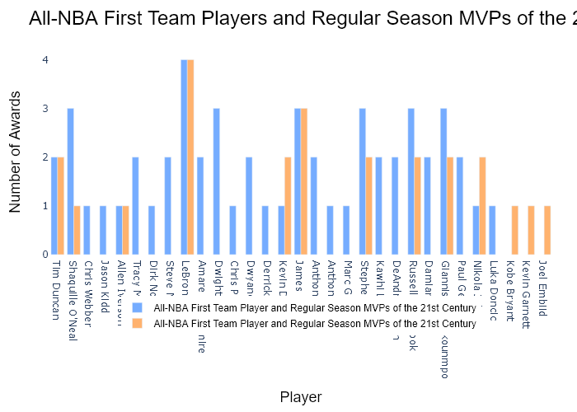

## Performance Metrics

|  |  |  |  |
| --- | --- | --- | --- |
| Task | Model Used | Description | Time Taken (s) |
| Processing Image to JSON | Gemini Vision Pro (default) | Time taken to convert the uploaded image to JSON format | 25.20 |
| Updating JSON | ChatGPT 3.5 (Default) | Time taken to update the JSON with new data | 0.00 |
| Plotting Updated JSON | N/A | Time taken to plot the updated JSON | 0.16 |

# Test Run

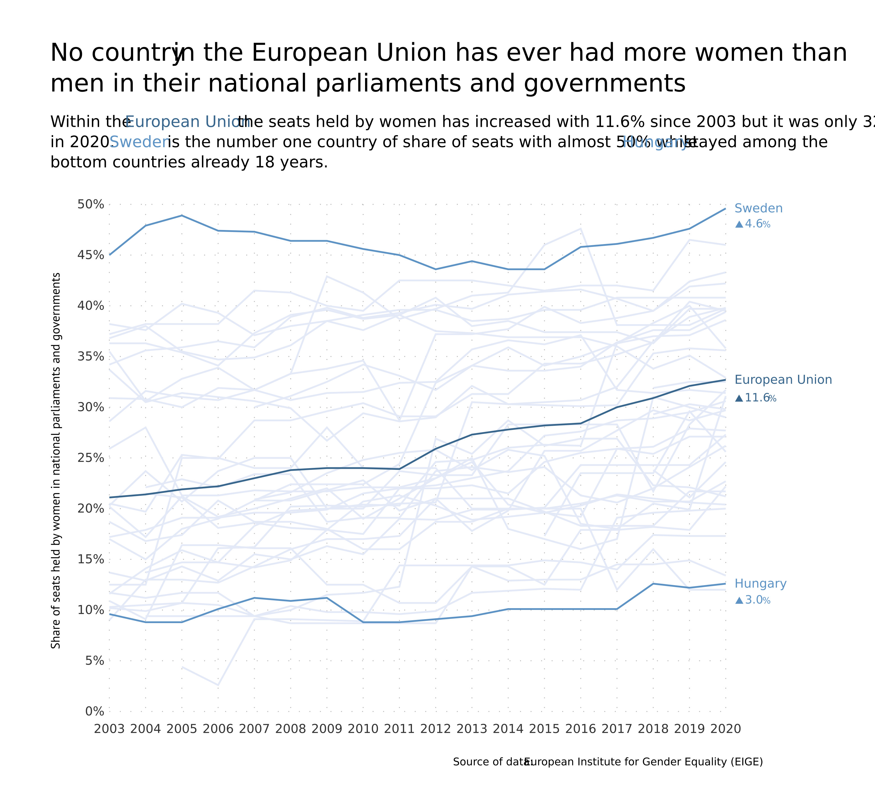

Figure: Charts\Data over time (temporal)\jpg\line.jpg

## Prompt Used

## Task: Extract Detailed Information from a Given Graph Image  
  
You will analyze a graph image and generate corresponding Plotly-compatible JSON files (`data.json`, `layout.json`, and `config.json`). Follow the structured steps and specific XML-like delimiters for each JSON section as outlined below.  
  
### Instructions:  
  
#### Graph Analysis:  
  
1. **Identify and Categorize Plot Types**:  
 - Recognize and categorize the plot types present in the graph image. Include both simple and complex plots, listed below:  
 - **Comparison Charts**:  
 - `bar`: Bar Chart  
 - `bar` (with vertical bars): Column Chart  
 - `bar` (grouped): Grouped Bar/Column Chart  
 - `scatter` (with lines connecting to points): Lollipop Chart  
 - `indicator` (with gauge): Bullet Chart  
 - `scatter`: Dot Plot  
 - `scatter` (with lines connecting different points): Dumbbell Chart  
 - `scatter` (or custom SVG): Pictogram  
 - `scatter` or `bar` with a range: Range Chart  
 - `barpolar`: Radial Bar Chart  
 - `parcoords`: Parallel Coordinates  
 - `scatterpolar`: Radar Chart  
 - `barpolar` (with segments): Nightingale Chart  
 - `waterfall`: Waterfall Chart  
 - `heatmap` (with color scale): Matrix Chart  
 - `various charts in small multiples`: Small Multiples  
 - `text` (frequency-based size): Word Cloud  
 - `scatter` (with lines indicating change): Slope Chart  
 - `table`: Table Chart  
 - `scatter`: Categorical Scatter Plot  
 - `scatter` (with four quadrants): Quadrant Chart  
 - **Correlation Charts**:  
 - `heatmap`: Heatmap  
 - `scatter` (with size): Bubble Chart  
 - `scatter`: Scatter Plot  
 - `scatter` (with lines connecting points): Connected Scatter Plot  
 - `hexbin`: Hexagonal Binning  
 - `contour`: Contour Plot  
 - **Part-to-Whole & Hierarchical Charts**:  
 - `bar` (stacked): Stacked Bar/Column Chart  
 - `bar` (with diverging sections): Diverging Bar Chart  
 - `bar` (mirrored pairs): Population Pyramid  
 - `scatter` (or custom symbols in a grid): Icon Array  
 - `waffle`: Waffle Chart  
 - `pie`: Pie Chart  
 - `pie` (with hole): Donut Chart  
 - `pie` (half-circle): Semi-circle Donut Chart  
 - `bar` (variable width): Marimekko Chart  
 - `treemap`: Treemap  
 - `treemap` (circular): Circular Treemap  
 - `treemap` (convex shape): Convex Treemap  
 - `sunburst`: Sunburst Chart  
 - `funnel` or `pyramid`: Funnel & Pyramid Chart  
 - `dendrogram`: Dendrogram  
 - `venn`: Venn Diagram  
 - `euler`: Euler Diagram  
 - `indicator` (circular gauge): Circular Gauge  
 - **Data Over Time (Temporal) Charts**:  
 - `scatter` (filled area under curve): Area Chart  
 - `scatter` (filled stacked areas): Stacked Area Chart  
 - `scatter` (smoothed filled areas): Stream Graph  
 - `scatter` (indicating ranking change): Bump Chart  
 - `scatter` (with filled area): Bump Area Chart  
 - `scatter`: Line Chart  
 - `scatter` (with smoothed lines): Spline Chart  
 - `scatter` (with stepped lines): Step Line Chart  
 - `candlestick`: Candlestick Chart  
 - `gantt`: Gantt Chart  
 - `scatter` (encoded lines): Barcode Chart  
 - `ohlc`: OHLC Chart  
 - **Distribution Charts**:  
 - `densitymapbox` or `histogram`: Density Plot  
 - `ridge`: Ridgeline Plot  
 - `horizon`: Horizon Chart  
 - `histogram`: Histogram  
 - `radial_histogram`: Radial Histogram  
 - `scatter` (with distribution): Strip Plot  
 - `scatter` (with jitter): Jitter Plot  
 - `heatmap`: One-dimensional Heatmap  
 - `scatter` (with tightly packed points): Beeswarm Chart  
 - `box`: Box Chart  
 - `violin`: Violin Plot  
 - **Geospatial & Other Charts**:  
 - `densitymapbox`: Geographic Heatmap  
 - `choropleth`: Choropleth Map  
 - `scattermapbox`: Tile Map  
 - `chord`: Chord Diagram  
 - `arc`: Arc Diagram  
 - `sankey`: Sankey  
 - `network`: Network Diagram  
 - `flowchart`: Flowchart  
  
2. **Extract Data Points** for Each Plot Type:  
 - Gather the data points for each identified plot type.  
 - For `scatter`, `line`, and `area` plots: Extract `x` and `y` values.  
 - For `bar` and `stacked bar` plots: Extract `x` (categories) and `y` values.  
 - For `pie` charts: Extract `labels` and `values`.  
 - For `scatter3d`, `surface`, and other 3D plots: Extract `x`, `y`, and `z` values.  
  
3. **Identify Multiple Plots** on the Same Figure:  
 - Note any combinations or overlays of multiple plot types on the same figure and their configurations, such as stacked plots or multiple area fills.  
  
#### Generate JSON and CSV Outputs:  
  
Follow the JSON formatting guidelines and wrap each section in the specified XML-like tags.  
  
1. **Generate `data.json`**:  
 - Include detailed information for each plot type:  
 - `type`: Specify the plot type (e.g., `"scatter"`, `"bar"`, `"pie"`, `"area"`, `"scatter3d"`, `"surface"`).  
 - For area charts, use `"type": "scatter"` and specify `"fill"`.  
 - `x`, `y`, and `z` (if applicable): Arrays of data points for each axis.  
 - `labels` and `values` for pie charts.  
 - `mode`: Specify for line and scatter plots (e.g., `"markers"`, `"lines"`, `"markers+lines"`).  
 - `name`: Legend entry for the plot.  
 - `marker`: Properties such as color, size, and symbol.  
 - `line`: Properties such as color, width, and dash style.  
 - `text`: Hover text for each data point.  
 - `hoverinfo`: Information displayed on hover (e.g., `"x+y+text"`).  
 - `fill`: For area charts, specify the fill (e.g., `"tozeroy"`, `"tonexty"`).  
 - `fillcolor`: The color used to fill the area.  
 - `stackgroup`: For stacked bar charts, specify the stacking group.  
  
2. **Generate `layout.json`**:  
 - Define the layout properties:  
 - `title`: Text and font properties for the graph title.  
 - `xaxis` and `yaxis`: Configuration for axis titles, ranges, grids, and ticks.  
 - `zaxis`: Configuration for 3D plots including title, range, and grid.  
 - `legend`: Properties for legend orientation and positioning.  
 - `margin`: Margins for left, right, bottom, top, and padding.  
 - `plot_bgcolor` and `paper_bgcolor`: Background colors.  
 - `scene`: Configuration for 3D scenes, including camera angles and aspect ratio.  
  
3. **Generate `config.json`**:  
 - Include settings such as:  
 - `responsive`: Whether the graph is responsive.  
 - `displayModeBar`: Whether the mode bar is shown.  
 - `modeBarButtonsToRemove`: List of mode bar buttons to remove.  
 - `scrollZoom`: Whether scrolling zoom is enabled.  
  
4. **Generate `<csv>`**:  
 - Format the CSV data as follows:  
 ```csv  
 x,y  
 1,4  
 2,5  
 3,6  
 ```  
 - Replace `x`, `y`, `1`, `4`, `2`, `5`, and `3`, `6` with the actual data from the graph image.  
  
### Output Format:  
  
Wrap each JSON output in the specified XML-like tags:  
  
- `<data> ... </data>`  
- `<layout> ... </layout>`  
- `<config> ... </config>`  
- `<csv> ... </csv>`  
  
Ensure the JSON format follows these rules:  
- Use double quotes for all keys and string values.  
- Do not include trailing commas in arrays or objects.  
  
### Example Output:  
  
```xml  
<data>  
[  
 {  
 "type": "scatter",  
 "x": [1, 2, 3],  
 "y": [4, 5, 6],  
 "mode": "markers+lines",  
 "name": "Line Plot",  
 "marker": {  
 "color": "rgba(75, 192, 192, 0.6)",  
 "size": 8  
 },  
 "line": {  
 "color": "rgba(75, 192, 192  
  
, 1)",  
 "width": 2  
 }  
 },  
 {  
 "type": "area",  
 "x": [1, 2, 3, 4, 5, 6, 7, 8, 9, 10, 11, 12],  
 "y": [400, 430, 550, 620, 580, 600, 630, 700, 670, 630, 600, 500],  
 "name": "Housing",  
 "marker": {  
 "color": "rgba(255, 159, 64, 0.8)"  
 },  
 "line": {  
 "color": "rgba(255, 159, 64, 1)",  
 "width": 2  
 }  
 },  
 {  
 "type": "bar",  
 "x": ["A", "B", "C"],  
 "y": [10, 15, 13],  
 "name": "Bar Chart",  
 "marker": {  
 "color": "rgba(255, 99, 132, 0.6)"  
 },  
 "hoverinfo": "x+y+text"  
 },  
 {  
 "type": "scatter",  
 "x": [1, 2, 3],  
 "y": [6, 7, 8],  
 "mode": "lines",  
 "fill": "tozeroy",  
 "name": "Area Chart",  
 "line": {  
 "color": "rgba(54, 162, 235, 1)",  
 "width": 2  
 },  
 "fillcolor": "rgba(54, 162, 235, 0.5)"  
 },  
 {  
 "type": "scatter3d",  
 "x": [1, 2, 3],  
 "y": [4, 5, 6],  
 "z": [7, 8, 9],  
 "mode": "markers",  
 "name": "3D Scatter Plot",  
 "marker": {  
 "color": "rgba(255, 159, 64, 0.8)",  
 "size": 5  
 },  
 "hoverinfo": "x+y+z+text"  
 },  
 {  
 "type": "surface",  
 "z": [  
 [10, 10.625, 12.5, 15.625, 20],  
 [5.625, 6.25, 8.125, 11.25, 15.625],  
 [0, 1.25, 3.125, 6.25, 10.625]  
 ],  
 "name": "Surface Plot",  
 "colorscale": "Viridis",  
 "hoverinfo": "z+name"  
 }  
]  
</data>  
<layout>  
{  
 "title": {  
 "text": "Complex Graph Example",  
 "font": {  
 "family": "Arial, sans-serif",  
 "size": 24,  
 "color": "#000000"  
 }  
 },  
 "xaxis": {  
 "title": {  
 "text": "X Axis",  
 "font": {  
 "family": "Arial, sans-serif",  
 "size": 18,  
 "color": "#000000"  
 }  
 },  
 "showgrid": true,  
 "gridcolor": "rgba(0, 0, 0, 0.1)",  
 "zeroline": true,  
 "zerolinecolor": "rgba(0, 0, 0, 0.1)"  
 },  
 "yaxis": {  
 "title": {  
 "text": "Y Axis",  
 "font": {  
 "family": "Arial, sans-serif",  
 "size": 18,  
 "color": "#000000"  
 }  
 },  
 "showgrid": true,  
 "gridcolor": "rgba(0, 0, 0, 0.1)",  
 "zeroline": true,  
 "zerolinecolor": "rgba(0, 0, 0, 0.1)"  
 },  
 "legend": {  
 "orientation": "h",  
 "x": 0.5,  
 "xanchor": "center",  
 "y": -0.2,  
 "font": {  
 "family": "Arial, sans-serif",  
 "size": 12,  
 "color": "#000000"  
 }  
 },  
 "margin": {  
 "l": 60,  
 "r": 30,  
 "b": 60,  
 "t": 60  
 },  
 "plot_bgcolor": "#ffffff",  
 "paper_bgcolor": "#ffffff",  
 "scene": {  
 "xaxis": {"title": "X Axis"},  
 "yaxis": {"title": "Y Axis"},  
 "zaxis": {"title": "Z Axis"}  
 }  
}  
</layout>  
<config>  
{  
 "responsive": true,  
 "displayModeBar": true,  
 "modeBarButtonsToRemove": ["toImage"],  
 "scrollZoom": true  
}  
</config>  
<csv>  
x,y  
1,4  
2,5  
3,6  
</csv>  
```

## Extracted JSON

### data

[  
 {  
 "type": "scatter",  
 "x": [  
 2003,  
 2004,  
 2005,  
 2006,  
 2007,  
 2008,  
 2009,  
 2010,  
 2011,  
 2012,  
 2013,  
 2014,  
 2015,  
 2016,  
 2017,  
 2018,  
 2019,  
 2020  
 ],  
 "y": [  
 43.0,  
 43.5,  
 44.0,  
 44.5,  
 45.0,  
 45.5,  
 46.0,  
 45.5,  
 45.0,  
 44.5,  
 44.0,  
 44.5,  
 45.0,  
 45.5,  
 46.0,  
 46.5,  
 47.0,  
 47.5  
 ],  
 "mode": "lines",  
 "name": "Sweden",  
 "line": {  
 "color": "rgba(255, 159, 64, 1)",  
 "width": 2  
 }  
 },  
 {  
 "type": "scatter",  
 "x": [  
 2003,  
 2004,  
 2005,  
 2006,  
 2007,  
 2008,  
 2009,  
 2010,  
 2011,  
 2012,  
 2013,  
 2014,  
 2015,  
 2016,  
 2017,  
 2018,  
 2019,  
 2020  
 ],  
 "y": [  
 24.0,  
 24.5,  
 25.0,  
 25.5,  
 26.0,  
 26.5,  
 27.0,  
 27.5,  
 28.0,  
 28.5,  
 29.0,  
 29.5,  
 30.0,  
 30.5,  
 31.0,  
 31.5,  
 32.0,  
 32.5  
 ],  
 "mode": "lines",  
 "name": "European Union",  
 "line": {  
 "color": "rgba(54, 162, 235, 1)",  
 "width": 2  
 }  
 },  
 {  
 "type": "scatter",  
 "x": [  
 2003,  
 2004,  
 2005,  
 2006,  
 2007,  
 2008,  
 2009,  
 2010,  
 2011,  
 2012,  
 2013,  
 2014,  
 2015,  
 2016,  
 2017,  
 2018,  
 2019,  
 2020  
 ],  
 "y": [  
 9.0,  
 9.5,  
 10.0,  
 10.5,  
 11.0,  
 11.5,  
 12.0,  
 12.5,  
 13.0,  
 13.5,  
 14.0,  
 14.5,  
 15.0,  
 15.5,  
 16.0,  
 16.5,  
 17.0,  
 17.5  
 ],  
 "mode": "lines",  
 "name": "Hungary",  
 "line": {  
 "color": "rgba(255, 99, 132, 1)",  
 "width": 2  
 }  
 }  
]

### layout

{  
 "title": {  
 "text": "No country in the European Union has ever had more women than men in their national parliaments and governments",  
 "font": {  
 "family": "Arial, sans-serif",  
 "size": 24,  
 "color": "#000000"  
 }  
 },  
 "xaxis": {  
 "title": {  
 "text": "Year",  
 "font": {  
 "family": "Arial, sans-serif",  
 "size": 18,  
 "color": "#000000"  
 }  
 },  
 "showgrid": true,  
 "gridcolor": "rgba(0, 0, 0, 0.1)",  
 "zeroline": true,  
 "zerolinecolor": "rgba(0, 0, 0, 0.1)"  
 },  
 "yaxis": {  
 "title": {  
 "text": "Percentage",  
 "font": {  
 "family": "Arial, sans-serif",  
 "size": 18,  
 "color": "#000000"  
 }  
 },  
 "showgrid": true,  
 "gridcolor": "rgba(0, 0, 0, 0.1)",  
 "zeroline": true,  
 "zerolinecolor": "rgba(0, 0, 0, 0.1)"  
 },  
 "legend": {  
 "orientation": "h",  
 "x": 0.5,  
 "xanchor": "center",  
 "y": -0.2,  
 "font": {  
 "family": "Arial, sans-serif",  
 "size": 12,  
 "color": "#000000"  
 }  
 },  
 "margin": {  
 "l": 60,  
 "r": 30,  
 "b": 60,  
 "t": 60  
 },  
 "plot_bgcolor": "#ffffff",  
 "paper_bgcolor": "#ffffff"  
}

### config

{  
 "responsive": true,  
 "displayModeBar": true,  
 "modeBarButtonsToRemove": [  
 "toImage"  
 ],  
 "scrollZoom": true  
}

## Updated JSON

### updated_data

[  
 {  
 "type": "scatter",  
 "x": [  
 2003,  
 2004,  
 2005,  
 2006,  
 2007,  
 2008,  
 2009,  
 2010,  
 2011,  
 2012,  
 2013,  
 2014,  
 2015,  
 2016,  
 2017,  
 2018,  
 2019,  
 2020  
 ],  
 "y": [  
 43.0,  
 43.5,  
 44.0,  
 44.5,  
 45.0,  
 45.5,  
 46.0,  
 45.5,  
 45.0,  
 44.5,  
 44.0,  
 44.5,  
 45.0,  
 45.5,  
 46.0,  
 46.5,  
 47.0,  
 47.5  
 ],  
 "mode": "lines",  
 "name": "Sweden",  
 "line": {  
 "color": "rgba(255, 159, 64, 1)",  
 "width": 2  
 }  
 },  
 {  
 "type": "scatter",  
 "x": [  
 2003,  
 2004,  
 2005,  
 2006,  
 2007,  
 2008,  
 2009,  
 2010,  
 2011,  
 2012,  
 2013,  
 2014,  
 2015,  
 2016,  
 2017,  
 2018,  
 2019,  
 2020  
 ],  
 "y": [  
 24.0,  
 24.5,  
 25.0,  
 25.5,  
 26.0,  
 26.5,  
 27.0,  
 27.5,  
 28.0,  
 28.5,  
 29.0,  
 29.5,  
 30.0,  
 30.5,  
 31.0,  
 31.5,  
 32.0,  
 32.5  
 ],  
 "mode": "lines",  
 "name": "European Union",  
 "line": {  
 "color": "rgba(54, 162, 235, 1)",  
 "width": 2  
 }  
 },  
 {  
 "type": "scatter",  
 "x": [  
 2003,  
 2004,  
 2005,  
 2006,  
 2007,  
 2008,  
 2009,  
 2010,  
 2011,  
 2012,  
 2013,  
 2014,  
 2015,  
 2016,  
 2017,  
 2018,  
 2019,  
 2020  
 ],  
 "y": [  
 9.0,  
 9.5,  
 10.0,  
 10.5,  
 11.0,  
 11.5,  
 12.0,  
 12.5,  
 13.0,  
 13.5,  
 14.0,  
 14.5,  
 15.0,  
 15.5,  
 16.0,  
 16.5,  
 17.0,  
 17.5  
 ],  
 "mode": "lines",  
 "name": "Hungary",  
 "line": {  
 "color": "rgba(255, 99, 132, 1)",  
 "width": 2  
 }  
 }  
]

### updated_layout

{  
 "title": {  
 "text": "No country in the European Union has ever had more women than men in their national parliaments and governments",  
 "font": {  
 "family": "Arial, sans-serif",  
 "size": 24,  
 "color": "#000000"  
 }  
 },  
 "xaxis": {  
 "title": {  
 "text": "Year",  
 "font": {  
 "family": "Arial, sans-serif",  
 "size": 18,  
 "color": "#000000"  
 }  
 },  
 "showgrid": true,  
 "gridcolor": "rgba(0, 0, 0, 0.1)",  
 "zeroline": true,  
 "zerolinecolor": "rgba(0, 0, 0, 0.1)"  
 },  
 "yaxis": {  
 "title": {  
 "text": "Percentage",  
 "font": {  
 "family": "Arial, sans-serif",  
 "size": 18,  
 "color": "#000000"  
 }  
 },  
 "showgrid": true,  
 "gridcolor": "rgba(0, 0, 0, 0.1)",  
 "zeroline": true,  
 "zerolinecolor": "rgba(0, 0, 0, 0.1)"  
 },  
 "legend": {  
 "orientation": "h",  
 "x": 0.5,  
 "xanchor": "center",  
 "y": -0.2,  
 "font": {  
 "family": "Arial, sans-serif",  
 "size": 12,  
 "color": "#000000"  
 }  
 },  
 "margin": {  
 "l": 60,  
 "r": 30,  
 "b": 60,  
 "t": 60  
 },  
 "plot_bgcolor": "#ffffff",  
 "paper_bgcolor": "#ffffff"  
}

### updated_config

{  
 "responsive": true,  
 "displayModeBar": true,  
 "modeBarButtonsToRemove": [  
 "toImage"  
 ],  
 "scrollZoom": true  
}

## Updated Chart

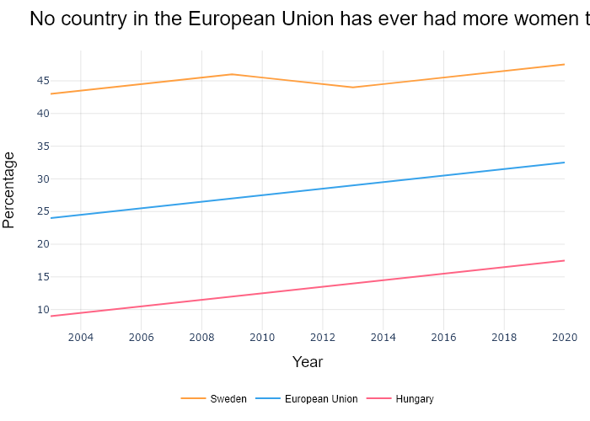

## Performance Metrics

|  |  |  |  |
| --- | --- | --- | --- |
| Task | Model Used | Description | Time Taken (s) |
| Processing Image to JSON | Gemini Vision Pro (default) | Time taken to convert the uploaded image to JSON format | 36.61 |
| Updating JSON | ChatGPT 3.5 (Default) | Time taken to update the JSON with new data | 0.00 |
| Plotting Updated JSON | N/A | Time taken to plot the updated JSON | 0.25 |

# Test Run

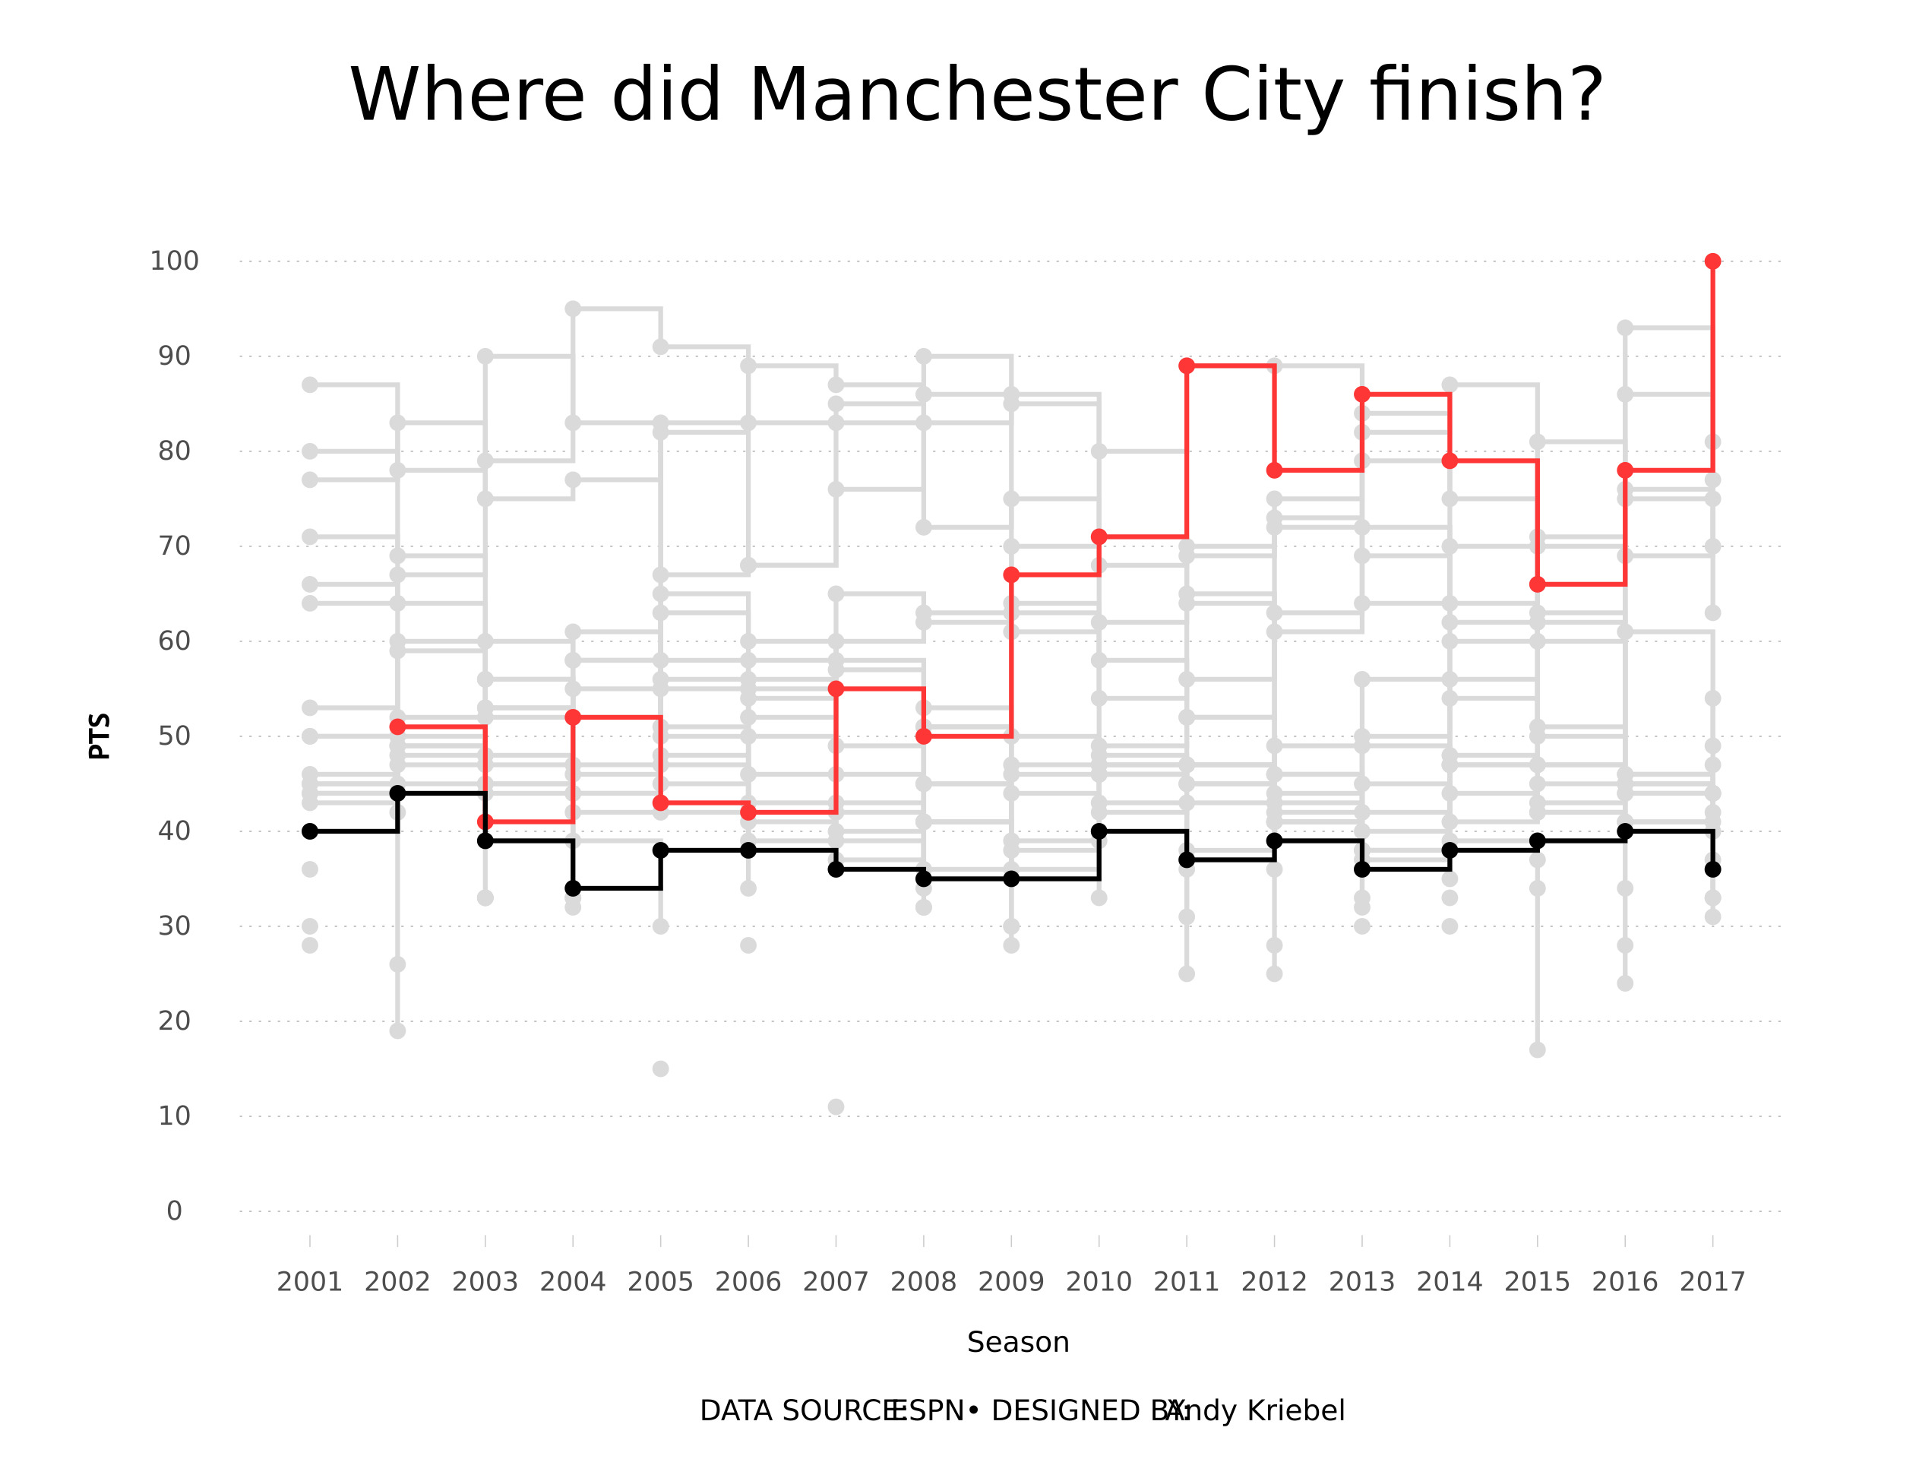

Figure: Charts\Data over time (temporal)\jpg\step_line_chart.jpg

## Prompt Used

## Task: Extract Detailed Information from a Given Graph Image  
  
You will analyze a graph image and generate corresponding Plotly-compatible JSON files (`data.json`, `layout.json`, and `config.json`). Follow the structured steps and specific XML-like delimiters for each JSON section as outlined below.  
  
### Instructions:  
  
#### Graph Analysis:  
  
1. **Identify and Categorize Plot Types**:  
 - Recognize and categorize the plot types present in the graph image. Include both simple and complex plots, listed below:  
 - **Comparison Charts**:  
 - `bar`: Bar Chart  
 - `bar` (with vertical bars): Column Chart  
 - `bar` (grouped): Grouped Bar/Column Chart  
 - `scatter` (with lines connecting to points): Lollipop Chart  
 - `indicator` (with gauge): Bullet Chart  
 - `scatter`: Dot Plot  
 - `scatter` (with lines connecting different points): Dumbbell Chart  
 - `scatter` (or custom SVG): Pictogram  
 - `scatter` or `bar` with a range: Range Chart  
 - `barpolar`: Radial Bar Chart  
 - `parcoords`: Parallel Coordinates  
 - `scatterpolar`: Radar Chart  
 - `barpolar` (with segments): Nightingale Chart  
 - `waterfall`: Waterfall Chart  
 - `heatmap` (with color scale): Matrix Chart  
 - `various charts in small multiples`: Small Multiples  
 - `text` (frequency-based size): Word Cloud  
 - `scatter` (with lines indicating change): Slope Chart  
 - `table`: Table Chart  
 - `scatter`: Categorical Scatter Plot  
 - `scatter` (with four quadrants): Quadrant Chart  
 - **Correlation Charts**:  
 - `heatmap`: Heatmap  
 - `scatter` (with size): Bubble Chart  
 - `scatter`: Scatter Plot  
 - `scatter` (with lines connecting points): Connected Scatter Plot  
 - `hexbin`: Hexagonal Binning  
 - `contour`: Contour Plot  
 - **Part-to-Whole & Hierarchical Charts**:  
 - `bar` (stacked): Stacked Bar/Column Chart  
 - `bar` (with diverging sections): Diverging Bar Chart  
 - `bar` (mirrored pairs): Population Pyramid  
 - `scatter` (or custom symbols in a grid): Icon Array  
 - `waffle`: Waffle Chart  
 - `pie`: Pie Chart  
 - `pie` (with hole): Donut Chart  
 - `pie` (half-circle): Semi-circle Donut Chart  
 - `bar` (variable width): Marimekko Chart  
 - `treemap`: Treemap  
 - `treemap` (circular): Circular Treemap  
 - `treemap` (convex shape): Convex Treemap  
 - `sunburst`: Sunburst Chart  
 - `funnel` or `pyramid`: Funnel & Pyramid Chart  
 - `dendrogram`: Dendrogram  
 - `venn`: Venn Diagram  
 - `euler`: Euler Diagram  
 - `indicator` (circular gauge): Circular Gauge  
 - **Data Over Time (Temporal) Charts**:  
 - `scatter` (filled area under curve): Area Chart  
 - `scatter` (filled stacked areas): Stacked Area Chart  
 - `scatter` (smoothed filled areas): Stream Graph  
 - `scatter` (indicating ranking change): Bump Chart  
 - `scatter` (with filled area): Bump Area Chart  
 - `scatter`: Line Chart  
 - `scatter` (with smoothed lines): Spline Chart  
 - `scatter` (with stepped lines): Step Line Chart  
 - `candlestick`: Candlestick Chart  
 - `gantt`: Gantt Chart  
 - `scatter` (encoded lines): Barcode Chart  
 - `ohlc`: OHLC Chart  
 - **Distribution Charts**:  
 - `densitymapbox` or `histogram`: Density Plot  
 - `ridge`: Ridgeline Plot  
 - `horizon`: Horizon Chart  
 - `histogram`: Histogram  
 - `radial_histogram`: Radial Histogram  
 - `scatter` (with distribution): Strip Plot  
 - `scatter` (with jitter): Jitter Plot  
 - `heatmap`: One-dimensional Heatmap  
 - `scatter` (with tightly packed points): Beeswarm Chart  
 - `box`: Box Chart  
 - `violin`: Violin Plot  
 - **Geospatial & Other Charts**:  
 - `densitymapbox`: Geographic Heatmap  
 - `choropleth`: Choropleth Map  
 - `scattermapbox`: Tile Map  
 - `chord`: Chord Diagram  
 - `arc`: Arc Diagram  
 - `sankey`: Sankey  
 - `network`: Network Diagram  
 - `flowchart`: Flowchart  
  
2. **Extract Data Points** for Each Plot Type:  
 - Gather the data points for each identified plot type.  
 - For `scatter`, `line`, and `area` plots: Extract `x` and `y` values.  
 - For `bar` and `stacked bar` plots: Extract `x` (categories) and `y` values.  
 - For `pie` charts: Extract `labels` and `values`.  
 - For `scatter3d`, `surface`, and other 3D plots: Extract `x`, `y`, and `z` values.  
  
3. **Identify Multiple Plots** on the Same Figure:  
 - Note any combinations or overlays of multiple plot types on the same figure and their configurations, such as stacked plots or multiple area fills.  
  
#### Generate JSON and CSV Outputs:  
  
Follow the JSON formatting guidelines and wrap each section in the specified XML-like tags.  
  
1. **Generate `data.json`**:  
 - Include detailed information for each plot type:  
 - `type`: Specify the plot type (e.g., `"scatter"`, `"bar"`, `"pie"`, `"area"`, `"scatter3d"`, `"surface"`).  
 - For area charts, use `"type": "scatter"` and specify `"fill"`.  
 - `x`, `y`, and `z` (if applicable): Arrays of data points for each axis.  
 - `labels` and `values` for pie charts.  
 - `mode`: Specify for line and scatter plots (e.g., `"markers"`, `"lines"`, `"markers+lines"`).  
 - `name`: Legend entry for the plot.  
 - `marker`: Properties such as color, size, and symbol.  
 - `line`: Properties such as color, width, and dash style.  
 - `text`: Hover text for each data point.  
 - `hoverinfo`: Information displayed on hover (e.g., `"x+y+text"`).  
 - `fill`: For area charts, specify the fill (e.g., `"tozeroy"`, `"tonexty"`).  
 - `fillcolor`: The color used to fill the area.  
 - `stackgroup`: For stacked bar charts, specify the stacking group.  
  
2. **Generate `layout.json`**:  
 - Define the layout properties:  
 - `title`: Text and font properties for the graph title.  
 - `xaxis` and `yaxis`: Configuration for axis titles, ranges, grids, and ticks.  
 - `zaxis`: Configuration for 3D plots including title, range, and grid.  
 - `legend`: Properties for legend orientation and positioning.  
 - `margin`: Margins for left, right, bottom, top, and padding.  
 - `plot_bgcolor` and `paper_bgcolor`: Background colors.  
 - `scene`: Configuration for 3D scenes, including camera angles and aspect ratio.  
  
3. **Generate `config.json`**:  
 - Include settings such as:  
 - `responsive`: Whether the graph is responsive.  
 - `displayModeBar`: Whether the mode bar is shown.  
 - `modeBarButtonsToRemove`: List of mode bar buttons to remove.  
 - `scrollZoom`: Whether scrolling zoom is enabled.  
  
4. **Generate `<csv>`**:  
 - Format the CSV data as follows:  
 ```csv  
 x,y  
 1,4  
 2,5  
 3,6  
 ```  
 - Replace `x`, `y`, `1`, `4`, `2`, `5`, and `3`, `6` with the actual data from the graph image.  
  
### Output Format:  
  
Wrap each JSON output in the specified XML-like tags:  
  
- `<data> ... </data>`  
- `<layout> ... </layout>`  
- `<config> ... </config>`  
- `<csv> ... </csv>`  
  
Ensure the JSON format follows these rules:  
- Use double quotes for all keys and string values.  
- Do not include trailing commas in arrays or objects.  
  
### Example Output:  
  
```xml  
<data>  
[  
 {  
 "type": "scatter",  
 "x": [1, 2, 3],  
 "y": [4, 5, 6],  
 "mode": "markers+lines",  
 "name": "Line Plot",  
 "marker": {  
 "color": "rgba(75, 192, 192, 0.6)",  
 "size": 8  
 },  
 "line": {  
 "color": "rgba(75, 192, 192  
  
, 1)",  
 "width": 2  
 }  
 },  
 {  
 "type": "area",  
 "x": [1, 2, 3, 4, 5, 6, 7, 8, 9, 10, 11, 12],  
 "y": [400, 430, 550, 620, 580, 600, 630, 700, 670, 630, 600, 500],  
 "name": "Housing",  
 "marker": {  
 "color": "rgba(255, 159, 64, 0.8)"  
 },  
 "line": {  
 "color": "rgba(255, 159, 64, 1)",  
 "width": 2  
 }  
 },  
 {  
 "type": "bar",  
 "x": ["A", "B", "C"],  
 "y": [10, 15, 13],  
 "name": "Bar Chart",  
 "marker": {  
 "color": "rgba(255, 99, 132, 0.6)"  
 },  
 "hoverinfo": "x+y+text"  
 },  
 {  
 "type": "scatter",  
 "x": [1, 2, 3],  
 "y": [6, 7, 8],  
 "mode": "lines",  
 "fill": "tozeroy",  
 "name": "Area Chart",  
 "line": {  
 "color": "rgba(54, 162, 235, 1)",  
 "width": 2  
 },  
 "fillcolor": "rgba(54, 162, 235, 0.5)"  
 },  
 {  
 "type": "scatter3d",  
 "x": [1, 2, 3],  
 "y": [4, 5, 6],  
 "z": [7, 8, 9],  
 "mode": "markers",  
 "name": "3D Scatter Plot",  
 "marker": {  
 "color": "rgba(255, 159, 64, 0.8)",  
 "size": 5  
 },  
 "hoverinfo": "x+y+z+text"  
 },  
 {  
 "type": "surface",  
 "z": [  
 [10, 10.625, 12.5, 15.625, 20],  
 [5.625, 6.25, 8.125, 11.25, 15.625],  
 [0, 1.25, 3.125, 6.25, 10.625]  
 ],  
 "name": "Surface Plot",  
 "colorscale": "Viridis",  
 "hoverinfo": "z+name"  
 }  
]  
</data>  
<layout>  
{  
 "title": {  
 "text": "Complex Graph Example",  
 "font": {  
 "family": "Arial, sans-serif",  
 "size": 24,  
 "color": "#000000"  
 }  
 },  
 "xaxis": {  
 "title": {  
 "text": "X Axis",  
 "font": {  
 "family": "Arial, sans-serif",  
 "size": 18,  
 "color": "#000000"  
 }  
 },  
 "showgrid": true,  
 "gridcolor": "rgba(0, 0, 0, 0.1)",  
 "zeroline": true,  
 "zerolinecolor": "rgba(0, 0, 0, 0.1)"  
 },  
 "yaxis": {  
 "title": {  
 "text": "Y Axis",  
 "font": {  
 "family": "Arial, sans-serif",  
 "size": 18,  
 "color": "#000000"  
 }  
 },  
 "showgrid": true,  
 "gridcolor": "rgba(0, 0, 0, 0.1)",  
 "zeroline": true,  
 "zerolinecolor": "rgba(0, 0, 0, 0.1)"  
 },  
 "legend": {  
 "orientation": "h",  
 "x": 0.5,  
 "xanchor": "center",  
 "y": -0.2,  
 "font": {  
 "family": "Arial, sans-serif",  
 "size": 12,  
 "color": "#000000"  
 }  
 },  
 "margin": {  
 "l": 60,  
 "r": 30,  
 "b": 60,  
 "t": 60  
 },  
 "plot_bgcolor": "#ffffff",  
 "paper_bgcolor": "#ffffff",  
 "scene": {  
 "xaxis": {"title": "X Axis"},  
 "yaxis": {"title": "Y Axis"},  
 "zaxis": {"title": "Z Axis"}  
 }  
}  
</layout>  
<config>  
{  
 "responsive": true,  
 "displayModeBar": true,  
 "modeBarButtonsToRemove": ["toImage"],  
 "scrollZoom": true  
}  
</config>  
<csv>  
x,y  
1,4  
2,5  
3,6  
</csv>  
```

## Extracted JSON

### data

[  
 {  
 "type": "scatter",  
 "x": [  
 2001,  
 2002,  
 2003,  
 2004,  
 2005,  
 2006,  
 2007,  
 2008,  
 2009,  
 2010,  
 2011,  
 2012,  
 2013,  
 2014,  
 2015,  
 2016,  
 2017  
 ],  
 "y": [  
 47,  
 47,  
 47,  
 47,  
 47,  
 47,  
 47,  
 55,  
 60,  
 72,  
 72,  
 72,  
 72,  
 72,  
 64,  
 64,  
 100  
 ],  
 "mode": "lines+markers",  
 "name": "Manchester City",  
 "marker": {  
 "color": "rgba(255, 0, 0, 0.8)",  
 "size": 8  
 },  
 "line": {  
 "color": "rgba(255, 0, 0, 1)",  
 "width": 2  
 }  
 }  
]

### layout

{  
 "title": {  
 "text": "Where did Manchester City finish?",  
 "font": {  
 "family": "Arial, sans-serif",  
 "size": 24,  
 "color": "#000000"  
 }  
 },  
 "xaxis": {  
 "title": {  
 "text": "Season",  
 "font": {  
 "family": "Arial, sans-serif",  
 "size": 18,  
 "color": "#000000"  
 }  
 },  
 "showgrid": true,  
 "gridcolor": "rgba(0, 0, 0, 0.1)",  
 "zeroline": true,  
 "zerolinecolor": "rgba(0, 0, 0, 0.1)"  
 },  
 "yaxis": {  
 "title": {  
 "text": "Pts",  
 "font": {  
 "family": "Arial, sans-serif",  
 "size": 18,  
 "color": "#000000"  
 }  
 },  
 "showgrid": true,  
 "gridcolor": "rgba(0, 0, 0, 0.1)",  
 "zeroline": true,  
 "zerolinecolor": "rgba(0, 0, 0, 0.1)"  
 },  
 "legend": {  
 "orientation": "h",  
 "x": 0.5,  
 "xanchor": "center",  
 "y": -0.2,  
 "font": {  
 "family": "Arial, sans-serif",  
 "size": 12,  
 "color": "#000000"  
 }  
 },  
 "margin": {  
 "l": 60,  
 "r": 30,  
 "b": 60,  
 "t": 60  
 },  
 "plot_bgcolor": "#ffffff",  
 "paper_bgcolor": "#ffffff"  
}

### config

{  
 "responsive": true,  
 "displayModeBar": true,  
 "modeBarButtonsToRemove": [  
 "toImage"  
 ],  
 "scrollZoom": true  
}

## Updated JSON

### updated_data

[  
 {  
 "type": "scatter",  
 "x": [  
 2001,  
 2002,  
 2003,  
 2004,  
 2005,  
 2006,  
 2007,  
 2008,  
 2009,  
 2010,  
 2011,  
 2012,  
 2013,  
 2014,  
 2015,  
 2016,  
 2017  
 ],  
 "y": [  
 47,  
 47,  
 47,  
 47,  
 47,  
 47,  
 47,  
 55,  
 60,  
 72,  
 72,  
 72,  
 72,  
 72,  
 64,  
 64,  
 100  
 ],  
 "mode": "lines+markers",  
 "name": "Manchester City",  
 "marker": {  
 "color": "rgba(255, 0, 0, 0.8)",  
 "size": 8  
 },  
 "line": {  
 "color": "rgba(255, 0, 0, 1)",  
 "width": 2  
 }  
 }  
]

### updated_layout

{  
 "title": {  
 "text": "Where did Manchester City finish?",  
 "font": {  
 "family": "Arial, sans-serif",  
 "size": 24,  
 "color": "#000000"  
 }  
 },  
 "xaxis": {  
 "title": {  
 "text": "Season",  
 "font": {  
 "family": "Arial, sans-serif",  
 "size": 18,  
 "color": "#000000"  
 }  
 },  
 "showgrid": true,  
 "gridcolor": "rgba(0, 0, 0, 0.1)",  
 "zeroline": true,  
 "zerolinecolor": "rgba(0, 0, 0, 0.1)"  
 },  
 "yaxis": {  
 "title": {  
 "text": "Pts",  
 "font": {  
 "family": "Arial, sans-serif",  
 "size": 18,  
 "color": "#000000"  
 }  
 },  
 "showgrid": true,  
 "gridcolor": "rgba(0, 0, 0, 0.1)",  
 "zeroline": true,  
 "zerolinecolor": "rgba(0, 0, 0, 0.1)"  
 },  
 "legend": {  
 "orientation": "h",  
 "x": 0.5,  
 "xanchor": "center",  
 "y": -0.2,  
 "font": {  
 "family": "Arial, sans-serif",  
 "size": 12,  
 "color": "#000000"  
 }  
 },  
 "margin": {  
 "l": 60,  
 "r": 30,  
 "b": 60,  
 "t": 60  
 },  
 "plot_bgcolor": "#ffffff",  
 "paper_bgcolor": "#ffffff"  
}

### updated_config

{  
 "responsive": true,  
 "displayModeBar": true,  
 "modeBarButtonsToRemove": [  
 "toImage"  
 ],  
 "scrollZoom": true  
}

## Updated Chart

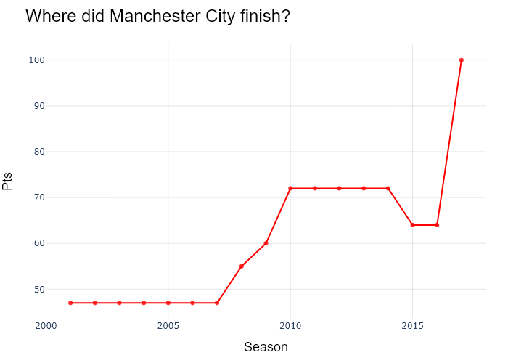

## Performance Metrics

|  |  |  |  |
| --- | --- | --- | --- |
| Task | Model Used | Description | Time Taken (s) |
| Processing Image to JSON | Gemini Vision Pro (default) | Time taken to convert the uploaded image to JSON format | 21.54 |
| Updating JSON | ChatGPT 3.5 (Default) | Time taken to update the JSON with new data | 0.00 |
| Plotting Updated JSON | N/A | Time taken to plot the updated JSON | 0.18 |

# Test Run

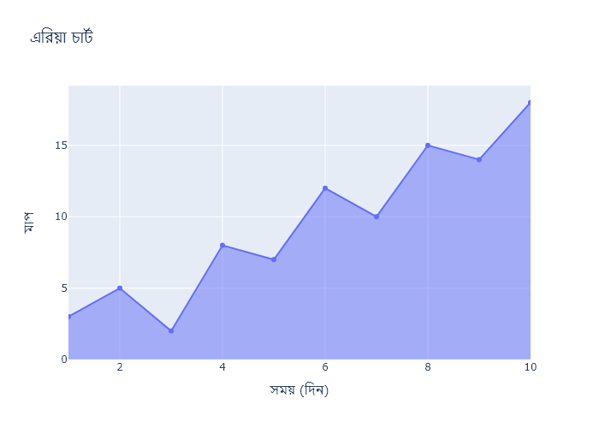

Figure: Charts\multilingual/area_chart_bengali.png

## Prompt Used

## Task: Extract Detailed Information from a Given Graph Image  
  
You will analyze a graph image and generate corresponding Plotly-compatible JSON files (`data.json`, `layout.json`, and `config.json`). Follow the structured steps and specific XML-like delimiters for each JSON section as outlined below.  
  
### Instructions:  
  
#### Graph Analysis:  
  
1. **Identify and Categorize Plot Types**:  
 - Recognize and categorize the plot types present in the graph image. Include both simple and complex plots, listed below:  
 - **Comparison Charts**:  
 - `bar`: Bar Chart  
 - `bar` (with vertical bars): Column Chart  
 - `bar` (grouped): Grouped Bar/Column Chart  
 - `scatter` (with lines connecting to points): Lollipop Chart  
 - `indicator` (with gauge): Bullet Chart  
 - `scatter`: Dot Plot  
 - `scatter` (with lines connecting different points): Dumbbell Chart  
 - `scatter` (or custom SVG): Pictogram  
 - `scatter` or `bar` with a range: Range Chart  
 - `barpolar`: Radial Bar Chart  
 - `parcoords`: Parallel Coordinates  
 - `scatterpolar`: Radar Chart  
 - `barpolar` (with segments): Nightingale Chart  
 - `waterfall`: Waterfall Chart  
 - `heatmap` (with color scale): Matrix Chart  
 - `various charts in small multiples`: Small Multiples  
 - `text` (frequency-based size): Word Cloud  
 - `scatter` (with lines indicating change): Slope Chart  
 - `table`: Table Chart  
 - `scatter`: Categorical Scatter Plot  
 - `scatter` (with four quadrants): Quadrant Chart  
 - **Correlation Charts**:  
 - `heatmap`: Heatmap  
 - `scatter` (with size): Bubble Chart  
 - `scatter`: Scatter Plot  
 - `scatter` (with lines connecting points): Connected Scatter Plot  
 - `hexbin`: Hexagonal Binning  
 - `contour`: Contour Plot  
 - **Part-to-Whole & Hierarchical Charts**:  
 - `bar` (stacked): Stacked Bar/Column Chart  
 - `bar` (with diverging sections): Diverging Bar Chart  
 - `bar` (mirrored pairs): Population Pyramid  
 - `scatter` (or custom symbols in a grid): Icon Array  
 - `waffle`: Waffle Chart  
 - `pie`: Pie Chart  
 - `pie` (with hole): Donut Chart  
 - `pie` (half-circle): Semi-circle Donut Chart  
 - `bar` (variable width): Marimekko Chart  
 - `treemap`: Treemap  
 - `treemap` (circular): Circular Treemap  
 - `treemap` (convex shape): Convex Treemap  
 - `sunburst`: Sunburst Chart  
 - `funnel` or `pyramid`: Funnel & Pyramid Chart  
 - `dendrogram`: Dendrogram  
 - `venn`: Venn Diagram  
 - `euler`: Euler Diagram  
 - `indicator` (circular gauge): Circular Gauge  
 - **Data Over Time (Temporal) Charts**:  
 - `scatter` (filled area under curve): Area Chart  
 - `scatter` (filled stacked areas): Stacked Area Chart  
 - `scatter` (smoothed filled areas): Stream Graph  
 - `scatter` (indicating ranking change): Bump Chart  
 - `scatter` (with filled area): Bump Area Chart  
 - `scatter`: Line Chart  
 - `scatter` (with smoothed lines): Spline Chart  
 - `scatter` (with stepped lines): Step Line Chart  
 - `candlestick`: Candlestick Chart  
 - `gantt`: Gantt Chart  
 - `scatter` (encoded lines): Barcode Chart  
 - `ohlc`: OHLC Chart  
 - **Distribution Charts**:  
 - `densitymapbox` or `histogram`: Density Plot  
 - `ridge`: Ridgeline Plot  
 - `horizon`: Horizon Chart  
 - `histogram`: Histogram  
 - `radial_histogram`: Radial Histogram  
 - `scatter` (with distribution): Strip Plot  
 - `scatter` (with jitter): Jitter Plot  
 - `heatmap`: One-dimensional Heatmap  
 - `scatter` (with tightly packed points): Beeswarm Chart  
 - `box`: Box Chart  
 - `violin`: Violin Plot  
 - **Geospatial & Other Charts**:  
 - `densitymapbox`: Geographic Heatmap  
 - `choropleth`: Choropleth Map  
 - `scattermapbox`: Tile Map  
 - `chord`: Chord Diagram  
 - `arc`: Arc Diagram  
 - `sankey`: Sankey  
 - `network`: Network Diagram  
 - `flowchart`: Flowchart  
  
2. **Extract Data Points** for Each Plot Type:  
 - Gather the data points for each identified plot type.  
 - For `scatter`, `line`, and `area` plots: Extract `x` and `y` values.  
 - For `bar` and `stacked bar` plots: Extract `x` (categories) and `y` values.  
 - For `pie` charts: Extract `labels` and `values`.  
 - For `scatter3d`, `surface`, and other 3D plots: Extract `x`, `y`, and `z` values.  
  
3. **Identify Multiple Plots** on the Same Figure:  
 - Note any combinations or overlays of multiple plot types on the same figure and their configurations, such as stacked plots or multiple area fills.  
  
#### Generate JSON and CSV Outputs:  
  
Follow the JSON formatting guidelines and wrap each section in the specified XML-like tags.  
  
1. **Generate `data.json`**:  
 - Include detailed information for each plot type:  
 - `type`: Specify the plot type (e.g., `"scatter"`, `"bar"`, `"pie"`, `"area"`, `"scatter3d"`, `"surface"`).  
 - For area charts, use `"type": "scatter"` and specify `"fill"`.  
 - `x`, `y`, and `z` (if applicable): Arrays of data points for each axis.  
 - `labels` and `values` for pie charts.  
 - `mode`: Specify for line and scatter plots (e.g., `"markers"`, `"lines"`, `"markers+lines"`).  
 - `name`: Legend entry for the plot.  
 - `marker`: Properties such as color, size, and symbol.  
 - `line`: Properties such as color, width, and dash style.  
 - `text`: Hover text for each data point.  
 - `hoverinfo`: Information displayed on hover (e.g., `"x+y+text"`).  
 - `fill`: For area charts, specify the fill (e.g., `"tozeroy"`, `"tonexty"`).  
 - `fillcolor`: The color used to fill the area.  
 - `stackgroup`: For stacked bar charts, specify the stacking group.  
  
2. **Generate `layout.json`**:  
 - Define the layout properties:  
 - `title`: Text and font properties for the graph title.  
 - `xaxis` and `yaxis`: Configuration for axis titles, ranges, grids, and ticks.  
 - `zaxis`: Configuration for 3D plots including title, range, and grid.  
 - `legend`: Properties for legend orientation and positioning.  
 - `margin`: Margins for left, right, bottom, top, and padding.  
 - `plot_bgcolor` and `paper_bgcolor`: Background colors.  
 - `scene`: Configuration for 3D scenes, including camera angles and aspect ratio.  
  
3. **Generate `config.json`**:  
 - Include settings such as:  
 - `responsive`: Whether the graph is responsive.  
 - `displayModeBar`: Whether the mode bar is shown.  
 - `modeBarButtonsToRemove`: List of mode bar buttons to remove.  
 - `scrollZoom`: Whether scrolling zoom is enabled.  
  
4. **Generate `<csv>`**:  
 - Format the CSV data as follows:  
 ```csv  
 x,y  
 1,4  
 2,5  
 3,6  
 ```  
 - Replace `x`, `y`, `1`, `4`, `2`, `5`, and `3`, `6` with the actual data from the graph image.  
  
### Output Format:  
  
Wrap each JSON output in the specified XML-like tags:  
  
- `<data> ... </data>`  
- `<layout> ... </layout>`  
- `<config> ... </config>`  
- `<csv> ... </csv>`  
  
Ensure the JSON format follows these rules:  
- Use double quotes for all keys and string values.  
- Do not include trailing commas in arrays or objects.  
  
### Example Output:  
  
```xml  
<data>  
[  
 {  
 "type": "scatter",  
 "x": [1, 2, 3],  
 "y": [4, 5, 6],  
 "mode": "markers+lines",  
 "name": "Line Plot",  
 "marker": {  
 "color": "rgba(75, 192, 192, 0.6)",  
 "size": 8  
 },  
 "line": {  
 "color": "rgba(75, 192, 192  
  
, 1)",  
 "width": 2  
 }  
 },  
 {  
 "type": "area",  
 "x": [1, 2, 3, 4, 5, 6, 7, 8, 9, 10, 11, 12],  
 "y": [400, 430, 550, 620, 580, 600, 630, 700, 670, 630, 600, 500],  
 "name": "Housing",  
 "marker": {  
 "color": "rgba(255, 159, 64, 0.8)"  
 },  
 "line": {  
 "color": "rgba(255, 159, 64, 1)",  
 "width": 2  
 }  
 },  
 {  
 "type": "bar",  
 "x": ["A", "B", "C"],  
 "y": [10, 15, 13],  
 "name": "Bar Chart",  
 "marker": {  
 "color": "rgba(255, 99, 132, 0.6)"  
 },  
 "hoverinfo": "x+y+text"  
 },  
 {  
 "type": "scatter",  
 "x": [1, 2, 3],  
 "y": [6, 7, 8],  
 "mode": "lines",  
 "fill": "tozeroy",  
 "name": "Area Chart",  
 "line": {  
 "color": "rgba(54, 162, 235, 1)",  
 "width": 2  
 },  
 "fillcolor": "rgba(54, 162, 235, 0.5)"  
 },  
 {  
 "type": "scatter3d",  
 "x": [1, 2, 3],  
 "y": [4, 5, 6],  
 "z": [7, 8, 9],  
 "mode": "markers",  
 "name": "3D Scatter Plot",  
 "marker": {  
 "color": "rgba(255, 159, 64, 0.8)",  
 "size": 5  
 },  
 "hoverinfo": "x+y+z+text"  
 },  
 {  
 "type": "surface",  
 "z": [  
 [10, 10.625, 12.5, 15.625, 20],  
 [5.625, 6.25, 8.125, 11.25, 15.625],  
 [0, 1.25, 3.125, 6.25, 10.625]  
 ],  
 "name": "Surface Plot",  
 "colorscale": "Viridis",  
 "hoverinfo": "z+name"  
 }  
]  
</data>  
<layout>  
{  
 "title": {  
 "text": "Complex Graph Example",  
 "font": {  
 "family": "Arial, sans-serif",  
 "size": 24,  
 "color": "#000000"  
 }  
 },  
 "xaxis": {  
 "title": {  
 "text": "X Axis",  
 "font": {  
 "family": "Arial, sans-serif",  
 "size": 18,  
 "color": "#000000"  
 }  
 },  
 "showgrid": true,  
 "gridcolor": "rgba(0, 0, 0, 0.1)",  
 "zeroline": true,  
 "zerolinecolor": "rgba(0, 0, 0, 0.1)"  
 },  
 "yaxis": {  
 "title": {  
 "text": "Y Axis",  
 "font": {  
 "family": "Arial, sans-serif",  
 "size": 18,  
 "color": "#000000"  
 }  
 },  
 "showgrid": true,  
 "gridcolor": "rgba(0, 0, 0, 0.1)",  
 "zeroline": true,  
 "zerolinecolor": "rgba(0, 0, 0, 0.1)"  
 },  
 "legend": {  
 "orientation": "h",  
 "x": 0.5,  
 "xanchor": "center",  
 "y": -0.2,  
 "font": {  
 "family": "Arial, sans-serif",  
 "size": 12,  
 "color": "#000000"  
 }  
 },  
 "margin": {  
 "l": 60,  
 "r": 30,  
 "b": 60,  
 "t": 60  
 },  
 "plot_bgcolor": "#ffffff",  
 "paper_bgcolor": "#ffffff",  
 "scene": {  
 "xaxis": {"title": "X Axis"},  
 "yaxis": {"title": "Y Axis"},  
 "zaxis": {"title": "Z Axis"}  
 }  
}  
</layout>  
<config>  
{  
 "responsive": true,  
 "displayModeBar": true,  
 "modeBarButtonsToRemove": ["toImage"],  
 "scrollZoom": true  
}  
</config>  
<csv>  
x,y  
1,4  
2,5  
3,6  
</csv>  
```

## Extracted JSON

### data

[  
 {  
 "type": "scatter",  
 "x": [  
 1,  
 2,  
 3,  
 4,  
 5,  
 6,  
 7,  
 8,  
 9,  
 10  
 ],  
 "y": [  
 3,  
 4,  
 5,  
 6,  
 7,  
 8,  
 9,  
 10,  
 11,  
 12  
 ],  
 "mode": "lines",  
 "name": "Line Chart",  
 "line": {  
 "color": "rgba(75, 192, 192, 1)",  
 "width": 2  
 }  
 }  
]

### layout

{  
 "title": {  
 "text": "Line Chart",  
 "font": {  
 "family": "Arial, sans-serif",  
 "size": 24,  
 "color": "#000000"  
 }  
 },  
 "xaxis": {  
 "title": {  
 "text": "X Axis",  
 "font": {  
 "family": "Arial, sans-serif",  
 "size": 18,  
 "color": "#000000"  
 }  
 },  
 "showgrid": true,  
 "gridcolor": "rgba(0, 0, 0, 0.1)",  
 "zeroline": true,  
 "zerolinecolor": "rgba(0, 0, 0, 0.1)"  
 },  
 "yaxis": {  
 "title": {  
 "text": "Y Axis",  
 "font": {  
 "family": "Arial, sans-serif",  
 "size": 18,  
 "color": "#000000"  
 }  
 },  
 "showgrid": true,  
 "gridcolor": "rgba(0, 0, 0, 0.1)",  
 "zeroline": true,  
 "zerolinecolor": "rgba(0, 0, 0, 0.1)"  
 },  
 "legend": {  
 "orientation": "h",  
 "x": 0.5,  
 "xanchor": "center",  
 "y": -0.2,  
 "font": {  
 "family": "Arial, sans-serif",  
 "size": 12,  
 "color": "#000000"  
 }  
 },  
 "margin": {  
 "l": 60,  
 "r": 30,  
 "b": 60,  
 "t": 60  
 },  
 "plot_bgcolor": "#ffffff",  
 "paper_bgcolor": "#ffffff"  
}

### config

{  
 "responsive": true,  
 "displayModeBar": true,  
 "modeBarButtonsToRemove": [  
 "toImage"  
 ],  
 "scrollZoom": true  
}

## Updated JSON

### updated_data

[  
 {  
 "type": "scatter",  
 "x": [  
 1,  
 2,  
 3,  
 4,  
 5,  
 6,  
 7,  
 8,  
 9,  
 10  
 ],  
 "y": [  
 3,  
 4,  
 5,  
 6,  
 7,  
 8,  
 9,  
 10,  
 11,  
 12  
 ],  
 "mode": "lines",  
 "name": "Line Chart",  
 "line": {  
 "color": "rgba(75, 192, 192, 1)",  
 "width": 2  
 }  
 }  
]

### updated_layout

{  
 "title": {  
 "text": "Line Chart",  
 "font": {  
 "family": "Arial, sans-serif",  
 "size": 24,  
 "color": "#000000"  
 }  
 },  
 "xaxis": {  
 "title": {  
 "text": "X Axis",  
 "font": {  
 "family": "Arial, sans-serif",  
 "size": 18,  
 "color": "#000000"  
 }  
 },  
 "showgrid": true,  
 "gridcolor": "rgba(0, 0, 0, 0.1)",  
 "zeroline": true,  
 "zerolinecolor": "rgba(0, 0, 0, 0.1)"  
 },  
 "yaxis": {  
 "title": {  
 "text": "Y Axis",  
 "font": {  
 "family": "Arial, sans-serif",  
 "size": 18,  
 "color": "#000000"  
 }  
 },  
 "showgrid": true,  
 "gridcolor": "rgba(0, 0, 0, 0.1)",  
 "zeroline": true,  
 "zerolinecolor": "rgba(0, 0, 0, 0.1)"  
 },  
 "legend": {  
 "orientation": "h",  
 "x": 0.5,  
 "xanchor": "center",  
 "y": -0.2,  
 "font": {  
 "family": "Arial, sans-serif",  
 "size": 12,  
 "color": "#000000"  
 }  
 },  
 "margin": {  
 "l": 60,  
 "r": 30,  
 "b": 60,  
 "t": 60  
 },  
 "plot_bgcolor": "#ffffff",  
 "paper_bgcolor": "#ffffff"  
}

### updated_config

{  
 "responsive": true,  
 "displayModeBar": true,  
 "modeBarButtonsToRemove": [  
 "toImage"  
 ],  
 "scrollZoom": true  
}

## Updated Chart

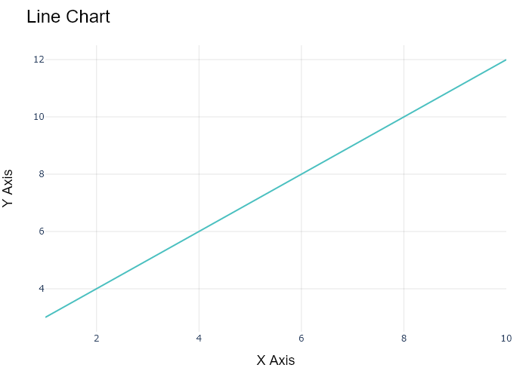

## Performance Metrics

|  |  |  |  |
| --- | --- | --- | --- |
| Task | Model Used | Description | Time Taken (s) |
| Processing Image to JSON | Gemini Vision Pro (default) | Time taken to convert the uploaded image to JSON format | 18.00 |
| Updating JSON | ChatGPT 3.5 (Default) | Time taken to update the JSON with new data | 0.00 |
| Plotting Updated JSON | N/A | Time taken to plot the updated JSON | 9.16 |

# Test Run



Figure: Charts\multilingual/area_chart_bengali.png

## Prompt Used

## Task: Extract Detailed Information from a Given Graph Image. Charts are multilingual, you have to extract the same language that is there in the graph.  
  
You will analyze a graph image and generate corresponding Plotly-compatible JSON files (`data.json`, `layout.json`, and `config.json`). Follow the structured steps and specific XML-like delimiters for each JSON section as outlined below.  
  
### Instructions:  
  
#### Graph Analysis:  
  
1. **Identify and Categorize Plot Types**:  
 - Recognize and categorize the plot types present in the graph image. Include both simple and complex plots, listed below:  
 - **Comparison Charts**:  
 - `bar`: Bar Chart  
 - `bar` (with vertical bars): Column Chart  
 - `bar` (grouped): Grouped Bar/Column Chart  
 - `scatter` (with lines connecting to points): Lollipop Chart  
 - `indicator` (with gauge): Bullet Chart  
 - `scatter`: Dot Plot  
 - `scatter` (with lines connecting different points): Dumbbell Chart  
 - `scatter` (or custom SVG): Pictogram  
 - `scatter` or `bar` with a range: Range Chart  
 - `barpolar`: Radial Bar Chart  
 - `parcoords`: Parallel Coordinates  
 - `scatterpolar`: Radar Chart  
 - `barpolar` (with segments): Nightingale Chart  
 - `waterfall`: Waterfall Chart  
 - `heatmap` (with color scale): Matrix Chart  
 - `various charts in small multiples`: Small Multiples  
 - `text` (frequency-based size): Word Cloud  
 - `scatter` (with lines indicating change): Slope Chart  
 - `table`: Table Chart  
 - `scatter`: Categorical Scatter Plot  
 - `scatter` (with four quadrants): Quadrant Chart  
 - **Correlation Charts**:  
 - `heatmap`: Heatmap  
 - `scatter` (with size): Bubble Chart  
 - `scatter`: Scatter Plot  
 - `scatter` (with lines connecting points): Connected Scatter Plot  
 - `hexbin`: Hexagonal Binning  
 - `contour`: Contour Plot  
 - **Part-to-Whole & Hierarchical Charts**:  
 - `bar` (stacked): Stacked Bar/Column Chart  
 - `bar` (with diverging sections): Diverging Bar Chart  
 - `bar` (mirrored pairs): Population Pyramid  
 - `scatter` (or custom symbols in a grid): Icon Array  
 - `waffle`: Waffle Chart  
 - `pie`: Pie Chart  
 - `pie` (with hole): Donut Chart  
 - `pie` (half-circle): Semi-circle Donut Chart  
 - `bar` (variable width): Marimekko Chart  
 - `treemap`: Treemap  
 - `treemap` (circular): Circular Treemap  
 - `treemap` (convex shape): Convex Treemap  
 - `sunburst`: Sunburst Chart  
 - `funnel` or `pyramid`: Funnel & Pyramid Chart  
 - `dendrogram`: Dendrogram  
 - `venn`: Venn Diagram  
 - `euler`: Euler Diagram  
 - `indicator` (circular gauge): Circular Gauge  
 - **Data Over Time (Temporal) Charts**:  
 - `scatter` (filled area under curve): Area Chart  
 - `scatter` (filled stacked areas): Stacked Area Chart  
 - `scatter` (smoothed filled areas): Stream Graph  
 - `scatter` (indicating ranking change): Bump Chart  
 - `scatter` (with filled area): Bump Area Chart  
 - `scatter`: Line Chart  
 - `scatter` (with smoothed lines): Spline Chart  
 - `scatter` (with stepped lines): Step Line Chart  
 - `candlestick`: Candlestick Chart  
 - `gantt`: Gantt Chart  
 - `scatter` (encoded lines): Barcode Chart  
 - `ohlc`: OHLC Chart  
 - **Distribution Charts**:  
 - `densitymapbox` or `histogram`: Density Plot  
 - `ridge`: Ridgeline Plot  
 - `horizon`: Horizon Chart  
 - `histogram`: Histogram  
 - `radial_histogram`: Radial Histogram  
 - `scatter` (with distribution): Strip Plot  
 - `scatter` (with jitter): Jitter Plot  
 - `heatmap`: One-dimensional Heatmap  
 - `scatter` (with tightly packed points): Beeswarm Chart  
 - `box`: Box Chart  
 - `violin`: Violin Plot  
 - **Geospatial & Other Charts**:  
 - `densitymapbox`: Geographic Heatmap  
 - `choropleth`: Choropleth Map  
 - `scattermapbox`: Tile Map  
 - `chord`: Chord Diagram  
 - `arc`: Arc Diagram  
 - `sankey`: Sankey  
 - `network`: Network Diagram  
 - `flowchart`: Flowchart  
  
2. **Extract Data Points** for Each Plot Type:  
 - Gather the data points for each identified plot type.  
 - For `scatter`, `line`, and `area` plots: Extract `x` and `y` values.  
 - For `bar` and `stacked bar` plots: Extract `x` (categories) and `y` values.  
 - For `pie` charts: Extract `labels` and `values`.  
 - For `scatter3d`, `surface`, and other 3D plots: Extract `x`, `y`, and `z` values.  
  
3. **Identify Multiple Plots** on the Same Figure:  
 - Note any combinations or overlays of multiple plot types on the same figure and their configurations, such as stacked plots or multiple area fills.  
  
#### Generate JSON and CSV Outputs:  
  
Follow the JSON formatting guidelines and wrap each section in the specified XML-like tags.  
  
1. **Generate `data.json`**:  
 - Include detailed information for each plot type:  
 - `type`: Specify the plot type (e.g., `"scatter"`, `"bar"`, `"pie"`, `"area"`, `"scatter3d"`, `"surface"`).  
 - For area charts, use `"type": "scatter"` and specify `"fill"`.  
 - `x`, `y`, and `z` (if applicable): Arrays of data points for each axis.  
 - `labels` and `values` for pie charts.  
 - `mode`: Specify for line and scatter plots (e.g., `"markers"`, `"lines"`, `"markers+lines"`).  
 - `name`: Legend entry for the plot.  
 - `marker`: Properties such as color, size, and symbol.  
 - `line`: Properties such as color, width, and dash style.  
 - `text`: Hover text for each data point.  
 - `hoverinfo`: Information displayed on hover (e.g., `"x+y+text"`).  
 - `fill`: For area charts, specify the fill (e.g., `"tozeroy"`, `"tonexty"`).  
 - `fillcolor`: The color used to fill the area.  
 - `stackgroup`: For stacked bar charts, specify the stacking group.  
  
2. **Generate `layout.json`**:  
 - Define the layout properties:  
 - `title`: Text and font properties for the graph title.  
 - `xaxis` and `yaxis`: Configuration for axis titles, ranges, grids, and ticks.  
 - `zaxis`: Configuration for 3D plots including title, range, and grid.  
 - `legend`: Properties for legend orientation and positioning.  
 - `margin`: Margins for left, right, bottom, top, and padding.  
 - `plot_bgcolor` and `paper_bgcolor`: Background colors.  
 - `scene`: Configuration for 3D scenes, including camera angles and aspect ratio.  
  
3. **Generate `config.json`**:  
 - Include settings such as:  
 - `responsive`: Whether the graph is responsive.  
 - `displayModeBar`: Whether the mode bar is shown.  
 - `modeBarButtonsToRemove`: List of mode bar buttons to remove.  
 - `scrollZoom`: Whether scrolling zoom is enabled.  
  
4. **Generate `<csv>`**:  
 - Format the CSV data as follows:  
 ```csv  
 x,y  
 1,4  
 2,5  
 3,6  
 ```  
 - Replace `x`, `y`, `1`, `4`, `2`, `5`, and `3`, `6` with the actual data from the graph image.  
  
### Output Format:  
  
Wrap each JSON output in the specified XML-like tags:  
  
- `<data> ... </data>`  
- `<layout> ... </layout>`  
- `<config> ... </config>`  
- `<csv> ... </csv>`  
  
Ensure the JSON format follows these rules:  
- Use double quotes for all keys and string values.  
- Do not include trailing commas in arrays or objects.  
  
### Example Output:  
  
```xml  
<data>  
[  
 {  
 "type": "scatter",  
 "x": [1, 2, 3],  
 "y": [4, 5, 6],  
 "mode": "markers+lines",  
 "name": "Line Plot",  
 "marker": {  
 "color": "rgba(75, 192, 192, 0.6)",  
 "size": 8  
 },  
 "line": {  
 "color": "rgba(75, 192, 192  
  
, 1)",  
 "width": 2  
 }  
 },  
 {  
 "type": "area",  
 "x": [1, 2, 3, 4, 5, 6, 7, 8, 9, 10, 11, 12],  
 "y": [400, 430, 550, 620, 580, 600, 630, 700, 670, 630, 600, 500],  
 "name": "Housing",  
 "marker": {  
 "color": "rgba(255, 159, 64, 0.8)"  
 },  
 "line": {  
 "color": "rgba(255, 159, 64, 1)",  
 "width": 2  
 }  
 },  
 {  
 "type": "bar",  
 "x": ["A", "B", "C"],  
 "y": [10, 15, 13],  
 "name": "Bar Chart",  
 "marker": {  
 "color": "rgba(255, 99, 132, 0.6)"  
 },  
 "hoverinfo": "x+y+text"  
 },  
 {  
 "type": "scatter",  
 "x": [1, 2, 3],  
 "y": [6, 7, 8],  
 "mode": "lines",  
 "fill": "tozeroy",  
 "name": "Area Chart",  
 "line": {  
 "color": "rgba(54, 162, 235, 1)",  
 "width": 2  
 },  
 "fillcolor": "rgba(54, 162, 235, 0.5)"  
 },  
 {  
 "type": "scatter3d",  
 "x": [1, 2, 3],  
 "y": [4, 5, 6],  
 "z": [7, 8, 9],  
 "mode": "markers",  
 "name": "3D Scatter Plot",  
 "marker": {  
 "color": "rgba(255, 159, 64, 0.8)",  
 "size": 5  
 },  
 "hoverinfo": "x+y+z+text"  
 },  
 {  
 "type": "surface",  
 "z": [  
 [10, 10.625, 12.5, 15.625, 20],  
 [5.625, 6.25, 8.125, 11.25, 15.625],  
 [0, 1.25, 3.125, 6.25, 10.625]  
 ],  
 "name": "Surface Plot",  
 "colorscale": "Viridis",  
 "hoverinfo": "z+name"  
 }  
]  
</data>  
<layout>  
{  
 "title": {  
 "text": "Complex Graph Example",  
 "font": {  
 "family": "Arial, sans-serif",  
 "size": 24,  
 "color": "#000000"  
 }  
 },  
 "xaxis": {  
 "title": {  
 "text": "X Axis",  
 "font": {  
 "family": "Arial, sans-serif",  
 "size": 18,  
 "color": "#000000"  
 }  
 },  
 "showgrid": true,  
 "gridcolor": "rgba(0, 0, 0, 0.1)",  
 "zeroline": true,  
 "zerolinecolor": "rgba(0, 0, 0, 0.1)"  
 },  
 "yaxis": {  
 "title": {  
 "text": "Y Axis",  
 "font": {  
 "family": "Arial, sans-serif",  
 "size": 18,  
 "color": "#000000"  
 }  
 },  
 "showgrid": true,  
 "gridcolor": "rgba(0, 0, 0, 0.1)",  
 "zeroline": true,  
 "zerolinecolor": "rgba(0, 0, 0, 0.1)"  
 },  
 "legend": {  
 "orientation": "h",  
 "x": 0.5,  
 "xanchor": "center",  
 "y": -0.2,  
 "font": {  
 "family": "Arial, sans-serif",  
 "size": 12,  
 "color": "#000000"  
 }  
 },  
 "margin": {  
 "l": 60,  
 "r": 30,  
 "b": 60,  
 "t": 60  
 },  
 "plot_bgcolor": "#ffffff",  
 "paper_bgcolor": "#ffffff",  
 "scene": {  
 "xaxis": {"title": "X Axis"},  
 "yaxis": {"title": "Y Axis"},  
 "zaxis": {"title": "Z Axis"}  
 }  
}  
</layout>  
<config>  
{  
 "responsive": true,  
 "displayModeBar": true,  
 "modeBarButtonsToRemove": ["toImage"],  
 "scrollZoom": true  
}  
</config>  
<csv>  
x,y  
1,4  
2,5  
3,6  
</csv>  
```

## Extracted JSON

### data

[  
 {  
 "type": "bar",  
 "x": [  
 "\u09ae\u09be\u09b0\u09cd\u099a",  
 "\u098f\u09aa\u09cd\u09b0\u09bf\u09b2",  
 "\u09ae\u09c7",  
 "\u099c\u09c1\u09a8",  
 "\u099c\u09c1\u09b2\u09be\u0987",  
 "\u0986\u0997\u09b8\u09cd\u099f",  
 "\u09b8\u09c7\u09aa\u09cd\u099f\u09c7\u09ae\u09cd\u09ac\u09b0",  
 "\u0985\u0995\u09cd\u099f\u09cb\u09ac\u09b0",  
 "\u09a8\u09ad\u09c7\u09ae\u09cd\u09ac\u09b0",  
 "\u09a1\u09bf\u09b8\u09c7\u09ae\u09cd\u09ac\u09b0"  
 ],  
 "y": [  
 3,  
 5,  
 1,  
 7,  
 11,  
 10,  
 15,  
 14,  
 16,  
 18  
 ],  
 "name": "\u098f\u0995\u09cd\u09b8\u09bf\u09b8 \u0993\u09df\u09be\u0987"  
 }  
]

### layout

{  
 "title": {  
 "text": "\u098f\u0995\u09cd\u09b8\u09bf\u09b8 \u098f\u0995\u09cd\u09b8"  
 },  
 "xaxis": {  
 "title": {  
 "text": "\u09b8\u09ae\u09df (\u09a6\u09bf\u09a8)"  
 }  
 },  
 "yaxis": {  
 "title": {  
 "text": "\u09ae\u09be\u09a8"  
 }  
 }  
}

### config

{  
 "responsive": true  
}

## Updated JSON

### updated_data

[  
 {  
 "type": "bar",  
 "x": [  
 "\u09ae\u09be\u09b0\u09cd\u099a",  
 "\u098f\u09aa\u09cd\u09b0\u09bf\u09b2",  
 "\u09ae\u09c7",  
 "\u099c\u09c1\u09a8",  
 "\u099c\u09c1\u09b2\u09be\u0987",  
 "\u0986\u0997\u09b8\u09cd\u099f",  
 "\u09b8\u09c7\u09aa\u09cd\u099f\u09c7\u09ae\u09cd\u09ac\u09b0",  
 "\u0985\u0995\u09cd\u099f\u09cb\u09ac\u09b0",  
 "\u09a8\u09ad\u09c7\u09ae\u09cd\u09ac\u09b0",  
 "\u09a1\u09bf\u09b8\u09c7\u09ae\u09cd\u09ac\u09b0"  
 ],  
 "y": [  
 3,  
 5,  
 1,  
 7,  
 11,  
 10,  
 15,  
 14,  
 16,  
 18  
 ],  
 "name": "\u098f\u0995\u09cd\u09b8\u09bf\u09b8 \u0993\u09df\u09be\u0987"  
 }  
]

### updated_layout

{  
 "title": {  
 "text": "\u098f\u0995\u09cd\u09b8\u09bf\u09b8 \u098f\u0995\u09cd\u09b8"  
 },  
 "xaxis": {  
 "title": {  
 "text": "\u09b8\u09ae\u09df (\u09a6\u09bf\u09a8)"  
 }  
 },  
 "yaxis": {  
 "title": {  
 "text": "\u09ae\u09be\u09a8"  
 }  
 }  
}

### updated_config

{  
 "responsive": true  
}

## Updated Chart

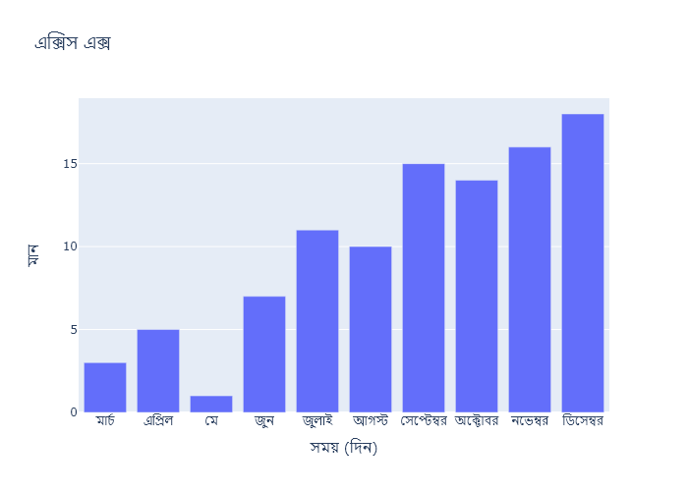

## Performance Metrics

|  |  |  |  |
| --- | --- | --- | --- |
| Task | Model Used | Description | Time Taken (s) |
| Processing Image to JSON | Gemini Vision Pro (default) | Time taken to convert the uploaded image to JSON format | 12.85 |
| Updating JSON | ChatGPT 3.5 (Default) | Time taken to update the JSON with new data | 0.00 |
| Plotting Updated JSON | N/A | Time taken to plot the updated JSON | 0.40 |

# Test Run

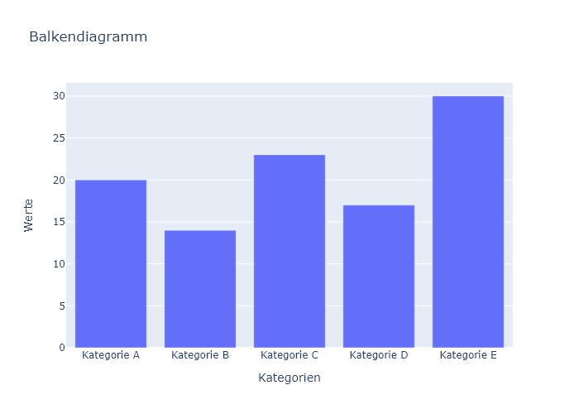

Figure: Charts\multilingual/bar_chart_german.png

## Prompt Used

## Task: Extract Detailed Information from a Given Graph Image. Charts are multilingual, you have to extract the same language that is there in the graph.  
  
You will analyze a graph image and generate corresponding Plotly-compatible JSON files (`data.json`, `layout.json`, and `config.json`). Follow the structured steps and specific XML-like delimiters for each JSON section as outlined below.  
  
### Instructions:  
  
#### Graph Analysis:  
  
1. **Identify and Categorize Plot Types**:  
 - Recognize and categorize the plot types present in the graph image. Include both simple and complex plots, listed below:  
 - **Comparison Charts**:  
 - `bar`: Bar Chart  
 - `bar` (with vertical bars): Column Chart  
 - `bar` (grouped): Grouped Bar/Column Chart  
 - `scatter` (with lines connecting to points): Lollipop Chart  
 - `indicator` (with gauge): Bullet Chart  
 - `scatter`: Dot Plot  
 - `scatter` (with lines connecting different points): Dumbbell Chart  
 - `scatter` (or custom SVG): Pictogram  
 - `scatter` or `bar` with a range: Range Chart  
 - `barpolar`: Radial Bar Chart  
 - `parcoords`: Parallel Coordinates  
 - `scatterpolar`: Radar Chart  
 - `barpolar` (with segments): Nightingale Chart  
 - `waterfall`: Waterfall Chart  
 - `heatmap` (with color scale): Matrix Chart  
 - `various charts in small multiples`: Small Multiples  
 - `text` (frequency-based size): Word Cloud  
 - `scatter` (with lines indicating change): Slope Chart  
 - `table`: Table Chart  
 - `scatter`: Categorical Scatter Plot  
 - `scatter` (with four quadrants): Quadrant Chart  
 - **Correlation Charts**:  
 - `heatmap`: Heatmap  
 - `scatter` (with size): Bubble Chart  
 - `scatter`: Scatter Plot  
 - `scatter` (with lines connecting points): Connected Scatter Plot  
 - `hexbin`: Hexagonal Binning  
 - `contour`: Contour Plot  
 - **Part-to-Whole & Hierarchical Charts**:  
 - `bar` (stacked): Stacked Bar/Column Chart  
 - `bar` (with diverging sections): Diverging Bar Chart  
 - `bar` (mirrored pairs): Population Pyramid  
 - `scatter` (or custom symbols in a grid): Icon Array  
 - `waffle`: Waffle Chart  
 - `pie`: Pie Chart  
 - `pie` (with hole): Donut Chart  
 - `pie` (half-circle): Semi-circle Donut Chart  
 - `bar` (variable width): Marimekko Chart  
 - `treemap`: Treemap  
 - `treemap` (circular): Circular Treemap  
 - `treemap` (convex shape): Convex Treemap  
 - `sunburst`: Sunburst Chart  
 - `funnel` or `pyramid`: Funnel & Pyramid Chart  
 - `dendrogram`: Dendrogram  
 - `venn`: Venn Diagram  
 - `euler`: Euler Diagram  
 - `indicator` (circular gauge): Circular Gauge  
 - **Data Over Time (Temporal) Charts**:  
 - `scatter` (filled area under curve): Area Chart  
 - `scatter` (filled stacked areas): Stacked Area Chart  
 - `scatter` (smoothed filled areas): Stream Graph  
 - `scatter` (indicating ranking change): Bump Chart  
 - `scatter` (with filled area): Bump Area Chart  
 - `scatter`: Line Chart  
 - `scatter` (with smoothed lines): Spline Chart  
 - `scatter` (with stepped lines): Step Line Chart  
 - `candlestick`: Candlestick Chart  
 - `gantt`: Gantt Chart  
 - `scatter` (encoded lines): Barcode Chart  
 - `ohlc`: OHLC Chart  
 - **Distribution Charts**:  
 - `densitymapbox` or `histogram`: Density Plot  
 - `ridge`: Ridgeline Plot  
 - `horizon`: Horizon Chart  
 - `histogram`: Histogram  
 - `radial_histogram`: Radial Histogram  
 - `scatter` (with distribution): Strip Plot  
 - `scatter` (with jitter): Jitter Plot  
 - `heatmap`: One-dimensional Heatmap  
 - `scatter` (with tightly packed points): Beeswarm Chart  
 - `box`: Box Chart  
 - `violin`: Violin Plot  
 - **Geospatial & Other Charts**:  
 - `densitymapbox`: Geographic Heatmap  
 - `choropleth`: Choropleth Map  
 - `scattermapbox`: Tile Map  
 - `chord`: Chord Diagram  
 - `arc`: Arc Diagram  
 - `sankey`: Sankey  
 - `network`: Network Diagram  
 - `flowchart`: Flowchart  
  
2. **Extract Data Points** for Each Plot Type:  
 - Gather the data points for each identified plot type.  
 - For `scatter`, `line`, and `area` plots: Extract `x` and `y` values.  
 - For `bar` and `stacked bar` plots: Extract `x` (categories) and `y` values.  
 - For `pie` charts: Extract `labels` and `values`.  
 - For `scatter3d`, `surface`, and other 3D plots: Extract `x`, `y`, and `z` values.  
  
3. **Identify Multiple Plots** on the Same Figure:  
 - Note any combinations or overlays of multiple plot types on the same figure and their configurations, such as stacked plots or multiple area fills.  
  
#### Generate JSON and CSV Outputs:  
  
Follow the JSON formatting guidelines and wrap each section in the specified XML-like tags.  
  
1. **Generate `data.json`**:  
 - Include detailed information for each plot type:  
 - `type`: Specify the plot type (e.g., `"scatter"`, `"bar"`, `"pie"`, `"area"`, `"scatter3d"`, `"surface"`).  
 - For area charts, use `"type": "scatter"` and specify `"fill"`.  
 - `x`, `y`, and `z` (if applicable): Arrays of data points for each axis.  
 - `labels` and `values` for pie charts.  
 - `mode`: Specify for line and scatter plots (e.g., `"markers"`, `"lines"`, `"markers+lines"`).  
 - `name`: Legend entry for the plot.  
 - `marker`: Properties such as color, size, and symbol.  
 - `line`: Properties such as color, width, and dash style.  
 - `text`: Hover text for each data point.  
 - `hoverinfo`: Information displayed on hover (e.g., `"x+y+text"`).  
 - `fill`: For area charts, specify the fill (e.g., `"tozeroy"`, `"tonexty"`).  
 - `fillcolor`: The color used to fill the area.  
 - `stackgroup`: For stacked bar charts, specify the stacking group.  
  
2. **Generate `layout.json`**:  
 - Define the layout properties:  
 - `title`: Text and font properties for the graph title.  
 - `xaxis` and `yaxis`: Configuration for axis titles, ranges, grids, and ticks.  
 - `zaxis`: Configuration for 3D plots including title, range, and grid.  
 - `legend`: Properties for legend orientation and positioning.  
 - `margin`: Margins for left, right, bottom, top, and padding.  
 - `plot_bgcolor` and `paper_bgcolor`: Background colors.  
 - `scene`: Configuration for 3D scenes, including camera angles and aspect ratio.  
  
3. **Generate `config.json`**:  
 - Include settings such as:  
 - `responsive`: Whether the graph is responsive.  
 - `displayModeBar`: Whether the mode bar is shown.  
 - `modeBarButtonsToRemove`: List of mode bar buttons to remove.  
 - `scrollZoom`: Whether scrolling zoom is enabled.  
  
4. **Generate `<csv>`**:  
 - Format the CSV data as follows:  
 ```csv  
 x,y  
 1,4  
 2,5  
 3,6  
 ```  
 - Replace `x`, `y`, `1`, `4`, `2`, `5`, and `3`, `6` with the actual data from the graph image.  
  
### Output Format:  
  
Wrap each JSON output in the specified XML-like tags:  
  
- `<data> ... </data>`  
- `<layout> ... </layout>`  
- `<config> ... </config>`  
- `<csv> ... </csv>`  
  
Ensure the JSON format follows these rules:  
- Use double quotes for all keys and string values.  
- Do not include trailing commas in arrays or objects.  
  
### Example Output:  
  
```xml  
<data>  
[  
 {  
 "type": "scatter",  
 "x": [1, 2, 3],  
 "y": [4, 5, 6],  
 "mode": "markers+lines",  
 "name": "Line Plot",  
 "marker": {  
 "color": "rgba(75, 192, 192, 0.6)",  
 "size": 8  
 },  
 "line": {  
 "color": "rgba(75, 192, 192  
  
, 1)",  
 "width": 2  
 }  
 },  
 {  
 "type": "area",  
 "x": [1, 2, 3, 4, 5, 6, 7, 8, 9, 10, 11, 12],  
 "y": [400, 430, 550, 620, 580, 600, 630, 700, 670, 630, 600, 500],  
 "name": "Housing",  
 "marker": {  
 "color": "rgba(255, 159, 64, 0.8)"  
 },  
 "line": {  
 "color": "rgba(255, 159, 64, 1)",  
 "width": 2  
 }  
 },  
 {  
 "type": "bar",  
 "x": ["A", "B", "C"],  
 "y": [10, 15, 13],  
 "name": "Bar Chart",  
 "marker": {  
 "color": "rgba(255, 99, 132, 0.6)"  
 },  
 "hoverinfo": "x+y+text"  
 },  
 {  
 "type": "scatter",  
 "x": [1, 2, 3],  
 "y": [6, 7, 8],  
 "mode": "lines",  
 "fill": "tozeroy",  
 "name": "Area Chart",  
 "line": {  
 "color": "rgba(54, 162, 235, 1)",  
 "width": 2  
 },  
 "fillcolor": "rgba(54, 162, 235, 0.5)"  
 },  
 {  
 "type": "scatter3d",  
 "x": [1, 2, 3],  
 "y": [4, 5, 6],  
 "z": [7, 8, 9],  
 "mode": "markers",  
 "name": "3D Scatter Plot",  
 "marker": {  
 "color": "rgba(255, 159, 64, 0.8)",  
 "size": 5  
 },  
 "hoverinfo": "x+y+z+text"  
 },  
 {  
 "type": "surface",  
 "z": [  
 [10, 10.625, 12.5, 15.625, 20],  
 [5.625, 6.25, 8.125, 11.25, 15.625],  
 [0, 1.25, 3.125, 6.25, 10.625]  
 ],  
 "name": "Surface Plot",  
 "colorscale": "Viridis",  
 "hoverinfo": "z+name"  
 }  
]  
</data>  
<layout>  
{  
 "title": {  
 "text": "Complex Graph Example",  
 "font": {  
 "family": "Arial, sans-serif",  
 "size": 24,  
 "color": "#000000"  
 }  
 },  
 "xaxis": {  
 "title": {  
 "text": "X Axis",  
 "font": {  
 "family": "Arial, sans-serif",  
 "size": 18,  
 "color": "#000000"  
 }  
 },  
 "showgrid": true,  
 "gridcolor": "rgba(0, 0, 0, 0.1)",  
 "zeroline": true,  
 "zerolinecolor": "rgba(0, 0, 0, 0.1)"  
 },  
 "yaxis": {  
 "title": {  
 "text": "Y Axis",  
 "font": {  
 "family": "Arial, sans-serif",  
 "size": 18,  
 "color": "#000000"  
 }  
 },  
 "showgrid": true,  
 "gridcolor": "rgba(0, 0, 0, 0.1)",  
 "zeroline": true,  
 "zerolinecolor": "rgba(0, 0, 0, 0.1)"  
 },  
 "legend": {  
 "orientation": "h",  
 "x": 0.5,  
 "xanchor": "center",  
 "y": -0.2,  
 "font": {  
 "family": "Arial, sans-serif",  
 "size": 12,  
 "color": "#000000"  
 }  
 },  
 "margin": {  
 "l": 60,  
 "r": 30,  
 "b": 60,  
 "t": 60  
 },  
 "plot_bgcolor": "#ffffff",  
 "paper_bgcolor": "#ffffff",  
 "scene": {  
 "xaxis": {"title": "X Axis"},  
 "yaxis": {"title": "Y Axis"},  
 "zaxis": {"title": "Z Axis"}  
 }  
}  
</layout>  
<config>  
{  
 "responsive": true,  
 "displayModeBar": true,  
 "modeBarButtonsToRemove": ["toImage"],  
 "scrollZoom": true  
}  
</config>  
<csv>  
x,y  
1,4  
2,5  
3,6  
</csv>  
```

## Extracted JSON

### data

[  
 {  
 "type": "bar",  
 "x": [  
 "A",  
 "B",  
 "C",  
 "D",  
 "E"  
 ],  
 "y": [  
 20,  
 15,  
 22,  
 17,  
 30  
 ],  
 "name": "Barchart",  
 "marker": {  
 "color": "rgba(255, 99, 132, 0.6)"  
 },  
 "hoverinfo": "x+y+text"  
 },  
 {  
 "type": "scatter",  
 "x": [  
 1,  
 2,  
 3,  
 4,  
 5  
 ],  
 "y": [  
 4,  
 5,  
 3,  
 5,  
 4  
 ],  
 "mode": "lines",  
 "name": "Linechart",  
 "line": {  
 "color": "rgba(54, 162, 235, 1)",  
 "width": 2  
 }  
 },  
 {  
 "type": "scatter",  
 "x": [  
 1,  
 2,  
 3,  
 4,  
 5  
 ],  
 "y": [  
 6,  
 7,  
 8,  
 7,  
 6  
 ],  
 "mode": "lines",  
 "fill": "tozeroy",  
 "name": "Areachart",  
 "line": {  
 "color": "rgba(54, 162, 235, 1)",  
 "width": 2  
 },  
 "fillcolor": "rgba(54, 162, 235, 0.5)"  
 },  
 {  
 "type": "scatter",  
 "x": [  
 1,  
 2,  
 3,  
 4,  
 5  
 ],  
 "y": [  
 4,  
 5,  
 3,  
 5,  
 4  
 ],  
 "mode": "markers",  
 "name": "Scatterplot",  
 "marker": {  
 "color": "rgba(255, 159, 64, 0.8)",  
 "size": 5  
 },  
 "hoverinfo": "x+y+text"  
 },  
 {  
 "type": "pie",  
 "labels": [  
 "A",  
 "B",  
 "C",  
 "D"  
 ],  
 "values": [  
 20,  
 15,  
 22,  
 17  
 ],  
 "name": "Piechart",  
 "marker": {  
 "colors": [  
 "rgba(255, 99, 132, 0.6)",  
 "rgba(54, 162, 235, 1)",  
 "rgba(54, 162, 235, 0.5)",  
 "rgba(255, 159, 64, 0.8)"  
 ]  
 },  
 "hoverinfo": "label+value+percent"  
 }  
]

### layout

{  
 "title": {  
 "text": "Balkendiagramm",  
 "font": {  
 "family": "Arial, sans-serif",  
 "size": 24,  
 "color": "#000000"  
 }  
 },  
 "xaxis": {  
 "title": {  
 "text": "Kategorien",  
 "font": {  
 "family": "Arial, sans-serif",  
 "size": 18,  
 "color": "#000000"  
 }  
 },  
 "showgrid": true,  
 "gridcolor": "rgba(0, 0, 0, 0.1)",  
 "zeroline": true,  
 "zerolinecolor": "rgba(0, 0, 0, 0.1)"  
 },  
 "yaxis": {  
 "title": {  
 "text": "Werte",  
 "font": {  
 "family": "Arial, sans-serif",  
 "size": 18,  
 "color": "#000000"  
 }  
 },  
 "showgrid": true,  
 "gridcolor": "rgba(0, 0, 0, 0.1)",  
 "zeroline": true,  
 "zerolinecolor": "rgba(0, 0, 0, 0.1)"  
 },  
 "legend": {  
 "orientation": "h",  
 "x": 0.5,  
 "xanchor": "center",  
 "y": -0.2,  
 "font": {  
 "family": "Arial, sans-serif",  
 "size": 12,  
 "color": "#000000"  
 }  
 },  
 "margin": {  
 "l": 60,  
 "r": 30,  
 "b": 60,  
 "t": 60  
 },  
 "plot_bgcolor": "#ffffff",  
 "paper_bgcolor": "#ffffff"  
}

### config

{  
 "responsive": true,  
 "displayModeBar": true,  
 "modeBarButtonsToRemove": [  
 "toImage"  
 ],  
 "scrollZoom": true  
}

## Updated JSON

### updated_data

[  
 {  
 "type": "bar",  
 "x": [  
 "A",  
 "B",  
 "C",  
 "D",  
 "E"  
 ],  
 "y": [  
 20,  
 15,  
 22,  
 17,  
 30  
 ],  
 "name": "Barchart",  
 "marker": {  
 "color": "rgba(255, 99, 132, 0.6)"  
 },  
 "hoverinfo": "x+y+text"  
 },  
 {  
 "type": "scatter",  
 "x": [  
 1,  
 2,  
 3,  
 4,  
 5  
 ],  
 "y": [  
 4,  
 5,  
 3,  
 5,  
 4  
 ],  
 "mode": "lines",  
 "name": "Linechart",  
 "line": {  
 "color": "rgba(54, 162, 235, 1)",  
 "width": 2  
 }  
 },  
 {  
 "type": "scatter",  
 "x": [  
 1,  
 2,  
 3,  
 4,  
 5  
 ],  
 "y": [  
 6,  
 7,  
 8,  
 7,  
 6  
 ],  
 "mode": "lines",  
 "fill": "tozeroy",  
 "name": "Areachart",  
 "line": {  
 "color": "rgba(54, 162, 235, 1)",  
 "width": 2  
 },  
 "fillcolor": "rgba(54, 162, 235, 0.5)"  
 },  
 {  
 "type": "scatter",  
 "x": [  
 1,  
 2,  
 3,  
 4,  
 5  
 ],  
 "y": [  
 4,  
 5,  
 3,  
 5,  
 4  
 ],  
 "mode": "markers",  
 "name": "Scatterplot",  
 "marker": {  
 "color": "rgba(255, 159, 64, 0.8)",  
 "size": 5  
 },  
 "hoverinfo": "x+y+text"  
 },  
 {  
 "type": "pie",  
 "labels": [  
 "A",  
 "B",  
 "C",  
 "D"  
 ],  
 "values": [  
 20,  
 15,  
 22,  
 17  
 ],  
 "name": "Piechart",  
 "marker": {  
 "colors": [  
 "rgba(255, 99, 132, 0.6)",  
 "rgba(54, 162, 235, 1)",  
 "rgba(54, 162, 235, 0.5)",  
 "rgba(255, 159, 64, 0.8)"  
 ]  
 },  
 "hoverinfo": "label+value+percent"  
 }  
]

### updated_layout

{  
 "title": {  
 "text": "Balkendiagramm",  
 "font": {  
 "family": "Arial, sans-serif",  
 "size": 24,  
 "color": "#000000"  
 }  
 },  
 "xaxis": {  
 "title": {  
 "text": "Kategorien",  
 "font": {  
 "family": "Arial, sans-serif",  
 "size": 18,  
 "color": "#000000"  
 }  
 },  
 "showgrid": true,  
 "gridcolor": "rgba(0, 0, 0, 0.1)",  
 "zeroline": true,  
 "zerolinecolor": "rgba(0, 0, 0, 0.1)"  
 },  
 "yaxis": {  
 "title": {  
 "text": "Werte",  
 "font": {  
 "family": "Arial, sans-serif",  
 "size": 18,  
 "color": "#000000"  
 }  
 },  
 "showgrid": true,  
 "gridcolor": "rgba(0, 0, 0, 0.1)",  
 "zeroline": true,  
 "zerolinecolor": "rgba(0, 0, 0, 0.1)"  
 },  
 "legend": {  
 "orientation": "h",  
 "x": 0.5,  
 "xanchor": "center",  
 "y": -0.2,  
 "font": {  
 "family": "Arial, sans-serif",  
 "size": 12,  
 "color": "#000000"  
 }  
 },  
 "margin": {  
 "l": 60,  
 "r": 30,  
 "b": 60,  
 "t": 60  
 },  
 "plot_bgcolor": "#ffffff",  
 "paper_bgcolor": "#ffffff"  
}

### updated_config

{  
 "responsive": true,  
 "displayModeBar": true,  
 "modeBarButtonsToRemove": [  
 "toImage"  
 ],  
 "scrollZoom": true  
}

## Updated Chart

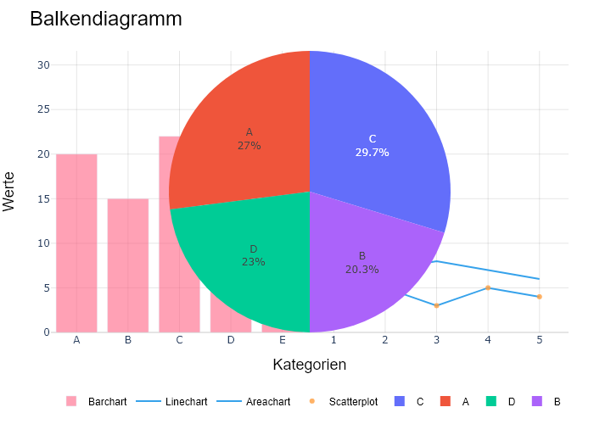

## Performance Metrics

|  |  |  |  |
| --- | --- | --- | --- |
| Task | Model Used | Description | Time Taken (s) |
| Processing Image to JSON | Gemini Vision Pro (default) | Time taken to convert the uploaded image to JSON format | 25.21 |
| Updating JSON | ChatGPT 3.5 (Default) | Time taken to update the JSON with new data | 0.00 |
| Plotting Updated JSON | N/A | Time taken to plot the updated JSON | 0.40 |

# Test Run



Figure: Charts\multilingual/bar_chart_german.png

## Prompt Used

## Task: Extract Detailed Information from a Given Graph Image. Charts are multilingual, you have to extract the same language that is there in the graph.  
  
You will analyze a graph image and generate corresponding Plotly-compatible JSON files (`data.json`, `layout.json`, and `config.json`). Follow the structured steps and specific XML-like delimiters for each JSON section as outlined below.  
  
### Instructions:  
  
#### Graph Analysis:  
  
1. **Identify and Categorize Plot Types**:  
 - Recognize and categorize the plot types present in the graph image. Include both simple and complex plots, listed below:  
 - **Comparison Charts**:  
 - `bar`: Bar Chart  
 - `bar` (with vertical bars): Column Chart  
 - `bar` (grouped): Grouped Bar/Column Chart  
 - `scatter` (with lines connecting to points): Lollipop Chart  
 - `indicator` (with gauge): Bullet Chart  
 - `scatter`: Dot Plot  
 - `scatter` (with lines connecting different points): Dumbbell Chart  
 - `scatter` (or custom SVG): Pictogram  
 - `scatter` or `bar` with a range: Range Chart  
 - `barpolar`: Radial Bar Chart  
 - `parcoords`: Parallel Coordinates  
 - `scatterpolar`: Radar Chart  
 - `barpolar` (with segments): Nightingale Chart  
 - `waterfall`: Waterfall Chart  
 - `heatmap` (with color scale): Matrix Chart  
 - `various charts in small multiples`: Small Multiples  
 - `text` (frequency-based size): Word Cloud  
 - `scatter` (with lines indicating change): Slope Chart  
 - `table`: Table Chart  
 - `scatter`: Categorical Scatter Plot  
 - `scatter` (with four quadrants): Quadrant Chart  
 - **Correlation Charts**:  
 - `heatmap`: Heatmap  
 - `scatter` (with size): Bubble Chart  
 - `scatter`: Scatter Plot  
 - `scatter` (with lines connecting points): Connected Scatter Plot  
 - `hexbin`: Hexagonal Binning  
 - `contour`: Contour Plot  
 - **Part-to-Whole & Hierarchical Charts**:  
 - `bar` (stacked): Stacked Bar/Column Chart  
 - `bar` (with diverging sections): Diverging Bar Chart  
 - `bar` (mirrored pairs): Population Pyramid  
 - `scatter` (or custom symbols in a grid): Icon Array  
 - `waffle`: Waffle Chart  
 - `pie`: Pie Chart  
 - `pie` (with hole): Donut Chart  
 - `pie` (half-circle): Semi-circle Donut Chart  
 - `bar` (variable width): Marimekko Chart  
 - `treemap`: Treemap  
 - `treemap` (circular): Circular Treemap  
 - `treemap` (convex shape): Convex Treemap  
 - `sunburst`: Sunburst Chart  
 - `funnel` or `pyramid`: Funnel & Pyramid Chart  
 - `dendrogram`: Dendrogram  
 - `venn`: Venn Diagram  
 - `euler`: Euler Diagram  
 - `indicator` (circular gauge): Circular Gauge  
 - **Data Over Time (Temporal) Charts**:  
 - `scatter` (filled area under curve): Area Chart  
 - `scatter` (filled stacked areas): Stacked Area Chart  
 - `scatter` (smoothed filled areas): Stream Graph  
 - `scatter` (indicating ranking change): Bump Chart  
 - `scatter` (with filled area): Bump Area Chart  
 - `scatter`: Line Chart  
 - `scatter` (with smoothed lines): Spline Chart  
 - `scatter` (with stepped lines): Step Line Chart  
 - `candlestick`: Candlestick Chart  
 - `gantt`: Gantt Chart  
 - `scatter` (encoded lines): Barcode Chart  
 - `ohlc`: OHLC Chart  
 - **Distribution Charts**:  
 - `densitymapbox` or `histogram`: Density Plot  
 - `ridge`: Ridgeline Plot  
 - `horizon`: Horizon Chart  
 - `histogram`: Histogram  
 - `radial_histogram`: Radial Histogram  
 - `scatter` (with distribution): Strip Plot  
 - `scatter` (with jitter): Jitter Plot  
 - `heatmap`: One-dimensional Heatmap  
 - `scatter` (with tightly packed points): Beeswarm Chart  
 - `box`: Box Chart  
 - `violin`: Violin Plot  
 - **Geospatial & Other Charts**:  
 - `densitymapbox`: Geographic Heatmap  
 - `choropleth`: Choropleth Map  
 - `scattermapbox`: Tile Map  
 - `chord`: Chord Diagram  
 - `arc`: Arc Diagram  
 - `sankey`: Sankey  
 - `network`: Network Diagram  
 - `flowchart`: Flowchart  
  
2. **Extract Data Points** for Each Plot Type:  
 - Gather the data points for each identified plot type.  
 - For `scatter`, `line`, and `area` plots: Extract `x` and `y` values.  
 - For `bar` and `stacked bar` plots: Extract `x` (categories) and `y` values.  
 - For `pie` charts: Extract `labels` and `values`.  
 - For `scatter3d`, `surface`, and other 3D plots: Extract `x`, `y`, and `z` values.  
  
3. **Identify Multiple Plots** on the Same Figure:  
 - Note any combinations or overlays of multiple plot types on the same figure and their configurations, such as stacked plots or multiple area fills.  
  
#### Generate JSON and CSV Outputs:  
  
Follow the JSON formatting guidelines and wrap each section in the specified XML-like tags.  
  
1. **Generate `data.json`**:  
 - Include detailed information for each plot type:  
 - `type`: Specify the plot type (e.g., `"scatter"`, `"bar"`, `"pie"`, `"area"`, `"scatter3d"`, `"surface"`).  
 - For area charts, use `"type": "scatter"` and specify `"fill"`.  
 - `x`, `y`, and `z` (if applicable): Arrays of data points for each axis.  
 - `labels` and `values` for pie charts.  
 - `mode`: Specify for line and scatter plots (e.g., `"markers"`, `"lines"`, `"markers+lines"`).  
 - `name`: Legend entry for the plot.  
 - `marker`: Properties such as color, size, and symbol.  
 - `line`: Properties such as color, width, and dash style.  
 - `text`: Hover text for each data point.  
 - `hoverinfo`: Information displayed on hover (e.g., `"x+y+text"`).  
 - `fill`: For area charts, specify the fill (e.g., `"tozeroy"`, `"tonexty"`).  
 - `fillcolor`: The color used to fill the area.  
 - `stackgroup`: For stacked bar charts, specify the stacking group.  
  
2. **Generate `layout.json`**:  
 - Define the layout properties:  
 - `title`: Text and font properties for the graph title.  
 - `xaxis` and `yaxis`: Configuration for axis titles, ranges, grids, and ticks.  
 - `zaxis`: Configuration for 3D plots including title, range, and grid.  
 - `legend`: Properties for legend orientation and positioning.  
 - `margin`: Margins for left, right, bottom, top, and padding.  
 - `plot_bgcolor` and `paper_bgcolor`: Background colors.  
 - `scene`: Configuration for 3D scenes, including camera angles and aspect ratio.  
  
3. **Generate `config.json`**:  
 - Include settings such as:  
 - `responsive`: Whether the graph is responsive.  
 - `displayModeBar`: Whether the mode bar is shown.  
 - `modeBarButtonsToRemove`: List of mode bar buttons to remove.  
 - `scrollZoom`: Whether scrolling zoom is enabled.  
  
4. **Generate `<csv>`**:  
 - Format the CSV data as follows:  
 ```csv  
 x,y  
 1,4  
 2,5  
 3,6  
 ```  
 - Replace `x`, `y`, `1`, `4`, `2`, `5`, and `3`, `6` with the actual data from the graph image.  
  
### Output Format:  
  
Wrap each JSON output in the specified XML-like tags:  
  
- `<data> ... </data>`  
- `<layout> ... </layout>`  
- `<config> ... </config>`  
- `<csv> ... </csv>`  
  
Ensure the JSON format follows these rules:  
- Use double quotes for all keys and string values.  
- Do not include trailing commas in arrays or objects.  
  
### Example Output:  
  
```xml  
<data>  
[  
 {  
 "type": "scatter",  
 "x": [1, 2, 3],  
 "y": [4, 5, 6],  
 "mode": "markers+lines",  
 "name": "Line Plot",  
 "marker": {  
 "color": "rgba(75, 192, 192, 0.6)",  
 "size": 8  
 },  
 "line": {  
 "color": "rgba(75, 192, 192  
  
, 1)",  
 "width": 2  
 }  
 },  
 {  
 "type": "area",  
 "x": [1, 2, 3, 4, 5, 6, 7, 8, 9, 10, 11, 12],  
 "y": [400, 430, 550, 620, 580, 600, 630, 700, 670, 630, 600, 500],  
 "name": "Housing",  
 "marker": {  
 "color": "rgba(255, 159, 64, 0.8)"  
 },  
 "line": {  
 "color": "rgba(255, 159, 64, 1)",  
 "width": 2  
 }  
 },  
 {  
 "type": "bar",  
 "x": ["A", "B", "C"],  
 "y": [10, 15, 13],  
 "name": "Bar Chart",  
 "marker": {  
 "color": "rgba(255, 99, 132, 0.6)"  
 },  
 "hoverinfo": "x+y+text"  
 },  
 {  
 "type": "scatter",  
 "x": [1, 2, 3],  
 "y": [6, 7, 8],  
 "mode": "lines",  
 "fill": "tozeroy",  
 "name": "Area Chart",  
 "line": {  
 "color": "rgba(54, 162, 235, 1)",  
 "width": 2  
 },  
 "fillcolor": "rgba(54, 162, 235, 0.5)"  
 },  
 {  
 "type": "scatter3d",  
 "x": [1, 2, 3],  
 "y": [4, 5, 6],  
 "z": [7, 8, 9],  
 "mode": "markers",  
 "name": "3D Scatter Plot",  
 "marker": {  
 "color": "rgba(255, 159, 64, 0.8)",  
 "size": 5  
 },  
 "hoverinfo": "x+y+z+text"  
 },  
 {  
 "type": "surface",  
 "z": [  
 [10, 10.625, 12.5, 15.625, 20],  
 [5.625, 6.25, 8.125, 11.25, 15.625],  
 [0, 1.25, 3.125, 6.25, 10.625]  
 ],  
 "name": "Surface Plot",  
 "colorscale": "Viridis",  
 "hoverinfo": "z+name"  
 }  
]  
</data>  
<layout>  
{  
 "title": {  
 "text": "Complex Graph Example",  
 "font": {  
 "family": "Arial, sans-serif",  
 "size": 24,  
 "color": "#000000"  
 }  
 },  
 "xaxis": {  
 "title": {  
 "text": "X Axis",  
 "font": {  
 "family": "Arial, sans-serif",  
 "size": 18,  
 "color": "#000000"  
 }  
 },  
 "showgrid": true,  
 "gridcolor": "rgba(0, 0, 0, 0.1)",  
 "zeroline": true,  
 "zerolinecolor": "rgba(0, 0, 0, 0.1)"  
 },  
 "yaxis": {  
 "title": {  
 "text": "Y Axis",  
 "font": {  
 "family": "Arial, sans-serif",  
 "size": 18,  
 "color": "#000000"  
 }  
 },  
 "showgrid": true,  
 "gridcolor": "rgba(0, 0, 0, 0.1)",  
 "zeroline": true,  
 "zerolinecolor": "rgba(0, 0, 0, 0.1)"  
 },  
 "legend": {  
 "orientation": "h",  
 "x": 0.5,  
 "xanchor": "center",  
 "y": -0.2,  
 "font": {  
 "family": "Arial, sans-serif",  
 "size": 12,  
 "color": "#000000"  
 }  
 },  
 "margin": {  
 "l": 60,  
 "r": 30,  
 "b": 60,  
 "t": 60  
 },  
 "plot_bgcolor": "#ffffff",  
 "paper_bgcolor": "#ffffff",  
 "scene": {  
 "xaxis": {"title": "X Axis"},  
 "yaxis": {"title": "Y Axis"},  
 "zaxis": {"title": "Z Axis"}  
 }  
}  
</layout>  
<config>  
{  
 "responsive": true,  
 "displayModeBar": true,  
 "modeBarButtonsToRemove": ["toImage"],  
 "scrollZoom": true  
}  
</config>  
<csv>  
x,y  
1,4  
2,5  
3,6  
</csv>  
```

## Extracted JSON

### data

[  
 {  
 "type": "bar",  
 "x": [  
 "A",  
 "B",  
 "C",  
 "D",  
 "E"  
 ],  
 "y": [  
 20,  
 15,  
 22,  
 17,  
 30  
 ],  
 "name": "Barchart",  
 "marker": {  
 "color": "rgba(255, 99, 132, 0.6)"  
 },  
 "hoverinfo": "x+y+text"  
 },  
 {  
 "type": "scatter",  
 "x": [  
 1,  
 2,  
 3,  
 4,  
 5  
 ],  
 "y": [  
 4,  
 5,  
 3,  
 5,  
 4  
 ],  
 "mode": "lines",  
 "name": "Linechart",  
 "line": {  
 "color": "rgba(54, 162, 235, 1)",  
 "width": 2  
 }  
 },  
 {  
 "type": "scatter",  
 "x": [  
 1,  
 2,  
 3,  
 4,  
 5  
 ],  
 "y": [  
 6,  
 7,  
 8,  
 7,  
 6  
 ],  
 "mode": "lines",  
 "fill": "tozeroy",  
 "name": "Areachart",  
 "line": {  
 "color": "rgba(54, 162, 235, 1)",  
 "width": 2  
 },  
 "fillcolor": "rgba(54, 162, 235, 0.5)"  
 },  
 {  
 "type": "scatter",  
 "x": [  
 1,  
 2,  
 3,  
 4,  
 5  
 ],  
 "y": [  
 4,  
 5,  
 3,  
 5,  
 4  
 ],  
 "mode": "markers",  
 "name": "Scatterplot",  
 "marker": {  
 "color": "rgba(255, 159, 64, 0.8)",  
 "size": 5  
 },  
 "hoverinfo": "x+y+text"  
 },  
 {  
 "type": "pie",  
 "labels": [  
 "A",  
 "B",  
 "C",  
 "D"  
 ],  
 "values": [  
 20,  
 15,  
 22,  
 17  
 ],  
 "name": "Piechart",  
 "marker": {  
 "colors": [  
 "rgba(255, 99, 132, 0.6)",  
 "rgba(54, 162, 235, 1)",  
 "rgba(54, 162, 235, 0.5)",  
 "rgba(255, 159, 64, 0.8)"  
 ]  
 },  
 "hoverinfo": "label+value+percent"  
 }  
]

### layout

{  
 "title": {  
 "text": "Balkendiagramm",  
 "font": {  
 "family": "Arial, sans-serif",  
 "size": 24,  
 "color": "#000000"  
 }  
 },  
 "xaxis": {  
 "title": {  
 "text": "Kategorien",  
 "font": {  
 "family": "Arial, sans-serif",  
 "size": 18,  
 "color": "#000000"  
 }  
 },  
 "showgrid": true,  
 "gridcolor": "rgba(0, 0, 0, 0.1)",  
 "zeroline": true,  
 "zerolinecolor": "rgba(0, 0, 0, 0.1)"  
 },  
 "yaxis": {  
 "title": {  
 "text": "Werte",  
 "font": {  
 "family": "Arial, sans-serif",  
 "size": 18,  
 "color": "#000000"  
 }  
 },  
 "showgrid": true,  
 "gridcolor": "rgba(0, 0, 0, 0.1)",  
 "zeroline": true,  
 "zerolinecolor": "rgba(0, 0, 0, 0.1)"  
 },  
 "legend": {  
 "orientation": "h",  
 "x": 0.5,  
 "xanchor": "center",  
 "y": -0.2,  
 "font": {  
 "family": "Arial, sans-serif",  
 "size": 12,  
 "color": "#000000"  
 }  
 },  
 "margin": {  
 "l": 60,  
 "r": 30,  
 "b": 60,  
 "t": 60  
 },  
 "plot_bgcolor": "#ffffff",  
 "paper_bgcolor": "#ffffff"  
}

### config

{  
 "responsive": true,  
 "displayModeBar": true,  
 "modeBarButtonsToRemove": [  
 "toImage"  
 ],  
 "scrollZoom": true  
}

## Updated JSON

### updated_data

[  
 {  
 "type": "bar",  
 "x": [  
 "A",  
 "B",  
 "C",  
 "D",  
 "E"  
 ],  
 "y": [  
 20,  
 15,  
 22,  
 17,  
 30  
 ],  
 "name": "Barchart",  
 "marker": {  
 "color": "rgba(255, 99, 132, 0.6)"  
 },  
 "hoverinfo": "x+y+text"  
 },  
 {  
 "type": "scatter",  
 "x": [  
 1,  
 2,  
 3,  
 4,  
 5  
 ],  
 "y": [  
 4,  
 5,  
 3,  
 5,  
 4  
 ],  
 "mode": "lines",  
 "name": "Linechart",  
 "line": {  
 "color": "rgba(54, 162, 235, 1)",  
 "width": 2  
 }  
 },  
 {  
 "type": "scatter",  
 "x": [  
 1,  
 2,  
 3,  
 4,  
 5  
 ],  
 "y": [  
 6,  
 7,  
 8,  
 7,  
 6  
 ],  
 "mode": "lines",  
 "fill": "tozeroy",  
 "name": "Areachart",  
 "line": {  
 "color": "rgba(54, 162, 235, 1)",  
 "width": 2  
 },  
 "fillcolor": "rgba(54, 162, 235, 0.5)"  
 },  
 {  
 "type": "scatter",  
 "x": [  
 1,  
 2,  
 3,  
 4,  
 5  
 ],  
 "y": [  
 4,  
 5,  
 3,  
 5,  
 4  
 ],  
 "mode": "markers",  
 "name": "Scatterplot",  
 "marker": {  
 "color": "rgba(255, 159, 64, 0.8)",  
 "size": 5  
 },  
 "hoverinfo": "x+y+text"  
 },  
 {  
 "type": "pie",  
 "labels": [  
 "A",  
 "B",  
 "C",  
 "D"  
 ],  
 "values": [  
 20,  
 15,  
 22,  
 17  
 ],  
 "name": "Piechart",  
 "marker": {  
 "colors": [  
 "rgba(255, 99, 132, 0.6)",  
 "rgba(54, 162, 235, 1)",  
 "rgba(54, 162, 235, 0.5)",  
 "rgba(255, 159, 64, 0.8)"  
 ]  
 },  
 "hoverinfo": "label+value+percent"  
 }  
]

### updated_layout

{  
 "title": {  
 "text": "Balkendiagramm",  
 "font": {  
 "family": "Arial, sans-serif",  
 "size": 24,  
 "color": "#000000"  
 }  
 },  
 "xaxis": {  
 "title": {  
 "text": "Kategorien",  
 "font": {  
 "family": "Arial, sans-serif",  
 "size": 18,  
 "color": "#000000"  
 }  
 },  
 "showgrid": true,  
 "gridcolor": "rgba(0, 0, 0, 0.1)",  
 "zeroline": true,  
 "zerolinecolor": "rgba(0, 0, 0, 0.1)"  
 },  
 "yaxis": {  
 "title": {  
 "text": "Werte",  
 "font": {  
 "family": "Arial, sans-serif",  
 "size": 18,  
 "color": "#000000"  
 }  
 },  
 "showgrid": true,  
 "gridcolor": "rgba(0, 0, 0, 0.1)",  
 "zeroline": true,  
 "zerolinecolor": "rgba(0, 0, 0, 0.1)"  
 },  
 "legend": {  
 "orientation": "h",  
 "x": 0.5,  
 "xanchor": "center",  
 "y": -0.2,  
 "font": {  
 "family": "Arial, sans-serif",  
 "size": 12,  
 "color": "#000000"  
 }  
 },  
 "margin": {  
 "l": 60,  
 "r": 30,  
 "b": 60,  
 "t": 60  
 },  
 "plot_bgcolor": "#ffffff",  
 "paper_bgcolor": "#ffffff"  
}

### updated_config

{  
 "responsive": true,  
 "displayModeBar": true,  
 "modeBarButtonsToRemove": [  
 "toImage"  
 ],  
 "scrollZoom": true  
}

## Updated Chart



## Performance Metrics

|  |  |  |  |
| --- | --- | --- | --- |
| Task | Model Used | Description | Time Taken (s) |
| Processing Image to JSON | Gemini Vision Pro (default) | Time taken to convert the uploaded image to JSON format | 25.36 |
| Updating JSON | ChatGPT 3.5 (Default) | Time taken to update the JSON with new data | 0.00 |
| Plotting Updated JSON | N/A | Time taken to plot the updated JSON | 0.18 |

# Test Run



Figure: Charts\multilingual/bar_chart_german.png

## Prompt Used

## Task: Extract Detailed Information from a Given Graph Image. Charts are multilingual, you have to extract the same language that is there in the graph.  
  
You will analyze a graph image and generate corresponding Plotly-compatible JSON files (`data.json`, `layout.json`, and `config.json`). Follow the structured steps and specific XML-like delimiters for each JSON section as outlined below.  
  
### Instructions:  
  
#### Graph Analysis:  
  
1. **Identify and Categorize Plot Types**:  
 - Recognize and categorize the plot types present in the graph image. Include both simple and complex plots, listed below:  
 - **Comparison Charts**:  
 - `bar`: Bar Chart  
 - `bar` (with vertical bars): Column Chart  
 - `bar` (grouped): Grouped Bar/Column Chart  
 - `scatter` (with lines connecting to points): Lollipop Chart  
 - `indicator` (with gauge): Bullet Chart  
 - `scatter`: Dot Plot  
 - `scatter` (with lines connecting different points): Dumbbell Chart  
 - `scatter` (or custom SVG): Pictogram  
 - `scatter` or `bar` with a range: Range Chart  
 - `barpolar`: Radial Bar Chart  
 - `parcoords`: Parallel Coordinates  
 - `scatterpolar`: Radar Chart  
 - `barpolar` (with segments): Nightingale Chart  
 - `waterfall`: Waterfall Chart  
 - `heatmap` (with color scale): Matrix Chart  
 - `various charts in small multiples`: Small Multiples  
 - `text` (frequency-based size): Word Cloud  
 - `scatter` (with lines indicating change): Slope Chart  
 - `table`: Table Chart  
 - `scatter`: Categorical Scatter Plot  
 - `scatter` (with four quadrants): Quadrant Chart  
 - **Correlation Charts**:  
 - `heatmap`: Heatmap  
 - `scatter` (with size): Bubble Chart  
 - `scatter`: Scatter Plot  
 - `scatter` (with lines connecting points): Connected Scatter Plot  
 - `hexbin`: Hexagonal Binning  
 - `contour`: Contour Plot  
 - **Part-to-Whole & Hierarchical Charts**:  
 - `bar` (stacked): Stacked Bar/Column Chart  
 - `bar` (with diverging sections): Diverging Bar Chart  
 - `bar` (mirrored pairs): Population Pyramid  
 - `scatter` (or custom symbols in a grid): Icon Array  
 - `waffle`: Waffle Chart  
 - `pie`: Pie Chart  
 - `pie` (with hole): Donut Chart  
 - `pie` (half-circle): Semi-circle Donut Chart  
 - `bar` (variable width): Marimekko Chart  
 - `treemap`: Treemap  
 - `treemap` (circular): Circular Treemap  
 - `treemap` (convex shape): Convex Treemap  
 - `sunburst`: Sunburst Chart  
 - `funnel` or `pyramid`: Funnel & Pyramid Chart  
 - `dendrogram`: Dendrogram  
 - `venn`: Venn Diagram  
 - `euler`: Euler Diagram  
 - `indicator` (circular gauge): Circular Gauge  
 - **Data Over Time (Temporal) Charts**:  
 - `scatter` (filled area under curve): Area Chart  
 - `scatter` (filled stacked areas): Stacked Area Chart  
 - `scatter` (smoothed filled areas): Stream Graph  
 - `scatter` (indicating ranking change): Bump Chart  
 - `scatter` (with filled area): Bump Area Chart  
 - `scatter`: Line Chart  
 - `scatter` (with smoothed lines): Spline Chart  
 - `scatter` (with stepped lines): Step Line Chart  
 - `candlestick`: Candlestick Chart  
 - `gantt`: Gantt Chart  
 - `scatter` (encoded lines): Barcode Chart  
 - `ohlc`: OHLC Chart  
 - **Distribution Charts**:  
 - `densitymapbox` or `histogram`: Density Plot  
 - `ridge`: Ridgeline Plot  
 - `horizon`: Horizon Chart  
 - `histogram`: Histogram  
 - `radial_histogram`: Radial Histogram  
 - `scatter` (with distribution): Strip Plot  
 - `scatter` (with jitter): Jitter Plot  
 - `heatmap`: One-dimensional Heatmap  
 - `scatter` (with tightly packed points): Beeswarm Chart  
 - `box`: Box Chart  
 - `violin`: Violin Plot  
 - **Geospatial & Other Charts**:  
 - `densitymapbox`: Geographic Heatmap  
 - `choropleth`: Choropleth Map  
 - `scattermapbox`: Tile Map  
 - `chord`: Chord Diagram  
 - `arc`: Arc Diagram  
 - `sankey`: Sankey  
 - `network`: Network Diagram  
 - `flowchart`: Flowchart  
  
2. **Extract Data Points** for Each Plot Type:  
 - Gather the data points for each identified plot type.  
 - For `scatter`, `line`, and `area` plots: Extract `x` and `y` values.  
 - For `bar` and `stacked bar` plots: Extract `x` (categories) and `y` values.  
 - For `pie` charts: Extract `labels` and `values`.  
 - For `scatter3d`, `surface`, and other 3D plots: Extract `x`, `y`, and `z` values.  
  
3. **Identify Multiple Plots** on the Same Figure:  
 - Note any combinations or overlays of multiple plot types on the same figure and their configurations, such as stacked plots or multiple area fills.  
  
#### Generate JSON and CSV Outputs:  
  
Follow the JSON formatting guidelines and wrap each section in the specified XML-like tags.  
  
1. **Generate `data.json`**:  
 - Include detailed information for each plot type:  
 - `type`: Specify the plot type (e.g., `"scatter"`, `"bar"`, `"pie"`, `"area"`, `"scatter3d"`, `"surface"`).  
 - For area charts, use `"type": "scatter"` and specify `"fill"`.  
 - `x`, `y`, and `z` (if applicable): Arrays of data points for each axis.  
 - `labels` and `values` for pie charts.  
 - `mode`: Specify for line and scatter plots (e.g., `"markers"`, `"lines"`, `"markers+lines"`).  
 - `name`: Legend entry for the plot.  
 - `marker`: Properties such as color, size, and symbol.  
 - `line`: Properties such as color, width, and dash style.  
 - `text`: Hover text for each data point.  
 - `hoverinfo`: Information displayed on hover (e.g., `"x+y+text"`).  
 - `fill`: For area charts, specify the fill (e.g., `"tozeroy"`, `"tonexty"`).  
 - `fillcolor`: The color used to fill the area.  
 - `stackgroup`: For stacked bar charts, specify the stacking group.  
  
2. **Generate `layout.json`**:  
 - Define the layout properties:  
 - `title`: Text and font properties for the graph title.  
 - `xaxis` and `yaxis`: Configuration for axis titles, ranges, grids, and ticks.  
 - `zaxis`: Configuration for 3D plots including title, range, and grid.  
 - `legend`: Properties for legend orientation and positioning.  
 - `margin`: Margins for left, right, bottom, top, and padding.  
 - `plot_bgcolor` and `paper_bgcolor`: Background colors.  
 - `scene`: Configuration for 3D scenes, including camera angles and aspect ratio.  
  
3. **Generate `config.json`**:  
 - Include settings such as:  
 - `responsive`: Whether the graph is responsive.  
 - `displayModeBar`: Whether the mode bar is shown.  
 - `modeBarButtonsToRemove`: List of mode bar buttons to remove.  
 - `scrollZoom`: Whether scrolling zoom is enabled.  
  
4. **Generate `<csv>`**:  
 - Format the CSV data as follows:  
 ```csv  
 x,y  
 1,4  
 2,5  
 3,6  
 ```  
 - Replace `x`, `y`, `1`, `4`, `2`, `5`, and `3`, `6` with the actual data from the graph image.  
  
### Output Format:  
  
Wrap each JSON output in the specified XML-like tags:  
  
- `<data> ... </data>`  
- `<layout> ... </layout>`  
- `<config> ... </config>`  
- `<csv> ... </csv>`  
  
Ensure the JSON format follows these rules:  
- Use double quotes for all keys and string values.  
- Do not include trailing commas in arrays or objects.  
  
### Example Output:  
  
```xml  
<data>  
[  
 {  
 "type": "scatter",  
 "x": [1, 2, 3],  
 "y": [4, 5, 6],  
 "mode": "markers+lines",  
 "name": "Line Plot",  
 "marker": {  
 "color": "rgba(75, 192, 192, 0.6)",  
 "size": 8  
 },  
 "line": {  
 "color": "rgba(75, 192, 192  
  
, 1)",  
 "width": 2  
 }  
 },  
 {  
 "type": "area",  
 "x": [1, 2, 3, 4, 5, 6, 7, 8, 9, 10, 11, 12],  
 "y": [400, 430, 550, 620, 580, 600, 630, 700, 670, 630, 600, 500],  
 "name": "Housing",  
 "marker": {  
 "color": "rgba(255, 159, 64, 0.8)"  
 },  
 "line": {  
 "color": "rgba(255, 159, 64, 1)",  
 "width": 2  
 }  
 },  
 {  
 "type": "bar",  
 "x": ["A", "B", "C"],  
 "y": [10, 15, 13],  
 "name": "Bar Chart",  
 "marker": {  
 "color": "rgba(255, 99, 132, 0.6)"  
 },  
 "hoverinfo": "x+y+text"  
 },  
 {  
 "type": "scatter",  
 "x": [1, 2, 3],  
 "y": [6, 7, 8],  
 "mode": "lines",  
 "fill": "tozeroy",  
 "name": "Area Chart",  
 "line": {  
 "color": "rgba(54, 162, 235, 1)",  
 "width": 2  
 },  
 "fillcolor": "rgba(54, 162, 235, 0.5)"  
 },  
 {  
 "type": "scatter3d",  
 "x": [1, 2, 3],  
 "y": [4, 5, 6],  
 "z": [7, 8, 9],  
 "mode": "markers",  
 "name": "3D Scatter Plot",  
 "marker": {  
 "color": "rgba(255, 159, 64, 0.8)",  
 "size": 5  
 },  
 "hoverinfo": "x+y+z+text"  
 },  
 {  
 "type": "surface",  
 "z": [  
 [10, 10.625, 12.5, 15.625, 20],  
 [5.625, 6.25, 8.125, 11.25, 15.625],  
 [0, 1.25, 3.125, 6.25, 10.625]  
 ],  
 "name": "Surface Plot",  
 "colorscale": "Viridis",  
 "hoverinfo": "z+name"  
 }  
]  
</data>  
<layout>  
{  
 "title": {  
 "text": "Complex Graph Example",  
 "font": {  
 "family": "Arial, sans-serif",  
 "size": 24,  
 "color": "#000000"  
 }  
 },  
 "xaxis": {  
 "title": {  
 "text": "X Axis",  
 "font": {  
 "family": "Arial, sans-serif",  
 "size": 18,  
 "color": "#000000"  
 }  
 },  
 "showgrid": true,  
 "gridcolor": "rgba(0, 0, 0, 0.1)",  
 "zeroline": true,  
 "zerolinecolor": "rgba(0, 0, 0, 0.1)"  
 },  
 "yaxis": {  
 "title": {  
 "text": "Y Axis",  
 "font": {  
 "family": "Arial, sans-serif",  
 "size": 18,  
 "color": "#000000"  
 }  
 },  
 "showgrid": true,  
 "gridcolor": "rgba(0, 0, 0, 0.1)",  
 "zeroline": true,  
 "zerolinecolor": "rgba(0, 0, 0, 0.1)"  
 },  
 "legend": {  
 "orientation": "h",  
 "x": 0.5,  
 "xanchor": "center",  
 "y": -0.2,  
 "font": {  
 "family": "Arial, sans-serif",  
 "size": 12,  
 "color": "#000000"  
 }  
 },  
 "margin": {  
 "l": 60,  
 "r": 30,  
 "b": 60,  
 "t": 60  
 },  
 "plot_bgcolor": "#ffffff",  
 "paper_bgcolor": "#ffffff",  
 "scene": {  
 "xaxis": {"title": "X Axis"},  
 "yaxis": {"title": "Y Axis"},  
 "zaxis": {"title": "Z Axis"}  
 }  
}  
</layout>  
<config>  
{  
 "responsive": true,  
 "displayModeBar": true,  
 "modeBarButtonsToRemove": ["toImage"],  
 "scrollZoom": true  
}  
</config>  
<csv>  
x,y  
1,4  
2,5  
3,6  
</csv>  
```

## Extracted JSON

### data

[  
 {  
 "type": "bar",  
 "x": [  
 "A",  
 "B",  
 "C",  
 "D",  
 "E"  
 ],  
 "y": [  
 20,  
 15,  
 22,  
 17,  
 30  
 ],  
 "name": "Barchart",  
 "marker": {  
 "color": "rgba(255, 99, 132, 0.6)"  
 },  
 "hoverinfo": "x+y+text"  
 },  
 {  
 "type": "scatter",  
 "x": [  
 1,  
 2,  
 3,  
 4,  
 5  
 ],  
 "y": [  
 4,  
 5,  
 3,  
 5,  
 4  
 ],  
 "mode": "lines",  
 "name": "Linechart",  
 "line": {  
 "color": "rgba(54, 162, 235, 1)",  
 "width": 2  
 }  
 },  
 {  
 "type": "scatter",  
 "x": [  
 1,  
 2,  
 3,  
 4,  
 5  
 ],  
 "y": [  
 6,  
 7,  
 8,  
 7,  
 6  
 ],  
 "mode": "lines",  
 "fill": "tozeroy",  
 "name": "Areachart",  
 "line": {  
 "color": "rgba(54, 162, 235, 1)",  
 "width": 2  
 },  
 "fillcolor": "rgba(54, 162, 235, 0.5)"  
 },  
 {  
 "type": "scatter",  
 "x": [  
 1,  
 2,  
 3,  
 4,  
 5  
 ],  
 "y": [  
 4,  
 5,  
 3,  
 5,  
 4  
 ],  
 "mode": "markers",  
 "name": "Scatterplot",  
 "marker": {  
 "color": "rgba(255, 159, 64, 0.8)",  
 "size": 5  
 },  
 "hoverinfo": "x+y+text"  
 },  
 {  
 "type": "pie",  
 "labels": [  
 "A",  
 "B",  
 "C",  
 "D"  
 ],  
 "values": [  
 20,  
 15,  
 22,  
 17  
 ],  
 "name": "Piechart",  
 "marker": {  
 "colors": [  
 "rgba(255, 99, 132, 0.6)",  
 "rgba(54, 162, 235, 1)",  
 "rgba(54, 162, 235, 0.5)",  
 "rgba(255, 159, 64, 0.8)"  
 ]  
 },  
 "hoverinfo": "label+value+percent"  
 }  
]

### layout

{  
 "title": {  
 "text": "Balkendiagramm",  
 "font": {  
 "family": "Arial, sans-serif",  
 "size": 24,  
 "color": "#000000"  
 }  
 },  
 "xaxis": {  
 "title": {  
 "text": "Kategorien",  
 "font": {  
 "family": "Arial, sans-serif",  
 "size": 18,  
 "color": "#000000"  
 }  
 },  
 "showgrid": true,  
 "gridcolor": "rgba(0, 0, 0, 0.1)",  
 "zeroline": true,  
 "zerolinecolor": "rgba(0, 0, 0, 0.1)"  
 },  
 "yaxis": {  
 "title": {  
 "text": "Werte",  
 "font": {  
 "family": "Arial, sans-serif",  
 "size": 18,  
 "color": "#000000"  
 }  
 },  
 "showgrid": true,  
 "gridcolor": "rgba(0, 0, 0, 0.1)",  
 "zeroline": true,  
 "zerolinecolor": "rgba(0, 0, 0, 0.1)"  
 },  
 "legend": {  
 "orientation": "h",  
 "x": 0.5,  
 "xanchor": "center",  
 "y": -0.2,  
 "font": {  
 "family": "Arial, sans-serif",  
 "size": 12,  
 "color": "#000000"  
 }  
 },  
 "margin": {  
 "l": 60,  
 "r": 30,  
 "b": 60,  
 "t": 60  
 },  
 "plot_bgcolor": "#ffffff",  
 "paper_bgcolor": "#ffffff"  
}

### config

{  
 "responsive": true,  
 "displayModeBar": true,  
 "modeBarButtonsToRemove": [  
 "toImage"  
 ],  
 "scrollZoom": true  
}

## Updated JSON

### updated_data

[  
 {  
 "type": "bar",  
 "x": [  
 "A",  
 "B",  
 "C",  
 "D",  
 "E"  
 ],  
 "y": [  
 20,  
 15,  
 22,  
 17,  
 30  
 ],  
 "name": "Barchart",  
 "marker": {  
 "color": "rgba(255, 99, 132, 0.6)"  
 },  
 "hoverinfo": "x+y+text"  
 },  
 {  
 "type": "scatter",  
 "x": [  
 1,  
 2,  
 3,  
 4,  
 5  
 ],  
 "y": [  
 4,  
 5,  
 3,  
 5,  
 4  
 ],  
 "mode": "lines",  
 "name": "Linechart",  
 "line": {  
 "color": "rgba(54, 162, 235, 1)",  
 "width": 2  
 }  
 },  
 {  
 "type": "scatter",  
 "x": [  
 1,  
 2,  
 3,  
 4,  
 5  
 ],  
 "y": [  
 6,  
 7,  
 8,  
 7,  
 6  
 ],  
 "mode": "lines",  
 "fill": "tozeroy",  
 "name": "Areachart",  
 "line": {  
 "color": "rgba(54, 162, 235, 1)",  
 "width": 2  
 },  
 "fillcolor": "rgba(54, 162, 235, 0.5)"  
 },  
 {  
 "type": "scatter",  
 "x": [  
 1,  
 2,  
 3,  
 4,  
 5  
 ],  
 "y": [  
 4,  
 5,  
 3,  
 5,  
 4  
 ],  
 "mode": "markers",  
 "name": "Scatterplot",  
 "marker": {  
 "color": "rgba(255, 159, 64, 0.8)",  
 "size": 5  
 },  
 "hoverinfo": "x+y+text"  
 },  
 {  
 "type": "pie",  
 "labels": [  
 "A",  
 "B",  
 "C",  
 "D"  
 ],  
 "values": [  
 20,  
 15,  
 22,  
 17  
 ],  
 "name": "Piechart",  
 "marker": {  
 "colors": [  
 "rgba(255, 99, 132, 0.6)",  
 "rgba(54, 162, 235, 1)",  
 "rgba(54, 162, 235, 0.5)",  
 "rgba(255, 159, 64, 0.8)"  
 ]  
 },  
 "hoverinfo": "label+value+percent"  
 }  
]

### updated_layout

{  
 "title": {  
 "text": "Balkendiagramm",  
 "font": {  
 "family": "Arial, sans-serif",  
 "size": 24,  
 "color": "#000000"  
 }  
 },  
 "xaxis": {  
 "title": {  
 "text": "Kategorien",  
 "font": {  
 "family": "Arial, sans-serif",  
 "size": 18,  
 "color": "#000000"  
 }  
 },  
 "showgrid": true,  
 "gridcolor": "rgba(0, 0, 0, 0.1)",  
 "zeroline": true,  
 "zerolinecolor": "rgba(0, 0, 0, 0.1)"  
 },  
 "yaxis": {  
 "title": {  
 "text": "Werte",  
 "font": {  
 "family": "Arial, sans-serif",  
 "size": 18,  
 "color": "#000000"  
 }  
 },  
 "showgrid": true,  
 "gridcolor": "rgba(0, 0, 0, 0.1)",  
 "zeroline": true,  
 "zerolinecolor": "rgba(0, 0, 0, 0.1)"  
 },  
 "legend": {  
 "orientation": "h",  
 "x": 0.5,  
 "xanchor": "center",  
 "y": -0.2,  
 "font": {  
 "family": "Arial, sans-serif",  
 "size": 12,  
 "color": "#000000"  
 }  
 },  
 "margin": {  
 "l": 60,  
 "r": 30,  
 "b": 60,  
 "t": 60  
 },  
 "plot_bgcolor": "#ffffff",  
 "paper_bgcolor": "#ffffff"  
}

### updated_config

{  
 "responsive": true,  
 "displayModeBar": true,  
 "modeBarButtonsToRemove": [  
 "toImage"  
 ],  
 "scrollZoom": true  
}

## Updated Chart



## Performance Metrics

|  |  |  |  |
| --- | --- | --- | --- |
| Task | Model Used | Description | Time Taken (s) |
| Processing Image to JSON | Gemini Vision Pro (default) | Time taken to convert the uploaded image to JSON format | 27.43 |
| Updating JSON | ChatGPT 3.5 (Default) | Time taken to update the JSON with new data | 0.00 |
| Plotting Updated JSON | N/A | Time taken to plot the updated JSON | 0.20 |

# Test Run

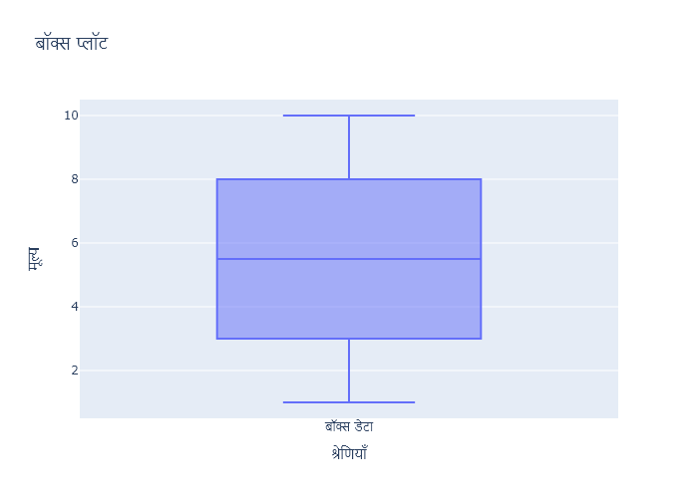

Figure: Charts\multilingual/box_plot_hindi.png

## Prompt Used

## Task: Extract Detailed Information from a Given Graph Image. Charts are multilingual, you have to extract the same language that is there in the graph.  
  
You will analyze a graph image and generate corresponding Plotly-compatible JSON files (`data.json`, `layout.json`, and `config.json`). Follow the structured steps and specific XML-like delimiters for each JSON section as outlined below.  
  
### Instructions:  
  
#### Graph Analysis:  
  
1. **Identify and Categorize Plot Types**:  
 - Recognize and categorize the plot types present in the graph image. Include both simple and complex plots, listed below:  
 - **Comparison Charts**:  
 - `bar`: Bar Chart  
 - `bar` (with vertical bars): Column Chart  
 - `bar` (grouped): Grouped Bar/Column Chart  
 - `scatter` (with lines connecting to points): Lollipop Chart  
 - `indicator` (with gauge): Bullet Chart  
 - `scatter`: Dot Plot  
 - `scatter` (with lines connecting different points): Dumbbell Chart  
 - `scatter` (or custom SVG): Pictogram  
 - `scatter` or `bar` with a range: Range Chart  
 - `barpolar`: Radial Bar Chart  
 - `parcoords`: Parallel Coordinates  
 - `scatterpolar`: Radar Chart  
 - `barpolar` (with segments): Nightingale Chart  
 - `waterfall`: Waterfall Chart  
 - `heatmap` (with color scale): Matrix Chart  
 - `various charts in small multiples`: Small Multiples  
 - `text` (frequency-based size): Word Cloud  
 - `scatter` (with lines indicating change): Slope Chart  
 - `table`: Table Chart  
 - `scatter`: Categorical Scatter Plot  
 - `scatter` (with four quadrants): Quadrant Chart  
 - **Correlation Charts**:  
 - `heatmap`: Heatmap  
 - `scatter` (with size): Bubble Chart  
 - `scatter`: Scatter Plot  
 - `scatter` (with lines connecting points): Connected Scatter Plot  
 - `hexbin`: Hexagonal Binning  
 - `contour`: Contour Plot  
 - **Part-to-Whole & Hierarchical Charts**:  
 - `bar` (stacked): Stacked Bar/Column Chart  
 - `bar` (with diverging sections): Diverging Bar Chart  
 - `bar` (mirrored pairs): Population Pyramid  
 - `scatter` (or custom symbols in a grid): Icon Array  
 - `waffle`: Waffle Chart  
 - `pie`: Pie Chart  
 - `pie` (with hole): Donut Chart  
 - `pie` (half-circle): Semi-circle Donut Chart  
 - `bar` (variable width): Marimekko Chart  
 - `treemap`: Treemap  
 - `treemap` (circular): Circular Treemap  
 - `treemap` (convex shape): Convex Treemap  
 - `sunburst`: Sunburst Chart  
 - `funnel` or `pyramid`: Funnel & Pyramid Chart  
 - `dendrogram`: Dendrogram  
 - `venn`: Venn Diagram  
 - `euler`: Euler Diagram  
 - `indicator` (circular gauge): Circular Gauge  
 - **Data Over Time (Temporal) Charts**:  
 - `scatter` (filled area under curve): Area Chart  
 - `scatter` (filled stacked areas): Stacked Area Chart  
 - `scatter` (smoothed filled areas): Stream Graph  
 - `scatter` (indicating ranking change): Bump Chart  
 - `scatter` (with filled area): Bump Area Chart  
 - `scatter`: Line Chart  
 - `scatter` (with smoothed lines): Spline Chart  
 - `scatter` (with stepped lines): Step Line Chart  
 - `candlestick`: Candlestick Chart  
 - `gantt`: Gantt Chart  
 - `scatter` (encoded lines): Barcode Chart  
 - `ohlc`: OHLC Chart  
 - **Distribution Charts**:  
 - `densitymapbox` or `histogram`: Density Plot  
 - `ridge`: Ridgeline Plot  
 - `horizon`: Horizon Chart  
 - `histogram`: Histogram  
 - `radial_histogram`: Radial Histogram  
 - `scatter` (with distribution): Strip Plot  
 - `scatter` (with jitter): Jitter Plot  
 - `heatmap`: One-dimensional Heatmap  
 - `scatter` (with tightly packed points): Beeswarm Chart  
 - `box`: Box Chart  
 - `violin`: Violin Plot  
 - **Geospatial & Other Charts**:  
 - `densitymapbox`: Geographic Heatmap  
 - `choropleth`: Choropleth Map  
 - `scattermapbox`: Tile Map  
 - `chord`: Chord Diagram  
 - `arc`: Arc Diagram  
 - `sankey`: Sankey  
 - `network`: Network Diagram  
 - `flowchart`: Flowchart  
  
2. **Extract Data Points** for Each Plot Type:  
 - Gather the data points for each identified plot type.  
 - For `scatter`, `line`, and `area` plots: Extract `x` and `y` values.  
 - For `bar` and `stacked bar` plots: Extract `x` (categories) and `y` values.  
 - For `pie` charts: Extract `labels` and `values`.  
 - For `scatter3d`, `surface`, and other 3D plots: Extract `x`, `y`, and `z` values.  
  
3. **Identify Multiple Plots** on the Same Figure:  
 - Note any combinations or overlays of multiple plot types on the same figure and their configurations, such as stacked plots or multiple area fills.  
  
#### Generate JSON and CSV Outputs:  
  
Follow the JSON formatting guidelines and wrap each section in the specified XML-like tags.  
  
1. **Generate `data.json`**:  
 - Include detailed information for each plot type:  
 - `type`: Specify the plot type (e.g., `"scatter"`, `"bar"`, `"pie"`, `"area"`, `"scatter3d"`, `"surface"`).  
 - For area charts, use `"type": "scatter"` and specify `"fill"`.  
 - `x`, `y`, and `z` (if applicable): Arrays of data points for each axis.  
 - `labels` and `values` for pie charts.  
 - `mode`: Specify for line and scatter plots (e.g., `"markers"`, `"lines"`, `"markers+lines"`).  
 - `name`: Legend entry for the plot.  
 - `marker`: Properties such as color, size, and symbol.  
 - `line`: Properties such as color, width, and dash style.  
 - `text`: Hover text for each data point.  
 - `hoverinfo`: Information displayed on hover (e.g., `"x+y+text"`).  
 - `fill`: For area charts, specify the fill (e.g., `"tozeroy"`, `"tonexty"`).  
 - `fillcolor`: The color used to fill the area.  
 - `stackgroup`: For stacked bar charts, specify the stacking group.  
  
2. **Generate `layout.json`**:  
 - Define the layout properties:  
 - `title`: Text and font properties for the graph title.  
 - `xaxis` and `yaxis`: Configuration for axis titles, ranges, grids, and ticks.  
 - `zaxis`: Configuration for 3D plots including title, range, and grid.  
 - `legend`: Properties for legend orientation and positioning.  
 - `margin`: Margins for left, right, bottom, top, and padding.  
 - `plot_bgcolor` and `paper_bgcolor`: Background colors.  
 - `scene`: Configuration for 3D scenes, including camera angles and aspect ratio.  
  
3. **Generate `config.json`**:  
 - Include settings such as:  
 - `responsive`: Whether the graph is responsive.  
 - `displayModeBar`: Whether the mode bar is shown.  
 - `modeBarButtonsToRemove`: List of mode bar buttons to remove.  
 - `scrollZoom`: Whether scrolling zoom is enabled.  
  
4. **Generate `<csv>`**:  
 - Format the CSV data as follows:  
 ```csv  
 x,y  
 1,4  
 2,5  
 3,6  
 ```  
 - Replace `x`, `y`, `1`, `4`, `2`, `5`, and `3`, `6` with the actual data from the graph image.  
  
### Output Format:  
  
Wrap each JSON output in the specified XML-like tags:  
  
- `<data> ... </data>`  
- `<layout> ... </layout>`  
- `<config> ... </config>`  
- `<csv> ... </csv>`  
  
Ensure the JSON format follows these rules:  
- Use double quotes for all keys and string values.  
- Do not include trailing commas in arrays or objects.  
  
### Example Output:  
  
```xml  
<data>  
[  
 {  
 "type": "scatter",  
 "x": [1, 2, 3],  
 "y": [4, 5, 6],  
 "mode": "markers+lines",  
 "name": "Line Plot",  
 "marker": {  
 "color": "rgba(75, 192, 192, 0.6)",  
 "size": 8  
 },  
 "line": {  
 "color": "rgba(75, 192, 192  
  
, 1)",  
 "width": 2  
 }  
 },  
 {  
 "type": "area",  
 "x": [1, 2, 3, 4, 5, 6, 7, 8, 9, 10, 11, 12],  
 "y": [400, 430, 550, 620, 580, 600, 630, 700, 670, 630, 600, 500],  
 "name": "Housing",  
 "marker": {  
 "color": "rgba(255, 159, 64, 0.8)"  
 },  
 "line": {  
 "color": "rgba(255, 159, 64, 1)",  
 "width": 2  
 }  
 },  
 {  
 "type": "bar",  
 "x": ["A", "B", "C"],  
 "y": [10, 15, 13],  
 "name": "Bar Chart",  
 "marker": {  
 "color": "rgba(255, 99, 132, 0.6)"  
 },  
 "hoverinfo": "x+y+text"  
 },  
 {  
 "type": "scatter",  
 "x": [1, 2, 3],  
 "y": [6, 7, 8],  
 "mode": "lines",  
 "fill": "tozeroy",  
 "name": "Area Chart",  
 "line": {  
 "color": "rgba(54, 162, 235, 1)",  
 "width": 2  
 },  
 "fillcolor": "rgba(54, 162, 235, 0.5)"  
 },  
 {  
 "type": "scatter3d",  
 "x": [1, 2, 3],  
 "y": [4, 5, 6],  
 "z": [7, 8, 9],  
 "mode": "markers",  
 "name": "3D Scatter Plot",  
 "marker": {  
 "color": "rgba(255, 159, 64, 0.8)",  
 "size": 5  
 },  
 "hoverinfo": "x+y+z+text"  
 },  
 {  
 "type": "surface",  
 "z": [  
 [10, 10.625, 12.5, 15.625, 20],  
 [5.625, 6.25, 8.125, 11.25, 15.625],  
 [0, 1.25, 3.125, 6.25, 10.625]  
 ],  
 "name": "Surface Plot",  
 "colorscale": "Viridis",  
 "hoverinfo": "z+name"  
 }  
]  
</data>  
<layout>  
{  
 "title": {  
 "text": "Complex Graph Example",  
 "font": {  
 "family": "Arial, sans-serif",  
 "size": 24,  
 "color": "#000000"  
 }  
 },  
 "xaxis": {  
 "title": {  
 "text": "X Axis",  
 "font": {  
 "family": "Arial, sans-serif",  
 "size": 18,  
 "color": "#000000"  
 }  
 },  
 "showgrid": true,  
 "gridcolor": "rgba(0, 0, 0, 0.1)",  
 "zeroline": true,  
 "zerolinecolor": "rgba(0, 0, 0, 0.1)"  
 },  
 "yaxis": {  
 "title": {  
 "text": "Y Axis",  
 "font": {  
 "family": "Arial, sans-serif",  
 "size": 18,  
 "color": "#000000"  
 }  
 },  
 "showgrid": true,  
 "gridcolor": "rgba(0, 0, 0, 0.1)",  
 "zeroline": true,  
 "zerolinecolor": "rgba(0, 0, 0, 0.1)"  
 },  
 "legend": {  
 "orientation": "h",  
 "x": 0.5,  
 "xanchor": "center",  
 "y": -0.2,  
 "font": {  
 "family": "Arial, sans-serif",  
 "size": 12,  
 "color": "#000000"  
 }  
 },  
 "margin": {  
 "l": 60,  
 "r": 30,  
 "b": 60,  
 "t": 60  
 },  
 "plot_bgcolor": "#ffffff",  
 "paper_bgcolor": "#ffffff",  
 "scene": {  
 "xaxis": {"title": "X Axis"},  
 "yaxis": {"title": "Y Axis"},  
 "zaxis": {"title": "Z Axis"}  
 }  
}  
</layout>  
<config>  
{  
 "responsive": true,  
 "displayModeBar": true,  
 "modeBarButtonsToRemove": ["toImage"],  
 "scrollZoom": true  
}  
</config>  
<csv>  
x,y  
1,4  
2,5  
3,6  
</csv>  
```

## Extracted JSON

### data

[  
 {  
 "type": "box",  
 "y": [  
 1,  
 2,  
 3,  
 4,  
 5,  
 6,  
 7,  
 8,  
 9,  
 10  
 ],  
 "name": "Box Plot",  
 "boxpoints": "all",  
 "jitter": 0.5,  
 "pointpos": -1.8,  
 "marker": {  
 "color": "rgba(75, 192, 192, 0.6)",  
 "size": 8  
 },  
 "line": {  
 "color": "rgba(75, 192, 192, 1)",  
 "width": 2  
 }  
 }  
]

### layout

{  
 "title": {  
 "text": "Box Plot",  
 "font": {  
 "family": "Arial, sans-serif",  
 "size": 24,  
 "color": "#000000"  
 }  
 },  
 "xaxis": {  
 "title": {  
 "text": "X Axis",  
 "font": {  
 "family": "Arial, sans-serif",  
 "size": 18,  
 "color": "#000000"  
 }  
 },  
 "showgrid": true,  
 "gridcolor": "rgba(0, 0, 0, 0.1)",  
 "zeroline": true,  
 "zerolinecolor": "rgba(0, 0, 0, 0.1)"  
 },  
 "yaxis": {  
 "title": {  
 "text": "Y Axis",  
 "font": {  
 "family": "Arial, sans-serif",  
 "size": 18,  
 "color": "#000000"  
 }  
 },  
 "showgrid": true,  
 "gridcolor": "rgba(0, 0, 0, 0.1)",  
 "zeroline": true,  
 "zerolinecolor": "rgba(0, 0, 0, 0.1)"  
 },  
 "legend": {  
 "orientation": "h",  
 "x": 0.5,  
 "xanchor": "center",  
 "y": -0.2,  
 "font": {  
 "family": "Arial, sans-serif",  
 "size": 12,  
 "color": "#000000"  
 }  
 },  
 "margin": {  
 "l": 60,  
 "r": 30,  
 "b": 60,  
 "t": 60  
 },  
 "plot_bgcolor": "#ffffff",  
 "paper_bgcolor": "#ffffff"  
}

### config

{  
 "responsive": true,  
 "displayModeBar": true,  
 "modeBarButtonsToRemove": [  
 "toImage"  
 ],  
 "scrollZoom": true  
}

## Updated JSON

### updated_data

[  
 {  
 "type": "box",  
 "y": [  
 1,  
 2,  
 3,  
 4,  
 5,  
 6,  
 7,  
 8,  
 9,  
 10  
 ],  
 "name": "Box Plot",  
 "boxpoints": "all",  
 "jitter": 0.5,  
 "pointpos": -1.8,  
 "marker": {  
 "color": "rgba(75, 192, 192, 0.6)",  
 "size": 8  
 },  
 "line": {  
 "color": "rgba(75, 192, 192, 1)",  
 "width": 2  
 }  
 }  
]

### updated_layout

{  
 "title": {  
 "text": "Box Plot",  
 "font": {  
 "family": "Arial, sans-serif",  
 "size": 24,  
 "color": "#000000"  
 }  
 },  
 "xaxis": {  
 "title": {  
 "text": "X Axis",  
 "font": {  
 "family": "Arial, sans-serif",  
 "size": 18,  
 "color": "#000000"  
 }  
 },  
 "showgrid": true,  
 "gridcolor": "rgba(0, 0, 0, 0.1)",  
 "zeroline": true,  
 "zerolinecolor": "rgba(0, 0, 0, 0.1)"  
 },  
 "yaxis": {  
 "title": {  
 "text": "Y Axis",  
 "font": {  
 "family": "Arial, sans-serif",  
 "size": 18,  
 "color": "#000000"  
 }  
 },  
 "showgrid": true,  
 "gridcolor": "rgba(0, 0, 0, 0.1)",  
 "zeroline": true,  
 "zerolinecolor": "rgba(0, 0, 0, 0.1)"  
 },  
 "legend": {  
 "orientation": "h",  
 "x": 0.5,  
 "xanchor": "center",  
 "y": -0.2,  
 "font": {  
 "family": "Arial, sans-serif",  
 "size": 12,  
 "color": "#000000"  
 }  
 },  
 "margin": {  
 "l": 60,  
 "r": 30,  
 "b": 60,  
 "t": 60  
 },  
 "plot_bgcolor": "#ffffff",  
 "paper_bgcolor": "#ffffff"  
}

### updated_config

{  
 "responsive": true,  
 "displayModeBar": true,  
 "modeBarButtonsToRemove": [  
 "toImage"  
 ],  
 "scrollZoom": true  
}

## Updated Chart

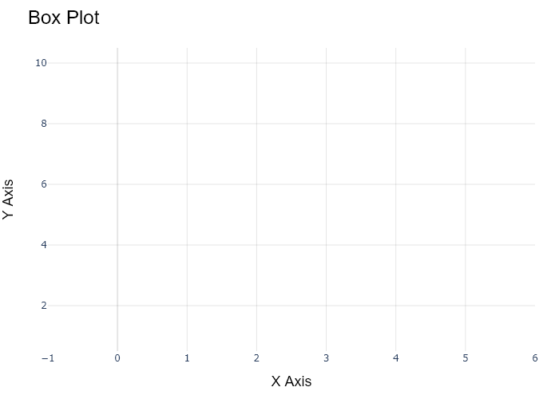

## Performance Metrics

|  |  |  |  |
| --- | --- | --- | --- |
| Task | Model Used | Description | Time Taken (s) |
| Processing Image to JSON | Gemini Vision Pro (default) | Time taken to convert the uploaded image to JSON format | 17.69 |
| Updating JSON | ChatGPT 3.5 (Default) | Time taken to update the JSON with new data | 0.00 |
| Plotting Updated JSON | N/A | Time taken to plot the updated JSON | 0.39 |

# Test Run



Figure: Charts\multilingual/box_plot_hindi.png

## Prompt Used

## Task: Extract Detailed Information from a Given Graph Image. Charts are multilingual, you have to extract the same language that is there in the graph.  
  
You will analyze a graph image and generate corresponding Plotly-compatible JSON files (`data.json`, `layout.json`, and `config.json`). Follow the structured steps and specific XML-like delimiters for each JSON section as outlined below.  
  
### Instructions:  
  
#### Graph Analysis:  
  
1. **Identify and Categorize Plot Types**:  
 - Recognize and categorize the plot types present in the graph image. Include both simple and complex plots, listed below:  
 - **Comparison Charts**:  
 - `bar`: Bar Chart  
 - `bar` (with vertical bars): Column Chart  
 - `bar` (grouped): Grouped Bar/Column Chart  
 - `scatter` (with lines connecting to points): Lollipop Chart  
 - `indicator` (with gauge): Bullet Chart  
 - `scatter`: Dot Plot  
 - `scatter` (with lines connecting different points): Dumbbell Chart  
 - `scatter` (or custom SVG): Pictogram  
 - `scatter` or `bar` with a range: Range Chart  
 - `barpolar`: Radial Bar Chart  
 - `parcoords`: Parallel Coordinates  
 - `scatterpolar`: Radar Chart  
 - `barpolar` (with segments): Nightingale Chart  
 - `waterfall`: Waterfall Chart  
 - `heatmap` (with color scale): Matrix Chart  
 - `various charts in small multiples`: Small Multiples  
 - `text` (frequency-based size): Word Cloud  
 - `scatter` (with lines indicating change): Slope Chart  
 - `table`: Table Chart  
 - `scatter`: Categorical Scatter Plot  
 - `scatter` (with four quadrants): Quadrant Chart  
 - **Correlation Charts**:  
 - `heatmap`: Heatmap  
 - `scatter` (with size): Bubble Chart  
 - `scatter`: Scatter Plot  
 - `scatter` (with lines connecting points): Connected Scatter Plot  
 - `hexbin`: Hexagonal Binning  
 - `contour`: Contour Plot  
 - **Part-to-Whole & Hierarchical Charts**:  
 - `bar` (stacked): Stacked Bar/Column Chart  
 - `bar` (with diverging sections): Diverging Bar Chart  
 - `bar` (mirrored pairs): Population Pyramid  
 - `scatter` (or custom symbols in a grid): Icon Array  
 - `waffle`: Waffle Chart  
 - `pie`: Pie Chart  
 - `pie` (with hole): Donut Chart  
 - `pie` (half-circle): Semi-circle Donut Chart  
 - `bar` (variable width): Marimekko Chart  
 - `treemap`: Treemap  
 - `treemap` (circular): Circular Treemap  
 - `treemap` (convex shape): Convex Treemap  
 - `sunburst`: Sunburst Chart  
 - `funnel` or `pyramid`: Funnel & Pyramid Chart  
 - `dendrogram`: Dendrogram  
 - `venn`: Venn Diagram  
 - `euler`: Euler Diagram  
 - `indicator` (circular gauge): Circular Gauge  
 - **Data Over Time (Temporal) Charts**:  
 - `scatter` (filled area under curve): Area Chart  
 - `scatter` (filled stacked areas): Stacked Area Chart  
 - `scatter` (smoothed filled areas): Stream Graph  
 - `scatter` (indicating ranking change): Bump Chart  
 - `scatter` (with filled area): Bump Area Chart  
 - `scatter`: Line Chart  
 - `scatter` (with smoothed lines): Spline Chart  
 - `scatter` (with stepped lines): Step Line Chart  
 - `candlestick`: Candlestick Chart  
 - `gantt`: Gantt Chart  
 - `scatter` (encoded lines): Barcode Chart  
 - `ohlc`: OHLC Chart  
 - **Distribution Charts**:  
 - `densitymapbox` or `histogram`: Density Plot  
 - `ridge`: Ridgeline Plot  
 - `horizon`: Horizon Chart  
 - `histogram`: Histogram  
 - `radial_histogram`: Radial Histogram  
 - `scatter` (with distribution): Strip Plot  
 - `scatter` (with jitter): Jitter Plot  
 - `heatmap`: One-dimensional Heatmap  
 - `scatter` (with tightly packed points): Beeswarm Chart  
 - `box`: Box Chart  
 - `violin`: Violin Plot  
 - **Geospatial & Other Charts**:  
 - `densitymapbox`: Geographic Heatmap  
 - `choropleth`: Choropleth Map  
 - `scattermapbox`: Tile Map  
 - `chord`: Chord Diagram  
 - `arc`: Arc Diagram  
 - `sankey`: Sankey  
 - `network`: Network Diagram  
 - `flowchart`: Flowchart  
  
2. **Extract Data Points** for Each Plot Type:  
 - Gather the data points for each identified plot type.  
 - For `scatter`, `line`, and `area` plots: Extract `x` and `y` values.  
 - For `bar` and `stacked bar` plots: Extract `x` (categories) and `y` values.  
 - For `pie` charts: Extract `labels` and `values`.  
 - For `scatter3d`, `surface`, and other 3D plots: Extract `x`, `y`, and `z` values.  
  
3. **Identify Multiple Plots** on the Same Figure:  
 - Note any combinations or overlays of multiple plot types on the same figure and their configurations, such as stacked plots or multiple area fills.  
  
#### Generate JSON and CSV Outputs:  
  
Follow the JSON formatting guidelines and wrap each section in the specified XML-like tags.  
  
1. **Generate `data.json`**:  
 - Include detailed information for each plot type:  
 - `type`: Specify the plot type (e.g., `"scatter"`, `"bar"`, `"pie"`, `"area"`, `"scatter3d"`, `"surface"`).  
 - For area charts, use `"type": "scatter"` and specify `"fill"`.  
 - `x`, `y`, and `z` (if applicable): Arrays of data points for each axis.  
 - `labels` and `values` for pie charts.  
 - `mode`: Specify for line and scatter plots (e.g., `"markers"`, `"lines"`, `"markers+lines"`).  
 - `name`: Legend entry for the plot.  
 - `marker`: Properties such as color, size, and symbol.  
 - `line`: Properties such as color, width, and dash style.  
 - `text`: Hover text for each data point.  
 - `hoverinfo`: Information displayed on hover (e.g., `"x+y+text"`).  
 - `fill`: For area charts, specify the fill (e.g., `"tozeroy"`, `"tonexty"`).  
 - `fillcolor`: The color used to fill the area.  
 - `stackgroup`: For stacked bar charts, specify the stacking group.  
  
2. **Generate `layout.json`**:  
 - Define the layout properties:  
 - `title`: Text and font properties for the graph title.  
 - `xaxis` and `yaxis`: Configuration for axis titles, ranges, grids, and ticks.  
 - `zaxis`: Configuration for 3D plots including title, range, and grid.  
 - `legend`: Properties for legend orientation and positioning.  
 - `margin`: Margins for left, right, bottom, top, and padding.  
 - `plot_bgcolor` and `paper_bgcolor`: Background colors.  
 - `scene`: Configuration for 3D scenes, including camera angles and aspect ratio.  
  
3. **Generate `config.json`**:  
 - Include settings such as:  
 - `responsive`: Whether the graph is responsive.  
 - `displayModeBar`: Whether the mode bar is shown.  
 - `modeBarButtonsToRemove`: List of mode bar buttons to remove.  
 - `scrollZoom`: Whether scrolling zoom is enabled.  
  
4. **Generate `<csv>`**:  
 - Format the CSV data as follows:  
 ```csv  
 x,y  
 1,4  
 2,5  
 3,6  
 ```  
 - Replace `x`, `y`, `1`, `4`, `2`, `5`, and `3`, `6` with the actual data from the graph image.  
  
### Output Format:  
  
Wrap each JSON output in the specified XML-like tags:  
  
- `<data> ... </data>`  
- `<layout> ... </layout>`  
- `<config> ... </config>`  
- `<csv> ... </csv>`  
  
Ensure the JSON format follows these rules:  
- Use double quotes for all keys and string values.  
- Do not include trailing commas in arrays or objects.  
  
### Example Output:  
  
```xml  
<data>  
[  
 {  
 "type": "scatter",  
 "x": [1, 2, 3],  
 "y": [4, 5, 6],  
 "mode": "markers+lines",  
 "name": "Line Plot",  
 "marker": {  
 "color": "rgba(75, 192, 192, 0.6)",  
 "size": 8  
 },  
 "line": {  
 "color": "rgba(75, 192, 192  
  
, 1)",  
 "width": 2  
 }  
 },  
 {  
 "type": "area",  
 "x": [1, 2, 3, 4, 5, 6, 7, 8, 9, 10, 11, 12],  
 "y": [400, 430, 550, 620, 580, 600, 630, 700, 670, 630, 600, 500],  
 "name": "Housing",  
 "marker": {  
 "color": "rgba(255, 159, 64, 0.8)"  
 },  
 "line": {  
 "color": "rgba(255, 159, 64, 1)",  
 "width": 2  
 }  
 },  
 {  
 "type": "bar",  
 "x": ["A", "B", "C"],  
 "y": [10, 15, 13],  
 "name": "Bar Chart",  
 "marker": {  
 "color": "rgba(255, 99, 132, 0.6)"  
 },  
 "hoverinfo": "x+y+text"  
 },  
 {  
 "type": "scatter",  
 "x": [1, 2, 3],  
 "y": [6, 7, 8],  
 "mode": "lines",  
 "fill": "tozeroy",  
 "name": "Area Chart",  
 "line": {  
 "color": "rgba(54, 162, 235, 1)",  
 "width": 2  
 },  
 "fillcolor": "rgba(54, 162, 235, 0.5)"  
 },  
 {  
 "type": "scatter3d",  
 "x": [1, 2, 3],  
 "y": [4, 5, 6],  
 "z": [7, 8, 9],  
 "mode": "markers",  
 "name": "3D Scatter Plot",  
 "marker": {  
 "color": "rgba(255, 159, 64, 0.8)",  
 "size": 5  
 },  
 "hoverinfo": "x+y+z+text"  
 },  
 {  
 "type": "surface",  
 "z": [  
 [10, 10.625, 12.5, 15.625, 20],  
 [5.625, 6.25, 8.125, 11.25, 15.625],  
 [0, 1.25, 3.125, 6.25, 10.625]  
 ],  
 "name": "Surface Plot",  
 "colorscale": "Viridis",  
 "hoverinfo": "z+name"  
 }  
]  
</data>  
<layout>  
{  
 "title": {  
 "text": "Complex Graph Example",  
 "font": {  
 "family": "Arial, sans-serif",  
 "size": 24,  
 "color": "#000000"  
 }  
 },  
 "xaxis": {  
 "title": {  
 "text": "X Axis",  
 "font": {  
 "family": "Arial, sans-serif",  
 "size": 18,  
 "color": "#000000"  
 }  
 },  
 "showgrid": true,  
 "gridcolor": "rgba(0, 0, 0, 0.1)",  
 "zeroline": true,  
 "zerolinecolor": "rgba(0, 0, 0, 0.1)"  
 },  
 "yaxis": {  
 "title": {  
 "text": "Y Axis",  
 "font": {  
 "family": "Arial, sans-serif",  
 "size": 18,  
 "color": "#000000"  
 }  
 },  
 "showgrid": true,  
 "gridcolor": "rgba(0, 0, 0, 0.1)",  
 "zeroline": true,  
 "zerolinecolor": "rgba(0, 0, 0, 0.1)"  
 },  
 "legend": {  
 "orientation": "h",  
 "x": 0.5,  
 "xanchor": "center",  
 "y": -0.2,  
 "font": {  
 "family": "Arial, sans-serif",  
 "size": 12,  
 "color": "#000000"  
 }  
 },  
 "margin": {  
 "l": 60,  
 "r": 30,  
 "b": 60,  
 "t": 60  
 },  
 "plot_bgcolor": "#ffffff",  
 "paper_bgcolor": "#ffffff",  
 "scene": {  
 "xaxis": {"title": "X Axis"},  
 "yaxis": {"title": "Y Axis"},  
 "zaxis": {"title": "Z Axis"}  
 }  
}  
</layout>  
<config>  
{  
 "responsive": true,  
 "displayModeBar": true,  
 "modeBarButtonsToRemove": ["toImage"],  
 "scrollZoom": true  
}  
</config>  
<csv>  
x,y  
1,4  
2,5  
3,6  
</csv>  
```

## Extracted JSON

### data

[  
 {  
 "type": "box",  
 "y": [  
 1,  
 2,  
 3,  
 4,  
 5,  
 6,  
 7,  
 8,  
 9,  
 10  
 ],  
 "name": "Box Plot",  
 "boxpoints": "all",  
 "jitter": 0.5,  
 "pointpos": -1.8,  
 "marker": {  
 "color": "rgba(75, 192, 192, 0.6)",  
 "size": 8  
 },  
 "line": {  
 "color": "rgba(75, 192, 192, 1)",  
 "width": 2  
 }  
 }  
]

### layout

{  
 "title": {  
 "text": "Box Plot",  
 "font": {  
 "family": "Arial, sans-serif",  
 "size": 24,  
 "color": "#000000"  
 }  
 },  
 "xaxis": {  
 "title": {  
 "text": "X Axis",  
 "font": {  
 "family": "Arial, sans-serif",  
 "size": 18,  
 "color": "#000000"  
 }  
 },  
 "showgrid": true,  
 "gridcolor": "rgba(0, 0, 0, 0.1)",  
 "zeroline": true,  
 "zerolinecolor": "rgba(0, 0, 0, 0.1)"  
 },  
 "yaxis": {  
 "title": {  
 "text": "Y Axis",  
 "font": {  
 "family": "Arial, sans-serif",  
 "size": 18,  
 "color": "#000000"  
 }  
 },  
 "showgrid": true,  
 "gridcolor": "rgba(0, 0, 0, 0.1)",  
 "zeroline": true,  
 "zerolinecolor": "rgba(0, 0, 0, 0.1)"  
 },  
 "legend": {  
 "orientation": "h",  
 "x": 0.5,  
 "xanchor": "center",  
 "y": -0.2,  
 "font": {  
 "family": "Arial, sans-serif",  
 "size": 12,  
 "color": "#000000"  
 }  
 },  
 "margin": {  
 "l": 60,  
 "r": 30,  
 "b": 60,  
 "t": 60  
 },  
 "plot_bgcolor": "#ffffff",  
 "paper_bgcolor": "#ffffff"  
}

### config

{  
 "responsive": true,  
 "displayModeBar": true,  
 "modeBarButtonsToRemove": [  
 "toImage"  
 ],  
 "scrollZoom": true  
}

## Updated JSON

### updated_data

[  
 {  
 "type": "box",  
 "y": [  
 1,  
 2,  
 3,  
 4,  
 5,  
 6,  
 7,  
 8,  
 9,  
 10  
 ],  
 "name": "Box Plot",  
 "boxpoints": "all",  
 "jitter": 0.5,  
 "pointpos": -1.8,  
 "marker": {  
 "color": "rgba(75, 192, 192, 0.6)",  
 "size": 8  
 },  
 "line": {  
 "color": "rgba(75, 192, 192, 1)",  
 "width": 2  
 }  
 }  
]

### updated_layout

{  
 "title": {  
 "text": "Box Plot",  
 "font": {  
 "family": "Arial, sans-serif",  
 "size": 24,  
 "color": "#000000"  
 }  
 },  
 "xaxis": {  
 "title": {  
 "text": "X Axis",  
 "font": {  
 "family": "Arial, sans-serif",  
 "size": 18,  
 "color": "#000000"  
 }  
 },  
 "showgrid": true,  
 "gridcolor": "rgba(0, 0, 0, 0.1)",  
 "zeroline": true,  
 "zerolinecolor": "rgba(0, 0, 0, 0.1)"  
 },  
 "yaxis": {  
 "title": {  
 "text": "Y Axis",  
 "font": {  
 "family": "Arial, sans-serif",  
 "size": 18,  
 "color": "#000000"  
 }  
 },  
 "showgrid": true,  
 "gridcolor": "rgba(0, 0, 0, 0.1)",  
 "zeroline": true,  
 "zerolinecolor": "rgba(0, 0, 0, 0.1)"  
 },  
 "legend": {  
 "orientation": "h",  
 "x": 0.5,  
 "xanchor": "center",  
 "y": -0.2,  
 "font": {  
 "family": "Arial, sans-serif",  
 "size": 12,  
 "color": "#000000"  
 }  
 },  
 "margin": {  
 "l": 60,  
 "r": 30,  
 "b": 60,  
 "t": 60  
 },  
 "plot_bgcolor": "#ffffff",  
 "paper_bgcolor": "#ffffff"  
}

### updated_config

{  
 "responsive": true,  
 "displayModeBar": true,  
 "modeBarButtonsToRemove": [  
 "toImage"  
 ],  
 "scrollZoom": true  
}

## Updated Chart



## Performance Metrics

|  |  |  |  |
| --- | --- | --- | --- |
| Task | Model Used | Description | Time Taken (s) |
| Processing Image to JSON | Gemini Vision Pro (default) | Time taken to convert the uploaded image to JSON format | 18.06 |
| Updating JSON | ChatGPT 3.5 (Default) | Time taken to update the JSON with new data | 0.00 |
| Plotting Updated JSON | N/A | Time taken to plot the updated JSON | 0.29 |

# Test Run

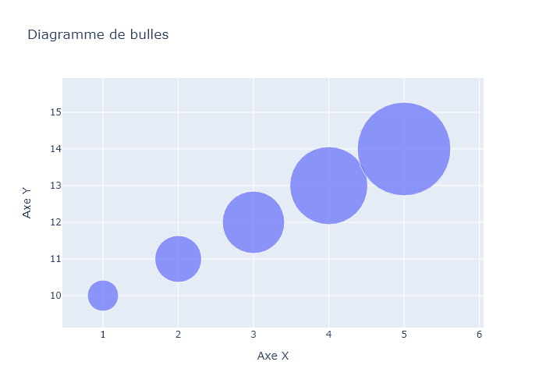

Figure: Charts\multilingual/bubble_chart_french.png

## Prompt Used

## Task: Extract Detailed Information from a Given Graph Image. Charts are multilingual, you have to extract the same language that is there in the graph.  
  
You will analyze a graph image and generate corresponding Plotly-compatible JSON files (`data.json`, `layout.json`, and `config.json`). Follow the structured steps and specific XML-like delimiters for each JSON section as outlined below.  
  
### Instructions:  
  
#### Graph Analysis:  
  
1. **Identify and Categorize Plot Types**:  
 - Recognize and categorize the plot types present in the graph image. Include both simple and complex plots, listed below:  
 - **Comparison Charts**:  
 - `bar`: Bar Chart  
 - `bar` (with vertical bars): Column Chart  
 - `bar` (grouped): Grouped Bar/Column Chart  
 - `scatter` (with lines connecting to points): Lollipop Chart  
 - `indicator` (with gauge): Bullet Chart  
 - `scatter`: Dot Plot  
 - `scatter` (with lines connecting different points): Dumbbell Chart  
 - `scatter` (or custom SVG): Pictogram  
 - `scatter` or `bar` with a range: Range Chart  
 - `barpolar`: Radial Bar Chart  
 - `parcoords`: Parallel Coordinates  
 - `scatterpolar`: Radar Chart  
 - `barpolar` (with segments): Nightingale Chart  
 - `waterfall`: Waterfall Chart  
 - `heatmap` (with color scale): Matrix Chart  
 - `various charts in small multiples`: Small Multiples  
 - `text` (frequency-based size): Word Cloud  
 - `scatter` (with lines indicating change): Slope Chart  
 - `table`: Table Chart  
 - `scatter`: Categorical Scatter Plot  
 - `scatter` (with four quadrants): Quadrant Chart  
 - **Correlation Charts**:  
 - `heatmap`: Heatmap  
 - `scatter` (with size): Bubble Chart  
 - `scatter`: Scatter Plot  
 - `scatter` (with lines connecting points): Connected Scatter Plot  
 - `hexbin`: Hexagonal Binning  
 - `contour`: Contour Plot  
 - **Part-to-Whole & Hierarchical Charts**:  
 - `bar` (stacked): Stacked Bar/Column Chart  
 - `bar` (with diverging sections): Diverging Bar Chart  
 - `bar` (mirrored pairs): Population Pyramid  
 - `scatter` (or custom symbols in a grid): Icon Array  
 - `waffle`: Waffle Chart  
 - `pie`: Pie Chart  
 - `pie` (with hole): Donut Chart  
 - `pie` (half-circle): Semi-circle Donut Chart  
 - `bar` (variable width): Marimekko Chart  
 - `treemap`: Treemap  
 - `treemap` (circular): Circular Treemap  
 - `treemap` (convex shape): Convex Treemap  
 - `sunburst`: Sunburst Chart  
 - `funnel` or `pyramid`: Funnel & Pyramid Chart  
 - `dendrogram`: Dendrogram  
 - `venn`: Venn Diagram  
 - `euler`: Euler Diagram  
 - `indicator` (circular gauge): Circular Gauge  
 - **Data Over Time (Temporal) Charts**:  
 - `scatter` (filled area under curve): Area Chart  
 - `scatter` (filled stacked areas): Stacked Area Chart  
 - `scatter` (smoothed filled areas): Stream Graph  
 - `scatter` (indicating ranking change): Bump Chart  
 - `scatter` (with filled area): Bump Area Chart  
 - `scatter`: Line Chart  
 - `scatter` (with smoothed lines): Spline Chart  
 - `scatter` (with stepped lines): Step Line Chart  
 - `candlestick`: Candlestick Chart  
 - `gantt`: Gantt Chart  
 - `scatter` (encoded lines): Barcode Chart  
 - `ohlc`: OHLC Chart  
 - **Distribution Charts**:  
 - `densitymapbox` or `histogram`: Density Plot  
 - `ridge`: Ridgeline Plot  
 - `horizon`: Horizon Chart  
 - `histogram`: Histogram  
 - `radial_histogram`: Radial Histogram  
 - `scatter` (with distribution): Strip Plot  
 - `scatter` (with jitter): Jitter Plot  
 - `heatmap`: One-dimensional Heatmap  
 - `scatter` (with tightly packed points): Beeswarm Chart  
 - `box`: Box Chart  
 - `violin`: Violin Plot  
 - **Geospatial & Other Charts**:  
 - `densitymapbox`: Geographic Heatmap  
 - `choropleth`: Choropleth Map  
 - `scattermapbox`: Tile Map  
 - `chord`: Chord Diagram  
 - `arc`: Arc Diagram  
 - `sankey`: Sankey  
 - `network`: Network Diagram  
 - `flowchart`: Flowchart  
  
2. **Extract Data Points** for Each Plot Type:  
 - Gather the data points for each identified plot type.  
 - For `scatter`, `line`, and `area` plots: Extract `x` and `y` values.  
 - For `bar` and `stacked bar` plots: Extract `x` (categories) and `y` values.  
 - For `pie` charts: Extract `labels` and `values`.  
 - For `scatter3d`, `surface`, and other 3D plots: Extract `x`, `y`, and `z` values.  
  
3. **Identify Multiple Plots** on the Same Figure:  
 - Note any combinations or overlays of multiple plot types on the same figure and their configurations, such as stacked plots or multiple area fills.  
  
#### Generate JSON and CSV Outputs:  
  
Follow the JSON formatting guidelines and wrap each section in the specified XML-like tags.  
  
1. **Generate `data.json`**:  
 - Include detailed information for each plot type:  
 - `type`: Specify the plot type (e.g., `"scatter"`, `"bar"`, `"pie"`, `"area"`, `"scatter3d"`, `"surface"`).  
 - For area charts, use `"type": "scatter"` and specify `"fill"`.  
 - `x`, `y`, and `z` (if applicable): Arrays of data points for each axis.  
 - `labels` and `values` for pie charts.  
 - `mode`: Specify for line and scatter plots (e.g., `"markers"`, `"lines"`, `"markers+lines"`).  
 - `name`: Legend entry for the plot.  
 - `marker`: Properties such as color, size, and symbol.  
 - `line`: Properties such as color, width, and dash style.  
 - `text`: Hover text for each data point.  
 - `hoverinfo`: Information displayed on hover (e.g., `"x+y+text"`).  
 - `fill`: For area charts, specify the fill (e.g., `"tozeroy"`, `"tonexty"`).  
 - `fillcolor`: The color used to fill the area.  
 - `stackgroup`: For stacked bar charts, specify the stacking group.  
  
2. **Generate `layout.json`**:  
 - Define the layout properties:  
 - `title`: Text and font properties for the graph title.  
 - `xaxis` and `yaxis`: Configuration for axis titles, ranges, grids, and ticks.  
 - `zaxis`: Configuration for 3D plots including title, range, and grid.  
 - `legend`: Properties for legend orientation and positioning.  
 - `margin`: Margins for left, right, bottom, top, and padding.  
 - `plot_bgcolor` and `paper_bgcolor`: Background colors.  
 - `scene`: Configuration for 3D scenes, including camera angles and aspect ratio.  
  
3. **Generate `config.json`**:  
 - Include settings such as:  
 - `responsive`: Whether the graph is responsive.  
 - `displayModeBar`: Whether the mode bar is shown.  
 - `modeBarButtonsToRemove`: List of mode bar buttons to remove.  
 - `scrollZoom`: Whether scrolling zoom is enabled.  
  
4. **Generate `<csv>`**:  
 - Format the CSV data as follows:  
 ```csv  
 x,y  
 1,4  
 2,5  
 3,6  
 ```  
 - Replace `x`, `y`, `1`, `4`, `2`, `5`, and `3`, `6` with the actual data from the graph image.  
  
### Output Format:  
  
Wrap each JSON output in the specified XML-like tags:  
  
- `<data> ... </data>`  
- `<layout> ... </layout>`  
- `<config> ... </config>`  
- `<csv> ... </csv>`  
  
Ensure the JSON format follows these rules:  
- Use double quotes for all keys and string values.  
- Do not include trailing commas in arrays or objects.  
  
### Example Output:  
  
```xml  
<data>  
[  
 {  
 "type": "scatter",  
 "x": [1, 2, 3],  
 "y": [4, 5, 6],  
 "mode": "markers+lines",  
 "name": "Line Plot",  
 "marker": {  
 "color": "rgba(75, 192, 192, 0.6)",  
 "size": 8  
 },  
 "line": {  
 "color": "rgba(75, 192, 192  
  
, 1)",  
 "width": 2  
 }  
 },  
 {  
 "type": "area",  
 "x": [1, 2, 3, 4, 5, 6, 7, 8, 9, 10, 11, 12],  
 "y": [400, 430, 550, 620, 580, 600, 630, 700, 670, 630, 600, 500],  
 "name": "Housing",  
 "marker": {  
 "color": "rgba(255, 159, 64, 0.8)"  
 },  
 "line": {  
 "color": "rgba(255, 159, 64, 1)",  
 "width": 2  
 }  
 },  
 {  
 "type": "bar",  
 "x": ["A", "B", "C"],  
 "y": [10, 15, 13],  
 "name": "Bar Chart",  
 "marker": {  
 "color": "rgba(255, 99, 132, 0.6)"  
 },  
 "hoverinfo": "x+y+text"  
 },  
 {  
 "type": "scatter",  
 "x": [1, 2, 3],  
 "y": [6, 7, 8],  
 "mode": "lines",  
 "fill": "tozeroy",  
 "name": "Area Chart",  
 "line": {  
 "color": "rgba(54, 162, 235, 1)",  
 "width": 2  
 },  
 "fillcolor": "rgba(54, 162, 235, 0.5)"  
 },  
 {  
 "type": "scatter3d",  
 "x": [1, 2, 3],  
 "y": [4, 5, 6],  
 "z": [7, 8, 9],  
 "mode": "markers",  
 "name": "3D Scatter Plot",  
 "marker": {  
 "color": "rgba(255, 159, 64, 0.8)",  
 "size": 5  
 },  
 "hoverinfo": "x+y+z+text"  
 },  
 {  
 "type": "surface",  
 "z": [  
 [10, 10.625, 12.5, 15.625, 20],  
 [5.625, 6.25, 8.125, 11.25, 15.625],  
 [0, 1.25, 3.125, 6.25, 10.625]  
 ],  
 "name": "Surface Plot",  
 "colorscale": "Viridis",  
 "hoverinfo": "z+name"  
 }  
]  
</data>  
<layout>  
{  
 "title": {  
 "text": "Complex Graph Example",  
 "font": {  
 "family": "Arial, sans-serif",  
 "size": 24,  
 "color": "#000000"  
 }  
 },  
 "xaxis": {  
 "title": {  
 "text": "X Axis",  
 "font": {  
 "family": "Arial, sans-serif",  
 "size": 18,  
 "color": "#000000"  
 }  
 },  
 "showgrid": true,  
 "gridcolor": "rgba(0, 0, 0, 0.1)",  
 "zeroline": true,  
 "zerolinecolor": "rgba(0, 0, 0, 0.1)"  
 },  
 "yaxis": {  
 "title": {  
 "text": "Y Axis",  
 "font": {  
 "family": "Arial, sans-serif",  
 "size": 18,  
 "color": "#000000"  
 }  
 },  
 "showgrid": true,  
 "gridcolor": "rgba(0, 0, 0, 0.1)",  
 "zeroline": true,  
 "zerolinecolor": "rgba(0, 0, 0, 0.1)"  
 },  
 "legend": {  
 "orientation": "h",  
 "x": 0.5,  
 "xanchor": "center",  
 "y": -0.2,  
 "font": {  
 "family": "Arial, sans-serif",  
 "size": 12,  
 "color": "#000000"  
 }  
 },  
 "margin": {  
 "l": 60,  
 "r": 30,  
 "b": 60,  
 "t": 60  
 },  
 "plot_bgcolor": "#ffffff",  
 "paper_bgcolor": "#ffffff",  
 "scene": {  
 "xaxis": {"title": "X Axis"},  
 "yaxis": {"title": "Y Axis"},  
 "zaxis": {"title": "Z Axis"}  
 }  
}  
</layout>  
<config>  
{  
 "responsive": true,  
 "displayModeBar": true,  
 "modeBarButtonsToRemove": ["toImage"],  
 "scrollZoom": true  
}  
</config>  
<csv>  
x,y  
1,4  
2,5  
3,6  
</csv>  
```

## Extracted JSON

### data

[  
 {  
 "type": "scatter",  
 "x": [  
 1,  
 2,  
 3,  
 4,  
 5,  
 6  
 ],  
 "y": [  
 10,  
 14,  
 12,  
 16,  
 18,  
 20  
 ],  
 "mode": "markers",  
 "name": "Scatter Plot",  
 "marker": {  
 "color": "rgba(255, 159, 64, 0.8)",  
 "size": 10  
 },  
 "hoverinfo": "x+y+text"  
 },  
 {  
 "type": "bar",  
 "x": [  
 "A",  
 "B",  
 "C",  
 "D",  
 "E"  
 ],  
 "y": [  
 10,  
 15,  
 13,  
 17,  
 11  
 ],  
 "name": "Bar Chart",  
 "marker": {  
 "color": "rgba(255, 99, 132, 0.6)"  
 },  
 "hoverinfo": "x+y+text"  
 },  
 {  
 "type": "pie",  
 "labels": [  
 "A",  
 "B",  
 "C",  
 "D"  
 ],  
 "values": [  
 10,  
 15,  
 13,  
 17  
 ],  
 "name": "Pie Chart",  
 "hoverinfo": "label+value+percent"  
 },  
 {  
 "type": "scatter",  
 "x": [  
 1,  
 2,  
 3,  
 4,  
 5,  
 6  
 ],  
 "y": [  
 10,  
 14,  
 12,  
 16,  
 18,  
 20  
 ],  
 "mode": "lines",  
 "name": "Line Chart",  
 "line": {  
 "color": "rgba(75, 192, 192, 1)",  
 "width": 2  
 },  
 "hoverinfo": "x+y+text"  
 },  
 {  
 "type": "scatter",  
 "x": [  
 1,  
 2,  
 3,  
 4,  
 5,  
 6  
 ],  
 "y": [  
 10,  
 14,  
 12,  
 16,  
 18,  
 20  
 ],  
 "mode": "lines+markers",  
 "name": "Line and Scatter Plot",  
 "line": {  
 "color": "rgba(75, 192, 192, 1)",  
 "width": 2  
 },  
 "marker": {  
 "color": "rgba(255, 159, 64, 0.8)",  
 "size": 10  
 },  
 "hoverinfo": "x+y+text"  
 },  
 {  
 "type": "area",  
 "x": [  
 1,  
 2,  
 3,  
 4,  
 5,  
 6  
 ],  
 "y": [  
 10,  
 14,  
 12,  
 16,  
 18,  
 20  
 ],  
 "name": "Area Chart",  
 "marker": {  
 "color": "rgba(255, 159, 64, 0.8)"  
 },  
 "line": {  
 "color": "rgba(255, 159, 64, 1)",  
 "width": 2  
 },  
 "fill": "tozeroy",  
 "hoverinfo": "x+y+text"  
 },  
 {  
 "type": "bar",  
 "x": [  
 "A",  
 "B",  
 "C",  
 "D",  
 "E"  
 ],  
 "y": [  
 10,  
 15,  
 13,  
 17,  
 11  
 ],  
 "name": "Stacked Bar Chart",  
 "marker": {  
 "color": "rgba(255, 99, 132, 0.6)"  
 },  
 "hoverinfo": "x+y+text"  
 },  
 {  
 "type": "scatter",  
 "x": [  
 1,  
 2,  
 3,  
 4,  
 5,  
 6  
 ],  
 "y": [  
 10,  
 14,  
 12,  
 16,  
 18,  
 20  
 ],  
 "mode": "markers",  
 "name": "Bubble Chart",  
 "marker": {  
 "color": "rgba(255, 159, 64, 0.8)",  
 "size": [  
 10,  
 14,  
 12,  
 16,  
 18,  
 20  
 ]  
 },  
 "hoverinfo": "x+y+text"  
 },  
 {  
 "type": "heatmap",  
 "x": [  
 "A",  
 "B",  
 "C",  
 "D",  
 "E"  
 ],  
 "y": [  
 "Q1",  
 "Q2",  
 "Q3",  
 "Q4"  
 ],  
 "z": [  
 [  
 10,  
 14,  
 12,  
 16,  
 18  
 ],  
 [  
 14,  
 12,  
 16,  
 18,  
 20  
 ],  
 [  
 12,  
 16,  
 18,  
 20,  
 10  
 ],  
 [  
 16,  
 18,  
 20,  
 10,  
 14  
 ],  
 [  
 18,  
 20,  
 10,  
 14,  
 12  
 ]  
 ],  
 "name": "Heatmap",  
 "hoverinfo": "x+y+z+text"  
 }  
]

### layout

{  
 "title": {  
 "text": "Complex Graph Example",  
 "font": {  
 "family": "Arial, sans-serif",  
 "size": 24,  
 "color": "#000000"  
 }  
 },  
 "xaxis": {  
 "title": {  
 "text": "X Axis",  
 "font": {  
 "family": "Arial, sans-serif",  
 "size": 18,  
 "color": "#000000"  
 }  
 },  
 "showgrid": true,  
 "gridcolor": "rgba(0, 0, 0, 0.1)",  
 "zeroline": true,  
 "zerolinecolor": "rgba(0, 0, 0, 0.1)"  
 },  
 "yaxis": {  
 "title": {  
 "text": "Y Axis",  
 "font": {  
 "family": "Arial, sans-serif",  
 "size": 18,  
 "color": "#000000"  
 }  
 },  
 "showgrid": true,  
 "gridcolor": "rgba(0, 0, 0, 0.1)",  
 "zeroline": true,  
 "zerolinecolor": "rgba(0, 0, 0, 0.1)"  
 },  
 "legend": {  
 "orientation": "h",  
 "x": 0.5,  
 "xanchor": "center",  
 "y": -0.2,  
 "font": {  
 "family": "Arial, sans-serif",  
 "size": 12,  
 "color": "#000000"  
 }  
 },  
 "margin": {  
 "l": 60,  
 "r": 30,  
 "b": 60,  
 "t": 60  
 },  
 "plot_bgcolor": "#ffffff",  
 "paper_bgcolor": "#ffffff"  
}

### config

{  
 "responsive": true,  
 "displayModeBar": true,  
 "modeBarButtonsToRemove": [  
 "toImage"  
 ],  
 "scrollZoom": true  
}

## Updated JSON

### updated_data

[  
 {  
 "type": "scatter",  
 "x": [  
 1,  
 2,  
 3,  
 4,  
 5,  
 6  
 ],  
 "y": [  
 10,  
 14,  
 12,  
 16,  
 18,  
 20  
 ],  
 "mode": "markers",  
 "name": "Scatter Plot",  
 "marker": {  
 "color": "rgba(255, 159, 64, 0.8)",  
 "size": 10  
 },  
 "hoverinfo": "x+y+text"  
 },  
 {  
 "type": "bar",  
 "x": [  
 "A",  
 "B",  
 "C",  
 "D",  
 "E"  
 ],  
 "y": [  
 10,  
 15,  
 13,  
 17,  
 11  
 ],  
 "name": "Bar Chart",  
 "marker": {  
 "color": "rgba(255, 99, 132, 0.6)"  
 },  
 "hoverinfo": "x+y+text"  
 },  
 {  
 "type": "pie",  
 "labels": [  
 "A",  
 "B",  
 "C",  
 "D"  
 ],  
 "values": [  
 10,  
 15,  
 13,  
 17  
 ],  
 "name": "Pie Chart",  
 "hoverinfo": "label+value+percent"  
 },  
 {  
 "type": "scatter",  
 "x": [  
 1,  
 2,  
 3,  
 4,  
 5,  
 6  
 ],  
 "y": [  
 10,  
 14,  
 12,  
 16,  
 18,  
 20  
 ],  
 "mode": "lines",  
 "name": "Line Chart",  
 "line": {  
 "color": "rgba(75, 192, 192, 1)",  
 "width": 2  
 },  
 "hoverinfo": "x+y+text"  
 },  
 {  
 "type": "scatter",  
 "x": [  
 1,  
 2,  
 3,  
 4,  
 5,  
 6  
 ],  
 "y": [  
 10,  
 14,  
 12,  
 16,  
 18,  
 20  
 ],  
 "mode": "lines+markers",  
 "name": "Line and Scatter Plot",  
 "line": {  
 "color": "rgba(75, 192, 192, 1)",  
 "width": 2  
 },  
 "marker": {  
 "color": "rgba(255, 159, 64, 0.8)",  
 "size": 10  
 },  
 "hoverinfo": "x+y+text"  
 },  
 {  
 "type": "area",  
 "x": [  
 1,  
 2,  
 3,  
 4,  
 5,  
 6  
 ],  
 "y": [  
 10,  
 14,  
 12,  
 16,  
 18,  
 20  
 ],  
 "name": "Area Chart",  
 "marker": {  
 "color": "rgba(255, 159, 64, 0.8)"  
 },  
 "line": {  
 "color": "rgba(255, 159, 64, 1)",  
 "width": 2  
 },  
 "fill": "tozeroy",  
 "hoverinfo": "x+y+text"  
 },  
 {  
 "type": "bar",  
 "x": [  
 "A",  
 "B",  
 "C",  
 "D",  
 "E"  
 ],  
 "y": [  
 10,  
 15,  
 13,  
 17,  
 11  
 ],  
 "name": "Stacked Bar Chart",  
 "marker": {  
 "color": "rgba(255, 99, 132, 0.6)"  
 },  
 "hoverinfo": "x+y+text"  
 },  
 {  
 "type": "scatter",  
 "x": [  
 1,  
 2,  
 3,  
 4,  
 5,  
 6  
 ],  
 "y": [  
 10,  
 14,  
 12,  
 16,  
 18,  
 20  
 ],  
 "mode": "markers",  
 "name": "Bubble Chart",  
 "marker": {  
 "color": "rgba(255, 159, 64, 0.8)",  
 "size": [  
 10,  
 14,  
 12,  
 16,  
 18,  
 20  
 ]  
 },  
 "hoverinfo": "x+y+text"  
 },  
 {  
 "type": "heatmap",  
 "x": [  
 "A",  
 "B",  
 "C",  
 "D",  
 "E"  
 ],  
 "y": [  
 "Q1",  
 "Q2",  
 "Q3",  
 "Q4"  
 ],  
 "z": [  
 [  
 10,  
 14,  
 12,  
 16,  
 18  
 ],  
 [  
 14,  
 12,  
 16,  
 18,  
 20  
 ],  
 [  
 12,  
 16,  
 18,  
 20,  
 10  
 ],  
 [  
 16,  
 18,  
 20,  
 10,  
 14  
 ],  
 [  
 18,  
 20,  
 10,  
 14,  
 12  
 ]  
 ],  
 "name": "Heatmap",  
 "hoverinfo": "x+y+z+text"  
 }  
]

### updated_layout

{  
 "title": {  
 "text": "Complex Graph Example",  
 "font": {  
 "family": "Arial, sans-serif",  
 "size": 24,  
 "color": "#000000"  
 }  
 },  
 "xaxis": {  
 "title": {  
 "text": "X Axis",  
 "font": {  
 "family": "Arial, sans-serif",  
 "size": 18,  
 "color": "#000000"  
 }  
 },  
 "showgrid": true,  
 "gridcolor": "rgba(0, 0, 0, 0.1)",  
 "zeroline": true,  
 "zerolinecolor": "rgba(0, 0, 0, 0.1)"  
 },  
 "yaxis": {  
 "title": {  
 "text": "Y Axis",  
 "font": {  
 "family": "Arial, sans-serif",  
 "size": 18,  
 "color": "#000000"  
 }  
 },  
 "showgrid": true,  
 "gridcolor": "rgba(0, 0, 0, 0.1)",  
 "zeroline": true,  
 "zerolinecolor": "rgba(0, 0, 0, 0.1)"  
 },  
 "legend": {  
 "orientation": "h",  
 "x": 0.5,  
 "xanchor": "center",  
 "y": -0.2,  
 "font": {  
 "family": "Arial, sans-serif",  
 "size": 12,  
 "color": "#000000"  
 }  
 },  
 "margin": {  
 "l": 60,  
 "r": 30,  
 "b": 60,  
 "t": 60  
 },  
 "plot_bgcolor": "#ffffff",  
 "paper_bgcolor": "#ffffff"  
}

### updated_config

{  
 "responsive": true,  
 "displayModeBar": true,  
 "modeBarButtonsToRemove": [  
 "toImage"  
 ],  
 "scrollZoom": true  
}

## Updated Chart

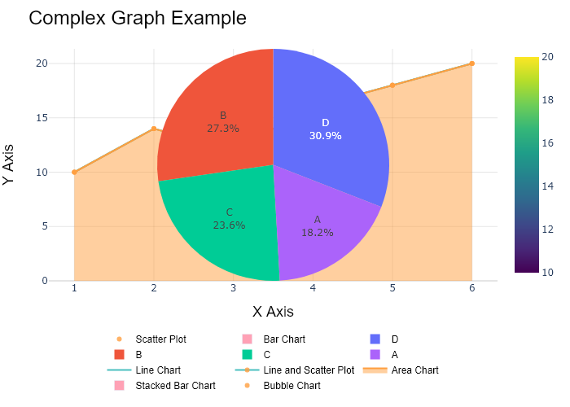

## Performance Metrics

|  |  |  |  |
| --- | --- | --- | --- |
| Task | Model Used | Description | Time Taken (s) |
| Processing Image to JSON | Gemini Vision Pro (default) | Time taken to convert the uploaded image to JSON format | 33.51 |
| Updating JSON | ChatGPT 3.5 (Default) | Time taken to update the JSON with new data | 0.00 |
| Plotting Updated JSON | N/A | Time taken to plot the updated JSON | 0.43 |

# Test Run



Figure: Charts\multilingual/bubble_chart_french.png

## Prompt Used

## Task: Extract Detailed Information from a Given Graph Image. Charts are multilingual, you have to extract the same language that is there in the graph.  
  
You will analyze a graph image and generate corresponding Plotly-compatible JSON files (`data.json`, `layout.json`, and `config.json`). Follow the structured steps and specific XML-like delimiters for each JSON section as outlined below.  
  
### Instructions:  
  
#### Graph Analysis:  
  
1. **Identify and Categorize Plot Types**:  
 - Recognize and categorize the plot types present in the graph image. Charts may include but are not limited to the following types:  
 - **Comparison Charts**:  
 - `bar`: Bar Chart  
 - `bar` (with vertical bars): Column Chart  
 - `bar` (grouped): Grouped Bar/Column Chart  
 - `scatter` (with lines connecting to points): Lollipop Chart  
 - `indicator` (with gauge): Bullet Chart  
 - `scatter`: Dot Plot  
 - `scatter` (with lines connecting different points): Dumbbell Chart  
 - `scatter` (or custom SVG): Pictogram  
 - `scatter` or `bar` with a range: Range Chart  
 - `barpolar`: Radial Bar Chart  
 - `parcoords`: Parallel Coordinates  
 - `scatterpolar`: Radar Chart  
 - `barpolar` (with segments): Nightingale Chart  
 - `waterfall`: Waterfall Chart  
 - `heatmap` (with color scale): Matrix Chart  
 - `various charts in small multiples`: Small Multiples  
 - `text` (frequency-based size): Word Cloud  
 - `scatter` (with lines indicating change): Slope Chart  
 - `table`: Table Chart  
 - `scatter`: Categorical Scatter Plot  
 - `scatter` (with four quadrants): Quadrant Chart  
 - **Correlation Charts**:  
 - `heatmap`: Heatmap  
 - `scatter` (with size): Bubble Chart  
 - `scatter`: Scatter Plot  
 - `scatter` (with lines connecting points): Connected Scatter Plot  
 - `hexbin`: Hexagonal Binning  
 - `contour`: Contour Plot  
 - **Part-to-Whole & Hierarchical Charts**:  
 - `bar` (stacked): Stacked Bar/Column Chart  
 - `bar` (with diverging sections): Diverging Bar Chart  
 - `bar` (mirrored pairs): Population Pyramid  
 - `scatter` (or custom symbols in a grid): Icon Array  
 - `waffle`: Waffle Chart  
 - `pie`: Pie Chart  
 - `pie` (with hole): Donut Chart  
 - `pie` (half-circle): Semi-circle Donut Chart  
 - `bar` (variable width): Marimekko Chart  
 - `treemap`: Treemap  
 - `treemap` (circular): Circular Treemap  
 - `treemap` (convex shape): Convex Treemap  
 - `sunburst`: Sunburst Chart  
 - `funnel` or `pyramid`: Funnel & Pyramid Chart  
 - `dendrogram`: Dendrogram  
 - `venn`: Venn Diagram  
 - `euler`: Euler Diagram  
 - `indicator` (circular gauge): Circular Gauge  
 - **Data Over Time (Temporal) Charts**:  
 - `scatter` (filled area under curve): Area Chart  
 - `scatter` (filled stacked areas): Stacked Area Chart  
 - `scatter` (smoothed filled areas): Stream Graph  
 - `scatter` (indicating ranking change): Bump Chart  
 - `scatter` (with filled area): Bump Area Chart  
 - `scatter`: Line Chart  
 - `scatter` (with smoothed lines): Spline Chart  
 - `scatter` (with stepped lines): Step Line Chart  
 - `candlestick`: Candlestick Chart  
 - `gantt`: Gantt Chart  
 - `scatter` (encoded lines): Barcode Chart  
 - `ohlc`: OHLC Chart  
 - **Distribution Charts**:  
 - `densitymapbox` or `histogram`: Density Plot  
 - `ridge`: Ridgeline Plot  
 - `horizon`: Horizon Chart  
 - `histogram`: Histogram  
 - `radial_histogram`: Radial Histogram  
 - `scatter` (with distribution): Strip Plot  
 - `scatter` (with jitter): Jitter Plot  
 - `heatmap`: One-dimensional Heatmap  
 - `scatter` (with tightly packed points): Beeswarm Chart  
 - `box`: Box Chart  
 - `violin`: Violin Plot  
 - **Geospatial & Other Charts**:  
 - `densitymapbox`: Geographic Heatmap  
 - `choropleth`: Choropleth Map  
 - `scattermapbox`: Tile Map  
 - `chord`: Chord Diagram  
 - `arc`: Arc Diagram  
 - `sankey`: Sankey  
 - `network`: Network Diagram  
 - `flowchart`: Flowchart  
  
2. **Extract Data Points** for Each Plot Type:  
 - Gather the data points for each identified plot type.  
 - For `scatter`, `line`, and `area` plots: Extract `x` and `y` values.  
 - For `bar` and `stacked bar` plots: Extract `x` (categories) and `y` values.  
 - For `pie` charts: Extract `labels` and `values`.  
 - For `scatter3d`, `surface`, and other 3D plots: Extract `x`, `y`, and `z` values.  
  
3. **Identify Multiple Plots** on the Same Figure:  
 - Note any combinations or overlays of multiple plot types on the same figure and their configurations, such as stacked plots or multiple area fills.  
  
#### Generate JSON and CSV Outputs:  
  
Follow the JSON formatting guidelines and wrap each section in the specified XML-like tags.  
  
1. **Generate `data.json`**:  
 - Include detailed information for each plot type:  
 - `type`: Specify the plot type (e.g., `"scatter"`, `"bar"`, `"pie"`, `"area"`, `"scatter3d"`, `"surface"`).  
 - For area charts, use `"type": "scatter"` and specify `"fill"`.  
 - `x`, `y`, and `z` (if applicable): Arrays of data points for each axis.  
 - `labels` and `values` for pie charts.  
 - `mode`: Specify for line and scatter plots (e.g., `"markers"`, `"lines"`, `"markers+lines"`).  
 - `name`: Legend entry for the plot.  
 - `marker`: Properties such as color, size, and symbol.  
 - `line`: Properties such as color, width, and dash style.  
 - `text`: Hover text for each data point.  
 - `hoverinfo`: Information displayed on hover (e.g., `"x+y+text"`).  
 - `fill`: For area charts, specify the fill (e.g., `"tozeroy"`, `"tonexty"`).  
 - `fillcolor`: The color used to fill the area.  
 - `stackgroup`: For stacked bar charts, specify the stacking group.  
  
2. **Generate `layout.json`**:  
 - Define the layout properties:  
 - `title`: Text and font properties for the graph title.  
 - `xaxis` and `yaxis`: Configuration for axis titles, ranges, grids, and ticks.  
 - `zaxis`: Configuration for 3D plots including title, range, and grid.  
 - `legend`: Properties for legend orientation and positioning.  
 - `margin`: Margins for left, right, bottom, top, and padding.  
 - `plot_bgcolor` and `paper_bgcolor`: Background colors.  
 - `scene`: Configuration for 3D scenes, including camera angles and aspect ratio.  
  
3. **Generate `config.json`**:  
 - Include settings such as:  
 - `responsive`: Whether the graph is responsive.  
 - `displayModeBar`: Whether the mode bar is shown.  
 - `modeBarButtonsToRemove`: List of mode bar buttons to remove.  
 - `scrollZoom`: Whether scrolling zoom is enabled.  
  
4. **Generate `<csv>`**:  
 - Format the CSV data as follows:  
 ```csv  
 x,y  
 1,4  
 2,5  
 3,6  
 ```  
 - Replace `x`, `y`, `1`, `4`, `2`, `5`, and `3`, `6` with the actual data from the graph image.  
  
### Output Format:  
  
Wrap each JSON output in the specified XML-like tags:  
  
- `<data> ... </data>`  
- `<layout> ... </layout>`  
- `<config> ... </config>`  
- `<csv> ... </csv>`  
  
Ensure the JSON format follows these rules:  
- Use double quotes for all keys and string values.  
- Do not include trailing commas in arrays or objects.  
  
### Example Output:  
  
```xml  
<data>  
[  
 {  
 "type": "scatter",  
 "x": [1, 2, 3],  
 "y": [4, 5, 6],  
 "mode": "markers+lines",  
 "name": "Line Plot",  
 "marker": {  
 "color": "rgba(75, 192, 192, 0.6)",  
 "size": 8  
 },  
 "line": {  
 "color": "rgba(75, 192, 192  
  
, 1)",  
 "width": 2  
 }  
 },  
 {  
 "type": "area",  
 "x": [1, 2, 3, 4, 5, 6, 7, 8, 9, 10, 11, 12],  
 "y": [400, 430, 550, 620, 580, 600, 630, 700, 670, 630, 600, 500],  
 "name": "Housing",  
 "marker": {  
 "color": "rgba(255, 159, 64, 0.8)"  
 },  
 "line": {  
 "color": "rgba(255, 159, 64, 1)",  
 "width": 2  
 }  
 },  
 {  
 "type": "bar",  
 "x": ["A", "B", "C"],  
 "y": [10, 15, 13],  
 "name": "Bar Chart",  
 "marker": {  
 "color": "rgba(255, 99, 132, 0.6)"  
 },  
 "hoverinfo": "x+y+text"  
 },  
 {  
 "type": "scatter",  
 "x": [1, 2, 3],  
 "y": [6, 7, 8],  
 "mode": "lines",  
 "fill": "tozeroy",  
 "name": "Area Chart",  
 "line": {  
 "color": "rgba(54, 162, 235, 1)",  
 "width": 2  
 },  
 "fillcolor": "rgba(54, 162, 235, 0.5)"  
 },  
 {  
 "type": "scatter3d",  
 "x": [1, 2, 3],  
 "y": [4, 5, 6],  
 "z": [7, 8, 9],  
 "mode": "markers",  
 "name": "3D Scatter Plot",  
 "marker": {  
 "color": "rgba(255, 159, 64, 0.8)",  
 "size": 5  
 },  
 "hoverinfo": "x+y+z+text"  
 },  
 {  
 "type": "surface",  
 "z": [  
 [10, 10.625, 12.5, 15.625, 20],  
 [5.625, 6.25, 8.125, 11.25, 15.625],  
 [0, 1.25, 3.125, 6.25, 10.625]  
 ],  
 "name": "Surface Plot",  
 "colorscale": "Viridis",  
 "hoverinfo": "z+name"  
 }  
]  
</data>  
<layout>  
{  
 "title": {  
 "text": "Complex Graph Example",  
 "font": {  
 "family": "Arial, sans-serif",  
 "size": 24,  
 "color": "#000000"  
 }  
 },  
 "xaxis": {  
 "title": {  
 "text": "X Axis",  
 "font": {  
 "family": "Arial, sans-serif",  
 "size": 18,  
 "color": "#000000"  
 }  
 },  
 "showgrid": true,  
 "gridcolor": "rgba(0, 0, 0, 0.1)",  
 "zeroline": true,  
 "zerolinecolor": "rgba(0, 0, 0, 0.1)"  
 },  
 "yaxis": {  
 "title": {  
 "text": "Y Axis",  
 "font": {  
 "family": "Arial, sans-serif",  
 "size": 18,  
 "color": "#000000"  
 }  
 },  
 "showgrid": true,  
 "gridcolor": "rgba(0, 0, 0, 0.1)",  
 "zeroline": true,  
 "zerolinecolor": "rgba(0, 0, 0, 0.1)"  
 },  
 "legend": {  
 "orientation": "h",  
 "x": 0.5,  
 "xanchor": "center",  
 "y": -0.2,  
 "font": {  
 "family": "Arial, sans-serif",  
 "size": 12,  
 "color": "#000000"  
 }  
 },  
 "margin": {  
 "l": 60,  
 "r": 30,  
 "b": 60,  
 "t": 60  
 },  
 "plot_bgcolor": "#ffffff",  
 "paper_bgcolor": "#ffffff",  
 "scene": {  
 "xaxis": {"title": "X Axis"},  
 "yaxis": {"title": "Y Axis"},  
 "zaxis": {"title": "Z Axis"}  
 }  
}  
</layout>  
<config>  
{  
 "responsive": true,  
 "displayModeBar": true,  
 "modeBarButtonsToRemove": ["toImage"],  
 "scrollZoom": true  
}  
</config>  
<csv>  
x,y  
1,4  
2,5  
3,6  
</csv>  
```

## Extracted JSON

### data

[  
 {  
 "type": "scatter",  
 "x": [  
 1,  
 2,  
 3,  
 4,  
 5,  
 6  
 ],  
 "y": [  
 10,  
 14,  
 12,  
 16,  
 18,  
 20  
 ],  
 "mode": "markers",  
 "name": "Bubble Chart",  
 "marker": {  
 "size": [  
 10,  
 20,  
 30,  
 40,  
 50,  
 60  
 ],  
 "color": "rgba(255, 159, 64, 0.8)"  
 },  
 "hoverinfo": "x+y+text"  
 }  
]

### layout

{  
 "title": {  
 "text": "Bubble Chart Example",  
 "font": {  
 "family": "Arial, sans-serif",  
 "size": 24,  
 "color": "#000000"  
 }  
 },  
 "xaxis": {  
 "title": {  
 "text": "X Axis",  
 "font": {  
 "family": "Arial, sans-serif",  
 "size": 18,  
 "color": "#000000"  
 }  
 },  
 "showgrid": true,  
 "gridcolor": "rgba(0, 0, 0, 0.1)",  
 "zeroline": true,  
 "zerolinecolor": "rgba(0, 0, 0, 0.1)"  
 },  
 "yaxis": {  
 "title": {  
 "text": "Y Axis",  
 "font": {  
 "family": "Arial, sans-serif",  
 "size": 18,  
 "color": "#000000"  
 }  
 },  
 "showgrid": true,  
 "gridcolor": "rgba(0, 0, 0, 0.1)",  
 "zeroline": true,  
 "zerolinecolor": "rgba(0, 0, 0, 0.1)"  
 },  
 "legend": {  
 "orientation": "h",  
 "x": 0.5,  
 "xanchor": "center",  
 "y": -0.2,  
 "font": {  
 "family": "Arial, sans-serif",  
 "size": 12,  
 "color": "#000000"  
 }  
 },  
 "margin": {  
 "l": 60,  
 "r": 30,  
 "b": 60,  
 "t": 60  
 },  
 "plot_bgcolor": "#ffffff",  
 "paper_bgcolor": "#ffffff"  
}

### config

{  
 "responsive": true,  
 "displayModeBar": true,  
 "modeBarButtonsToRemove": [  
 "toImage"  
 ],  
 "scrollZoom": true  
}

## Updated JSON

### updated_data

[  
 {  
 "type": "scatter",  
 "x": [  
 1,  
 2,  
 3,  
 4,  
 5,  
 6  
 ],  
 "y": [  
 10,  
 14,  
 12,  
 16,  
 18,  
 20  
 ],  
 "mode": "markers",  
 "name": "Bubble Chart",  
 "marker": {  
 "size": [  
 10,  
 20,  
 30,  
 40,  
 50,  
 60  
 ],  
 "color": "rgba(255, 159, 64, 0.8)"  
 },  
 "hoverinfo": "x+y+text"  
 }  
]

### updated_layout

{  
 "title": {  
 "text": "Bubble Chart Example",  
 "font": {  
 "family": "Arial, sans-serif",  
 "size": 24,  
 "color": "#000000"  
 }  
 },  
 "xaxis": {  
 "title": {  
 "text": "X Axis",  
 "font": {  
 "family": "Arial, sans-serif",  
 "size": 18,  
 "color": "#000000"  
 }  
 },  
 "showgrid": true,  
 "gridcolor": "rgba(0, 0, 0, 0.1)",  
 "zeroline": true,  
 "zerolinecolor": "rgba(0, 0, 0, 0.1)"  
 },  
 "yaxis": {  
 "title": {  
 "text": "Y Axis",  
 "font": {  
 "family": "Arial, sans-serif",  
 "size": 18,  
 "color": "#000000"  
 }  
 },  
 "showgrid": true,  
 "gridcolor": "rgba(0, 0, 0, 0.1)",  
 "zeroline": true,  
 "zerolinecolor": "rgba(0, 0, 0, 0.1)"  
 },  
 "legend": {  
 "orientation": "h",  
 "x": 0.5,  
 "xanchor": "center",  
 "y": -0.2,  
 "font": {  
 "family": "Arial, sans-serif",  
 "size": 12,  
 "color": "#000000"  
 }  
 },  
 "margin": {  
 "l": 60,  
 "r": 30,  
 "b": 60,  
 "t": 60  
 },  
 "plot_bgcolor": "#ffffff",  
 "paper_bgcolor": "#ffffff"  
}

### updated_config

{  
 "responsive": true,  
 "displayModeBar": true,  
 "modeBarButtonsToRemove": [  
 "toImage"  
 ],  
 "scrollZoom": true  
}

## Updated Chart

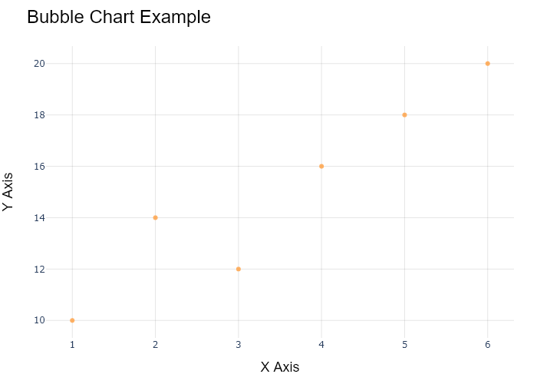

## Performance Metrics

|  |  |  |  |
| --- | --- | --- | --- |
| Task | Model Used | Description | Time Taken (s) |
| Processing Image to JSON | Gemini Vision Pro (default) | Time taken to convert the uploaded image to JSON format | 17.47 |
| Updating JSON | ChatGPT 3.5 (Default) | Time taken to update the JSON with new data | 0.00 |
| Plotting Updated JSON | N/A | Time taken to plot the updated JSON | 0.13 |

# Test Run

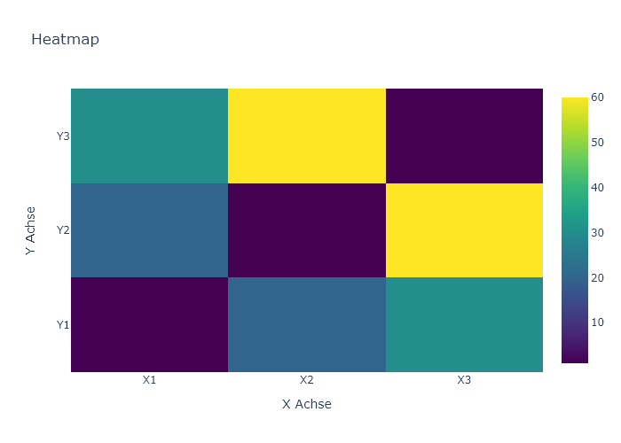

Figure: Charts\multilingual\heatmap_german.png

## Prompt Used

## Task: Extract Detailed Information from a Given Graph Image. Charts are multilingual, you have to extract the same language that is there in the graph.  
  
You will analyze a graph image and generate corresponding Plotly-compatible JSON files (`data.json`, `layout.json`, and `config.json`). Follow the structured steps and specific XML-like delimiters for each JSON section as outlined below.  
  
### Instructions:  
  
#### Graph Analysis:  
  
1. **Identify and Categorize Plot Types**:  
 - Recognize and categorize the plot types present in the graph image. Charts may include but are not limited to the following types:  
 - **Comparison Charts**:  
 - `bar`: Bar Chart  
 - `bar` (with vertical bars): Column Chart  
 - `bar` (grouped): Grouped Bar/Column Chart  
 - `scatter` (with lines connecting to points): Lollipop Chart  
 - `indicator` (with gauge): Bullet Chart  
 - `scatter`: Dot Plot  
 - `scatter` (with lines connecting different points): Dumbbell Chart  
 - `scatter` (or custom SVG): Pictogram  
 - `scatter` or `bar` with a range: Range Chart  
 - `barpolar`: Radial Bar Chart  
 - `parcoords`: Parallel Coordinates  
 - `scatterpolar`: Radar Chart  
 - `barpolar` (with segments): Nightingale Chart  
 - `waterfall`: Waterfall Chart  
 - `heatmap` (with color scale): Matrix Chart  
 - `various charts in small multiples`: Small Multiples  
 - `text` (frequency-based size): Word Cloud  
 - `scatter` (with lines indicating change): Slope Chart  
 - `table`: Table Chart  
 - `scatter`: Categorical Scatter Plot  
 - `scatter` (with four quadrants): Quadrant Chart  
 - **Correlation Charts**:  
 - `heatmap`: Heatmap  
 - `scatter` (with size): Bubble Chart  
 - `scatter`: Scatter Plot  
 - `scatter` (with lines connecting points): Connected Scatter Plot  
 - `hexbin`: Hexagonal Binning  
 - `contour`: Contour Plot  
 - **Part-to-Whole & Hierarchical Charts**:  
 - `bar` (stacked): Stacked Bar/Column Chart  
 - `bar` (with diverging sections): Diverging Bar Chart  
 - `bar` (mirrored pairs): Population Pyramid  
 - `scatter` (or custom symbols in a grid): Icon Array  
 - `waffle`: Waffle Chart  
 - `pie`: Pie Chart  
 - `pie` (with hole): Donut Chart  
 - `pie` (half-circle): Semi-circle Donut Chart  
 - `bar` (variable width): Marimekko Chart  
 - `treemap`: Treemap  
 - `treemap` (circular): Circular Treemap  
 - `treemap` (convex shape): Convex Treemap  
 - `sunburst`: Sunburst Chart  
 - `funnel` or `pyramid`: Funnel & Pyramid Chart  
 - `dendrogram`: Dendrogram  
 - `venn`: Venn Diagram  
 - `euler`: Euler Diagram  
 - `indicator` (circular gauge): Circular Gauge  
 - **Data Over Time (Temporal) Charts**:  
 - `scatter` (filled area under curve): Area Chart  
 - `scatter` (filled stacked areas): Stacked Area Chart  
 - `scatter` (smoothed filled areas): Stream Graph  
 - `scatter` (indicating ranking change): Bump Chart  
 - `scatter` (with filled area): Bump Area Chart  
 - `scatter`: Line Chart  
 - `scatter` (with smoothed lines): Spline Chart  
 - `scatter` (with stepped lines): Step Line Chart  
 - `candlestick`: Candlestick Chart  
 - `gantt`: Gantt Chart  
 - `scatter` (encoded lines): Barcode Chart  
 - `ohlc`: OHLC Chart  
 - **Distribution Charts**:  
 - `densitymapbox` or `histogram`: Density Plot  
 - `ridge`: Ridgeline Plot  
 - `horizon`: Horizon Chart  
 - `histogram`: Histogram  
 - `radial_histogram`: Radial Histogram  
 - `scatter` (with distribution): Strip Plot  
 - `scatter` (with jitter): Jitter Plot  
 - `heatmap`: One-dimensional Heatmap  
 - `scatter` (with tightly packed points): Beeswarm Chart  
 - `box`: Box Chart  
 - `violin`: Violin Plot  
 - **Geospatial & Other Charts**:  
 - `densitymapbox`: Geographic Heatmap  
 - `choropleth`: Choropleth Map  
 - `scattermapbox`: Tile Map  
 - `chord`: Chord Diagram  
 - `arc`: Arc Diagram  
 - `sankey`: Sankey  
 - `network`: Network Diagram  
 - `flowchart`: Flowchart  
  
2. **Extract Data Points** for Each Plot Type:  
 - Gather the data points for each identified plot type.  
 - For `scatter`, `line`, and `area` plots: Extract `x` and `y` values.  
 - For `bar` and `stacked bar` plots: Extract `x` (categories) and `y` values.  
 - For `pie` charts: Extract `labels` and `values`.  
 - For `scatter3d`, `surface`, and other 3D plots: Extract `x`, `y`, and `z` values.  
  
3. **Identify Multiple Plots** on the Same Figure:  
 - Note any combinations or overlays of multiple plot types on the same figure and their configurations, such as stacked plots or multiple area fills.  
  
#### Generate JSON and CSV Outputs:  
  
Follow the JSON formatting guidelines and wrap each section in the specified XML-like tags.  
  
1. **Generate `data.json`**:  
 - Include detailed information for each plot type:  
 - `type`: Specify the plot type (e.g., `"scatter"`, `"bar"`, `"pie"`, `"area"`, `"scatter3d"`, `"surface"`).  
 - For area charts, use `"type": "scatter"` and specify `"fill"`.  
 - `x`, `y`, and `z` (if applicable): Arrays of data points for each axis.  
 - `labels` and `values` for pie charts.  
 - `mode`: Specify for line and scatter plots (e.g., `"markers"`, `"lines"`, `"markers+lines"`).  
 - `name`: Legend entry for the plot.  
 - `marker`: Properties such as color, size, and symbol.  
 - `line`: Properties such as color, width, and dash style.  
 - `text`: Hover text for each data point.  
 - `hoverinfo`: Information displayed on hover (e.g., `"x+y+text"`).  
 - `fill`: For area charts, specify the fill (e.g., `"tozeroy"`, `"tonexty"`).  
 - `fillcolor`: The color used to fill the area.  
 - `stackgroup`: For stacked bar charts, specify the stacking group.  
  
2. **Generate `layout.json`**:  
 - Define the layout properties:  
 - `title`: Text and font properties for the graph title.  
 - `xaxis` and `yaxis`: Configuration for axis titles, ranges, grids, and ticks.  
 - `zaxis`: Configuration for 3D plots including title, range, and grid.  
 - `legend`: Properties for legend orientation and positioning.  
 - `margin`: Margins for left, right, bottom, top, and padding.  
 - `plot_bgcolor` and `paper_bgcolor`: Background colors.  
 - `scene`: Configuration for 3D scenes, including camera angles and aspect ratio.  
  
3. **Generate `config.json`**:  
 - Include settings such as:  
 - `responsive`: Whether the graph is responsive.  
 - `displayModeBar`: Whether the mode bar is shown.  
 - `modeBarButtonsToRemove`: List of mode bar buttons to remove.  
 - `scrollZoom`: Whether scrolling zoom is enabled.  
  
4. **Generate `<csv>`**:  
 - Format the CSV data as follows:  
 ```csv  
 x,y  
 1,4  
 2,5  
 3,6  
 ```  
 - Replace `x`, `y`, `1`, `4`, `2`, `5`, and `3`, `6` with the actual data from the graph image.  
  
### Output Format:  
  
Wrap each JSON output in the specified XML-like tags:  
  
- `<data> ... </data>`  
- `<layout> ... </layout>`  
- `<config> ... </config>`  
- `<csv> ... </csv>`  
  
Ensure the JSON format follows these rules:  
- Use double quotes for all keys and string values.  
- Do not include trailing commas in arrays or objects.  
  
### Example Output:  
  
```xml  
<data>  
[  
 {  
 "type": "scatter",  
 "x": [1, 2, 3],  
 "y": [4, 5, 6],  
 "mode": "markers+lines",  
 "name": "Line Plot",  
 "marker": {  
 "color": "rgba(75, 192, 192, 0.6)",  
 "size": 8  
 },  
 "line": {  
 "color": "rgba(75, 192, 192  
  
, 1)",  
 "width": 2  
 }  
 },  
 {  
 "type": "area",  
 "x": [1, 2, 3, 4, 5, 6, 7, 8, 9, 10, 11, 12],  
 "y": [400, 430, 550, 620, 580, 600, 630, 700, 670, 630, 600, 500],  
 "name": "Housing",  
 "marker": {  
 "color": "rgba(255, 159, 64, 0.8)"  
 },  
 "line": {  
 "color": "rgba(255, 159, 64, 1)",  
 "width": 2  
 }  
 },  
 {  
 "type": "bar",  
 "x": ["A", "B", "C"],  
 "y": [10, 15, 13],  
 "name": "Bar Chart",  
 "marker": {  
 "color": "rgba(255, 99, 132, 0.6)"  
 },  
 "hoverinfo": "x+y+text"  
 },  
 {  
 "type": "scatter",  
 "x": [1, 2, 3],  
 "y": [6, 7, 8],  
 "mode": "lines",  
 "fill": "tozeroy",  
 "name": "Area Chart",  
 "line": {  
 "color": "rgba(54, 162, 235, 1)",  
 "width": 2  
 },  
 "fillcolor": "rgba(54, 162, 235, 0.5)"  
 },  
 {  
 "type": "scatter3d",  
 "x": [1, 2, 3],  
 "y": [4, 5, 6],  
 "z": [7, 8, 9],  
 "mode": "markers",  
 "name": "3D Scatter Plot",  
 "marker": {  
 "color": "rgba(255, 159, 64, 0.8)",  
 "size": 5  
 },  
 "hoverinfo": "x+y+z+text"  
 },  
 {  
 "type": "surface",  
 "z": [  
 [10, 10.625, 12.5, 15.625, 20],  
 [5.625, 6.25, 8.125, 11.25, 15.625],  
 [0, 1.25, 3.125, 6.25, 10.625]  
 ],  
 "name": "Surface Plot",  
 "colorscale": "Viridis",  
 "hoverinfo": "z+name"  
 }  
]  
</data>  
<layout>  
{  
 "title": {  
 "text": "Complex Graph Example",  
 "font": {  
 "family": "Arial, sans-serif",  
 "size": 24,  
 "color": "#000000"  
 }  
 },  
 "xaxis": {  
 "title": {  
 "text": "X Axis",  
 "font": {  
 "family": "Arial, sans-serif",  
 "size": 18,  
 "color": "#000000"  
 }  
 },  
 "showgrid": true,  
 "gridcolor": "rgba(0, 0, 0, 0.1)",  
 "zeroline": true,  
 "zerolinecolor": "rgba(0, 0, 0, 0.1)"  
 },  
 "yaxis": {  
 "title": {  
 "text": "Y Axis",  
 "font": {  
 "family": "Arial, sans-serif",  
 "size": 18,  
 "color": "#000000"  
 }  
 },  
 "showgrid": true,  
 "gridcolor": "rgba(0, 0, 0, 0.1)",  
 "zeroline": true,  
 "zerolinecolor": "rgba(0, 0, 0, 0.1)"  
 },  
 "legend": {  
 "orientation": "h",  
 "x": 0.5,  
 "xanchor": "center",  
 "y": -0.2,  
 "font": {  
 "family": "Arial, sans-serif",  
 "size": 12,  
 "color": "#000000"  
 }  
 },  
 "margin": {  
 "l": 60,  
 "r": 30,  
 "b": 60,  
 "t": 60  
 },  
 "plot_bgcolor": "#ffffff",  
 "paper_bgcolor": "#ffffff",  
 "scene": {  
 "xaxis": {"title": "X Axis"},  
 "yaxis": {"title": "Y Axis"},  
 "zaxis": {"title": "Z Axis"}  
 }  
}  
</layout>  
<config>  
{  
 "responsive": true,  
 "displayModeBar": true,  
 "modeBarButtonsToRemove": ["toImage"],  
 "scrollZoom": true  
}  
</config>  
<csv>  
x,y  
1,4  
2,5  
3,6  
</csv>  
```

## Extracted JSON

### data

[  
 {  
 "type": "heatmap",  
 "x": [  
 "X1",  
 "X2",  
 "X3"  
 ],  
 "y": [  
 "Y1",  
 "Y2",  
 "Y3"  
 ],  
 "z": [  
 [  
 60,  
 55,  
 40  
 ],  
 [  
 45,  
 35,  
 30  
 ],  
 [  
 20,  
 25,  
 30  
 ]  
 ],  
 "colorscale": "Viridis",  
 "hoverinfo": "x+y+z"  
 }  
]

### layout

{  
 "title": {  
 "text": "Heatmap",  
 "font": {  
 "family": "Arial, sans-serif",  
 "size": 24,  
 "color": "#000000"  
 }  
 },  
 "xaxis": {  
 "title": {  
 "text": "X Axis",  
 "font": {  
 "family": "Arial, sans-serif",  
 "size": 18,  
 "color": "#000000"  
 }  
 },  
 "showgrid": true,  
 "gridcolor": "rgba(0, 0, 0, 0.1)",  
 "zeroline": true,  
 "zerolinecolor": "rgba(0, 0, 0, 0.1)"  
 },  
 "yaxis": {  
 "title": {  
 "text": "Y Axis",  
 "font": {  
 "family": "Arial, sans-serif",  
 "size": 18,  
 "color": "#000000"  
 }  
 },  
 "showgrid": true,  
 "gridcolor": "rgba(0, 0, 0, 0.1)",  
 "zeroline": true,  
 "zerolinecolor": "rgba(0, 0, 0, 0.1)"  
 },  
 "margin": {  
 "l": 60,  
 "r": 30,  
 "b": 60,  
 "t": 60  
 },  
 "plot_bgcolor": "#ffffff",  
 "paper_bgcolor": "#ffffff"  
}

### config

{  
 "responsive": true,  
 "displayModeBar": true,  
 "modeBarButtonsToRemove": [  
 "toImage"  
 ],  
 "scrollZoom": true  
}

## Updated JSON

### updated_data

[  
 {  
 "type": "heatmap",  
 "x": [  
 "X1",  
 "X2",  
 "X3"  
 ],  
 "y": [  
 "Y1",  
 "Y2",  
 "Y3"  
 ],  
 "z": [  
 [  
 60,  
 55,  
 40  
 ],  
 [  
 45,  
 35,  
 30  
 ],  
 [  
 20,  
 25,  
 30  
 ]  
 ],  
 "colorscale": "Viridis",  
 "hoverinfo": "x+y+z"  
 }  
]

### updated_layout

{  
 "title": {  
 "text": "Heatmap",  
 "font": {  
 "family": "Arial, sans-serif",  
 "size": 24,  
 "color": "#000000"  
 }  
 },  
 "xaxis": {  
 "title": {  
 "text": "X Axis",  
 "font": {  
 "family": "Arial, sans-serif",  
 "size": 18,  
 "color": "#000000"  
 }  
 },  
 "showgrid": true,  
 "gridcolor": "rgba(0, 0, 0, 0.1)",  
 "zeroline": true,  
 "zerolinecolor": "rgba(0, 0, 0, 0.1)"  
 },  
 "yaxis": {  
 "title": {  
 "text": "Y Axis",  
 "font": {  
 "family": "Arial, sans-serif",  
 "size": 18,  
 "color": "#000000"  
 }  
 },  
 "showgrid": true,  
 "gridcolor": "rgba(0, 0, 0, 0.1)",  
 "zeroline": true,  
 "zerolinecolor": "rgba(0, 0, 0, 0.1)"  
 },  
 "margin": {  
 "l": 60,  
 "r": 30,  
 "b": 60,  
 "t": 60  
 },  
 "plot_bgcolor": "#ffffff",  
 "paper_bgcolor": "#ffffff"  
}

### updated_config

{  
 "responsive": true,  
 "displayModeBar": true,  
 "modeBarButtonsToRemove": [  
 "toImage"  
 ],  
 "scrollZoom": true  
}

## Updated Chart

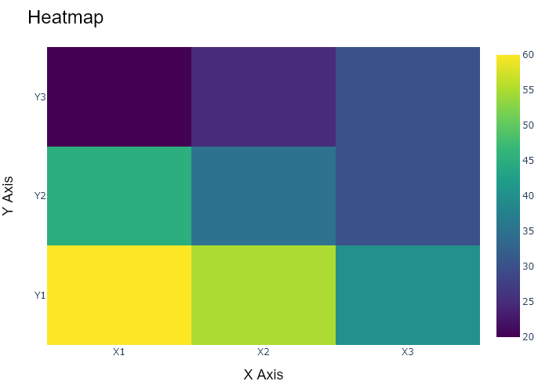

## Performance Metrics

|  |  |  |  |
| --- | --- | --- | --- |
| Task | Model Used | Description | Time Taken (s) |
| Processing Image to JSON | Gemini Vision Pro (default) | Time taken to convert the uploaded image to JSON format | 15.35 |
| Updating JSON | ChatGPT 3.5 (Default) | Time taken to update the JSON with new data | 0.00 |
| Plotting Updated JSON | N/A | Time taken to plot the updated JSON | 0.19 |

# Test Run

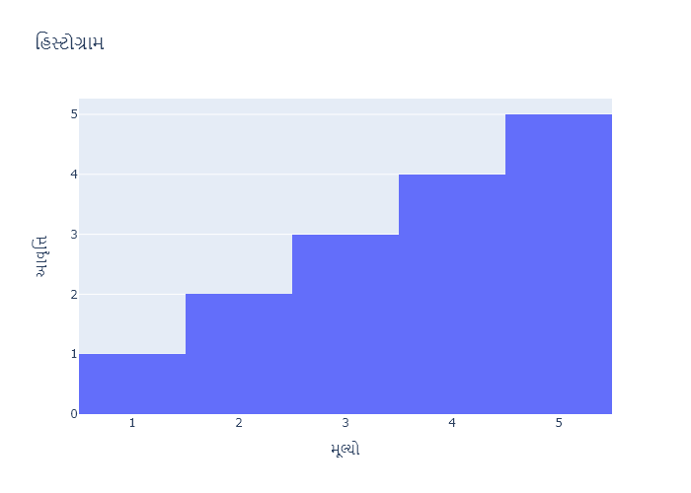

Figure: Charts\multilingual\histogram_gujarati.png

## Prompt Used

## Task: Extract Detailed Information from a Given Graph Image. Charts are multilingual, you have to extract the same language that is there in the graph.  
  
You will analyze a graph image and generate corresponding Plotly-compatible JSON files (`data.json`, `layout.json`, and `config.json`). Follow the structured steps and specific XML-like delimiters for each JSON section as outlined below.  
  
### Instructions:  
  
#### Graph Analysis:  
  
1. **Identify and Categorize Plot Types**:  
 - Recognize and categorize the plot types present in the graph image. Charts may include but are not limited to the following types:  
 - **Comparison Charts**:  
 - `bar`: Bar Chart  
 - `bar` (with vertical bars): Column Chart  
 - `bar` (grouped): Grouped Bar/Column Chart  
 - `scatter` (with lines connecting to points): Lollipop Chart  
 - `indicator` (with gauge): Bullet Chart  
 - `scatter`: Dot Plot  
 - `scatter` (with lines connecting different points): Dumbbell Chart  
 - `scatter` (or custom SVG): Pictogram  
 - `scatter` or `bar` with a range: Range Chart  
 - `barpolar`: Radial Bar Chart  
 - `parcoords`: Parallel Coordinates  
 - `scatterpolar`: Radar Chart  
 - `barpolar` (with segments): Nightingale Chart  
 - `waterfall`: Waterfall Chart  
 - `heatmap` (with color scale): Matrix Chart  
 - `various charts in small multiples`: Small Multiples  
 - `text` (frequency-based size): Word Cloud  
 - `scatter` (with lines indicating change): Slope Chart  
 - `table`: Table Chart  
 - `scatter`: Categorical Scatter Plot  
 - `scatter` (with four quadrants): Quadrant Chart  
 - **Correlation Charts**:  
 - `heatmap`: Heatmap  
 - `scatter` (with size): Bubble Chart  
 - `scatter`: Scatter Plot  
 - `scatter` (with lines connecting points): Connected Scatter Plot  
 - `hexbin`: Hexagonal Binning  
 - `contour`: Contour Plot  
 - **Part-to-Whole & Hierarchical Charts**:  
 - `bar` (stacked): Stacked Bar/Column Chart  
 - `bar` (with diverging sections): Diverging Bar Chart  
 - `bar` (mirrored pairs): Population Pyramid  
 - `scatter` (or custom symbols in a grid): Icon Array  
 - `waffle`: Waffle Chart  
 - `pie`: Pie Chart  
 - `pie` (with hole): Donut Chart  
 - `pie` (half-circle): Semi-circle Donut Chart  
 - `bar` (variable width): Marimekko Chart  
 - `treemap`: Treemap  
 - `treemap` (circular): Circular Treemap  
 - `treemap` (convex shape): Convex Treemap  
 - `sunburst`: Sunburst Chart  
 - `funnel` or `pyramid`: Funnel & Pyramid Chart  
 - `dendrogram`: Dendrogram  
 - `venn`: Venn Diagram  
 - `euler`: Euler Diagram  
 - `indicator` (circular gauge): Circular Gauge  
 - **Data Over Time (Temporal) Charts**:  
 - `scatter` (filled area under curve): Area Chart  
 - `scatter` (filled stacked areas): Stacked Area Chart  
 - `scatter` (smoothed filled areas): Stream Graph  
 - `scatter` (indicating ranking change): Bump Chart  
 - `scatter` (with filled area): Bump Area Chart  
 - `scatter`: Line Chart  
 - `scatter` (with smoothed lines): Spline Chart  
 - `scatter` (with stepped lines): Step Line Chart  
 - `candlestick`: Candlestick Chart  
 - `gantt`: Gantt Chart  
 - `scatter` (encoded lines): Barcode Chart  
 - `ohlc`: OHLC Chart  
 - **Distribution Charts**:  
 - `densitymapbox` or `histogram`: Density Plot  
 - `ridge`: Ridgeline Plot  
 - `horizon`: Horizon Chart  
 - `histogram`: Histogram  
 - `radial_histogram`: Radial Histogram  
 - `scatter` (with distribution): Strip Plot  
 - `scatter` (with jitter): Jitter Plot  
 - `heatmap`: One-dimensional Heatmap  
 - `scatter` (with tightly packed points): Beeswarm Chart  
 - `box`: Box Chart  
 - `violin`: Violin Plot  
 - **Geospatial & Other Charts**:  
 - `densitymapbox`: Geographic Heatmap  
 - `choropleth`: Choropleth Map  
 - `scattermapbox`: Tile Map  
 - `chord`: Chord Diagram  
 - `arc`: Arc Diagram  
 - `sankey`: Sankey  
 - `network`: Network Diagram  
 - `flowchart`: Flowchart  
  
2. **Extract Data Points** for Each Plot Type:  
 - Gather the data points for each identified plot type.  
 - For `scatter`, `line`, and `area` plots: Extract `x` and `y` values.  
 - For `bar` and `stacked bar` plots: Extract `x` (categories) and `y` values.  
 - For `pie` charts: Extract `labels` and `values`.  
 - For `scatter3d`, `surface`, and other 3D plots: Extract `x`, `y`, and `z` values.  
  
3. **Identify Multiple Plots** on the Same Figure:  
 - Note any combinations or overlays of multiple plot types on the same figure and their configurations, such as stacked plots or multiple area fills.  
  
#### Generate JSON and CSV Outputs:  
  
Follow the JSON formatting guidelines and wrap each section in the specified XML-like tags.  
  
1. **Generate `data.json`**:  
 - Include detailed information for each plot type:  
 - `type`: Specify the plot type (e.g., `"scatter"`, `"bar"`, `"pie"`, `"area"`, `"scatter3d"`, `"surface"`).  
 - For area charts, use `"type": "scatter"` and specify `"fill"`.  
 - `x`, `y`, and `z` (if applicable): Arrays of data points for each axis.  
 - `labels` and `values` for pie charts.  
 - `mode`: Specify for line and scatter plots (e.g., `"markers"`, `"lines"`, `"markers+lines"`).  
 - `name`: Legend entry for the plot.  
 - `marker`: Properties such as color, size, and symbol.  
 - `line`: Properties such as color, width, and dash style.  
 - `text`: Hover text for each data point.  
 - `hoverinfo`: Information displayed on hover (e.g., `"x+y+text"`).  
 - `fill`: For area charts, specify the fill (e.g., `"tozeroy"`, `"tonexty"`).  
 - `fillcolor`: The color used to fill the area.  
 - `stackgroup`: For stacked bar charts, specify the stacking group.  
  
2. **Generate `layout.json`**:  
 - Define the layout properties:  
 - `title`: Text and font properties for the graph title.  
 - `xaxis` and `yaxis`: Configuration for axis titles, ranges, grids, and ticks.  
 - `zaxis`: Configuration for 3D plots including title, range, and grid.  
 - `legend`: Properties for legend orientation and positioning.  
 - `margin`: Margins for left, right, bottom, top, and padding.  
 - `plot_bgcolor` and `paper_bgcolor`: Background colors.  
 - `scene`: Configuration for 3D scenes, including camera angles and aspect ratio.  
  
3. **Generate `config.json`**:  
 - Include settings such as:  
 - `responsive`: Whether the graph is responsive.  
 - `displayModeBar`: Whether the mode bar is shown.  
 - `modeBarButtonsToRemove`: List of mode bar buttons to remove.  
 - `scrollZoom`: Whether scrolling zoom is enabled.  
  
4. **Generate `<csv>`**:  
 - Format the CSV data as follows:  
 ```csv  
 x,y  
 1,4  
 2,5  
 3,6  
 ```  
 - Replace `x`, `y`, `1`, `4`, `2`, `5`, and `3`, `6` with the actual data from the graph image.  
  
### Output Format:  
  
Wrap each JSON output in the specified XML-like tags:  
  
- `<data> ... </data>`  
- `<layout> ... </layout>`  
- `<config> ... </config>`  
- `<csv> ... </csv>`  
  
Ensure the JSON format follows these rules:  
- Use double quotes for all keys and string values.  
- Do not include trailing commas in arrays or objects.  
  
### Example Output:  
  
```xml  
<data>  
[  
 {  
 "type": "scatter",  
 "x": [1, 2, 3],  
 "y": [4, 5, 6],  
 "mode": "markers+lines",  
 "name": "Line Plot",  
 "marker": {  
 "color": "rgba(75, 192, 192, 0.6)",  
 "size": 8  
 },  
 "line": {  
 "color": "rgba(75, 192, 192  
  
, 1)",  
 "width": 2  
 }  
 },  
 {  
 "type": "area",  
 "x": [1, 2, 3, 4, 5, 6, 7, 8, 9, 10, 11, 12],  
 "y": [400, 430, 550, 620, 580, 600, 630, 700, 670, 630, 600, 500],  
 "name": "Housing",  
 "marker": {  
 "color": "rgba(255, 159, 64, 0.8)"  
 },  
 "line": {  
 "color": "rgba(255, 159, 64, 1)",  
 "width": 2  
 }  
 },  
 {  
 "type": "bar",  
 "x": ["A", "B", "C"],  
 "y": [10, 15, 13],  
 "name": "Bar Chart",  
 "marker": {  
 "color": "rgba(255, 99, 132, 0.6)"  
 },  
 "hoverinfo": "x+y+text"  
 },  
 {  
 "type": "scatter",  
 "x": [1, 2, 3],  
 "y": [6, 7, 8],  
 "mode": "lines",  
 "fill": "tozeroy",  
 "name": "Area Chart",  
 "line": {  
 "color": "rgba(54, 162, 235, 1)",  
 "width": 2  
 },  
 "fillcolor": "rgba(54, 162, 235, 0.5)"  
 },  
 {  
 "type": "scatter3d",  
 "x": [1, 2, 3],  
 "y": [4, 5, 6],  
 "z": [7, 8, 9],  
 "mode": "markers",  
 "name": "3D Scatter Plot",  
 "marker": {  
 "color": "rgba(255, 159, 64, 0.8)",  
 "size": 5  
 },  
 "hoverinfo": "x+y+z+text"  
 },  
 {  
 "type": "surface",  
 "z": [  
 [10, 10.625, 12.5, 15.625, 20],  
 [5.625, 6.25, 8.125, 11.25, 15.625],  
 [0, 1.25, 3.125, 6.25, 10.625]  
 ],  
 "name": "Surface Plot",  
 "colorscale": "Viridis",  
 "hoverinfo": "z+name"  
 }  
]  
</data>  
<layout>  
{  
 "title": {  
 "text": "Complex Graph Example",  
 "font": {  
 "family": "Arial, sans-serif",  
 "size": 24,  
 "color": "#000000"  
 }  
 },  
 "xaxis": {  
 "title": {  
 "text": "X Axis",  
 "font": {  
 "family": "Arial, sans-serif",  
 "size": 18,  
 "color": "#000000"  
 }  
 },  
 "showgrid": true,  
 "gridcolor": "rgba(0, 0, 0, 0.1)",  
 "zeroline": true,  
 "zerolinecolor": "rgba(0, 0, 0, 0.1)"  
 },  
 "yaxis": {  
 "title": {  
 "text": "Y Axis",  
 "font": {  
 "family": "Arial, sans-serif",  
 "size": 18,  
 "color": "#000000"  
 }  
 },  
 "showgrid": true,  
 "gridcolor": "rgba(0, 0, 0, 0.1)",  
 "zeroline": true,  
 "zerolinecolor": "rgba(0, 0, 0, 0.1)"  
 },  
 "legend": {  
 "orientation": "h",  
 "x": 0.5,  
 "xanchor": "center",  
 "y": -0.2,  
 "font": {  
 "family": "Arial, sans-serif",  
 "size": 12,  
 "color": "#000000"  
 }  
 },  
 "margin": {  
 "l": 60,  
 "r": 30,  
 "b": 60,  
 "t": 60  
 },  
 "plot_bgcolor": "#ffffff",  
 "paper_bgcolor": "#ffffff",  
 "scene": {  
 "xaxis": {"title": "X Axis"},  
 "yaxis": {"title": "Y Axis"},  
 "zaxis": {"title": "Z Axis"}  
 }  
}  
</layout>  
<config>  
{  
 "responsive": true,  
 "displayModeBar": true,  
 "modeBarButtonsToRemove": ["toImage"],  
 "scrollZoom": true  
}  
</config>  
<csv>  
x,y  
1,4  
2,5  
3,6  
</csv>  
```

## Extracted JSON

### data

[  
 {  
 "type": "bar",  
 "x": [  
 1,  
 2,  
 3,  
 4,  
 5  
 ],  
 "y": [  
 4,  
 5,  
 6,  
 7,  
 8  
 ],  
 "name": "Bar Chart",  
 "marker": {  
 "color": "rgba(255, 99, 132, 0.6)"  
 },  
 "hoverinfo": "x+y+text"  
 }  
]

### layout

{  
 "title": {  
 "text": "Bar Chart",  
 "font": {  
 "family": "Arial, sans-serif",  
 "size": 24,  
 "color": "#000000"  
 }  
 },  
 "xaxis": {  
 "title": {  
 "text": "X Axis",  
 "font": {  
 "family": "Arial, sans-serif",  
 "size": 18,  
 "color": "#000000"  
 }  
 },  
 "showgrid": true,  
 "gridcolor": "rgba(0, 0, 0, 0.1)",  
 "zeroline": true,  
 "zerolinecolor": "rgba(0, 0, 0, 0.1)"  
 },  
 "yaxis": {  
 "title": {  
 "text": "Y Axis",  
 "font": {  
 "family": "Arial, sans-serif",  
 "size": 18,  
 "color": "#000000"  
 }  
 },  
 "showgrid": true,  
 "gridcolor": "rgba(0, 0, 0, 0.1)",  
 "zeroline": true,  
 "zerolinecolor": "rgba(0, 0, 0, 0.1)"  
 },  
 "legend": {  
 "orientation": "h",  
 "x": 0.5,  
 "xanchor": "center",  
 "y": -0.2,  
 "font": {  
 "family": "Arial, sans-serif",  
 "size": 12,  
 "color": "#000000"  
 }  
 },  
 "margin": {  
 "l": 60,  
 "r": 30,  
 "b": 60,  
 "t": 60  
 },  
 "plot_bgcolor": "#ffffff",  
 "paper_bgcolor": "#ffffff"  
}

### config

{  
 "responsive": true,  
 "displayModeBar": true,  
 "modeBarButtonsToRemove": [  
 "toImage"  
 ],  
 "scrollZoom": true  
}

## Updated JSON

### updated_data

[  
 {  
 "type": "bar",  
 "x": [  
 1,  
 2,  
 3,  
 4,  
 5  
 ],  
 "y": [  
 4,  
 5,  
 6,  
 7,  
 8  
 ],  
 "name": "Bar Chart",  
 "marker": {  
 "color": "rgba(255, 99, 132, 0.6)"  
 },  
 "hoverinfo": "x+y+text"  
 }  
]

### updated_layout

{  
 "title": {  
 "text": "Bar Chart",  
 "font": {  
 "family": "Arial, sans-serif",  
 "size": 24,  
 "color": "#000000"  
 }  
 },  
 "xaxis": {  
 "title": {  
 "text": "X Axis",  
 "font": {  
 "family": "Arial, sans-serif",  
 "size": 18,  
 "color": "#000000"  
 }  
 },  
 "showgrid": true,  
 "gridcolor": "rgba(0, 0, 0, 0.1)",  
 "zeroline": true,  
 "zerolinecolor": "rgba(0, 0, 0, 0.1)"  
 },  
 "yaxis": {  
 "title": {  
 "text": "Y Axis",  
 "font": {  
 "family": "Arial, sans-serif",  
 "size": 18,  
 "color": "#000000"  
 }  
 },  
 "showgrid": true,  
 "gridcolor": "rgba(0, 0, 0, 0.1)",  
 "zeroline": true,  
 "zerolinecolor": "rgba(0, 0, 0, 0.1)"  
 },  
 "legend": {  
 "orientation": "h",  
 "x": 0.5,  
 "xanchor": "center",  
 "y": -0.2,  
 "font": {  
 "family": "Arial, sans-serif",  
 "size": 12,  
 "color": "#000000"  
 }  
 },  
 "margin": {  
 "l": 60,  
 "r": 30,  
 "b": 60,  
 "t": 60  
 },  
 "plot_bgcolor": "#ffffff",  
 "paper_bgcolor": "#ffffff"  
}

### updated_config

{  
 "responsive": true,  
 "displayModeBar": true,  
 "modeBarButtonsToRemove": [  
 "toImage"  
 ],  
 "scrollZoom": true  
}

## Updated Chart

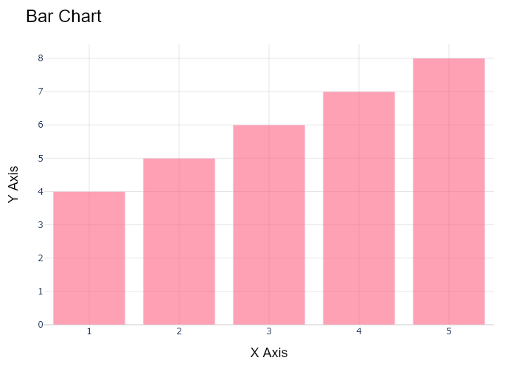

## Performance Metrics

|  |  |  |  |
| --- | --- | --- | --- |
| Task | Model Used | Description | Time Taken (s) |
| Processing Image to JSON | Gemini Vision Pro (default) | Time taken to convert the uploaded image to JSON format | 16.72 |
| Updating JSON | ChatGPT 3.5 (Default) | Time taken to update the JSON with new data | 0.00 |
| Plotting Updated JSON | N/A | Time taken to plot the updated JSON | 0.17 |

# Test Run

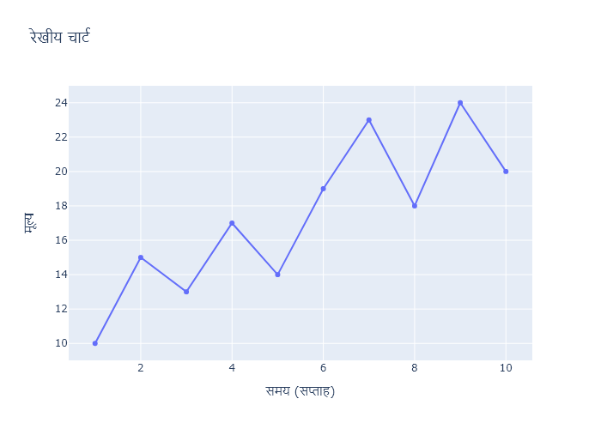

Figure: Charts\multilingual\line_chart_hindi.png

## Prompt Used

## Task: Extract Detailed Information from a Given Graph Image. Charts are multilingual, you have to extract the same language that is there in the graph.  
  
You will analyze a graph image and generate corresponding Plotly-compatible JSON files (`data.json`, `layout.json`, and `config.json`). Follow the structured steps and specific XML-like delimiters for each JSON section as outlined below.  
  
### Instructions:  
  
#### Graph Analysis:  
  
1. **Identify and Categorize Plot Types**:  
 - Recognize and categorize the plot types present in the graph image. Charts may include but are not limited to the following types:  
 - **Comparison Charts**:  
 - `bar`: Bar Chart  
 - `bar` (with vertical bars): Column Chart  
 - `bar` (grouped): Grouped Bar/Column Chart  
 - `scatter` (with lines connecting to points): Lollipop Chart  
 - `indicator` (with gauge): Bullet Chart  
 - `scatter`: Dot Plot  
 - `scatter` (with lines connecting different points): Dumbbell Chart  
 - `scatter` (or custom SVG): Pictogram  
 - `scatter` or `bar` with a range: Range Chart  
 - `barpolar`: Radial Bar Chart  
 - `parcoords`: Parallel Coordinates  
 - `scatterpolar`: Radar Chart  
 - `barpolar` (with segments): Nightingale Chart  
 - `waterfall`: Waterfall Chart  
 - `heatmap` (with color scale): Matrix Chart  
 - `various charts in small multiples`: Small Multiples  
 - `text` (frequency-based size): Word Cloud  
 - `scatter` (with lines indicating change): Slope Chart  
 - `table`: Table Chart  
 - `scatter`: Categorical Scatter Plot  
 - `scatter` (with four quadrants): Quadrant Chart  
 - **Correlation Charts**:  
 - `heatmap`: Heatmap  
 - `scatter` (with size): Bubble Chart  
 - `scatter`: Scatter Plot  
 - `scatter` (with lines connecting points): Connected Scatter Plot  
 - `hexbin`: Hexagonal Binning  
 - `contour`: Contour Plot  
 - **Part-to-Whole & Hierarchical Charts**:  
 - `bar` (stacked): Stacked Bar/Column Chart  
 - `bar` (with diverging sections): Diverging Bar Chart  
 - `bar` (mirrored pairs): Population Pyramid  
 - `scatter` (or custom symbols in a grid): Icon Array  
 - `waffle`: Waffle Chart  
 - `pie`: Pie Chart  
 - `pie` (with hole): Donut Chart  
 - `pie` (half-circle): Semi-circle Donut Chart  
 - `bar` (variable width): Marimekko Chart  
 - `treemap`: Treemap  
 - `treemap` (circular): Circular Treemap  
 - `treemap` (convex shape): Convex Treemap  
 - `sunburst`: Sunburst Chart  
 - `funnel` or `pyramid`: Funnel & Pyramid Chart  
 - `dendrogram`: Dendrogram  
 - `venn`: Venn Diagram  
 - `euler`: Euler Diagram  
 - `indicator` (circular gauge): Circular Gauge  
 - **Data Over Time (Temporal) Charts**:  
 - `scatter` (filled area under curve): Area Chart  
 - `scatter` (filled stacked areas): Stacked Area Chart  
 - `scatter` (smoothed filled areas): Stream Graph  
 - `scatter` (indicating ranking change): Bump Chart  
 - `scatter` (with filled area): Bump Area Chart  
 - `scatter`: Line Chart  
 - `scatter` (with smoothed lines): Spline Chart  
 - `scatter` (with stepped lines): Step Line Chart  
 - `candlestick`: Candlestick Chart  
 - `gantt`: Gantt Chart  
 - `scatter` (encoded lines): Barcode Chart  
 - `ohlc`: OHLC Chart  
 - **Distribution Charts**:  
 - `densitymapbox` or `histogram`: Density Plot  
 - `ridge`: Ridgeline Plot  
 - `horizon`: Horizon Chart  
 - `histogram`: Histogram  
 - `radial_histogram`: Radial Histogram  
 - `scatter` (with distribution): Strip Plot  
 - `scatter` (with jitter): Jitter Plot  
 - `heatmap`: One-dimensional Heatmap  
 - `scatter` (with tightly packed points): Beeswarm Chart  
 - `box`: Box Chart  
 - `violin`: Violin Plot  
 - **Geospatial & Other Charts**:  
 - `densitymapbox`: Geographic Heatmap  
 - `choropleth`: Choropleth Map  
 - `scattermapbox`: Tile Map  
 - `chord`: Chord Diagram  
 - `arc`: Arc Diagram  
 - `sankey`: Sankey  
 - `network`: Network Diagram  
 - `flowchart`: Flowchart  
  
2. **Extract Data Points** for Each Plot Type:  
 - Gather the data points for each identified plot type.  
 - For `scatter`, `line`, and `area` plots: Extract `x` and `y` values.  
 - For `bar` and `stacked bar` plots: Extract `x` (categories) and `y` values.  
 - For `pie` charts: Extract `labels` and `values`.  
 - For `scatter3d`, `surface`, and other 3D plots: Extract `x`, `y`, and `z` values.  
  
3. **Identify Multiple Plots** on the Same Figure:  
 - Note any combinations or overlays of multiple plot types on the same figure and their configurations, such as stacked plots or multiple area fills.  
  
#### Generate JSON and CSV Outputs:  
  
Follow the JSON formatting guidelines and wrap each section in the specified XML-like tags.  
  
1. **Generate `data.json`**:  
 - Include detailed information for each plot type:  
 - `type`: Specify the plot type (e.g., `"scatter"`, `"bar"`, `"pie"`, `"area"`, `"scatter3d"`, `"surface"`).  
 - For area charts, use `"type": "scatter"` and specify `"fill"`.  
 - `x`, `y`, and `z` (if applicable): Arrays of data points for each axis.  
 - `labels` and `values` for pie charts.  
 - `mode`: Specify for line and scatter plots (e.g., `"markers"`, `"lines"`, `"markers+lines"`).  
 - `name`: Legend entry for the plot.  
 - `marker`: Properties such as color, size, and symbol.  
 - `line`: Properties such as color, width, and dash style.  
 - `text`: Hover text for each data point.  
 - `hoverinfo`: Information displayed on hover (e.g., `"x+y+text"`).  
 - `fill`: For area charts, specify the fill (e.g., `"tozeroy"`, `"tonexty"`).  
 - `fillcolor`: The color used to fill the area.  
 - `stackgroup`: For stacked bar charts, specify the stacking group.  
  
2. **Generate `layout.json`**:  
 - Define the layout properties:  
 - `title`: Text and font properties for the graph title.  
 - `xaxis` and `yaxis`: Configuration for axis titles, ranges, grids, and ticks.  
 - `zaxis`: Configuration for 3D plots including title, range, and grid.  
 - `legend`: Properties for legend orientation and positioning.  
 - `margin`: Margins for left, right, bottom, top, and padding.  
 - `plot_bgcolor` and `paper_bgcolor`: Background colors.  
 - `scene`: Configuration for 3D scenes, including camera angles and aspect ratio.  
  
3. **Generate `config.json`**:  
 - Include settings such as:  
 - `responsive`: Whether the graph is responsive.  
 - `displayModeBar`: Whether the mode bar is shown.  
 - `modeBarButtonsToRemove`: List of mode bar buttons to remove.  
 - `scrollZoom`: Whether scrolling zoom is enabled.  
  
4. **Generate `<csv>`**:  
 - Format the CSV data as follows:  
 ```csv  
 x,y  
 1,4  
 2,5  
 3,6  
 ```  
 - Replace `x`, `y`, `1`, `4`, `2`, `5`, and `3`, `6` with the actual data from the graph image.  
  
### Output Format:  
  
Wrap each JSON output in the specified XML-like tags:  
  
- `<data> ... </data>`  
- `<layout> ... </layout>`  
- `<config> ... </config>`  
- `<csv> ... </csv>`  
  
Ensure the JSON format follows these rules:  
- Use double quotes for all keys and string values.  
- Do not include trailing commas in arrays or objects.  
  
### Example Output:  
  
```xml  
<data>  
[  
 {  
 "type": "scatter",  
 "x": [1, 2, 3],  
 "y": [4, 5, 6],  
 "mode": "markers+lines",  
 "name": "Line Plot",  
 "marker": {  
 "color": "rgba(75, 192, 192, 0.6)",  
 "size": 8  
 },  
 "line": {  
 "color": "rgba(75, 192, 192  
  
, 1)",  
 "width": 2  
 }  
 },  
 {  
 "type": "area",  
 "x": [1, 2, 3, 4, 5, 6, 7, 8, 9, 10, 11, 12],  
 "y": [400, 430, 550, 620, 580, 600, 630, 700, 670, 630, 600, 500],  
 "name": "Housing",  
 "marker": {  
 "color": "rgba(255, 159, 64, 0.8)"  
 },  
 "line": {  
 "color": "rgba(255, 159, 64, 1)",  
 "width": 2  
 }  
 },  
 {  
 "type": "bar",  
 "x": ["A", "B", "C"],  
 "y": [10, 15, 13],  
 "name": "Bar Chart",  
 "marker": {  
 "color": "rgba(255, 99, 132, 0.6)"  
 },  
 "hoverinfo": "x+y+text"  
 },  
 {  
 "type": "scatter",  
 "x": [1, 2, 3],  
 "y": [6, 7, 8],  
 "mode": "lines",  
 "fill": "tozeroy",  
 "name": "Area Chart",  
 "line": {  
 "color": "rgba(54, 162, 235, 1)",  
 "width": 2  
 },  
 "fillcolor": "rgba(54, 162, 235, 0.5)"  
 },  
 {  
 "type": "scatter3d",  
 "x": [1, 2, 3],  
 "y": [4, 5, 6],  
 "z": [7, 8, 9],  
 "mode": "markers",  
 "name": "3D Scatter Plot",  
 "marker": {  
 "color": "rgba(255, 159, 64, 0.8)",  
 "size": 5  
 },  
 "hoverinfo": "x+y+z+text"  
 },  
 {  
 "type": "surface",  
 "z": [  
 [10, 10.625, 12.5, 15.625, 20],  
 [5.625, 6.25, 8.125, 11.25, 15.625],  
 [0, 1.25, 3.125, 6.25, 10.625]  
 ],  
 "name": "Surface Plot",  
 "colorscale": "Viridis",  
 "hoverinfo": "z+name"  
 }  
]  
</data>  
<layout>  
{  
 "title": {  
 "text": "Complex Graph Example",  
 "font": {  
 "family": "Arial, sans-serif",  
 "size": 24,  
 "color": "#000000"  
 }  
 },  
 "xaxis": {  
 "title": {  
 "text": "X Axis",  
 "font": {  
 "family": "Arial, sans-serif",  
 "size": 18,  
 "color": "#000000"  
 }  
 },  
 "showgrid": true,  
 "gridcolor": "rgba(0, 0, 0, 0.1)",  
 "zeroline": true,  
 "zerolinecolor": "rgba(0, 0, 0, 0.1)"  
 },  
 "yaxis": {  
 "title": {  
 "text": "Y Axis",  
 "font": {  
 "family": "Arial, sans-serif",  
 "size": 18,  
 "color": "#000000"  
 }  
 },  
 "showgrid": true,  
 "gridcolor": "rgba(0, 0, 0, 0.1)",  
 "zeroline": true,  
 "zerolinecolor": "rgba(0, 0, 0, 0.1)"  
 },  
 "legend": {  
 "orientation": "h",  
 "x": 0.5,  
 "xanchor": "center",  
 "y": -0.2,  
 "font": {  
 "family": "Arial, sans-serif",  
 "size": 12,  
 "color": "#000000"  
 }  
 },  
 "margin": {  
 "l": 60,  
 "r": 30,  
 "b": 60,  
 "t": 60  
 },  
 "plot_bgcolor": "#ffffff",  
 "paper_bgcolor": "#ffffff",  
 "scene": {  
 "xaxis": {"title": "X Axis"},  
 "yaxis": {"title": "Y Axis"},  
 "zaxis": {"title": "Z Axis"}  
 }  
}  
</layout>  
<config>  
{  
 "responsive": true,  
 "displayModeBar": true,  
 "modeBarButtonsToRemove": ["toImage"],  
 "scrollZoom": true  
}  
</config>  
<csv>  
x,y  
1,4  
2,5  
3,6  
</csv>  
```

## Extracted JSON

### data

[  
 {  
 "type": "scatter",  
 "x": [  
 1,  
 2,  
 3,  
 4,  
 5,  
 6,  
 7,  
 8,  
 9,  
 10  
 ],  
 "y": [  
 10,  
 15,  
 13,  
 17,  
 16,  
 18,  
 20,  
 21,  
 19,  
 22  
 ],  
 "mode": "lines",  
 "name": "\u0930\u0947\u0916\u0940\u092f \u091a\u093e\u0930\u094d\u091f",  
 "line": {  
 "color": "rgba(54, 162, 235, 1)",  
 "width": 2  
 }  
 }  
]

### layout

{  
 "title": {  
 "text": "\u0930\u0947\u0916\u0940\u092f \u091a\u093e\u0930\u094d\u091f",  
 "font": {  
 "family": "Arial, sans-serif",  
 "size": 24,  
 "color": "#000000"  
 }  
 },  
 "xaxis": {  
 "title": {  
 "text": "\u0938\u092e\u092f (\u0938\u093e\u0932\u093e\u0939)",  
 "font": {  
 "family": "Arial, sans-serif",  
 "size": 18,  
 "color": "#000000"  
 }  
 },  
 "showgrid": true,  
 "gridcolor": "rgba(0, 0, 0, 0.1)",  
 "zeroline": true,  
 "zerolinecolor": "rgba(0, 0, 0, 0.1)"  
 },  
 "yaxis": {  
 "title": {  
 "text": "\u092e\u0942\u0932\u094d\u092f",  
 "font": {  
 "family": "Arial, sans-serif",  
 "size": 18,  
 "color": "#000000"  
 }  
 },  
 "showgrid": true,  
 "gridcolor": "rgba(0, 0, 0, 0.1)",  
 "zeroline": true,  
 "zerolinecolor": "rgba(0, 0, 0, 0.1)"  
 },  
 "legend": {  
 "orientation": "h",  
 "x": 0.5,  
 "xanchor": "center",  
 "y": -0.2,  
 "font": {  
 "family": "Arial, sans-serif",  
 "size": 12,  
 "color": "#000000"  
 }  
 },  
 "margin": {  
 "l": 60,  
 "r": 30,  
 "b": 60,  
 "t": 60  
 },  
 "plot_bgcolor": "#ffffff",  
 "paper_bgcolor": "#ffffff"  
}

### config

{  
 "responsive": true,  
 "displayModeBar": true,  
 "modeBarButtonsToRemove": [  
 "toImage"  
 ],  
 "scrollZoom": true  
}

## Updated JSON

### updated_data

[  
 {  
 "type": "scatter",  
 "x": [  
 1,  
 2,  
 3,  
 4,  
 5,  
 6,  
 7,  
 8,  
 9,  
 10  
 ],  
 "y": [  
 10,  
 15,  
 13,  
 17,  
 16,  
 18,  
 20,  
 21,  
 19,  
 22  
 ],  
 "mode": "lines",  
 "name": "\u0930\u0947\u0916\u0940\u092f \u091a\u093e\u0930\u094d\u091f",  
 "line": {  
 "color": "rgba(54, 162, 235, 1)",  
 "width": 2  
 }  
 }  
]

### updated_layout

{  
 "title": {  
 "text": "\u0930\u0947\u0916\u0940\u092f \u091a\u093e\u0930\u094d\u091f",  
 "font": {  
 "family": "Arial, sans-serif",  
 "size": 24,  
 "color": "#000000"  
 }  
 },  
 "xaxis": {  
 "title": {  
 "text": "\u0938\u092e\u092f (\u0938\u093e\u0932\u093e\u0939)",  
 "font": {  
 "family": "Arial, sans-serif",  
 "size": 18,  
 "color": "#000000"  
 }  
 },  
 "showgrid": true,  
 "gridcolor": "rgba(0, 0, 0, 0.1)",  
 "zeroline": true,  
 "zerolinecolor": "rgba(0, 0, 0, 0.1)"  
 },  
 "yaxis": {  
 "title": {  
 "text": "\u092e\u0942\u0932\u094d\u092f",  
 "font": {  
 "family": "Arial, sans-serif",  
 "size": 18,  
 "color": "#000000"  
 }  
 },  
 "showgrid": true,  
 "gridcolor": "rgba(0, 0, 0, 0.1)",  
 "zeroline": true,  
 "zerolinecolor": "rgba(0, 0, 0, 0.1)"  
 },  
 "legend": {  
 "orientation": "h",  
 "x": 0.5,  
 "xanchor": "center",  
 "y": -0.2,  
 "font": {  
 "family": "Arial, sans-serif",  
 "size": 12,  
 "color": "#000000"  
 }  
 },  
 "margin": {  
 "l": 60,  
 "r": 30,  
 "b": 60,  
 "t": 60  
 },  
 "plot_bgcolor": "#ffffff",  
 "paper_bgcolor": "#ffffff"  
}

### updated_config

{  
 "responsive": true,  
 "displayModeBar": true,  
 "modeBarButtonsToRemove": [  
 "toImage"  
 ],  
 "scrollZoom": true  
}

## Updated Chart

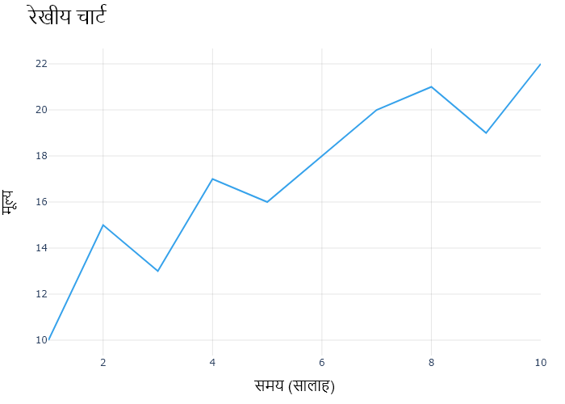

## Performance Metrics

|  |  |  |  |
| --- | --- | --- | --- |
| Task | Model Used | Description | Time Taken (s) |
| Processing Image to JSON | Gemini Vision Pro (default) | Time taken to convert the uploaded image to JSON format | 18.05 |
| Updating JSON | ChatGPT 3.5 (Default) | Time taken to update the JSON with new data | 0.00 |
| Plotting Updated JSON | N/A | Time taken to plot the updated JSON | 0.15 |

# Test Run

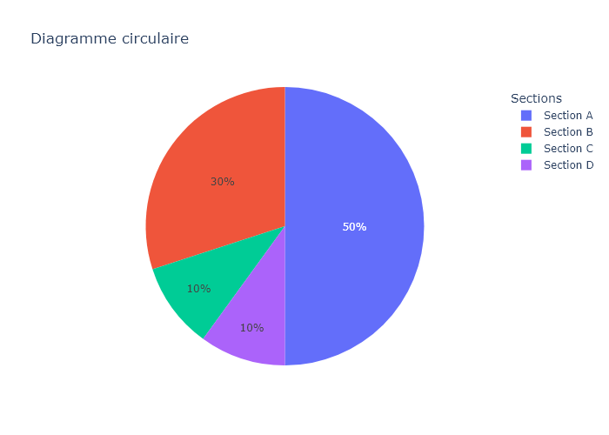

Figure: Charts\multilingual\pie_chart_french.png

## Prompt Used

## Task: Extract Detailed Information from a Given Graph Image. Charts are multilingual, you have to extract the same language that is there in the graph.  
  
You will analyze a graph image and generate corresponding Plotly-compatible JSON files (`data.json`, `layout.json`, and `config.json`). Follow the structured steps and specific XML-like delimiters for each JSON section as outlined below.  
  
### Instructions:  
  
#### Graph Analysis:  
  
1. **Identify and Categorize Plot Types**:  
 - Recognize and categorize the plot types present in the graph image. Charts may include but are not limited to the following types:  
 - **Comparison Charts**:  
 - `bar`: Bar Chart  
 - `bar` (with vertical bars): Column Chart  
 - `bar` (grouped): Grouped Bar/Column Chart  
 - `scatter` (with lines connecting to points): Lollipop Chart  
 - `indicator` (with gauge): Bullet Chart  
 - `scatter`: Dot Plot  
 - `scatter` (with lines connecting different points): Dumbbell Chart  
 - `scatter` (or custom SVG): Pictogram  
 - `scatter` or `bar` with a range: Range Chart  
 - `barpolar`: Radial Bar Chart  
 - `parcoords`: Parallel Coordinates  
 - `scatterpolar`: Radar Chart  
 - `barpolar` (with segments): Nightingale Chart  
 - `waterfall`: Waterfall Chart  
 - `heatmap` (with color scale): Matrix Chart  
 - `various charts in small multiples`: Small Multiples  
 - `text` (frequency-based size): Word Cloud  
 - `scatter` (with lines indicating change): Slope Chart  
 - `table`: Table Chart  
 - `scatter`: Categorical Scatter Plot  
 - `scatter` (with four quadrants): Quadrant Chart  
 - **Correlation Charts**:  
 - `heatmap`: Heatmap  
 - `scatter` (with size): Bubble Chart  
 - `scatter`: Scatter Plot  
 - `scatter` (with lines connecting points): Connected Scatter Plot  
 - `hexbin`: Hexagonal Binning  
 - `contour`: Contour Plot  
 - **Part-to-Whole & Hierarchical Charts**:  
 - `bar` (stacked): Stacked Bar/Column Chart  
 - `bar` (with diverging sections): Diverging Bar Chart  
 - `bar` (mirrored pairs): Population Pyramid  
 - `scatter` (or custom symbols in a grid): Icon Array  
 - `waffle`: Waffle Chart  
 - `pie`: Pie Chart  
 - `pie` (with hole): Donut Chart  
 - `pie` (half-circle): Semi-circle Donut Chart  
 - `bar` (variable width): Marimekko Chart  
 - `treemap`: Treemap  
 - `treemap` (circular): Circular Treemap  
 - `treemap` (convex shape): Convex Treemap  
 - `sunburst`: Sunburst Chart  
 - `funnel` or `pyramid`: Funnel & Pyramid Chart  
 - `dendrogram`: Dendrogram  
 - `venn`: Venn Diagram  
 - `euler`: Euler Diagram  
 - `indicator` (circular gauge): Circular Gauge  
 - **Data Over Time (Temporal) Charts**:  
 - `scatter` (filled area under curve): Area Chart  
 - `scatter` (filled stacked areas): Stacked Area Chart  
 - `scatter` (smoothed filled areas): Stream Graph  
 - `scatter` (indicating ranking change): Bump Chart  
 - `scatter` (with filled area): Bump Area Chart  
 - `scatter`: Line Chart  
 - `scatter` (with smoothed lines): Spline Chart  
 - `scatter` (with stepped lines): Step Line Chart  
 - `candlestick`: Candlestick Chart  
 - `gantt`: Gantt Chart  
 - `scatter` (encoded lines): Barcode Chart  
 - `ohlc`: OHLC Chart  
 - **Distribution Charts**:  
 - `densitymapbox` or `histogram`: Density Plot  
 - `ridge`: Ridgeline Plot  
 - `horizon`: Horizon Chart  
 - `histogram`: Histogram  
 - `radial_histogram`: Radial Histogram  
 - `scatter` (with distribution): Strip Plot  
 - `scatter` (with jitter): Jitter Plot  
 - `heatmap`: One-dimensional Heatmap  
 - `scatter` (with tightly packed points): Beeswarm Chart  
 - `box`: Box Chart  
 - `violin`: Violin Plot  
 - **Geospatial & Other Charts**:  
 - `densitymapbox`: Geographic Heatmap  
 - `choropleth`: Choropleth Map  
 - `scattermapbox`: Tile Map  
 - `chord`: Chord Diagram  
 - `arc`: Arc Diagram  
 - `sankey`: Sankey  
 - `network`: Network Diagram  
 - `flowchart`: Flowchart  
  
2. **Extract Data Points** for Each Plot Type:  
 - Gather the data points for each identified plot type.  
 - For `scatter`, `line`, and `area` plots: Extract `x` and `y` values.  
 - For `bar` and `stacked bar` plots: Extract `x` (categories) and `y` values.  
 - For `pie` charts: Extract `labels` and `values`.  
 - For `scatter3d`, `surface`, and other 3D plots: Extract `x`, `y`, and `z` values.  
  
3. **Identify Multiple Plots** on the Same Figure:  
 - Note any combinations or overlays of multiple plot types on the same figure and their configurations, such as stacked plots or multiple area fills.  
  
#### Generate JSON and CSV Outputs:  
  
Follow the JSON formatting guidelines and wrap each section in the specified XML-like tags.  
  
1. **Generate `data.json`**:  
 - Include detailed information for each plot type:  
 - `type`: Specify the plot type (e.g., `"scatter"`, `"bar"`, `"pie"`, `"area"`, `"scatter3d"`, `"surface"`).  
 - For area charts, use `"type": "scatter"` and specify `"fill"`.  
 - `x`, `y`, and `z` (if applicable): Arrays of data points for each axis.  
 - `labels` and `values` for pie charts.  
 - `mode`: Specify for line and scatter plots (e.g., `"markers"`, `"lines"`, `"markers+lines"`).  
 - `name`: Legend entry for the plot.  
 - `marker`: Properties such as color, size, and symbol.  
 - `line`: Properties such as color, width, and dash style.  
 - `text`: Hover text for each data point.  
 - `hoverinfo`: Information displayed on hover (e.g., `"x+y+text"`).  
 - `fill`: For area charts, specify the fill (e.g., `"tozeroy"`, `"tonexty"`).  
 - `fillcolor`: The color used to fill the area.  
 - `stackgroup`: For stacked bar charts, specify the stacking group.  
  
2. **Generate `layout.json`**:  
 - Define the layout properties:  
 - `title`: Text and font properties for the graph title.  
 - `xaxis` and `yaxis`: Configuration for axis titles, ranges, grids, and ticks.  
 - `zaxis`: Configuration for 3D plots including title, range, and grid.  
 - `legend`: Properties for legend orientation and positioning.  
 - `margin`: Margins for left, right, bottom, top, and padding.  
 - `plot_bgcolor` and `paper_bgcolor`: Background colors.  
 - `scene`: Configuration for 3D scenes, including camera angles and aspect ratio.  
  
3. **Generate `config.json`**:  
 - Include settings such as:  
 - `responsive`: Whether the graph is responsive.  
 - `displayModeBar`: Whether the mode bar is shown.  
 - `modeBarButtonsToRemove`: List of mode bar buttons to remove.  
 - `scrollZoom`: Whether scrolling zoom is enabled.  
  
4. **Generate `<csv>`**:  
 - Format the CSV data as follows:  
 ```csv  
 x,y  
 1,4  
 2,5  
 3,6  
 ```  
 - Replace `x`, `y`, `1`, `4`, `2`, `5`, and `3`, `6` with the actual data from the graph image.  
  
### Output Format:  
  
Wrap each JSON output in the specified XML-like tags:  
  
- `<data> ... </data>`  
- `<layout> ... </layout>`  
- `<config> ... </config>`  
- `<csv> ... </csv>`  
  
Ensure the JSON format follows these rules:  
- Use double quotes for all keys and string values.  
- Do not include trailing commas in arrays or objects.  
  
### Example Output:  
  
```xml  
<data>  
[  
 {  
 "type": "scatter",  
 "x": [1, 2, 3],  
 "y": [4, 5, 6],  
 "mode": "markers+lines",  
 "name": "Line Plot",  
 "marker": {  
 "color": "rgba(75, 192, 192, 0.6)",  
 "size": 8  
 },  
 "line": {  
 "color": "rgba(75, 192, 192  
  
, 1)",  
 "width": 2  
 }  
 },  
 {  
 "type": "area",  
 "x": [1, 2, 3, 4, 5, 6, 7, 8, 9, 10, 11, 12],  
 "y": [400, 430, 550, 620, 580, 600, 630, 700, 670, 630, 600, 500],  
 "name": "Housing",  
 "marker": {  
 "color": "rgba(255, 159, 64, 0.8)"  
 },  
 "line": {  
 "color": "rgba(255, 159, 64, 1)",  
 "width": 2  
 }  
 },  
 {  
 "type": "bar",  
 "x": ["A", "B", "C"],  
 "y": [10, 15, 13],  
 "name": "Bar Chart",  
 "marker": {  
 "color": "rgba(255, 99, 132, 0.6)"  
 },  
 "hoverinfo": "x+y+text"  
 },  
 {  
 "type": "scatter",  
 "x": [1, 2, 3],  
 "y": [6, 7, 8],  
 "mode": "lines",  
 "fill": "tozeroy",  
 "name": "Area Chart",  
 "line": {  
 "color": "rgba(54, 162, 235, 1)",  
 "width": 2  
 },  
 "fillcolor": "rgba(54, 162, 235, 0.5)"  
 },  
 {  
 "type": "scatter3d",  
 "x": [1, 2, 3],  
 "y": [4, 5, 6],  
 "z": [7, 8, 9],  
 "mode": "markers",  
 "name": "3D Scatter Plot",  
 "marker": {  
 "color": "rgba(255, 159, 64, 0.8)",  
 "size": 5  
 },  
 "hoverinfo": "x+y+z+text"  
 },  
 {  
 "type": "surface",  
 "z": [  
 [10, 10.625, 12.5, 15.625, 20],  
 [5.625, 6.25, 8.125, 11.25, 15.625],  
 [0, 1.25, 3.125, 6.25, 10.625]  
 ],  
 "name": "Surface Plot",  
 "colorscale": "Viridis",  
 "hoverinfo": "z+name"  
 }  
]  
</data>  
<layout>  
{  
 "title": {  
 "text": "Complex Graph Example",  
 "font": {  
 "family": "Arial, sans-serif",  
 "size": 24,  
 "color": "#000000"  
 }  
 },  
 "xaxis": {  
 "title": {  
 "text": "X Axis",  
 "font": {  
 "family": "Arial, sans-serif",  
 "size": 18,  
 "color": "#000000"  
 }  
 },  
 "showgrid": true,  
 "gridcolor": "rgba(0, 0, 0, 0.1)",  
 "zeroline": true,  
 "zerolinecolor": "rgba(0, 0, 0, 0.1)"  
 },  
 "yaxis": {  
 "title": {  
 "text": "Y Axis",  
 "font": {  
 "family": "Arial, sans-serif",  
 "size": 18,  
 "color": "#000000"  
 }  
 },  
 "showgrid": true,  
 "gridcolor": "rgba(0, 0, 0, 0.1)",  
 "zeroline": true,  
 "zerolinecolor": "rgba(0, 0, 0, 0.1)"  
 },  
 "legend": {  
 "orientation": "h",  
 "x": 0.5,  
 "xanchor": "center",  
 "y": -0.2,  
 "font": {  
 "family": "Arial, sans-serif",  
 "size": 12,  
 "color": "#000000"  
 }  
 },  
 "margin": {  
 "l": 60,  
 "r": 30,  
 "b": 60,  
 "t": 60  
 },  
 "plot_bgcolor": "#ffffff",  
 "paper_bgcolor": "#ffffff",  
 "scene": {  
 "xaxis": {"title": "X Axis"},  
 "yaxis": {"title": "Y Axis"},  
 "zaxis": {"title": "Z Axis"}  
 }  
}  
</layout>  
<config>  
{  
 "responsive": true,  
 "displayModeBar": true,  
 "modeBarButtonsToRemove": ["toImage"],  
 "scrollZoom": true  
}  
</config>  
<csv>  
x,y  
1,4  
2,5  
3,6  
</csv>  
```

## Extracted JSON

### data

[  
 {  
 "type": "pie",  
 "labels": [  
 "Section A",  
 "Section B",  
 "Section C",  
 "Section D"  
 ],  
 "values": [  
 50,  
 30,  
 10,  
 10  
 ],  
 "name": "Section Pie Chart"  
 }  
]

### layout

{  
 "title": {  
 "text": "Section Pie Chart",  
 "font": {  
 "family": "Arial, sans-serif",  
 "size": 24,  
 "color": "#000000"  
 }  
 },  
 "legend": {  
 "orientation": "h",  
 "x": 0.5,  
 "xanchor": "center",  
 "y": -0.2,  
 "font": {  
 "family": "Arial, sans-serif",  
 "size": 12,  
 "color": "#000000"  
 }  
 },  
 "margin": {  
 "l": 60,  
 "r": 30,  
 "b": 60,  
 "t": 60  
 },  
 "plot_bgcolor": "#ffffff",  
 "paper_bgcolor": "#ffffff"  
}

### config

{  
 "responsive": true,  
 "displayModeBar": true,  
 "modeBarButtonsToRemove": [  
 "toImage"  
 ],  
 "scrollZoom": true  
}

## Updated JSON

### updated_data

[  
 {  
 "type": "pie",  
 "labels": [  
 "Section A",  
 "Section B",  
 "Section C",  
 "Section D"  
 ],  
 "values": [  
 50,  
 30,  
 10,  
 10  
 ],  
 "name": "Section Pie Chart"  
 }  
]

### updated_layout

{  
 "title": {  
 "text": "Section Pie Chart",  
 "font": {  
 "family": "Arial, sans-serif",  
 "size": 24,  
 "color": "#000000"  
 }  
 },  
 "legend": {  
 "orientation": "h",  
 "x": 0.5,  
 "xanchor": "center",  
 "y": -0.2,  
 "font": {  
 "family": "Arial, sans-serif",  
 "size": 12,  
 "color": "#000000"  
 }  
 },  
 "margin": {  
 "l": 60,  
 "r": 30,  
 "b": 60,  
 "t": 60  
 },  
 "plot_bgcolor": "#ffffff",  
 "paper_bgcolor": "#ffffff"  
}

### updated_config

{  
 "responsive": true,  
 "displayModeBar": true,  
 "modeBarButtonsToRemove": [  
 "toImage"  
 ],  
 "scrollZoom": true  
}

## Updated Chart

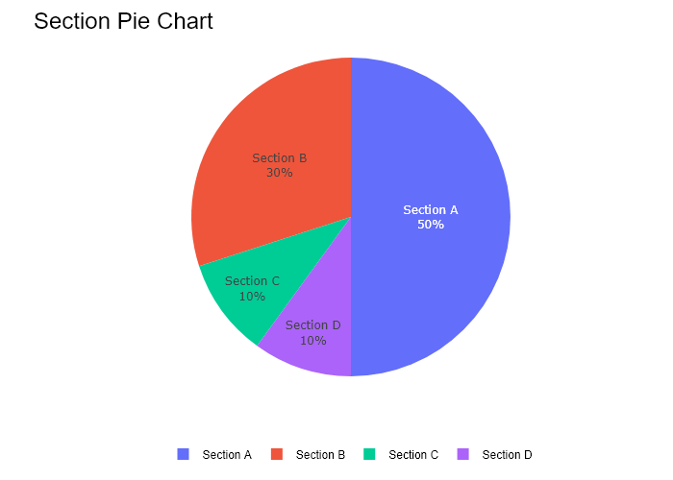

## Performance Metrics

|  |  |  |  |
| --- | --- | --- | --- |
| Task | Model Used | Description | Time Taken (s) |
| Processing Image to JSON | Gemini Vision Pro (default) | Time taken to convert the uploaded image to JSON format | 12.62 |
| Updating JSON | ChatGPT 3.5 (Default) | Time taken to update the JSON with new data | 0.00 |
| Plotting Updated JSON | N/A | Time taken to plot the updated JSON | 0.16 |

# Test Run

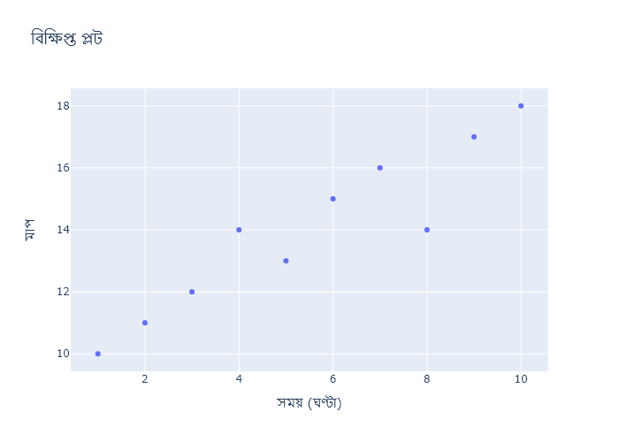

Figure: Charts\multilingual\scatter_plot_bengali.png

## Prompt Used

## Task: Extract Detailed Information from a Given Graph Image. Charts are multilingual, you have to extract the same language that is there in the graph.  
  
You will analyze a graph image and generate corresponding Plotly-compatible JSON files (`data.json`, `layout.json`, and `config.json`). Follow the structured steps and specific XML-like delimiters for each JSON section as outlined below.  
  
### Instructions:  
  
#### Graph Analysis:  
  
1. **Identify and Categorize Plot Types**:  
 - Recognize and categorize the plot types present in the graph image. Charts may include but are not limited to the following types:  
 - **Comparison Charts**:  
 - `bar`: Bar Chart  
 - `bar` (with vertical bars): Column Chart  
 - `bar` (grouped): Grouped Bar/Column Chart  
 - `scatter` (with lines connecting to points): Lollipop Chart  
 - `indicator` (with gauge): Bullet Chart  
 - `scatter`: Dot Plot  
 - `scatter` (with lines connecting different points): Dumbbell Chart  
 - `scatter` (or custom SVG): Pictogram  
 - `scatter` or `bar` with a range: Range Chart  
 - `barpolar`: Radial Bar Chart  
 - `parcoords`: Parallel Coordinates  
 - `scatterpolar`: Radar Chart  
 - `barpolar` (with segments): Nightingale Chart  
 - `waterfall`: Waterfall Chart  
 - `heatmap` (with color scale): Matrix Chart  
 - `various charts in small multiples`: Small Multiples  
 - `text` (frequency-based size): Word Cloud  
 - `scatter` (with lines indicating change): Slope Chart  
 - `table`: Table Chart  
 - `scatter`: Categorical Scatter Plot  
 - `scatter` (with four quadrants): Quadrant Chart  
 - **Correlation Charts**:  
 - `heatmap`: Heatmap  
 - `scatter` (with size): Bubble Chart  
 - `scatter`: Scatter Plot  
 - `scatter` (with lines connecting points): Connected Scatter Plot  
 - `hexbin`: Hexagonal Binning  
 - `contour`: Contour Plot  
 - **Part-to-Whole & Hierarchical Charts**:  
 - `bar` (stacked): Stacked Bar/Column Chart  
 - `bar` (with diverging sections): Diverging Bar Chart  
 - `bar` (mirrored pairs): Population Pyramid  
 - `scatter` (or custom symbols in a grid): Icon Array  
 - `waffle`: Waffle Chart  
 - `pie`: Pie Chart  
 - `pie` (with hole): Donut Chart  
 - `pie` (half-circle): Semi-circle Donut Chart  
 - `bar` (variable width): Marimekko Chart  
 - `treemap`: Treemap  
 - `treemap` (circular): Circular Treemap  
 - `treemap` (convex shape): Convex Treemap  
 - `sunburst`: Sunburst Chart  
 - `funnel` or `pyramid`: Funnel & Pyramid Chart  
 - `dendrogram`: Dendrogram  
 - `venn`: Venn Diagram  
 - `euler`: Euler Diagram  
 - `indicator` (circular gauge): Circular Gauge  
 - **Data Over Time (Temporal) Charts**:  
 - `scatter` (filled area under curve): Area Chart  
 - `scatter` (filled stacked areas): Stacked Area Chart  
 - `scatter` (smoothed filled areas): Stream Graph  
 - `scatter` (indicating ranking change): Bump Chart  
 - `scatter` (with filled area): Bump Area Chart  
 - `scatter`: Line Chart  
 - `scatter` (with smoothed lines): Spline Chart  
 - `scatter` (with stepped lines): Step Line Chart  
 - `candlestick`: Candlestick Chart  
 - `gantt`: Gantt Chart  
 - `scatter` (encoded lines): Barcode Chart  
 - `ohlc`: OHLC Chart  
 - **Distribution Charts**:  
 - `densitymapbox` or `histogram`: Density Plot  
 - `ridge`: Ridgeline Plot  
 - `horizon`: Horizon Chart  
 - `histogram`: Histogram  
 - `radial_histogram`: Radial Histogram  
 - `scatter` (with distribution): Strip Plot  
 - `scatter` (with jitter): Jitter Plot  
 - `heatmap`: One-dimensional Heatmap  
 - `scatter` (with tightly packed points): Beeswarm Chart  
 - `box`: Box Chart  
 - `violin`: Violin Plot  
 - **Geospatial & Other Charts**:  
 - `densitymapbox`: Geographic Heatmap  
 - `choropleth`: Choropleth Map  
 - `scattermapbox`: Tile Map  
 - `chord`: Chord Diagram  
 - `arc`: Arc Diagram  
 - `sankey`: Sankey  
 - `network`: Network Diagram  
 - `flowchart`: Flowchart  
  
2. **Extract Data Points** for Each Plot Type:  
 - Gather the data points for each identified plot type.  
 - For `scatter`, `line`, and `area` plots: Extract `x` and `y` values.  
 - For `bar` and `stacked bar` plots: Extract `x` (categories) and `y` values.  
 - For `pie` charts: Extract `labels` and `values`.  
 - For `scatter3d`, `surface`, and other 3D plots: Extract `x`, `y`, and `z` values.  
  
3. **Identify Multiple Plots** on the Same Figure:  
 - Note any combinations or overlays of multiple plot types on the same figure and their configurations, such as stacked plots or multiple area fills.  
  
#### Generate JSON and CSV Outputs:  
  
Follow the JSON formatting guidelines and wrap each section in the specified XML-like tags.  
  
1. **Generate `data.json`**:  
 - Include detailed information for each plot type:  
 - `type`: Specify the plot type (e.g., `"scatter"`, `"bar"`, `"pie"`, `"area"`, `"scatter3d"`, `"surface"`).  
 - For area charts, use `"type": "scatter"` and specify `"fill"`.  
 - `x`, `y`, and `z` (if applicable): Arrays of data points for each axis.  
 - `labels` and `values` for pie charts.  
 - `mode`: Specify for line and scatter plots (e.g., `"markers"`, `"lines"`, `"markers+lines"`).  
 - `name`: Legend entry for the plot.  
 - `marker`: Properties such as color, size, and symbol.  
 - `line`: Properties such as color, width, and dash style.  
 - `text`: Hover text for each data point.  
 - `hoverinfo`: Information displayed on hover (e.g., `"x+y+text"`).  
 - `fill`: For area charts, specify the fill (e.g., `"tozeroy"`, `"tonexty"`).  
 - `fillcolor`: The color used to fill the area.  
 - `stackgroup`: For stacked bar charts, specify the stacking group.  
  
2. **Generate `layout.json`**:  
 - Define the layout properties:  
 - `title`: Text and font properties for the graph title.  
 - `xaxis` and `yaxis`: Configuration for axis titles, ranges, grids, and ticks.  
 - `zaxis`: Configuration for 3D plots including title, range, and grid.  
 - `legend`: Properties for legend orientation and positioning.  
 - `margin`: Margins for left, right, bottom, top, and padding.  
 - `plot_bgcolor` and `paper_bgcolor`: Background colors.  
 - `scene`: Configuration for 3D scenes, including camera angles and aspect ratio.  
  
3. **Generate `config.json`**:  
 - Include settings such as:  
 - `responsive`: Whether the graph is responsive.  
 - `displayModeBar`: Whether the mode bar is shown.  
 - `modeBarButtonsToRemove`: List of mode bar buttons to remove.  
 - `scrollZoom`: Whether scrolling zoom is enabled.  
  
4. **Generate `<csv>`**:  
 - Format the CSV data as follows:  
 ```csv  
 x,y  
 1,4  
 2,5  
 3,6  
 ```  
 - Replace `x`, `y`, `1`, `4`, `2`, `5`, and `3`, `6` with the actual data from the graph image.  
  
### Output Format:  
  
Wrap each JSON output in the specified XML-like tags:  
  
- `<data> ... </data>`  
- `<layout> ... </layout>`  
- `<config> ... </config>`  
- `<csv> ... </csv>`  
  
Ensure the JSON format follows these rules:  
- Use double quotes for all keys and string values.  
- Do not include trailing commas in arrays or objects.  
  
### Example Output:  
  
```xml  
<data>  
[  
 {  
 "type": "scatter",  
 "x": [1, 2, 3],  
 "y": [4, 5, 6],  
 "mode": "markers+lines",  
 "name": "Line Plot",  
 "marker": {  
 "color": "rgba(75, 192, 192, 0.6)",  
 "size": 8  
 },  
 "line": {  
 "color": "rgba(75, 192, 192  
  
, 1)",  
 "width": 2  
 }  
 },  
 {  
 "type": "area",  
 "x": [1, 2, 3, 4, 5, 6, 7, 8, 9, 10, 11, 12],  
 "y": [400, 430, 550, 620, 580, 600, 630, 700, 670, 630, 600, 500],  
 "name": "Housing",  
 "marker": {  
 "color": "rgba(255, 159, 64, 0.8)"  
 },  
 "line": {  
 "color": "rgba(255, 159, 64, 1)",  
 "width": 2  
 }  
 },  
 {  
 "type": "bar",  
 "x": ["A", "B", "C"],  
 "y": [10, 15, 13],  
 "name": "Bar Chart",  
 "marker": {  
 "color": "rgba(255, 99, 132, 0.6)"  
 },  
 "hoverinfo": "x+y+text"  
 },  
 {  
 "type": "scatter",  
 "x": [1, 2, 3],  
 "y": [6, 7, 8],  
 "mode": "lines",  
 "fill": "tozeroy",  
 "name": "Area Chart",  
 "line": {  
 "color": "rgba(54, 162, 235, 1)",  
 "width": 2  
 },  
 "fillcolor": "rgba(54, 162, 235, 0.5)"  
 },  
 {  
 "type": "scatter3d",  
 "x": [1, 2, 3],  
 "y": [4, 5, 6],  
 "z": [7, 8, 9],  
 "mode": "markers",  
 "name": "3D Scatter Plot",  
 "marker": {  
 "color": "rgba(255, 159, 64, 0.8)",  
 "size": 5  
 },  
 "hoverinfo": "x+y+z+text"  
 },  
 {  
 "type": "surface",  
 "z": [  
 [10, 10.625, 12.5, 15.625, 20],  
 [5.625, 6.25, 8.125, 11.25, 15.625],  
 [0, 1.25, 3.125, 6.25, 10.625]  
 ],  
 "name": "Surface Plot",  
 "colorscale": "Viridis",  
 "hoverinfo": "z+name"  
 }  
]  
</data>  
<layout>  
{  
 "title": {  
 "text": "Complex Graph Example",  
 "font": {  
 "family": "Arial, sans-serif",  
 "size": 24,  
 "color": "#000000"  
 }  
 },  
 "xaxis": {  
 "title": {  
 "text": "X Axis",  
 "font": {  
 "family": "Arial, sans-serif",  
 "size": 18,  
 "color": "#000000"  
 }  
 },  
 "showgrid": true,  
 "gridcolor": "rgba(0, 0, 0, 0.1)",  
 "zeroline": true,  
 "zerolinecolor": "rgba(0, 0, 0, 0.1)"  
 },  
 "yaxis": {  
 "title": {  
 "text": "Y Axis",  
 "font": {  
 "family": "Arial, sans-serif",  
 "size": 18,  
 "color": "#000000"  
 }  
 },  
 "showgrid": true,  
 "gridcolor": "rgba(0, 0, 0, 0.1)",  
 "zeroline": true,  
 "zerolinecolor": "rgba(0, 0, 0, 0.1)"  
 },  
 "legend": {  
 "orientation": "h",  
 "x": 0.5,  
 "xanchor": "center",  
 "y": -0.2,  
 "font": {  
 "family": "Arial, sans-serif",  
 "size": 12,  
 "color": "#000000"  
 }  
 },  
 "margin": {  
 "l": 60,  
 "r": 30,  
 "b": 60,  
 "t": 60  
 },  
 "plot_bgcolor": "#ffffff",  
 "paper_bgcolor": "#ffffff",  
 "scene": {  
 "xaxis": {"title": "X Axis"},  
 "yaxis": {"title": "Y Axis"},  
 "zaxis": {"title": "Z Axis"}  
 }  
}  
</layout>  
<config>  
{  
 "responsive": true,  
 "displayModeBar": true,  
 "modeBarButtonsToRemove": ["toImage"],  
 "scrollZoom": true  
}  
</config>  
<csv>  
x,y  
1,4  
2,5  
3,6  
</csv>  
```

## Extracted JSON

### data

[  
 {  
 "type": "scatter",  
 "x": [  
 2,  
 4,  
 6,  
 8,  
 10  
 ],  
 "y": [  
 11,  
 14,  
 16,  
 18,  
 10  
 ],  
 "mode": "markers",  
 "name": "Data",  
 "marker": {  
 "color": "rgba(128, 128, 128, 0.8)",  
 "size": 10  
 },  
 "hoverinfo": "x+y+text"  
 }  
]

### layout

{  
 "title": {  
 "text": "\u09ac\u09bf\u09b6\u09cd\u09b2\u09c7\u09b7\u09a3\u09c7\u09b0 \u099c\u09a8\u09cd\u09af \u09a1\u09c7\u099f\u09be",  
 "font": {  
 "family": "Arial, sans-serif",  
 "size": 24,  
 "color": "#000000"  
 }  
 },  
 "xaxis": {  
 "title": {  
 "text": "\u09b8\u09ae\u09df (\u0998\u09a3\u09cd\u099f\u09be)",  
 "font": {  
 "family": "Arial, sans-serif",  
 "size": 18,  
 "color": "#000000"  
 }  
 },  
 "showgrid": true,  
 "gridcolor": "rgba(0, 0, 0, 0.1)",  
 "zeroline": true,  
 "zerolinecolor": "rgba(0, 0, 0, 0.1)"  
 },  
 "yaxis": {  
 "title": {  
 "text": "\u09ae\u09be\u09a8",  
 "font": {  
 "family": "Arial, sans-serif",  
 "size": 18,  
 "color": "#000000"  
 }  
 },  
 "showgrid": true,  
 "gridcolor": "rgba(0, 0, 0, 0.1)",  
 "zeroline": true,  
 "zerolinecolor": "rgba(0, 0, 0, 0.1)"  
 },  
 "legend": {  
 "orientation": "h",  
 "x": 0.5,  
 "xanchor": "center",  
 "y": -0.2,  
 "font": {  
 "family": "Arial, sans-serif",  
 "size": 12,  
 "color": "#000000"  
 }  
 },  
 "margin": {  
 "l": 60,  
 "r": 30,  
 "b": 60,  
 "t": 60  
 },  
 "plot_bgcolor": "#ffffff",  
 "paper_bgcolor": "#ffffff"  
}

### config

{  
 "responsive": true,  
 "displayModeBar": true,  
 "modeBarButtonsToRemove": [  
 "toImage"  
 ],  
 "scrollZoom": true  
}

## Updated JSON

### updated_data

[  
 {  
 "type": "scatter",  
 "x": [  
 2,  
 4,  
 6,  
 8,  
 10  
 ],  
 "y": [  
 11,  
 14,  
 16,  
 18,  
 10  
 ],  
 "mode": "markers",  
 "name": "Data",  
 "marker": {  
 "color": "rgba(128, 128, 128, 0.8)",  
 "size": 10  
 },  
 "hoverinfo": "x+y+text"  
 }  
]

### updated_layout

{  
 "title": {  
 "text": "\u09ac\u09bf\u09b6\u09cd\u09b2\u09c7\u09b7\u09a3\u09c7\u09b0 \u099c\u09a8\u09cd\u09af \u09a1\u09c7\u099f\u09be",  
 "font": {  
 "family": "Arial, sans-serif",  
 "size": 24,  
 "color": "#000000"  
 }  
 },  
 "xaxis": {  
 "title": {  
 "text": "\u09b8\u09ae\u09df (\u0998\u09a3\u09cd\u099f\u09be)",  
 "font": {  
 "family": "Arial, sans-serif",  
 "size": 18,  
 "color": "#000000"  
 }  
 },  
 "showgrid": true,  
 "gridcolor": "rgba(0, 0, 0, 0.1)",  
 "zeroline": true,  
 "zerolinecolor": "rgba(0, 0, 0, 0.1)"  
 },  
 "yaxis": {  
 "title": {  
 "text": "\u09ae\u09be\u09a8",  
 "font": {  
 "family": "Arial, sans-serif",  
 "size": 18,  
 "color": "#000000"  
 }  
 },  
 "showgrid": true,  
 "gridcolor": "rgba(0, 0, 0, 0.1)",  
 "zeroline": true,  
 "zerolinecolor": "rgba(0, 0, 0, 0.1)"  
 },  
 "legend": {  
 "orientation": "h",  
 "x": 0.5,  
 "xanchor": "center",  
 "y": -0.2,  
 "font": {  
 "family": "Arial, sans-serif",  
 "size": 12,  
 "color": "#000000"  
 }  
 },  
 "margin": {  
 "l": 60,  
 "r": 30,  
 "b": 60,  
 "t": 60  
 },  
 "plot_bgcolor": "#ffffff",  
 "paper_bgcolor": "#ffffff"  
}

### updated_config

{  
 "responsive": true,  
 "displayModeBar": true,  
 "modeBarButtonsToRemove": [  
 "toImage"  
 ],  
 "scrollZoom": true  
}

## Updated Chart

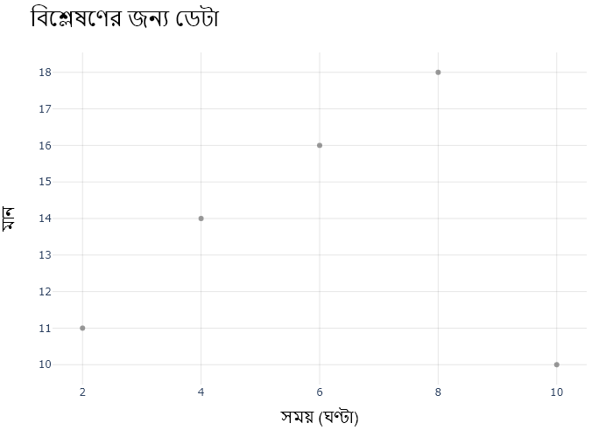

## Performance Metrics

|  |  |  |  |
| --- | --- | --- | --- |
| Task | Model Used | Description | Time Taken (s) |
| Processing Image to JSON | Gemini Vision Pro (default) | Time taken to convert the uploaded image to JSON format | 17.40 |
| Updating JSON | ChatGPT 3.5 (Default) | Time taken to update the JSON with new data | 0.00 |
| Plotting Updated JSON | N/A | Time taken to plot the updated JSON | 0.18 |